**Phu Quoc - Fishing Tour - Watching Coral Reefs 3 Days 2**

*Attention:*

-Departure: Ha Noi

-Time: 3 days 2 nights

-Vehicle: planes

-Price: ~~3900000đ~~ to 3690000đ.

-Image:

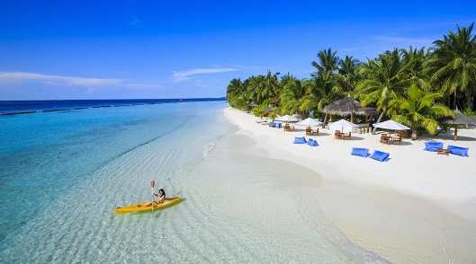 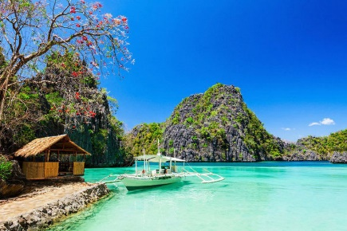 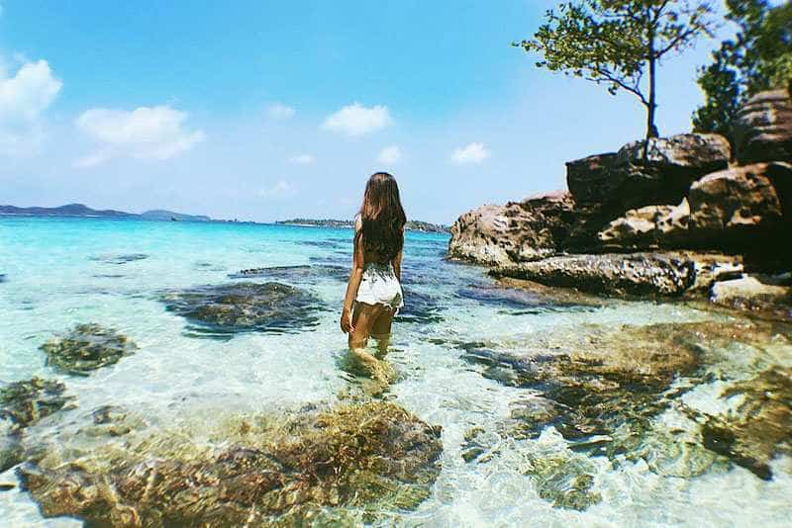

**I.Introduce:**

**TOUR PHU QUOC**

Phu Quoc is known as the pearl island and is one of the most beautiful beaches of Vietnam located in Kien Giang province. Nature bestows Phu Quoc with harmonious scenery, cool and pleasant climate all year round, rich in tourism potential. In addition, Phu Quoc has long, beautiful beaches, clear blue water and long white sandy beaches, which will be an ideal destination for couples to honeymoon or a vacation for family.

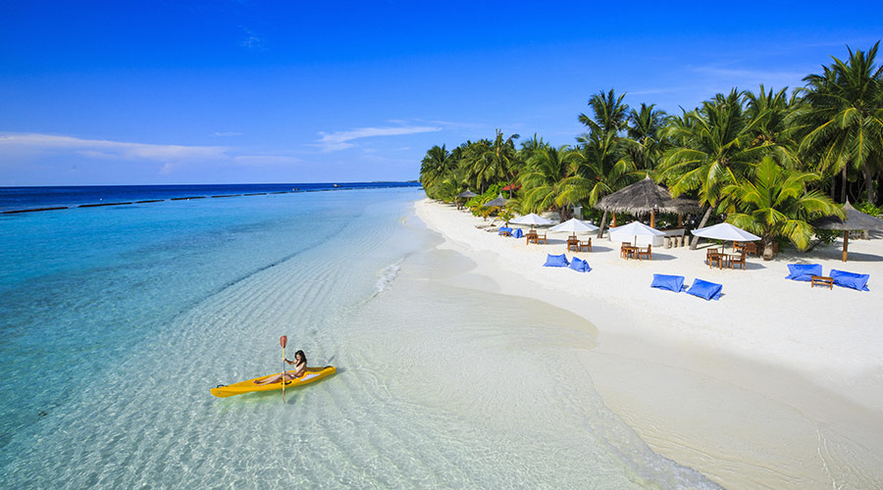

Around the island there are many beautiful beaches such as Truong beach, Khem beach, Ganh Dau, Rach Tram and Vem canal. Visitors can swim in the sea, stream, climb mountains, enter caves, go to the forest ...

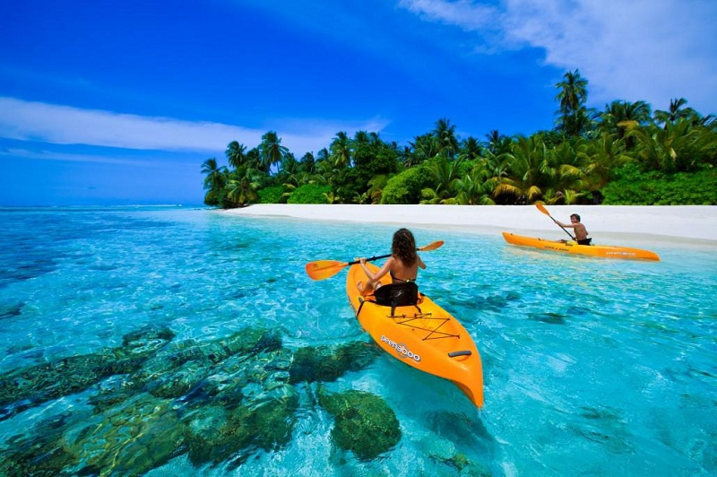

Some international tourists also compare the beauty of the beach in Phu Quoc to be as attractive as the famous beaches in the famous Hawaiian Gulf of America or the wild beaches in the Caribbean ... Because of its location in the western sea of ​​Vietnam, in Vietnam this is the only place to watch the sun set into the sea or sunset in the true sense ...

Phu Quoc's famous specialties are fish sauce, sweet, aromatic flavor made from a special anchovy, high protein (over 25ºC), annually producing about 6 million liters. Phu Quoc beach has many kinds of valuable seafood such as prawns, mackerel, plaice, grouper, and mackerel ...

**II.** **Tour schedule:**

**1.Day 1:**

HA NOI - PHU QUOC _____________________________________________________________________

Morning: Car and guide pick you up at the meeting place in the center of Hanoi, departure to Noi Bai airport. HDV procedures for delegation flight to Phu Quoc. Phu Quoc airport, car to the hotel to send luggage. Then depart for Dong Daotham: Dinh Cau, Ham Ninh Fishing Village.

At the end of the tour, you board the car to the restaurant for lunch. Then check in hotel / resort, rest freely.

Afternoon: You focus on the beach to join the Team Building program with attractive motor games organized by cheerleaders.

Evening: Have dinner at the restaurant, enjoy seafood dishes Phu Quoc. Freedom to stroll Dinh Cau night market, explore the very rich and unique cuisine of Phu Quoc. Overnight in Phu Quoc.

_____________________________________________________________________

**2.Day 2:**

FISHING FISH - SANDING CORAL OF AN THOI ISLAND _____________________________________________________________________

Morning: Have breakfast at the hotel. Departure along Bai Truong 20km to the south of the island to visit: Japanese pearl farming area, Phu Quoc's largest dried seafood market. Go to An Thoi international deep-water port, take a cruise to the southern archipelago, fish at Hon Dam, Mui Ong Doi and Gieng Ngu islands (enjoy fresh fish with tamarind sauce, which tourists have just caught on board), you You can see the 12 islands of the An Thoi archipelago, enjoy swimming and watching the sparkling and magical world of coral at Ong Ong Cape. Lunch at Bai Sao. Free swimming.

Afternoon: Continue to visit Phu Quoc Prison, Pepper Spring Garden, barrel house to produce fish sauce.

Evening: Have dinner at the restaurant. Freedom to roam, explore Duong Dong town at night. Overnight in Phu Quoc.

_____________________________________________________________________

**3.Day 3:**

PHU QUOC- HA NOI _____________________________________________________________________

Morning: Have breakfast. Free walking, shopping until the time of checking out the hotel.

Bus transfer to Phu Quoc airport, HDV procedures for delegation to flight back to Hanoi.

Back to Noi Bai airport, the bus will pick you up to the original pickup. Farewell union, end of the tour.

_____________________________________________________________________

**III.** **INCLUDED AND TERMS:**

**Service includes:**

Transportation: Newer cars, air-conditioners, shuttle to visit the program in Phu Quoc

Shuttle bus from Hanoi center - Noi Bai airport according to the program

3-star hotel / resort: Thien Hai Son / Cuu Long / Huong Bien, ... (Standard 2 pax / room, single or double occupancy in a female room)

Eating: The menu varies with each meal:

             + 02 breakfast buffet at the hotel / resort

             + 04 main meals at local restaurant

Sightseeing: Tickets to the attractions in the program

Fishing vessel / boat, fishing equipment according to the program

Team Building: sounds, items, cheerleaders

Tour guide: Serving notes, meals, breaks for customers according to the program.

Travel insurance: According to the date of the tour, the maximum level of compensation is VND 50,000,000 / case.

Gifts: Viet Center tourist hat, mineral water and cold towels to serve the day of the tour

Attractive, interesting gifts for individuals / teams winning the Team Building program

**Services not included:**

Round trip air ticket Hanoi - Phu Quoc

Personal expenses, telephone, laundry, minibar, sightseeing, dining, out of program transportation and VAT