**Tour Sai Gon – Vung Tau – Đai Nam**

*Attention:*

-Departure: Ha Noi.

-Time: 4 days 3 nights.

-Vehicle: planes

-Price: 3000000đ.

-Image:

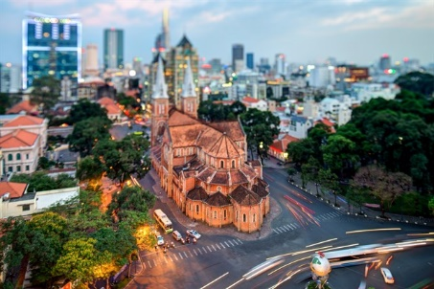 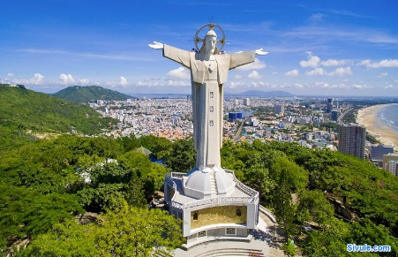 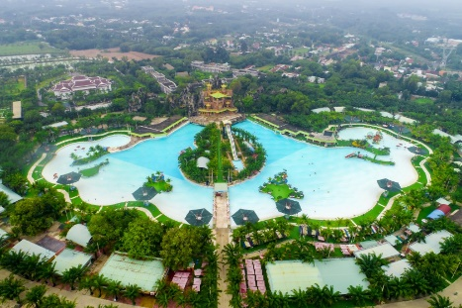

**I.Introduce:**

**SAI GON TOURISM**

Traveling to Saigon - Ho Chi Minh City for more than 300 years, you can meet the high-rise buildings are close, the entertainment area, busy shopping centers, but also no shortage of old villas. glass, the traditional markets have existed for hundreds of years. Saigon is large and does not lack the "specialty" tourism such as Saigon River Cruise by boat, visiting West Pham Ngu Lao Street, shopping at Ben Thanh Market or returning to Can Gio beach ....

Not bustling and bustling like Saigon but Vung Tau is still enough to attract visitors by a harmonious combination of natural populations of sea, mountains and urban architecture and cultural works such as monuments, pagodas, church ... give Vung Tau the advantage of a beautiful coastal city.

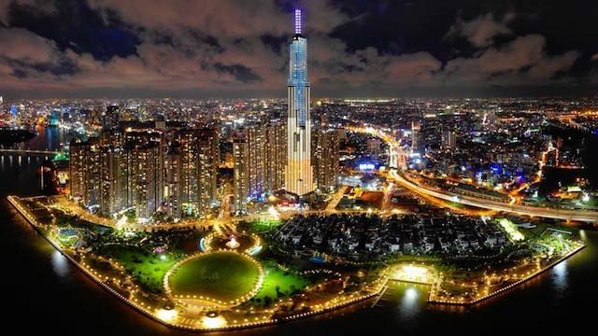Continuing the journey, the next destination will be Dai Nam Tourism Area - a cultural source, ethnic beauty, Vietnamese people with cultural and spiritual values, bringing good luck to each tourist. come here.

**II.** **Tour schedule:**

**1.Day 1:**

HA NOI- HO CHI MINH CITY _____________________________________________________________________

Afternoon: Pleasant Tour guide and car pick you up at the meeting point of central Hanoi, departure to Noi Bai airport, procedures for flight ... to Tp. Ho Chi Minh

After about 2 hours flying, to the city named Uncle Ho, considered "Pearl of the Far East", the bus takes the delegation to dinner at the restaurant. Check hotel.

Evening: Free to roam, explore the city at night. Overnight at hotel.

_____________________________________________________________________

**2.Day 2:** HO CHI MINH CITY- VUNG TAU _____________________________________________________________________

Have breakfast at Hotel. Check procedures.

In the morning: Tourists take you to visit Dai Nam with attractions: Dai Nam Van Hien, Dai Nam Quoc Tu, ... You are free to visit Dai Nam Zoo, entertainment at amusement parks: swimming artificial, roller coaster, skiing, watching movies XD, ... (expenses excluded)

Noon: Group lunch at the restaurant.

Afternoon: Depart for Vung Tau. Go to Vung Tau coastal city, you conquer Mount Tao Phung 800m high with Christ statue, panoramic view of the mountains, the sea and the city. Vung Tau from an altitude of nearly 1,000 m. You return to the hotel room. Freedom swimming in Vung Tau.

Evening: Dinner at the restaurant. Freedom to explore Vung Tau city at night. Overnight in Vung Tau.

_____________________________________________________________________

**3.Day 3:**

VUNG TAU- HO CHI MINH CITY _____________________________________________________________________

Have breakfast at Hotel.

In the morning: Depart for a tour of a beautiful coastal city with: White Palace, Thich Ca Phat Dai, Dinh Thang Tam - population including Thang Tam temple, Ngu Hanh temple and Ca Ong tomb, hidden values precious chemicals of Vung Tau coastal residents. Check out hotel rooms, have lunch at the restaurant.

Afternoon: Departure back to Ho Chi Minh City. Go to the city center, Doan check in hotel. Free rest

Evening: Dinner at the restaurant. Free to explore the city at night. Overnight at hotel.

_____________________________________________________________________

**4.Day 4:**

HO CHI MINH CITY- HA NOI_____________________________________________________________________

Have breakfast at Hotel. Check procedures.

In the morning: Depart for a tour of the city with attractions: Reunification Palace, Ho Chi Minh Museum (Dragon Wharf), Central District 1 with Notre Dame Cathedral, City Post Office, Ben Thanh Market , … Lunch at the restaurant.

Afternoon: Car takes you to Tan Son Nhat airport to make procedures for flight ... back to Hanoi. Arrive at Noi Bai airport. Car pick you up to the original meeting point. End program. Farewell to you, see you again

_____________________________________________________________________

**III.** **INCLUDED AND TERMS:**

**Service includes:**

Newer travel cars, air-conditioned, shuttle to visit the program in the south

The shuttle sees off Hanoi center <-> Noi Bai airport according to the program

3-star hotel: 2 guests / room (if male or female travelers paired 3 / room)

Eating meals program

+ Breakfast at the hotel.

+ Eat at the restaurant

Sightseeing: One-time admission to attractions, attractions according to the program

Enthusiastic tour guide, experience under the program.

Travel insurance by day tour, the maximum level of compensation 20,000,000 VND / case

Drinks + cold towels on the itinerary.

Viet Center Tourist travel cap

**Services not included:**

VAT, single bed room, phone, tickets to entertainment games at Dai Nam Tourist Area and other personal expenses.

Return ticket Hanoi - Ho Chi Minh City according to the program.