**Honeymoon Tour Ngoc Ngoc Island 4 Days 3**

*Attention:*

-Departure: Ha Noi.

-Time: 4 days 3 nights.

-Vehicle: planes

-Price: ~~4850000đ~~ to 4690000đ.

-Image:

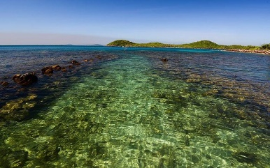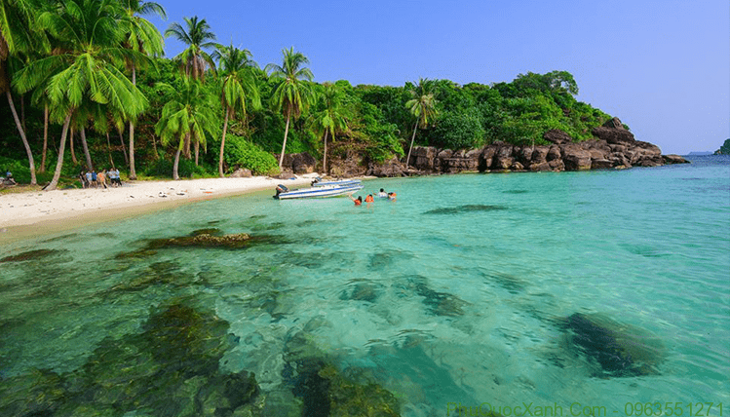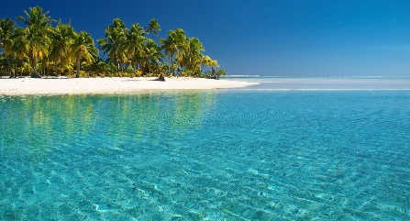

**I.Introduce:**

**PHU QUOC TRAVEL TOURISM**

Phu Quoc is known as the pearl island and is one of the most beautiful beaches of Vietnam located in Kien Giang province. Nature bestows Phu Quoc with harmonious scenery, cool and pleasant climate all year round, rich in tourism potential. In addition, Phu Quoc owns long, beautiful beaches, clear blue water and fine white sand beaches, which will be an ideal destination for couples to honeymoon.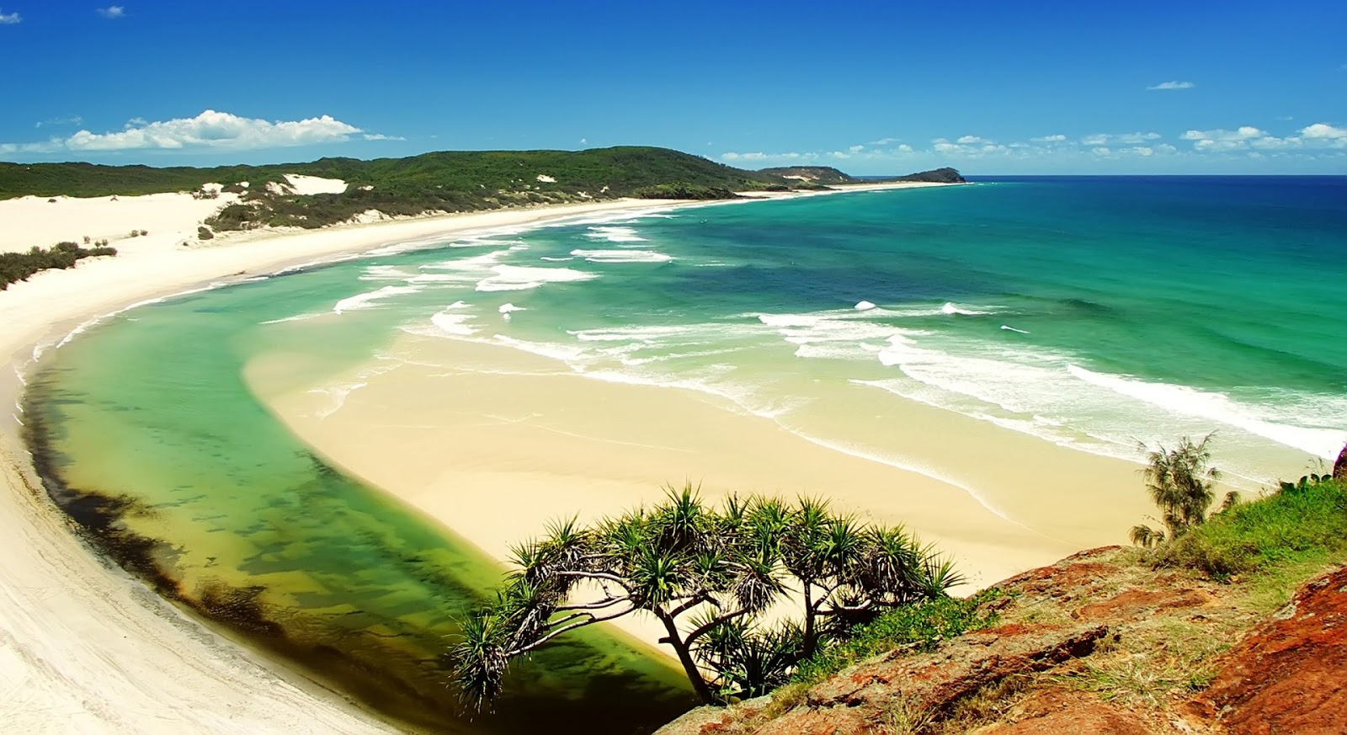Some international tourists also compare the beauty of the beach in Phu Quoc to be as attractive as the famous beaches in the famous Hawaiian Gulf of America or the wild beaches in the Caribbean ... Because of its location in the western sea of ​​Vietnam, in Vietnam this is the only place to watch the sun set into the sea or sunset in the true sense ...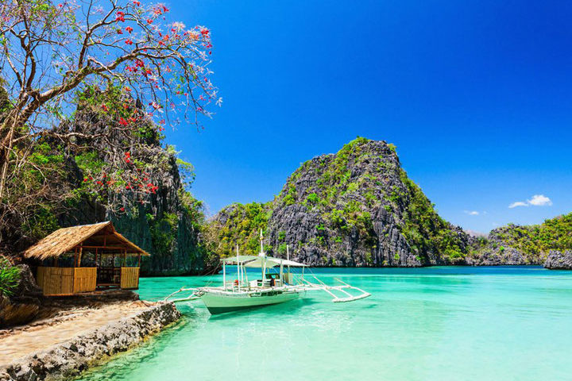In Ngoc Phu Quoc Island, there are many interesting attractions such as Phu Quoc National Park, Phu Quoc Prison Museum or Suoi Tranh Museum ... In terms of cuisine, this is also a famous land for specialties of fish sauce. Phu Quoc is famous, and visitors do not miss the opportunity to enjoy it, as this is an indispensable ingredient in Vietnamese meals.

**II.** **Tour schedule:**

**1.Day 1:**

HA NOI- PHU QUOC _____________________________________________________________________

In the morning: Pleasant tour bus will pick you up at the meeting place in the inner city, depart for Noi Bai airport and start your honeymoon trip by flight to Phu Quoc.

At Phu Quoc airport, your private car will pick you up to check in luxurious, romantic, cozy, decorated with the golden light of candles, the scent of roses, the sweetness of chocolate. la with drunken wine of wine create an ideal space for couples. Enjoy a lunch at the restaurant.

Afternoon: The two of you will have free time for each other, relax and swim at the very convenient private beach of the resort

Evening: The special dinner at the restaurant in a cozy atmosphere of candles and flowers will end gently on your first honeymoon. Overnight in Phu Quoc.

_____________________________________________________________________

**2.Day 2:**

DISCOVER NGOC ISLAND _____________________________________________________________________

Breakfast at hotel / resort.

In the morning: The two of you will have a full day to explore Phu Quoc pearl island.

Afternoon: After a peaceful lunch at Bai Sao, we will take you to visit fish sauce production establishments and pepper gardens.

Before returning to the resort, you will have moments of peace, a beautiful cafe located on a private beach with a fine sand beach invested by Australia's pearl culture company.

Evening: Freedom to walk at the resort, explore the town, Duong Dong night market, enjoy the food at the night market. Overnight in Phu Quoc.

_____________________________________________________________________

**3.Day 3:**

SEPARATE DAY FOR TWO YOU – FREEDOM _____________________________________________________________________

Have breakfast at Hotel.

Morning: A motorbike ready at the resort for you two today. You can use the car until check out the next day. Freedom to relax and relax at the resort or explore Vinpearl or ride to Duong Dong reservoir, explore the pristine stream with clear puddles ... Freedom for lunch.

Afternoon: Freedom to rest at the resort. If you still want to discover more about Phu Quoc, a trek together on a motorbike to the north of the island: primeval forest on Phu Quoc island.

Overnight in Phu Quoc.

_____________________________________________________________________

**4.Day 4:**

PHU QUOC- HA NOI _____________________________________________________________________

Have breakfast at Hotel.

Morning: Free to relax at the hotel or shopping for gifts and specialties for relatives at home such as pepper, dried seafood, fish sauce, ...

Then our car will take you to the airport for flight ... to Hanoi. Arriving at Noi Bai airport, the bus will take you back home. See you again.

_____________________________________________________________________

**III.** **INCLUDED AND TERMS:**

**Service includes :**

New 4-seater car, luxurious shuttle center <–> Noi Bai airport

New and luxurious 4-seater vehicle serving the program in Phu Quoc

Return flight ticket Hanoi - Phu Quoc according to the program

4-star Hotel / Resort: Saigon Phu Quoc / Eden, ...

Eating meals program

Sightseeing: One-time admission to attractions in the program

Motorbike for you two to use

Candles, flowers, chocolate and wine in the first room in the hotel room

Professional, enthusiastic, thoughtful tour guides according to the program

**The service does not include:**

Other meals, drinks.

Personal costs