Begin

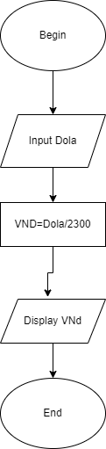

Input dola

VND= dola/23000

Display VND

End