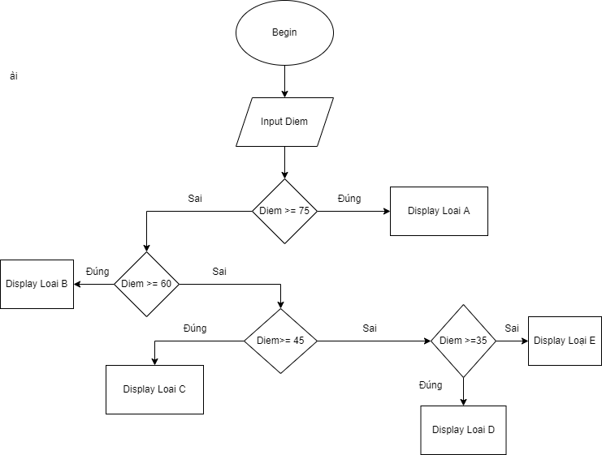

Begin

Input Diem

If Diem>=75

display Loai A

else

if Diem>=60

display Loai B

else

if Diem>=45

display Loai C

else

if Diem>=35

display Loai D

else Loai E