Begin

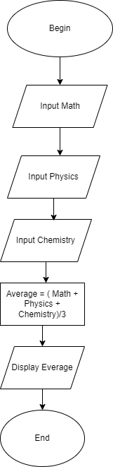

Input math, physics, chemistry

average = ( math+ physics+ chemistry )/3

Display average

End