The methods I use in order to analysis numbers from 0 to 9 are:

1.Contour Hierarchy

2.Convexity and Hull

About the method for reducing noises of camera -> I explain in the code.

Here are the types of number I will use to analysis:



Now, I will show you how to apply these methods in the project:

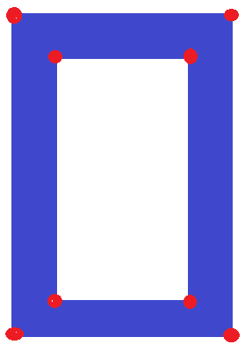Step1: Access the coordinates of each corner of an object, count all of them like this:

After I count them, here are the results, I use variable “myCounter” as the number of corners.

If myCounter = 8 => Number: 0.

If myCounter = 4 => Number: 1.

If myCounter = 10 => Number: 4.

If myCounter = 6 => Number: 7.

If myCounter = 12 => Number :2,3,5,6,8,9.

Step2: Use hierarchy as a method to classify the groups:

Group1: [-1,-1,-1,-1]

Group2: [-1,-1,1,-1],[-1,-1,-1,0]

Group3: [-1,-1,1,-1],[2,-1,-1,0],[-1,1,-1,0]

If we don’t know about above arrays, check the link below, it will help you understand my idea:

Group1 is for number 2,3,5.

Group2 is for number 6 and 9.

Group 3 is for number 8

Hence, we now have only 5 numbers (the number 8 is detected by above method).

Step3: We use convexity and hull to detect number 6,9 and 3. Check the link below if you want to understand this method:



Here, I only use the point-far (yellow points). As can be seen here, if all the yellow points on the right => Number 3. The points under the half of shape’s height is for number 6 and the rest is for number 9.

Step4: Access the coordinates of the corners of the objects again to analysis 2 numbers (2 and 5):

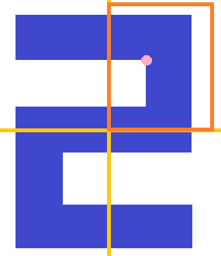

In my code, you can see the line” if(approx[2][0][y]> int((x+w)/2)) and (y < approx[2][0][y+1] < int((y+h)/2))”. The is the way I access the pink point. If it in the orange zone, it definitely is number 2. And the rest one is number 5.

Here are the links: