Data Scientist: Analytics Specialist

Usage Funnels with Warby Parker

Warby Parker is a transformative lifestyle brand with a lofty objective: to offer designer eyewear at a revolutionary price while leading the way for socially conscious businesses. Founded in 2010 and named after two characters in an early Jack Kerouac journal, Warby Parker believes in creative thinking, smart design, and doing good in the world. For every pair of eyeglasses and sunglasses sold, a pair is distributed to someone in need.
In this project, you will analyze different Warby Parker marketing funnels in order to calculate conversion rates. Here are the funnels and the tables that you are given:
Quiz Funnel:
- survey
Home Try-On Funnel:
- quiz
- home_try_on
- purchase
This project was a collaboration with Warby Parker’s Data Science team (thank you!) and uses fictional data.
Let’s get started!

Tasks
6/6 complete
Mark the tasks as complete by checking them off

Quiz Funnel:
1.
To help users find their perfect frame, Warby Parker has a Style Quiz that has the following questions:
  - “What are you looking for?”
  - “What’s your fit?”
  - “Which shapes do you like?”
  - “Which colors do you like?”
  - “When was your last eye exam?”
The users’ responses are stored in a table called survey.
Select all columns from the first 10 rows. What columns does the table have?
Hint
-- Quiz Funnel
SELECT *
FROM survey
LIMIT 10;
Copy to Clipboard
The survey table has the following columns:
  - question
  - user_id
  - response
-- starts a single line comment. The text after -- will be ignored (not executed).
2.
Users will “give up” at different points in the survey. Let’s analyze how many users move from Question 1 to Question 2, etc.
Create a quiz funnel using the GROUP BY command.
What is the number of responses for each question?
Hint
SELECT question,
COUNT(DISTINCT user_id)
FROM survey
GROUP BY question;
Copy to Clipboard
You can also use column reference number:
SELECT question,
COUNT(DISTINCT user_id)
FROM survey
GROUP BY 1;
Copy to Clipboard
  - Question 1 - ?
  - Question 2 - ?
  - Question 3 - ?
  - Question 4 - ?
  - Question 5 - ?
3.
Using a spreadsheet program like Excel or Google Sheets, calculate the percentage of users who answer each question:
Which question(s) of the quiz have a lower completion rates?
What do you think is the reason?
Hint
We divide the number of people completing each step by the number of people completing the previous step:
Question Number | Percent Completing this Question
1 | 100%
2 | ? %
3 | ? %
4 | ? %
5 | ? %

Make sure to elaborate on your reasonings.

Home Try-On Funnel:
4.
Warby Parker’s purchase funnel is:
Take the Style Quiz → Home Try-On → Purchase the Perfect Pair of Glasses
During the Home Try-On stage, we will be conducting an A/B Test:
  - 50% of the users will get 3 pairs to try on
  - 50% of the users will get 5 pairs to try on
Let’s find out whether or not users who get more pairs to try on at home will be more likely to make a purchase.
The data will be distributed across three tables:
  - quiz
  - home_try_on
  - purchase
Examine the first five rows of each table
What are the column names?
Hint
-- Home Try-On Funnel
SELECT *
FROM quiz
LIMIT 5;
SELECT *
FROM home_try_on
LIMIT 5;
SELECT *
FROM purchase
LIMIT 5;
Copy to Clipboard
quiz table has the following columns:
  - user_id
  - style
  - fit
  - shape
  - color

home_try_on table has the following columns:
  - user_id
  - number_of_pairs
  - address

purchase table has the following columns:
  - user_id
  - product_id
  - style
  - model_name
  - color
  - price
5.
We’d like to create a new table with the following layout:
user_id | is_home_try_on | number_of_pairs | is_purchase
4e8118dc | True | 3 | False
291f1cca | True | 5 | False
75122300 | False | NULL | False

Each row will represent a single user from the browse table:
  - If the user has any entries in home_try_on, then is_home_try_on will be True.
  - number_of_pairs comes from home_try_on table
  - If the user has any entries in purchase, then is_purchase will be True.
Use a LEFT JOIN to combine the three tables, starting with the top of the funnel (quiz) and ending with the bottom of the funnel (purchase).
Select only the first 10 rows from this table (otherwise, the query will run really slowly).
Hint
We use a LEFT JOIN to combine the three tables, starting at the top of the funnel (browse) and ending with the bottom of the funnel (purchase).
SELECT DISTINCT q.user_id,
h.user_id IS NOT NULL AS 'is_home_try_on',
h.number_of_pairs,
p.user_id IS NOT NULL AS 'is_purchase'
FROM quiz q
LEFT JOIN home_try_on h
ON q.user_id = h.user_id
LEFT JOIN purchase p
ON p.user_id = q.user_id
LIMIT 10;
Copy to Clipboard
6.
Once we have the data in this format, we can analyze it in several ways:
  - We can calculate overall conversion rates by aggregating across all rows.
  - We can compare conversion from quiz→home_try_on and home_try_on→purchase.
  - We can calculate the difference in purchase rates between customers who had 3 number_of_pairs with ones who had 5.
  - And more!
We can also use the original tables to calculate things like:
  - The most common results of the style quiz.
  - The most common types of purchase made.
  - And more!
What are some actionable insights for Warby Parker?
Hint
If you want to review the Funnels Lesson, click here.
This checkpoint is open-ended.

Calculating Churn Review
You can now calculate a churn rate over time for a company:
month | churn_rate
2017-01-01 | 0.127
2017-02-01 | 0.125
2017-03-01 | 0.237

It looks like our sample company did something in March that doubled the churn rate. They might want to look into that…
In this lesson you learned:
- The churn rate is a percent of subscribers at the beginning of a period that cancel within that period. “Monthly churn” is a typical metric and what was used in the examples.
- How to calculate this metric using SQL for a single month. This used COUNT() and conditions to determine the number of subscribers that were active and how many canceled.
- A more complex method to track the subscriber churn rate over many months.
SOLUTION

WITH months AS (
SELECT
'2017-01-01' AS first_day,
'2017-01-31' AS last_day
UNION
SELECT
'2017-02-01' AS first_day,
'2017-02-28' AS last_day
UNION
SELECT
'2017-03-01' AS first_day,
'2017-03-31' AS last_day
),
cross_join AS (
SELECT *
FROM subscriptions
CROSS JOIN months
),
status AS (
SELECT
id,
first_day AS month,
CASE
WHEN (subscription_start < first_day)
AND (
subscription_end > first_day
OR subscription_end IS NULL
) THEN 1
ELSE 0
END AS is_active,
CASE
WHEN subscription_end BETWEEN first_day AND last_day THEN 1
ELSE 0
END AS is_canceled
FROM cross_join
),
status_aggregate AS (
SELECT
month,
SUM(is_active) AS active,
SUM(is_canceled) AS canceled
FROM status
GROUP BY month
)
SELECT
month,
1.0 * canceled / active AS churn_rate
FROM status_aggregate;

Calculating Churn Rates

Data - subscriptions-churn.csv
Four months into launching Codeflix, management asks you to look into subscription churn rates. It’s early on in the business and people are excited to know how the company is doing.
The marketing department is particularly interested in how the churn compares between two segments of users. They provide you with a dataset containing subscription data for users who were acquired through two distinct channels.
The dataset provided to you contains one SQL table, subscriptions. Within the table, there are 4 columns:
- id - the subscription id
- subscription_start - the start date of the subscription
- subscription_end - the end date of the subscription
- segment - this identifies which segment the subscription owner belongs to
Codeflix requires a minimum subscription length of 31 days, so a user can never start and end their subscription in the same month.
If you get stuck during this project or would like to see an experienced developer work through it, click “Get Unstuck“ to see a project walkthrough video.

Tasks
9/9 complete
Mark the tasks as complete by checking them off

Get familiar with the data
1.
Take a look at the first 100 rows of data in the subscriptions table. How many different segments do you see?
Hint
Use a SELECT statement and be sure to LIMIT 100.
2.
Determine the range of months of data provided. Which months will you be able to calculate churn for?
Hint
Use MIN and MAX to examine the range of subscription_start.

Calculate churn rate for each segment
3.
You’ll be calculating the churn rate for both segments (87 and 30) over the first 3 months of 2017 (you can’t calculate it for December, since there are no subscription_end values yet). To get started, create a temporary table of months.
Hint
WITH months AS
(SELECT
'2017-01-01' as first_day,
'2017-01-31' as last_day
UNION
...
)
Copy to Clipboard
4.
Create a temporary table, cross_join, from subscriptions and your months. Be sure to SELECT every column.
Hint
The syntax to join table1 and table2 is:
desired_temp_table AS
(SELECT table1.*, table2.*
FROM table1
CROSS JOIN table2)
Copy to Clipboard
5.
Create a temporary table, status, from the cross_join table you created. This table should contain:
  - id selected from cross_join
  - month as an alias of first_day
  - is_active_87 created using a CASE WHEN to find any users from segment 87 who existed prior to the beginning of the month. This is 1 if true and 0 otherwise.
  - is_active_30 created using a CASE WHEN to find any users from segment 30 who existed prior to the beginning of the month. This is 1 if true and 0 otherwise.
Stuck? Get a hint
6.
Add an is_canceled_87 and an is_canceled_30 column to the status temporary table. This should be 1 if the subscription is canceled during the month and 0 otherwise.
Hint
You can use BETWEEN to determine if the subscription_end is between the first_day and last_day of the month.
7.
Create a status_aggregate temporary table that is a SUM of the active and canceled subscriptions for each segment, for each month.
The resulting columns should be:
  - sum_active_87
  - sum_active_30
  - sum_canceled_87
  - sum_canceled_30
Hint
Be sure to GROUP BY month to ensure you get a SUM for each month.
8.
Calculate the churn rates for the two segments over the three month period. Which segment has a lower churn rate?
Hint
Calculate churn by dividing the sum_canceled_ by the sum_active_ for each segment.

Bonus
9.
How would you modify this code to support a large number of segments?
Hint
Avoid hard coding the segment numbers.
SELECT *
FROM subscriptions
LIMIT 10;

SELECT MIN(subscription_start) AS 'Earliest Date',
MAX(subscription_end) AS 'Last Date'
FROM subscriptions;

WITH months AS (
SELECT '2017-01-01' AS first_day, '2017-01-31' AS last_day
UNION
SELECT '2017-02-01', '2017-02-28'
UNION
SELECT '2017-03-01', '2017-03-31'
);

…

Attribution Queries

Data folder - CoolTShirts
CoolTShirts sells shirts of all kinds, as long as they are T-shaped and cool. Recently, CTS started a few marketing campaigns to increase website visits and purchases. Using touch attribution, they’d like to map their customers’ journey: from initial visit to purchase. They can use that information to optimize their marketing campaigns. This project will guide you through some of that process.
At this point you should have taken the lesson on touch attribution. This project will guide you through a number of queries on CoolTShirts’ user data (see the schema here).
Check off the steps as you go. In the rare chance that your project gets stuck in a bad state — maybe you accidentally edited the data —, refresh the page.
If you get stuck during this project or would like to see an experienced developer work through it, click “Get Unstuck“ to see a project walkthrough video.

Tasks
7/7 complete
Mark the tasks as complete by checking them off

Get familiar with CoolTShirts
1.
How many campaigns and sources does CoolTShirts use? Which source is used for each campaign?
Use three queries:
  - one for the number of distinct campaigns,
  - one for the number of distinct sources,
  - one to find how they are related.
Hint
The first two queries will use SELECT COUNT(DISTINCT column_name).
The third query will use SELECT DISTINCT column1, column2.
2.
What pages are on the CoolTShirts website?
Find the distinct values of the page_name column.
Hint
There are four distinct values in page_name.

What is the user journey?
3.
How many first touches is each campaign responsible for?
You’ll need to use a first-touch query. Group by campaign and count the number of first touches for each.
Hint
Here’s an example of a first-touch query:
WITH first_touch AS (
SELECT user_id,
MIN(timestamp) as first_touch_at
FROM page_visits
GROUP BY user_id)
SELECT ft.user_id,
ft.first_touch_at,
pv.utm_source,
pv.utm_campaign
FROM first_touch ft
JOIN page_visits pv
ON ft.user_id = pv.user_id
AND ft.first_touch_at = pv.timestamp;
Copy to Clipboard
Here’s the query to count first touches per campaign and source. first_touch is the set of all first touches. ft_attr is the same set with source and campaign columns added.
You may group by utm_campaign or both utm_campaignand utm_source.
WITH first_touch AS (
/* ... */),
ft_attr AS (
SELECT ft.user_id,
ft.first_touch_at,
pv.utm_source,
pv.utm_campaign
FROM first_touch ft
JOIN page_visits pv
ON ft.user_id = pv.user_id
AND ft.first_touch_at = pv.timestamp
)
SELECT ft_attr.utm_source,
ft_attr.utm_campaign,
COUNT(*)
FROM ft_attr
GROUP BY 1, 2
ORDER BY 3 DESC;
Copy to Clipboard
4.
How many last touches is each campaign responsible for?
Starting with the last-touch query from the lesson, group by campaign and count the number of last touches for each.
Hint
Here’s the query to count last touches per campaign and source. last_touch is the set of all last touches. lt_attr is the same set with source and campaign columns added.
You may group by utm_campaign or both utm_campaignand utm_source.
WITH last_touch AS (
/* ... */),
lt_attr AS (
SELECT lt.user_id,
lt.last_touch_at,
pv.utm_source,
pv.utm_campaign,
pv.page_name
FROM last_touch lt
JOIN page_visits pv
ON lt.user_id = pv.user_id
AND lt.last_touch_at = pv.timestamp
)
SELECT lt_attr.utm_source,
lt_attr.utm_campaign,
COUNT(*)
FROM lt_attr
GROUP BY 1, 2
ORDER BY 3 DESC;
Copy to Clipboard
5.
How many visitors make a purchase?
Count the distinct users who visited the page named 4 - purchase.
Stuck? Get a hint
6.
How many last touches on the purchase page is each campaign responsible for?
This query will look similar to your last-touch query, but with an additional WHERE clause.
Hint
In your subquery for last touches (the one using MAX(timestamp)), make sure to use a WHERE clause on page_name:
WITH last_touch AS (
SELECT user_id,
MAX(timestamp) AS last_touch_at
FROM page_visits
WHERE page_name = '4 - purchase'
GROUP BY user_id),
Copy to Clipboard
7.
CoolTShirts can re-invest in 5 campaigns. Given your findings in the project, which should they pick and why?
Hint
This task is open-ended.

/*
Here's the first-touch query, in case you need it
*/

SELECT COUNT(DISTINCT utm_campaign)
FROM page_visits;

SELECT COUNT(DISTINCT utm_source)
FROM page_visits;

SELECT DISTINCT utm_campaign, utm_source
FROM page_visits;

SELECT DISTINCT utm_source, utm_campaign
FROM page_visits
WHERE utm_campaign ='getting-to-know-cool-tshirts'
ORDER BY utm_source;

SELECT DISTINCT page_name AS 'Name of the Page'
FROM page_visits;

SELECT user_id,
MIN(timestamp) AS first_touch
FROM page_visits
GROUP BY user_id;

WITH first_touch AS (
SELECT user_id,
MIN(timestamp) as first_touch_at
FROM page_visits
GROUP BY user_id)
SELECT ft.user_id,
ft.first_touch_at,
pv.utm_source,
pv.utm_campaign
FROM first_touch ft
JOIN page_visits pv
ON ft.user_id = pv.user_id
AND ft.first_touch_at = pv.timestamp;

Analyze Twitch Gaming Data

https://www.codecademy.com/paths/data-analyst/tracks/dsaly-advanced-sql-for-data-science/modules/dacp-twitch/projects/analyze-data-with-sql-twitch


Twitch is the world’s leading live streaming platform for gamers, with 15 million daily active users. Using data to understand its users and products is one of the main responsibilities of the Twitch Data Science Team.
In this project, you will be working with two tables that contain Twitch users’ stream viewing data and chat room usage data.
Stream viewing data:
- stream table
Chat usage data:
- chat table
The Twitch Science Team provided this practice dataset. You can download the .csv files (800,000 rows) from GitHub.
Let’s get started!
If you get stuck during this project or would like to see an experienced developer work through it, click Get Unstuck to see a walkthrough video.

Tasks
12/12 complete
Mark the tasks as complete by checking them off

Getting Started:
1.
Start by getting a feel for the stream table and the chat table.
Select the first 20 rows from each of the two tables.
What are the column names?
Hint
Using the LIMIT clause caps the number of rows in the result.
It is a simple way to keep queries from taking too long to run if you are dealing with a large dataset.
SELECT column_name
FROM table_name
LIMIT 20;
Copy to Clipboard
stream has the following columns:
  - time
  - device_id
  - login
  - channel
  - country
  - player
  - game
  - stream_format
  - subscriber
chat has the following columns:
  - time
  - device_id
  - login
  - channel
  - country
  - player
  - game
2.
What are the unique games in the stream table?
Hint
DISTINCT is used to return only distinct (different) values.
SELECT DISTINCT column_name
FROM table_name;
Copy to Clipboard
The results should look like:
  - League of Legends
  - DayZ
  - Dota 2
  - Heroes of the Storm
  - Counter-Strike: Global Offensive
  - Hearthstone: Heroes of Warcraft
  - The Binding of Isaac: Rebirth
  - Agar.io
  - Gaming Talk Shows
  - Rocket League
  - World of Tanks
  - ARK: Survival Evolved
  - SpeedRunners
  - Breaking Point
  - Duck Game
  - Devil May Cry 4: Special Edition
  - Block N Load
  - Fallout 3
  - Batman: Arkham Knight
3.
What are the unique channels in the stream table?
Hint
The DISTINCT channels should be:
  - frank
  - george
  - estelle
  - morty
  - kramer
  - jerry
  - helen
  - newman
  - elaine
  - susan
Yada yada yada…

Aggregate Functions:
4.
What are the most popular games in the stream table?
Create a list of games and their number of viewers using GROUP BY.
Hint
You can GROUP BY the games:
SELECT game, COUNT(*)
FROM stream
GROUP BY game
ORDER BY COUNT(*) DESC;
Copy to Clipboard
You can rewrite this using column reference numbers instead of column names:
SELECT game, COUNT(*)
FROM stream
GROUP BY 1
ORDER BY 2 DESC;
Copy to Clipboard
5.
These are some big numbers from the game League of Legends (also known as LoL).
Where are these LoL stream viewers located?
Create a list of countries and their number of LoL viewers using WHERE and GROUP BY.
Hint
SELECT country, COUNT(*)
FROM stream
WHERE game = 'League of Legends'
GROUP BY 1
ORDER BY 2 DESC;
Copy to Clipboard
Oh wow, that is very international!
You can also add a LIMIT 10 at the bottom to cap the results.
6.
The player column contains the source the user is using to view the stream (site, iphone, android, etc).
Create a list of players and their number of streamers.
Hint
SELECT player, COUNT(*)
FROM stream
GROUP BY 1
ORDER BY 2 DESC;
Copy to Clipboard
7.
Create a new column named genre for each of the games.
Group the games into their genres: Multiplayer Online Battle Arena (MOBA), First Person Shooter (FPS), Survival, and Other.
Using CASE, your logic should be:
  - If League of Legends → MOBA
  - If Dota 2 → MOBA
  - If Heroes of the Storm → MOBA
  - If Counter-Strike: Global Offensive → FPS
  - If DayZ → Survival
  - If ARK: Survival Evolved → Survival
  - Else → Other
Use GROUP BY and ORDER BY to showcase only the unique game titles.
Hint
A CASE statement allows us to create different outputs. It is SQL’s way of handling if-then logic.
In this question, we are trying to figure out the different genres of games, and each of its viewer counts.
Before we do that, however, we will select the game column and create a new column called genre that has these genres: MOBA, FPS, Survival, and Other.
After that, we will make a third column that is COUNT(*) and we are going to GROUP BY the game column and sort the result by COUNT(*) in a descending order:
SELECT game,
CASE
WHEN game = 'Dota 2'
THEN 'MOBA'
WHEN game = 'League of Legends'
THEN 'MOBA'
WHEN game = 'Heroes of the Storm'
THEN 'MOBA'
WHEN game = 'Counter-Strike: Global Offensive'
THEN 'FPS'
WHEN game = 'DayZ'
THEN 'Survival'
WHEN game = 'ARK: Survival Evolved'
THEN 'Survival'
ELSE 'Other'
END AS 'genre',
COUNT(*)
FROM stream
GROUP BY 1
ORDER BY 3 DESC;
Copy to Clipboard

How does view count change in the course of a day?
8.
Before we get started, let’s run this query and take a look at the time column from the stream table:
SELECT time
FROM stream
LIMIT 10;
Copy to Clipboard
The data type of the time column is DATETIME. It is for storing a date/time value in the database.
Notice that the values are formatted like:
2015-01-01 18:33:52
So the format is:
YYYY-MM-DD HH:MM:SS
Hint
The HH is the hour of the day, from 0 to 23.
The MM is the minute of the hour, from 0 to 59.
The SS is the seconds within a minute, from 0 to 59.
9.
SQLite comes with a strftime() function - a very powerful function that allows you to return a formatted date.
It takes two arguments:
strftime(format, column)
Let’s test this function out:
SELECT time,
strftime('%S', time)
FROM stream
GROUP BY 1
LIMIT 20;
Copy to Clipboard
What do you think this does? Open the hint if you’d like to learn more.
Hint
This returns the seconds, SS, of the timestamp column!
For strftime(__, timestamp):
  - %Y returns the year (YYYY)
  - %m returns the month (01-12)
  - %d returns the day of the month (1-31)
  - %H returns 24-hour clock (00-23)
  - %M returns the minute (00-59)
  - %S returns the seconds (00-59)
if time format is YYYY-MM-DD HH:MM:SS.
Read more on the SQLite documentation.
10.
Okay, now we understand how strftime() works. Let’s write a query that returns two columns:
  - The hours of the time column
  - The view count for each hour
Lastly, filter the result with only the users in your country using a WHERE clause.
Hint
SELECT strftime('%H', time),
COUNT(*)
FROM stream
GROUP BY 1;
Copy to Clipboard
Because this data is international and there are multiple time differences, let’s filter the result to a specific country:
SELECT strftime('%H', time),
COUNT(*)
FROM stream
WHERE country = 'US'
GROUP BY 1;
Copy to Clipboard

Joining the two tables:
11.
The stream table and the chat table share a column: device_id.
Let’s join the two tables on that column.
Hint
SELECT *
FROM stream
JOIN chat
ON stream.device_id = chat.device_id;
Copy to Clipboard
12.
Woohoo! You have completed the the guided practice, see what else you can dig up. For example:
  - What are your favorite games? Can you find some insights about its viewers and chat room users?
  - Is there anything you can do after joining the two tables?
The dataset .csv files are on GitHub.
Hint
P.S. Shout out to June Dershewitz (@jdersh), previous Head of Data Governance and Analytics, for working with us on this project!

--- Q1

SELECT *
FROM stream
LIMIT 10;

SELECT *
FROM chat
LIMIT 10;

-- Q2
SELECT DISTINCT(game)
FROM stream
WHERE game NOT NULL;

--Q3
SELECT DISTINCT(channel)
FROM stream;

--Q4
SELECT game, COUNT(game) AS 'popularity'
FROM stream
GROUP BY game
ORDER BY 2 DESC;
---- The following code return same result
SELECT game, COUNT(*)
FROM stream
GROUP BY 1
ORDER BY 2 DESC;

--Q5
SELECT country, COUNT(*)
FROM stream
WHERE game = 'League of Legends'
GROUP BY country
ORDER BY 2 DESC
LIMIT 10;

--Q6
SELECT player, COUNT(*)
FROM stream
GROUP BY 1
ORDER BY 2 DESC
LIMIT 10;

--Q7
SELECT game,
CASE
WHEN game = 'Dota 2'
THEN 'MOBA'
WHEN game = 'League of Legends'
THEN 'MOBA'
WHEN game = 'Heroes of the Storm'
THEN 'MOBA'
WHEN game = 'Counter-Strike: Global Offensive'
THEN 'FPS'
WHEN game = 'DayZ'
THEN 'Survival'
WHEN game = 'ARK: Survival Evolved'
THEN 'Survival'
ELSE 'Other'
END AS 'genre',
COUNT(*)
FROM stream
GROUP BY 1
ORDER BY 3 DESC;

This is related to previous – since they have same dataset. Here, it is expect to solve it with PYTHON ~(jupyter notebook#)

https://www.codecademy.com/paths/data-analyst/tracks/dsaly-advanced-sql-for-data-science/modules/dacp-twitch/projects/matplotlib-twitch
Ask the AI Learning Assistant
Connected to Codecademy
Get Unstuck
Tools


Visualize Twitch Gaming Data

Project Brief

Objective
Data Scientist: Analytics Specialist

Visualize Twitch Gaming Data

In this project, we will visualize Twitch data using Python and Matplotlib, in the forms of:
- Bar Graph: Featured Games
- Pie Chart: Stream Viewers’ Locations
- Line Graph: Time Series Analysis
The Twitch Science Team provided this practice dataset. You can download the .csv files (800,000 rows) from GitHub.
Note: This is data is scrubbed and is meant for practice use only.
If you get stuck during this project or would like to see an experienced developer work through it, click “Get Unstuck“ to see a project walkthrough video.

Tasks
0/12 complete
Mark the tasks as complete by checking them off

Bar Graph: Featured Games
1.
Twitch’s home page has a Featured Games section where it lists the “Games people are watching now”.
If we queried the Twitch practice dataset using SQL, we would get back the following list of the top 10 trending games (on January 1st, 2015) and their number of viewers:
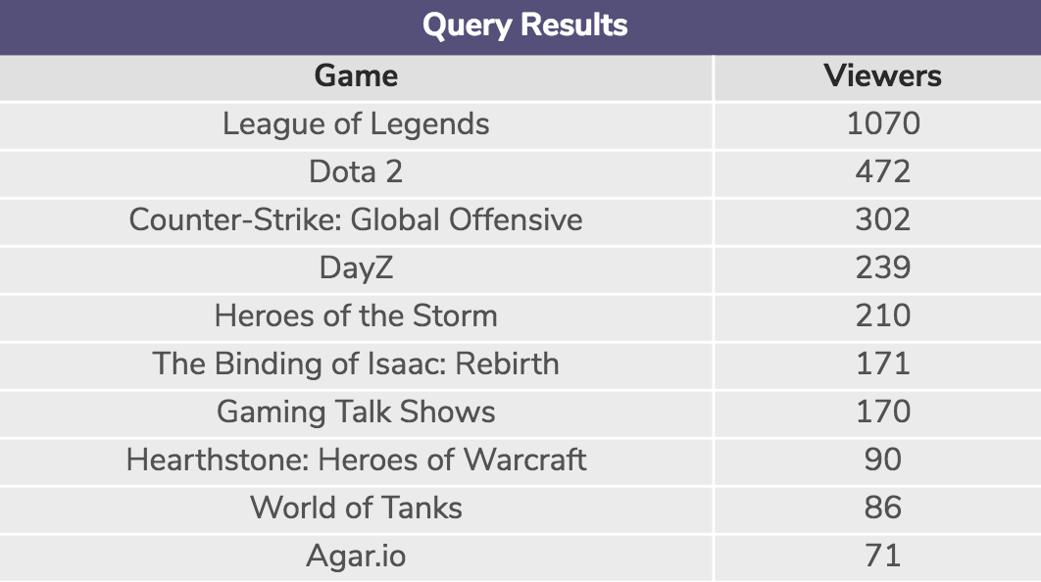
In the next few tasks, you are going to take this data and plot a bar graph using Matplotlib.
Let’s get started!
Hint
The Featured Games section looks like:
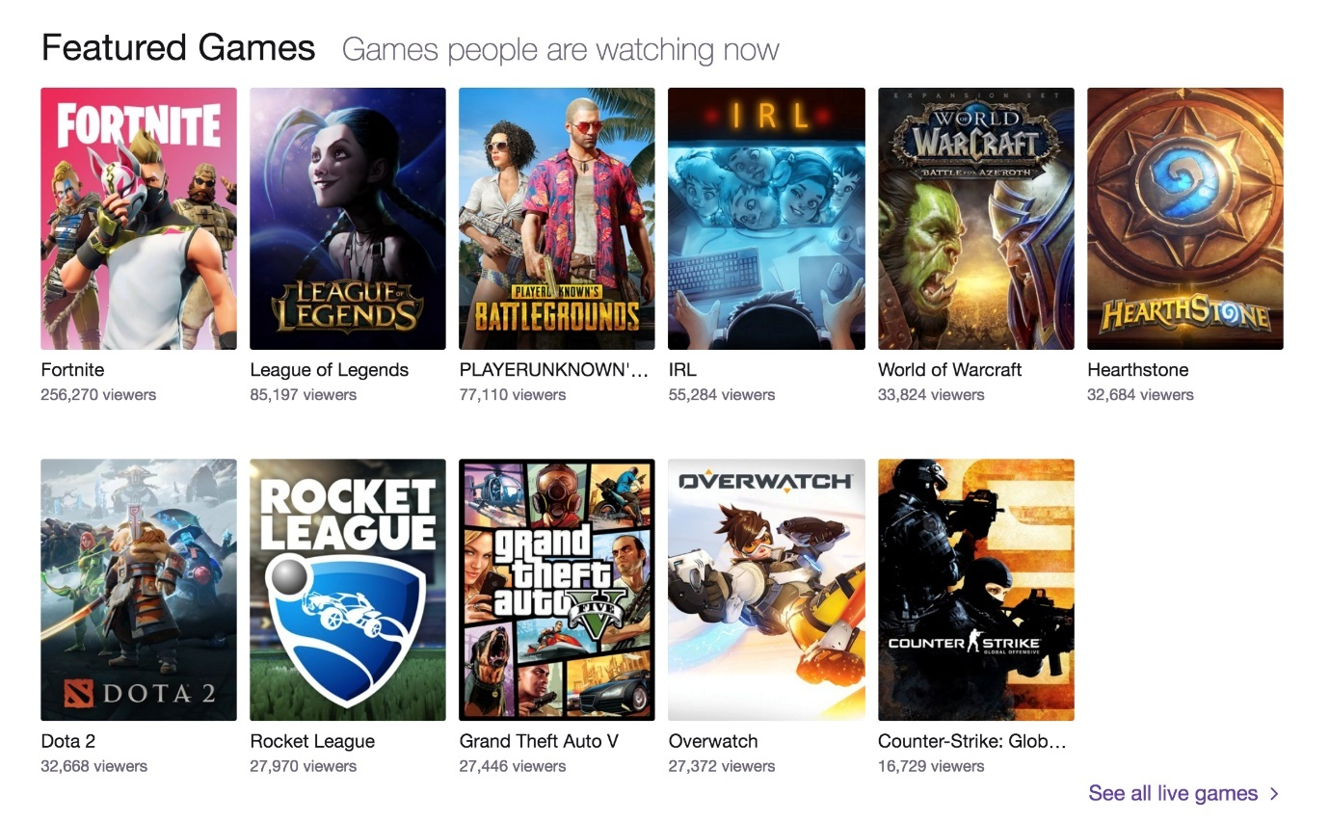
It has the top 10 or 11 trending games (with the highest viewers).
2.
The games and viewers are already loaded in the script.py file:
games = ["LoL", "Dota 2", "CS:GO", "DayZ", "HOS", "Isaac", "Shows", "Hearth", "WoT", "Agar.io"]
viewers = [1070, 472, 302, 239, 210, 171, 170, 90, 86, 71]
Copy to Clipboard
Now, use the plt.bar() to plot a bar graph using range(len(games)) and viewers as arguments.
Feel free to pick a color, too (using color='____').
Then, use plt.show() to visualize it.
Hint
Pick out a color from Matplotlib color codes for your bar graph.
Here is an example of what plt.bar() can look like:
plt.bar(range(len(games)), viewers, color='slateblue')
Copy to Clipboard
3.
Awesome, let’s make the graph more informative by doing the following:
  - Add a title
  - Add a legend
  - Add axis labels
  - Add ticks
  - Add tick labels (rotate if necessary)
Hint
For adding a title:
plt.title('Featured Games Viewers')
Copy to Clipboard
For adding a legend:
plt.legend(["Twitch"])
Copy to Clipboard
For adding axis labels:
plt.xlabel('Games')
plt.ylabel('Viewers')
Copy to Clipboard
For adding ticks
ax = plt.subplot()
ax.set_xticks([0, 1, 2, 3, 4, 5, 6, 7, 8, 9, 10])
Copy to Clipboard
For adding tick tables and rotating to fit:
ax.set_xticklabels(games, rotation=30)
Copy to Clipboard
4.
The visualization should look something like:
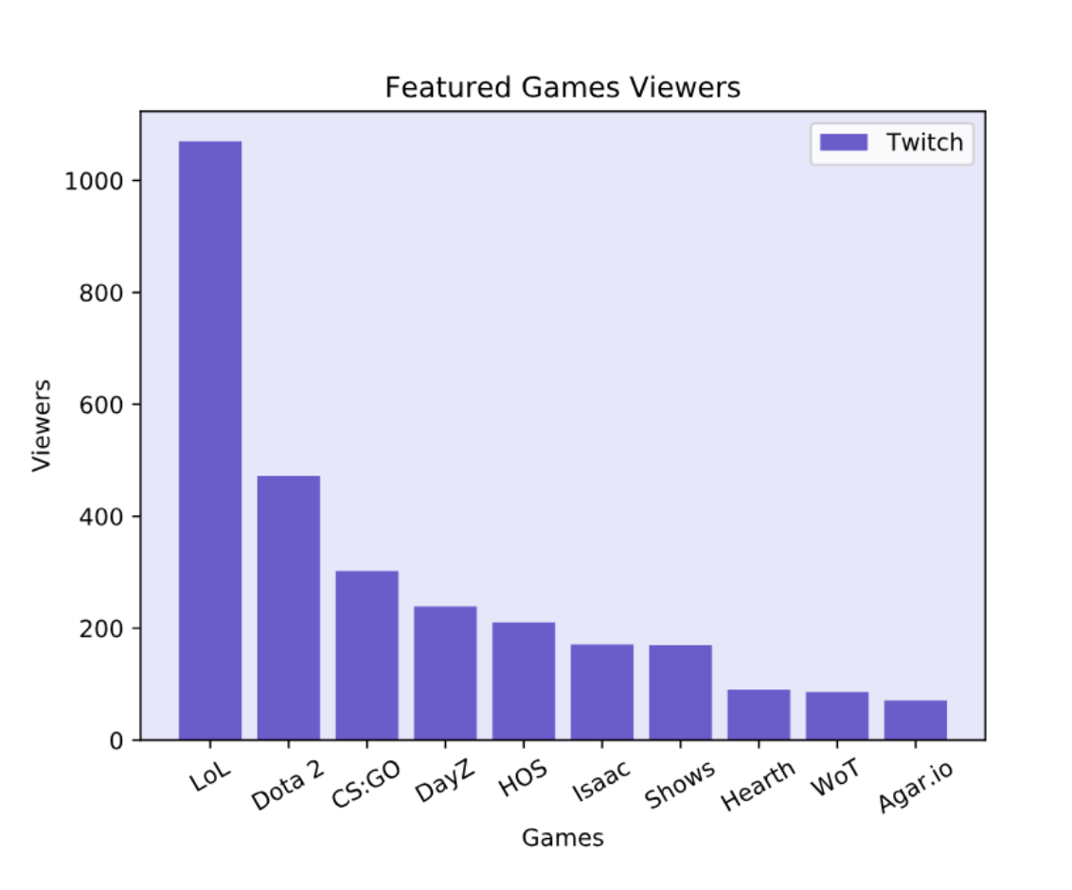
League of Legends really dominated the list on January 1st, 2015!
Open the hint for the full code.
Hint
Answer:
games = ["LoL", "Dota 2", "CS:GO", "DayZ", "HOS", "Isaac", "Shows", "Hearth", "WoT", "Agar.io"]
viewers = [1070, 472, 302, 239, 210, 171, 170, 90, 86, 71]
plt.bar(range(len(games)), viewers, color='slateblue')
plt.legend(["Twitch"])
plt.xlabel('Games')
plt.ylabel('Viewers')
ax = plt.subplot()
ax.set_xticks(range(0, 10))
ax.set_xticklabels(games, rotation=30)
plt.show()
# We can add plt.clf() to clear the current figure, our bar graph, before creating our next figure, the pie chart
plt.clf()
Copy to Clipboard

Pie Chart: League of Legends Viewers' Whereabouts
5.
There are 1070 League of Legends viewers from this dataset. Where are they coming from?
If we queried the Twitch practice dataset using SQL, our results would return the following:
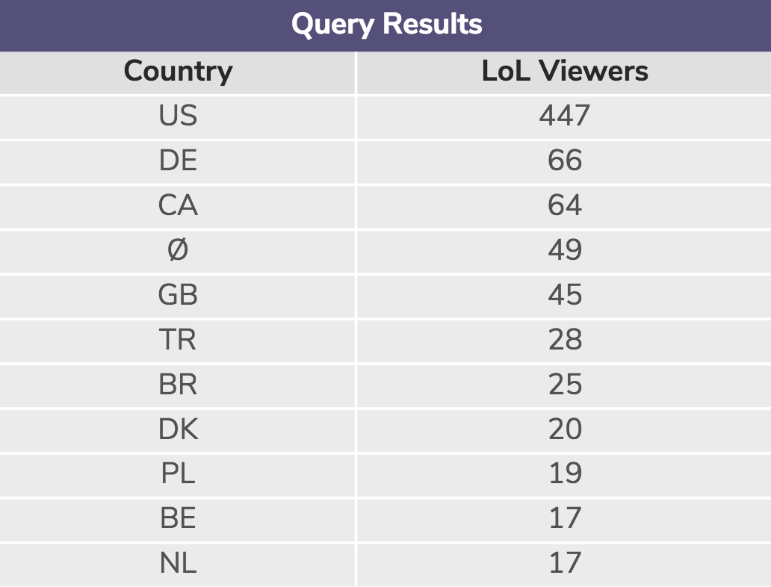
As well as other countries that accounted for another 279 stream viewers.
In the next few tasks, you are going to take this data and make a pie chart.
Let’s get started!
Hint
These country abbriviations are:
  - US - United States 
  - DE - Germany 
  - CA - Canada 
  - ∅ - N/A
  - GB - Great Britain 
  - TR - Turkey 
  - BR - Brazil 
  - DK - Denmark 
  - PL - Poland 
  - BE - Belgium 
  - NL - Netherlands 
  - Others
labels = ["US", "DE", "CA", "N/A", "GB", "TR", "BR", "DK", "PL", "BE", "NL", "Others"]
countries = [447, 66, 64, 49, 45, 28, 25, 20, 19, 17, 17, 279]
# Make your pie chart here
plt.pie(countries)
plt.axis('equal')
plt.show()
Copy to Clipboard
6.
The labels and countries are already loaded into script.py:
labels = ["US", "DE", "CA", "N/A", "GB", "TR", "BR", "DK", "PL", "BE", "NL", "Others"]
countries = [447, 66, 64, 49, 45, 28, 25, 20, 19, 17, 17, 279]
Copy to Clipboard
Let’s add some colors!
Because there are 12 countries (including N/A and Others), let’s create an array called colors and add 12 color codes to it, like so:
colors = ['lightskyblue', 'gold', 'lightcoral', 'gainsboro', 'royalblue', 'lightpink', 'darkseagreen', 'sienna', 'khaki', 'gold', 'violet', 'yellowgreen']
Copy to Clipboard
Check out the Matplotlib color codes to find your inner Bob Ross.
Then, use plt.pie() to plot a pie chart.
Don’t forget to throw in the countries variable and the colors = colors.
Lastly, use plt.show() to visualize it.
Hint
Your plt.bar() should look like:
plt.pie(countries, colors=colors)
Copy to Clipboard
Don’t forget to include this at the very end:
plt.show()
Copy to Clipboard
7.
Optional: Let’s make it more visually appealing and more informative.
First, let’s “explode”, or break out, the 1st slice (United States):
explode = (0.1, 0, 0, 0, 0, 0, 0, 0, 0, 0, 0, 0)
Copy to Clipboard
Then, inside plt.pie(), we are going to:
  - Add the explode
  - Add shadows
  - Turn the pie 345 degrees
  - Add percentages
  - Configure the percentages’ placement
So it look something like:
plt.pie(countries, explode=explode, colors=colors, shadow=True, startangle=345, autopct='%1.0f%%', pctdistance=1.15)
Copy to Clipboard
Also, we can add a title:
plt.title("League of Legends Viewers' Whereabouts")
Copy to Clipboard
And legends:
plt.legend(labels, loc="right")
Copy to Clipboard
Hint
The 0.1 in the explode array specifies the fraction of the radius with which to offset the wedge(s).
8.
The visualization should look something like:
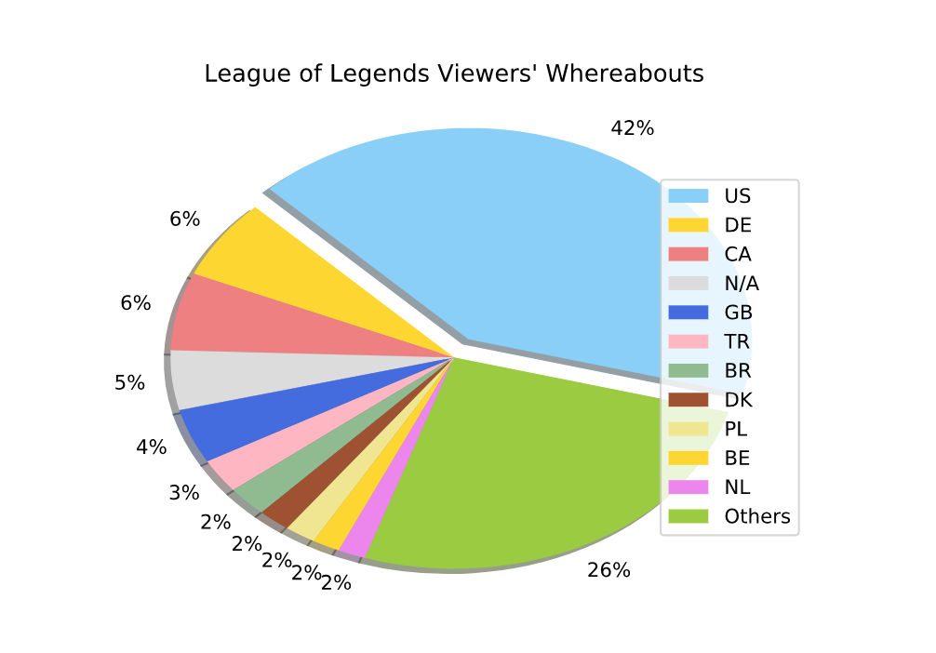
Open the hint for the full code.
Hint
Answer:
import codecademylib3_seaborn
from matplotlib import pyplot as plt
import numpy as np
import pandas as pd
labels = ["US", "DE", "CA", "N/A", "GB", "TR", "BR", "DK", "PL", "BE", "NL", "Others"]
countries = [447, 66, 64, 49, 45, 28, 25, 20, 19, 17, 17, 279]
colors = ['lightskyblue', 'gold', 'lightcoral', 'gainsboro', 'royalblue', 'lightpink', 'darkseagreen', 'sienna', 'khaki', 'gold', 'violet', 'yellowgreen']
# Make your pie chart here
explode = (0.1, 0, 0, 0, 0, 0, 0, 0, 0, 0, 0, 0)
plt.pie(countries, explode=explode, colors=colors, shadow=True, startangle=345, autopct='%1.0f%%', pctdistance=1.15)
plt.title("League of Legends Viewers' Whereabouts")
plt.legend(labels, loc="right")
plt.show()
# We can add plt.clf() to clear the current figure, our pie chart,before creating our next figure, the line graph
plt.clf()
Copy to Clipboard

Line Graph: Time Series Analysis
9.
We were able to find the number of US viewers at different hours of the day on January 1st, 2015:
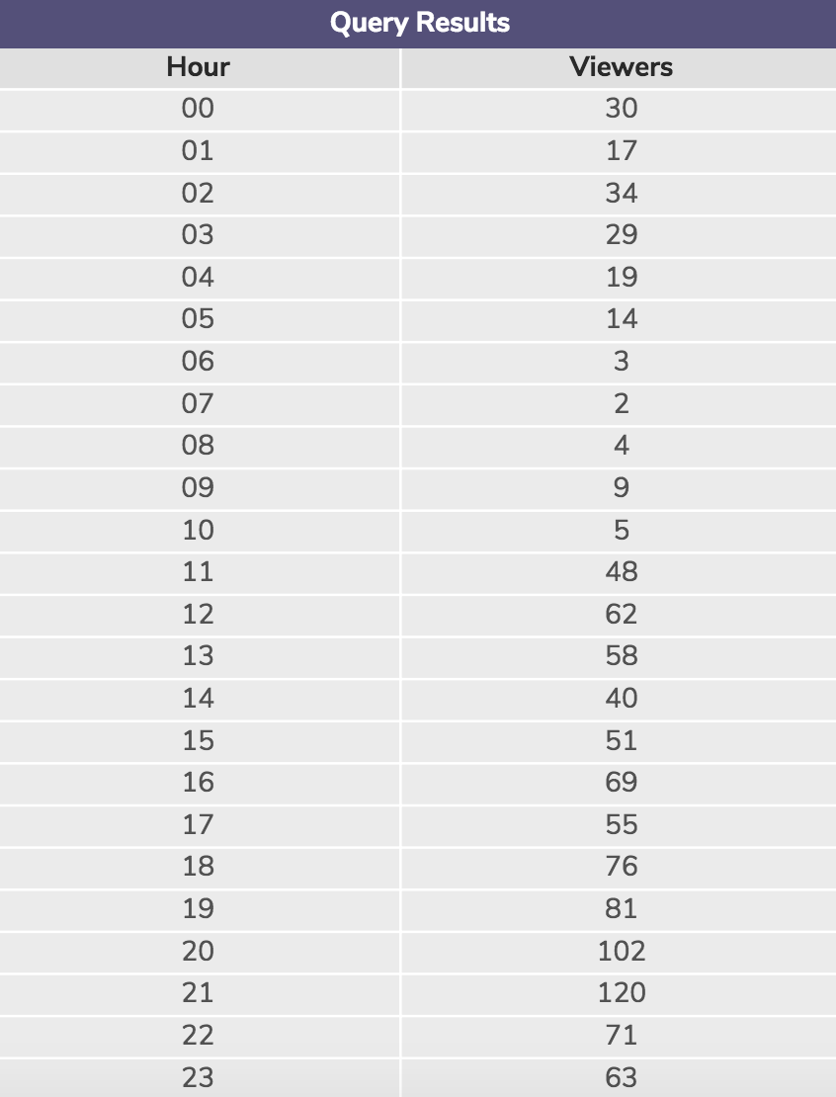
Let’s make this into a line graph.
Hint
import codecademylib3_seaborn
from matplotlib import pyplot as plt
import numpy as np
import pandas as pd
hour = range(24)
viewers_hour = [30, 17, 34, 29, 19, 14, 3, 2, 4, 9, 5, 48, 62, 58, 40, 51, 69, 55, 76, 81, 102, 120, 71, 63]
plt.title("Time Series")
plt.xlabel("Hour")
plt.ylabel("Viewers")
plt.plot(hour, viewers_hour)
plt.legend(['2015-01-01'])
ax = plt.subplot()
ax.set_xticks(hour)
ax.set_yticks([0, 20, 40, 60, 80, 100, 120, 140])
y_upper = [i + (i*0.15) for i in viewers_hour]
y_lower = [i - (i*0.15) for i in viewers_hour]
plt.fill_between(hour, y_lower, y_upper, alpha=0.2)
plt.show()
Copy to Clipboard
10.
The hour and viewers_hour area already loaded into script.py:
hour = range(24)
viewers_hour = [30, 17, 34, 29, 19, 14, 3, 2, 4, 9, 5, 48, 62, 58, 40, 51, 69, 55, 76, 81, 102, 120, 71, 63]
Copy to Clipboard
Use plt.plot() to plot a line graph.
Don’t forget to throw in hour and viewers_hour.
Then, add the title, the axis labels, legend, and ticks.
Lastly, use plt.show() to visualize.
Hint
plt.title("Time Series")
plt.xlabel("Hour")
plt.ylabel("Viewers")
plt.plot(hour, viewers_hour)
plt.legend(['2015-01-01'])
ax = plt.subplot()
ax.set_xticks(hour)
ax.set_yticks([0, 20, 40, 60, 80, 100, 120])
plt.show()
Copy to Clipboard
11.
There is some uncertainty in these numbers because some people leave their browsers open. Let’s account for a 15% error in the viewers_hour data.
First, create a list containing the upper bound of the viewers_hour and call it y_upper.
Then, create a list containing the lower bound of the viewers_hour and call it y_lower.
Lastly, use plt.fill_between() to shade the error, with an alpha of 0.2.
Hint
The y_upper should be: each element of viewers_hour + 0.15 * that element.
The y_lower should be: each element of viewers_hour - 0.15 * that element.
y_upper = [i + (i*0.15) for i in viewers_hour]
y_lower = [i - (i*0.15) for i in viewers_hour]
Copy to Clipboard
The plt.fill_between() should look something like:
plt.fill_between(hour, y_lower, y_upper, alpha=0.2)
Copy to Clipboard
12.
Your line graph should look something like:
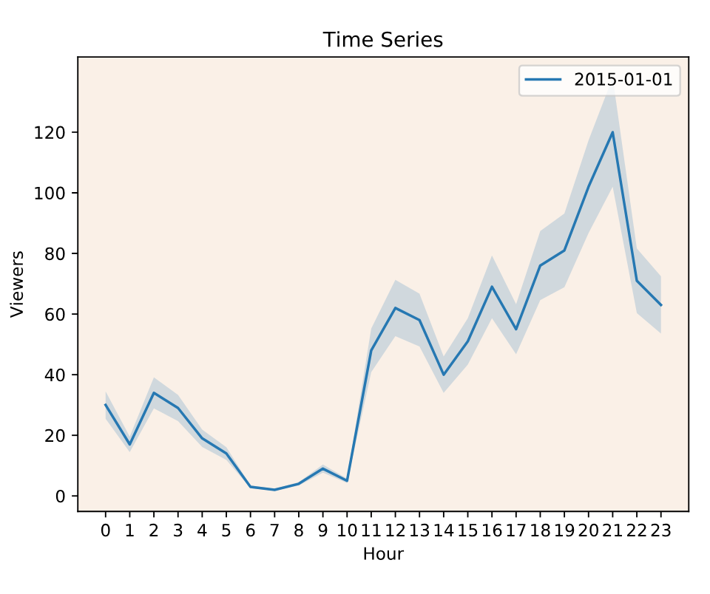
Look at the peak around 9 pm!
Open the hint for the full code.
Hint
Answer:
import codecademylib3_seaborn
from matplotlib import pyplot as plt
import numpy as np
import pandas as pd
hour = range(24)
viewers_hour = [30, 17, 34, 29, 19, 14, 3, 2, 4, 9, 5, 48, 62, 58, 40, 51, 69, 55, 76, 81, 102, 120, 71, 63]
plt.title("Time Series")
plt.xlabel("Hour")
plt.ylabel("Viewers")
plt.plot(hour, viewers_hour)
plt.legend(['2015-01-01'])
ax = plt.subplot()
ax.set_xticks(hour)
ax.set_yticks([0, 20, 40, 60, 80, 100, 120])
y_upper = [i + (i*0.15) for i in viewers_hour]
y_lower = [i - (i*0.15) for i in viewers_hour]
plt.fill_between(hour, y_lower, y_upper, alpha=0.2)
plt.show()
Copy to Clipboard

Code Review

