**PROBLEM 1 - MATLAB Solution**

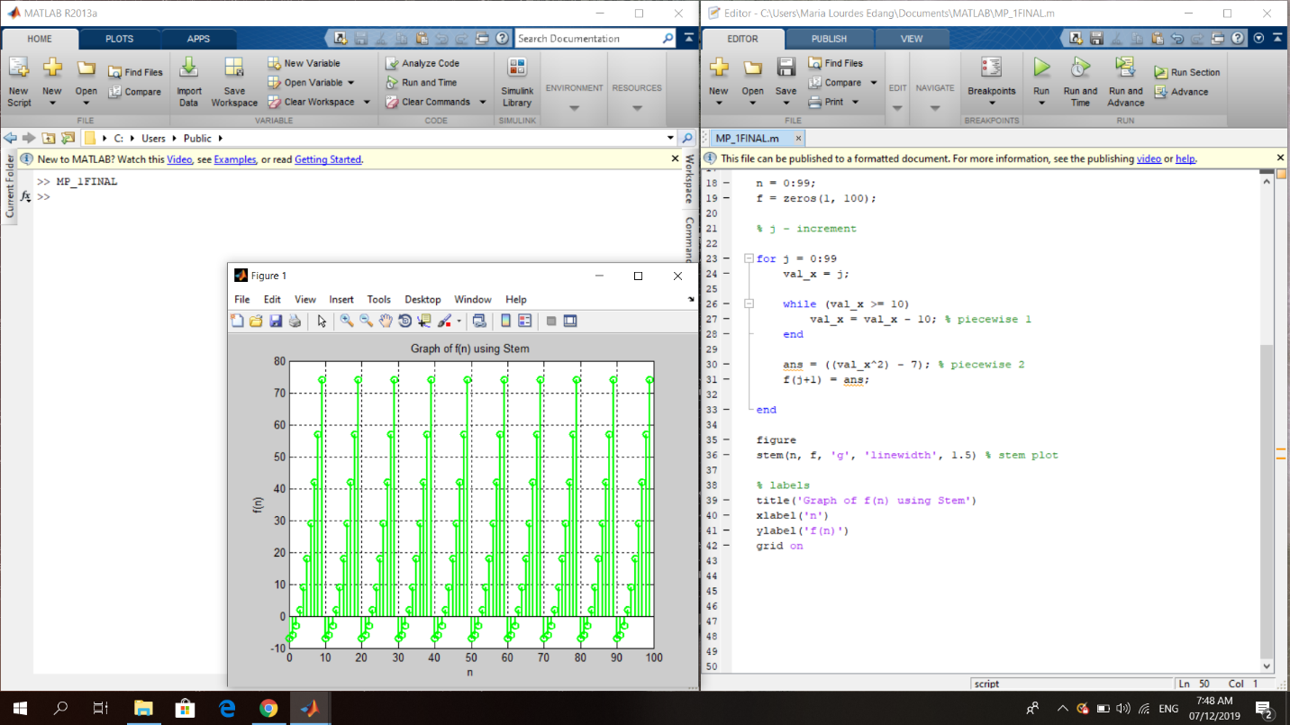

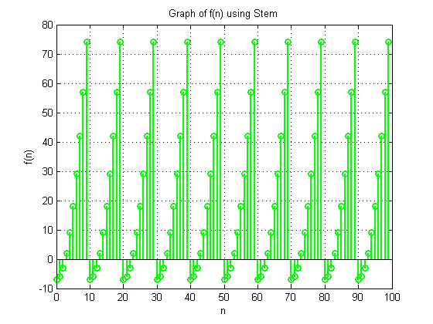

**Evaluation of the Graph:**

**The graph showcases the values 0 to 100 in x-coordinate and values -10 to 80 in the y-coordinate. If the highest point in the stem plot reached Point 74 in the y-coordinate, the plot goes back down to the lowest point which is almost Point -10 in the same coordinate. The graph increases as x and y coordinates increases. This happens repeatedly which is around 10 times, until it reaches the last point in the x-coordinate where they y-coordinate is back again at the top.**