Engagement With a Coordination Game Derived From Fall Risk Assessment: Exploratory Observational Study
Sidney K. T. Tam and Chi Fai Cheung
Behaviour and Knowledge Engineering Research Centre
Department of Industrial and Systems Engineering
The Hong Kong Polytechnic University, Hong Kong, China
Corresponding author: sidney.tam@connect.polyu.hk

Abstract
Background: Engagement with a game developed for fall risk assessment may depend on its presentation, equipment and social setting. A non-clinical web deployment allows engagement to be described without the clinical assessment apparatus.
Objective: To describe the compiled engagement record of a web-based coordination game derived from a gamified fall risk assessment and identify requirements for a reproducible evaluation of subsequent design changes.
Methods: An exploratory observational study examined a March-April 2026 deployment through Hong Kong-based personal and community networks. The compiled sample comprised 120 adults aged 25-80 years who returned results files, counted by age band and by initial-dropout, returned and non-return classifications. No invitation denominator was available, the classification rule and event timing could not be reconstructed, and no clinical outcomes were measured.
Results: The aggregate summary classified 23 of 120 records (19.2%) as initial dropouts and 15 of these 23 (65.2%) as returned. Initial-dropout classifications were 0 of 38 (0.0%), 7 of 41 (17.1%) and 16 of 41 (39.0%) in the 25-44, 45-64 and 65-80 age bands; 10 of 16 oldest-band initial-dropout records (62.5%) also carried a returned classification. These figures describe compiled labels, not sustained retention or an observed disengagement-return sequence.
Conclusions: The compiled record raises questions about engagement with a redesigned coordination game but does not establish that clinical decoupling reduced abandonment. A reproducible account requires participant-level source linkage, documented outcome rules and the administered instruments. Comparisons with the earlier clinical deployment remain contextual.
Keywords: gamification; older adults; engagement; coordination game; fall risk assessment; formative evaluation; human-computer interaction

Introduction

Background
A survey of 200 residents at a Guangzhou care facility, from a resident population of 280, found that 39% had used an installed fall risk assessment (FRA) system; among prior users, approximately 74% reported an adverse or unacceptable first experience and, of that subgroup, approximately 82% reported no subsequent return [1]. A subsequent eight-week deployment with 30 residents examined engagement with a gamified FRA at the clinical station. In that cohort, 70.0% recorded three or fewer completed runs and none of 21 low-engagement participants recorded a later run during the observation window [2]. These earlier observations motivated a redesign of the way participants encountered the game.
Technology-acceptance and gamification approaches offer design resources for older users [3,4,5], but their inclusion does not establish sustained engagement. The programme proposed failure-induced abandonment syndrome (FIAS) as a provisional label for non-return following an adverse, personally salient experience [1,2]. FIAS is not a clinical diagnosis or a validated measurement construct. One candidate explanation draws on the endowment effect and loss aversion [6,7,8]: feedback attached to a health assessment may be interpreted as a threat to perceived capability. Identity threat, willingness to accept or pay, and participants' appraisal of failure were not measured in the present study.
Existing work already connects enjoyment, meaning and older-adult game design. The gerontoludic position prioritises enjoyable play and the diversity of ageing [9], while affective game planning links appraisal to meaningful interaction [10]. These perspectives motivate the present design question without establishing its answer. Ordinary attrition also remains relevant; its contextual predictors cannot be excluded by a comparison between separate deployments [11].

Study Objective
This study describes the compiled engagement record of a skiing-style coordination game ported to a web build and offered without the FRA assessment apparatus. Stage 3 was a non-clinical behavioural study: it collected game-related records and questionnaire responses rather than clinical balance, fall-risk or other health-performance measurements. The objectives were to describe the available classifications and their age distribution, examine the limits of the available record, and identify implications for subsequent game development. The study does not estimate the isolated effect of clinical framing, demonstrate learning, or evaluate the accuracy of an FRA instrument.

Methods

Study Design and Setting
The March-April 2026 deployment was exploratory and observational. Reporting follows the STROBE (Strengthening the Reporting of Observational Studies in Epidemiology) checklist for cross-sectional studies, provided as Multimedia Appendix 1. The game was distributed through the authors' Hong Kong-based networks, with onward forwarding through personal contacts, work contacts, a charity community network, university support channels and medical-centre peers. Gameplay was offered away from the clinical FRA station. Supervision of play was not required, in contrast to the therapist-supervised Stage-2 sessions. The authors report that some older participants played on a tablet with a research assistant beside them to help operate the device, without playing on their behalf; the number of such sessions, the participants concerned and the devices used were not recorded, so assistance cannot be linked to individual records. The earlier Stage-2 cohort [2] provides background only and was not a concurrent control group.

Participants and Recruitment
The compiled record contains 120 adults aged 25-80 years: 38 aged 25-44, 41 aged 45-64 and 41 aged 65-80; 48 were recorded as men and 72 as women, and all were recorded as having high-school education or above. Enrolment information was limited to age band, gender and education. Distributor briefs addressed players aged 45 and over and players aged 18-45. The analysed denominator comprises returned materials included in the aggregate summary. The number invited, the number receiving a forwarded invitation and the number beginning gameplay without returning a file were not compiled. Consequently, a recruitment response rate or population-wide retention rate cannot be estimated.
A separate cohort was used because the Stage-2 residents had prior experience of the clinically attached system. Onward forwarding extended recruitment beyond the authors' immediate contacts, but does not establish independence from researcher influence or eliminate volunteer-selection bias.

Participant Information and Game Presentation
The authors describe the participant invitation as a university-headed invitation to play a skiing game during March-April 2026. The account states that the invitation introduced falls and balance training, disclosed the game's origin in an FRA balance platform, and offered a browser version with that platform decoupled. The available invitation document is a retrospective account created on 4 August 2026; the original version as distributed has not been linked to the manuscript record. It therefore documents the authors' account of the communication rather than independently establishing the wording each participant received. A distributor email described the activity as a coordination game and said that clinical context was being dropped. The original communications are needed to resolve the extent of health-related framing at recruitment.
The redesign removed the pressure-panel station, the pre-session clinical scan and participant-facing clinical scores or risk outputs. The skiing mechanic was retained in a browser implementation, while input device, location and possible assistance differed from Stage 2. Recruitment could still refer to the health-related origin. The design change is therefore described as removal of clinical apparatus and outputs within a broader deployment change, rather than a verified elimination of all health framing.

Game Build and Intended Procedure
The archived Stage-3 build is identified as Alpine_Coordination_Game_Stage3_v2.2.html, a 37,279-byte HTML file with SHA-256 prefix 42bc3df6; the archive identifies it as byte-identical to the _v2 file. Runs use a distance goal or a time cap: 200 m or 30 seconds, and 400 m or 60 seconds. The build's zero-failure mode does not slow the player following a bump. It supports keyboard arrows and a joystick or foot pad through the browser Gamepad API. The archived version lacks touch controls, although the reconstructed invitation mentions touchscreen play and the authors report tablet-assisted sessions; a touch-capable version was first created in August 2026. Which input those tablet sessions used, or whether a different build reached them, has not been reconciled. Figure 1 illustrates the archived design at staged difficulty settings.

Figure 1. Archived Stage-3 coordination-game design at staged difficulty multipliers. Steering uses keyboard arrows, a controller or foot pad. The illustrated interface omits clinical labels, clinical scores and risk outputs. These screenshots illustrate the archived design and do not verify the settings or version used by every participant.
The distributor brief suggested five sessions, whereas the aggregate register labels initial dropout as stopping before five attempts. The record does not establish whether those units were separate visits or runs within one sitting. The intended five-attempt procedure is therefore distinguished from verified protocol completion. The build includes an enabled-by-default option to request language-model difficulty advice, with a local-rule fallback. The absence of an embedded credential and the browser configuration support an inference that local rules operated, but no retained runtime log verifies whether a model request succeeded. No claim of demonstrated GPT or other language-model effectiveness is made.

Outcomes and Source Records
The primary available quantities are the register's compiled classifications: initial dropout, returned among initial dropouts, and non-return among initial dropouts. The only documented descriptive rule is the initial-dropout label, 'dropped out before completing 5 attempts'. The rule actually applied during aggregation is not retained in the compiled record. Dates of first play, disengagement and return, a disengagement checkpoint, reminders and assistance are also unavailable in that record. The counts consequently cannot distinguish immediate replay from later re-engagement. The complement of the eight non-return classifications is 112 records; it does not establish completion of five attempts or activity at an observation-window endpoint and is not reported as a retention outcome.
Two questionnaire-related counts are retained as positive-coded responses in the aggregate summary. The summary labels the items as liking the game as a reflection of eye-leg coordination and using it for regular health training if accessible; the retrospective invitation instead describes a coordination challenge and willingness to play regularly. The administered wording, language, response scale and positivity threshold have not been reconciled. These counts are not treated as validated measures of coordination, intrinsic motivation, intention or the success of a framing manipulation.
All Stage-3 numerical results in this manuscript originate in the Preliminary_Summary sheet of the Stage-3 data logbook. The participant-level sheets in that workbook do not yet contain the source-linked observations needed to regenerate the summary. The authors report that returned exports and research records are retained. The distinction between the existing aggregate summary and the participant-level reconstruction remains explicit; unverified imported records are not used to fill gaps in the Stage-3 cohort.

Statistical Analysis
Counts and percentages are presented with their explicit denominators. Wilson score 95% confidence intervals are calculated from the reported counts. Age-band differences are examined using an exploratory chi-square test and a Fisher exact comparison of the youngest and oldest bands; these comparisons were selected after age-stratified tabulation. The intervals and tests are conditional on the supplied counts and classification validity. They do not account for selection into the file-returning sample or resolve classification uncertainty. No causal contrast with Stage 2, time-to-event model, participant-level retention-intention relationship or learning-effect estimate is calculated.

Ethical Considerations
Participation was voluntary and unpaid. Consent was informed and implied: the invitation and distribution e-mails, as recorded in the authors' account, described the study, the game records and questionnaire responses to be collected and their aggregate use, and stated that participation was voluntary and could be withdrawn at any time; returning the results file and questionnaire responses constituted consent, and no written consent instrument was administered. No personal names were requested at enrolment; the identifiers used for analysis are separated from identifying correspondence; and no clinical health-performance assessment was undertaken in Stage 3.
Stage-3 collection took place in March-April 2026. The authors state that collection followed the supervisor's confirmation to proceed and that an administrative misunderstanding between the researcher and the administration office delayed the formal application; this account rests on the authors' statement rather than on a dated record cited here. The programme's human-subjects ethics application, reference HSEARS20260805008, was submitted and approved on 6 August 2026 by the Departmental Research Committee of the Department of Industrial and Systems Engineering on behalf of The Hong Kong Polytechnic University Institutional Review Board, with a stated approval period of 16 June 2024 to 30 October 2026. The application described Stages 1-3 as already conducted, so the formal ethics decision followed the Stage-3 collection period. The supervisor's confirmation is reported separately from the later formal decision; whether it constitutes an authorised ethics determination, and how the decision treats the earlier procedures, are matters for explicit institutional clarification that has not yet been obtained.

Results

Compiled Classification Counts
Of the 120 records in the aggregate summary, 23 (19.2%) carried an initial-dropout classification. Fifteen of those 23 (65.2%; 95% CI 44.9%-81.2%) also carried a returned classification and eight (6.7% of the full sample) a non-return classification. The remaining 97 records are the arithmetic complement of the initial-dropout count. These labels and denominators are presented in Table 1 and Figure 2 without treating them as a verified sequence of behavioural events.
Table 1. Compiled Stage-3 classifications and their denominators.
Classification | Count / denominator | Percentage
Initial-dropout label | 23 / 120 | 19.2
Returned label among initial dropouts | 15 / 23 | 65.2
Non-return label among initial dropouts | 8 / 23 | 34.8
Non-return label in the full summary | 8 / 120 | 6.7
Complement of the initial-dropout count | 97 / 120 | 80.8
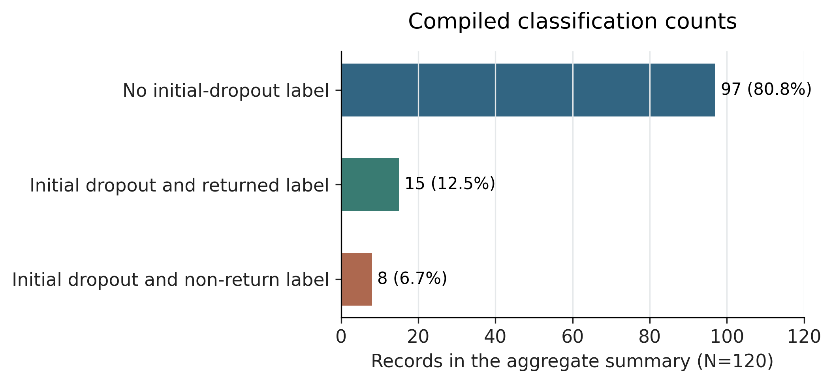
Figure 2. Mutually exclusive categories derived from the aggregate summary (N=120). The 97 records without an initial-dropout label are calculated as 120 minus 23; this complement does not establish five-attempt completion. The other categories contain 15 returned and eight non-return labels among initial dropouts. No verified event chronology or voluntary return is implied.
Initial-dropout classifications increased across the age bands: 0 of 38 (0.0%), 7 of 41 (17.1%) and 16 of 41 (39.0%). The three-band chi-square test and the youngest-versus-oldest Fisher exact test both yielded P<.001 on the reported counts. These are exploratory associations between age band and compiled labels. Among initial-dropout records, five of seven in the 45-64 band and ten of sixteen in the 65-80 band also carried a returned classification. The youngest band had no initial-dropout records, so a conditional returned percentage is undefined for that band (Table 2; Figures 3 and 4).
Table 2. Age distribution of the compiled classifications.
Age band in years | Records, n | Initial dropout, n (%) | Returned, n / dropout n | Non-return, n (%)
25-44 | 38 | 0 (0.0) | Not applicable | 0 (0.0)
45-64 | 41 | 7 (17.1) | 5 / 7 | 2 (4.9)
65-80 | 41 | 16 (39.0) | 10 / 16 | 6 (14.6)
Total | 120 | 23 (19.2) | 15 / 23 | 8 (6.7)
Percentages in the initial-dropout and non-return columns use the age-band denominator. Returned classifications are a subset of initial-dropout classifications. No observation-window endpoint or unprompted return is established by these labels.

Figure 3. Initial-dropout and non-return classifications as percentages of each age band. Non-return classifications are a subset of initial-dropout classifications. The labels do not establish a defined end-of-window outcome.

Figure 4. Returned classifications among initial-dropout records. Error bars are conditional Wilson 95% intervals calculated from the reported counts. The 25-44-year band had no initial-dropout records, so its conditional percentage is undefined. Stage 2 is not plotted as a baseline or control.

Questionnaire Coding in the Aggregate Summary
The summary records 86 of 120 responses (71.7%) as positive on the coordination-related item and 76 of 120 (63.3%) as positive on the regular-use-related item. The latter counts are 25 of 38, 28 of 41 and 23 of 41 across ascending age bands (Table 3; Figure 5). Conditional Wilson 95% CIs for the principal compiled quantities are listed in Table 4. These are reported coding frequencies pending reconciliation with the administered instrument. The age breakdown for the coordination-related item is unavailable. No percentage-point 'commitment gap' is interpreted, because the behavioural classifications and questionnaire items do not establish comparable or paired constructs.
Table 3. Positive-coded questionnaire responses reported in the aggregate summary.
Summary item | 25-44 years | 45-64 years | 65-80 years | All records
Coordination-related item | Not available | Not available | Not available | 86/120 (71.7%)
Regular-use-related item | 25/38 (65.8%) | 28/41 (68.3%) | 23/41 (56.1%) | 76/120 (63.3%)
Item labels are descriptive identifiers for the compiled counts. They do not replace the original administered wording, response scale or scoring threshold.
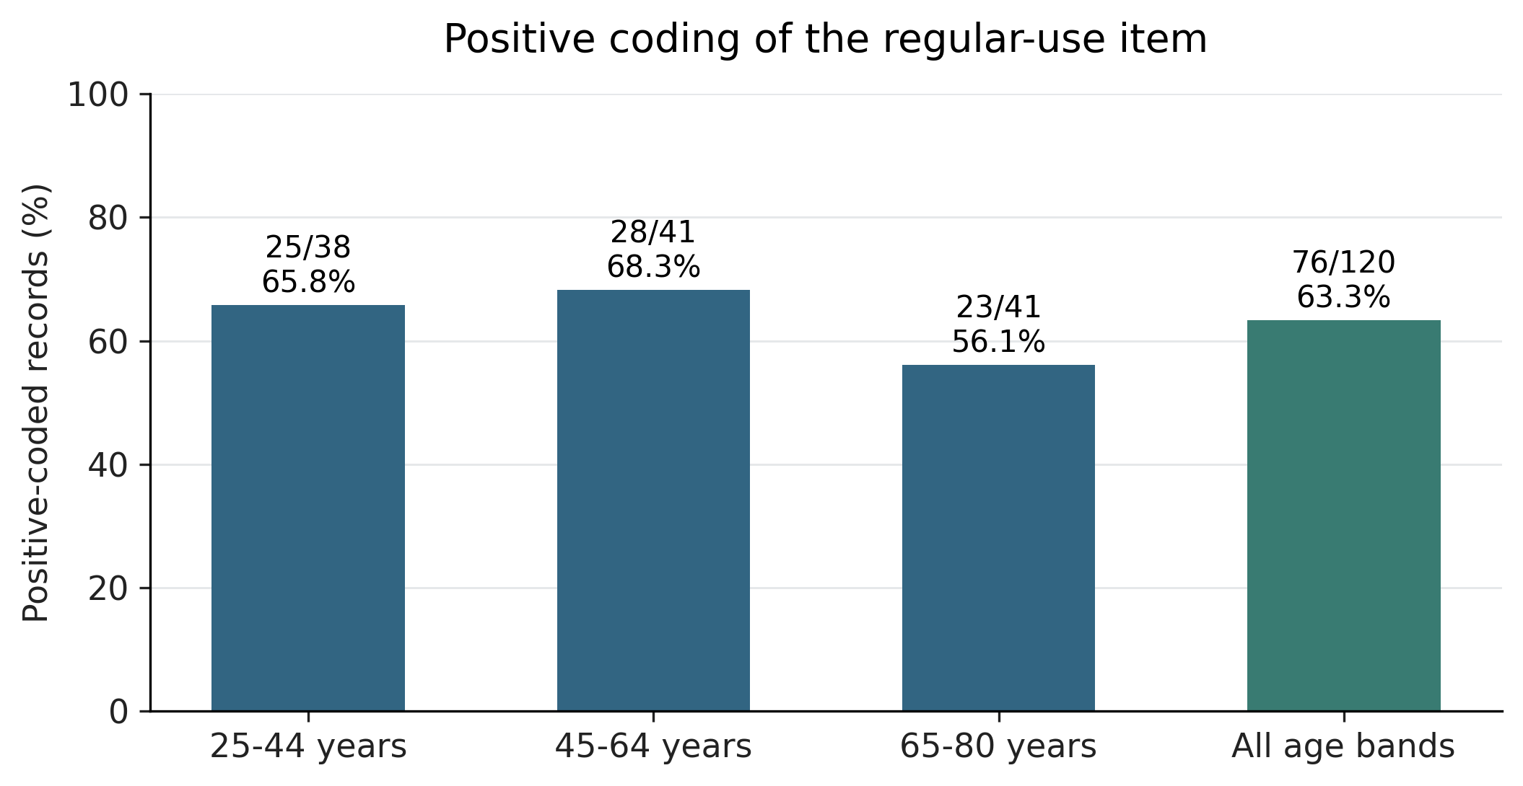
Figure 5. Positive-coded responses to the regular-use-related item in the aggregate summary. Denominators are the corresponding age-band totals and the full sample. The administered wording, scale and scoring threshold require reconciliation. This figure does not compare questionnaire responses with a retention outcome.

Confidence Intervals for Compiled Quantities
Table 4. Conditional Wilson intervals for selected compiled Stage-3 quantities.
Compiled quantity | Count / denominator | Percentage | 95% CI in %
Initial-dropout label, all records | 23 / 120 | 19.2 | 13.1 to 27.1
Returned label among initial dropouts | 15 / 23 | 65.2 | 44.9 to 81.2
Returned label, 65-80-year initial dropouts | 10 / 16 | 62.5 | 38.6 to 81.5
Non-return label, 65-80-year band | 6 / 41 | 14.6 | 6.9 to 28.4
Positive-coded coordination item | 86 / 120 | 71.7 | 63.0 to 79.0
Positive-coded regular-use item | 76 / 120 | 63.3 | 54.4 to 71.4
The intervals use the reported counts and a binomial model. They do not incorporate recruitment selection, uncertain classification rules or questionnaire-coding uncertainty.

Discussion

Principal Findings
The study describes the transfer of a game from an FRA station to a non-clinical browser deployment and the associated aggregate engagement record. Initial-dropout labels were concentrated in the older bands, and most initial-dropout records also carried a returned label. The applied classification rule and event timing cannot be reconstructed from the aggregate summary. The figures therefore do not demonstrate sustained retention, voluntary re-engagement after a defined failure, or a benefit from clinical decoupling. The implementation provides a case for examining which aspects of presentation, task demands and support should be measured in a subsequent evaluation.

Comparison With Prior Work
Stage 2 reported no later run among 21 low-engagement residents [2]. That observation is relevant background, but cannot be treated as a baseline rate for the Stage-3 participants. The cohorts differed in health and residential status, digital familiarity, equipment and input demands, recruitment channel, supervision and observation structure. Novelty and ordinary attrition may also contribute [11]. An absence of clinical apparatus in Stage 3 does not isolate framing, particularly because the recruitment account retained health-related language and assistance was not recorded consistently.
The candidate FIAS explanation proposes that an adverse experience attached to an assessment of one's body could discourage further participation. The Stage-3 build's zero-failure mode and the absence of measured perceived failure or identity threat prevent a test of that mechanism. A bump is not necessarily experienced as failure, and the present records do not establish such an appraisal. The earlier observation that three of six residents in the strongest-abandonment cluster showed a positive recorded balance-index change and did not return [2] remains contextual; Stage 3 collected no corresponding clinical index.
Gerontoludic and appraisal-based design already recognise that enjoyment, meaning and personal interpretation matter to older players [9,10]. The present design offers a practical case of removing assessment apparatus while retaining a familiar gameplay mechanic. A source-linked engagement record could inform the application of these frameworks, although the current classifications do not test their psychological mechanisms. Age-band differences also do not establish uniform preferences or capabilities within the oldest group.

Design Implications
Game performance, willingness to use a system and sustained participation require separate measures. The current aggregate questionnaire counts cannot establish whether the same individuals both continued and declined regular use. A subsequent evaluation should link these observations by participant and distinguish immediate replay, later return and longer-term use. It should also record access, burden, enjoyment, fatigue and assistance before attributing disengagement to a single psychological process.
Feedback should describe the task, the adjustment and an actionable next step. Self-efficacy and stereotype-threat literature can inform hypotheses about supportive communication [12,13,14], but those mechanisms were not measured here. If a future version reintroduces clinically valid risk information, that information should be communicated accurately, with uncertainty and appropriate support; gameplay scores should not be presented as a diagnosis or as a verdict on personal worth.
A post-deployment expert consultation described failure-related withdrawal in physical group exercise and the possible value of human support. This is an interpretive contribution from a different activity, not validation of the electronic game's mechanism. It motivates recording facilitation and social context in a later study. The present evidence does not establish that dispersed play eliminated group influence or that coaching reduced dropout.

Subsequent Development and Related Records
The original Stage 3B component study began in a separate cohort after a repository-dated protocol of 8-9 August 2026. It crossed adaptive versus static presentation with zero-failure versus game-over modes; it did not manipulate clinical framing. At the 26 September cut-off, its record comprised one verified return, five researcher-solicited returns received on 15 September 2026 on a superseded build and excluded on verification, and no clean-run return. It provided no confirmatory result and is not used to support the Stage-3 estimates.

Limitations
The respondent-only denominator limits generalisation beyond the 120 compiled records. Missing source-linked participant compilation, uncertain timing and undocumented applied classification rules limit the meaning of the primary outcomes. Questionnaire wording and coding require reconciliation. The reconstructed invitation and the unrecorded extent of research-assistant help with device operation limit conclusions about participants' exposure to a particular framing. Version and input-device differences also need to be linked to individual records.
The historical comparison does not identify an effect of clinical framing, and no clinical outcome, identity-threat mechanism, learning-retention outcome or language-model benefit was measured. The formal ethics decision followed the Stage-3 collection period, making the chronology and the institution's determination material to interpretation and reporting.

Future Evaluation
A future study could compare presentations within the same recruitment population while holding equipment, task demands and assistance constant. It should define disengagement, reminders and a return window before collection; retain timestamps and participant-level source links; and preserve the administered questionnaires and scoring rules. A clinical-framing question requires a measured framing exposure and comparable clinical and non-clinical conditions. If fear of falling is relevant, a suitable instrument such as the Falls Efficacy Scale-International [15] could be selected for that later protocol; it was not administered here.
An adaptive-learning evaluation would additionally specify the target skill, establish comparable assessment forms and measure delayed unassisted performance. Immediate game scores, perceived improvement and durable learning should remain distinct. Any future study requires the applicable prospective ethics determination and prespecified hypotheses and endpoints. No new trial or completed protocol is claimed in this paper.

Conclusions
A compiled record of a non-clinical coordination-game deployment contains age-related differences in initial-dropout classifications and returned labels for most records classified as initial dropouts. The applied rules, event timing and questionnaire instrument remain insufficiently documented for stronger behavioural conclusions. The record does not establish that removing clinical apparatus reduced abandonment. Its current value is in describing the redesign and the specific evidence needed to evaluate engagement reproducibly.

Acknowledgments
The authors thank the network partners and participants who supported distribution and collection. Supervision by Prof. Chi Fai Cheung at The Hong Kong Polytechnic University is gratefully acknowledged.

Funding
This research received no external funding.

Data Availability
The aggregate Stage-3 data logbook and archived game build are retained with the first author's thesis records. The research team retains returned exports and the distribution and return correspondence that records implied consent; participant-level compilation linked to the reported aggregates is pending. Requests for access should be directed to the corresponding author and will require review of de-identification, participant consent and institutional conditions. The present statement does not imply that a fully reconciled participant-level dataset has already been released.

Authors' Contributions
SKTT led the research programme, the deployment, the compilation of the record and the preparation of the manuscript. CFC supervised the research programme and reviewed the manuscript. Both authors approved the final version.

Conflicts of Interest
The authors declare no competing financial interests. The Stage-2 study was conducted with the residential care provider operating that facility; the provider had no role in the present Stage-3 study. Participants were recruited through the authors' networks.

Use of Generative Artificial Intelligence
Anthropic's Claude Code assisted system development, including the HTML port. OpenAI's ChatGPT and Anthropic's Claude assisted manuscript revision, consistency review and preparation of plotting code for the revision dated 27 September 2026. Figures 2-5 were generated deterministically from the reported aggregate counts using plotting software; no participant observations were generated. The authors retain responsibility for the accuracy of the text, references, analyses and figures. Assistance in development or writing does not establish operation or effectiveness of a language model during participant gameplay.

Related Publications
The programme's Stage-1 conference manuscript [1] and Stage-2 companion manuscript [2] concern separate study records; their results are cited as background and are not presented as new Stage-3 findings. The present paper's primary dataset is the March-April Stage-3 aggregate record.

Abbreviations
API: application programming interface
CI: confidence interval
FIAS: failure-induced abandonment syndrome
FRA: fall risk assessment
GPT: generative pretrained transformer
HTML: Hypertext Markup Language

References
1. Tam SKT, Cheung CF. Investigating low utilisation of fall risk assessment among elderly users: A critical review through TAM and Octalysis frameworks with gamification approach. Paper SS-293. 10th International Conference on Management Engineering, Software Engineering and Service Sciences (ICMSS 2026); March 20-22, 2026; Wuhan, China. Conference Publishing Services. Accepted for presentation and publication; submitted to IEEE Xplore.
2. Tam SKT, Cheung CF. Gamification as a proactive approach: A study of elderly failure-induced abandonment in gamified Fall Risk Assessment. Manuscript submitted to Journal of Information & Knowledge Management; 2026. Submission identifier JIKM-S-26-02466.
3. An S, Cheung CF, Willoughby KW. A gamification approach for enhancing older adults' technology adoption and knowledge transfer: A case study in mobile payments technology. Technological Forecasting and Social Change. 2024;205:123456. doi:10.1016/j.techfore.2024.123456.
4. Chen K, Chan AHS. Gerontechnology acceptance by elderly Hong Kong Chinese: A senior technology acceptance model (STAM). Ergonomics. 2014;57(5):635-652. doi:10.1080/00140139.2014.895855.
5. Chou YK. Actionable Gamification: Beyond Points, Badges, and Leaderboards. Fremont, CA: Octalysis Media; 2015.
6. Thaler R. Toward a positive theory of consumer choice. Journal of Economic Behavior & Organization. 1980;1(1):39-60.
7. Kahneman D, Knetsch JL, Thaler RH. Experimental tests of the endowment effect and the Coase theorem. Journal of Political Economy. 1990;98(6):1325-1348.
8. Kahneman D, Tversky A. Prospect theory: An analysis of decision under risk. Econometrica. 1979;47(2):263-291.
9. De Schutter B, Vanden Abeele V. Towards a gerontoludic manifesto. Anthropology & Aging. 2015;36(2):112-120. doi:10.5195/aa.2015.104.
10. Khalili-Mahani N, De Schutter B. Affective game planning for health applications: Quantitative extension of gerontoludic design based on the appraisal theory of stress and coping. JMIR Serious Games. 2019;7(2):e13303. doi:10.2196/13303.
11. Eysenbach G. The law of attrition. Journal of Medical Internet Research. 2005;7(1):e11. doi:10.2196/jmir.7.1.e11.
12. Barber SJ. An examination of age-based stereotype threat about cognitive decline. Perspectives on Psychological Science. 2017;12(1):62-90. doi:10.1177/1745691616656345.
13. McGlone MS, Aronson J. Stereotype threat, identity salience, and spatial reasoning. Journal of Applied Developmental Psychology. 2006;27(5):486-493.
14. Bandura A. Self-Efficacy: The Exercise of Control. New York, NY: WH Freeman; 1997.
15. Yardley L, Beyer N, Hauer K, Kempen G, Piot-Ziegler C, Todd C. Development and initial validation of the Falls Efficacy Scale-International (FES-I). Age and Ageing. 2005;34(6):614-619. doi:10.1093/ageing/afi196.

