Decoupling the Clinical Attachment from Gamified Fall Risk Assessment: Between-Cohort Evidence for a Frame-Sensitive Account of Elderly Abandonment
Sidney K. T. Tam and Chi Fai Cheung
Behaviour and Knowledge Engineering Research Centre, Department of Industrial and Systems Engineering,
The Hong Kong Polytechnic University, Hong Kong, China
Corresponding author: sidney.tam@connect.polyu.hk

Abstract
Earlier work in this programme documented rapid abandonment, with no documented return within the observation window, of a gamified, AI-assisted Fall Risk Assessment (FRA) by elderly residents after early failure: 70.0% had three or fewer recorded completed game runs and none of the 21 low-engagement participants had a later recorded run, even where the recorded balance index had improved. Two rival readings of that result make opposite predictions — a dispositional reading, on which gamification does not transfer to frail older adults, and a coupling reading, on which the attachment of the game to a clinical verdict on the user's body carried the failure. This paper reports the evaluation that separates them: a between-cohort quasi-experimental remote deployment in which the game was ported to an HTML build and distributed by e-mail. Participants played unsupervised on their own computers, using a trackpad, arrow keys or, where available, a foot-pad sensor; the skiing mechanic, five-attempt rule and session structure were retained in the port, while the participant-facing clinical attachment was removed as a package — the clinical apparatus and setting, pre-session clinical scan, clinical labels and participant-facing clinical outputs, with no medical or fall-prevention vocabulary in the game or its instructions — and the activity was framed as an eye-leg coordination challenge. One hundred and twenty community-dwelling adults aged 25-80 were recruited through the authors' Hong Kong-based networks across three age bands (38 aged 25-44, 41 aged 45-64, 41 aged 65-80). In the preliminary aggregate record — compiled from the results files and questionnaire responses of the 120 participants who returned them by e-mail, without per-participant session dates, so that dropout and return are compiled classifications whose timing rule cannot be reconstructed from the aggregates — end-of-window retention was 93.3% overall and 85.4% in the 65-80 band; 15 of 23 initial dropouts returned voluntarily (65.2%; 10 of 16, or 62.5%, in the 65-80 band); coordination-challenge endorsement was 71.7%; and stated regular-use intention was 63.3% overall and 56.1% in the 65-80 band. Initial dropout climbed steeply with age (0 of 38 versus 16 of 41; Fisher's exact p < 0.0001), while observed non-return converged to low levels in every band (0.0%, 4.9%, 14.6%). The pattern is consistent with the coupling account and inconsistent with the dispositional account, within the limits of a between-cohort, multi-component design in which platform, input device, setting and supervision changed alongside framing. A residual 29.3-percentage-point gap between end-of-window retention and regular-use intention in the oldest band motivates adaptive learning — trajectory-oriented feedback with calibrated challenge — as the design response, carried here as a design direction specified for future study rather than as a tested result; the within-cohort randomised study that could carry the causal claim is outlined, not commenced.
Keywords: fall risk assessment, gamification, elderly technology abandonment, FIAS, decoupling, framing, endowment effect, adaptive learning.

I. Introduction
A survey of 200 residents at a Guangzhou care facility (of a resident population of 280) found that only 39% had ever used an installed FRA system; among users, approximately 74% failed on their first attempt and 82% did not return [1]. A subsequent eight-week action-research deployment with thirty residents tested whether a gamified, AI-assisted FRA — engineered to satisfy the acceptance and gamification design criteria of the technology-acceptance [5], [6] and Octalysis [7] literatures — would sustain engagement. It did not: 70.0% of participants (95% CI 52.1-83.3%) had three or fewer recorded completed runs, 26.7% had a single completed run, and none of the 21 low-engagement participants had a later recorded run within the study window (95% CI 0.0-15.5%) [2]. Most strikingly, three of the six participants in the strongest-abandonment cluster recorded a positive change in the balance index in their only recorded run and still did not return.
That rejection is ambiguous between two explanations. Under the dispositional explanation, gamification simply does not work for frail older adults: the literature's successes with non-clinical technologies do not transfer. Under the coupling explanation, the game was never the problem: attaching the gameplay to a clinical verdict on the user's own body changed the meaning of failure, and the failure-induced abandonment (FIAS) documented in [1], [2] is a property of that attachment. The two explanations make opposite predictions for a decoupled version of the same game. This paper reports that evaluation. It evaluates a participant-facing redesign package in a separate cohort; it does not isolate a single causal variable, and its claims are calibrated accordingly.
The two accounts frame the deployment's directional expectations. Under the dispositional account, removing the clinical cues changes little: elderly non-return stays high and post-failure return stays near zero. Under the coupling account, the decoupled game behaves like the elderly gamification successes in the literature: observed non-return falls below the coupled rate, some initial dropouts return after failure, and most participants recognise the intended frame, with a substantial proportion expressing regular-use intention. The three-band cohort also permits an exploratory test of a second null hypothesis, H0-age (no difference between age groups under decoupling), examined after the age-stratified data were tabulated: if the burden the coupling imposes is age-linked, initial dropout will differ by age even under decoupling and H0-age will fall.

II. Theoretical Background

A. The FIAS Account and the Endowment Mechanism
FIAS (Failure-Induced Abandonment Syndrome) is a provisional behavioural construct: active, rapid and persistent non-return after an adverse first experience under identity-relevant conditions [1]. The candidate mechanism developed in [2] runs through the endowment effect [3], [4] and its loss-aversion basis [11]. An elderly participant arrives carrying an identity-level asset — the belief in their own physical capability. A clinically framed failure forces a devaluation of that asset. The willingness-to-accept (WTA) such a devaluation is very high, because the asset is neither fungible nor separable from the person's sense of self; the willingness-to-pay (WTP) for re-engagement — bounded by finite expected benefits — cannot match it. On this account the transaction never clears and the participant never returns, which is consistent with the observed zero re-engagement. Extending the endowment effect to health self-concept goes beyond the domains in which it has been demonstrated experimentally; it is carried here as a candidate mechanism, not a measured one.

B. Two Appraisal Regimes
The same account implies a structural proposition: an endowment-protective appraisal and a learning-trajectory appraisal are competing readings of the same feedback event. Read against a fixed self-concept, a failure is a verdict on a possessed asset; read against a learning curve, it is a data point on a trajectory. The two regimes route identical information — a missed obstacle on a pressure panel — to different targets: the self, or the task. Which regime a participant enters is hypothesised to depend on the frame the deployment establishes. This proposition motivates both the decoupling evaluated here (remove the verdict frame) and the adaptive-learning design direction discussed in Section VI (install the trajectory frame); as a claim of mutual exclusion it is theoretical, and its direct test is specified as future work.

III. Method: A Participant-Facing Decoupling Package in a Separate Cohort

A. Design Logic of the Coordination-Challenge Framing
The design problem was practical. A pure entertainment framing would not recruit meaningfully; a health-assessment framing re-activates the very mechanism under study. The deployment therefore framed the activity as an eye-leg coordination challenge: participants were told the game tests how quickly the eyes can spot obstacles and how fast the legs can respond, and that response speed improves with practice. The framing was chosen for three properties: it avoids the physical-decline schema that 'balance' and 'fall' language activates; it avoids cognitive-decline connotations; and it presents performance as inherently variable rather than as a stable capacity, so that no identity-level reference point is established for a failure to threaten.

B. The Decoupling Package
Relative to the coupled deployment of [2], the participant-facing clinical attachment was removed as a package, and the removal was implemented by re-platforming: the game was ported to an HTML build and sent to participants by e-mail, so that play occurred away from the clinical station altogether. The package comprised presentation of the activity as a purely-fun coordination game (the invitation disclosed the doctoral research context, including its fall-risk origin, but the game and its instructions carried no medical or fall-prevention vocabulary); the absence of any pre-session clinical scan; the absence of clinical labels, and of any clinical station or setting; and the absence of participant-facing clinical outputs, with no balance score or risk index shown at any point. The skiing mechanic, five-attempt rule and session structure were retained in the ported build; the pressure-panel apparatus and in-person supervision were not — participants played unsupervised on their own computers using a trackpad, arrow keys or, where available, a foot-pad sensor. In-run difficulty adaptation in the ported build operated through the game's built-in rule agent only: the distributed HTML file carried no API credentials and browser cross-origin policy blocks direct model calls, so every Stage-3 session ran under rule-based difficulty adaptation and no large-language-model adaptation operated. Participant-level clinical balance telemetry was not collected. Because cohort, setting, platform, input device, supervision and recruitment channel also differed, the design estimates the combined association of the decoupled condition and its context with behaviour. Figure 1 shows the ported build at five staged difficulty levels.

Figure 1. The coordination-challenge game (archived HTML build, Stage-3 design lineage) at staged difficulty multipliers x0.40-x1.40. Obstacle density and scroll speed scale with the difficulty multiplier; the interface carries no clinical labels, scores or risk outputs.

C. Participants
One hundred and twenty community-dwelling adults aged 25-80 were recruited through the authors' Hong Kong-based networks — family and personal contacts, work contacts, a charity community network, university support channels and working peers in medical centres: 38 aged 25-44, 41 aged 45-64 and 41 aged 65-80; 48 men and 72 women; all reported high-school education or above. The invitation e-mails disclosed the research context, including the programme's fall-risk origin, while presenting the activity itself as a purely-fun coordination game; the game and its instructions used no medical or fall-prevention vocabulary. Recruiting three age bands builds the comparison group into the study and operationalises the exploratory test of H0-age introduced in Section I. Data collection is complete: each participant returned, by e-mail, the results file logged by the HTML build (including the session score and game-logged data) together with their questionnaire responses. This paper reports the preliminary aggregate record compiled from those returns; participant-level compilation continues beyond it. Participation was voluntary and unpaid, by informed, implied consent: the distribution e-mails explained the purpose of the game and questionnaire and the use of replies, recipients could decline by simply not taking part, and returning the results file and responses constituted consent; no written consent instrument was administered, which is acknowledged in Section VII. Identities were separated from the analysed records, which retain only a participant code, age band, gender and education; the distribution and return e-mails are retained in the authors' records. The programme's application for human subjects ethics review was approved (reference HSEARS20260805008; Principal Investigator Prof. C. F. Cheung; approved 6 August 2026 by the Departmental Research Committee of the Department of Industrial and Systems Engineering on behalf of the PolyU Institutional Review Board; approval period 16 June 2024 – 30 October 2026); the application, submitted on 6 August 2026 after Stages 1–3 had been conducted, described those procedures as conducted, and the approval period spans the programme's fieldwork, including the Stage-3B window.
Two recruitment decisions were deliberate. The Stage-2 facility of [2] was not re-used: its residents already carried direct experience of the coupled system, and prior exposure would have contaminated a first-contact test of the decoupled frame, so a separate cohort was a design choice rather than only a constraint. Distribution also extended beyond the authors' immediate circle through onward (snowball) forwarding by the receiving organisations and contacts, so that a portion of participants were personally unknown to the authors, reducing the risk that participation reflected personal obligation to the researcher. Onward forwarding also leaves the cohort without a compiled invitation denominator: the 120 participants are those whose returned materials were compiled, not the number of people to whom the build was forwarded, so no response rate can be computed and every proportion reported below is conditional on the observed file-returning sample.

D. Outcomes and Analysis
Outcomes are behavioural and stated, observed from the returned game logs and questionnaire responses: initial dropout (disengagement after the first play contact before the five-attempt protocol was completed — an incomplete first session, or no continuation beyond it; the aggregate register labels this outcome 'dropped out before completing 5 attempts', and whether those five are attempts within one sitting or separate sessions is not resolved by the register); voluntary return after initial dropout (a subsequently logged completed session); observed non-return at the end of the study window (an initial dropout with no returned session inside the window, retention being its complement over the cohort, so that a participant who dropped out and later returned counts as retained). Counting a participant first as an initial dropout and then as returning inside the same window presupposes a disengagement checkpoint earlier than the window's end; the aggregate register preserves neither that checkpoint nor per-participant session dates, so the timing rule behind the dropout and return classifications cannot be reconstructed from the aggregates, and the counts are reported as compiled classifications subject to this definitional limit. The two stated outcomes are coordination-challenge endorsement (a manipulation check on the intended frame, measuring frame recognition rather than motivational orientation) and stated regular-use intention. Proportions carry Wilson score 95% confidence intervals; band contrasts use Fisher's exact and chi-square tests. No time-to-event modelling is used.

IV. Results (Preliminary Aggregate Record)
Overall, 23 of 120 participants (19.2%) were classified as initial dropouts ('dropped out before completing 5 attempts'); 15 of the 23 (65.2%; 95% CI 44.9-81.2%) returned voluntarily; 8 (6.7%) did not return, giving end-of-window retention of 93.3% (Table 1) — a proportion of the observed file-returning sample of 120, not of everyone invited or everyone who started. Figure 2 traces the flow.
Table 1. Overall engagement and dropout (N = 120).
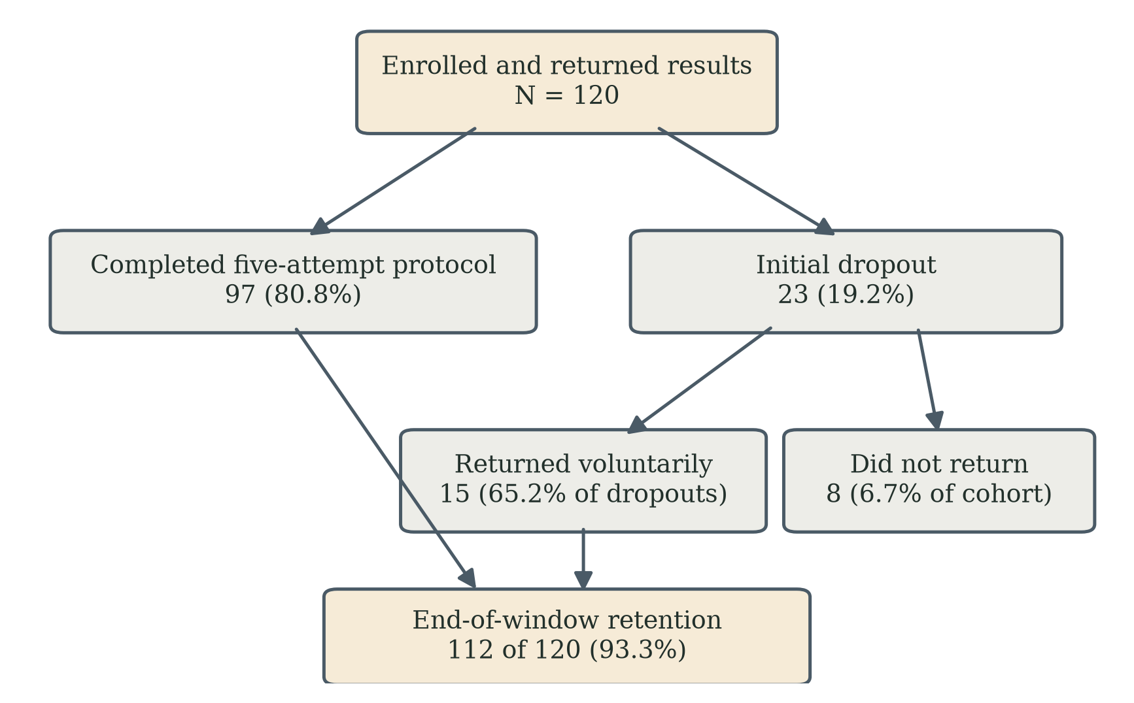
Figure 2. Participant flow in the preliminary aggregate record (N = 120). Voluntary return after initial dropout is the study's central behavioural outcome; dropout and return are compiled classifications whose timing rule cannot be reconstructed from the aggregate record. In the coupled Stage-2 deployment the corresponding count of later recorded runs was zero.
Metric | n | %
Initial dropout ('dropped out before completing 5 attempts') | 23 | 19.2
Voluntary return after initial dropout | 15 | 65.2 of dropouts
Observed non-return at end of window | 8 | 6.7
Retention at end of window | 112 | 93.3
Engagement was strongly age-stratified (Table 2). Initial dropout rose from 0.0% (0 of 38) in the 25-44 band through 17.1% (7 of 41) in the 45-64 band to 39.0% (16 of 41) in the 65-80 band (chi-square across bands p < 0.001; 25-44 versus 65-80, Fisher's exact p < 0.0001), nullifying H0-age for initial engagement. Observed non-return, by contrast, converged to low levels in every band: 0.0%, 4.9% and 14.6% (95% CI 6.9-28.4% in the 65-80 band), because most older dropouts came back: 10 of 16 in the 65-80 band (62.5%; 95% CI 38.6-81.5%) against 0 of 21 observed re-engagements in the coupled deployment of [2]. Figure 3 shows the divergence of the two rates, and Figure 4 the return behaviour behind that convergence: 71.4% of initial dropouts returned in the 45-64 band, 62.5% in the 65-80 band and 65.2% overall, against a 0% return count in the coupled deployment. The pooled 65.2% figure is a descriptive summary; the age-matched comparison is the more relevant evidential anchor. The non-overlapping Wilson intervals (62.5%, 95% CI 38.6-81.5%, versus 0.0%, 95% CI 0.0-15.5%) describe a strong difference in observed proportions, but they are not a substitute for a randomised hypothesis test, because the samples are independent and contextually different.
Table 2. Age-stratified engagement.
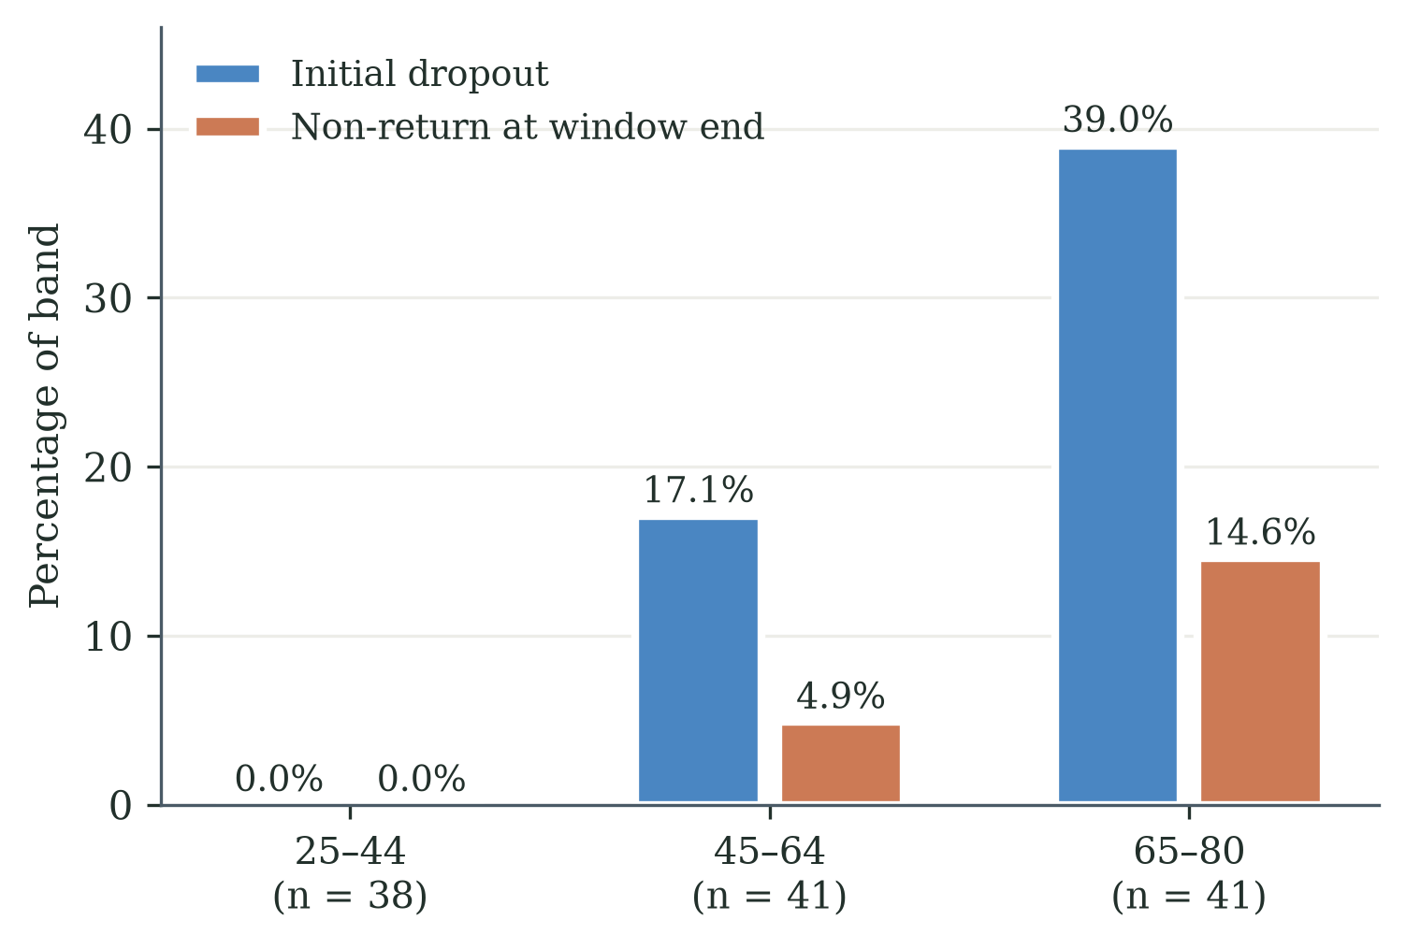
Figure 3. The age gradient: initial dropout climbs steeply with age (0.0%, 17.1%, 39.0%) while non-return at the window end stays low in every band (0.0%, 4.9%, 14.6%) - most older participants who drop out come back under the decoupled condition.
Age band | n | Initial dropout | Returned | Non-return | Retention
25–44 | 38 | 0 (0.0%) | 0 | 0 (0.0%) | 100.0%
45–64 | 41 | 7 (17.1%) | 5 | 2 (4.9%) | 95.1%
65–80 | 41 | 16 (39.0%) | 10 | 6 (14.6%) | 85.4%
Total | 120 | 23 (19.2%) | 15 | 8 (6.7%) | 93.3%

Figure 4. Voluntary return after initial dropout by age band: 71.4% in the 45-64 band, 62.5% in the 65-80 band and 65.2% overall, against a 0% return count in the coupled deployment of [2]. Return after initial dropout is the study's central behavioural outcome; dropout and return are compiled classifications whose timing rule cannot be reconstructed from the aggregate record.
Coordination-challenge endorsement reached 71.7% (86 of 120; 95% CI 63.0-79.0%), indicating that most participants perceived the intended frame; the per-band breakdown was not retained in the preliminary summary and no per-band endorsement claim is made. Stated regular-use intention was 63.3% overall (76 of 120) — 65.8%, 68.3% and 56.1% by band (Table 3). In the 65-80 band, the difference between observed end-of-window retention (85.4%) and stated regular-use intention (56.1%; 95% CI 41.0-70.1%) is 29.3 percentage points; the two are distinct constructs, and the difference is a design diagnostic rather than a measured causal effect. Figure 5 shows the two rates by age band, and Table 4 consolidates the key contrasts of the two deployments with their intervals and tests.
Table 3. Endorsement and stated regular-use intention.
Item | 25–44 | 45–64 | 65–80 | Total
Coordination-challenge endorsement | — | — | — | 71.7%
Would use regularly if accessible | 65.8% | 68.3% | 56.1% | 63.3%
Table 4. Consolidated statistical results for the key contrasts of the coupled and decoupled deployments.
Contrast or quantity | Estimate | 95% CI | n | Test / source
Three or fewer recorded completed runs (Stage 2, coupled) | 70.0% | 52.1–83.3%* | 30 | Wilson interval; [2]
Later recorded run among low-engagement participants (Stage 2, coupled) | 0.0% | 0.0–15.5%* | 21 | Wilson interval; [2]
Return after initial dropout, all bands (Stage 3) | 65.2% | 44.9–81.2%* | 23 | Wilson interval; Table 1
Return after initial dropout, 65–80 band (Stage 3) | 62.5% | 38.6–81.5%* | 16 | Wilson interval; Table 2
Observed non-return, 65–80 band (Stage 3) | 14.6% | 6.9–28.4%* | 41 | Wilson interval; Table 2
Coordination-challenge endorsement (Stage 3) | 71.7% | 63.0–79.0%* | 120 | Wilson interval; Table 3
Regular-use intention, 65–80 band (Stage 3) | 56.1% | 41.0–70.1%* | 41 | Wilson interval; Table 3
Retention–intention difference, 65–80 band (Stage 3) | 29.3 pp | see note | 41 | Distinct outcomes; Section V
*Wilson score intervals computed from the reported counts. The retention–intention difference is descriptive: the two measures are distinct constructs, and the difference may not represent a simple paired effect.

Figure 5. Observed end-of-window retention versus stated regular-use intention by age band: the 29.3-percentage-point commitment gap in the 65-80 band. Retention and intention are distinct constructs; the gap is a design diagnostic, not a measured causal effect.

V. Discussion

A. Frame-Sensitive Versus Dispositional Accounts
The pattern is one-sided between the two rival readings. The decoupled game was accepted by the elderly cohort at levels consistent with what the gamification literature predicts for non-clinical technologies — 85.4% end-of-window retention in the 65-80 band (returned dropouts counted as retained), voluntary return in ten of sixteen cases, majority stated intention — none of which the dispositional account predicted. The result is therefore consistent with gamification theory holding for this population, and with the failure documented in [2] residing in the coupling rather than in the game or the participants. End-of-window retention was high in all three age bands (100.0%, 95.1% and 85.4%); the pattern is general, not an elderly concession. The causal interpretation remains bounded: the cohorts differed in setting, platform, input device, supervision, recruitment, residential status, age distribution, health profile and prior exposure, and the decoupling was a package rather than a single variable — indeed, the decoupled condition was delivered by re-platforming the game entirely. Stated as a candidate scope condition, the combined evidence of the two deployments reads: gamification theory holds for older adults — until the gamified activity is attached to a purpose-based technology whose purpose, such as health assessment, touches the identity-level value propositions of the user; at that boundary the failure pattern of [2] appears, and FIAS names that pattern. The boundary remains a hypothesis. Nor should the contrast between the deployments be read as proof of two discrete behavioural regimes: post-failure return was common here and absent in [2], a large and theoretically important contrast whose causal interpretation remains bounded by separate cohorts, contexts, recruitment channels and observation structures. The decisive test would be a within-cohort randomised comparison, which is outlined as future work in Section VIII and has not been commenced.

B. The Objective-Score-Improvement/Non-Return Paradox Reconsidered
The coupled deployment's sharpest observation was that three of the six strongest-abandonment participants improved on the recorded balance index and still never returned. The present deployment deliberately collected no clinical telemetry, so that pattern cannot be replicated directly; what it measures instead is whether participants who initially disengaged returned under the decoupled condition. Fifteen of twenty-three did. This is consistent with the proposition that an adverse gameplay event need not become an absorbing non-return state when no clinical verdict is attached. It does not demonstrate that the proposed mental account remained open, that the paradox was resolved, or that the same individuals would have behaved differently under the coupled condition. What the two deployments together add to the paradox is its other half: under the clinical frame, improvement did not bring users back; under the game frame, even failure did not keep them away.

C. The Age Gradient Read Through the WTA/WTP Account
The age-stratified pattern is what an identity-level account predicts. The burden that the coupling imposes is age-linked — initial dropout climbs steeply with age even under decoupling — but under the decoupled condition that burden no longer converts into abandonment, because most older dropouts return. In WTA/WTP terms: with no clinical verdict attached, a slow round does not devalue an identity-level asset, the WTA for accepting failure stays low, and re-engagement clears. The account remains inferential — no WTA/WTP elicitation was performed in this deployment — and its direct measurement belongs to the within-cohort study outlined in Section VIII, which has not been commenced.

D. The Commitment Gap and the Adaptive-Learning Direction
Decoupling did not answer every engagement question. Half of the older participants who happily completed the session saw no place for the game in their weekly lives: the 29.3-point gap between retention and stated intention (Figure 5) marks the boundary of what removing the threat can achieve. Decoupling removes a reason to leave; it does not add a reason to return. And decoupling faces a deeper limit: the FRA's clinical purpose is the entire point of deploying it, so the purpose must eventually return to the experience — the design question is how it can return without re-igniting the identity threat. The design response this motivates is adaptive learning: presenting performance as movement on a personal trajectory, with challenge calibrated to evolving capability, so that a rising curve becomes the reason to return — and eventually becomes the frame within which the clinical purpose can be re-attached without re-activating the identity threat. The gap does not identify adaptive learning as its sole remedy; fatigue, access, burden, relevance and enjoyment are plausible contributors, and any future study of the direction would need to pair behavioural follow-up with measures of each. A pre-specified (repository-dated) Stage-3B component study of adaptive against static presentation was commenced in a separate cohort; as Section VIII records, it is reported at cut-off as a descriptive record with no confirmatory result, and it is not used here as the test of the adaptive-learning claim.

E. Interpretive Support from an Adjacent Discipline
After the deployment, the commitment-gap interpretation was examined in a single expert consultation with Dr Sarah C. W. Yuan of the Center on the Family, University of Hawai'i at Mānoa — a medical sociologist and demographer of aging whose field of practice, group exercise and physical games for balance with no electronic game and no clinical instrument attached, is deliberately distant from this programme's apparatus. Three of her observations bear on this paper. First, in her programmes older adults tend to drop out after a failure unless a physician, assistant or coach helps them past the rejection; failure-linked dropout appears even with no clinical attachment at all, and is recoverable through human support. Second, in her experience older adults intrinsically avoid clinically oriented individual assessment of their current health status: they fear facing a negative risk result — an independent statement, from the sociology of aging, of the identity-level avoidance the FIAS account proposes. Third, she regards gamification as effective for promoting health technology, and expects hard rejection precisely when the activity is linked to clinical results; on that basis she explicitly supported the decoupling design and the adaptive-learning proposition. The consultation adds a social mechanism the present data could not supply: partnering, group play and a coach who leads the activity reduce initial dropout and, downstream, abandonment — which motivates a group-deployment variant of the protocol — and predictable or expected results correspond to what a visible personal trajectory provides. The evidential limits are stated plainly: this is one consultation, reported as interpretive support from an adjacent discipline rather than validation, and its observations concern physical group exercise, so their transfer to electronic games is an argued expectation rather than a demonstrated result.

VI. Design Implications for Practitioners
The account and the present associations translate into five design levers for any gamified health technology serving older users. They are stated as design guidance derived from the programme's evidence and theory; their causal evaluation would belong to a within-cohort study of the kind outlined in Section VIII, and none of them is confirmed here.
First, engineer the attribution pathway. Whether feedback from a failure flows into the participant's model of the task or their model of themselves is set by the framing — the activity's name, the on-screen metrics, staff language and the ambient narrative of the deployment site. If the pathway is not designed, the environment will set it, and in elderly care settings it will set it toward health-deficit. The coordination-challenge framing evaluated here is one engineered pathway; 71.7% endorsement indicates most participants received it.
Second, keep the belief structure open. Present performance as inherently variable ('your response will differ each session — that is normal'), emphasise ranges rather than single summary scores, and never let one failure read as a verdict.
Third, respect the endowment boundary. The vulnerable moments are the initial framing before the first session, the first failure event, and the between-session reflection in which the participant decides whether to return. Each deserves explicit design attention: a success-guaranteeing first session, immediate mastery-oriented reframing at failure [12], and a return path that requires no renewed self-justification.
Fourth, design feedback for its interpretive affordance, not only its information content. A difficulty reduction presented silently, or in clinical terms, reads as 'the system detected my weakness'; the same adjustment presented as 'finding the right speed for your reactions' reads as help. No output shown to the participant should be readable as a health verdict. The commitment-gap finding adds the forward-looking lever: install a visible personal trajectory, so that returning has a positive reason and not merely the absence of a negative one.
Fifth, design the social context. Where deployment allows, structured group play with a leading coach appears protective against failure-linked dropout, whereas unstructured peer comparison may still threaten identity; predictable, shared expectations of results help. A group-deployment variant of the protocol is the practical form of this lever, and a future within-cohort study of the kind outlined in Section VIII could operationalise the distinction.

VII. Limitations
The comparison with [2] is between-cycle and between-cohort, without randomisation; the decoupling is a multi-component package that includes a change of platform, input device, setting and supervision (an e-mailed HTML build played unsupervised on participants' own computers, rather than the supervised pressure-panel station of [2]); the proposed mechanisms (endowment [3], [4], mental accounting, stereotype threat [9], [10]) were not directly measured; regular-use intention is stated, not longitudinal behaviour; this paper reports the preliminary aggregate record compiled from participants' e-mailed returns, with participant-level compilation continuing beyond it; input device varied by participant and was not centrally standardised; remote unsupervised play means session conditions were not controlled; participants were volunteers in Chinese-cultural settings, and generalisation beyond these contexts is untested; consent was informed but implied rather than written; no clinical telemetry was collected, so no claim about clinical outcomes under decoupling is made; the invitation disclosed the programme's fall-risk research origin, so Stage 3 tests artefact-level decoupling rather than concealment of purpose; the 120 analysed participants are those whose returned materials were compiled, no invitation denominator was compiled, and the aggregate record preserves neither a disengagement checkpoint nor per-participant session dates, so dropout and return are compiled classifications of uncertain timing; the framing item measures frame recognition rather than motivational orientation; the adaptive-learning design direction discussed in Sections V and VI was not deployed in this cohort, and the separately commenced Stage-3B component study (Section VIII) had produced no confirmatory result at the cut-off of this paper; and the expert consultation of Section V.E is a single interpretive account from an adjacent discipline, not validation.
Two further rivals are named rather than left implicit. Ordinary attrition [8] is frame-indifferent and therefore does not predict the between-cohort difference in post-failure return, though the package confounds above bound that inference. And because the [2] cohort lived with the station — a common-room setting in which a shared narrative about what the machine signifies can circulate — while the present participants played dispersed and alone, the decoupling package also removed the group narrative environment; a collective-narrative account of non-use is therefore conceded as a plausible component of the between-cohort difference — one strand of which is anchored by a recorded Stage-2 field observation of peers' visible dropout contributing to abandonment [2] — and group-level instrumentation is added to the requirements of any future within-cohort study.

VIII. The Stage-3B Component Study at Cut-off, and Future Work
A. The Stage-3B component study as commenced. After the present results were in hand, a component study (Stage 3B of the programme) was pre-specified — its protocol and analysis hierarchy are repository-dated 8–9 August 2026, before recruitment; it is not registry-registered — and commenced. It is a silent 2×2 design crossing adaptive (A) against static (B) difficulty presentation with zero-failure (ZF) against game-over (GO) failure modes, in a new, remotely recruited cohort: assignment is drawn at random per participant at first enrolment and persisted in the browser's local storage; the adaptive arm's rule agent steps difficulty up above 80% clearance and eases it below 40%, while the static arm runs at a fixed ×0.85 pace with coaching suppressed; consent is recorded in-build before play; and one confirmatory contrast was pre-specified (adaptive versus static on questionnaire item D2, willingness to play regularly, top-two-box, pooled across failure modes), with the failure-mode factor and the interaction exploratory. Builds were distributed 10–12 August 2026 through five device-tagged copies, input-mode logging was added on 13 August, and a frozen study edition (build stamp Alpine_Coordination_Game_v3.1s_Stage3B_FROZEN20260915; twenty distributor-tagged copies hosted on GitHub Pages) opened a clean-run window from 15 September to 15 October 2026. The record at the cut-off of this paper (26 September 2026) is descriptive: one verified return (15 August 2026, on the August build); five returns received on 15 September were excluded as researcher-solicited plays on the pre-freeze 13-August edition, all in one arm; and no clean-run return was on record. No confirmatory analysis is reported, and the paper's claims do not depend on one. The study was designed to examine the adaptive-learning direction of Section V.D, not the coupling claim, because clinical framing is not a factor in it.
B. Why the learning measurement must be re-articulated first. In the course of that study the authors judged that its learning measurement was not articulated to the adaptive-learning construct, and it is no longer used as the test of that construct. The build records immediate task performance (clearance on the course played), which is not durable learning; course forms across sessions were not equated, so performance under changing difficulty or assistance is not comparable across sessions; the adaptive arm bundles difficulty adjustment with coaching, so its contrast estimates an adaptive-support package rather than difficulty adjustment alone; and the unit of randomisation and each participant's first-exposure version require per-participant recording. A test of adaptive learning therefore needs, before any confirmatory contrast: separate reporting of participation, performance and learning; equated reference conditions (the same course form and assistance level at comparable checkpoints); and an unassisted delayed test on an equated form as the learning outcome, with difficulty, assistance and task version recorded for every run.
C. Future work (proposed, not commenced). A three-arm randomised within-cohort study is proposed — it has not been commenced and no protocol for it is repository-dated — to convert the present associations into causal tests: Arm 1, the coupled game (control); Arm 2, the decoupled coordination-challenge framing; Arm 3, the coupled game with a structured coaching layer. Its primary endpoint would be re-engagement within seven days of first failure. Such a study would add instruments this deployment lacked: baseline FES-I [13], a validated motivational measure administered before any outcome is observed, WTA/WTP elicitation after the first session, harmonised session-level logging with timestamps, and a group-level component in response to the collective-narrative rival named in Section VII. A nested-model quantitative comparison — specified in the programme as a prospective analysis architecture, with no model yet fitted — could be run alongside it, to test whether prospectively measured FIAS operators add incremental explanatory power beyond demographics and senior-technology-acceptance constructs, with likelihood-ratio, information-criterion, discrimination, calibration and decision-curve analyses, and with any FIAS predictor excluding the elements that define the outcome. Hypotheses and endpoints for these studies should be pre-specified and publicly registered before any data collection; no registration exists at the time of writing, and no commitment to run either study is made here.

IX. Conclusion
Offered the same game mechanics without the clinical attachment — an HTML port of the game, played on their own computers — a separate cohort of 120 adults, including 41 aged 65-80, accepted it at the levels the gamification literature predicts, and most older participants who initially dropped out came back. The evidence is consistent with a frame-sensitive account of elderly abandonment: the problem documented in this programme lives at the attachment between gameplay and clinical verdict, not in gamification and not in the population. As a candidate scope condition, still a hypothesis: gamification theory holds for older adults until the activity is attached to a purpose-based technology whose verdicts touch identity-level concerns; at that boundary, FIAS names the failure pattern. What decoupling leaves open — the commitment gap — points the engineering programme toward adaptive learning as the driver that can make returning worthwhile, and a within-cohort randomised study — outlined in Section VIII, not yet commenced — as the test that could make the causal claim this design cannot. Adaptive learning is carried here as a design direction and a future study, not as a demonstrated result.

Acknowledgments
The authors thank the Hong Kong network partners — work contacts, the charity community network, university supporters and medical-centre colleagues — who distributed the game build, and all participants who returned their game logs and questionnaire responses. Supervision by Prof. Chi Fai Cheung at The Hong Kong Polytechnic University is gratefully acknowledged. AI tooling used in the programme's game development is an enabling technology; the contribution of this paper is the behavioural evaluation and the design framework it informs.

Declarations
Funding. This research received no external funding.
Conflicts of interest. The authors declare no competing financial interests. The Stage-2 study reported in [2] was conducted in partnership with the residential care provider operating that facility; the provider had no role in the present study. Participants in the present study were volunteers recruited through the authors' networks.
Data availability. The preliminary aggregate record underlying this paper is compiled in the Stage-3 data logbook archived with the first author's thesis; participant-level compilation from the returned files continues, as stated in Section III. The Stage-3B design, build and returns record summarised in Section VIII is archived with the same thesis. De-identified records are available from the corresponding author on reasonable request, subject to the ethics constraints governing the programme.
Use of artificial intelligence. Anthropic's Claude Code was used as an engineering assistant during system development, including the HTML port deployed in this study; the engineering decisions remain the developers' own. AI-assisted drafting and editing tools were used in manuscript preparation under full author review and responsibility.
Related publications. A conference paper (Tam & Cheung, ICMSS 2026 [1]) reports the programme's Stage-1 critical review, and a companion manuscript [2] reports the Stage-2 coupled deployment; this paper reports the Stage-3 decoupled deployment. Stage-1 and Stage-2 figures are restated here only for comparison, with citation; no result is presented as new in more than one of the three.

References
[1] S. K. T. Tam and C. F. Cheung, “Investigating low utilisation of fall risk assessment among elderly users: A critical review through TAM and Octalysis frameworks with gamification approach,” paper SS-293, in Proc. 10th Int. Conf. on Management Engineering, Software Engineering and Service Sciences (ICMSS 2026), Wuhan, China, 20–22 Mar. 2026, Conference Publishing Services (CPS), accepted for presentation and publication; submitted to IEEE Xplore.
[2] S. K. T. Tam and C. F. Cheung, “Gamification as a proactive approach: A study of elderly failure-induced abandonment in gamified Fall Risk Assessment,” manuscript submitted to J. Inf. Knowl. Manag. (JIKM-S-26-02466), 2026 (Paper 2 of this programme).
[3] R. Thaler, “Toward a positive theory of consumer choice,” J. Econ. Behav. Organ., vol. 1, no. 1, pp. 39-60, 1980.
[4] D. Kahneman, J. L. Knetsch, and R. H. Thaler, “Experimental tests of the endowment effect and the Coase theorem,” J. Political Econ., vol. 98, no. 6, pp. 1325-1348, 1990.
[5] S. An, C. F. Cheung, and K. W. Willoughby, “A gamification approach for enhancing older adults' technology adoption and knowledge transfer,” Technol. Forecast. Soc. Change, vol. 205, 2024.
[6] K. Chen and A. H. S. Chan, “Gerontechnology acceptance by elderly Hong Kong Chinese: STAM,” Ergonomics, vol. 57, no. 5, pp. 635-652, 2014.
[7] Y.-K. Chou, Actionable Gamification: Beyond Points, Badges, and Leaderboards. Fremont, CA: Octalysis Media, 2015.
[8] G. Eysenbach, “The law of attrition,” J. Med. Internet Res., vol. 7, no. 1, e11, 2005.
[9] S. J. Barber, “An examination of age-based stereotype threat about cognitive decline,” Perspect. Psychol. Sci., vol. 12, no. 1, pp. 62-90, 2017.
[10] M. S. McGlone and J. Aronson, “Stereotype threat, identity salience, and spatial reasoning,” J. Appl. Dev. Psychol., vol. 27, no. 5, pp. 486-493, 2006.
[11] D. Kahneman and A. Tversky, “Prospect theory: An analysis of decision under risk,” Econometrica, vol. 47, no. 2, pp. 263-291, 1979.
[12] A. Bandura, Self-Efficacy: The Exercise of Control. New York: W. H. Freeman, 1997.
[13] L. Yardley et al., “Development and initial validation of the Falls Efficacy Scale-International (FES-I),” Age Ageing, vol. 34, no. 6, pp. 614-619, 2005.

