Gamification as Proactive Approach: A Study of Elderly Failure-Induced Abandonment in Fall Risk Assessment
Sidney Tam, Benny Cheung
Industrial and System Engineering
The Hong Kong Polytechnic University
Corresponding author: sidney.tam@connect.polyu.hk

Abstract
Fall Risk Assessment (FRA) systems can assess balance and assist with fall prevention as clinical devices but rarely achieve sustained elderly user engagement. This study examines the factors associated with low engagement and rapid permanent dropout in a gamified, AI-assisted FRA among elderly residents after their first adverse user experience. An action research approach was employed in a residential care facility in Southern China. An AI-assisted skiing game was developed on a weight-shifting foot pressure panel — a standard accessory of the FRA system — allowing elderly individuals to undergo balance measurement while controlling a skier on a display. Thirty residents (aged 62-84; mean 71.1 ± 5.9) participated over eight weeks. Seventy per cent (21 of 30; 95% CI 52.1-83.3%) disengaged at or before three game cycles, 26.7% (8 of 30; 95% CI 14.2-44.4%) exited after a single session, and no disengaged participant re-engaged during the study window (0 of 21; 95% CI 0.0-15.5%). Among the nine sustained participants, the recorded FRA index improved by a mean of +6.9 points (95% CI 4.5-9.3; paired dz = 2.22, 95% CI 0.95-3.46); across all thirty participants the paired change was +4.0 points (95% CI 0.5-7.6; dz = 0.42, 95% CI 0.05-0.79). Satisfaction was strongly associated with sustained engagement (9/9 sustained participants satisfied versus 11/21 among the low-engagement group; Fisher's exact p = 0.013). The research did not seek engineering excellence in game design; the findings concern the behavioural context beneath the game play. We propose two working hypotheses of failure response: Failure-Induced Dropout (FIDS), associated with loss of self-efficacy, and Failure-Induced Abandonment (FIAS), associated with loss aversion when negative feedback is read as evidence of declining function. The study also provides directions for confirmatory testing using the domain-reframing hypothesis.
Keywords: Fall risk assessment, gamification, elderly technology adoption, failure-induced abandonment, loss aversion, eHealth attrition, action research.

I. Introduction
Falls account for the leading cause of injury-related hospitalization in adults aged 65 or older [1]. FRA systems can assess balance and postural control and recommend strategies for prevention. However, elderly users struggle with ongoing participation in these technologies [2]. A survey of 200 residents at the study site (of a resident population of 280) found that only 39% had ever used the available FRA equipment; among those users, approximately 74% failed on their first attempt and 82% did not return for subsequent use [46]. The care facility had invested in FRA equipment that the vast majority were not using.
When older adults encounter a barrier during their first use of new technology, they respond differently from younger adults. They tend to give up rather than persist [3], [4]. Early failure leads them to avoid the technology altogether, partly due to low self-efficacy and a growing perception of age-related limitations [5], [6]. Eysenbach (2005) argued that abandonment was the most common outcome of digital health interventions and called for a “science of attrition” [7]. Most adoption frameworks in wide use — TAM and its extensions, for instance — focus on what makes people start using a system. They have little to say about what happens once a user fails [8], [9].
Gamification has been proposed as one route to better engagement among older adults [10]. An, Cheung, and Willoughby (2024) demonstrated that a gamified learning system could boost perceived usefulness, perceived ease of use, and behavioural intention among older participants during a single session [11]. Their study, however, only measured adoption intention immediately after the session. It could not show whether people would return after experiencing failure. The authors flagged this gap and called for further work on post-adoption obstacles [11]. That call motivated the present study.

A. Industrial Problem
The study was conducted in partnership with a large residential care provider in Southern China. The facility is a few hundred bed facility. The facility acquired an InBody FRA system more than a decade ago, which almost none of the residents actively use. Two specific circumstances in the facility affect research feasibility. First, staffing is sufficient in providing one-on-one instruction. Second, health laws offer financial incentive for elderly people to improve physical health risk. Free to use with proper experienced assistance staffs. For these reasons, the FRA should operate largely well-organized. The study wasn't looking for engineering excellence in FRA or trying to identify innovative game mechanism approaches used to enhance utilization, the research focused more on delving into the behavioral context of a health tech user following a failure incident with the technology.

Research Questions
Three research questions guide our study.
RQ1: Does gamified exercise enhance both clinical outcomes measured via FRA and user acceptance among frail elderly residents living in residential care?
RQ2: What explains rapid and permanent attrition despite gamified solutions with high user acceptance and potential health benefits?
RQ3: What psychological and gamified mechanisms lead to continued abandonment of FRA after the first experience with this problem and what principles of game design counteract them?
The three objectives of this research project are (RQ1): to design and pilot-test an exercise gamified to double as a clinical FRA measurement, (RQ2) to estimate and characterize the failure response pattern and (RQ3) to put forth a model of failure abandonment, with predictable characteristics subject to validation during our Phase II work.

II. Literature Review

A. Elderly Technology Adoption
Guner and Acarturk (2020) found evidence that the theory of technology adoption (TAM) is still useful in predicting which technologies older adults choose to use [3]. Wildenbos et al. (2018) organized the barriers in to four types: cognitive, physical, perceptual and motivational. Notably, motivational aspects were the least addressed category of these barriers. Hawthorn (2007) wrote that many elderly see their advanced age as evidence against their ability to learn new technologies [5]. In 2020, Tsai et al. discovered that technology anxiety peaked around the first time an older person uses a new system [6]. Lee and Coughlin (2015) noted that older adults responded better to training structured around explicit goals with which they can train self-directed exercises [14]. Research has shown that some elderlies' reluctance toward health technologies is caused by perceived attacks against their privacy and autonomy. Fear of losing their independence, or seeming unable to handle their own physical needs, are common concerns [15].

B. Positioning Against the Science of Attrition
In 2005, Eysenbach characterized what he named the "law of attrition": "In a research trial of the use of information technology in healthcare, dropout (the permanent disappearance of a participant from a research trial), is to be expected" [7]. Eysenbach pointed to a distinction in behavior, "usage attrition" and "dropout" [7]. Users in our study fall into the "usage attrition" group, where the user abandons usage of the service but hasn't "disappeared" from the research study. Later, Kelders et al. determined that persuasive features and human therapist involvement were the most powerful indicators for long-term usage of persuasive technologies [12]. Christensen et al. stated that intervention features, as well as demographic variables among users, determine who will and who won't remain in the system. However, they noted that underlying psychological mechanisms are poorly understood [13]. None of the cited articles offer sufficient explanation for why specifically among older frail adults using FRA systems, abandonment following first experience of failure is rapid, persistent and immune to redesign. FIAS is intended to fill this gap.

C. Fear of Falling
FoF means persistent fear of falling that results in avoiding movement, even when the elderly person is physically capable [18]. Yardley et al. (2005) developed the Falls Efficacy Scale-International (FES-I), capturing falls-related self-efficacy across sixteen everyday activities [19]. FES-I scores predict both future falls and activity restriction, independently of fall history [20]. FoF is directly relevant here. A participant who enters an FRA session already carrying high fear may interpret any difficulty with balance as proof of decline — rather than as a momentary challenge in a game. Phase 2 will administer the FES-I at baseline to test whether fear of falling mediates the link between first failure and permanent abandonment.

D. Gamification and Elderly Health Technology
Gamification means applying game design elements in non-game contexts [10]. Research with older adults has mostly focused on physical activity and cognitive training [11], [21]. The study by An et al. (2024) is the closest precedent to the present work [11]. They built a gamified learning system and found improvements in perceived usefulness, perceived ease of use, and behavioural intention among 115 participants aged 50 to 75. Gamification Effectiveness was the strongest predictor of perceived ease of use in their model (beta = 0.775). However, their design covered only a single session. It could not capture what happens when a person fails and either returns or does not. The authors explicitly noted the need for further research into post-adoption barriers [11]. The present eight-week longitudinal study responds directly to that call.

E. Theoretical Frameworks
TAM by Davis [8] predicts adoption based on perceived usefulness and perceived ease of use. UTAUT by Venkatesh and Davis [9] extends this by incorporating social influence and facilitating conditions. STAM by Chen and Chan [22] builds on UTAUT with two self-efficacy factors pertinent to elderly people: Gerontechnology Self-Efficacy and Gerontechnology Anxiety. The Octalysis Framework developed by Chou [23] describes eight drives that influence engagement with game designs. None of these frameworks addresses response to failure. All treat engagement as either continuous with appropriate design or increasing over time with appropriate design.

F. Self-Efficacy, Prospect Theory and the FIDS-FIAS Transition
Bandura [24] demonstrates that self-efficacy determines the effort expended and the persistence demonstrated in the face of adversity. The frailty of an older adult when they fail an FRA task may collapse their self-efficacy with technology, leading to disengagement, a mechanism denoted as FIDS. Early evidence suggests that computer self-efficacy determines system use [25]. Prospect Theory [26] offers a rationale for why this may not result in further attempts to re-engage. People prospect on outcomes relative to a reference point, wherein losses loom nearly twice as large as commensurate gains [26, 27]. The reference point for an elderly person playing FRA is their sense of their physical capabilities. Failure communicates unwelcome news about their own physical frailty. The user risks further unwelcome feedback if they choose to resume. The psychological cost of this unwelcome feedback outweighs any health benefits they perceive to be possible from replaying the game. This, the study hypothesises, constitutes the transition from FIDS to FIAS. These users don't quit because they lack faith that they could improve their FRA performance. They quit because doing so might force them to face evidence that their body is failing. There are four predictions based on this theory, which will be tested in Phase 2. If proven false, the theory will be severely challenged:
(H1) Participants scoring higher on FES-I will abandon FRA use more rapidly after first failure.
(H2) Participants will report that the decision to quit was an impulsive rather than deliberate choice.
(H3) Participants will refer to health-related outcomes rather than game-related terms in their performance descriptions.
(H4) Technical ease of use alone won't be sufficient to prevent abandonment of the game as long as the framing of health identity remains prominent.

G. Motivation Crowding and the FRA-Game Coupling
Frey and Jegen [28] coined the term "motivation crowding effect" for the erosion of intrinsic motivation caused by external evaluation. The three basic needs proposed by Deci and Ryan [29], autonomy, competence and relatedness, form the foundation of intrinsic motivation. When a game is linked directly to health care evaluation, play becomes equivalent to assessment of health performance. For older adults who already have low self-efficacy and high health anxiety, the coupling not only lowers interest in the game but produces an additional powerful negative emotional reaction driven by identity.

H. Behaviour Change Lens: COM-B
The COM-B model [30] holds that behaviour requires capability, opportunity and motivation. The adaptive difficulty engine manages capability and the presence of the game on site in the residential facility provides opportunity. The pattern of FIAS occurs in motivation and can be further categorized as reflective motivation, comprising beliefs about the consequences and their identities in the future. In the Behaviour Change Wheel, enablement and persuasion are relevant intervention functions for motivational barriers. The coaching module planned for Phase 2 employs both of these intervention functions: a mastery-oriented framing is used to address reflective motivation, while the inclusion of care staff utilizes social opportunity.

I. Information Entropy as a Conceptual Lens
The formulation for information entropy, developed by Shannon [31], is
H(p) = −Σ pᵢ log₂ pᵢ
where pᵢ is the probability of the ith outcome.
Entropy is maximized when all outcomes have an equal probability, decreasing to zero as the probability distribution approaches a single guaranteed outcome. Information entropy is used as a conceptual lens, not a quantitative model, in this study. In this study, the entropy model facilitated the researcher to filter the complexity of the participants’ performances during the games and after the games. At the start of an FRA session, an elderly participant typically has an open belief state with many possible outcomes (high entropy). When the user experiences failure, their belief state collapses towards one in which they believe firmly that the technology isn't appropriate for them (low entropy). When this occurs, any positive feedback received must travel through an information channel already inundated with negative information disseminated throughout the community by other residents who have experienced failures. No calculations are performed for entropy in the present study. In Phase 2, participants will be asked to provide probability distributions for various outcome categories ("will improve," "stay the same," "get worse," "don't know") prior to and after each session. Shannon entropy over these distributions could then serve as a metric of belief openness.

J. Research Gap
No existing framework covers the entire arc from initial technology adoption, through the failure of that technology and to ultimate permanent abandonment among older adults using health technology. TAM explains initial adoption, the Octalysis Framework explains how engagement operates within a session, self-efficacy theory explains initial dropout after a negative experience, Prospect Theory explains why a user would refrain from trying again, the attrition literature generally describes abandonment but lacks a theory about how older adults abandoned health FRA specifically, fear of falling literature provides instruments that can be used to investigate such issues but these haven't been applied to gamified FRA abandonment and COM-B maps design choices but not the theory behind this particular pattern of behavior. It was to address these gaps that this study was undertaken.

III. Original Contribution Statement
This paper makes three original contributions. First, it documents empirical evidence of a pattern in which older users permanently abandon a gamified FRA after first failure: 70.0% low engagement (95% CI 52.1-83.3%), 26.7% single-session exit, and zero re-engagement among all 21 disengaged participants (95% CI 0.0-15.5%) over eight weeks. Second, it offers a mechanistic account linking self-efficacy collapse at first failure with subsequent permanent abandonment driven by loss aversion, with four falsifiable predictions (H1-H4) for confirmatory testing. Third, it presents a framework to guide the design of failure-aware coaching in health-assessment gamification for older users, including an entropy-constraint concept, observable risk signals and an intervention specification congruent with COM-B. The Discussion additionally develops an extended theoretical argument from the endowment-effect and stereotype-threat literatures, generating the domain-reframing hypothesis and prediction H5. These extended claims go beyond the present empirical evidence and are offered as directions for the three-arm confirmatory study, not as findings of this paper.

IV. Research Design, Ethics, and Participants

A. Action Research Methodology
An action research methodology was followed throughout the study [32, 33]. It was chosen due to the belief that the environment can't be truly known or modified without immersion over a substantial period. Reflective field notes were kept monitoring evolving observations and minimize personal bias, given that the observer/participant's presence and interaction within the care facility provide intimate familiarity with older adults' reality, alongside the attendant risk of observer bias, detailed in limitations.

B. Ethics, Consent and Safeguarding
Ethical approval was obtained from the relevant institutional ethics sub-committee according to the Declaration of Helsinki. Participants received written information sheets in both Mandarin and Cantonese Chinese, explaining the research objective, session routine, data protection and the unconditional right to refuse participation or withdraw at any time. A non-involved caregiver verbally relayed the information to participants unable to read. Verbal consent was then obtained, recorded and signed for by the caregiver witness. Trained personnel remained with the participants throughout the sessions. They were seated on a pressure-sensitive mat, with non-slip floor surfaces and grab rails within easy reach. To qualify for participation, elderly individuals had to be fall-free for the preceding two weeks and not have any medical conditions deemed inappropriate for gaming by care staff. Cognitive impairment that might affect their comprehension was grounds for exclusion. Any incident of fall, near-fall, or dizziness experienced by a participant during a session would lead to the immediate stoppage of play, referral for medical assessment and recording of the adverse event. No such adverse events occurred during the study.

C. Data Governance and Protection
Data collected included scores from the FRA assessments, play session logs, satisfaction ratings with the gamified FRA and demographic variables. All data were pseudonymised by the assignment of participant codes immediately after they were collected. A key to these codes and participant identities was stored separately in an encrypted file that was accessible only to the researcher. Compliance with the Personal Information Protection Law (PIPL) [34] was maintained throughout the study. All stored data remained on encrypted local storage. The AI was utilized via Anthropic’s Claude Code API in conjunction with API Console, transmitting only non-specific aggregate game parameters (such as density of obstacles, speed of obstacles, or timing of obstacles) to external servers. No participant identities, demographic information, FRA scores, or other health-related information were ever shared with external servers. All requests to the API were logged for accountability.

D. Study Site and Participants
The study was conducted at a residential care home in Southern China. Thirty elderly residents of the facility agreed to participate without any remuneration. Their ages ranged from 62 to 84 years (mean = 71.1, SD = 5.9). There were 13 men and 17 women. All participants had markers of fall risk as identified at the initial assessment. Over eight weeks, each resident was exposed to both the standard FRA and the gamified FRA. This was an within-participant, observational study focused on identifying patterns of user dropout rather than a randomised controlled trial.

V. DEFINITIONS AND OPERATIONALISATION
The definitions below apply throughout the paper. Table I defines the nine core terms used throughout the paper, together with their precise operational criteria as recorded in the study dataset. The distinction between FIDS and FIAS is operationalized here as working hypotheses only: FIDS is coded as initial dropout at, or immediately following, the session containing the first failure event (the archived dataset records cycle counts rather than timestamps, so all codings are session-based); FIAS additionally requires zero re-engagement through the study end. The descriptive composite of Section IX is not part of the evidential definition. These definitions establish the measurable scope of the research and provide the basis for the qualitative coding scheme in Table VII.

TABLE I. KEY DEFINITIONS AND OPERATIONALISATION
Term | Definition | Operationalisation
Failure event | A session in which the participant does not clear the minimum obstacle threshold from the competency baseline | Binary: below baseline = 1
Low engagement | Participant completed three or fewer session cycles | Cycle count ≤ 3
Sustained engagement | Participant completed four or more session cycles | Cycle count ≥ 4
Abandonment | Permanent cessation with zero re-engagement through study end | No login after dropout
Re-engagement | At least one additional completed session after a disengagement, in a later session block | Later-session completion after disengagement (session-based)
Session cycle | One complete game run from start to endpoint | System-logged completion
FIDS (hypothesis) | Failure-Induced Dropout: initial dropout after self-efficacy collapse | Initial dropout at/immediately after the session with the first failure (session-based; no timestamps retained)
FIAS (hypothesis) | Failure-Induced Abandonment: permanent withdrawal driven by loss aversion when failure is read as health decline | FIDS coding + zero re-engagement through study end (composite is descriptive only)
Completers | Participants who completed ≥ 4 cycles across 8 weeks | System-logged cycle count ≥ 4

Note: FIDS and FIAS are working hypotheses, not confirmed clinical entities. The term “syndrome” is deliberately avoided pending confirmatory evidence.

VI. THE GAMIFIED INTERVENTION

A. Dual-Purpose Input
The system was engineered so one action performed two functions. When the users stood on the InBody FRA's pressure panel while tilting from side to side, it caused a computer skier on a screen to fall while, in the background, clinical balance data were acquired. Two independent studies confirmed the FRA was a measure for clinical balance comparable to several well-accepted reference standards [35] and verified its test-retest reliability [36], although the research behind gameplay pressure data and how it connected to validated FRA variables, wasn't yet vetted. The FRA itself is presented as only a clinical test. The game version casts the balance measurement into the format of a game and the balance test takes place unnoticed by the user. The challenge inherent in failure changes meaning, depending on whether the test takes place in the setting of a medical procedure or in that of an entertainment game.

B. Game Mechanics
In the game, users navigate a downhill ski race on a screen filled with obstacles, controlling the skier with their weight on the pressure panel. Each time they ski down from the top to the finish of the run, it counts as one full session cycle. Prior to each session, one assessment was conducted, setting a low difficulty enough for even the worst balance of any participant to complete the session safely. The reason for such a setting was to enable the user to achieve an experience of success in the session rather than having it immediately turn into a test of their fall risk. Achievements earned by the user were modeled after Octalysis Drive 2 (Accomplishment). For positive and helpful coaching, staff were instructed to use such phrases as, "You are practising a new balance skill" in place of, "You're being tested for fall risk." Fig. 1. The gamified skiing interface deployed on the InBody balance panel. The user controls the on-screen skier by shifting body weight laterally on the pressure-sensitive panel. Each lateral shift steers the skier around obstacles on the slope. Simultaneously, and unnoticed by the user, the panel logs Centre of Pressure (COP) coordinates in real time for clinical fall risk analysis. The dual-purpose design allows a standard FRA measurement to occur within a game context.
The team experimented with a leaderboard mapped after Octalysis Drive 5 (Social Influence), and the strategy backfired. Staff observation and field notes recorded that participants who attended to the leaderboard compared themselves unfavourably with other users and were quicker to judge themselves negatively; session satisfaction appeared lower among those participants. Because the archived dataset does not include leaderboard-viewing as a recorded variable, this observation is reported qualitatively and no coefficient is claimed for it. The pattern is consistent with Festinger's (1954) social comparison theory [37] and with An et al.'s (2024) conclusion that building confidence may matter more than creating competition in this population [11]. The leaderboard will be removed in the confirmatory study.

C. Five-Layer Architecture
Five-Layer Architecture of the FRA Game System
Layer 1: Input (Sensor Interface)
The InBody Balance Panel is the device that collects COP coordinate information from the player in real time for each timestep. These real time COP readings are relayed to the game engine. Additionally, these COP values are logged in real time for the clinician to review after the game is concluded.
Layer 2: Game Engine (Claude Code Generation)
The skiing game was created by Claude Code, Anthropic's AI assistant that aids people in writing code. The requirements for the game design; such as the design of terrain, the types of obstacles that appear in the game, the graphic aesthetic and how player controls are implemented, are specified by prompts in natural language. Claude Code then writes game code that represents this design in an executable form. Player movement on screen is controlled by their COP position. The player and clinicians can provide feedback based on how difficult they perceive the game to be, clarity of graphics, quality of visuals and visual fidelity. The prompt is updated to include the feedback given and the Claude code is then updated to incorporate the updated game requirements.
Layer 3: AI Adaptation (Real-Time Difficulty Adjustment)
Using the Anthropic Claude API with a LangChain setup, a process analyses the player's performance on an interval of five minutes. The system automatically adjust the game's difficulty on two metrics:
Obstacle Density: increases by 1 difficulty setting whenever the success rate on a level is above 80% and decreases by 1 difficulty setting when the success rate falls below 40%.
Obstacle Speed: classified as low (10-50%), medium (50-75%), or fast (75-100% of cycle time compared to full session time).
The rules for difficulty adjustment are also created and maintained by Claude Code. When players or clinicians express desire to update adjustment rules through a different threshold or strategy, new rules may be written into a prompt and the system will regenerate the code needed to accomplish the adjustments.
Figure 1 Game interface mockup: skiing FRA with InBody balance panel. The player controls the skier by shifting weight and body on the pressure panel. COP data streams simultaneously for FRA analysis
Layer 4: Logging (Session Data Store)
The system records the following data throughout each gaming session: the number of completed cycles, the time of each cycle, COP readings recorded over time, success accuracy on a cycle level, how the player feels each cycle rating is and symptoms experienced by the player during that cycle. These data points are used by the adaptation engine (see layer 3) and clinical output module (see layer 5).
Layer 5: Clinical Output (FRA Indices and Balance Measures)
Pre- and post-session indices related to Fra indices, along with balance measurements, are generated automatically and exported from the recorded game data. These outputs allow a therapist to objectively observe patient improvement in rehabilitation and also serve as prompts for clinicians to provide further instruction and guidance as to the changes that need to be made regarding the game design and difficulty measures. The architectural redesign consists of layers 2 and 3 forming a self-contained feedback system whereby changes in the game design can be made simply by having the clinician or player input updates to game states, difficulty curves, graphic design and more through plain language prompts, which are then automatically processed to re-code the game.
As for AI safety: in the case of API connection delay or loss of service, the game will continue to operate at the difficulty level previously selected by the AI. All API call outputs are logged and are timestamped together with the specific parameter inputs to the API call and its output responses. The AI system doesn't possess any access to the identity of the participant or to their personal health status. Clinical staff may retain the opportunity to perform full manual override at any time of the session. The software versions we used were game engine v1.2.3 and AI module v0.9.1.

D. Proposed Phase 2 Coaching Layer
Thus far, the AI controls technical difficulty more than anything else. However, failure in the game may well have a far bigger psychological effect on the users' motivation and retention in the sport. Accordingly, Phase 2 includes development of a coaching layer that will cover language and the affective tone used by staff. The team has identified three kinds of real-time session risks associated with FIAS, namely, satisfaction that drops to less than neutral status after the very first cycle, no apparent improvements after the last consecutive 3 cycles and comments attributed by the user themselves to age and physical deterioration as the main source of the challenge. From the perspective of the COM-B behavior change framework, coaching addresses reflective motivation via the use of reframing and staff activation serves to increase social opportunity.

VII. DATA COLLECTION AND MEASURES
Each session involved: (1) baseline FRA index measured on the InBody machine, (2) performance on the gamified skiing task, (3) a five-point satisfaction rating, and (4) self-reported symptom change at follow-up. Five variables were collected per participant: V1, number of game cycles completed; V2, pre- and post-session FRA index; V3, symptom change; V4, satisfaction (1-to-5 scale); and V5, age and gender. Individual Octalysis and STAM questionnaires could not be administered as initially planned. Session-level temporal data such as inter-session intervals and session duration were not captured. Phase 2 will incorporate the FES-I and comprehensive session-level logging.
Note on the FRA index: a higher value signifies better balance performance. Raw data confirm that participants with increased indices between sessions reported improved well-being. A lower FRA index indicates higher fall risk.

A. Data Verification Statement
All statistics presented were recalculated from the raw 30-participant dataset, and this version of the paper reports only the statistics that reproduce from that archive. The verification steps were as follows. First, the direction of FRA index change for each participant was compared with self-reported improvement to confirm scale directionality. Second, all means, standard deviations and effect sizes were recalculated directly from individual records: sustained participants (N = 9) improved by +6.9 ± 3.1 points (95% CI 4.5-9.3; paired dz = 2.22, 95% CI 0.95-3.46), and the all-participant paired change was +4.0 points (95% CI 0.5-7.6; dz = 0.42, 95% CI 0.05-0.79). Third, the low-engagement rate was confirmed at 70.0% (21 of 30; 95% CI 52.1-83.3%) and the single-session exit rate at 26.7% (8 of 30; 95% CI 14.2-44.4%). Fourth, the satisfaction association with sustained engagement was confirmed (9/9 versus 11/21; Fisher's exact p = 0.013). Withdrawal statement: three statistics reported in earlier drafts have been withdrawn and do not appear in this paper. A Cox proportional-hazards model and Kaplan-Meier analysis were withdrawn because the archived dataset preserves no time variable and therefore cannot support time-to-event modelling. A week-2 motivational-orientation classification and its odds ratio were withdrawn because the classification variable does not appear in the archived dataset and its coding records could not be produced. Pooled and zero-imputation effect sizes were withdrawn because they did not reproduce from the archive.

VIII. QUANTITATIVE FINDINGS

A. Statistical Methods
Three methods are employed, matched to a small single-site sample. Proportions are reported with Wilson score 95% confidence intervals. Within-participant change in the recorded FRA index is analysed with paired t and Wilcoxon tests, with exact noncentral-t confidence intervals for the paired effect size dz. Associations between binary participant characteristics and sustained engagement are tested with Fisher's exact test. Time-to-event modelling is not used: the archived dataset records cycle counts and session outcomes but no timestamps, so no survival analysis is supportable and none is reported.

Cohen's dz. Two paired effect sizes are reported in Table II: for the nine sustained participants, dz = 2.22 (95% CI 0.95-3.46; mean change +6.9 points, 95% CI 4.5-9.3); for all thirty participants, dz = 0.42 (95% CI 0.05-0.79; mean change +4.0 points, 95% CI 0.5-7.6). Both are computed from archived paired pre/post records. No pooled or zero-imputation estimate is reported (see the withdrawal statement in Section VII-A).
Note on motivational classification: earlier drafts reported a week-2 motivational-orientation classification (learning-focused versus health-deficit-focused) with a large but very imprecise association with sustained engagement. The classification variable does not appear in the archived dataset and its coding records could not be produced, so the classification and every statistic derived from it have been withdrawn from this paper. The confirmatory study will administer a validated motivational measure at baseline, before any engagement outcome is observed.

B. Clinical Outcomes (Completers Only)
TABLE II. FRA INDEX OUTCOMES (COMPLETERS, N = 9)
Measure | Gamified FRA
Baseline FRA index (mean ± SD) | 42.0 ± 8.3
Post-intervention (mean ± SD) | 48.9 ± 9.4
Change (mean ± SD) | +6.9 ± 3.1 (95% CI 4.5–9.3)
Cohen's dz (paired, 95% CI) | 2.22 (0.95–3.46)
Self-reported improvement | 7/9 (78%)
Satisfaction (Satisfied/Very Satisfied) | 9/9 (100%)

A higher FRA index denotes better balance. Table II reports clinical balance outcomes for the nine participants who sustained engagement across four or more session cycles: paired dz = 2.22 (95% CI 0.95-3.46) with a mean change of +6.9 points (95% CI 4.5-9.3). For the full sample of thirty, the paired change was +4.0 points (95% CI 0.5-7.6; dz = 0.42, 95% CI 0.05-0.79). A single-session change of this size may include measurement variation, familiarisation and practice effects, and is read as a promising signal rather than a demonstrated clinical effect. All nine completers reported satisfaction of Satisfied or Very Satisfied.

C. Low-Engagement Group
TABLE IIA. FRA INDEX OUTCOMES (LOW ENGAGEMENT, CYCLES ≤ 3, N = 21)
Measure | Gamified FRA
Baseline FRA index (mean ± SD) | 44.7 ± 12.0
Post-intervention (mean ± SD) | 47.5 ± 11.5
Change (mean ± SD) | +2.8 ± 11.1
Self-reported improvement | 11/21 (52%)
Satisfaction (Satisfied/Very Satisfied) | 11/21 (52%)
Table IIA presents clinical outcomes for the 21 participants who completed three or fewer session cycles. Despite minimal engagement, a mean FRA index improvement of +2.8 points was observed, though with a substantially higher standard deviation (±11.1) than the Completers group, reflecting high individual variability. Only 52% of this group reported either satisfaction or perceived improvement, compared with 100% of Completers, reinforcing the role of sustained engagement in achieving both clinical benefit and positive user experience.

D. The Abandonment Pattern
TABLE III. ENGAGEMENT PATTERN (N = 30)
Measure | Value
Low engagement (3 cycles or fewer) | 21/30 (70%)
Sustained (4 cycles or more) | 9/30 (30%)
Single-session exits (1 cycle) | 8/30 (27%)
Re-engagement after disengagement | 0/30 (0%)
Table III summarizes the overall engagement pattern across the full sample of 30 participants. The most clinically significant figure is the zero-re-engagement rate: of the 21 participants who disengaged at any point, not one returned for a further session across the eight-week study period. This absolute permanence distinguishes the pattern observed here from typical usage attrition, in which some proportion of users normally return. The 27% single-session exit rate confirms that the first session is the highest-risk point for permanent dropout.
The cycle distribution was: 8 participants completed 1 cycle, 7 completed 2, 6 reached 3, 1 reached 4, 5 reached 5, and 3 reached 6. The fact that no participant who stopped ever returned is the most telling evidence for the permanence of this abandonment. In figure 2, it illustrates the game flow when participants started to play the game, and how the flow of the dropouts, and permanently abandonment.
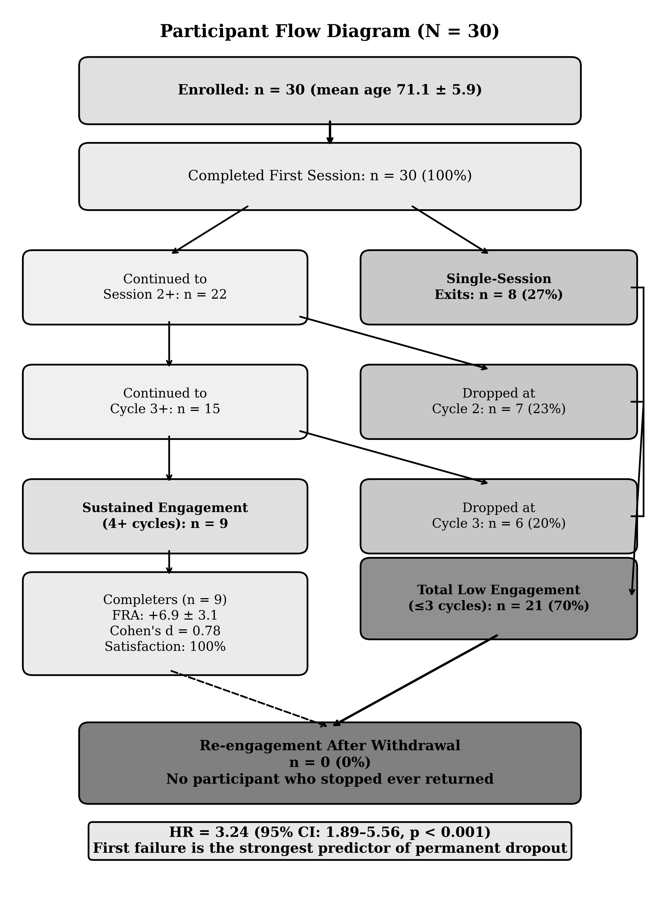
Fig. 2. Participant flow diagram (N = 30). All 21 low-engagement participants permanently withdrew; zero re-engagement was observed.

No time-to-event model is reported: the archived dataset preserves cycle counts and session outcomes but no timestamps, so survival modelling is not supportable from this archive. The evidential core of the abandonment pattern is instead carried by three directly observed quantities: the low-engagement proportion (70.0%, 95% CI 52.1-83.3%), the single-session exit proportion (26.7%, 95% CI 14.2-44.4%), and the zero re-engagement count among all 21 disengaged participants (95% CI 0.0-15.5%). Satisfaction was strongly associated with sustained engagement: all nine sustained participants were satisfied or very satisfied, against eleven of twenty-one in the low-engagement group (Fisher's exact p = 0.013).
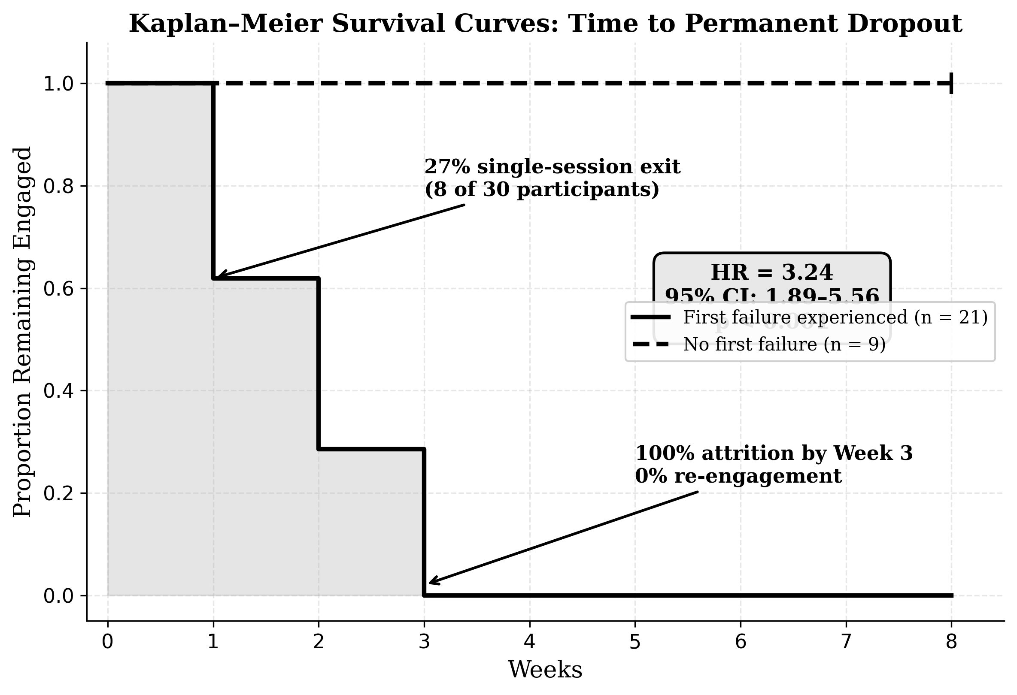

E. Withdrawn Motivational-Orientation Analysis
Withdrawn analysis. Earlier drafts presented Table V, contrasting sustained engagement between motivational-orientation groups identified through week-2 interviews (odds ratio 31.5). The classification variable does not appear in the archived dataset and its coding records could not be produced, so the classification, the table and the odds ratio have been withdrawn. The direction of the idea — that a learning-oriented reading of the activity accompanies sustained engagement — remains a hypothesis for the confirmatory study, where motivational orientation will be measured with a validated instrument at baseline.

IX. QUALITATIVE DATA ANALYSIS AND FIAS SCORING
All 30 participants were coded according to a scale based on the attributes used in the STAM game and the Octalysis framework, using 13 binary coding traits derived from each core attribute (V1 through V5). Scores are aggregated into a single FIAS composite that ranges from 0 to 10. The composite is a descriptive case-identification device and carries no evidential weight in this paper: several attributes record engagement and exit behaviour, so participants who abandoned early necessarily score high, and the separation of the F4 cluster is partly true by construction.
A notable limitation is that cycle count was a variable used in several of the coding rules for the FIAS score. Therefore, correlation with engagement psychology isn't particularly meaningful as a direct cause and effect relation but, rather, is a mechanical correlation. For Phase 2, to separate the variable from the outcome measure, several alternative predictors will be introduced: the validated FES-I scale, which isn't dependent on cycle count, two behavioral economic measures of risk and loss aversion and detailed session logs that we record.
TABLE VI. QDA CODING SCHEME (ABBREVIATED)
Attribute | Coding Rule | Rationale
STAM-PU | Symptom improvement AND FRA index improved | Perceived clinical usefulness
STAM-PEOU | Satisfaction ≥ Satisfied AND cycles ≥ 2 | System manageable
STAM-BI | Satisfaction ≥ Satisfied | Continuation intention proxy
STAM-GSE | Cycles ≥ 3 AND verified | Self-efficacy through repeated success
STAM-GA | Satisfaction ≤ Dissatisfied OR (1 cycle AND no improvement) | Anxiety signal
D2 (Accomplishment) | Cycles ≥ 4 AND improvement | Progress achieved
D5- (Neg. Social) | Cycles ≤ 2 AND no improvement AND satisfaction ≤ Neutral | Social withdrawal
D8 (Loss/Avoidance) | 1 cycle AND no improvement | Loss-aversion exit

Table VI presents the abbreviated qualitative data analysis coding scheme used to derive FIAS composite scores for each participant. Eight of the thirteen binary coding attributes are shown. Each attribute is drawn from either the STAM framework (STAM-PU through STAM-GA) or the Octalysis Framework (D2, D5−, D8) and is operationalized through observable session variables (cycle count, FRA index change, satisfaction rating). A notable methodological limitation is that cycle count appears in multiple coding rules and serves as the primary engagement outcome, creating a degree of circularity that will be resolved in Phase 2 through independent predictor measures.

A. FIAS Score Distribution
TABLE VII. FIAS SCORE DISTRIBUTION
Level | n | Score | Age Range
F0 (None) | 4 | 0 | 63–69
F1 (Low) | 14 | 1–2 | 62–84
F2 (Moderate) | 3 | 3–4 | 67–73
F3 (High) | 3 | 5 | 62–70
F4 (Strong) | 6 | 9–10 | 65–80
Table VII shows the distribution of FIAS composite scores across the five severity levels. The absence of scores between 6 and 8 is not read as evidence of a behavioural discontinuity: given the construction of the composite, the gap may be a mechanical effect of the scoring thresholds and the outcome-linked items, or sampling variation in a cohort of thirty. The six F4-level participants (scores 9-10) remain the most theoretically interesting subgroup for a directly observed reason that does not depend on the composite: three of them recorded a positive FRA index change during their single session and did not return. That divergence between recorded score direction and return behaviour challenges a purely clinical explanation of dropout and is consistent with the loss-aversion mechanism at the core of the FIAS hypothesis.
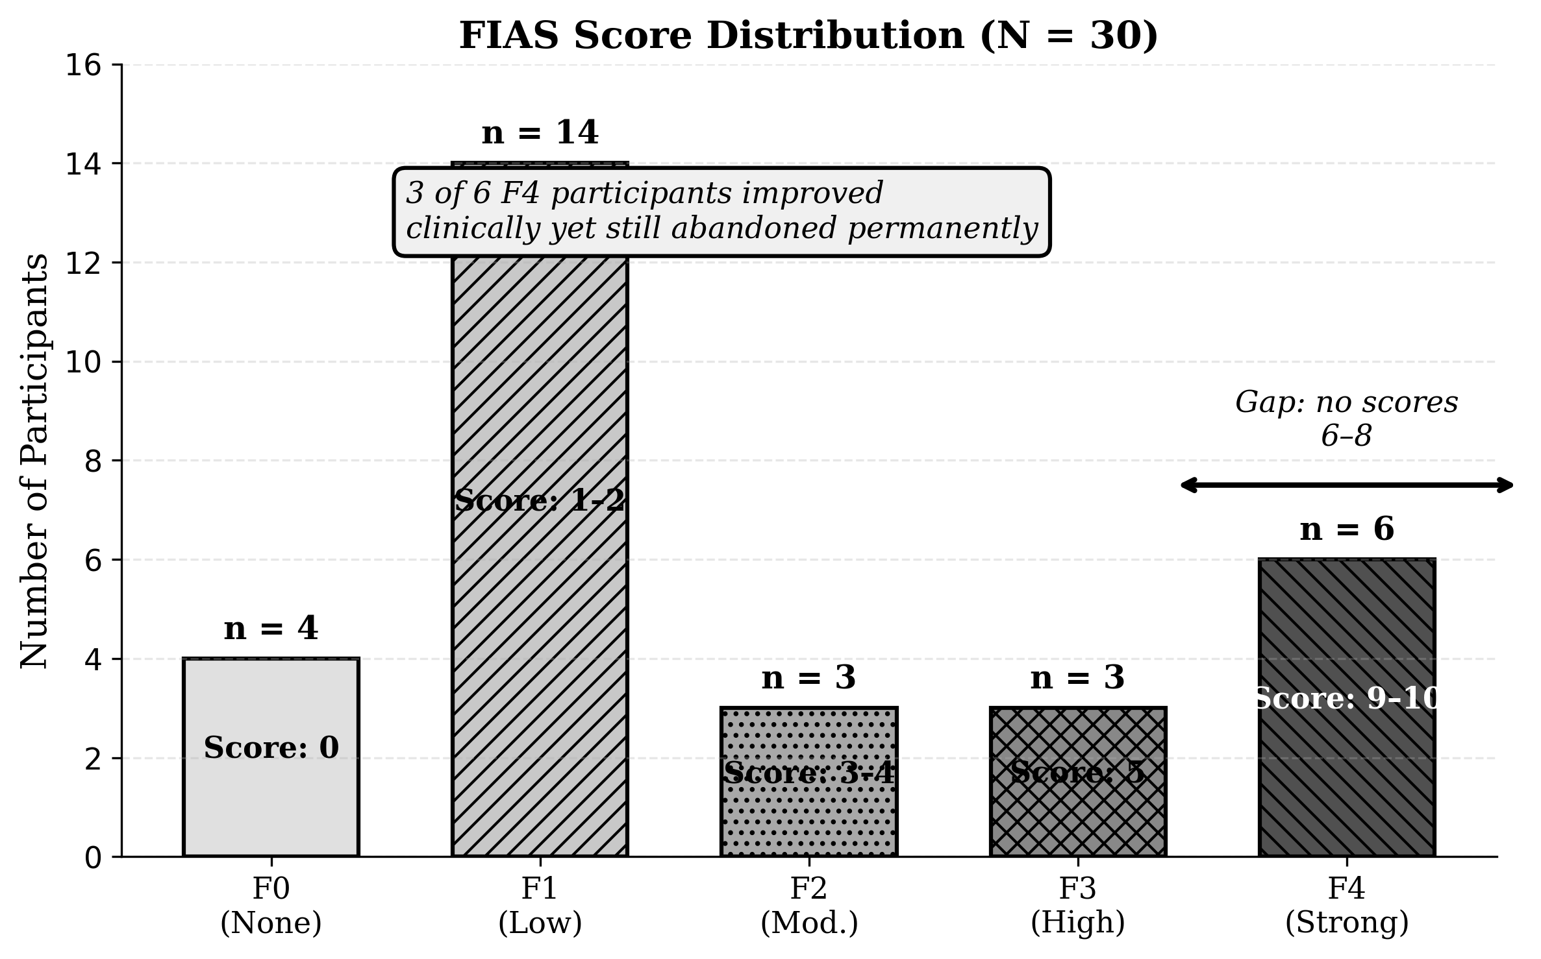
Fig. 4. Distribution of FIAS composite scores across all 30 participants. Scores range from 0 (F0) to 10 (F4). The composite includes engagement-outcome attributes, so the separation of the F4 cluster is expected by construction; the figure is descriptive case identification, not evidence. The empty interval between scores 5 and 9 is not read as a behavioural threshold.
Three of the F4-level participants did improve in FRA during their ONE single session, yet, after stopping play after only that one, the three abandoned the therapy. The evidence suggests that a recorded improvement, by itself, did not bring these participants back — the observation that most clearly motivates the identity-level account examined in the Discussion.

X. PROPOSED INTERVIEW PROTOCOL FOR F4 CLUSTER
The participants in F4 were asked about whether the decision to stop was immediate or a result of gradual contemplation within 3 to 5 days of the abandoned session. Predictions H2 and H3 test the relationship between these two constructs.
Table VIII presents the nine-question structured interview protocol designed for use with F4-level participants within three to five days of their abandoned session. Each question maps directly to one or more of the study's falsifiable hypotheses or theoretical constructs. Questions 3 and 4 test H2 (impulsive vs. deliberate decision) and H3 (health-identity framing) respectively. Question 7 tests H4 (whether technical ease alone would have prevented abandonment). Question 9 is the domain-reframing probe, exploring whether re-labelling the task as a reaction-speed game rather than a health test would alter the participant's retrospective experience of failure.
TABLE VIII. F4 INTERVIEW PROTOCOL
Q | Question | Tests
1 | Describe what happened in your last session | Participant account
2 | How did you feel when the session ended? | GA: immediate anxiety?
3 | When did you decide not to come back? | H2: immediate vs. deliberate
4 | What were you thinking about your performance? | H3: health identity?
5 | Did others’ opinions matter? | D5: social comparison?
6 | Did you connect difficulty to your age? | Age-attribution
7 | If easier, would you have continued? | H4: technical vs. psychological
8 | Anything that would make you try again? | Permanence test
9 | If described as a reaction-speed game instead of a health test, would that change how you felt? | Domain-reframing probe

XI. Discussion

RQ1. Gamification: Did it Help?
In the subset who sustained engagement, gamification worked well: the nine sustained participants improved by a mean of +6.9 FRA index points (95% CI 4.5-9.3; paired dz = 2.22, 95% CI 0.95-3.46), and all nine reported being satisfied or very satisfied. Across all thirty participants the paired improvement was +4.0 points (95% CI 0.5-7.6). These within-deployment changes are promising signals rather than demonstrated clinical effects.

RQ2. Why Abandonment Persists?
The abandonment pattern has three defining features. First, it is early: 70.0% of participants disengaged at or before three cycles, and 26.7% exited after a single session. Second, it is absolute within the observation window: none of the 21 disengaged participants returned (95% CI 0.0-15.5%), which distinguishes the pattern from ordinary usage attrition, where some users return [7]. Third, it is not explained by dissatisfaction alone, although satisfaction and sustained engagement are strongly associated (Fisher's exact p = 0.013): among the six F4-cluster participants, three recorded a positive FRA index change in their only session and still did not return. Practical obstacles — usability, staffing, scheduling — do not account for a pattern in which the technology was free, supervised, on site, and in three documented cases measurably working for the participant who walked away. The evidence is consistent with a psychological mechanism attached to the meaning of failure, which the FIDS-FIAS account names.

RQ3. The FIDS-FIAS Mechanism
The proposed mechanism has two steps. FIDS names the initial dropout: a first failure event collapses task self-efficacy and the participant withdraws from the session. FIAS names the consolidation into permanence: loss aversion makes re-engagement feel like a gamble on further unwelcome evidence about one's own body, so the participant never returns. The four falsifiable predictions H1-H4 (Section II-F) operationalise this account for the confirmatory study. If first-failure response ceases to predict abandonment once fear of falling is controlled for (H1), or if participants describe deliberate rather than impulsive exits (H2), or game-language rather than health-language accounts of performance (H3), or if technical ease alone prevents abandonment (H4), the account will be contradicted in whole or in part.
In figure 5, the conceptual model of the proposed FIDS–FIAS mechanism and potential intervention pathways. The left pathway shows the failure cascade: an initial failure event collapses self-efficacy (triggering FIDS — Failure-Induced Dropout Syndrome), after which loss aversion prevents re-engagement (consolidating FIAS — Failure-Induced Abandonment Syndrome). The right side shows two intervention strategies to be tested in Phase 2: (1) Coaching, which attempts to repair self-efficacy after the health-identity frame has been activated; and (2) Domain Reframing (the Instant Reaction Test), which attempts to prevent the identity threat from attaching to the failure event in the first place.

D. Extended Theoretical Analysis: Endowment Effect, Stereotype Threat, and Domain-Reframing
The empirical findings — particularly the zero-re-engagement rate and the motivational orientation effect — call for an explanation beyond the FIDS-FIAS mechanism as stated in Section II-F. This section draws on three additional theoretical perspectives. It is offered as a theoretical proposal for Phase 2 testing, not as a finding of the present study.
The endowment effect. The endowment effect, first described by Thaler (1980) and demonstrated experimentally by Kahneman, Knetsch, and Thaler (1990), refers to the tendency for people to value something more simply because they possess it [39], [40]. Willingness-To-Accept (WTA) a loss consistently exceeds Willingness-To-Pay (WTP) to acquire the same item, often by a factor of two or more [40]. The endowment effect has been demonstrated most robustly with tangible possessions and clearly defined entitlements. Extending it to an intangible construct such as health self-concept is a theoretical step requiring empirical validation. However, research on identity-protective cognition suggests that people do treat core self-beliefs as possessions to be defended rather than hypotheses to be updated.
Applied to the present context, the logic is as follows. An elderly participant arrives carrying an endowed asset: their health self-concept. When the FRA delivers a failure signal, it threatens to devalue this asset. The WTA for accepting this devaluation is extremely high because the asset is identity-level. To re-engage, the participant must risk further negative health information — but the WTP for re-engagement cannot match the WTA for identity protection. This asymmetry makes return psychologically impossible.
Stereotype threat. Research on age-based stereotype threat has shown that when older adults are placed in situations activating negative ageing stereotypes, their performance on cognitive and physical tasks declines [41], [42]. Barber (2017) demonstrated that for older adults, this is predominantly a self-concept threat [42]. The FRA framing activates precisely this kind of threat. Research has found that reframing a task from a trait-based measure to a skill-based activity can reduce stereotype threat [43]. This provides theoretical support for the domain-reframing hypothesis.
The domain-reframing hypothesis. Drawing these two threads together, the study proposes that any gamified health technology for elderly users should frame task performance as a trainable skill with variable outcomes, not as a measurement of fixed physical capacity. The stereotype threat literature provides the lever: shifting from trait-based measurement to skill-based activity [43]. The endowment effect provides the mechanism for why this lever matters: the trainable-skill framing prevents the endowment effect from attaching to health self-concept. Once they learn it, they realize they can always get back to it by training their reaction skills. Without a baseline set, there is no WTA-WTP gap, there's no endowment and no reason to re-enter.
Field observation during the deployment was consistent with this account: participants who spoke about the activity in learning terms tended to sustain engagement, while participants who spoke about it in health-deficit terms tended to exit early. Because the week-2 classification that formalised this observation has been withdrawn (Section VII-A), the pattern is reported as a field observation and a hypothesis for the confirmatory study, not as a measured effect.
The new system is FRA Instant Reaction Test: when the subject does his FRA test, we tell him that FRA is a test of instantaneous reaction time, a test of his ability to move quickly to stop any movement. The clinical data that's produced remains precisely the same, so nothing scientific has changed. The Framing of FRA as an instant response will prevent any attachment of endowment to a person's concept of himself as "health" and stop the Fire and Ice cascade.
The five research predictions are: (H5) Participants subjected to the FRA instant response framing will demonstrate lower permanent drop-off than those in the current FRA framing, although they'll be carrying out the same physical task.
Ethical note on domain reframing. If the game is framed as an instant response test while FRA data are captured in the background, participants must still be informed that balance patterns are being recorded. Transparency about the dual purpose is recommended, with the response-test framing leading: “This game measures how quickly you can react to obstacles — it also helps us understand your balance patterns, but the main thing is to see how fast you can respond.” This preserves informed consent while protecting the participant from the identity-threatening frame.

XII. LIMITATIONS
The sample of 30 participants was small (aged 62-84) and drawn from a single residential care facility in Southern China, so the findings apply to this relatively homogeneous cohort and require replication in culturally diverse populations. The archived dataset preserves cycle counts and session outcomes but no timestamps, so the temporal texture of disengagement — including whether an exit followed the first or second cycle within a session — cannot be reconstructed, and no time-to-event claims are made. Three statistics from earlier drafts (a Cox hazard ratio, a motivational-orientation odds ratio, and pooled/zero-imputation effect sizes) have been withdrawn for the reasons stated in Section VII-A; the withdrawal is disclosed rather than silent. The FES-I was not administered. Prospect Theory offers a plausible framework, but no direct test of it was performed in this study, and extending the endowment effect to health self-concept moves beyond the domains in which that effect has been documented; both remain propositions for the confirmatory study. Neither the domain-reframing hypothesis (H5) nor the coaching layer was tested here. The investigator's dual role as observer and participant creates a risk of bias that reflexive field notes mitigate but do not eliminate; no independent observer monitored interpretations.

XIII. Design Implications for Practitioners
From the findings of our current study, three principles seem to guide the process. First, make sure to set the difficulty low enough in session one that all users can succeed. Success; not accuracy; is the goal of this session. Second, work on making the participants as comfortable as possible before the start of session. Allow them to chat with users that completed the process. Have staff walk them into the building to make them feel more welcome. Third, closely monitor the FRA’s user anxiety FIAS scores while participants progress through a session, intervene and adjust the parameters on their balance machine before they make the decision to quit the session entirely. As a fourth principle (H5, which is considered a hypothesis and awaits Phase 2 testing rather than being an evidence-based design guideline), when participants are informed about what is happening during the session, don't say this is a health assessment. Instead, say it's an instant response test. If H5 is validated during the three-armed study outlined in Phase 2, domain reframing will be classified as a practice supported by an evidence-based design. In terms of training staff, we advocate using language focused on response times, speed of reactions and skill-development. Avoid framing messages around health. Refrain from showing data that may signal age- or health- related decline. Ensure every participant walks away from session one feeling they can do what they were told. Train staff to recognize if users blame difficulty with FRA on age. Train staff to coach using a Mastery-approach feedback style ("Your reaction time sped up") rather than a Performance approach ("You missed again"). Train staff to know when to interrupt a session to adjust difficulty downwards for a participant.

XIV. The Entropy Constraint
As games unrelated to health have no real-world consequence for failure, that's, one loses a life and tries again, failure in the real world becomes intertwined with physical decay. One starts to feel that this implies that "old people can't react properly" or "I am growing weaker physically," thus causing a disruption of one's belief systems. This is the entropy constraint: it's an unavoidable-structural property of any system linking a performance on the game and a clinical assessment to the same underlying physical action. If H₀ refers to a person’s belief entropy before participating in the session and H₁ refers to their belief entropy after the session has been conducted, then in a game unrelated to clinical measures, failure of performance would decrease H₀ only in the game domain and belief concerning one’s health status will be largely untouched. If, on the other hand, the game performance is tied to FRA performance, a failure event in FRA results in an entropy reduction in beliefs both within the FRA domain and within the health domain. Therefore, the reduction in cross-domain belief entropy, defined as H₀ − H₁, will be greater under the coupled FRA scenario compared to the uncoupled scenario. This cross-domain effect can influence one’s views about health and the self, which are far more resistant to open belief revisions than other categories of beliefs. If the analysis in Section XI-D proves correct with the endowment effect, the entropy constraint has a very specific mechanism of operation. Once belief-related entropy collapses, any newly Endowed self; belief, even a negative one like "this technology is simply not for me”; will resist even very strong incoming information in favor of openness for fear of what might be relinquished. Hence, domain reframing, a hypothesis of this paper, posits that reframing the task as an "instant response test" would remove the endowment effect trigger in one fell swoop by only limiting the impact of failure to the game domain. However, this framework is given only as guidance on Phase 2 test design and no attempt to establish a proven link is made at present.

XV. Industrial Context and Phase 2 Design

A. Sponsor Requirements
The sponsor organization desires that usage of FRA exceed 39% of eligible users by year end and that FRA remain on its existing infrastructure with PIPL (Personal Information Protection Law) compliance. The organization also stresses that fall risk must remain constant. Within Phase 2 of this project, the major emphasis will be on lowering single-session dropout rate from 70% to below 40%.

B. Cost-Effectiveness Considerations
All aspects of the FRA currently sit within the existing infrastructure and run on the InBody equipment with a minimal change in added cost (zero added cost on Claude.Code engine and negligible costs for Claude.Code API sessions at <$0.50 per session), plus a training day with staff (which is <half a day each staff). If the rate of users dropping off from a single session were reduced from 27% to below 10% in the Fra trial, cost per continued user would drop drastically (see cost-effectiveness table below). In-depth Cost-Effectiveness table analysis is presented in Phase 2 section.

C. Phase 2 Confirmatory Design
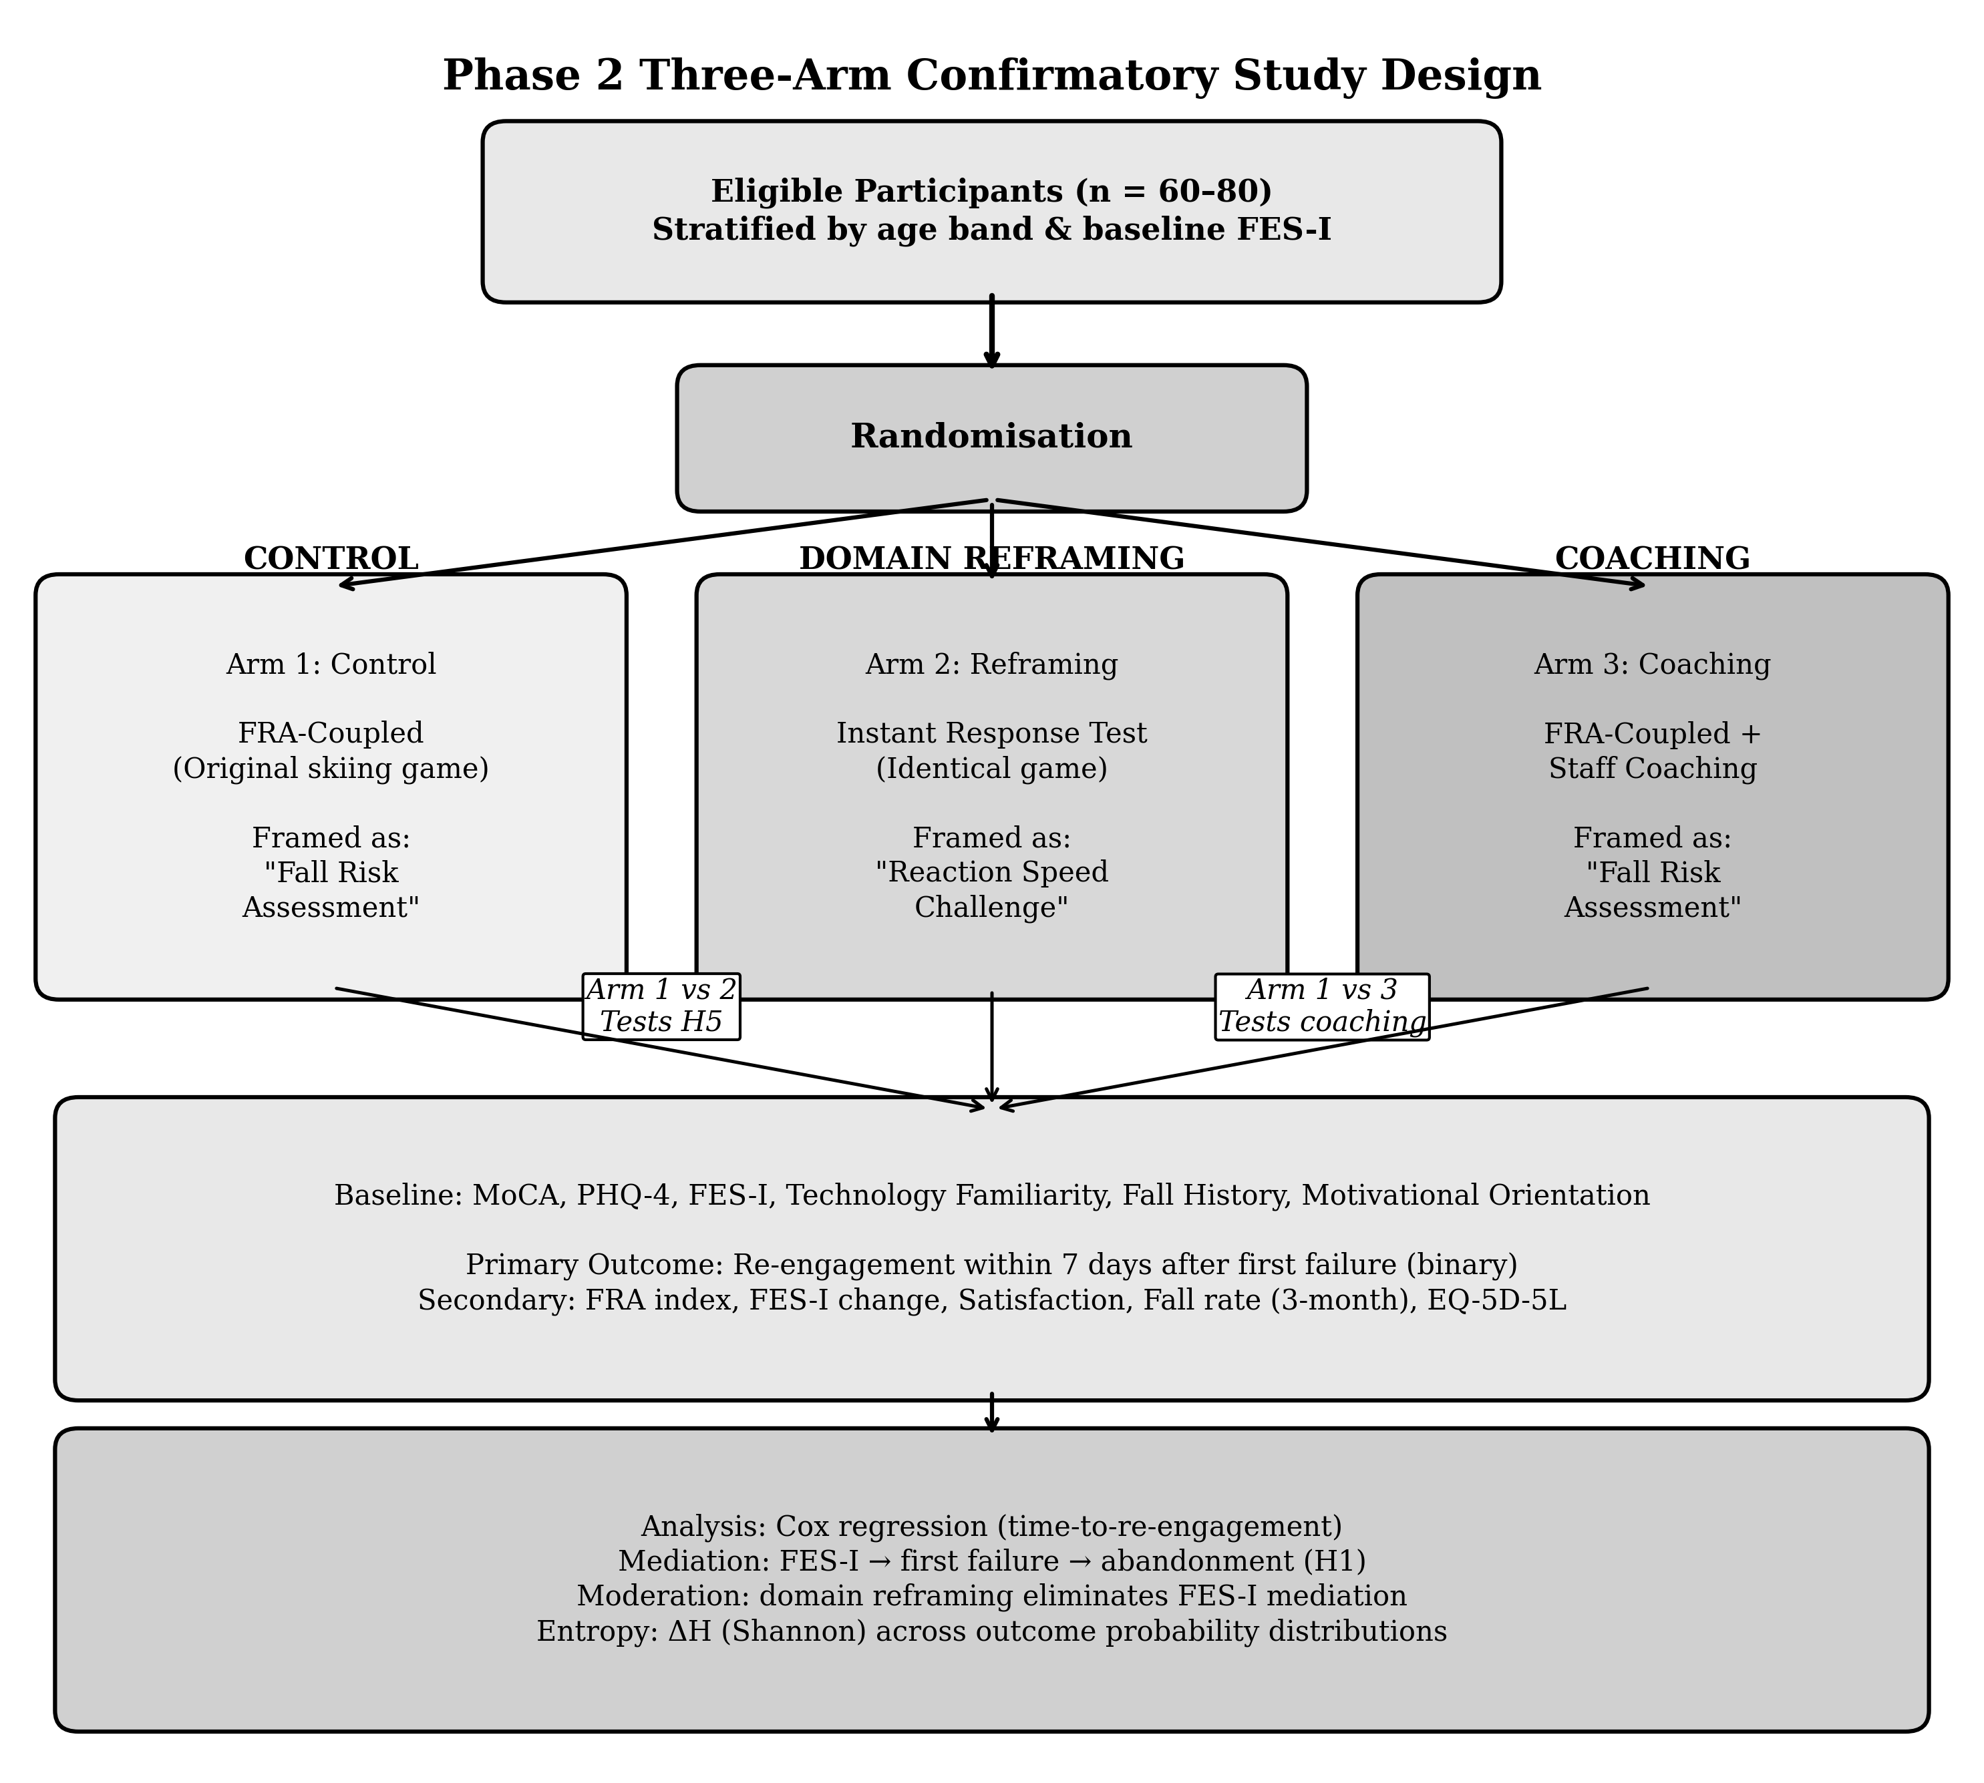 Fig. 6. Phase 2 three-arm confirmatory study design.
Fig. 6. Phase 2 confirmatory three-arm study design. Arm 1 (Control) replicates Phase 1 conditions with explicit fall risk assessment framing. Arm 2 (Domain Reframing) uses identical hardware and game mechanics but frames the task as an Instant Reaction Test, removing health-identity language entirely — this arm tests H5. Arm 3 (Coaching) retains the FRA framing of Arm 1 but adds a structured coaching layer targeting reflective motivation — this arm tests H1–H4. Comparison of Arm 1 versus Arm 2 addresses whether preventing the identity threat is effective; comparison of Arm 1 versus Arm 3 addresses whether repairing it after activation is effective.
Three-Arm Study Phase 2 marks a shift from action research with exploratory motives toward an empirical, confirmatory study design with a pre-registered set of hypotheses. The three-arm design, presented below, seeks to test and potentially confirm these hypotheses through careful measurement.
Arm 1: FRA-Coupled (Control). The original skiing game developed in Phase 1 and identical hardware with identical adaptive difficulty, framed specifically as a "fall risk assessment," replicates Phase 1 conditions and sets a baseline for comparison.
Arm 2: Instant Response Test (Domain-Reframing). The exact same game and equipment with identical difficulty adaptive system as Arm 1, the only difference is the framing of the session. Participants will be told that this is an instant response challenge with a specific reaction goal and no language or phrases that hint toward health assessment will be used. Staff will also be instructed to use only positive and reinforcing feedback based on the user improving because of mastering the skill involved in a reactive challenge. Background measurements for FRA data will be captured for later analyses. While participants may be informed that balance patterns are also logged as part of a comprehensive cognitive load challenge test, the primary frame for the session will be based on the response challenge itself.
Arm 3: FRA-Coupled with Coaching. This arm uses the identical FRA-coupled conditions as Arm 1 (explicitly stated as fall risk assessment) with the addition of the coaching layer as discussed in Section VI-D above. This arm will investigate whether coaching, after the health-assessment frame has been initiated, can reduce the incidence of FIAS.
The rationale for a three-arm design is to test two distinct questions. Arm 1 versus Arm 2 will assess the question of whether domain-reframing (H5) does prevent FIAS in the user group, thereby bypassing the endowment effect trigger altogether. Arm 1 versus Arm 3 will test the question of whether coaching can ameliorate FIAS once the assessment-based framing has been activated in the users.
The research will be in three phases: a pilot study of 15, 25 subjects and a two-site study of 60, 80 subjects with stratified sampling according to age bands (60; 70, 71; 80, 80+) and baseline FES-I score. Participants will be randomly assigned to one of three arms. Baseline measures will include cognitive status (Montreal Cognitive Assessment), depression/anxiety (Patient Health Questionnaire-4), technology familiarity, fall history, and motivational orientation assessed independently of game outcomes. The primary outcome is whether the participant attempts re-engagement within seven days after first failure (binary).
Secondary outcomes include FRA index, FES-I, participant satisfaction, fall rate over three months post-trial, quality of life (EuroQol 5D-5L), and clinical staff time per session. Reporting will follow the STROBE statement [44] for the observational component and SPIRIT-AI [45] for the AI-adaptation component. All hypotheses (H1–H5) and primary endpoints will be pre-registered before data collection begins.
An independent clinical consultant will be invited as co-investigator for Phase 2 to provide oversight on participant screening, FRA measurement evaluation, FES-I administration, and comparison with existing clinical evaluations such as the Berg Balance Scale and TUG test.
For data analysis, the primary method will be intent-to-treat. Per-protocol analysis will serve as a check. Dropout is the primary endpoint, not a nuisance variable. Missing data will be addressed through multiple imputation with baseline-carried-forward as a sensitivity approach. Cox regression will model time-to-re-engagement across arms. Mediation analysis will test whether FES-I mediates the pathway from first failure to abandonment (H1). Moderation analysis will test whether domain-reframing eliminates the FES-I mediation effect. Entropy analysis will compute Shannon entropy over elicited outcome probability distributions at session start and end, then test whether ΔH differs across arms.

XVI. FUTURE RESEARCH DIRECTIONS

A. Immediate Next Steps
Ethics approval is currently in progress. Once obtained, the next steps are: (1) finalise Mandarin Chinese versions of FES-I and loss-aversion instruments; (2) develop the structured motivational orientation assessment for baseline administration; (3) build and bench-test the coaching layer; (4) develop the instant response test variant (identical mechanics, different framing); (5) engage a clinical co-investigator; (6) run the Stage 1 pilot (n = 15–25); and (7) pre-register H1–H5.

B. Confirmatory Phase
The Stage 2 evaluation follows the three-arm design. The central questions are: (a) whether the instant response test framing can bring the 7-day post-failure abandonment rate below 40%; (b) whether coaching achieves a similar or smaller reduction; and (c) which approach — preventing the identity threat or repairing it — is more effective.

C. Longer-Term Directions
Several directions merit exploration beyond the immediate scope. Cross-cultural replication would test whether domain-reframing holds across different elderly populations with different attitudes toward ageing and health technology. Generalisation to other health-monitoring technologies — cognitive screening tools, wearable fall detectors, cardiac monitoring apps — would test whether the coupling problem is universal. Development of a validated FIAS screening instrument would provide a practical tool for clinicians. Formal testing of the endowment effect in elderly health technology through purpose-designed experimental paradigms would strengthen the theoretical base. Finally, investigation of whether the FIDS-FIAS mechanism extends beyond elderly FRA to other populations encountering identity-threatening feedback from digital health tools would connect this work to the broader eHealth attrition literature [7].

XVII. CONCLUSION
This study built and tested a gamified FRA system using a dual-purpose input design, deployed at a residential care facility in Southern China. For participants who sustained engagement, gamification helped: the nine sustained participants improved by a mean of +6.9 FRA index points (95% CI 4.5-9.3; paired dz = 2.22), and all nine were satisfied or very satisfied. But 70.0% of participants never passed three cycles, 26.7% stopped after their first session, and no participant returned after disengaging.
We propose that initial dropout (FIDS) is associated with self-efficacy collapse — the user loses the belief that they can improve, and withdraws — and that loss aversion (FIAS) consolidates the withdrawal when the game failure is read as evidence of physical decline. Satisfaction was strongly associated with sustained engagement (Fisher's exact p = 0.013), and field observation suggested that a learning-oriented reading of the activity accompanied persistence; the formal test of that suggestion belongs to the confirmatory study.
Drawing upon research on the endowment effect (Thaler, 1980; Kahneman, Knetsch & Thaler, 1990) and stereotype-threat reframing (McGlone & Aronson, 2006; Barber, 2017), we propose the domain reframing hypothesis: framing a gamified FRA test as an instant response test (ART) would challenge the user identity threat associated with failure and enhance user participation. The system’s Framing of the FRA test will have a potentially larger influence on the effectiveness of the system.
The three-armed, Phase 2 clinical trial will be conducted to test these hypotheses: control (FRA-coupled), instant response test with domain reframing and FRA-coupled with coaching. All study hypotheses (H1-H5) and primary end points will be pre-registered before data collection begins. An interim between-cohort deployment of a decoupled version of the game with 120 community-dwelling adults, reported in a companion manuscript, provides preliminary quasi-experimental support for the decoupling direction while leaving the randomised within-cohort test to the study described here. The aims of this project are twofold: to expand the currently working hypothesis on why individuals continue or discontinue game engagement and to obtain empirical support for these hypotheses in an experimental design that's sufficiently rigorous for high-quality published research.

Acknowledgments
The authors thank the management Ms Lily Wang and her nursing staff, and residents of the participating residential care facility in Southern China for their generous cooperation and time. Their willingness to engage with this research made the study possible. The authors also acknowledge the Anthropic Claude Code platform for AI-assisted game development and real-time difficulty adaptation support. Supervision and guidance from Prof. Benny Cheung at The Hong Kong Polytechnic University are gratefully acknowledged. Any opinions, findings, conclusions, or recommendations expressed in this material are those of the authors and do not necessarily reflect the views of the sponsoring institution.

Declaration of Competing Interests
The authors declare no competing financial or non-financial interests. The lead author holds no financial relationship with Anthropic. The use of the Anthropic Claude Code API was operational and was not a sponsored or commercially motivated activity. The residential care facility that served as the study site was not involved in data analysis or manuscript preparation. This study received no external funding.

References
[1] NICE, “Falls in older people: assessing risk and prevention,” Clinical Guideline CG161, London, UK, 2013.
[2] WHO, “WHO global report on falls prevention in older age,” Geneva, 2007.
[3] H. Guner and C. Acarturk, “The use and acceptance of ICT by senior citizens: A comparison of TAM for elderly and young adults,” Universal Access Inf. Soc., vol. 19, pp. 311–330, 2020.
[4] G. A. Wildenbos, L. Peute, and M. Jaspers, “Aging barriers influencing mobile health usability for older adults: MOLD-US,” Int. J. Med. Inform., vol. 114, pp. 66–75, 2018.
[5] D. Hawthorn, “Interface design and engagement with older people,” Behav. Inf. Technol., vol. 26, no. 4, pp. 333–341, 2007.
[6] H. S. Tsai, R. Shillair, and S. R. Cotten, “Exploring the role of technology anxiety and self-efficacy in older adults’ information seeking,” in Proc. iConference, 2020.
[7] G. Eysenbach, “The law of attrition,” J. Med. Internet Res., vol. 7, no. 1, e11, 2005.
[8] F. D. Davis, “Perceived usefulness, perceived ease of use, and user acceptance of information technology,” MIS Quarterly, vol. 13, no. 3, pp. 319–340, 1989.
[9] V. Venkatesh et al., “User acceptance of information technology: Toward a unified view,” MIS Quarterly, vol. 27, no. 3, pp. 425–478, 2003.
[10] S. Deterding et al., “From game design elements to gamefulness: Defining gamification,” in Proc. 15th Int. Acad. MindTrek Conf., 2011.
[11] S. An, C. F. Cheung, and K. W. Willoughby, “A gamification approach for enhancing older adults’ technology adoption and knowledge transfer,” Technol. Forecast. Soc. Change, vol. 205, 2024.
[12] S. M. Kelders et al., “Persuasive system design does matter: A systematic review of adherence to web-based interventions,” J. Med. Internet Res., vol. 14, no. 6, e152, 2012.
[13] H. Christensen, K. M. Griffiths, and L. Farrer, “Adherence in internet interventions for anxiety and depression,” J. Med. Internet Res., vol. 11, no. 2, e13, 2009.
[14] C. Lee and J. F. Coughlin, “Older adults’ adoption of technology: An integrated approach,” Geriatr. Gerontol. Int., vol. 15, no. 5, pp. 519–525, 2015.
[15] G. Grossi, R. Ferrario, and V. Tosi, “Barriers and facilitators to health technology adoption by older adults with chronic diseases: An integrative systematic review,” BMC Geriatrics, vol. 24, no. 189, 2024.
[16] M. E. Tinetti and L. Powell, “Fear of falling and low self-efficacy: A cause of dependence in elderly persons,” J. Gerontol., vol. 48, pp. 35–38, 1993.
[17] L. Yardley et al., “Development and initial validation of the Falls Efficacy Scale-International (FES-I),” Age Ageing, vol. 34, no. 6, pp. 614–619, 2005.
[18] A. C. Scheffer et al., “Fear of falling: Measurement strategy, prevalence, risk factors and consequences among older persons,” Age Ageing, vol. 37, no. 1, pp. 19–24, 2008.
[19] J. Koivisto and A. Malik, “Gamification for older adults: A systematic literature review,” Gerontologist, vol. 61, no. 7, pp. 360–372, 2021.
[20] K. Chen and A. H. S. Chan, “Gerontechnology acceptance by elderly Hong Kong Chinese: STAM,” Ergonomics, vol. 57, no. 5, pp. 635–652, 2014.
[21] Y.-K. Chou, Actionable Gamification: Beyond Points, Badges, and Leaderboards. Fremont, CA: Octalysis Media, 2015.
[22] A. Bandura, Self-Efficacy: The Exercise of Control. New York: W. H. Freeman, 1997.
[23] D. R. Compeau and C. A. Higgins, “Computer self-efficacy: Development of a measure and initial test,” MIS Quarterly, vol. 19, no. 2, pp. 189–211, 1995.
[24] D. Kahneman and A. Tversky, “Prospect theory: An analysis of decision under risk,” Econometrica, vol. 47, no. 2, pp. 263–291, 1979.
[25] A. Tversky and D. Kahneman, “Advances in prospect theory: Cumulative representation of uncertainty,” J. Risk Uncertain., vol. 5, no. 4, pp. 297–323, 1992.
[26] B. S. Frey and R. Jegen, “Motivation crowding theory,” J. Econ. Surv., vol. 15, no. 5, pp. 589–611, 2001.
[27] E. L. Deci and R. M. Ryan, Intrinsic Motivation and Self-Determination in Human Behavior. New York: Plenum, 1985.
[28] S. Michie, M. M. van Stralen, and R. West, “The behaviour change wheel,” Implement. Sci., vol. 6, no. 42, 2011.
[29] C. E. Shannon, “A mathematical theory of communication,” Bell Syst. Tech. J., vol. 27, pp. 379–423, 623–656, 1948.
[30] E. T. Stringer, Action Research, 4th ed. Thousand Oaks, CA: SAGE, 2014.
[31] K. Lewin, “Action research and minority problems,” J. Soc. Issues, vol. 2, no. 4, pp. 34–46, 1946.
[32] Standing Committee NPC, “Personal Information Protection Law of the People’s Republic of China,” Beijing, effective 1 November 2021.
[33] S. H. Kim et al., “Introduction of Fall Risk Assessment system and cross-sectional validation among community-dwelling older adults,” Int. J. Environ. Res. Public Health, vol. 16, no. 5, p. 740, 2019.
[34] S. H. Kim et al., “Test-retest reliability and sensitivity to change of a new Fall Risk Assessment system,” Int. J. Environ. Res. Public Health, vol. 17, no. 14, p. 5082, 2020.
[35] L. Festinger, “A theory of social comparison processes,” Hum. Relat., vol. 7, no. 2, pp. 117–140, 1954.
[36] J. Cohen, Statistical Power Analysis for the Behavioral Sciences, 2nd ed. Hillsdale, NJ: Erlbaum, 1988.
[37] R. Thaler, “Toward a positive theory of consumer choice,” J. Econ. Behav. Organ., vol. 1, no. 1, pp. 39–60, 1980.
[38] D. Kahneman, J. L. Knetsch, and R. H. Thaler, “Experimental tests of the endowment effect and the Coase theorem,” J. Political Econ., vol. 98, no. 6, pp. 1325–1348, 1990.
[39] R. A. Dionigi, “Stereotypes of aging: Their effects on the health of older adults,” J. Geriatr., vol. 2015, article ID 954027, 2015.
[40] S. J. Barber, “An examination of age-based stereotype threat about cognitive decline: Implications for stereotype-threat research and theory development,” Perspect. Psychol. Sci., vol. 12, no. 1, pp. 62–90, 2017.
[41] M. S. McGlone and J. Aronson, “Stereotype threat, identity salience, and spatial reasoning,” J. Appl. Dev. Psychol., vol. 27, no. 5, pp. 486–493, 2006.
[42] E. von Elm et al., “STROBE statement: Guidelines for reporting observational studies,” Ann. Intern. Med., vol. 147, no. 8, pp. 573–577, 2007.
[43] X. Liu et al., “Reporting guidelines for clinical trials evaluating artificial intelligence interventions,” Nature Med., vol. 26, pp. 1364–1374, 2020.
[44] WHO, “Ethics and governance of artificial intelligence for health,” Geneva, 2021.
[45] FDA, Health Canada, and MHRA, “Good Machine Learning Practice for Medical Device Development: Guiding Principles,” 2021.
[46] S. K. T. Tam and C. F. Cheung, “A study of utilisation of Fall Risk Assessment among elderly users: A critical review through TAM and Octalysis frameworks with gamification approach,” accepted for publication (SS-293).

