Gamification as a Proactive Approach: A Study of Elderly Failure-Induced Abandonment in Gamified Fall Risk Assessment
Sidney K. T. Tam and Chi Fai Cheung
Behaviour and Knowledge Engineering Research Centre, Department of Industrial and Systems Engineering,
The Hong Kong Polytechnic University, Hong Kong, China
Corresponding author: sidney.tam@connect.polyu.hk

Abstract
Fall Risk Assessment (FRA) systems can assess balance and support fall prevention as clinical devices, but rarely achieve sustained elderly user engagement. This study examines the factors associated with low engagement and rapid, permanent dropout in a gamified, AI-assisted FRA among elderly residents after their first adverse user experience. An action-research approach was employed at a residential care facility in Southern China. An AI-assisted skiing game was developed on the FRA system's weight-shifting foot pressure panel, allowing elderly individuals to undergo balance measurement while steering a skier on a display. Thirty residents (aged 62-84; mean 71.1 ± 5.9) participated over eight weeks. Seventy per cent (21 of 30; 95% CI 52.1-83.3%) disengaged at or before three game cycles, 26.7% (8 of 30; 95% CI 14.2-44.4%) exited after a single session, and no disengaged participant re-engaged within the study window (0 of 21; 95% CI 0.0-15.5%). Among the nine sustained participants the recorded FRA index improved by +6.9 points (95% CI 4.5-9.3; paired dz = 2.22, 95% CI 0.95-3.46); across all thirty, the paired change was +4.0 points (95% CI 0.5-7.6; dz = 0.42, 95% CI 0.05-0.79). Satisfaction was strongly associated with sustained engagement (9/9 versus 11/21; Fisher's exact p = 0.013). Most strikingly, three participants whose recorded index improved during their only session still never returned. The study did not seek engineering excellence in game design; its findings concern the behavioural context beneath the play. We carry two working hypotheses of failure response: Failure-Induced Dropout (FIDS), associated with self-efficacy collapse at first failure, and Failure-Induced Abandonment (FIAS), associated with loss aversion when negative feedback is read as evidence of declining function. Four falsifiable predictions (H1-H4) and a domain-reframing hypothesis (H5) are specified for a pre-registered three-arm confirmatory study.
Keywords: fall risk assessment, gamification, elderly technology adoption, failure-induced abandonment, loss aversion, eHealth attrition, action research.

I. Introduction
Falls are the leading cause of injury-related hospitalisation in adults aged 65 or older [1], [2]. FRA systems assess balance and postural control and recommend prevention strategies, yet elderly users struggle with ongoing participation in these technologies. A survey of 200 residents at the study site (of a resident population of 280) found that only 39% had ever used the installed FRA equipment; among those users, approximately 74% failed on their first attempt and 82% did not return [46]. The facility had invested in a clinically validated system that the great majority of its residents were not using.
When older adults encounter a barrier during first use of a new technology, they respond differently from younger adults: they tend to give up rather than persist [3], [4], partly through low self-efficacy and a growing perception of age-related limitation [5], [6]. Eysenbach argued that abandonment is the most common outcome of digital health interventions and called for a 'science of attrition' [7]. The adoption frameworks in wide use — TAM and its extensions — concern what makes people start using a system and have little to say about what happens after a user fails [8], [9].
Gamification has been proposed as one route to better engagement among older adults [10]. An, Cheung and Willoughby reported that a gamified learning system lifted perceived usefulness, ease of use and behavioural intention among older participants within a single session [11], while noting that their design could not show whether people return after experiencing failure, and calling for work on post-adoption obstacles. That call motivated the present study.

A. Industrial Problem
The study was conducted in partnership with a large residential care provider in Southern China, at a facility of several hundred beds that acquired an InBody FRA system and found it largely unused. Two circumstances make the setting a strong test: staffing is sufficient for one-on-one instruction, and use is free with experienced assistance, so the standard practical barriers — cost, access, support — are largely absent. The research therefore focused not on engineering excellence in the FRA or novel game mechanisms, but on the behavioural context of a health-technology user following a failure incident with the technology.

B. Research Questions
RQ1: Does gamified exercise enhance both clinical outcomes measured via FRA and user acceptance among frail elderly residents in residential care? RQ2: What explains rapid and permanent attrition despite a gamified deployment with high user acceptance and potential health benefit? RQ3: What psychological mechanisms lead to continued abandonment of FRA after the first adverse experience, and what principles of game design might counteract them? The objectives are correspondingly: to design and pilot-test an exercise gamified to double as a clinical FRA measurement (RQ1); to characterise the failure-response pattern (RQ2); and to propose a model of failure abandonment with falsifiable predictions for confirmatory testing (RQ3).

II. Literature Review

A. Elderly Technology Adoption
Guner and Acarturk found that TAM remains useful in predicting which technologies older adults choose to use [3]. Wildenbos et al. organised ageing barriers into cognitive, physical, perceptual and motivational types, with motivational aspects the least addressed [4]. Hawthorn observed that many elderly people read their age as evidence against their ability to learn new technologies [5], and Tsai et al. found technology anxiety peaking at first use [6]. Lee and Coughlin noted that older adults respond better to training structured around explicit goals [14], and reviews report that reluctance toward health technologies is often driven by perceived threats to autonomy and independence [15].

B. Positioning Against the Science of Attrition
Eysenbach's 'law of attrition' distinguished usage attrition from research dropout [7]; the users in this study fall into the former group. Kelders et al. found persuasive features and human involvement the strongest indicators of long-term adherence [12]; Christensen et al. noted that the psychological mechanisms beneath adherence remain poorly understood [13]. None of this literature explains why, specifically among frail older adults using FRA systems, abandonment after first failure is rapid, persistent and immune to redesign. FIAS is intended to fill this gap.

C. Fear of Falling
Fear of falling denotes persistent fear that results in activity avoidance even when the person is physically capable [16], [18]. Yardley et al. developed the Falls Efficacy Scale-International (FES-I), capturing falls-related self-efficacy across sixteen everyday activities [17]. A participant who enters an FRA session already carrying high fear may interpret any difficulty as proof of decline rather than as a momentary game challenge. The confirmatory study will administer the FES-I at baseline to test whether fear of falling mediates the link between first failure and permanent abandonment (H1).

D. Gamification and Elderly Health Technology
Gamification applies game-design elements in non-game contexts [10]; work with older adults has concentrated on physical activity and cognitive training [11], [19]. An et al. is the closest precedent: improvements in perceived usefulness, ease of use and behavioural intention among 115 participants aged 50-75, with gamification effectiveness the strongest predictor of ease of use [11]. Their design covered a single session and could not capture what happens when a person fails; the present eight-week longitudinal study responds directly to that limitation.

E. Theoretical Frameworks
TAM predicts adoption from perceived usefulness and ease of use [8]; UTAUT adds social influence and facilitating conditions [9]; STAM extends these for older users with gerontechnology self-efficacy and anxiety [20]; and the Octalysis framework describes eight core drives of engagement with game designs [21]. None of these frameworks addresses the response to failure: all treat engagement as continuous or increasing under appropriate design.

F. Self-Efficacy, Prospect Theory, and the FIDS-FIAS Transition
Bandura's work indicates that self-efficacy determines effort and persistence in the face of adversity [22], and computer self-efficacy shapes system use [23]. A frail older adult who fails an FRA task may experience a collapse of technology self-efficacy leading to disengagement — the mechanism denoted FIDS. Prospect Theory explains why re-engagement may not follow [24], [25]: people evaluate outcomes relative to a reference point, and losses loom roughly twice as large as commensurate gains. For an elderly person, the reference point is their sense of their own physical capability; failure delivers unwelcome news about it, and returning risks more. The psychological cost outweighs the perceived health benefit of replaying. This, the study hypothesises, constitutes the transition from FIDS to FIAS: users do not quit because they doubt they could improve — they quit because playing again might force them to face evidence that their body is failing. Four falsifiable predictions follow, to be tested in the confirmatory study: (H1) participants scoring higher on the FES-I will abandon more rapidly after first failure; (H2) participants will report the decision to quit as impulsive rather than deliberate; (H3) participants will describe their performance in health-related rather than game-related terms; (H4) technical ease of use alone will not prevent abandonment while the health-identity framing remains prominent.

G. Motivation Crowding and the FRA-Game Coupling
Frey and Jegen's motivation-crowding effect names the erosion of intrinsic motivation by external evaluation [26]; Deci and Ryan's basic needs — autonomy, competence, relatedness — ground intrinsic motivation [27]. When a game is linked directly to health evaluation, play becomes assessment. For older adults already carrying low self-efficacy and high health anxiety, the coupling not only lowers interest but can produce an identity-driven negative reaction.

H. Behaviour-Change Lens: COM-B
In COM-B terms [28], the adaptive difficulty engine manages capability and on-site deployment provides opportunity; the FIAS pattern lives in motivation — specifically reflective motivation, comprising beliefs about consequences and future identity. Enablement and persuasion are the relevant intervention functions, and the coaching layer proposed for the confirmatory study employs both: mastery-oriented framing for reflective motivation, and care staff for social opportunity.

I. Information Entropy as a Conceptual Lens
Shannon entropy, H(p) = −Σ pᵢ log₂ pᵢ [29], is used here as a conceptual lens, not a quantitative model. At the start of a session an elderly participant typically holds an open belief state about what the outcome might mean (high entropy). A failure can collapse that state toward a single conviction — 'this technology is not for me' (low entropy) — after which positive feedback must travel through a channel already dominated by negative information, including negative accounts circulating among residents. No entropy quantities are computed in this study; the confirmatory study will elicit outcome probability distributions before and after sessions so that entropy over those distributions can serve as a measure of belief openness.

J. Research Gap
No existing framework covers the full arc from initial adoption through failure to permanent abandonment among older users of health technology. TAM explains initial adoption; Octalysis explains within-session engagement; self-efficacy theory explains initial dropout; Prospect Theory explains non-return; the attrition literature describes abandonment without a mechanism for this population; the fear-of-falling literature supplies instruments not yet applied to gamified FRA; and COM-B maps design choices without the underlying theory. This study addresses that gap.

III. Original Contribution Statement
This paper makes three original contributions. First, it documents empirical evidence of a pattern in which older users permanently abandon a gamified FRA after first failure: 70.0% low engagement (95% CI 52.1-83.3%), 26.7% single-session exit (95% CI 14.2-44.4%), and zero re-engagement among all 21 disengaged participants (95% CI 0.0-15.5%) over eight weeks — including three participants whose recorded balance index improved in their only session. Second, it offers a mechanistic account linking self-efficacy collapse at first failure with subsequent permanent abandonment driven by loss aversion, with four falsifiable predictions (H1-H4). Third, it presents a framework for failure-aware coaching in health-assessment gamification, including an entropy-constraint concept, observable risk signals and an intervention specification congruent with COM-B. The Discussion develops an extended argument from the endowment-effect and stereotype-threat literatures, generating the domain-reframing hypothesis (H5). The extended claims go beyond the present evidence and are offered as directions for the pre-registered three-arm confirmatory study, not as findings.

IV. Research Design, Ethics and Participants

A. Action-Research Methodology
An action-research methodology was followed throughout [30], [31], chosen on the view that the environment cannot be understood or changed without sustained immersion. The observer-participant's presence in the care facility provides intimate familiarity with older adults' reality, alongside an attendant risk of observer bias; reflective field notes were kept to monitor evolving observations and limit personal bias, and the residual risk is stated in the limitations.

B. Ethics, Consent and Safeguarding
Ethical approval was obtained from the relevant institutional ethics sub-committee, and the study was conducted in accordance with the Declaration of Helsinki. Participants received written information sheets in Mandarin and Cantonese covering the research objective, session routine, data protection and the unconditional right to refuse or withdraw. For participants unable to read, a non-involved caregiver relayed the information verbally; verbal consent was recorded and signed for by the caregiver witness. Trained personnel remained present throughout sessions, with non-slip flooring and grab rails in reach. Eligibility required being fall-free for the preceding two weeks and having no medical condition deemed inappropriate by care staff; cognitive impairment affecting comprehension was grounds for exclusion. Any fall, near-fall or dizziness would trigger immediate stoppage, referral and adverse-event recording; no adverse events occurred.

C. Data Governance and Protection
Data collected comprised FRA assessment scores, play-session logs, satisfaction ratings and demographics. All data were pseudonymised at collection, with the code key stored separately and encrypted. Compliance with the Personal Information Protection Law (PIPL) [32] was maintained throughout. The AI difficulty-adaptation service received only non-identifying aggregate game parameters (obstacle density, speed, timing); no participant identities, demographics, FRA scores or other health information were transmitted to external servers, and all API requests were logged. Throughout the paper, the AI tooling is an enabling technology; the contribution is the behavioural analysis and design framework.

D. Study Site and Participants
Thirty elderly residents of the facility participated without remuneration: ages 62-84 (mean 71.1, SD 5.9), 13 men and 17 women, all with fall-risk markers identified at initial assessment. Over eight weeks, each resident was exposed to both the standard FRA and the gamified FRA. This was a within-participant observational study of dropout patterns, not a randomised controlled trial.

V. Definitions and Operationalisation
Table I defines the core terms with their operational criteria as recorded in the study dataset. FIDS and FIAS are operationalised as working hypotheses only. Because the archived dataset records cycle counts and session outcomes rather than timestamps, all codings are session-based: FIDS is coded as initial dropout at, or immediately following, the session containing the first failure event; FIAS additionally requires zero re-engagement through the study end. The descriptive composite of Section IX is not part of the evidential definition. The term 'syndrome' is deliberately avoided pending confirmatory evidence.
Table I. Key definitions and operationalisation.
Term | Definition | Operationalisation
Failure event | A session in which the participant does not clear the minimum obstacle threshold from the competency baseline | Binary: below baseline = 1
Low engagement | Three or fewer session cycles completed | Cycle count ≤ 3
Sustained engagement | Four or more session cycles completed | Cycle count ≥ 4
Abandonment | Permanent cessation with zero re-engagement through study end | No completed session after disengagement
Re-engagement | At least one additional completed session after disengagement, in a later session block | Later-session completion (session-based; no timestamps retained)
Session cycle | One complete game run from start to endpoint | System-logged completion
FIDS (hypothesis) | Failure-Induced Dropout: initial dropout after self-efficacy collapse | Initial dropout at/immediately after first-failure session
FIAS (hypothesis) | Failure-Induced Abandonment: permanent withdrawal driven by loss aversion when failure is read as health decline | FIDS coding + zero re-engagement through study end
Completers | Participants completing ≥ 4 cycles across 8 weeks | System-logged cycle count ≥ 4

VI. The Gamified Intervention

A. Dual-Purpose Input
The system was engineered so that one physical action performs two functions. Standing on the FRA's pressure panel and tilting from side to side steers an on-screen skier while, in the background, clinical balance data are acquired from the same centre-of-pressure (COP) stream. Independent studies have validated the FRA platform against reference balance batteries [33] and established its test-retest reliability [34]; whether gameplay-derived COP metrics are clinically interchangeable with validated FRA outputs has not been established and is not assumed. The FRA alone presents as a clinical test; the game version casts the same measurement as play, so the meaning of difficulty depends on whether the activity is experienced as a medical procedure or as a game.

B. Game Mechanics
Users navigate a downhill ski run filled with obstacles, steering by weight shift; each full run counts as one session cycle. A pre-session assessment set the initial difficulty low enough for the weakest-balance participant to complete safely, so that the first session could produce an experience of success rather than a de facto fall-risk test. Achievements followed Octalysis Drive 2 (Accomplishment) [21] (Fig. 1). Staff were instructed to use phrases such as 'you are practising a new balance skill' in place of 'you are being tested for fall risk'.
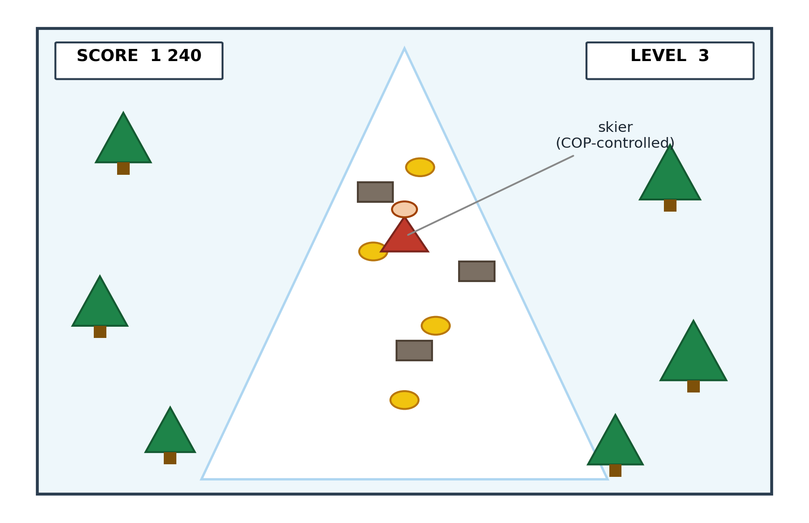
Fig. 1. The gamified skiing interface deployed on the InBody balance panel. The user steers the on-screen skier by shifting body weight laterally on the pressure-sensitive panel; each lateral shift is simultaneously logged as Centre-of-Pressure (COP) coordinates for clinical fall-risk analysis. The dual-purpose design allows a standard FRA measurement to occur within a game context.
A leaderboard mapped to Octalysis Drive 5 (Social Influence) was trialled, and the strategy backfired. Staff observation and field notes recorded that participants who attended to the leaderboard compared themselves unfavourably with other users and judged themselves more quickly and more negatively; satisfaction appeared lower among those participants. Because the archived dataset does not record leaderboard viewing as a variable, this observation is reported qualitatively and no coefficient is claimed. The pattern is consistent with social comparison theory [35] and with An et al.'s conclusion that building confidence matters more than competition in this population [11]. The leaderboard is removed from the confirmatory design.

C. Five-Layer Architecture
The system comprises five layers. Layer 1 (sensor interface): the pressure panel streams COP coordinates in real time, which are simultaneously logged for clinical review. Layer 2 (game engine): the skiing game consumes the COP stream as its control input; the engine was built with AI-assisted code generation from natural-language specifications, with design feedback from players and clinicians folded back into the specification. Layer 3 (AI adaptation): a language-model service, orchestrated through LangChain, reviews performance at five-minute intervals and adjusts obstacle density (one step up above 80% success, one step down below 40%) and speed banding. Layer 4 (logging): completed cycles, per-cycle timing, COP traces, success accuracy, per-cycle affect and symptoms. Layer 5 (clinical output): pre/post FRA indices and balance measures exported for therapist review. On API delay or loss, the game continues at the last-selected difficulty; all calls are logged with parameters and responses; the AI service has no access to participant identity or health status; staff can manually override at any time. The AI tooling here is an enabling technology — it lowered the cost of iterating engineering decisions that remain the developers' own.

D. Proposed Coaching Layer (Confirmatory Study)
The present AI layer manages technical difficulty; failure's larger effect may be psychological. The confirmatory study therefore adds a coaching layer governing language and affective tone. Three real-time FIAS risk signals are specified: satisfaction dropping below neutral after the first cycle; no improvement across three consecutive cycles; and participants attributing difficulty to age or physical deterioration. In COM-B terms, coaching addresses reflective motivation through reframing, and staff activation adds social opportunity.

VII. Data Collection and Measures
Each session involved: baseline FRA index on the InBody machine; performance on the gamified task; a five-point satisfaction rating; and self-reported symptom change at follow-up. Five variables were collected per participant: V1 cycles completed; V2 pre/post FRA index; V3 symptom change; V4 satisfaction; V5 age and gender. Individual Octalysis and STAM questionnaires could not be administered as initially planned. Session-level temporal data (inter-session intervals, durations) were not captured. A higher FRA index signifies better balance; participants with increased indices between sessions reported improved well-being.

A. Data Verification and Withdrawal Statement
All statistics in this paper were recalculated from the raw 30-participant dataset, and only statistics that reproduce from that archive are reported. Verification steps: (1) the direction of FRA index change was checked against self-reported improvement to confirm scale directionality; (2) all means, standard deviations and effect sizes were recalculated from individual records — sustained participants (N = 9): +6.9 ± 3.1 points (95% CI 4.5-9.3; paired dz = 2.22, 95% CI 0.95-3.46); all participants (N = 30): +4.0 points (95% CI 0.5-7.6; dz = 0.42, 95% CI 0.05-0.79); (3) the low-engagement rate was confirmed at 70.0% (95% CI 52.1-83.3%) and the single-session exit rate at 26.7% (95% CI 14.2-44.4%); (4) the satisfaction association with sustained engagement was confirmed (9/9 versus 11/21; Fisher's exact p = 0.013).
Withdrawal statement. Three statistics reported in earlier drafts have been withdrawn and do not appear in this paper. A Cox proportional-hazards model and Kaplan-Meier analysis were withdrawn because the archived dataset preserves no time variable and cannot support time-to-event modelling. A week-2 motivational-orientation classification and its odds ratio were withdrawn because the classification variable does not appear in the archived dataset and its coding records could not be produced. Pooled and zero-imputation effect sizes were withdrawn because they did not reproduce from the archive. The confirmatory study replaces these with pre-registered instruments administered at baseline and session-level logging with timestamps.

VIII. Quantitative Findings

A. Statistical Methods
Three methods are used, matched to a small single-site sample. Proportions carry Wilson score 95% confidence intervals. Within-participant change in the recorded FRA index is analysed with paired t and Wilcoxon tests, with exact noncentral-t confidence intervals for the paired effect size dz [36]. Associations between binary characteristics and sustained engagement use Fisher's exact test. No time-to-event modelling is used or reported (Section VII-A).

B. Clinical Outcomes
Table II. FRA index outcomes, sustained participants (N = 9).
Measure | Gamified FRA
Baseline FRA index (mean ± SD) | 42.0 ± 8.3
Post-intervention (mean ± SD) | 48.9 ± 9.4
Change (mean ± SD; 95% CI) | +6.9 ± 3.1 (4.5–9.3)
Cohen's dz (paired; 95% CI) | 2.22 (0.95–3.46)
Self-reported improvement | 7/9 (78%)
Satisfaction (Satisfied/Very Satisfied) | 9/9 (100%)
Table II reports outcomes for the nine participants who sustained engagement (≥ 4 cycles). Across the full sample of thirty, the paired change was +4.0 points (95% CI 0.5-7.6; dz = 0.42, 95% CI 0.05-0.79). A within-deployment change of this size may include measurement variation, familiarisation and practice effects, and is read as a promising signal rather than a demonstrated clinical effect.
Table IIA. FRA index outcomes, low-engagement group (cycles ≤ 3, N = 21).
Measure | Gamified FRA
Baseline FRA index (mean ± SD) | 44.7 ± 12.0
Post-intervention (mean ± SD) | 47.5 ± 11.5
Change (mean ± SD) | +2.8 ± 11.1
Self-reported improvement | 11/21 (52%)
Satisfaction (Satisfied/Very Satisfied) | 11/21 (52%)
Despite minimal engagement, the low-engagement group shows a mean change of +2.8 points with high variability. Only 52% reported satisfaction or perceived improvement, against 100% of sustained participants — satisfaction and sustained engagement are strongly associated (Fisher's exact p = 0.013).

C. The Abandonment Pattern
Table III. Engagement pattern (N = 30).
Measure | Value (95% CI)
Low engagement (≤ 3 cycles) | 21/30, 70.0% (52.1–83.3%)
Sustained (≥ 4 cycles) | 9/30, 30.0%
Single-session exits (1 cycle) | 8/30, 26.7% (14.2–44.4%)
Re-engagement after disengagement | 0/21, 0.0% (0.0–15.5%)
The cycle distribution was: eight participants completed one cycle, seven completed two, six reached three, one reached four, five reached five, and three reached six. The most telling figure is the zero re-engagement count: of the 21 participants who disengaged, not one returned within the eight-week window. This absolute permanence distinguishes the pattern from typical usage attrition, in which some users return [7]. The 26.7% single-session exit rate marks the first session as the highest-risk point (Fig. 2). No time-to-event model is reported: the archive preserves cycle counts, not timestamps. The evidential core of the pattern is carried by the three directly observed quantities in Table III and by the satisfaction association above.
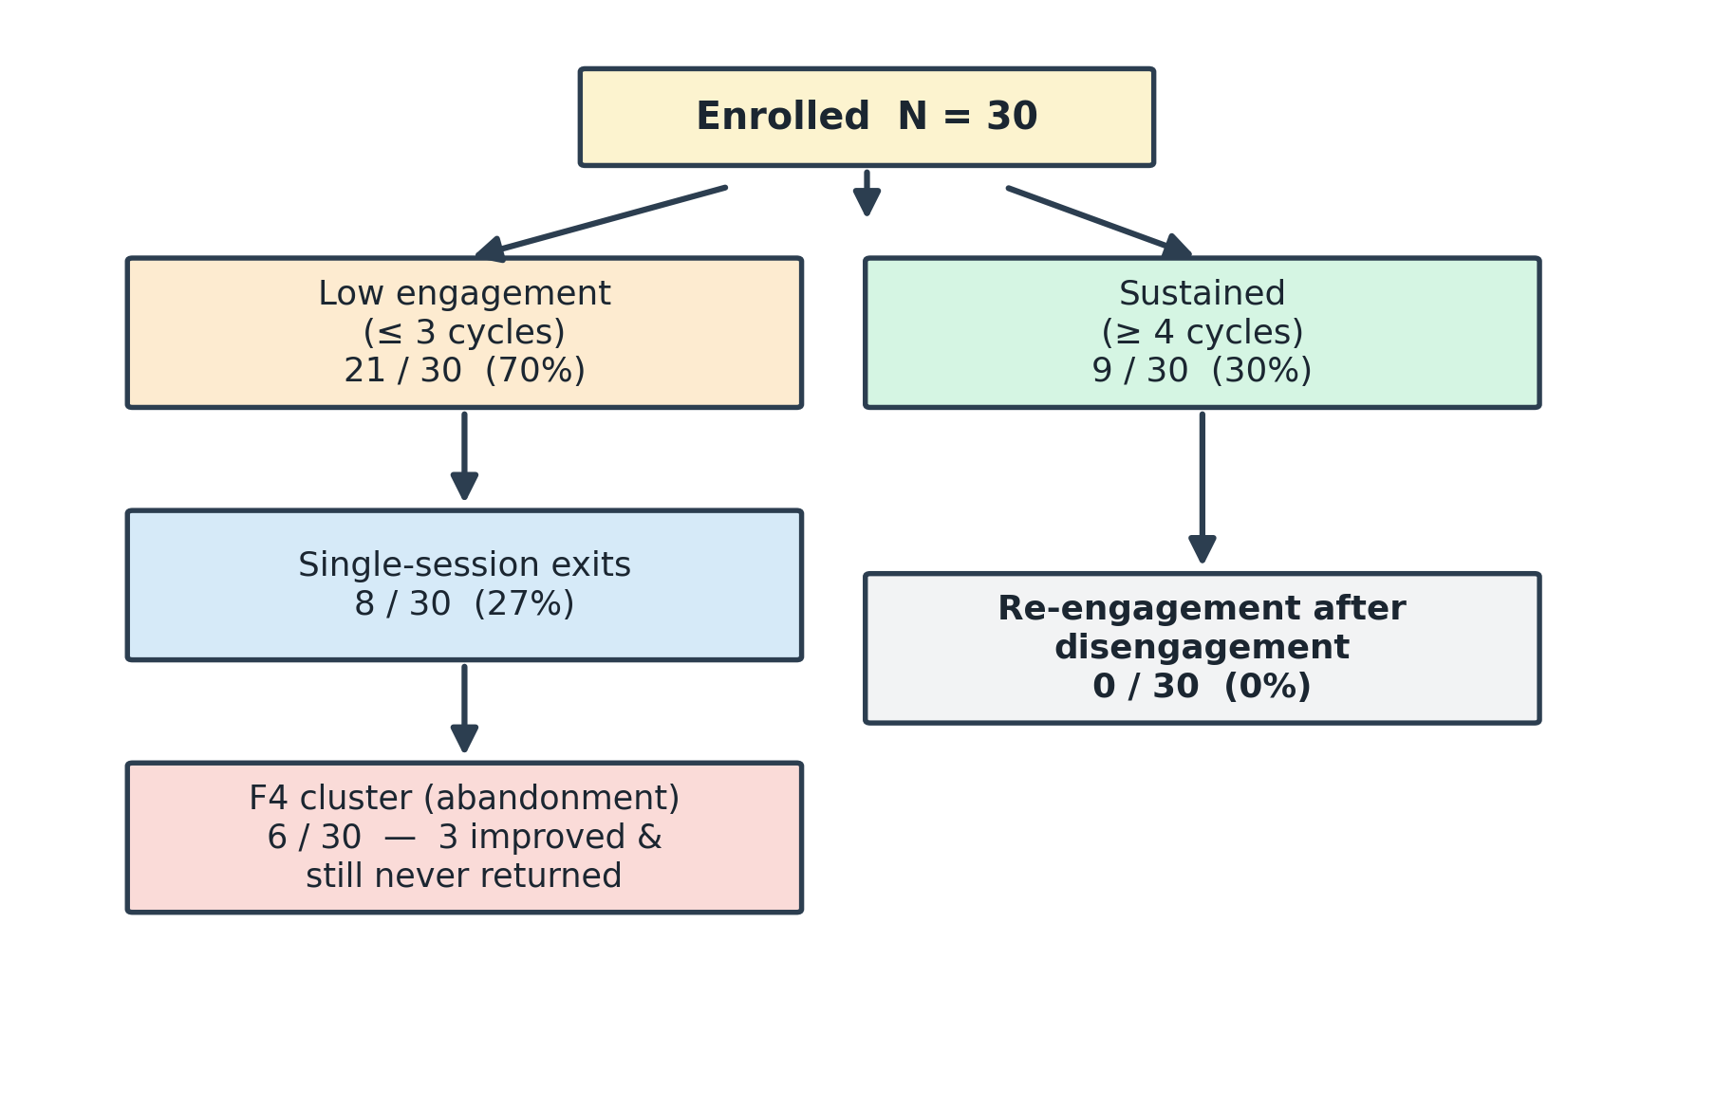
Fig. 2. Participant flow diagram (N = 30). Twenty-one participants disengaged at or before three cycles, including eight single-session exits; six formed the F4 abandonment cluster, of whom three recorded an improved FRA index in their only session and still never returned. No re-engagement after disengagement was observed (0 of 21).

IX. Qualitative Coding and the FIAS Composite
All 30 participants were coded with thirteen binary attributes drawn from STAM constructs and selected Octalysis drives, collapsed onto a 0-10 composite. The composite is a descriptive case-identification device and carries no evidential weight: several attributes record engagement and exit behaviour, so a participant who abandoned early necessarily scores high, and the clustering of the F4 group at the top of the scale is partly true by construction. Every evidential statement in this paper rests on directly observed behaviour — single-session exit, non-return, and the divergence between recorded score direction and return.
Table IV. Coding scheme (abbreviated; 8 of 13 attributes).
Attribute | Coding rule | Rationale
STAM-PU | Symptom improvement AND FRA index improved | Perceived clinical usefulness
STAM-PEOU | Satisfaction ≥ Satisfied AND cycles ≥ 2 | System manageable
STAM-BI | Satisfaction ≥ Satisfied | Continuation-intention proxy
STAM-GSE | Cycles ≥ 3 AND verified | Self-efficacy through repeated success
STAM-GA | Satisfaction ≤ Dissatisfied OR (1 cycle AND no improvement) | Anxiety signal
D2 (Accomplishment) | Cycles ≥ 4 AND improvement | Progress achieved
D5− (Neg. social) | Cycles ≤ 2 AND no improvement AND satisfaction ≤ Neutral | Social withdrawal
D8 (Loss/avoidance) | 1 cycle AND no improvement | Loss-aversion exit
Table V. Composite score distribution (descriptive).
Level | n | Score | Age range
F0 (none) | 4 | 0 | 63–69
F1 (low) | 14 | 1–2 | 62–84
F2 (moderate) | 3 | 3–4 | 67–73
F3 (high) | 3 | 5 | 62–70
F4 (strong) | 6 | 9–10 | 65–80
The empty interval between scores 5 and 9 is not read as evidence of a behavioural threshold: given the construction, it may be a mechanical effect of the scoring thresholds and outcome-linked items, or sampling variation in a cohort of thirty. What matters about the F4 group does not depend on the composite: three of its six members recorded a positive FRA index change in their single session and did not return. That divergence between recorded improvement and return behaviour challenges a purely clinical explanation of dropout and is the observation that most clearly motivates the identity-level account of the Discussion. (Fig. 3).
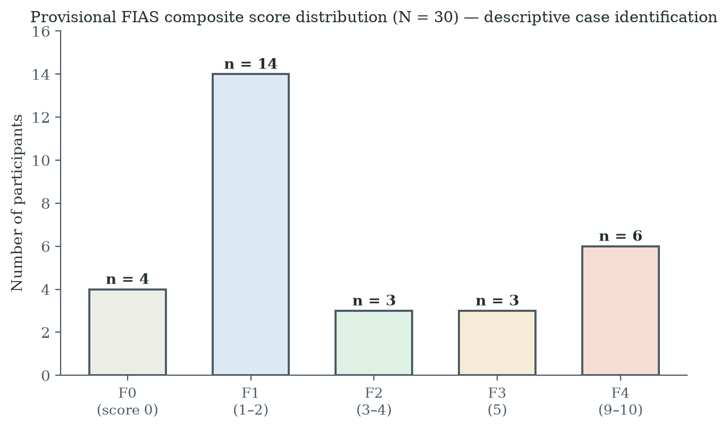
Fig. 3. Distribution of provisional FIAS composite scores (N = 30). The composite includes engagement-outcome attributes, so the separation of the F4 cluster is expected by construction; the figure is descriptive case identification, not evidence, and the empty interval between scores 5 and 9 is not read as a behavioural threshold.

X. F4 Interview Protocol
F4-cluster participants were interviewed within three to five days of the abandoned session about whether the decision to stop was immediate or deliberate. Table VI shows the nine-question protocol; questions 3 and 4 test H2 and H3, question 7 tests H4, and question 9 probes domain reframing.
Table VI. F4 interview protocol.
Q | Question | Tests
1 | Describe what happened in your last session | Account
2 | How did you feel when the session ended? | Immediate anxiety
3 | When did you decide not to come back? | H2: impulsive vs deliberate
4 | What were you thinking about your performance? | H3: health identity
5 | Did others' opinions matter? | Social comparison
6 | Did you connect difficulty to your age? | Age attribution
7 | If easier, would you have continued? | H4: technical vs psychological
8 | Anything that would make you try again? | Permanence
9 | If described as a reaction-speed game instead of a health test, would that change how you felt? | Domain-reframing probe

XI. Discussion

A. RQ1: Did Gamification Help?
For the subset who sustained engagement, yes: +6.9 FRA index points (95% CI 4.5-9.3; dz = 2.22), with all nine satisfied or very satisfied; across all thirty, +4.0 points (95% CI 0.5-7.6). These are promising within-deployment signals rather than demonstrated clinical effects.

B. RQ2: Why Does Abandonment Persist?
The pattern has three defining features. It is early: 70.0% disengaged at or before three cycles, 26.7% after one session. It is absolute within the window: none of 21 disengaged participants returned (95% CI 0.0-15.5%), unlike ordinary usage attrition [7]. And it is not accounted for by dissatisfaction alone: although satisfaction and engagement are strongly associated (p = 0.013), three F4 participants improved on the recorded index in their only session and still never returned. Practical obstacles — usability, staffing, cost, scheduling — do not explain a pattern in which the technology was free, supervised, on site, and in documented cases measurably working for the person who walked away. The evidence is consistent with a psychological mechanism attached to the meaning of failure.

C. RQ3: The FIDS-FIAS Mechanism
The proposed mechanism has two steps: FIDS names the initial dropout — first failure collapses task self-efficacy and the participant withdraws; FIAS names the consolidation — loss aversion makes re-engagement a gamble on further unwelcome evidence about one's own body, so the participant never returns. H1-H4 operationalise the account (Fig. 4). Field observation during the deployment was consistent with it: participants who spoke about the activity in learning terms tended to sustain engagement, while those who spoke in health-deficit terms tended to exit early. Because the week-2 classification that formalised this observation was withdrawn (Section VII-A), the pattern is reported as a field observation and a hypothesis for the confirmatory study, not as a measured effect.
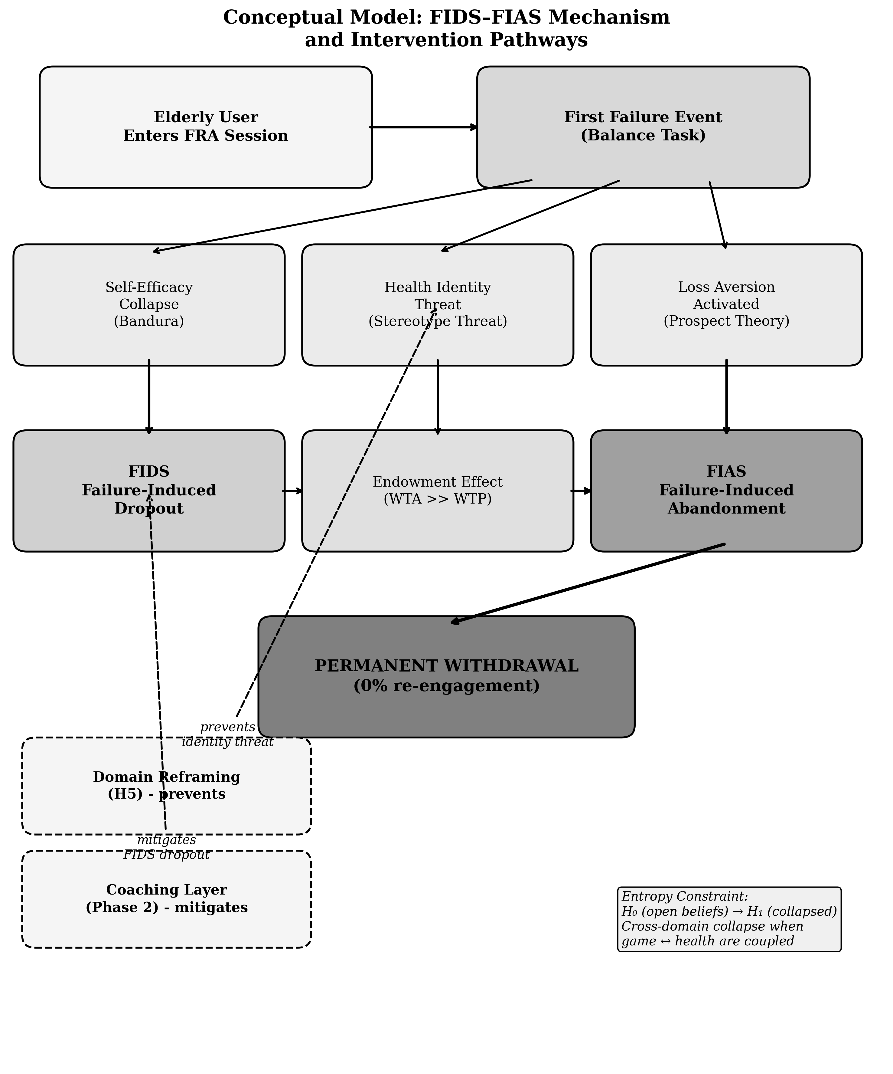
Fig. 4. Conceptual model of the proposed FIDS-FIAS mechanism and intervention pathways. The left pathway shows the hypothesised failure cascade: a first failure event collapses self-efficacy (FIDS), after which loss aversion — via an endowment-protective reading of the failure — consolidates permanent withdrawal (FIAS). The dashed elements show the two intervention routes for confirmatory testing: domain reframing (H5), which aims to prevent the identity threat from attaching, and the coaching layer, which aims to repair self-efficacy after activation. The mechanism is proposed, not directly measured.

D. Extended Theory: Endowment, Stereotype Threat, Domain Reframing
Three further perspectives are offered as theory for confirmatory testing, not as findings. The endowment effect [37], [38]: people value what they possess above what they might acquire, with willingness-to-accept (WTA) a loss typically exceeding willingness-to-pay (WTP) to obtain the same item. Applied here: an elderly participant arrives carrying an endowed, identity-level asset — their health self-concept. A clinically framed failure threatens to devalue it; the WTA for accepting that devaluation is extremely high, and the WTP for re-engagement — bounded by finite expected benefits — cannot match it. Identity-protective cognition research suggests people do treat core self-beliefs as possessions to defend. Extending endowment to an intangible self-concept is a theoretical step requiring validation. Stereotype threat [39], [40]: activating negative ageing stereotypes degrades older adults' performance, predominantly as self-concept threat [40]; reframing a task from trait measurement to skill activity reduces the threat [41]. Domain reframing draws the threads together: frame task performance as a trainable skill with variable outcomes, not a measurement of fixed capacity. With no fixed reference point, there is no endowed asset; with nothing to lose, the FIAS cascade has nothing to initiate. Prediction (H5): participants under an instant-response-test framing will show lower permanent dropout than under FRA framing, performing the identical physical task.
Ethical note. If the game is framed as a response test while FRA data are captured in the background, participants must still be informed that balance patterns are recorded. The recommended consent wording leads with the response-test framing and discloses the dual purpose: 'this game measures how quickly you can react to obstacles — it also helps us understand your balance patterns.' Disclosure is preserved; the identity-threatening frame is not imposed.

XII. Limitations
The sample of 30 was small (aged 62-84) and drawn from a single residential facility in Southern China; findings apply to this relatively homogeneous cohort and require replication elsewhere. The archive preserves cycle counts and session outcomes but no timestamps, so the temporal texture of disengagement cannot be reconstructed and no time-to-event claims are made. Three statistics from earlier drafts (a Cox hazard ratio, a motivational-orientation odds ratio, and pooled/zero-imputation effect sizes) have been withdrawn for the reasons in Section VII-A — disclosed rather than silent. The FES-I was not administered. Prospect Theory is a plausible frame but was not directly tested, and extending the endowment effect to health self-concept goes beyond its documented domains; both remain propositions. Neither H5 nor the coaching layer was tested here. The investigator's dual role as observer and participant creates a bias risk that reflexive notes mitigate but do not eliminate.

XIII. Design Implications for Practitioners
Four principles follow, three grounded in the present findings and one awaiting confirmation. First, set first-session difficulty low enough that every user succeeds; the first session's purpose is success, not measurement. Second, make participants comfortable before play — let them talk with residents who completed the process, and have staff accompany them in. Third, watch for the three FIAS risk signals during sessions (satisfaction below neutral after the first cycle; no improvement over three cycles; age-attribution talk) and intervene — adjust difficulty downward, reframe with mastery-oriented language ('your reaction time sped up') rather than performance language ('you missed again'). Fourth — the H5 hypothesis, pending confirmation — describe the session as a response challenge rather than a health assessment, avoid displaying any output the participant could read as a health verdict, and train staff in skill-development language.

XIV. The Entropy Constraint
A game with no real-world stakes confines the meaning of failure to the game domain: one loses a life and tries again. When game performance and clinical assessment are coupled to the same physical action, a failure event reduces belief entropy in both domains at once — the game and the participant's beliefs about their own health. This is the entropy constraint: a structural property of any system coupling play and assessment. Beliefs about health and self are far more resistant to reopening than game beliefs, and if the endowment analysis above is correct, a newly settled negative conviction ('this technology is not for me') will itself be defended as a possession. Domain reframing aims to confine failure's meaning to the game domain in one step. This framework guides the confirmatory design; no quantitative entropy claim is made here.

XV. Industrial Context and Confirmatory Design

A. Sponsor Requirements and Cost-Effectiveness
The sponsor requires FRA usage above 39% of eligible users, retention of existing infrastructure, PIPL compliance, and no increase in fall risk. The gamified system runs on the existing InBody equipment at negligible added cost (AI-service calls below US$0.50 per session; staff training under half a day per person). Reducing the single-session exit rate from 26.7% toward 10% would substantially reduce cost per continuing user; the full cost-effectiveness analysis belongs to the confirmatory phase.

B. Three-Arm Confirmatory Design
The confirmatory study marks the shift from exploratory action research to a pre-registered design. Arm 1 (control): the FRA-coupled game, framed explicitly as fall risk assessment, replicating the present conditions. Arm 2 (domain reframing): identical game, hardware and adaptation, framed as an instant response test with no health-assessment language; background FRA capture disclosed as in Section XI-D. Arm 3 (coaching): the FRA-coupled condition plus the coaching layer of Section VI-D. Arm 1 versus Arm 2 tests whether preventing the identity threat works (H5); Arm 1 versus Arm 3 tests whether repairing it after activation works (H1-H4) (Fig. 5). A pilot (n = 15-25) precedes a two-site study (n = 60-80) with stratified sampling by age band and baseline FES-I, randomised allocation, and baseline measures including cognitive status (MoCA), PHQ-4, technology familiarity, fall history and a validated motivational measure administered before any outcome is observed. The primary outcome is re-engagement attempt within seven days of first failure. Secondary outcomes include the FRA index, FES-I, satisfaction, three-month fall rate, EQ-5D-5L and staff time. Reporting follows STROBE [42] and SPIRIT-AI [43]; WHO and regulator guidance on AI in health informs the AI component [44], [45]. All hypotheses (H1-H5) and endpoints will be pre-registered before data collection.
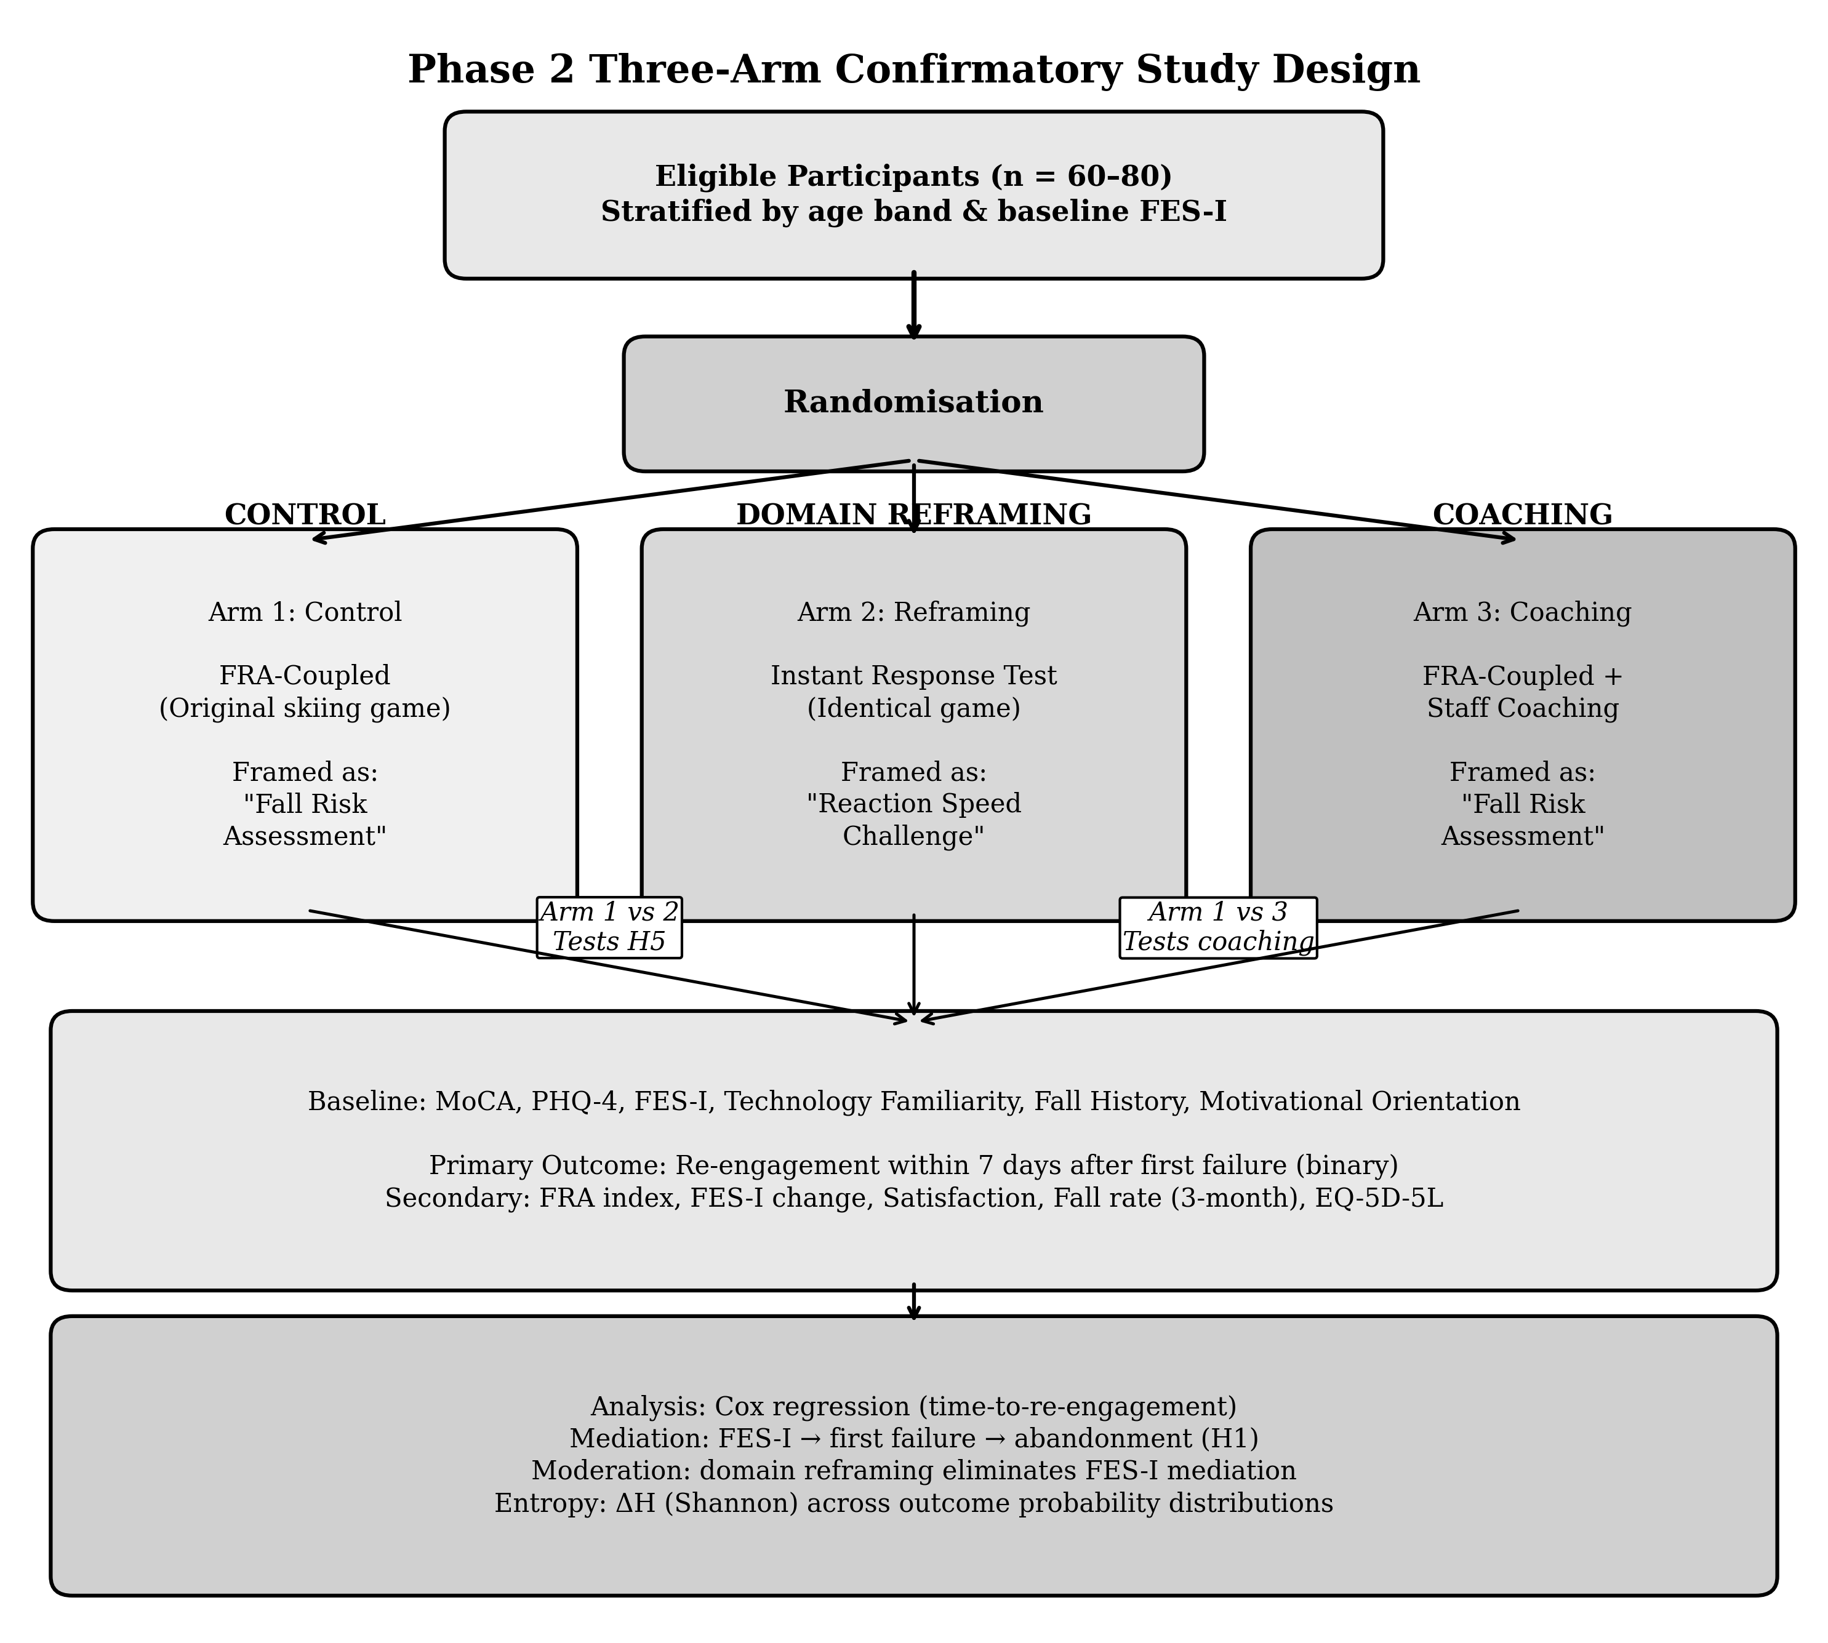
Fig. 5. Three-arm confirmatory study design. Arm 1 (control) replicates the present FRA-coupled conditions; Arm 2 (domain reframing) uses the identical game framed as a reaction-speed challenge, testing H5; Arm 3 adds the staff coaching layer to the FRA-coupled condition, testing H1-H4. Time-to-re-engagement analysis is supportable in this design because session-level logging with timestamps is pre-specified.
An interim between-cohort deployment of a decoupled version of the game with 120 community-dwelling adults, reported in a companion manuscript, provides preliminary quasi-experimental support for the decoupling direction — post-failure return where the present study observed none — while leaving the randomised within-cohort test to the design above.

XVI. Conclusion
This study built and tested a gamified FRA using a dual-purpose input design at a residential care facility in Southern China. For participants who sustained engagement, gamification helped: +6.9 FRA index points (95% CI 4.5-9.3; dz = 2.22), with all nine satisfied or very satisfied. But 70.0% never passed three cycles, 26.7% stopped after their first session, no participant returned after disengaging — and three participants whose recorded index improved in their only session were among those who never came back. We propose that initial dropout (FIDS) is associated with self-efficacy collapse and that loss aversion (FIAS) consolidates the withdrawal when game failure is read as evidence of physical decline. Satisfaction was strongly associated with sustained engagement (p = 0.013), and field observation suggested that a learning-oriented reading of the activity accompanied persistence — a suggestion whose formal test belongs to the pre-registered three-arm study, alongside the domain-reframing hypothesis drawn from the endowment-effect [37], [38] and stereotype-threat [40], [41] literatures. The framing of a gamified health technology may matter as much as its engineering; the confirmatory programme is designed to find out.

Acknowledgments
The authors thank the management and nursing staff, and the residents of the participating residential care facility in Southern China, for their generous cooperation. Supervision by Prof. Chi Fai Cheung at The Hong Kong Polytechnic University is gratefully acknowledged. AI tooling (Anthropic Claude Code and API services) was used as an enabling technology for game development and difficulty adaptation; the contribution of this paper is the behavioural analysis and the design framework. The authors declare no competing financial or non-financial interests; the lead author holds no financial relationship with Anthropic; the facility was not involved in data analysis or manuscript preparation; the study received no external funding.

References
[1] NICE, 'Falls in older people: assessing risk and prevention,' Clinical Guideline CG161, London, UK, 2013.
[2] WHO, 'WHO global report on falls prevention in older age,' Geneva, 2007.
[3] H. Guner and C. Acarturk, 'The use and acceptance of ICT by senior citizens: A comparison of TAM for elderly and young adults,' Universal Access Inf. Soc., vol. 19, pp. 311-330, 2020.
[4] G. A. Wildenbos, L. Peute, and M. Jaspers, 'Aging barriers influencing mobile health usability for older adults: MOLD-US,' Int. J. Med. Inform., vol. 114, pp. 66-75, 2018.
[5] D. Hawthorn, 'Interface design and engagement with older people,' Behav. Inf. Technol., vol. 26, no. 4, pp. 333-341, 2007.
[6] H. S. Tsai, R. Shillair, and S. R. Cotten, 'Exploring the role of technology anxiety and self-efficacy in older adults' information seeking,' in Proc. iConference, 2020.
[7] G. Eysenbach, 'The law of attrition,' J. Med. Internet Res., vol. 7, no. 1, e11, 2005.
[8] F. D. Davis, 'Perceived usefulness, perceived ease of use, and user acceptance of information technology,' MIS Quarterly, vol. 13, no. 3, pp. 319-340, 1989.
[9] V. Venkatesh et al., 'User acceptance of information technology: Toward a unified view,' MIS Quarterly, vol. 27, no. 3, pp. 425-478, 2003.
[10] S. Deterding et al., 'From game design elements to gamefulness: Defining gamification,' in Proc. 15th Int. Acad. MindTrek Conf., 2011.
[11] S. An, C. F. Cheung, and K. W. Willoughby, 'A gamification approach for enhancing older adults' technology adoption and knowledge transfer,' Technol. Forecast. Soc. Change, vol. 205, 2024.
[12] S. M. Kelders et al., 'Persuasive system design does matter: A systematic review of adherence to web-based interventions,' J. Med. Internet Res., vol. 14, no. 6, e152, 2012.
[13] H. Christensen, K. M. Griffiths, and L. Farrer, 'Adherence in internet interventions for anxiety and depression,' J. Med. Internet Res., vol. 11, no. 2, e13, 2009.
[14] C. Lee and J. F. Coughlin, 'Older adults' adoption of technology: An integrated approach,' Geriatr. Gerontol. Int., vol. 15, no. 5, pp. 519-525, 2015.
[15] G. Grossi, R. Ferrario, and V. Tosi, 'Barriers and facilitators to health technology adoption by older adults with chronic diseases,' BMC Geriatrics, vol. 24, no. 189, 2024.
[16] M. E. Tinetti and L. Powell, 'Fear of falling and low self-efficacy: A cause of dependence in elderly persons,' J. Gerontol., vol. 48, pp. 35-38, 1993.
[17] L. Yardley et al., 'Development and initial validation of the Falls Efficacy Scale-International (FES-I),' Age Ageing, vol. 34, no. 6, pp. 614-619, 2005.
[18] A. C. Scheffer et al., 'Fear of falling: Measurement strategy, prevalence, risk factors and consequences among older persons,' Age Ageing, vol. 37, no. 1, pp. 19-24, 2008.
[19] J. Koivisto and A. Malik, 'Gamification for older adults: A systematic literature review,' Gerontologist, vol. 61, no. 7, pp. 360-372, 2021.
[20] K. Chen and A. H. S. Chan, 'Gerontechnology acceptance by elderly Hong Kong Chinese: STAM,' Ergonomics, vol. 57, no. 5, pp. 635-652, 2014.
[21] Y.-K. Chou, Actionable Gamification: Beyond Points, Badges, and Leaderboards. Fremont, CA: Octalysis Media, 2015.
[22] A. Bandura, Self-Efficacy: The Exercise of Control. New York: W. H. Freeman, 1997.
[23] D. R. Compeau and C. A. Higgins, 'Computer self-efficacy: Development of a measure and initial test,' MIS Quarterly, vol. 19, no. 2, pp. 189-211, 1995.
[24] D. Kahneman and A. Tversky, 'Prospect theory: An analysis of decision under risk,' Econometrica, vol. 47, no. 2, pp. 263-291, 1979.
[25] A. Tversky and D. Kahneman, 'Advances in prospect theory: Cumulative representation of uncertainty,' J. Risk Uncertain., vol. 5, no. 4, pp. 297-323, 1992.
[26] B. S. Frey and R. Jegen, 'Motivation crowding theory,' J. Econ. Surv., vol. 15, no. 5, pp. 589-611, 2001.
[27] E. L. Deci and R. M. Ryan, Intrinsic Motivation and Self-Determination in Human Behavior. New York: Plenum, 1985.
[28] S. Michie, M. M. van Stralen, and R. West, 'The behaviour change wheel,' Implement. Sci., vol. 6, no. 42, 2011.
[29] C. E. Shannon, 'A mathematical theory of communication,' Bell Syst. Tech. J., vol. 27, pp. 379-423, 623-656, 1948.
[30] E. T. Stringer, Action Research, 4th ed. Thousand Oaks, CA: SAGE, 2014.
[31] K. Lewin, 'Action research and minority problems,' J. Soc. Issues, vol. 2, no. 4, pp. 34-46, 1946.
[32] Standing Committee NPC, 'Personal Information Protection Law of the People's Republic of China,' Beijing, effective 1 November 2021.
[33] S. H. Kim et al., 'Introduction of Fall Risk Assessment system and cross-sectional validation among community-dwelling older adults,' Int. J. Environ. Res. Public Health, vol. 16, no. 5, p. 740, 2019.
[34] S. H. Kim et al., 'Test-retest reliability and sensitivity to change of a new Fall Risk Assessment system,' Int. J. Environ. Res. Public Health, vol. 17, no. 14, p. 5082, 2020.
[35] L. Festinger, 'A theory of social comparison processes,' Hum. Relat., vol. 7, no. 2, pp. 117-140, 1954.
[36] J. Cohen, Statistical Power Analysis for the Behavioral Sciences, 2nd ed. Hillsdale, NJ: Erlbaum, 1988.
[37] R. Thaler, 'Toward a positive theory of consumer choice,' J. Econ. Behav. Organ., vol. 1, no. 1, pp. 39-60, 1980.
[38] D. Kahneman, J. L. Knetsch, and R. H. Thaler, 'Experimental tests of the endowment effect and the Coase theorem,' J. Political Econ., vol. 98, no. 6, pp. 1325-1348, 1990.
[39] R. A. Dionigi, 'Stereotypes of aging: Their effects on the health of older adults,' J. Geriatr., vol. 2015, art. 954027, 2015.
[40] S. J. Barber, 'An examination of age-based stereotype threat about cognitive decline,' Perspect. Psychol. Sci., vol. 12, no. 1, pp. 62-90, 2017.
[41] M. S. McGlone and J. Aronson, 'Stereotype threat, identity salience, and spatial reasoning,' J. Appl. Dev. Psychol., vol. 27, no. 5, pp. 486-493, 2006.
[42] E. von Elm et al., 'STROBE statement: Guidelines for reporting observational studies,' Ann. Intern. Med., vol. 147, no. 8, pp. 573-577, 2007.
[43] X. Liu et al., 'Reporting guidelines for clinical trials evaluating artificial intelligence interventions (SPIRIT-AI/CONSORT-AI),' Nature Med., vol. 26, pp. 1364-1374, 2020.
[44] WHO, 'Ethics and governance of artificial intelligence for health,' Geneva, 2021.
[45] FDA, Health Canada, and MHRA, 'Good Machine Learning Practice for Medical Device Development: Guiding Principles,' 2021.
[46] S. K. T. Tam and C. F. Cheung, 'A study of utilisation of Fall Risk Assessment among elderly users: A critical review through TAM and Octalysis frameworks with gamification approach,' accepted for publication (SS-293).

