Decoupling the Clinical Attachment from Gamified Fall Risk Assessment: Between-Cohort Evidence for a Frame-Sensitive Account of Elderly Abandonment
Sidney K. T. Tam and Chi Fai Cheung
Behaviour and Knowledge Engineering Research Centre, Department of Industrial and Systems Engineering,
The Hong Kong Polytechnic University, Hong Kong, China
Corresponding author: sidney.tam@connect.polyu.hk

Abstract
Earlier work in this programme documented rapid abandonment, with no documented return within the observation window, of a gamified, AI-assisted Fall Risk Assessment (FRA) by elderly residents after early failure: 70.0% had three or fewer recorded completed game runs and none of the 21 low-engagement participants had a later recorded run, even where the recorded balance index had improved. Two rival readings of that result make opposite predictions — a dispositional reading, on which gamification does not transfer to frail older adults, and a coupling reading, on which the attachment of the game to a clinical verdict on the user's body carried the failure. This paper reports the evaluation that separates them: a between-cohort quasi-experimental remote deployment in which the game was ported to an HTML build and distributed by e-mail. Participants played unsupervised on their own computers, using a trackpad, arrow keys or, where available, a foot-pad sensor; the skiing mechanic, five-attempt rule and session structure were retained in the port, while the participant-facing clinical attachment was removed as a package — the clinical apparatus and setting, recruitment language, pre-session clinical scan, clinical labels and participant-facing clinical outputs — and the activity was framed as an eye-leg coordination challenge. One hundred and twenty community-dwelling adults aged 25-80 were recruited through the authors' Hong Kong-based networks across three age bands (38 aged 25-44, 41 aged 45-64, 41 aged 65-80). In the preliminary aggregate record, compiled from the results files and questionnaire responses each participant returned by e-mail, retention at the end of the study window was 93.3% overall and 85.4% in the 65-80 band; 15 of 23 initial dropouts returned voluntarily (65.2%; 10 of 16, or 62.5%, in the 65-80 band); coordination-challenge endorsement was 71.7%; and stated regular-use intention was 63.3% overall and 56.1% in the 65-80 band. Initial dropout climbed steeply with age (0 of 38 versus 16 of 41; Fisher's exact p < 0.0001), while observed non-return converged to low levels in every band (0.0%, 4.9%, 14.6%). The pattern is consistent with the coupling account and inconsistent with the dispositional account, within the limits of a between-cohort, multi-component design in which platform, input device, setting and supervision changed alongside framing. A residual 29.3-percentage-point gap between end-of-window retention and regular-use intention in the oldest band motivates adaptive learning — trajectory-oriented feedback with calibrated challenge — as the design response, and a pre-specified within-cohort randomised study as the confirmatory test.
Keywords: fall risk assessment, gamification, elderly technology abandonment, FIAS, decoupling, framing, endowment effect, adaptive learning.

I. Introduction
A survey of 200 residents at a Guangzhou care facility (of a resident population of 280) found that only 39% had ever used an installed FRA system; among users, approximately 74% failed on their first attempt and 82% did not return [1]. A subsequent eight-week action-research deployment with thirty residents tested whether a gamified, AI-assisted FRA — engineered to satisfy the acceptance and gamification design criteria of the technology-acceptance and Octalysis literatures — would sustain engagement. It did not: 70.0% of participants (95% CI 52.1-83.3%) had three or fewer recorded completed runs, 26.7% had a single completed run, and none of the 21 low-engagement participants had a later recorded run within the study window (95% CI 0.0-15.5%) [2]. Most strikingly, three of the six participants in the strongest-abandonment cluster recorded a positive change in the balance index in their only recorded run and still did not return.
That rejection is ambiguous between two explanations. Under the dispositional explanation, gamification simply does not work for frail older adults: the literature's successes with non-clinical technologies do not transfer. Under the coupling explanation, the game was never the problem: attaching the gameplay to a clinical verdict on the user's own body changed the meaning of failure, and the failure-induced abandonment (FIAS) documented in [1], [2] is a property of that attachment. The two explanations make opposite predictions for a decoupled version of the same game. This paper reports that evaluation. It evaluates a participant-facing redesign package in a separate cohort; it does not isolate a single causal variable, and its claims are calibrated accordingly.

II. Theoretical Background

A. The FIAS Account and the Endowment Mechanism
FIAS (Failure-Induced Abandonment Syndrome) is a provisional behavioural construct: active, rapid and persistent non-return after an adverse first experience under identity-relevant conditions [1]. The candidate mechanism developed in [2] runs through the endowment effect [3], [4]. An elderly participant arrives carrying an identity-level asset — the belief in their own physical capability. A clinically framed failure forces a devaluation of that asset. The willingness-to-accept (WTA) such a devaluation is very high, because the asset is neither fungible nor separable from the person's sense of self; the willingness-to-pay (WTP) for re-engagement — bounded by finite expected benefits — cannot match it. On this account the transaction never clears and the participant never returns, which is consistent with the observed zero re-engagement. Extending the endowment effect to health self-concept goes beyond the domains in which it has been demonstrated experimentally; it is carried here as a candidate mechanism, not a measured one.

B. Two Appraisal Regimes
The same account implies a structural proposition: an endowment-protective appraisal and a learning-trajectory appraisal are competing readings of the same feedback event. Read against a fixed self-concept, a failure is a verdict on a possessed asset; read against a learning curve, it is a data point on a trajectory. The two regimes route identical information — a missed obstacle on a pressure panel — to different targets: the self, or the task. Which regime a participant enters is hypothesised to depend on the frame the deployment establishes. This proposition motivates both the decoupling evaluated here (remove the verdict frame) and the adaptive-learning design direction discussed in Section VI (install the trajectory frame); as a claim of mutual exclusion it is theoretical, and its direct test is specified as future work.

III. Method: A Participant-Facing Decoupling Package in a Separate Cohort

A. Design Logic of the Coordination-Challenge Framing
The design problem was practical. A pure entertainment framing would not recruit meaningfully; a health-assessment framing re-activates the very mechanism under study. The deployment therefore framed the activity as an eye-leg coordination challenge: participants were told the game tests how quickly the eyes can spot obstacles and how fast the legs can respond, and that response speed improves with practice. The framing was chosen for three properties: it avoids the physical-decline schema that 'balance' and 'fall' language activates; it avoids cognitive-decline connotations; and it presents performance as inherently variable rather than as a stable capacity, so that no identity-level reference point is established for a failure to threaten.

B. The Decoupling Package
Relative to the coupled deployment of [2], the participant-facing clinical attachment was removed as a package, and the removal was implemented by re-platforming: the game was ported to an HTML build and sent to participants by e-mail, so that play occurred away from the clinical station altogether. The package comprised presentation of the activity as a purely-fun coordination game (the invitation disclosed the doctoral research context, including its fall-risk origin, but the game and its instructions carried no medical or fall-prevention vocabulary); the absence of any pre-session clinical scan; the absence of clinical labels, and of any clinical station or setting; and the absence of participant-facing clinical outputs, with no balance score or risk index shown at any point. The skiing mechanic, five-attempt rule and session structure were retained in the ported build; the pressure-panel apparatus and in-person supervision were not — participants played unsupervised on their own computers using a trackpad, arrow keys or, where available, a foot-pad sensor. In-run difficulty adaptation in the ported build operated through the game's built-in rule agent; no external model calls are possible from a distributed HTML file, so no large-language-model adaptation operated in any Stage-3 session. Participant-level clinical balance telemetry was not collected. Because cohort, setting, platform, input device, supervision and recruitment channel also differed, the design estimates the combined association of the decoupled condition and its context with behaviour. Figure 1 shows the ported build at five staged difficulty levels.
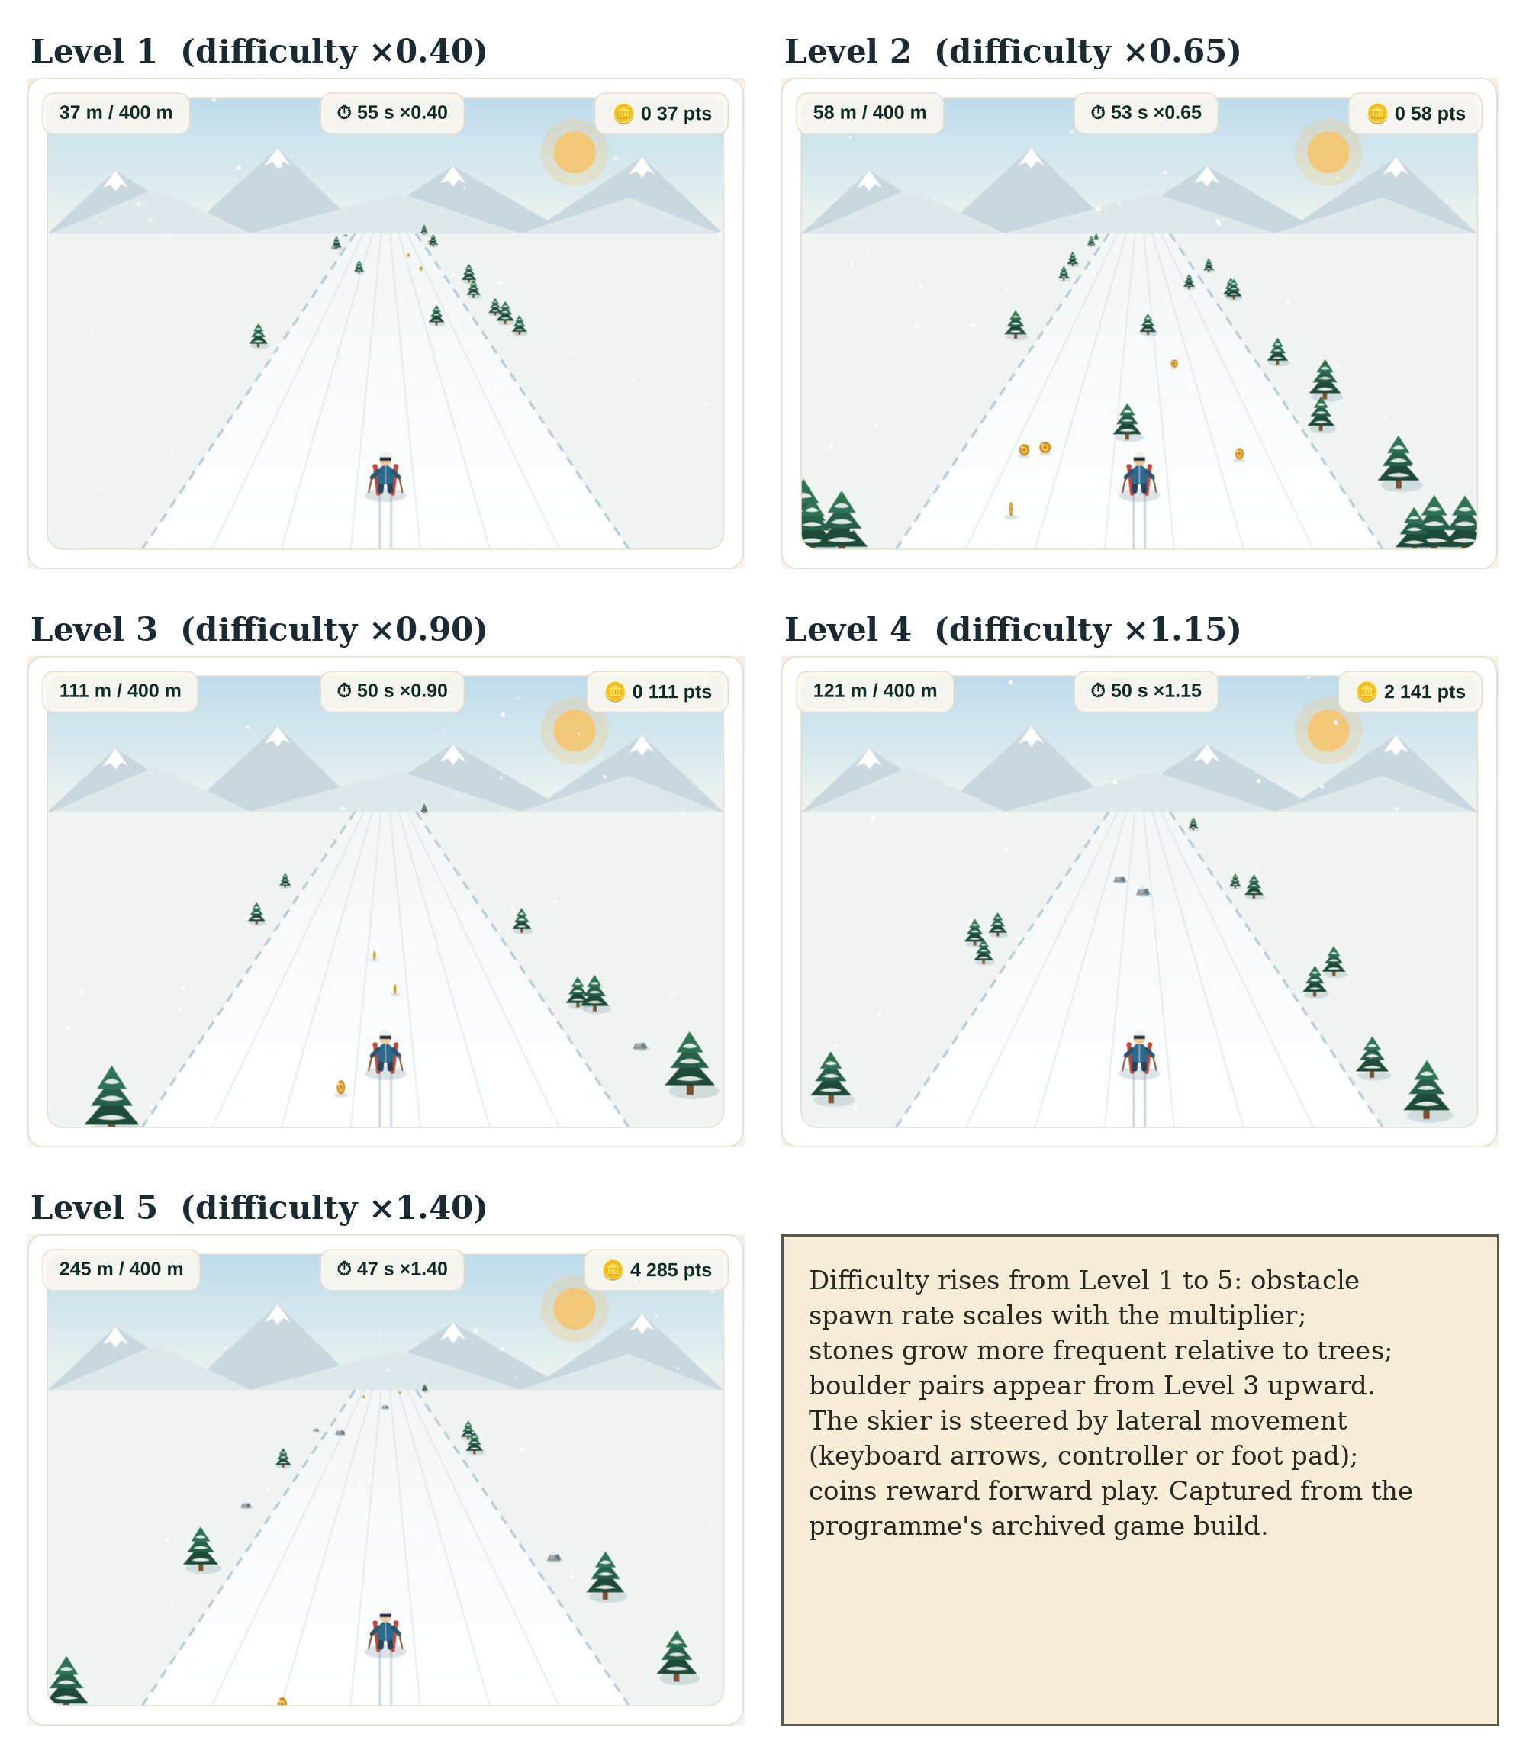
Figure 1. The coordination-challenge game (archived HTML build, Stage-3 design lineage) at staged difficulty multipliers x0.40-x1.40. Obstacle density and scroll speed scale with the difficulty multiplier; the interface carries no clinical labels, scores or risk outputs.

C. Participants
One hundred and twenty community-dwelling adults aged 25-80 were recruited through the authors' Hong Kong-based networks — family and personal contacts, work contacts, a charity community network, university support channels and working peers in medical centres: 38 aged 25-44, 41 aged 45-64 and 41 aged 65-80; 48 men and 72 women; all reported high-school education or above. The invitation e-mails disclosed the research context, including the programme's fall-risk origin, while presenting the activity itself as a purely-fun coordination game; the game and its instructions used no medical or fall-prevention vocabulary. Recruiting three age bands builds the comparison group into the study and licenses a second null hypothesis, H0-age: that under the decoupled condition there is no difference between age groups. Data collection is complete: each participant returned, by e-mail, the results file logged by the HTML build (including the session score and game-logged data) together with their questionnaire responses. This paper reports the preliminary aggregate record compiled from those returns; participant-level compilation continues beyond it. Participation was voluntary and unpaid, by informed, implied consent: the distribution e-mails explained the purpose of the game and questionnaire and the use of replies, and returning the results file and responses constituted consent; no written consent instrument was administered, which is acknowledged in Section VII. Identities were separated from the analysed records, which retain only a participant code, age band, gender and education. The programme operates under the ethics policy of The Hong Kong Polytechnic University; the programme was approved by the university's Human Subjects Ethics Sub-Committee (application reference HSEARS20260805008; Principal Investigator: Prof. C. F. Cheung; approved 6 August 2026 (approval period 16 June 2024 to 30 October 2026)).
Two recruitment decisions were deliberate. The Stage-2 facility of [2] was not re-used: its residents already carried direct experience of the coupled system, and prior exposure would have contaminated a first-contact test of the decoupled frame, so a separate cohort was a design choice rather than only a constraint. Distribution also extended beyond the authors' immediate circle through onward (snowball) forwarding by the receiving organisations and contacts, so that a portion of participants were personally unknown to the authors, reducing the risk that participation reflected personal obligation to the researcher.

D. Outcomes and Analysis
Outcomes are behavioural and stated, observed from the returned game logs and questionnaire responses: initial dropout (exit before completing the five-attempt protocol), voluntary return after initial dropout, observed non-return at the end of the study window, coordination-challenge endorsement (a manipulation check on the intended frame), and stated regular-use intention. Proportions carry Wilson score 95% confidence intervals; band contrasts use Fisher's exact and chi-square tests. No time-to-event modelling is used.

IV. Results (Preliminary Aggregate Record)
Overall, 23 of 120 participants (19.2%) dropped out before completing the protocol; 15 of the 23 (65.2%; 95% CI 44.9-81.2%) returned voluntarily; 8 (6.7%) did not return, giving end-of-window retention of 93.3% (Table 1). Figure 2 traces the flow.
Table 1. Overall engagement and dropout (N = 120).
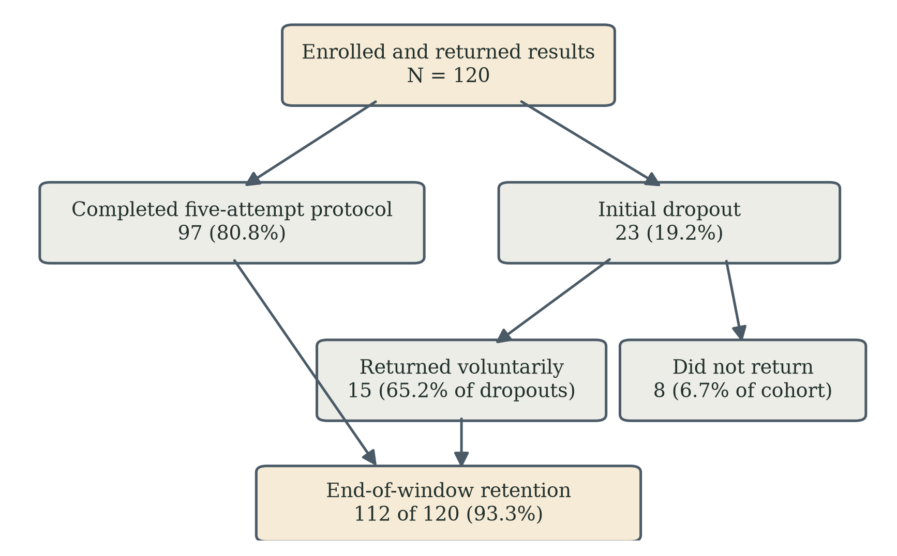
Figure 2. Participant flow in the preliminary aggregate record (N = 120). Voluntary return after initial dropout is the study's central behavioural outcome; in the coupled Stage-2 deployment the corresponding return count was zero.
Metric | n | %
Initial dropout before completing the protocol | 23 | 19.2
Voluntary return after initial dropout | 15 | 65.2 of dropouts
Observed non-return at end of window | 8 | 6.7
Retention at end of window | 112 | 93.3
Engagement was strongly age-stratified (Table 2). Initial dropout rose from 0.0% (0 of 38) in the 25-44 band through 17.1% (7 of 41) in the 45-64 band to 39.0% (16 of 41) in the 65-80 band (chi-square across bands p < 0.001; 25-44 versus 65-80, Fisher's exact p < 0.0001), nullifying H0-age for initial engagement. Observed non-return, by contrast, converged to low levels in every band: 0.0%, 4.9% and 14.6% (95% CI 6.9-28.4% in the 65-80 band), because most older dropouts came back: 10 of 16 in the 65-80 band (62.5%; 95% CI 38.6-81.5%) against 0 of 21 observed re-engagements in the coupled deployment of [2]. Figure 3 shows the divergence of the two rates.
Table 2. Age-stratified engagement.
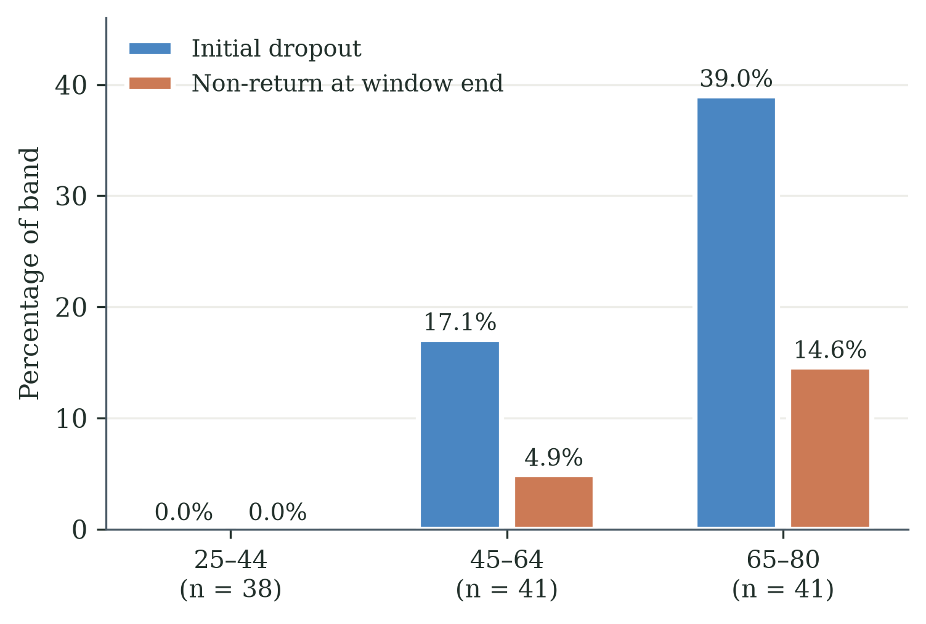
Figure 3. The age gradient: initial dropout climbs steeply with age (0.0%, 17.1%, 39.0%) while non-return at the window end stays low in every band (0.0%, 4.9%, 14.6%) - most older participants who drop out come back under the decoupled condition.
Age band | n | Initial dropout | Returned | Non-return | Retention
25–44 | 38 | 0 (0.0%) | 0 | 0 (0.0%) | 100.0%
45–64 | 41 | 7 (17.1%) | 5 | 2 (4.9%) | 95.1%
65–80 | 41 | 16 (39.0%) | 10 | 6 (14.6%) | 85.4%
Total | 120 | 23 (19.2%) | 15 | 8 (6.7%) | 93.3%
Coordination-challenge endorsement reached 71.7% (86 of 120; 95% CI 63.0-79.0%), indicating that most participants perceived the intended frame; the per-band breakdown was not retained in the preliminary summary and no per-band endorsement claim is made. Stated regular-use intention was 63.3% overall (76 of 120) — 65.8%, 68.3% and 56.1% by band (Table 3). In the 65-80 band, the difference between observed session retention (85.4%) and stated regular-use intention (56.1%; 95% CI 41.0-70.1%) is 29.3 percentage points; the two are distinct constructs, and the difference is a design diagnostic rather than a measured causal effect.
Table 3. Endorsement and stated regular-use intention.
Item | 25–44 | 45–64 | 65–80 | Total
Coordination-challenge endorsement | — | — | — | 71.7%
Would use regularly if accessible | 65.8% | 68.3% | 56.1% | 63.3%

V. Discussion

A. Frame-Sensitive Versus Dispositional Accounts
The pattern is one-sided between the two rival readings. The decoupled game was accepted by the elderly cohort at levels consistent with what the gamification literature predicts for non-clinical technologies — 85.4% end-of-window retention in the 65-80 band (returned dropouts counted as retained), voluntary return in ten of sixteen cases, majority stated intention — none of which the dispositional account predicted. The result is therefore consistent with gamification theory holding for this population, and with the failure documented in [2] residing in the coupling rather than in the game or the participants. The causal interpretation remains bounded: the cohorts differed in setting, platform, input device, supervision, recruitment, residential status, age distribution, health profile and prior exposure, and the decoupling was a package rather than a single variable — indeed, the decoupled condition was delivered by re-platforming the game entirely. The decisive confirmation is a within-cohort randomised comparison, which is specified as future work. Stated at the level of theory, the joint pattern is a candidate boundary condition for gamification theory: the theory holds for this population until the gamified activity is attached to a clinical verdict frame that touches identity-level value, and at that attachment the failure pattern of [2] appears. The randomised comparison is the test that can convert the boundary from candidate to claim.

B. The Age Gradient Read Through the WTA/WTP Account
The age-stratified pattern is what an identity-level account predicts. The burden that the coupling imposes is age-linked — initial dropout climbs steeply with age even under decoupling — but under the decoupled condition that burden no longer converts into abandonment, because most older dropouts return. In WTA/WTP terms: with no clinical verdict attached, a slow round does not devalue an identity-level asset, the WTA for accepting failure stays low, and re-engagement clears. The account remains inferential — no WTA/WTP elicitation was performed in this deployment — and its direct measurement is specified for the confirmatory study.

C. The Commitment Gap and the Adaptive-Learning Direction
Decoupling did not answer every engagement question. Half of the older participants who happily completed the session saw no place for the game in their weekly lives: the 29.3-point gap between end-of-window retention and stated intention marks the boundary of what removing the threat can achieve. Decoupling removes a reason to leave; it does not add a reason to return. The design response this motivates is adaptive learning: presenting performance as movement on a personal trajectory, with challenge calibrated to evolving capability, so that a rising curve becomes the reason to return — and eventually becomes the frame within which the clinical purpose can be re-attached without re-activating the identity threat. The gap does not identify adaptive learning as its sole remedy; fatigue, access, burden, relevance and enjoyment are plausible contributors, and the confirmatory study pairs behavioural follow-up with measures of each.

VI. Design Implications for Practitioners
The account and the present associations translate into four design levers for any gamified health technology serving older users. They are stated as design guidance derived from the programme's evidence and theory; their causal confirmation belongs to the study of Section VIII.
First, engineer the attribution pathway. Whether feedback from a failure flows into the participant's model of the task or their model of themselves is set by the framing — the activity's name, the on-screen metrics, staff language and the ambient narrative of the deployment site. If the pathway is not designed, the environment will set it, and in elderly care settings it will set it toward health-deficit. The coordination-challenge framing evaluated here is one engineered pathway; 71.7% endorsement indicates most participants received it.
Second, keep the belief structure open. Present performance as inherently variable ('your response will differ each session — that is normal'), emphasise ranges rather than single summary scores, and never let one failure read as a verdict.
Third, respect the endowment boundary. The vulnerable moments are the initial framing before the first session, the first failure event, and the between-session reflection in which the participant decides whether to return. Each deserves explicit design attention: a success-guaranteeing first session, immediate mastery-oriented reframing at failure, and a return path that requires no renewed self-justification.
Fourth, design feedback for its interpretive affordance, not only its information content. A difficulty reduction presented silently, or in clinical terms, reads as 'the system detected my weakness'; the same adjustment presented as 'finding the right speed for your reactions' reads as help. No output shown to the participant should be readable as a health verdict. The commitment-gap finding adds the forward-looking lever: install a visible personal trajectory, so that returning has a positive reason and not merely the absence of a negative one.

VII. Limitations
The comparison with [2] is between-cycle and between-cohort, without randomisation; the decoupling is a multi-component package that includes a change of platform, input device, setting and supervision (an e-mailed HTML build played unsupervised on participants' own computers, rather than the supervised pressure-panel station of [2]); the proposed mechanisms (endowment, mental accounting, stereotype threat) were not directly measured; regular-use intention is stated, not longitudinal behaviour; this paper reports the preliminary aggregate record compiled from participants' e-mailed returns, with participant-level compilation continuing beyond it; input device varied by participant and was not centrally standardised; remote unsupervised play means session conditions were not controlled; participants were volunteers in Chinese-cultural settings, and generalisation beyond these contexts is untested; consent was informed but implied rather than written; the invitation disclosed the programme's fall-risk research origin, so Stage 3 tests artefact-level decoupling rather than concealment of purpose; and no clinical telemetry was collected, so no claim about clinical outcomes under decoupling is made. Two further rivals are named rather than left implicit. Ordinary attrition is frame-indifferent and therefore does not predict the between-cohort difference in post-failure return, though the package confounds above bound that inference. And because the [2] cohort lived with the station - a common-room setting in which a shared narrative about what the machine signifies can circulate - while the present participants played dispersed and alone, the decoupling package also removed the group narrative environment; a collective-narrative account of non-use is therefore conceded as a plausible component of the between-cohort difference - one strand of which is anchored by a recorded Stage-2 field observation of peers' visible dropout contributing to abandonment [2], and group-level instrumentation is added to the requirements of the confirmatory study.

VIII. Future Work: The Within-Cohort Confirmatory Study
A three-arm randomised within-cohort study is pre-specified to convert the present associations into causal tests: Arm 1, the coupled game (control); Arm 2, the decoupled coordination-challenge framing; Arm 3, the coupled game with a structured coaching layer. The primary endpoint is re-engagement within seven days of first failure. The study adds instruments this deployment lacked: baseline FES-I, a validated motivational measure administered before any outcome is observed, WTA/WTP elicitation after the first session, and harmonised session-level logging with timestamps. Hypotheses and endpoints will be pre-registered before data collection begins. Since this manuscript was drafted, a first pre-registered element of the wider programme has been launched: a 2x2 field experiment crossing adaptive against static presentation with zero-failure against failure-possible modes in a new community cohort. It tests the adaptive-learning direction of Section V-C rather than the coupling claim; the three-arm study above remains the decisive test of coupling, and its instrumentation now includes a group-level component in response to the collective-narrative rival.

IX. Conclusion
Offered the same game mechanics without the clinical attachment — an HTML port of the game, played on their own computers — a separate cohort of 120 adults, including 41 aged 65-80, accepted it at the levels the gamification literature predicts, and most older participants who initially dropped out came back. The evidence is consistent with a frame-sensitive account of elderly abandonment: the problem documented in this programme lives at the attachment between gameplay and clinical verdict, not in gamification and not in the population. What decoupling leaves open — the commitment gap — points the engineering programme toward adaptive learning as the driver that can make returning worthwhile, and the pre-specified within-cohort study as the test that can make the causal claim this design cannot.

Acknowledgments
The authors thank the Hong Kong network partners — work contacts, the charity community network, university supporters and medical-centre colleagues — who distributed the game build, and all participants who returned their game logs and questionnaire responses. Supervision by Prof. Chi Fai Cheung at The Hong Kong Polytechnic University is gratefully acknowledged. AI tooling used in the programme's game development is an enabling technology; the contribution of this paper is the behavioural evaluation and the design framework it informs.

Declarations
Funding. This research received no external funding.
Conflicts of interest. The authors declare no competing financial interests. The Stage-2 study reported in [2] was conducted in partnership with the residential care provider operating that facility; the provider had no role in the present study. Participants in the present study were volunteers recruited through the authors' networks.
Data availability. The preliminary aggregate record underlying this paper is compiled in the Stage-3 data logbook archived with the first author's thesis; participant-level compilation from the returned files continues, as stated in Section II. De-identified records are available from the corresponding author on reasonable request, subject to the ethics constraints governing the programme.
Use of artificial intelligence. Anthropic's Claude Code was used as an engineering assistant during system development, including the HTML port deployed in this study; the engineering decisions remain the developers' own. AI-assisted drafting and editing tools were used in manuscript preparation under full author review and responsibility.
Related publications. A conference paper (Tam & Cheung, ICMSS 2026 [1]) reports the programme's Stage-1 critical review, and a companion manuscript [2] reports the Stage-2 coupled deployment; this paper reports the Stage-3 decoupled deployment. No results are duplicated across the three.

References
[1] S. K. T. Tam and C. F. Cheung, "Investigating low utilisation of fall risk assessment among elderly users: A critical review through TAM and Octalysis frameworks with gamification approach," paper SS-293, in Proc. 10th Int. Conf. on Management Engineering, Software Engineering and Service Sciences (ICMSS 2026), Wuhan, China, Mar. 2026, Conference Publishing Services (CPS), in press (IEEE Xplore).
[2] S. K. T. Tam and C. F. Cheung, “Gamification as proactive approach: A study of elderly failure-induced abandonment in Fall Risk Assessment,” manuscript under submission (Paper 2 of this programme).
[3] R. Thaler, “Toward a positive theory of consumer choice,” J. Econ. Behav. Organ., vol. 1, no. 1, pp. 39-60, 1980.
[4] D. Kahneman, J. L. Knetsch, and R. H. Thaler, “Experimental tests of the endowment effect and the Coase theorem,” J. Political Econ., vol. 98, no. 6, pp. 1325-1348, 1990.
[5] S. An, C. F. Cheung, and K. W. Willoughby, “A gamification approach for enhancing older adults' technology adoption and knowledge transfer,” Technol. Forecast. Soc. Change, vol. 205, 2024.
[6] K. Chen and A. H. S. Chan, “Gerontechnology acceptance by elderly Hong Kong Chinese: STAM,” Ergonomics, vol. 57, no. 5, pp. 635-652, 2014.
[7] Y.-K. Chou, Actionable Gamification: Beyond Points, Badges, and Leaderboards. Fremont, CA: Octalysis Media, 2015.
[8] G. Eysenbach, “The law of attrition,” J. Med. Internet Res., vol. 7, no. 1, e11, 2005.
[9] S. J. Barber, “An examination of age-based stereotype threat about cognitive decline,” Perspect. Psychol. Sci., vol. 12, no. 1, pp. 62-90, 2017.
[10] M. S. McGlone and J. Aronson, “Stereotype threat, identity salience, and spatial reasoning,” J. Appl. Dev. Psychol., vol. 27, no. 5, pp. 486-493, 2006.
[11] D. Kahneman and A. Tversky, “Prospect theory: An analysis of decision under risk,” Econometrica, vol. 47, no. 2, pp. 263-291, 1979.
[12] A. Bandura, Self-Efficacy: The Exercise of Control. New York: W. H. Freeman, 1997.
[13] L. Yardley et al., “Development and initial validation of the Falls Efficacy Scale-International (FES-I),” Age Ageing, vol. 34, no. 6, pp. 614-619, 2005.

