Gamification as a Proactive Approach: A Study of Elderly Failure-Induced Abandonment in Gamified Fall Risk Assessment
Sidney K. T. Tam and Chi Fai Cheung
Behaviour and Knowledge Engineering Research Centre, Department of Industrial and Systems Engineering, The Hong Kong Polytechnic University, Hong Kong, China
Corresponding author: sidney.tam@connect.polyu.hk
Abstract
Fall Risk Assessment (FRA) systems are, in knowledge-management terms, knowledge infrastructures: they convert balance telemetry into clinical knowledge and return it to the elderly user. Yet at the study facility only 39% of 200 surveyed residents had ever used the installed FRA, and most who failed at first use never returned. This paper reports an eight-week action-research deployment of a gamified, AI-assisted FRA with thirty residents (aged 62-84) of a Southern China care facility, in which one weight-shifting action steers a skiing game while yielding the clinical balance measurement. Seventy per cent of participants (21/30; 95% CI 52.1-83.3%) had three or fewer recorded completed game runs, and none of the 21 has a later recorded run within the study window (0/21; 95% CI 0.0-15.5%) - including three participants whose recorded balance index improved in their single recorded run. The assessment knowledge was generated and captured, yet participation collapsed; whether that knowledge was communicated to participants, and how they responded to it, were not individually recorded and are posed as open questions. Two working hypotheses are advanced - Failure-Induced Dropout (self-efficacy collapse) and Failure-Induced Abandonment (loss-averse rejection of unwelcome knowledge about one's own body) - with four falsifiable predictions and a domain-reframing hypothesis specified for a preregistered three-arm study. Practitioner guidance for knowledge-bearing technologies serving older users is derived.
Keywords: knowledge management; gamification; older adults; fall risk assessment; technology abandonment; knowledge acceptance; self-efficacy; loss aversion; artificial intelligence; action research

I. Introduction
Falls are the leading cause of injury-related hospitalisation in adults aged 65 or older (NICE, 2013; WHO, 2007). FRA systems assess balance and postural control and recommend prevention strategies, yet elderly users struggle with ongoing participation in these technologies. A survey of 200 residents at the study site (of a resident population of 280) found that only 39% had ever used the installed FRA equipment; among those users, approximately 74% failed on their first attempt and 82% did not return (Tam & Cheung, in press). The facility had invested in a clinically validated system that the great majority of its residents were not using.
When older adults encounter a barrier during first use of a new technology, they respond differently from younger adults: they tend to give up rather than persist (Guner & Acarturk, 2020; Wildenbos et al., 2018), partly through low self-efficacy and a growing perception of age-related limitation (Hawthorn, 2007; Tsai et al., 2020). Eysenbach (2005) argued that abandonment is the most common outcome of digital health interventions and called for a 'science of attrition'. The adoption frameworks in wide use — TAM and its extensions — concern what makes people start using a system and have little to say about what happens after a user fails (Davis, 1989; Venkatesh et al., 2003).
Gamification has been proposed as one route to better engagement among older adults (Deterding et al., 2011). An, Cheung and Willoughby (2024) reported that a gamified learning system lifted perceived usefulness, ease of use and behavioural intention among older participants within a single session, while noting that their design could not show whether people return after experiencing failure, and calling for work on post-adoption obstacles. That call motivated the present study.
The inquiry is also a knowledge-management one. An FRA station is a small knowledge infrastructure: it generates assessment information from balance telemetry, codifies it as a clinical index for therapist review, and is intended to return its meaning to the person assessed. In the deployment reported here, generation and codification were carried by the system itself; the open questions concern interpretation and use — what the assessment output came to mean to therapists and participants, and what happened when the assessment experience turned adverse and the intended beneficiary stopped participating in the very system that produces the knowledge. The contribution sought is accordingly not a new assessment technique but an account of where the chain from knowledge generation through interpretation to use can break for older users, together with an explicit statement, in the Discussion, of which links in that chain the study's records can and cannot resolve.

A. Industrial Problem
The study was conducted in partnership with a large residential care provider in Southern China, at a facility of several hundred beds that acquired an InBody FRA system and found it largely unused. Two circumstances make the setting a strong test: staffing is sufficient for one-on-one instruction, and use is free with experienced assistance, so the standard practical barriers — cost, access, support — are largely absent. The research therefore focused not on engineering excellence in the FRA or novel game mechanisms, but on the behavioural context of a health-technology user following a failure incident with the technology.

B. Research Questions
RQ1: Does gamified exercise enhance both clinical outcomes measured via FRA and user acceptance among frail elderly residents in residential care? RQ2: What explains rapid attrition, with no documented re-engagement within the observation window, despite a gamified deployment with high user acceptance and potential health benefit? RQ3: What psychological mechanisms lead to continued abandonment of FRA after the first adverse experience, and what principles of game design might counteract them? The objectives are correspondingly: to design and pilot-test an exercise gamified to double as a clinical FRA measurement (RQ1); to characterise the failure-response pattern (RQ2); and to propose a model of failure abandonment with falsifiable predictions for confirmatory testing (RQ3).

II. Literature Review

A. Elderly Technology Adoption
Guner and Acarturk (2020) found that TAM remains useful in predicting which technologies older adults choose to use. Wildenbos et al. (2018) organised ageing barriers into cognitive, physical, perceptual and motivational types, with motivational aspects the least addressed. Hawthorn (2007) observed that many elderly people read their age as evidence against their ability to learn new technologies, and Tsai et al. (2020) found technology anxiety peaking at first use. Lee and Coughlin (2015) noted that older adults respond better to training structured around explicit goals, and reviews report that reluctance toward health technologies is often driven by perceived threats to autonomy and independence (Grossi et al., 2024).

B. Positioning Against the Science of Attrition
Eysenbach's (2005) 'law of attrition' distinguished usage attrition from research dropout; the users in this study fall into the former group. Kelders et al. (2012) found persuasive features and human involvement the strongest indicators of long-term adherence; Christensen et al. (2009) noted that the psychological mechanisms beneath adherence remain poorly understood. None of this literature explains why, specifically among frail older adults using FRA systems, abandonment after first failure is rapid, persistent and immune to redesign. FIAS is intended to fill this gap.
At the level of whole technology programmes, nonadoption and abandonment are directly theorised by the NASSS framework (Greenhalgh et al., 2017), which locates their sources across the users, the technology, the organisation and the wider context of health and care deployments. NASSS therefore already accommodates the outcome observed here; what its domains do not specify is the psychological appraisal through which a single adverse experience becomes lasting non-return for a particular user. The FIDS-FIAS account is pitched at exactly that level: a candidate individual-level failure-appraisal mechanism, proposed to operate at the moment of an adverse assessment experience. It is offered as a complement to programme-level frameworks such as NASSS — a proposed refinement on the user side of such an analysis — not as a replacement for them, and its status remains hypothetical pending confirmatory testing.

C. Fear of Falling
Fear of falling denotes persistent fear that results in activity avoidance even when the person is physically capable (Scheffer et al., 2008; Tinetti & Powell, 1993). Yardley et al. (2005) developed the Falls Efficacy Scale-International (FES-I), capturing falls-related self-efficacy across sixteen everyday activities. A participant who enters an FRA session already carrying high fear may interpret any difficulty as proof of decline rather than as a momentary game challenge. The confirmatory study will administer the FES-I at baseline to test whether fear of falling mediates the link between first failure and documented non-return (H1).

D. Gamification and Elderly Health Technology
Gamification applies game-design elements in non-game contexts (Deterding et al., 2011); work with older adults has concentrated on physical activity and cognitive training, (Koivisto & Malik, 2021). An et al. (2024) is the closest precedent: improvements in perceived usefulness, ease of use and behavioural intention among 115 participants aged 50-75, with gamification effectiveness the strongest predictor of ease of use (An et al., 2024). Their design covered a single session and could not capture what happens when a person fails; the present eight-week longitudinal study responds directly to that limitation.

E. Theoretical Frameworks
TAM predicts adoption from perceived usefulness and ease of use (Davis, 1989); UTAUT adds social influence and facilitating conditions (Venkatesh et al., 2003); STAM extends these for older users with gerontechnology self-efficacy and anxiety (Chen & Chan, 2014); and the Octalysis framework describes eight core drives of engagement with game designs (Chou, 2015). None of these frameworks addresses the response to failure: all treat engagement as continuous or increasing under appropriate design.

F. Self-Efficacy, Prospect Theory, and the FIDS-FIAS Transition
Bandura's (1997) work indicates that self-efficacy determines effort and persistence in the face of adversity, and computer self-efficacy shapes system use (Compeau & Higgins, 1995). A frail older adult who fails an FRA task may experience a collapse of technology self-efficacy leading to disengagement — the mechanism denoted FIDS. Prospect Theory explains why re-engagement may not follow (Kahneman & Tversky, 1979; Tversky & Kahneman, 1992): people evaluate outcomes relative to a reference point, and losses loom roughly twice as large as commensurate gains. For an elderly person, the reference point is their sense of their own physical capability; failure delivers unwelcome news about it, and returning risks more. On this account, the psychological cost can outweigh the perceived health benefit of replaying. This, the study hypothesises, constitutes the transition from FIDS to FIAS: users do not quit because they doubt they could improve — they quit because playing again might force them to face evidence that their body is failing. Four falsifiable predictions follow, to be tested in the confirmatory study: (H1) participants scoring higher on the FES-I will abandon more rapidly after first failure; (H2) participants will report the decision to quit as impulsive rather than deliberate; (H3) participants will describe their performance in health-related rather than game-related terms; (H4) technical ease of use alone will not prevent abandonment while the health-identity framing remains prominent.

G. Motivation Crowding and the FRA-Game Coupling
Frey and Jegen's (2001) motivation-crowding effect names the erosion of intrinsic motivation by external evaluation; Deci and Ryan's (1985) basic needs — autonomy, competence, relatedness — ground intrinsic motivation. When a game is linked directly to health evaluation, play becomes assessment. For older adults already carrying low self-efficacy and high health anxiety, the coupling may not only lower interest but also produce an identity-driven negative reaction.

H. Behaviour-Change Lens: COM-B
In COM-B terms (Michie et al., 2011), the adaptive difficulty engine manages capability and on-site deployment provides opportunity; the hypothesised FIAS pattern is located in motivation — specifically reflective motivation, comprising beliefs about consequences and future identity. Enablement and persuasion are the relevant intervention functions, and the coaching layer proposed for the confirmatory study employs both: mastery-oriented framing for reflective motivation, and care staff for social opportunity.

I. Information Entropy as a Conceptual Lens
Shannon's (1948) notion of entropy is invoked here only as a conceptual lens — the idea that a failure event may collapse an initially open set of beliefs about what the outcome means into a single settled conviction — and no entropy quantity is computed or claimed in this study.

J. Research Gap
No existing framework covers the full arc from initial adoption through failure to abandonment without documented return among older users of health technology. TAM explains initial adoption; Octalysis explains within-session engagement; self-efficacy theory explains initial dropout; Prospect Theory explains non-return; the attrition literature describes abandonment without a mechanism for this population; NASSS (Greenhalgh et al., 2017) maps nonadoption and abandonment across users, technology, organisation and context without specifying the individual-level appraisal at the moment of an adverse assessment experience; the fear-of-falling literature supplies instruments not yet applied to gamified FRA; and COM-B maps design choices without the underlying theory. This study addresses that gap.

III. Original Contribution Statement
This paper makes three original contributions. First, it documents empirical evidence of a pattern in which older users stop using a gamified FRA after early failure and show no documented return within the observation window: 70.0% with three or fewer recorded completed runs (95% CI 52.1-83.3%), 26.7% with a single completed run (95% CI 14.2-44.4%), and no later recorded run among the 21 low-engagement participants (95% CI 0.0-15.5%) over eight weeks — including three participants whose recorded balance index improved in their only recorded run. Second, it proposes a mechanistic account — hypothesised, not measured — in which self-efficacy collapse at first failure is consolidated into permanent abandonment by loss aversion, with four falsifiable predictions (H1-H4). Third, it presents a framework for failure-aware coaching in health-assessment gamification, comprising observable risk signals and an intervention specification congruent with COM-B, specified for evaluation in the confirmatory study rather than tested here. The Discussion develops an extended argument from the endowment-effect and stereotype-threat literatures, generating the domain-reframing hypothesis (H5). The extended claims go beyond the present evidence and are offered as directions for the pre-registered three-arm confirmatory study, not as findings.

IV. Research Design, Ethics and Participants

A. Action-Research Methodology
An action-research methodology was followed throughout (Lewin, 1946; Stringer, 2014), chosen on the view that the environment cannot be understood or changed without sustained immersion. The observer-participant's presence in the care facility provides intimate familiarity with older adults' reality, alongside an attendant risk of observer bias; reflective field notes were kept to monitor evolving observations and limit personal bias, and the residual risk is stated in the limitations.

B. Ethics, Consent and Safeguarding
The programme operates under the ethics policy of The Hong Kong Polytechnic University and in accordance with the Declaration of Helsinki; the programme, including the characterisation of the Stage-2 consent arrangement, was approved by the university's Human Subjects Ethics Sub-Committee (application reference HSEARS20260805008; Principal Investigator: Prof. C. F. Cheung; approved 6 August 2026 by the Departmental Research Committee of the Department of Industrial and Systems Engineering on behalf of the PolyU Institutional Review Board, for the approval period 16 June 2024 to 30 October 2026, following completion of the June–August 2025 fieldwork; the approval covers the procedures as conducted). The procedure itself is reported exactly as conducted. The facility's management, operators and nursing team approved and supported the deployment (gatekeeper consent, recorded); residents were invited to try the gamified system as a facility activity, and play was voluntary and free of charge. Participants were not told during the deployment that play formed part of a research project: announcing a fall-risk study would have re-imposed the clinical assessment frame whose behavioural effect was under study, so incomplete disclosure was integral to the design. Written consent was obtained from the sustained participants at the close of the eight-week cycle; all data were pseudonymised at collection, and no identifiers were transmitted to third-party services. Trained facility personnel remained present throughout sessions, with non-slip flooring and grab rails in reach, and no adverse events occurred.

C. Data Governance and Protection
Data collected comprised FRA assessment scores, play-session logs, satisfaction ratings and demographics. All data were pseudonymised at collection, with the code key stored separately and encrypted. Compliance with the Personal Information Protection Law (PIPL) (Standing Committee of the National People's Congress, 2021) was maintained throughout. The AI difficulty-adaptation service received only non-identifying aggregate game parameters (obstacle density, speed, timing); no participant identities, demographics, FRA scores or other health information were transmitted to external servers, and all API requests were logged. Throughout the paper, the AI tooling is an enabling technology; the contribution is the behavioural analysis and design framework.

D. Study Site and Participants
Thirty elderly residents of the facility participated without remuneration: ages 62-84 (mean 71.1, SD 5.9), 13 men and 17 women, all with presenting fall-risk symptoms recorded in the study dataset. The facility extended the invitation to the 200 residents who had taken part in the Stage-1 survey; thirty joined, and the remaining 170 declined or did not take up the invitation - a self-selection boundary acknowledged in the Limitations. At the first attendance each participant completed a standard-mode FRA assessment before game play began; over the eight weeks participants then played the gamified FRA at the station in attended sessions. This was a single-group observational field study of dropout patterns, not a randomised controlled trial.
The thirty participants correspond to the study's raw-data archive as follows. The archive workbook holds 32 populated records; two of these, labelled 'Control' in the symptoms column (a man aged 36 and a woman aged 53), are test plays by facility staff/therapists — reference plays recorded to check that the system was operating correctly. They are not study participants and not facility residents in the target group, and they formed no part of any designed comparison: the label reflects record-keeping during system checking, not an experimental control condition, and no controlled comparison is made or implied in this paper. Excluding these two system-check records reproduces the 30-person analytical sample reported throughout. At the archive level, records carry stable pseudonymous participant codes, with the original records retained unchanged.
The deployment window and the subsequent analysis period are distinct phases of the study. The eight-week deployment was conducted between June and August 2025. The months that followed, extending into 2026, formed a data-processing period in which the study records were checked, the results analysed, and the therapists' observations — recorded contemporaneously during the deployment — interpreted. Apart from the post-deployment interviews with the nine sustained participants, conducted one to two days after the eight-week cycle, and the three centre-manager interviews (Section X), this period consisted of record and analysis work only: it involved no participant follow-up and no further participant contact.

V. Definitions and Operationalisation
Table 1 defines the core terms with their operational criteria as recorded in the study dataset. FIDS and FIAS are operationalised as working hypotheses only. Because the archived dataset records cycle counts and session outcomes rather than timestamps, all codings are session-based: FIDS is coded as initial dropout at, or immediately following, the session containing the first failure event; FIAS additionally requires zero re-engagement through the study end. The descriptive composite of Section IX is not part of the evidential definition. The term 'syndrome' is deliberately avoided pending confirmatory evidence.
Table 1. Key definitions and operationalisation.
Term | Definition | Operationalisation
Failure event | A session in which the participant does not clear the minimum obstacle threshold from the competency baseline | Binary: below baseline = 1
Low engagement | Three or fewer recorded completed runs | Cycle count ≤ 3
Sustained engagement | Four or more recorded completed runs (exploratory grouping) | Cycle count ≥ 4
Abandonment | Permanent cessation with zero re-engagement through study end | No completed session after disengagement
Re-engagement | At least one additional completed session after disengagement, in a later session block | Later-session completion (session-based; no timestamps retained)
Session cycle | One complete game run from start to endpoint | System-logged completion
FIDS (hypothesis) | Failure-Induced Dropout: initial dropout after self-efficacy collapse | Initial dropout at/immediately after first-failure session
FIAS (hypothesis) | Failure-Induced Abandonment: permanent withdrawal driven by loss aversion when failure is read as health decline | FIDS coding + zero re-engagement through study end
Completers | Participants completing ≥ 4 cycles across 8 weeks | System-logged cycle count ≥ 4

VI. The Gamified Intervention

A. Dual-Purpose Input
The system was engineered so that one physical action performs two functions (Figure 1). Standing on the FRA's pressure panel and tilting from side to side steers an on-screen skier while, in the background, clinical balance data are acquired from the same centre-of-pressure (COP) stream. Independent studies have validated the FRA platform against reference balance batteries (Park et al., 2019) and established its test-retest reliability (Kim et al., 2018); whether gameplay-derived COP metrics are clinically interchangeable with validated FRA outputs has not been established and is not assumed. The FRA alone presents as a clinical test; the game version casts the same measurement as play, so the meaning of difficulty depends on whether the activity is experienced as a medical procedure or as a game.
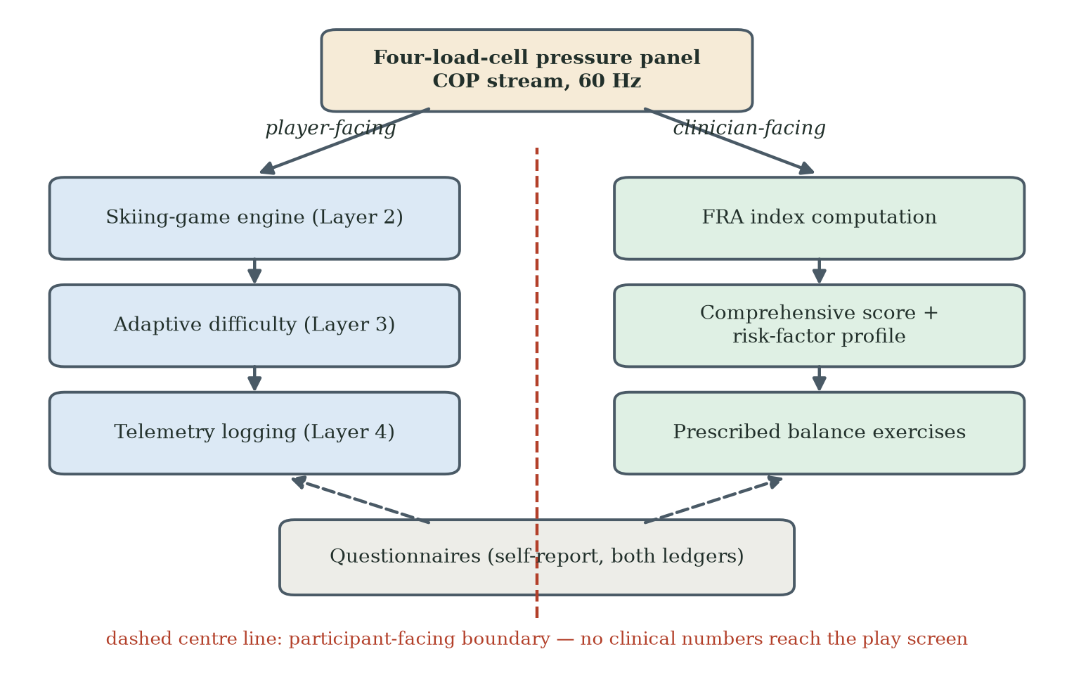
Figure 1. Integration of the FRA system into the skiing game. The four-load-cell pressure panel is shared: the centre-of-pressure stream feeds a player-facing pipeline (game engine, adaptive difficulty, telemetry logging) and a clinician-facing pipeline (FRA index computation, comprehensive score and risk-factor profile, prescribed balance exercises); questionnaires feed both ledgers through self-report. No clinical numbers cross the participant-facing boundary to the play screen.

B. Game Mechanics
Users navigate a downhill ski run filled with obstacles, steering by weight shift; each full run counts as one session cycle. A pre-session assessment set the initial difficulty low enough for the weakest-balance participant to complete safely, so that the first session could produce an experience of success rather than a de facto fall-risk test. Achievements followed Octalysis Drive 2 (Accomplishment) (Chou, 2015) (Figure 2). Figure 3 illustrates the presentation across the five difficulty levels; as its caption discloses, the screenshots come from the programme's archived successor build rather than the deployed Stage-2 build itself. Staff were instructed to use phrases such as 'you are practising a new balance skill' in place of 'you are being tested for fall risk'.
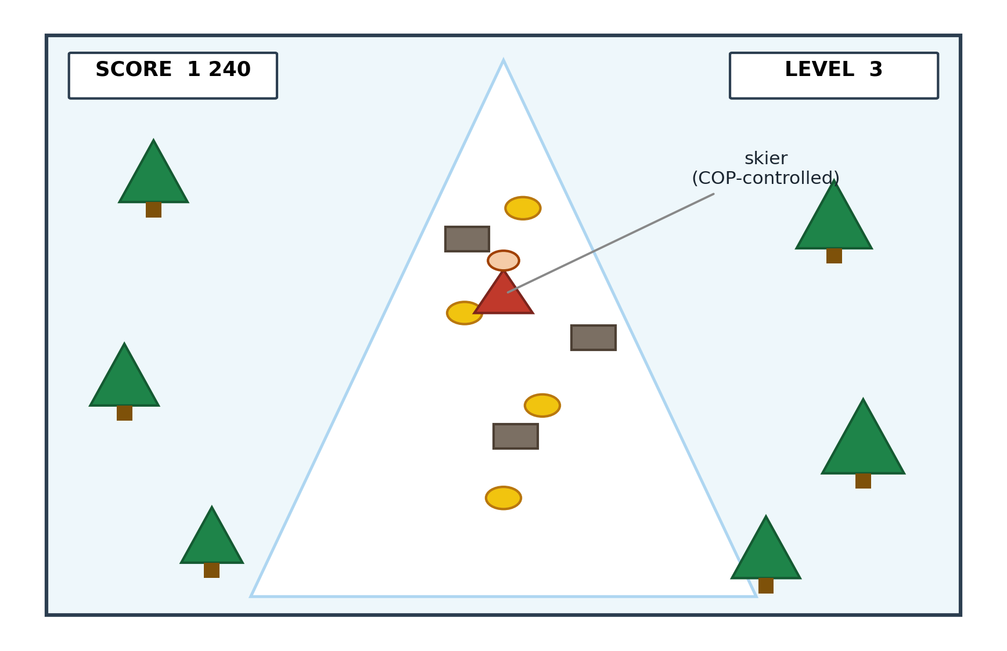
Figure 2. The gamified skiing interface deployed on the InBody balance panel. The user steers the on-screen skier by shifting body weight laterally on the pressure-sensitive panel; each lateral shift is simultaneously logged as centre-of-pressure coordinates for clinical fall-risk analysis.
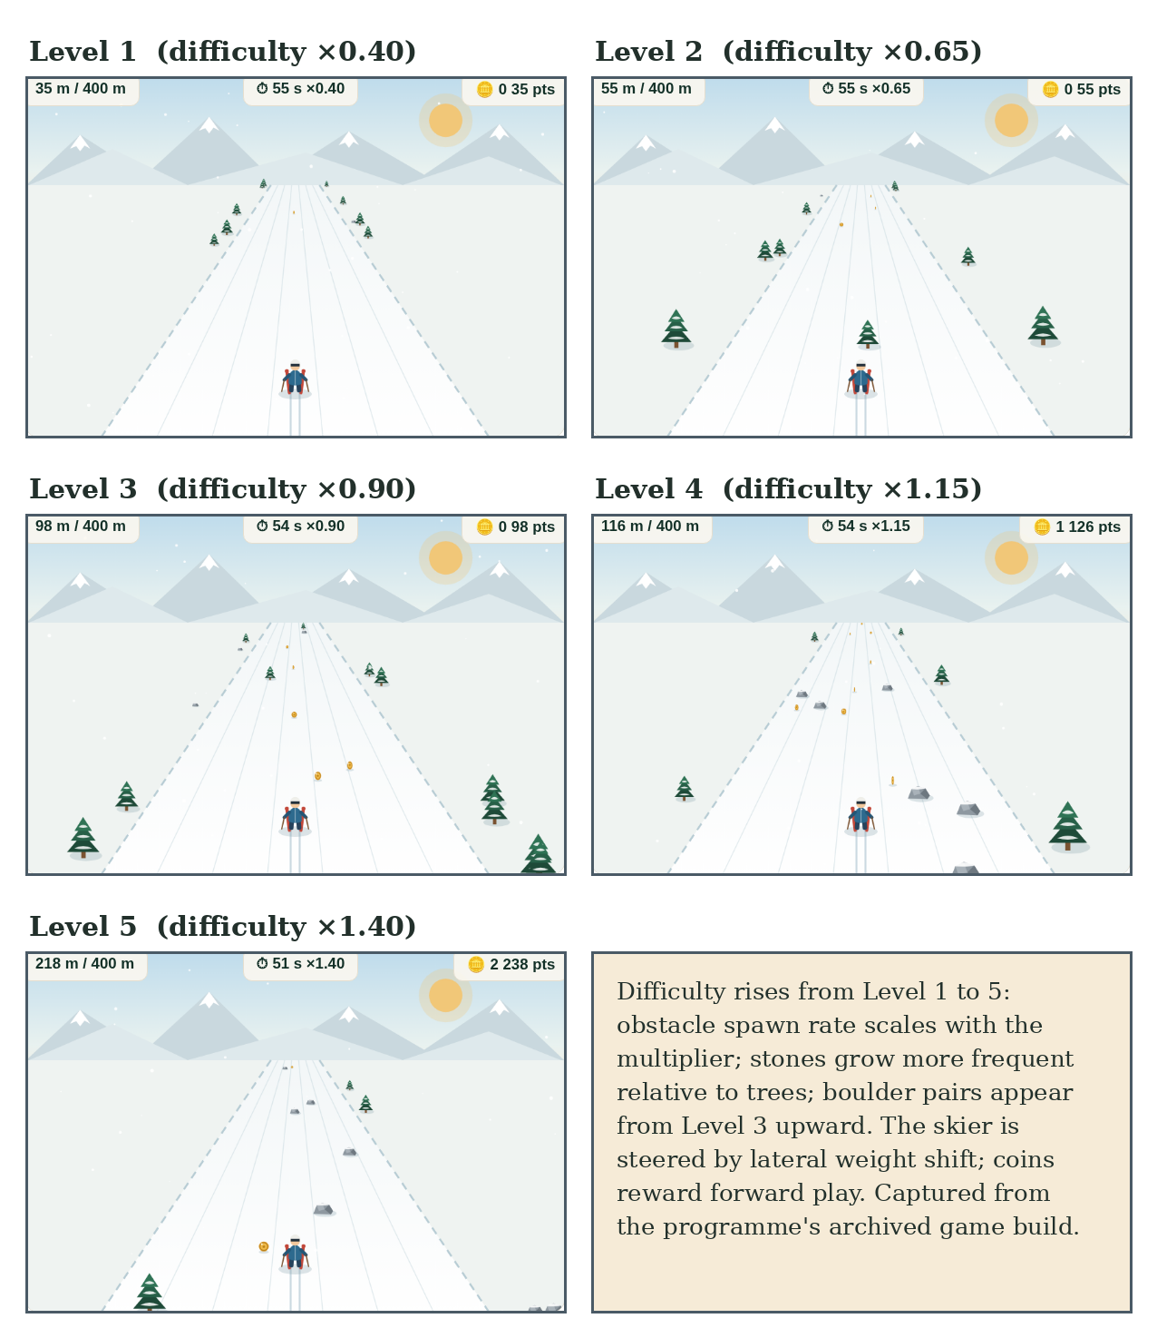
Figure 3. The skiing game across difficulty levels 1-5: obstacle spawn rate scales with the difficulty multiplier (x0.40 to x1.40), stones become more frequent relative to trees, and boulder pairs appear from Level 3 upward. Screenshots captured from the programme's archived game build — the successor build in the same design lineage as the system deployed in this study, not the deployed Stage-2 build itself.
A leaderboard mapped to Octalysis Drive 5 (Social Influence) was trialled, and the strategy backfired. Staff observation and field notes recorded that participants who attended to the leaderboard compared themselves unfavourably with other users and judged themselves more quickly and more negatively; satisfaction appeared lower among those participants. Because the archived dataset does not record leaderboard viewing as a variable, this observation is reported qualitatively and no coefficient is claimed. The pattern is consistent with social comparison theory (Festinger, 1954) and with An et al.'s (2024) conclusion that building confidence matters more than competition in this population. The leaderboard is removed from the confirmatory design.

C. Five-Layer Architecture
The system comprises five layers (Figure 4). Layer 1 (sensor interface): the pressure panel streams COP coordinates in real time, which are simultaneously logged for clinical review. Layer 2 (game engine): the skiing game consumes the COP stream as its control input; the engine was built with AI-assisted code generation from natural-language specifications, with design feedback from players and clinicians folded back into the specification. Layer 3 (AI adaptation): a language-model service, orchestrated through LangChain, reviews performance at five-minute intervals and adjusts obstacle density (one step up above 80% success, one step down below 40%) and speed banding. Layer 4 (logging): completed cycles, per-cycle timing, COP traces, success accuracy, per-cycle affect and symptoms. This layer describes logging capability as designed: the retained study archive preserves completed-cycle counts and session outcomes but no session-level telemetry or timestamps, so the per-cycle quantities listed here characterise the system's design rather than the records retained for analysis (Section VII). Layer 5 (clinical output): pre/post FRA indices and balance measures exported for therapist review. On API delay or loss, the game continues at the last-selected difficulty; all calls are logged with parameters and responses; the AI service has no access to participant identity or health status; staff can manually override at any time. The AI tooling here is an enabling technology — it lowered the cost of iterating engineering decisions that remain the developers' own.
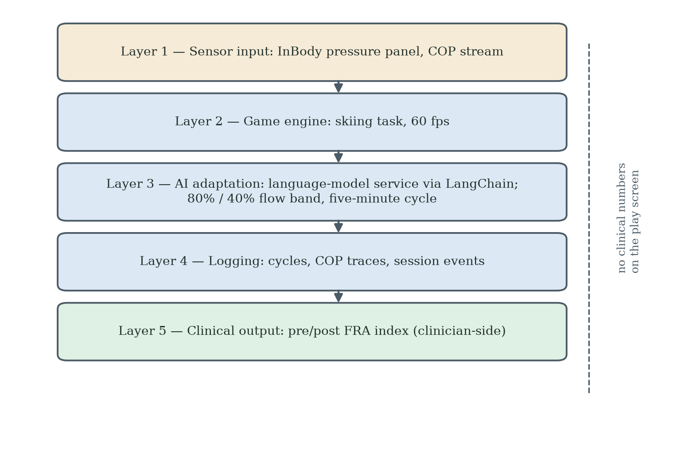
Figure 4. The five-layer system architecture. Layer 1 (sensor input) streams COP coordinates; Layer 2 (game engine) renders the skiing task; Layer 3 (AI adaptation) adjusts difficulty through a language-model service within an 80%/40% flow band; Layer 4 (logging) records cycles, traces and events; Layer 5 (clinical output) computes pre/post FRA indices on the clinician side. No clinical numbers are shown on the play screen.

D. Proposed Coaching Layer (Confirmatory Study)
The present AI layer manages technical difficulty; failure's larger effect may be psychological. The confirmatory study therefore adds a coaching layer governing language and affective tone. Three real-time FIAS risk signals are specified: satisfaction recorded below 'Satisfied' after the first run; no improvement across three consecutive cycles; and participants attributing difficulty to age or physical deterioration. In COM-B terms, coaching addresses reflective motivation through reframing, and staff activation adds social opportunity. Both the risk signals and the coaching and reframing responses are untested intervention hypotheses: none was deployed or evaluated in the present study, and their effects remain to be established in the confirmatory study.

VII. Data Collection and Measures
At the first attendance each participant completed a standard-mode FRA assessment (the FRA used without the game link) before game play began; because the dual-purpose input routes the pressure-panel signal into the same FRA measurement pathway, game play then produced assessment indexes as well. Each session involved performance on the gamified task with its FRA index output; in addition, a five-point satisfaction rating and a symptom-improvement judgement were recorded once per participant, the former via the after-game paper questionnaire and the latter compiled from therapist observation rather than participant self-report. Five variables were collected per participant: V1 cycles completed; V2 pre/post FRA index, where the 'before' value is the standard-mode assessment at first attendance and the 'after' value is the game-generated index from the final play, at whatever week it occurred; V3 symptom change; V4 satisfaction; V5 age and gender. Both indexes are produced automatically by the same measurement engine from the same centre-of-pressure pathway, so they share a scale; but pre/post changes span different exposure durations, for participants with one completed run the pair derives from that single recorded play, and the two values arise under different task contexts (assessment protocol versus game play), so the measured change contains any context effect alongside balance change. Individual Octalysis and STAM questionnaires could not be administered as initially planned. Session-level temporal data (inter-session intervals, durations) were not captured. A higher FRA index signifies better balance; the direction of recorded index change was checked against the symptom-improvement entries as part of verification (Section VII-A).
Therapist observations entered the record during the deployment itself. Therapists observed players during gameplay sessions in the course of ordinary facility practice and relayed their observations to the researcher on a near-daily basis across the eight weeks; the researcher recorded these accounts in field notes at the time. The observational record is therefore contemporaneous with the deployment, not a later reconstruction from recall. The therapists kept no written per-participant records of their own; attribution of observations to individual participants was performed by the researcher when compiling the field notes.
Table 2 provides a data dictionary for the archived variables, giving the source of each and the clarifications needed to read it correctly. Three clarifications bear emphasis. First, the exact administered wording, response options and timing of the satisfaction rating have not yet been reproduced from the instrument; the recorded values include 'Very satisfied', 'Satisfied', 'No comments' and 'Dissatisfied', and 'No comments' is not read as a neutral rating. Second, wherever satisfaction enters an analysis as a binary contrast, the second category is defined as all other recorded responses (including 'No comments'), not as 'dissatisfied'. Third, the verified flag records a therapist's check of the recorded contents against their knowledge of the participant: it is an accuracy check on the record, not a measure of self-efficacy or psychological confidence.
Table 2. Data dictionary for the archived study variables: source and clarifications.
Variable | Source | Clarifications
Before-game index | InBody FRA composite index from a standard-mode FRA assessment at the participant's first attendance, before game play (the FRA used without the game link). | Higher values indicate better performance; the manufacturer calibrates the population average near 70 and reports positive correlations with the Berg Balance Scale and the Short Physical Performance Battery (InBody Co., Ltd., 2022).
After-game index | Game-generated index from the final attended gameplay episode; the dual-purpose input routes the same centre-of-pressure stream into the same measurement engine. | Recorded for all participants, including those with few completed runs; for one-run participants the before/after pair spans a single attendance, and post-measurement timing varies by participant.
Game cycles | System-recorded count of completed downhill runs; one cycle is one completed run under the five-attempt rule. | The archive records completed-run counts, not attended visits: runs are not equated with sessions or visits, and incomplete attempts are not separately recorded.
Symptom improvement | Therapist observation (workbook column), relayed to and compiled by the researcher. | Not a participant self-report measure; reconciliation with the after-game questionnaire remains outstanding.
Satisfaction | Five-point scale rating recorded per participant via the after-game paper questionnaire. | Recorded values include 'Very satisfied', 'Satisfied', 'No comments' and 'Dissatisfied'; the exact administered wording, response options and timing have not yet been reproduced. 'No comments' is not a neutral rating; binary contrasts use 'Satisfied'/'Very satisfied' versus all other recorded responses.
Verified flag | Therapist check of the recorded contents (including improvement and cycle counts) against their knowledge of the participant. | An accuracy check on the record, not a measure of self-efficacy or psychological confidence; one study record could not be verified.

A. Data Verification and Withdrawal Statement
All statistics in this paper were recalculated from the raw 30-participant dataset, and only statistics that reproduce from that archive are reported. Verification steps: (1) the direction of FRA index change was checked against the recorded symptom-improvement entries to confirm scale directionality; (2) all means, standard deviations and effect sizes were recalculated from individual records — sustained participants (N = 9): +6.9 ± 3.1 points (95% CI 4.5-9.3; paired dz = 2.22, 95% CI 0.95-3.46); all participants (N = 30): +4.0 points (95% CI 0.5-7.6; dz = 0.42, 95% CI 0.05-0.79); (3) the low-engagement rate reproduced at 70.0% (95% CI 52.1-83.3%) and the single-completed-run rate at 26.7% (95% CI 14.2-44.4%); (4) the satisfaction association with sustained engagement was confirmed (9/9 versus 11/21; Fisher's exact p = 0.013).
A per-record verification flag complements these checks: the therapist reviewed each record's contents, including the symptom-improvement entry and the completed-cycle count, against their knowledge of the participant; the flag records whether a record's contents could be checked, not any psychological attribute of the participant. One study record could not be verified — that of a female participant aged 72, with one completed run, a recorded index change from 35 to 38, and a recorded satisfaction rating of 'Dissatisfied'. Her subsequent identification and location for verification could not be completed, the reason for her non-return is unknown, and no inference about that reason is drawn; in particular, this case is not treated as evidence of failure-induced abandonment. The record is retained in the primary analysis because eligibility follows the provenance of the record — it originates from an attended study session — and not the favourability of its values.
A sensitivity analysis was computed with and without this record. With all thirty records, the mean FRA index change is +4.03 points (95% CI 0.47–7.60; paired t p = 0.028) and the satisfaction–sustained-engagement association gives Fisher's exact p = 0.013; excluding the unverified record (n = 29), the corresponding values are +4.07 points (95% CI 0.38–7.76; p = 0.032) and p = 0.027. The pattern is similar under both analyses, and the primary analysis reports all thirty records.
Table 3. Sensitivity analysis of the principal statistics with and without the unverified record. The primary analysis retains all thirty records; eligibility follows record provenance, not the favourability of values.
Statistic | All records (n = 30) | Unverified record excluded (n = 29)
Mean FRA index change (points) | +4.03 | +4.07
95% CI for mean change | 0.47–7.60 | 0.38–7.76
Paired t test, p | 0.028 | 0.032
Satisfaction–sustained-engagement association (Fisher's exact test), p | 0.013 | 0.027
Withdrawal statement. Three statistics reported in earlier drafts have been withdrawn and do not appear in this paper. A Cox proportional-hazards model and Kaplan-Meier analysis were withdrawn because the archived dataset preserves no time variable and cannot support time-to-event modelling. A week-2 motivational-orientation classification and its odds ratio were withdrawn because the classification variable does not appear in the archived dataset and its coding records could not be produced. Pooled and zero-imputation effect sizes were withdrawn because they did not reproduce from the archive. The confirmatory study replaces these with pre-registered instruments administered at baseline and session-level logging with timestamps.

VIII. Quantitative Findings

A. Statistical Methods
Three methods are used, matched to a small single-site sample. Proportions carry Wilson score 95% confidence intervals. Within-participant change in the recorded FRA index is analysed with paired t and Wilcoxon tests, with exact noncentral-t confidence intervals for the paired effect size dz (Cohen, 1988). Associations between binary characteristics and sustained engagement use Fisher's exact test; the satisfaction contrast compares recorded ratings of 'Satisfied' or 'Very satisfied' with all other recorded responses (including 'No comments'), not with 'dissatisfied' (Section VII). No time-to-event modelling is used or reported (Section VII-A).

B. Recorded Balance-Index Changes
Table 4. Recorded FRA index changes, sustained participants (N = 9).
Measure | Gamified FRA
Baseline FRA index (mean ± SD) | 42.0 ± 8.3
Post-intervention (mean ± SD) | 48.9 ± 9.4
Change (mean ± SD; 95% CI) | +6.9 ± 3.1 (4.5–9.3)
Cohen's dz (paired; 95% CI) | 2.22 (0.95–3.46)
Improvement (therapist-observed) | 7/9 (78%)
Satisfaction (Satisfied/Very Satisfied) | 9/9 (100%)
Table 4 reports the recorded index changes for the nine participants who sustained engagement (≥ 4 completed runs — an exploratory grouping, formalised retrospectively around the protocol's three-to-five-play lower bound); this subgroup is defined by subsequent participation rather than by prior assignment, so its favourable changes cannot be read apart from that selection. Across the full sample of thirty, the paired change was +4.0 points (95% CI 0.5-7.6; dz = 0.42, 95% CI 0.05-0.79); this sample includes one record that could not be verified (Section VII-A), and the sensitivity analysis reported there shows a similar pattern with that record excluded (n = 29: +4.07 points, 95% CI 0.38-7.76; p = 0.032). As noted in Section VII, the paired values arise under different task conditions — a standard-mode assessment at first attendance against the game-generated index from the final attended play — so the recorded change contains any context effect alongside balance change, and exposure duration and endpoint timing differ across participants. A within-deployment change of this size may further include measurement variation, familiarisation and practice effects. Because this was a single-group observational deployment, the design does not isolate the causal effect of gamification; the figures are therefore reported as recorded changes, and a favourable difference does not of itself demonstrate a clinically meaningful benefit.
Table 5. Recorded FRA index changes, low-engagement group (cycles ≤ 3, N = 21).
Measure | Gamified FRA
Baseline FRA index (mean ± SD) | 44.7 ± 12.0
Post-intervention (mean ± SD) | 47.5 ± 11.5
Change (mean ± SD) | +2.8 ± 11.1
Improvement (therapist-observed) | 11/21 (52%)
Satisfaction (Satisfied/Very Satisfied) | 11/21 (52%)
Table 5 reports the low-engagement group: despite minimal engagement, it shows a mean change of +2.8 points with high variability. Only 52% have a recorded rating of Satisfied or better or a therapist-observed improvement entry, against 100% of sustained participants — satisfaction and sustained engagement are strongly associated (Fisher's exact p = 0.013).

C. The Engagement and Non-Return Pattern
Table 6. Engagement pattern (N = 30).
Measure | Value (95% CI)
Low engagement (≤ 3 cycles) | 21/30, 70.0% (52.1–83.3%)
Sustained (≥ 4 cycles) | 9/30, 30.0%
Single-session exits (1 cycle) | 8/30, 26.7% (14.2–44.4%)
Re-engagement after disengagement | 0/21, 0.0% (0.0–15.5%)
The cycle distribution was: eight participants completed one cycle, seven completed two, six reached three, one reached four, five reached five, and three reached six. Of the 21 low-engagement participants, none has a later recorded run within the eight-week window. This absence of documented return within the window distinguishes the pattern from typical usage attrition, in which some users return (Eysenbach, 2005). Eight participants (26.7%) have a single recorded completed run (Figure 5). No time-to-event model is reported: the archive preserves cycle counts, not timestamps. The evidential core of the pattern is carried by the three directly observed quantities in Table 6 and by the satisfaction association above.
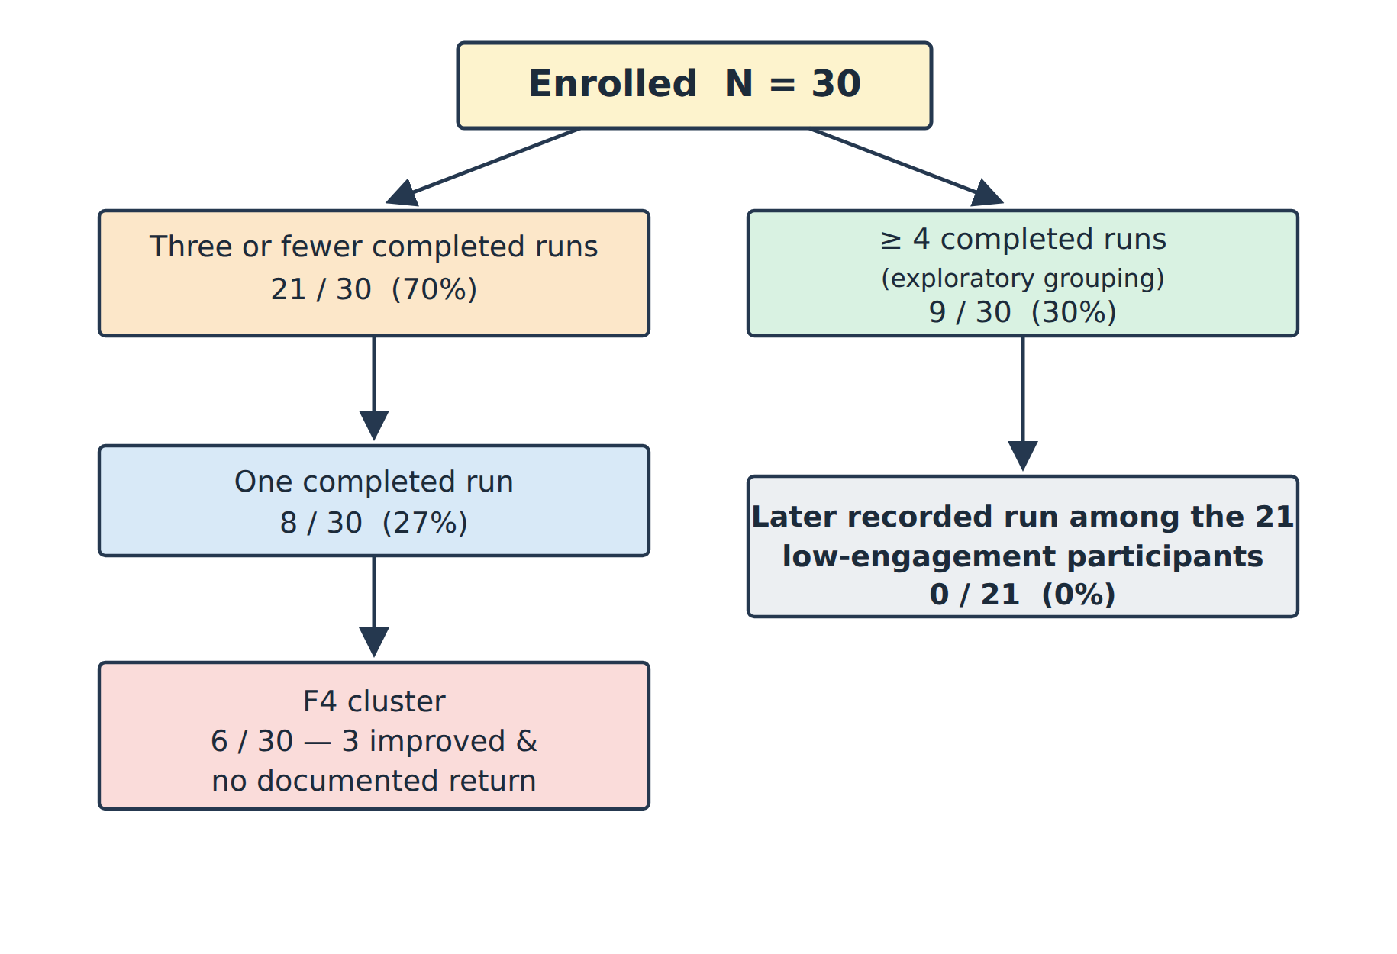
Figure 5. Participant flow (N = 30). Twenty-one participants had three or fewer recorded completed runs, including eight with a single completed run; six formed the F4 cluster, of whom three recorded an improved FRA index in their only recorded run and still never returned. No later recorded run was observed among the 21 (0 of 21).

IX. Qualitative Coding and the FIAS Composite
All 30 participants were coded with thirteen binary attributes (Table 7) drawn from STAM constructs and selected Octalysis drives, collapsed onto a 0-10 composite. The composite is a descriptive case-identification device and carries no evidential weight: several attributes record engagement and exit behaviour, so a participant who left early necessarily scores high, and the clustering of the F4 group at the top of the scale is partly true by construction. The attribute labels borrow construct names from STAM and Octalysis as organisational shorthand only: each coding rule operates on recorded behavioural fields — cycle counts, satisfaction ratings, recorded improvement and the therapist verification flag — and none of these fields measures the named psychological construct. The verification flag, in particular, records the therapist's check of recorded contents against their knowledge of the participant, not participant confidence or self-efficacy; no psychological state is inferred from cycle counts or satisfaction ratings in any evidential claim. Every evidential statement in this paper rests on directly observed behaviour — completed-run counts, documented non-return within the window, and the divergence between recorded score direction and return.
Table 7. Coding scheme (abbreviated; 8 of 13 attributes).
Attribute | Coding rule | Rationale
STAM-PU | Symptom improvement AND FRA index improved | Perceived clinical usefulness
STAM-PEOU | Satisfaction ≥ Satisfied AND cycles ≥ 2 | System manageable
STAM-BI | Satisfaction ≥ Satisfied | Continuation-intention proxy
STAM-GSE | Cycles ≥ 3 AND verified | Self-efficacy through repeated success
STAM-GA | Satisfaction recorded as Dissatisfied OR (1 completed run AND no observed improvement) | Anxiety signal
D2 (Accomplishment) | Cycles ≥ 4 AND improvement | Progress achieved
D5− (Neg. social) | Runs ≤ 2 AND no observed improvement AND satisfaction not recorded as Satisfied/Very satisfied | Social withdrawal
D8 (Loss/avoidance) | 1 cycle AND no improvement | Loss-aversion exit
Table 8. Composite score distribution (descriptive).
Level | n | Score | Age range
F0 (none) | 4 | 0 | 63–69
F1 (low) | 14 | 1–2 | 62–84
F2 (moderate) | 3 | 3–4 | 67–73
F3 (high) | 3 | 5 | 62–70
F4 (strong) | 6 | 9–10 | 65–80
The empty interval between scores 5 and 9 (Table 8; Figure 6) is not read as evidence of a behavioural threshold: given the construction, it may be a mechanical effect of the scoring thresholds and outcome-linked items, or sampling variation in a cohort of thirty. What matters about the F4 group does not depend on the composite: three of its six members recorded a positive FRA index change in their single session and did not return. That divergence between recorded improvement and return behaviour challenges a purely clinical explanation of dropout and is the observation that most clearly motivates the identity-level account of the Discussion.
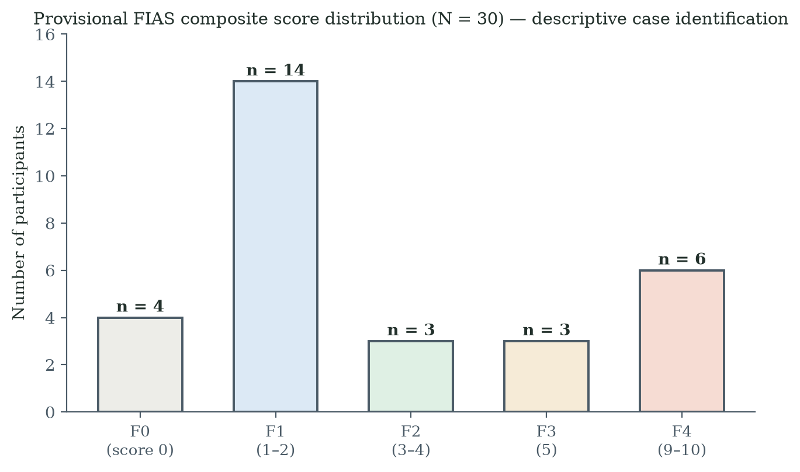
Figure 6. Distribution of provisional FIAS composite scores (N = 30). The composite includes engagement-outcome attributes, so the separation of the F4 cluster is expected by construction; the figure is descriptive case identification, not evidence, and the empty interval between scores 5 and 9 is not read as a behavioural threshold.

X. Qualitative Record and the F4 Interview Protocol (Designed, Not Administered)
The qualitative record on the persistence side comprises the post-deployment interviews with the nine sustained participants, conducted one to two days after the eight-week cycle using a paper interview questionnaire (Mandarin or Cantonese at the participant's preference; the researcher's contemporaneous notes are the primary record), together with three centre-manager interviews. The instrument's structure is documented in the author's entry-and-results record (archived with the study data): nine items - memorable experience (free text); enjoyment, FRA usefulness and discouragement (1-5); steering confidence and recovery confidence (0-10); play-again and FRA-again willingness; and reasons (free text). Entered ratings: enjoyment mean 4.3, usefulness 4.7, discouragement 1.9, steering confidence 7.4, recovery confidence 7.7; nine of nine would play again and nine of nine were willing to continue with the FRA. Two of the nine spontaneously remarked that they did not understand why others would not try the system; four criticised the visuals as weak or childish while rating the experience highly; and one record contains an internal contradiction between a disclaimed and an endorsed usefulness judgement, retained as recorded. The exact administered wording awaits verification against the paper forms. These interviews describe the experience of persistence only; they cannot establish the internal reasons of participants who discontinued.
A nine-question semi-structured interview protocol was designed for F4-cluster participants, to probe within days of a participant's last recorded run whether the decision to stop was immediate or deliberate (Table 9); questions 3 and 4 address H2 and H3, question 7 addresses H4, and question 9 probes domain reframing. The protocol was not administered in the present deployment - the F4 residents' negative reaction to the experience made a research interview inappropriate at the time - and no F4 interview data exist; it is specified for the confirmatory study. The deployment's qualitative record comprises the after-game paper questionnaire completed by all thirty participants (the source of the satisfaction data); post-deployment interviews with all nine sustained participants, conducted one to two days after the eight-week cycle in Mandarin or Cantonese via a paper interview questionnaire, with the researcher's notes as the primary record; and three interviews with centre managers capturing the operator perspective. Themes were developed by the researcher from the contemporaneous field notes, compiled through near-daily contact with the therapists over the eight weeks; reported speech from the field notes and interview records is paraphrase unless explicitly marked as verbatim, and observations that run against the proposed mechanism are retained rather than reconciled away (Table 8). Because the sustained-participant interviews sample only those who continued — a subgroup defined by the outcome itself — their content can inform an account of persistence; it cannot establish the internal reasons of the participants who discontinued, which remain undocumented in this deployment and are assigned to the confirmatory study's interview protocol.
Table 9. F4 interview protocol.
Q | Question | Tests
1 | Describe what happened in your last session | Account
2 | How did you feel when the session ended? | Immediate anxiety
3 | When did you decide not to come back? | H2: impulsive vs deliberate
4 | What were you thinking about your performance? | H3: health identity
5 | Did others' opinions matter? | Social comparison
6 | Did you connect difficulty to your age? | Age attribution
7 | If easier, would you have continued? | H4: technical vs psychological
8 | Anything that would make you try again? | Permanence
9 | If described as a reaction-speed game instead of a health test, would that change how you felt? | Domain-reframing probe

XI. Discussion

A. RQ1: Did Gamification Help?
For the nine who sustained engagement — a subgroup defined by subsequent participation — the recorded change was +6.9 FRA index points (95% CI 4.5-9.3; dz = 2.22), with all nine satisfied or very satisfied; across all thirty, +4.0 points (95% CI 0.5-7.6). These are recorded within-deployment changes rather than demonstrated effects of gamification: the design does not isolate gamification's causal contribution, and a favourable recorded difference does not of itself demonstrate clinically meaningful benefit (Section VIII-B).

B. RQ2: Why Does Abandonment Persist?
The pattern has three defining features. It is early: 70.0% of participants have three or fewer recorded completed runs, and 26.7% have one. It is absolute within the window: none of the 21 has a later recorded run (95% CI 0.0-15.5%), unlike ordinary usage attrition (Eysenbach, 2005). And it is not accounted for by satisfaction ratings alone: although satisfaction and engagement are strongly associated (p = 0.013), three F4 participants improved on the recorded index in their only recorded run and still never returned. Practical obstacles — usability, staffing, cost, scheduling — do not explain a pattern in which the technology was free, supervised, on site, and in documented cases the recorded index had risen for the person who walked away. The evidence is consistent with a psychological mechanism attached to the meaning of failure. The field notes additionally record the sequence in which the pattern unfolded: several players acknowledged the FRA's benefits and recorded index gains, encountered recurring in-game failures across their second and third cycles, and gave up despite the gains; and as dropouts accumulated, remaining players saw the thinning group, which contributed to further abandonment (field-note record retrieved from the archive during verification; a qualitative sequence, not an instrumented measure).
Table 10 assembles this qualitative record systematically, pairing each finding with the record that supports it and with the principal alternative interpretation. The designed F4 interview protocol was never administered (Section X), so no F4 interview material appears; contradictory cases are retained in the table rather than reconciled away.
Table 10. Qualitative findings, supporting records, and alternative interpretations.
Finding | Supporting record | Alternative interpretation
Collapse sequence: players acknowledged the FRA’s benefits and recorded index gains, met recurring in-game failures across their second and third runs, and gave up despite the gains. | Contemporaneous researcher field notes, compiled from near-daily therapist reports during the eight-week window; a qualitative sequence with no per-participant counts. | Ordinary attrition (novelty wear-off) coinciding with the second and third runs; the ordering rests on the note-taker’s account, not on instrumented timing.
Visible-dropout social channel: remaining players saw the group thinning as dropouts accumulated, which contributed to further abandonment. | Same field-note record, retrieved from the archive during verification. | A collective, socially shared narrative about the station (Section XII); visible thinning may reflect, rather than cause, exit decisions already made.
Verdict-fear stance: ‘the game is fun… but I do not want it telling me where my health problems are’ — a paraphrase from the researcher’s notes, not a verbatim quotation. | Stage-2 interview record (researcher’s notes as the primary record). | The interview record reaches sustained participants and centre managers only; the stance shows the salience of the clinical frame but cannot establish the internal reasons of those who discontinued.
Satisfaction and observed symptom improvement tracked engagement: 9/9 sustained participants recorded satisfied or very satisfied, against 11/21 in the low-engagement group. | Symptom-improvement entries compiled by the researcher from therapists’ near-daily verbal reports (therapists kept no written per-participant records); satisfaction ratings from the after-game questionnaire.; satisfaction ratings from the after-game participant questionnaire | Selection by outcome: the association may run in reverse, longer participation giving more opportunity for improvement and a positive rating; individual attribution of therapist observations was performed by the researcher at compilation.
Gains without return: most low-engagement participants left despite recorded index gains (group mean +2.8), and three F4-cluster members recorded an improved index in their single completed run yet did not return within the observation window. | Workbook index records paired with documented non-return within the observation window (no later recorded runs, corroborated by field observation). | Recorded gains of this size may reflect measurement variation or familiarisation; and because no clinical numbers were shown on the play screen, non-return need not have been decided in knowledge of the recorded gain.
Sustained-side puzzlement at non-participation: two of nine interviewees said they did not know why others would not try | Sustained-participant interview entry record (nine records; archived 10 September 2026) | Politeness or interviewer effect; a sustained-only view that cannot describe non-participants' reasons
Aesthetic criticism co-existing with satisfaction: four of nine criticised the visuals as weak or childish while rating enjoyment 4-5 | Same interview entry record | Cohort-specific taste; consistent with the infantilisation risk raised in expert consultation, but not evidence of its behavioural effect

C. RQ3: The FIDS-FIAS Mechanism
The proposed mechanism has two steps: FIDS names the initial dropout — first failure collapses task self-efficacy and the participant withdraws; FIAS names the consolidation — loss aversion makes re-engagement a gamble on further unwelcome evidence about one's own body, so the participant never returns. H1-H4 operationalise the account (Figure 7). Field observation during the deployment was consistent with it: participants who spoke about the activity in learning terms tended to sustain engagement, while those who spoke in health-deficit terms tended to exit early. Because the week-2 classification that formalised this observation was withdrawn (Section VII-A), the pattern is reported as a field observation and a hypothesis for the confirmatory study, not as a measured effect. In the wider programme's vocabulary, FIDS is the earlier, attrition-derived label and FIAS the corrected name for the overall pattern of active, persistent non-return; this paper retains both terms to mark the two steps of the proposed mechanism - the initial dropout and its consolidation into permanent abandonment - which map directly onto that correction.
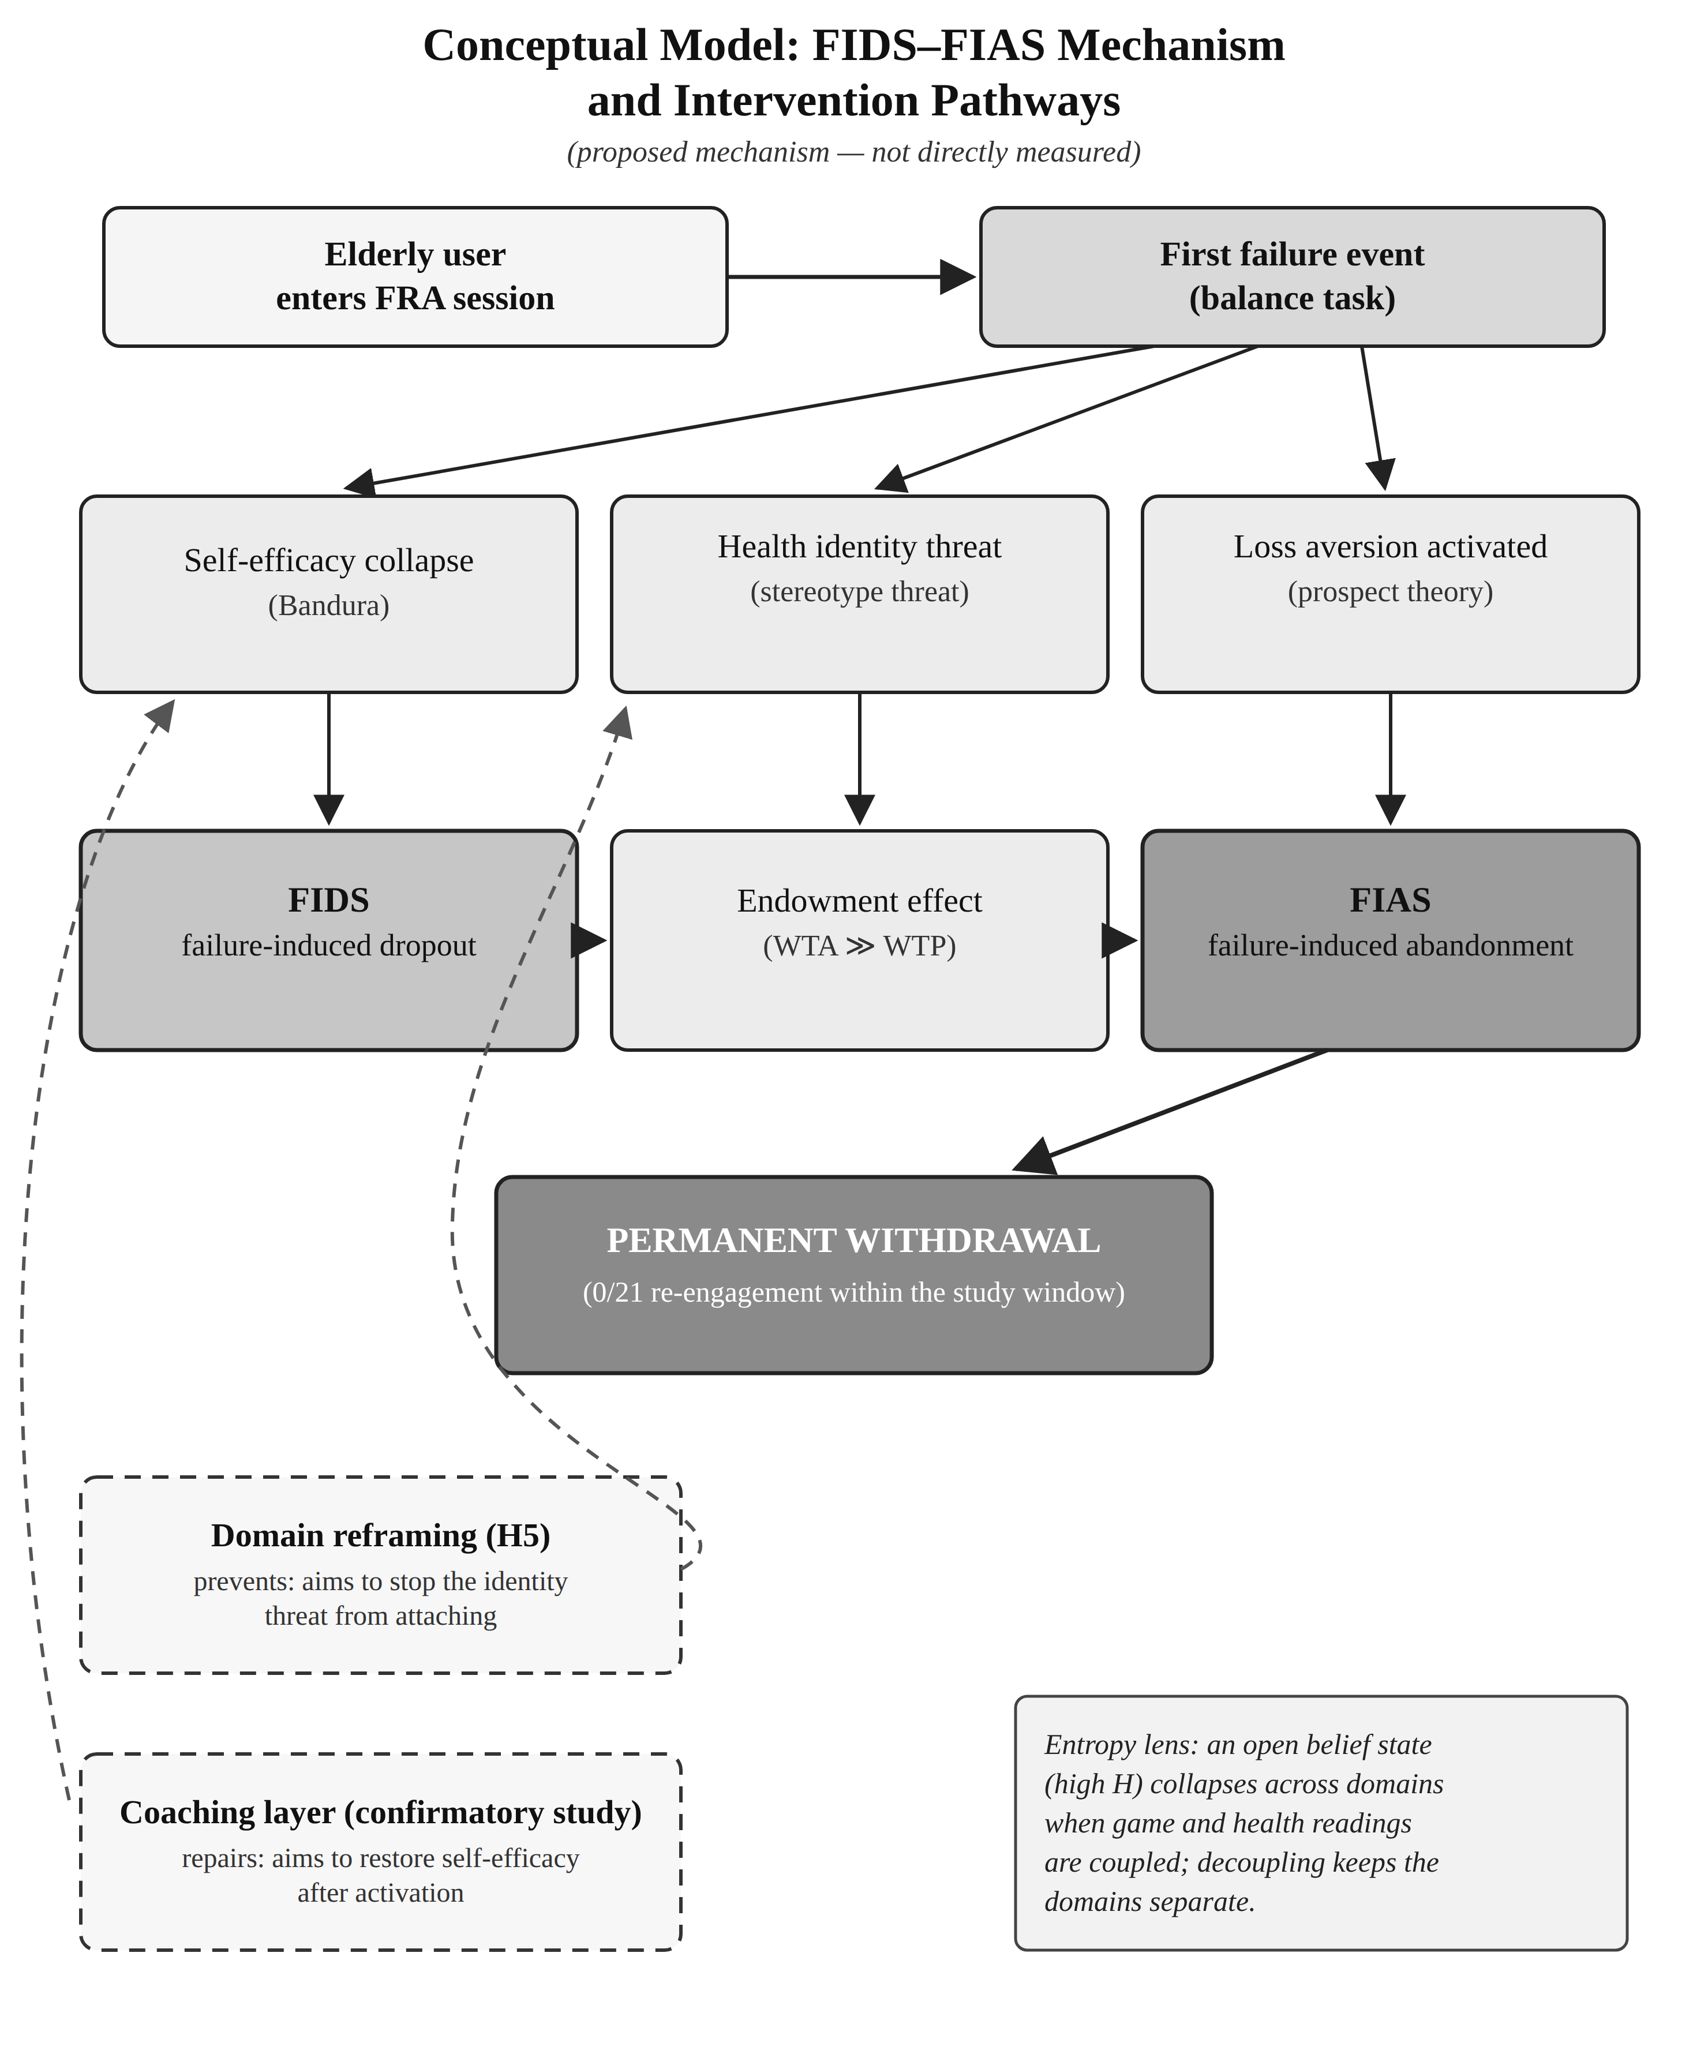
Figure 7. Conceptual model of the proposed FIDS-FIAS mechanism and intervention pathways: a first failure event collapses self-efficacy (FIDS), after which loss aversion consolidates permanent withdrawal (FIAS); the two intervention routes for confirmatory testing are domain reframing (H5, prevention) and the coaching layer (repair). The mechanism is proposed, not directly measured.

D. Extended Theory: Endowment, Stereotype Threat, Domain Reframing
Three further perspectives are offered as theory for confirmatory testing, not as findings. The endowment effect (Kahneman et al., 1990; Thaler, 1980): people value what they possess above what they might acquire, with willingness-to-accept (WTA) a loss typically exceeding willingness-to-pay (WTP) to obtain the same item. Applied here: an elderly participant arrives carrying an endowed, identity-level asset — their health self-concept. A clinically framed failure threatens to devalue it; the WTA for accepting that devaluation is extremely high, and the WTP for re-engagement — bounded by finite expected benefits — cannot match it. Identity-protective cognition research suggests people do treat core self-beliefs as possessions to defend. Extending endowment to an intangible self-concept is a theoretical step requiring validation. Stereotype threat (Barber, 2017; Dionigi, 2015): activating negative ageing stereotypes degrades older adults' performance, predominantly as self-concept threat (Barber, 2017); reframing a task from trait measurement to skill activity reduces the threat (McGlone & Aronson, 2006). Domain reframing draws the threads together: frame task performance as a trainable skill with variable outcomes, not a measurement of fixed capacity. With no fixed reference point, there is no endowed asset; with nothing to lose, the FIAS cascade has nothing to initiate. Prediction (H5): participants under an instant-response-test framing will show lower documented non-return than under FRA framing, performing the identical physical task.
Ethical note. If the game is framed as a response test while FRA data are captured in the background, participants must still be informed that balance patterns are recorded. The recommended consent wording leads with the response-test framing and discloses the dual purpose: 'this game measures how quickly you can react to obstacles — it also helps us understand your balance patterns.' Disclosure is preserved; the identity-threatening frame is not imposed.

E. A Knowledge-Management Reading: Four Unresolved Links
Read in knowledge-management terms, the deployment shows how far along its intended path the assessment knowledge can be traced and where the record stops. Generation and capture were built into the architecture: the same centre-of-pressure stream that steered the game was converted into FRA indices exported for therapist review, so creation and codification were carried by the system itself. From that point onward, however, four links in the knowledge chain were not individually recorded: what the therapist learned from each participant's assessment output; what, if anything, was communicated back to the participant; how the participant responded to any such communication; and whether that response connected to the participant's later participation. These links are stated here as unresolved questions, not findings. In particular, non-return does not by itself establish that a participant rejected the clinical knowledge the system produced: a person may stop playing while accepting the assessment's content, or keep playing while discounting it, and the archived records cannot distinguish these cases.
What the study adds to knowledge management is therefore a located problem rather than a resolved mechanism. In a system where knowledge generation is automatic, the least documented links were the interpretive and communicative ones between clinician and older user — and it is precisely at the moment of an adverse assessment experience, where the FIDS-FIAS account places its candidate mechanism, that those links would matter most. Recording each link explicitly — what is communicated, how it is received, and what follows — is added to the requirements of the confirmatory programme. This positioning also clarifies the relation to NASSS (Greenhalgh et al., 2017): NASSS supplies the programme-level map of nonadoption and abandonment across users, technology, organisation and context; FIDS-FIAS, if supported, would contribute one individual-level failure-appraisal mechanism within that map. The two operate at different levels and are complementary.

XII. Limitations
The sample of 30 was small (aged 62-84) and drawn from a single residential facility in Southern China; findings apply to this relatively homogeneous cohort and require replication elsewhere. The archive preserves cycle counts and session outcomes but no timestamps, so the temporal texture of disengagement cannot be reconstructed and no time-to-event claims are made. Three statistics from earlier drafts (a Cox hazard ratio, a motivational-orientation odds ratio, and pooled/zero-imputation effect sizes) have been withdrawn for the reasons in Section VII-A — disclosed rather than silent. One further record is reported as unverified (Section VII-A): the participant could not subsequently be identified and located for verification, and the reason for her non-return is unknown. The record is retained in the primary analysis on provenance grounds, is not cited as evidence of failure-induced abandonment, and the sensitivity analysis in Section VII-A shows a similar pattern with and without it (+4.03 versus +4.07 points; Fisher's exact p = 0.013 versus 0.027). The FES-I was not administered. Prospect Theory is a plausible frame but was not directly tested, and extending the endowment effect to health self-concept goes beyond its documented domains; both remain propositions. Neither H5 nor the coaching layer was tested here. The investigator's dual role as observer and participant creates a bias risk that reflexive notes mitigate but do not eliminate. Two rival readings deserve explicit statement rather than silence. The most parsimonious rival is ordinary attrition - boredom or novelty wear-off - but a gradual-decay account predicts declining session frequency before exit and occasional casual returns afterwards, and the record shows neither: recorded runs clustered at three or fewer, none of the 21 low-engagement participants has a later recorded run, and attrition does not select for players whose recorded index was improving; a residual attrition component nonetheless cannot be excluded without timestamps. Second, in a residential facility non-use may also be sustained by a collective, socially shared narrative about what the station signifies - a group-level account that this study's individual-level instruments cannot test. One strand of it is nonetheless anchored by a recorded field observation: the investigator's field notes record that remaining players, seeing that many peers had stopped attending, moved toward abandonment themselves - a field-note record retrieved from the archive during verification, not an instrumented measure. It is acknowledged as a plausible amplifier rather than argued away, and it adds a requirement to the confirmatory programme: at least one group-level design response, with individual clinical metrics never made socially visible. Finally, the cohort is self-selected: thirty of the 200 invited Stage-1 respondents joined, so the sample over-represents residents already willing to approach the station, while the disengagement pattern reported here occurred within that already-willing minority. The pre/post index pair also spans two measurement contexts - standard assessment mode and game play - so recorded change conflates balance change with any effect of the measurement context itself.

XIII. Design Implications for Practitioners
Four principles follow. They are practice heuristics motivated by the present observations rather than tested interventions: the coaching and reframing elements in particular have not been evaluated and await the confirmatory study. First, set first-session difficulty low enough that every user succeeds; the first session's purpose is success, not measurement. Second, make participants comfortable before play — let them talk with residents who completed the process, and have staff accompany them in. Third, watch for the three proposed FIAS risk signals during sessions (satisfaction recorded below 'Satisfied' after the first run; no improvement over three cycles; age-attribution talk) and intervene — adjust difficulty downward, reframe with mastery-oriented language ('your reaction time sped up') rather than performance language ('you missed again'). Fourth — the H5 hypothesis, pending confirmation — describe the session as a response challenge rather than a health assessment, avoid displaying any output the participant could read as a health verdict, and train staff in skill-development language.

XIV. The Entropy Constraint
The 'entropy constraint' named in this section's title is retained as a conceptual label only, for a structural property of any system that couples play with assessment: when game performance and clinical assessment share one physical action, failure in the game can acquire meaning about the participant's health, and domain reframing aims to confine the meaning of failure to the game domain. No information-theoretic quantity is computed or claimed, and the constraint functions here as a design consideration for the confirmatory study, not as a tested model.

XV. Industrial Context and Confirmatory Design

A. Sponsor Requirements and Cost-Effectiveness
The sponsor requires FRA usage above 39% of eligible users, retention of existing infrastructure, PIPL compliance, and no increase in fall risk. The gamified system runs on the existing InBody equipment at negligible added cost (AI-service calls below US$0.50 per session; staff training under half a day per person). Reducing the single-completed-run rate from 26.7% toward 10% would substantially reduce cost per continuing user; the full cost-effectiveness analysis belongs to the confirmatory phase.

B. Three-Arm Confirmatory Design
The confirmatory study marks the shift from exploratory action research to a pre-registered design. Arm 1 (control): the FRA-coupled game, framed explicitly as fall risk assessment, replicating the present conditions. Arm 2 (domain reframing): identical game, hardware and adaptation, framed as an instant response test with no health-assessment language; background FRA capture disclosed as in Section XI-D. Arm 3 (coaching): the FRA-coupled condition plus the coaching layer of Section VI-D. Arm 1 versus Arm 2 tests whether preventing the identity threat works (H5); Arm 1 versus Arm 3 tests whether repairing it after activation works (H1-H4) (Figure 8). A pilot (n = 15-25) precedes a two-site study (n = 60-80) with stratified sampling by age band and baseline FES-I, randomised allocation, and baseline measures including cognitive status (MoCA), PHQ-4, technology familiarity, fall history and a validated motivational measure administered before any outcome is observed. The primary outcome is re-engagement attempt within seven days of first failure. Secondary outcomes include the FRA index, FES-I, satisfaction, three-month fall rate, EQ-5D-5L and staff time. Reporting follows STROBE (von Elm et al., 2007) and SPIRIT-AI (Liu et al., 2020); WHO and regulator guidance on AI in health informs the AI component (FDA, Health Canada, & MHRA, 2021; WHO, 2021). All hypotheses (H1-H5) and endpoints will be pre-registered before data collection. A first element of the wider programme - a pre-registered 2x2 field experiment crossing adaptive against static presentation and zero-failure against failure-possible modes in a new community cohort - has since been launched; the three-arm coupling study remains the decisive test for the claims of this paper.
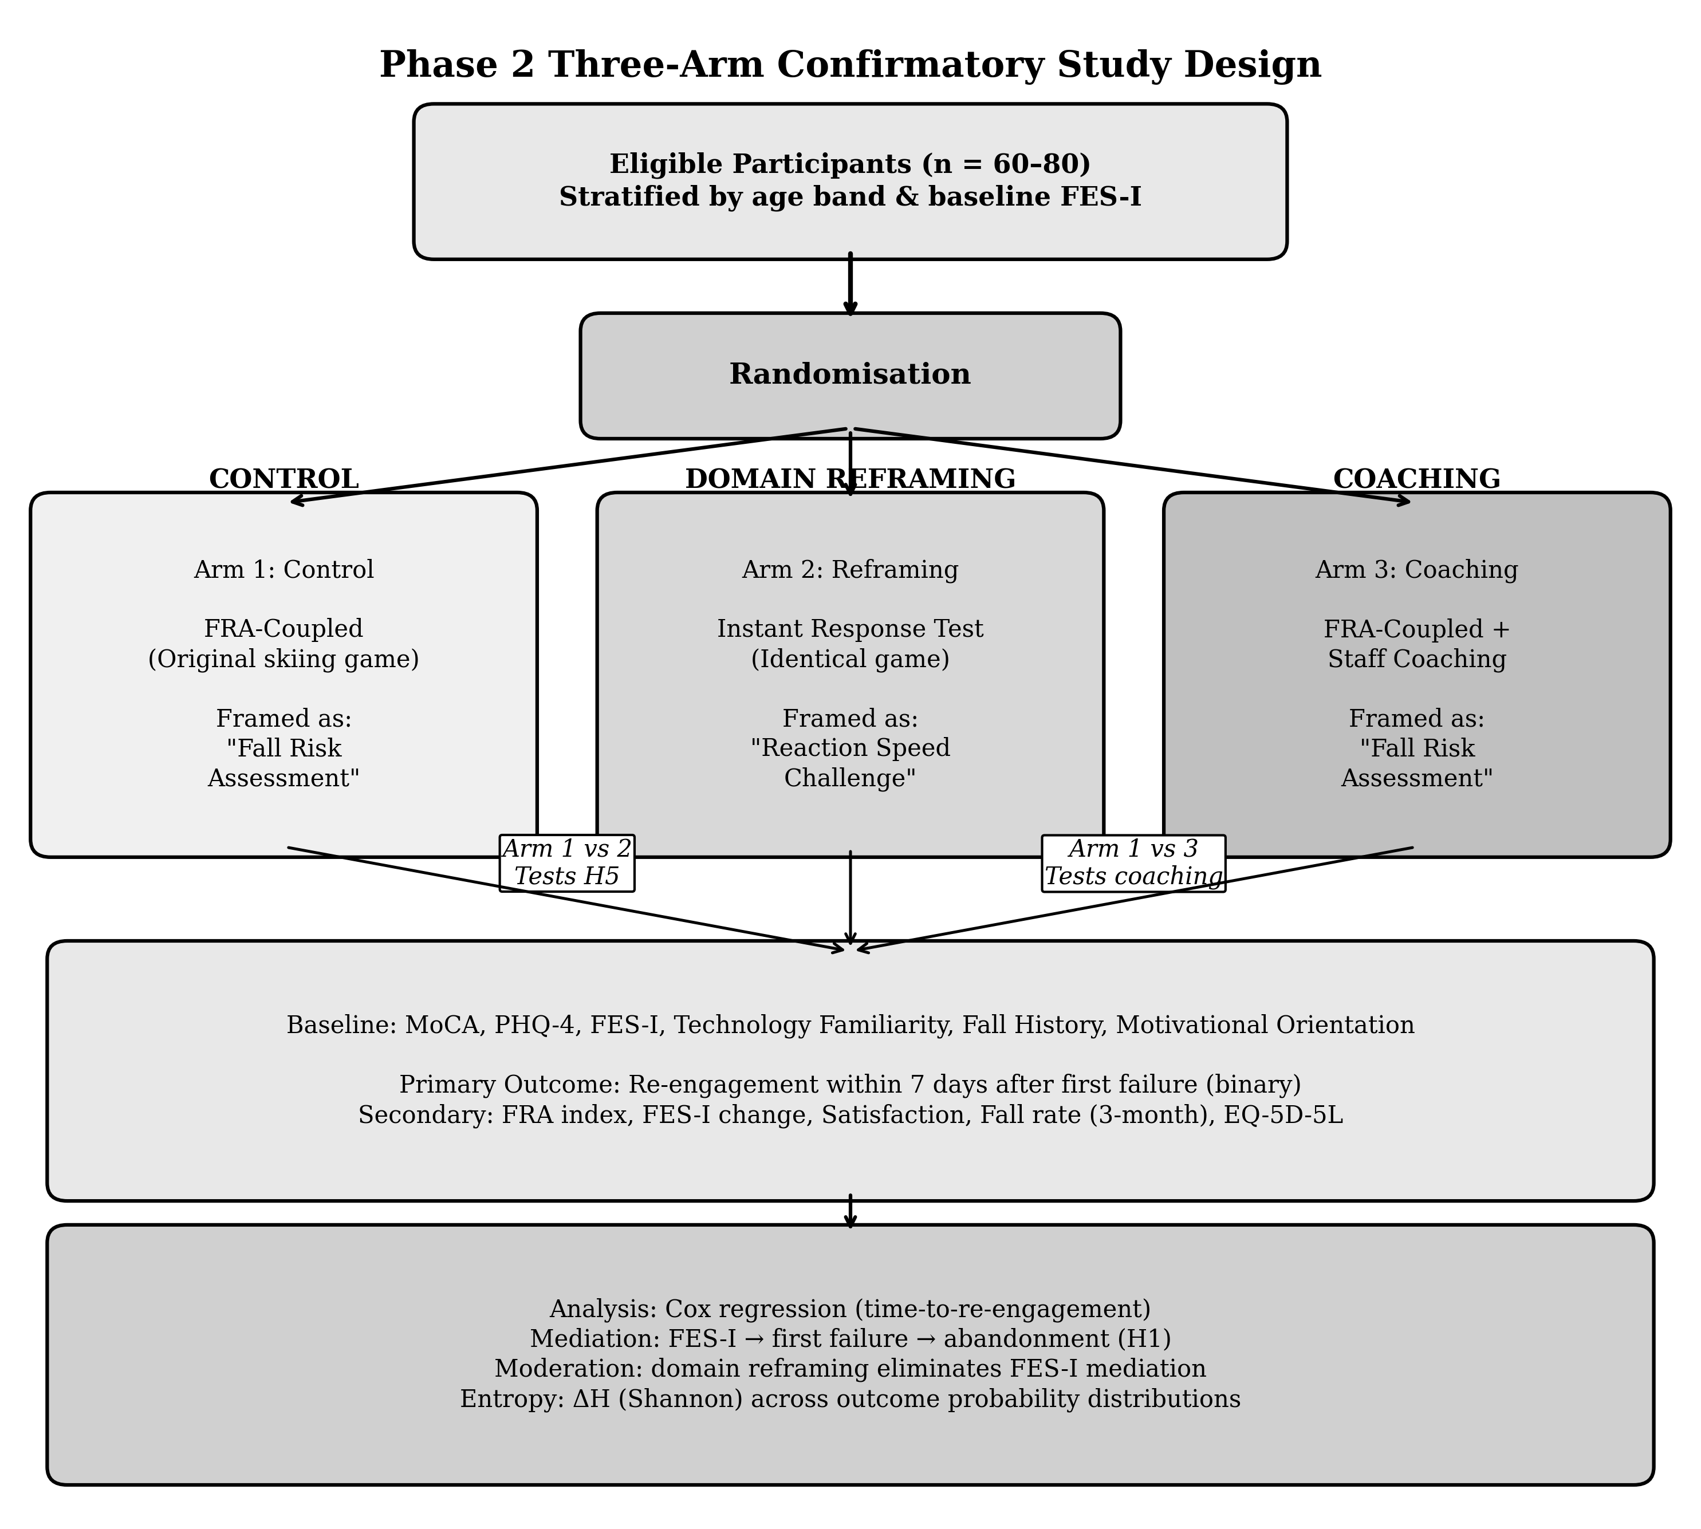
Figure 8. Three-arm confirmatory study design: Arm 1 (control, FRA-coupled), Arm 2 (domain reframing, reaction-speed framing; tests H5), Arm 3 (FRA-coupled with staff coaching; tests H1-H4). Time-to-re-engagement analysis is supportable in this design because session-level logging with timestamps is pre-specified.
An interim between-cohort deployment of a decoupled version of the game with 120 community-dwelling adults, reported in a companion manuscript, provides preliminary quasi-experimental support for the decoupling direction — post-failure return where the present study observed none — while leaving the randomised within-cohort test to the design above.

XVI. Conclusion
This study built and tested a gamified FRA using a dual-purpose input design at a residential care facility in Southern China. Among participants who sustained engagement — a subgroup defined by subsequent participation — the recorded balance index changed by +6.9 points on average (95% CI 4.5-9.3; dz = 2.22), with all nine satisfied or very satisfied; these are recorded changes under a single-group design that does not isolate the causal effect of gamification, not a demonstration that gamification improved balance. But 70.0% never passed three cycles, 26.7% stopped after their first session, no participant returned after disengaging — and three participants whose recorded index improved in their only recorded run were among those who never came back. We propose that initial dropout (FIDS) is associated with self-efficacy collapse and that loss aversion (FIAS) consolidates the withdrawal when game failure is read as evidence of physical decline. Satisfaction was strongly associated with sustained engagement (p = 0.013), and field observation suggested that a learning-oriented reading of the activity accompanied persistence — a suggestion whose formal test belongs to the pre-registered three-arm study, alongside the domain-reframing hypothesis drawn from the endowment-effect (Kahneman et al., 1990; Thaler, 1980) and stereotype-threat (Barber, 2017; McGlone & Aronson, 2006) literatures. The framing of a gamified health technology may matter as much as its engineering; the confirmatory programme is designed to find out. Read at the level of theory, the pattern points to a candidate boundary condition for gamification theory - the theory may hold for older adults until the gamified activity is attached to a clinical verdict that touches identity-level value - a claim consistent with early evidence from the programme's subsequent decoupling deployment (reported separately) and one the three-arm study can test under randomisation.

Declarations
Funding. This research received no external funding.
Conflicts of interest. The authors declare no competing financial interests. The study was conducted in partnership with the residential care provider operating the study facility; the provider had no role in study design, analysis, or the decision to publish.
Data availability. The pseudonymised participant-level dataset underlying this paper is archived with the first author's thesis (Appendix G, item G.2) and is available from the corresponding author on reasonable request, subject to the ethics constraints governing the study.
Use of artificial intelligence. Anthropic's Claude Code was used as an engineering assistant during system development; the engineering decisions remain the developers' own. AI-assisted drafting and editing tools were also used in the preparation of this manuscript; all AI-assisted text was reviewed, verified and approved by the authors, who take full responsibility for the content.
Related publications. Paper SS-293 (Tam & Cheung, 2026), accepted at ICMSS 2026, reports the Stage-1 critical review of the wider research programme; a companion manuscript reports the Stage-3 decoupled deployment; the present paper reports the Stage-2 gamified deployment. No results are duplicated across the three manuscripts.

References
An, S., Cheung, C. F., & Willoughby, K. W. (2024). A gamification approach for enhancing older adults' technology adoption and knowledge transfer. Technological Forecasting and Social Change, 205.
Bandura, A. (1997). Self-efficacy: The exercise of control. W. H. Freeman.
Barber, S. J. (2017). An examination of age-based stereotype threat about cognitive decline. Perspectives on Psychological Science, 12(1), 62–90.
Chen, K., & Chan, A. H. S. (2014). Gerontechnology acceptance by elderly Hong Kong Chinese: A senior technology acceptance model (STAM). Ergonomics, 57(5), 635–652.
Chou, Y.-K. (2015). Actionable gamification: Beyond points, badges, and leaderboards. Octalysis Media.
Christensen, H., Griffiths, K. M., & Farrer, L. (2009). Adherence in internet interventions for anxiety and depression. Journal of Medical Internet Research, 11(2), e13.
Cohen, J. (1988). Statistical power analysis for the behavioral sciences (2nd ed.). Erlbaum.
Compeau, D. R., & Higgins, C. A. (1995). Computer self-efficacy: Development of a measure and initial test. MIS Quarterly, 19(2), 189–211.
Davis, F. D. (1989). Perceived usefulness, perceived ease of use, and user acceptance of information technology. MIS Quarterly, 13(3), 319–340.
Deci, E. L., & Ryan, R. M. (1985). Intrinsic motivation and self-determination in human behavior. Plenum.
Deterding, S., Dixon, D., Khaled, R., & Nacke, L. (2011). From game design elements to gamefulness: Defining gamification. Proceedings of the 15th International Academic MindTrek Conference, 9–15.
Dionigi, R. A. (2015). Stereotypes of aging: Their effects on the health of older adults. Journal of Geriatrics, 2015, Article 954027.
Eysenbach, G. (2005). The law of attrition. Journal of Medical Internet Research, 7(1), e11.
Festinger, L. (1954). A theory of social comparison processes. Human Relations, 7(2), 117–140.
Frey, B. S., & Jegen, R. (2001). Motivation crowding theory. Journal of Economic Surveys, 15(5), 589–611.
Greenhalgh, T., Wherton, J., Papoutsi, C., Lynch, J., Hughes, G., A'Court, C., Hinder, S., Fahy, N., Procter, R., & Shaw, S. (2017). Beyond adoption: A new framework for theorizing and evaluating nonadoption, abandonment, and challenges to the scale-up, spread, and sustainability of health and care technologies. Journal of Medical Internet Research, 19(11), e367. https://doi.org/10.2196/jmir.8775
Grossi, G., Ferrario, R., & Tosi, V. (2024). Barriers and facilitators to health technology adoption by older adults with chronic diseases: An integrative systematic review. BMC Geriatrics, 24, Article 189.
Guner, H., & Acarturk, C. (2020). The use and acceptance of ICT by senior citizens: A comparison of TAM for elderly and young adults. Universal Access in the Information Society, 19, 311–330.
Hawthorn, D. (2007). Interface design and engagement with older people. Behaviour & Information Technology, 26(4), 333–341.
Kahneman, D., Knetsch, J. L., & Thaler, R. H. (1990). Experimental tests of the endowment effect and the Coase theorem. Journal of Political Economy, 98(6), 1325–1348.
Kahneman, D., & Tversky, A. (1979). Prospect theory: An analysis of decision under risk. Econometrica, 47(2), 263–291.
Kelders, S. M., Kok, R. N., Ossebaard, H. C., & Van Gemert-Pijnen, J. E. W. C. (2012). Persuasive system design does matter: A systematic review of adherence to web-based interventions. Journal of Medical Internet Research, 14(6), e152.
Kim, M., Kim, S., & Won, C. W. (2018). Test–retest reliability of the Fall Risk Assessment system. Annals of Geriatric Medicine and Research, 22(2), 80–87.
Koivisto, J., & Malik, A. (2021). Gamification for older adults: A systematic literature review. The Gerontologist, 61(7), 360–372.
Lee, C., & Coughlin, J. F. (2015). Older adults' adoption of technology: An integrated approach. Geriatrics & Gerontology International, 15(5), 519–525.
Lewin, K. (1946). Action research and minority problems. Journal of Social Issues, 2(4), 34–46.
Liu, X., Cruz Rivera, S., Moher, D., Calvert, M. J., & Denniston, A. K. (2020). Reporting guidelines for clinical trials evaluating artificial intelligence interventions. Nature Medicine, 26, 1364–1374.
McGlone, M. S., & Aronson, J. (2006). Stereotype threat, identity salience, and spatial reasoning. Journal of Applied Developmental Psychology, 27(5), 486–493.
Michie, S., van Stralen, M. M., & West, R. (2011). The behaviour change wheel: A new method for characterising and designing behaviour change interventions. Implementation Science, 6, Article 42.
National Institute for Health and Care Excellence [NICE]. (2013). Falls in older people: Assessing risk and prevention (Clinical Guideline CG161).
Park, W.-C., Kim, M., & Kim, S. (2019). Introduction of the Fall Risk Assessment system and cross-sectional validation among community-dwelling older adults. Annals of Rehabilitation Medicine, 43(1), 87–95.
Scheffer, A. C., Schuurmans, M. J., van Dijk, N., van der Hooft, T., & de Rooij, S. E. (2008). Fear of falling: Measurement strategy, prevalence, risk factors and consequences among older persons. Age and Ageing, 37(1), 19–24.
Shannon, C. E. (1948). A mathematical theory of communication. Bell System Technical Journal, 27, 379–423, 623–656.
Standing Committee of the National People's Congress. (2021). Personal Information Protection Law of the People's Republic of China.
Stringer, E. T. (2014). Action research (4th ed.). SAGE.
Tam, S. K. T., & Cheung, C. F. (2026). Investigating low utilisation of Fall Risk Assessment among elderly users: A critical review through TAM and Octalysis frameworks with gamification approach. Paper SS-293, accepted for presentation and publication at the 10th International Conference on Management Engineering, Software Engineering and Service Sciences (ICMSS 2026), Wuhan, China, 20-22 March 2026; Conference Publishing Services (CPS), submitted to IEEE Xplore (Ei Compendex/Scopus indexing).
Thaler, R. (1980). Toward a positive theory of consumer choice. Journal of Economic Behavior & Organization, 1(1), 39–60.
Tinetti, M. E., & Powell, L. (1993). Fear of falling and low self-efficacy: A cause of dependence in elderly persons. Journal of Gerontology, 48(Special issue), 35–38.
Tsai, H. S., Shillair, R., & Cotten, S. R. (2020). Exploring the role of technology anxiety and self-efficacy in older adults' information seeking. iConference 2020 Proceedings.
Tversky, A., & Kahneman, D. (1992). Advances in prospect theory: Cumulative representation of uncertainty. Journal of Risk and Uncertainty, 5(4), 297–323.
U.S. Food and Drug Administration, Health Canada, & Medicines and Healthcare products Regulatory Agency. (2021). Good machine learning practice for medical device development: Guiding principles.
Venkatesh, V., Morris, M. G., Davis, G. B., & Davis, F. D. (2003). User acceptance of information technology: Toward a unified view. MIS Quarterly, 27(3), 425–478.
von Elm, E., Altman, D. G., Egger, M., Pocock, S. J., Gøtzsche, P. C., & Vandenbroucke, J. P. (2007). The STROBE statement: Guidelines for reporting observational studies. Annals of Internal Medicine, 147(8), 573–577.
Wildenbos, G. A., Peute, L., & Jaspers, M. (2018). Aging barriers influencing mobile health usability for older adults: MOLD-US framework. International Journal of Medical Informatics, 114, 66–75.
World Health Organization [WHO]. (2007). WHO global report on falls prevention in older age.
World Health Organization. (2021). Ethics and governance of artificial intelligence for health.
Yardley, L., Beyer, N., Hauer, K., Kempen, G., Piot-Ziegler, C., & Todd, C. (2005). Development and initial validation of the Falls Efficacy Scale-International (FES-I). Age and Ageing, 34(6), 614–619.

