THE HONG KONG POLYTECHNIC UNIVERSITY
Department of Industrial and Systems Engineering
Behaviour and Knowledge Engineering Research Centre
EngD Programme Topic
Gamification as a Proactive Approach for Continuous Improvement and Innovation Enhancement
Thesis Title
From FIDS to FIAS:
A Behavioural Science Programme on Failure-Induced Abandonment in Gamified Fall Risk Assessment, Toward an Adaptive-Learning Framework
Sidney K. T. Tam
A thesis submitted in partial fulfilment of the requirements
for the degree of Doctor of Engineering (EngD)
June 2026

CERTIFICATE OF ORIGINALITY
I hereby declare that this thesis is my own work and that, to the best of my knowledge and belief, it reproduces no material previously published or written, nor material that has been accepted for the award of any other degree or diploma, except where due acknowledgement has been made in the text.
__________________________________ (Signed)
Sidney K. T. Tam (Name of student)

Abstract
Older adults abandon clinically valuable health technology at high rates, and the established models do not explain why. This thesis investigates the problem through Fall Risk Assessment (FRA), within the EngD topic Gamification as a Proactive Approach for Continuous Improvement and Innovation Enhancement. From the technology-acceptance and gamification literatures (TAM, STAM, Octalysis) it builds a null hypothesis: a well-designed gamified FRA will be accepted by older users, and adverse first experiences will not produce lasting abandonment. Three field stages test that hypothesis and follow its rejection to the thesis's findings.
Stage 1, a survey of 200 residents surveyed from a population of 280 at a Guangzhou care facility, found the retrospective signal: most prior FRA users reported an adverse first experience and never returned. Stage 2 tested the hypothesis prospectively with thirty residents using an AI-assisted skiing game whose weight-shift control doubles as the clinical measurement. Despite a design satisfying every acceptance and gamification criterion, seventy per cent of participants disengaged at or before three game cycles, none re-engaged, and abandonment persisted even where recorded balance scores improved. Stage 3, the attribution experiment, offered the same game to a separate cohort of 120 Hong Kong adults with the clinical attachment removed: the decoupled game was accepted at the levels the gamification literature predicts — 93.3% retention, and 65.2% of initial dropouts returning voluntarily — a pattern consistent with the coupling account and inconsistent with the dispositional account.
Three contributions follow. The problem finding is Failure-Induced Abandonment Syndrome (FIAS): a provisional, frame-sensitive behavioural construct structured by loss aversion, identity-relevant endowment, mental accounting and stereotype threat, proposed as candidate mechanisms rather than measured ones. The scope finding is a boundary condition for gamification theory: it holds for older adults until the gamified activity is attached to a purpose-based technology whose verdicts touch the user's identity-level concerns. The design discovery is adaptive learning — challenge calibrated to the individual, and failure reframed as information about a rising personal trajectory — continuous improvement operating at the level of the individual user, advanced as the behavioural-change driver that can safely re-attach clinical purpose and formalised as an engineering design framework for pre-specified prospective validation. The work is offered as exploratory engineering research: its discoveries are stated plainly, and each arrives with the confirmatory study it makes possible.
Keywords: gamification; continuous improvement; elderly technology adoption; Fall Risk Assessment; failure-induced abandonment; adaptive learning; behavioural economics; technology acceptance.

Acknowledgements
I am deeply grateful to my supervisor, Professor Chi Fai (Benny) Cheung, whose intellectual generosity, patience and consistent challenge have shaped every chapter of this thesis. His insistence on theoretical clarity and on engineering-actionable conclusions has set the standard against which every iteration was tested.
I thank the management and care staff of the Poly Group elderly housing facility in Guangzhou for opening their doors to this work, for explaining what they had been seeing for ten years, and for trusting me with their residents during the eight-week Stage-2 deployment. Without their hospitality and operational discipline this programme could not have begun.
I thank the Hong Kong community-recruitment channels who hosted Stage 3, and the participants across both cohorts. Many of them gave their time and their honesty without any direct return; this thesis is one outcome of what they entrusted to the work.
I thank Professor An, Professor Cheung and Professor Willoughby, whose 2024 study set the methodological standard against which Paper 1 was developed and whose work remained the closest precedent throughout. Their generosity in correspondence sharpened many arguments.
I thank the Department of Industrial and Systems Engineering and the Behaviour and Knowledge Engineering Research Centre at The Hong Kong Polytechnic University for the institutional environment in which this work was possible.
Finally, I thank my family, who carried more than their share for the last three years so that this work could be completed. Whatever value this thesis adds is theirs as much as it is mine.

Table of Contents
Abstract iii
Acknowledgements v
Table of Contents vi
List of Figures xiv
List of Tables xvi
List of Abbreviations xvii
Chapter 1 Introduction 1
1.1 The Point of Departure: An Empty Station in a Busy Hall 1
1.2 Why the Empty Station Is an Industry Problem, Not a Local Problem 1
1.3 The Demographic Backdrop 2
1.4 Falls, the Cascade, and the Fall Risk Assessment Technology 3
1.5 The Working Hypothesis Formed Before the Research Began 3
1.6 The Initial Survey: Building the Foundation of the Programme 4
1.7 The Three F4 Residents and the Objective-Score-Improvement/Non-Return Paradox 5
1.8 The Learn-to-Earn Philosophy: A Thread Running Through the Journey 6
1.9 The Decoupling Test and the Closure of the Empirical Arc 6
1.10 The Researcher's Position 7
1.11 Aim and Research Questions 8
1.12 Original Contributions 9
1.13 Scope, Boundaries, and What This Thesis Does Not Claim 9
1.14 Structure of the Thesis 10
Chapter 2 Literature Review and Theoretical Foundation 11
2.1 The Transformative Logic of the Literature Review 11
2.2 Stage One: The Technology Acceptance Lineage 12
2.2.1 TAM and the Two-Construct Core 12
2.2.2 TAM2, TAM3 and UTAUT 12
2.2.3 The Senior Technology Acceptance Model (STAM) 13
2.3 Stage Two: Gamification, Octalysis and the An–Cheung Demonstration 13
2.3.1 Defining Gamification 13
2.3.2 The Octalysis Framework 14
2.3.3 An, Cheung and Willoughby (2024): Evidence for TAM-STAM-Octalysis in Elderly Gamification 14
2.3.4 The Boundary: When the Technology is Attached to FRA 14
2.3.5 The Null Hypothesis Built From Stages One and Two
2.4 Stage Three: Self-Efficacy as the First Diagnostic Layer 15
2.4.1 Bandura's Self-Efficacy 15
2.4.2 Computer Self-Efficacy Among Older Adults 15
2.4.3 The Fear-and-Failure Cycle 16
2.4.4 What Self-Efficacy Explains and What It Does Not 16
2.5 Stage Four: Behavioural Science as a Candidate FIAS Account 16
2.5.1 Why Behavioural Science Is Required 16
2.5.2 Prospect Theory and Loss Aversion 17
2.5.3 The Endowment Effect on Identity-Level Assets 17
2.5.4 Mental Accounting of Health Outcomes 17
2.5.5 Stereotype Threat as the Trigger 18
2.5.6 A Four-Layer Behavioural Integration Proposed for FIAS 18
2.6 Stage Five: Positioning Decoupled Gameplay and Adaptive Learning as Design Responses 19
2.6.1 The Question Stage Four Leaves Open 19
2.6.2 Productive Failure and Adaptive Learning 19
2.6.2A The Theoretical Lineage of Adaptive Learning 19
2.6.2B Self-Determination Theory and Goal-Setting as Motivational Scaffolding 20
2.6.2C Zero-Failure Design: A Research-Generated Concept That Inverts Octalysis D8
2.6.3 Endowment-Protective and Learning-Trajectory Appraisals as Competing Regimes 21
2.6.4 Why Decoupled Gameplay Is a Critical but Non-Definitive Empirical Test 21
2.7 Supporting Evidence and Adjacent Frameworks 22
2.7.1 Gamification for Older Adults: The Koivisto and Malik Review 22
2.7.2 The NASSS Framework: Documented Abandonment Without a Mechanism 22
2.7.3 Cross-Cultural Reference: The Korean Comparison 23
2.7.4 Information Entropy as a Bridge Lens 23
2.8 Synthesis: The Five-Stage Transformative Argument 23
Chapter 3 Research Methodology 25
3.1 Action Research as the Methodological Frame 25
3.2 Three-Stage Design 25
3.3 Methodology Overview Infographic 26
3.4 Ethics, Consent, Data Governance 26
3.5 Methodological Limits and Mitigations 27
3.6 An Instrumentation Roadmap for the Adaptive-Learning Claim 27
Chapter 4 Stage 1 — From FIDS to FIAS 28
4.1 Purpose 28
4.1A What is Fall Risk Assessment (FRA)? Basic System Design and Features 29
4.2 The Guangzhou Survey (N = 200 of 280 Residents) 31
4.3 TAM, STAM and the Limitation for Retired Users 32
4.4 Octalysis and the In-Game Loss Assumption 32
4.5 Behavioural Science Lenses 33
4.6 Terminological Correction: FIDS to FIAS 33
4.7 Cross-Cultural Reference Point 34
4.8 Output and Stage-1 Limitations 34
Chapter 5 Stage 2 — Action Research with Gamified FRA 35
5.1 Research Questions and Hypotheses 35
5.2 Setting and Action-Research Approach 35
5.2A Integrating the FRA into the Skiing Game: The Dual-Purpose Mechanic in Detail 36
5.3 The Gamified Intervention — Skiing Game on the InBody Pressure Panel 39
5.3.1 The InBody Pressure Panel 40
5.3.2 Game Concept and Gameplay Loop 40
5.3.3 On-Screen Display 40
5.3.4 Five-Layer Architecture 41
5.3.5 Automatic Difficulty Adjustment System 42
5.3.6 Data Structures and Telemetry 43
5.3.7 Sample User Profile 43
5.3.8 Why a Skiing Game? 44
5.3.9 Development Methodology: The Claude Code-Assisted Workflow 44
5.3.10 Dynamic Game States: An Agentic-AI-Driven, Loss-Free Game Mechanic (Secondary Contribution) 46
5.4 Participants and Data Governance 48
5.5 Quantitative Findings 48
5.6 The F4 Cluster and the Objective-Score-Improvement/Non-Return Paradox 50
5.7 Theoretical Extension: Endowment, Stereotype Threat, Domain Reframing 51
5.8 Information-Entropy Lens 52
5.9 Limitations and What Stage 2 Establishes 52
Chapter 6 Stage 3 — Participant-Facing Decoupling: Between-Cohort Evidence for a Frame-Sensitive Account 54
6.1 Why a Decoupling Stage 54
6.2 Research Question and Predictions 54
6.3 Methodology: A Participant-Facing Decoupling Package in a Separate Cohort 54
6.4 Participants and Apparatus 55
6.5 Findings: A Substantial Behavioural Shift 55
6.6 The Objective-Score-Improvement/Non-Return Paradox Reconsidered 57
6.7 Frame-Sensitive versus Dispositional Accounts: Calibrated Inference 58
6.8 The Commitment Gap and Its Design Implication 58
6.8A The Commitment Gap Read Through Group Dynamics: An Expert Consultation 59
6.9 Limitations of Stage 3 59
6.10 Quantitative Comparison Against Existing Models 59
6.10.1 Three-Tier Nested Model Specification 60
6.10.2 Statistical Comparison Plan 61
6.10.3 Decision-Curve Analysis and Practical Significance 61
6.10.4 Pre-Specified Predictions 61
6.10.5 Provisional Estimates from the Existing Datasets 61
6.11 Consolidated Statistical Results 62
Chapter 7 Discussion: Adaptive Learning as the Behavioural-Change Driver 64
7.1 Why the Empirical Programme Forces Adaptive Learning 64
7.2 Adaptive Learning in the Gamification Literature 64
7.3 Endowment-Protective and Learning-Trajectory Appraisals as Competing Design Regimes 65
7.4 Formalising the Discovery: The Adaptive-Learning Framework 65
7.5 Prototype Stack: Engineering-Actionable Implementation 66
7.5.1 Reference Stack 66
7.5.2 Trajectory Visualisation Specification 68
7.5.3 Coaching Protocol Specification 68
7.5A One Architecture: Phenomenon, Principles, Engine 69
7.6 Applied Case Studies 69
7.6.1 Case Study A — FRA Reaction Mode (in development) 69
7.6.2 Case Study B — Continuous Glucose Monitoring (CGM) reframed as a Streak Companion (illustrative) 69
7.6.3 Case Study C — Sleep Tracker reframed as an Adventure Log (illustrative) 69
7.6.4 Cross-Case Synthesis 70
7.6A Dynamic Game States as a Loss-Free Mechanic: Reflecting the Literature-Review Knowledge Gaps 70
7.7 Boundary Conditions and Risks 71
7.8 Sequencing of the Three Principles 72
7.9 Adaptive Learning as Continuous Improvement: Closing the Loop to the EngD Topic 72
Chapter 8 Contributions, Alternative Explanations, Limitations and Ethics 74
8.1 Theoretical Contributions 74
8.2 Methodological Contributions 74
8.3 Empirical Contributions 74
8.4 Industrial and Practical Contributions 75
8.4A A Forward-Looking Contribution: The Language-Mode Boundary and Grounded Adaptive Learning 75
8.5 Alternative Explanations 76
8.5.1 Cohort Self-Selection 76
8.5.2 Novelty Effect 76
8.5.3 Demand Characteristics and Hawthorne Effect 76
8.5.4 Regression to the Mean 76
8.5.5 Physical Fatigue and Motor-Learning Limits 77
8.5.6 Language and Literacy Confounds 77
8.5.7 Mechanism-Aspecific Just-Better-Design Alternative 77
8.6 Limitations 77
8.6A A Seventh Limitation: The Language-Mode Boundary of the Layer-2 AI 78
8.6B Extending the Unit of Analysis: Abandonment as a Three-Party Decision
8.7 Ethical Considerations 78
8.7.1 Vulnerability of Frail Older Adults 78
8.7.2 Decoupling and the Deception Question 79
8.7.3 Autonomy, Dignity and the Right Not to Engage 79
8.7.4 Equity, Access and Deployment Risks 79
8.7.5 Embedded Researcher Bias 79
8.8 Future Research 80
8.9 Reproducibility and Data Availability 80
Chapter 9 Conclusion 82
9.1 What This Programme Set Out to Do 82
9.2 The Three-Stage Empirical Arc 82
9.3 The Central Finding: Evidence Consistent with a Coupling or Framing Effect 83
9.4 Decoupling Preserves the Viability of Game Theory for Elderly Engagement 84
9.5 Adaptive Learning as the Design Counter 84
9.6 Competing Appraisal Regimes: Endowment Protection and Learning Trajectory 85
9.7 Theoretical Contributions 85
9.8 Practical Contributions for Industry and Practice 86
9.8A A Secondary Contribution to Gamification: Agentic-AI-Driven Dynamic Game States 86
9.8B Future Research Proposition: From Telemetry-Conditioned to Person-Conditioned Adaptation 87
9.8C Bounded Implications for AI Evaluation 88
9.9 Limits of What Has Been Shown 92
9.10 Natural Extensions 92
9.11 Returning to the Three F4 Residents 92
9.12 Closing Synthesis 93
References 94
Appendices 101
Appendix A · Stage-1 Survey Instrument 102
A.1 · Survey Items 102
Appendix B · Stage-2 FIAS Coding Scheme 103
Appendix C · Stage-2 Qualitative Record and the F4 Interview Protocol (Designed, Not Administered) 104
C.1 · Question Set 104
Appendix D · Stage-3 Decoupling Questionnaire 105
D.1 · Post-Session Items 105
D.2 · Demographic Block (At Enrolment) 105
Appendix E · Five-Layer Architecture and Adaptive-Learning Reference Stack 106
E.1 · Layers L0–L4 (Stage-2 Operational) 106
E.2 · Layers L5–L7 (Adaptive-Learning Reference Stack) 106
E.3 · AI Safety Provisions 107
Appendix F · Glossary of Key Constructs 108
Appendix G · Raw Data, Photographs and Supplementary Materials 110
Appendix H · Expert Consultation Record 112

List of Figures
Figure 1.1. The intellectual structure of the thesis: from industrial problem through FIAS, the adaptive-learning framework and the dynamic game-state engine to the industrial outcome. 9
Figure 3.1. Three-stage action research programme. Each stage produces an empirical output and a theoretical revision; the three stages converge on the adaptive-learning framework design framework and the future-work programme. 26
Figure 4.1A. Fall Risk Assessment (FRA) system architecture as deployed at the Poly Group facility (InBody FRA510S). Step 1 captures sensory- and nervous-system tests on the four-load-cell footplate. Steps 2 and 3 add musculoskeletal mass and strength via the InBody BIA station and the IB-LS dynamometer. Four result sheets present sensory-system, nervous-system, musculoskeletal and integrated-balance scores; the comprehensive score and risk-factor profile are the clinical outputs of interest in this thesis. Adapted from InBody Co., Ltd. (2022). 30
Figure 4.1B. The FRA balance station as deployed in the rehabilitation room of the Guangzhou facility. 36
Figure 5.0. Integration of the FRA system into the skiing game. The four-load-cell footplate is shared; the COP stream feeds a player-facing pipeline (skiing-game engine, design parameters, adaptive difficulty engine, telemetry logger) on the left and a clinician-facing pipeline (FRA510S → InBody → IB-LS, pre/post FRA index, comprehensive score and risk-factor profile, prescribed Balance Exercises) on the right. The dashed line is the decoupling boundary applied at Stage 3. Questionnaires Q1-Q3 (Appendix B) feed both ledgers through self-report. 36
Figure 5.1. Skiing game on-screen display. The skier is controlled through Centre-of-Pressure shifts on the InBody panel; trees and rocks act as obstacles, gold coins reward forward play, and a level-and-score display is anchored to the top of the screen. 40
Figure 5.1A. The platform-game coupling demonstrated by a control person (development office, August 2024). 40
Figure 5.1B. The deployed game artefact across difficulty levels 1–5 (screenshots from the archived game build). 40
Figure 5.2. Five-layer architecture of the gamified FRA system. The dual-purpose mechanic links Layer 0 (sensor input) and Layer 4 (clinical output) through the gameplay layers without exposing clinical numbers to the user during play. 42
Figure 5.3. Proposed dynamic game-state architecture for the FRA skiing game. The controller (L2) selects among five non-terminal states on the basis of the L1 performance-state vector. The user-facing layer (L5) presents progress as a trajectory, and L6 checks frame congruence across visible cues. L0-L4 retain the existing sensing, game and measurement path. The architecture is a prospective extension and was not evaluated in the Stage-2 or Stage-3 empirical comparisons. 46
Figure 5.4. Participant-level pre/post recorded FRA index for the Stage-2 cohort (N = 30), by engagement group. 49
Figure 5.5. Participant flow diagram (Stage 2, N = 30): no re-engagement was observed among the twenty-one low-engagement participants during the eight-week study window. 50
Figure 5.6. Distribution of provisional FIAS composite scores across all 30 participants. The composite includes engagement-outcome attributes, so the separation of the F4 cluster is expected by construction; the figure is descriptive case identification, not evidence (§5.6). 51
Figure 5.7. Hypothesised FIDS-FIAS mechanism and intervention pathways. The left side presents a candidate sequence from first difficulty through reduced self-efficacy and identity-relevant loss appraisal to active non-return. The right side presents three proposed intervention routes: coaching, participant-facing decoupling and learning-oriented adaptation. The mechanism was not directly measured in the present studies. 52
Figure 6.1. Stage-3 retention and observed non-return at the end of the study window by age band (N = 120). 57
Figure 6.2. Return behaviour after initial dropout, by age band: 62.5% return rate in the 65–80 band. 57
Figure 6.3. Retention versus regular-use intention by age band: the 29.3-pp commitment gap in the 65–80 band. 59
Figure 7.1. adaptive-learning reference stack: existing five-layer FRA architecture (L0–L4) extended with three additional layers (L5 User-Facing Trajectory; L6 Staff Coaching Protocol; L7 Adaptive-Learning Telemetry). 68
Figure 8.1. The gerontechnology design space: measurement versus engagement, and the occupied middle ground. 79
Figure 9.2. Proposed person-conditioned adaptive loop. Game and pressure-panel events are synchronised with ethically justified behavioural or experiential inputs; the system updates a person-specific state estimate and selects the next game state within pre-specified safety limits. Outcomes such as retry, return, comprehension and burden feed the next cycle. The figure is a future architecture, not an empirical representation of Stage 2. 90

List of Tables
Table 2.1. From the rejected null hypothesis to candidate mechanisms: the structure of the FIAS account.
Table 3.1. The hypothesis architecture of the programme: where each claim originates, is stated, is tested, and stands.
Table 4.1. Stage-1 survey results (N = 200 residents surveyed, of a resident population of 280). 31
Table 4.2. TAM limitations for elderly FRA users. 32
Table 4.3. Octalysis drives contextualised against STAM characteristics. 33
Table 5.0. Skiing-game parameters by which the FRA COP signal is integrated into gameplay (extract; full specification in Game_States_and_Parameters.xlsx). 38
Table 5.1. Skiing game data structure summary. 43
Table 5.2. Stage-2 engagement pattern (N = 30). 48
Table 5.3. QFD deployment matrix: user needs mapped onto game technical characteristics.
Table 6.1. Stage-3 overall engagement and dropout (N = 120). 55
Table 6.2. Stage-3 age-stratified engagement. 55
Table 6.3. Stage-3 coordination endorsement and regular-use intention by age band. 56
Table 6.4. Three-tier nested model specification for the FIAS-vs-TAM/STAM quantitative comparison. 60
Table 6.5. Consolidated statistical results for the key contrasts of Stages 2 and 3. 62
Table 7.1. Adaptive-learning principles, function and empirical anchor. 66
Table 8.0. The four contribution registers and where each is stated. 72
Table 7.2. Adaptive-learning reference stack (L0–L7) mapped to adaptive-learning principles. 66
Table 9.2. Deployed Stage-2 adaptation configuration versus a proposed person-conditioned extension. The comparison describes two system architectures for future evaluation; it should not be read as a categorical comparison between all language-based AI and "full" intelligence. 89

List of Abbreviations
AI | Artificial Intelligence
AIC / BIC | Akaike / Bayesian Information Criterion
AUC | Area Under the (ROC) Curve
CI | Confidence Interval
COP | Centre of Pressure
FES-I | Falls Efficacy Scale – International
FIAS | Failure-Induced Abandonment Syndrome
FIDS | Failure-Induced Dropout Syndrome
FRA | Fall Risk Assessment
PEOU | Perceived Ease of Use
PIPL | Personal Information Protection Law (PRC)
PU | Perceived Usefulness
STAM | Senior Technology Acceptance Model
TAM | Technology Acceptance Model
UTAUT | Unified Theory of Acceptance and Use of Technology
WTA | Willingness To Accept
WTP | Willingness To Pay

Chapter 1 Introduction

1.1 The Point of Departure: An Empty Station in a Busy Hall
This thesis began with a small observation in a large rehabilitation hall. The hall belongs to a Poly Group elderly housing facility in Guangzhou, in Mainland Southern China. The facility is large by regional standards, with several hundred residents living on a single campus and a dedicated rehabilitation hall furnished with nine on-site physical training systems. Eight of the nine were in regular use during the author's first site visits in 2023. One was not. The Fall Risk Assessment (FRA) station stood in its corner of the hall, switched on, calibrated, and waiting. Residents walked past it on their way to the cardiovascular machines, the resistance trainers and the gait belt. They did not stop.
The pattern was not new. Facility records showed that FRA had been the lowest-utilised system in the hall for ten consecutive years. New touchscreen interfaces had been installed in 2017. Bilingual on-screen instructions had been added in 2019. The nursing team had been briefed on FRA benefits in 2021. Each campaign had produced a brief rise in use, followed by a return to baseline within four to eight weeks. By June 2024, the cumulative campaign effort had not changed the basic shape of the curve. The clinical lead at the facility believed the residual problem was access or instruction. The author, on early site visits, formed a different impression. Residents were not drifting away from the device. They appeared to be actively avoiding it.
The point of departure for this thesis is therefore an industrial puzzle, not a literature gap. A piece of clinically validated equipment, installed at no cost to residents, with documented benefit and an accessible interface, was producing close to zero engagement after a decade of remedial intervention. Standard explanations did not match the field signature. Something was happening at the moment of first contact, or shortly after it, that converted potential users into permanent non-users. Identifying what that something was, and translating the answer into a continuous-improvement design response, became the topic of this work.

1.2 Why the Empty Station Is an Industry Problem, Not a Local Problem
The Guangzhou facility is not anomalous. Across the elderly residential care sector in Hong Kong, Mainland China and several comparable economies, sensor-based health technologies that perform well in clinical validation studies routinely under-perform in residential deployment. The sector knows this. Procurement decisions are made on clinical evidence; deployment decisions are made on adoption assumptions; the gap between the two is absorbed quietly as facility-level under-utilisation. The empty FRA station in Guangzhou is one local visible manifestation of a sector-wide structural problem.
The cost of the structural problem is not abstract. A health technology that an older adult abandons after first contact does not protect that user from the outcome the technology was built to prevent. The user's eventual fall, fracture, hospital admission and decline are downstream of an engagement event that the technology never recovered from. The engagement event is therefore the engineering boundary of the entire intervention chain. If the user does not engage, the rest of the technology is inert. The Engineering Doctorate framing of the present programme follows directly from this observation: the engineering work is the design and continuous improvement of the engagement event itself, not the further refinement of equipment whose clinical case is already settled.

1.3 The Demographic Backdrop
Population ageing supplies the scale at which this problem operates. Global estimates anticipate 2.1 billion people aged 60 or older worldwide by 2050 (World Health Organization, 2024). China leads the transition: by 2024, about 297 million Chinese citizens were aged 60 or above, a figure expected to pass 400 million by 2035. Hong Kong sits further along the curve, with one of the highest life expectancies in the world; about one in three Hong Kong residents will be 65 or older by 2046. The pressure on health and care services is structural, not cyclical.
Two features of this transition matter for the present thesis. First, the cohort of older adults entering each new health technology is growing in absolute terms, which means that even modest abandonment rates produce large absolute populations of permanent non-users. Second, the cohort is becoming more demographically and educationally diverse, which means that any explanation of abandonment based on a stereotyped picture of older users will fit fewer of them with each passing year. The Stage-1 survey reported in Chapter 4 is administered to residents who, by the qualifying criteria, are not the popular caricature of older non-users: secondary educated or above, no significant cognitive impairment, capable of unsupported standing, sufficiently sighted to read screen instructions, and free of acute mental-health conditions. Whatever drives their abandonment is operating within a population that the standard non-use framings do not reach.

1.4 Falls, the Cascade, and the Fall Risk Assessment Technology
Falls supply the clinical backdrop. They are the leading cause of injury-related hospital admission among adults aged 65 and above (Centers for Disease Control and Prevention, 2023; World Health Organization, 2023). World Health Organization estimates indicate that approximately 28–35% of people aged 65 and over fall each year, rising to 32–42% for those over 70 years of age (World Health Organization, 2007, 2023). The cascade beyond the fall itself is what makes the problem distinctive. Fear of falling, measured by the Falls Efficacy Scale-International (Yardley et al., 2005), is itself a major risk factor for further falls. After a near-miss or a first fall, older adults often reduce activity, weakening balance further and raising the probability of the next fall. The cascade closes on itself.
FRA technology was developed to identify balance-related risk factors before a fall and to support targeted intervention. The InBody pressure-panel platform used in this programme measures centre-of-pressure shifts through a calibrated force-plate system. The cited validation and field studies provide the technical and clinical context for using the platform; the present thesis does not independently validate the device, its diagnostic accuracy or the clinical significance of short-term score change. Its intervention boundary is behavioural and engineering-focused: how the user experiences, interprets and returns to the technology. Existing FRA systems fail not because they are clinically ineffective, but because the behavioural consequences of early failure are insufficiently considered in system design. This thesis investigates how adaptive interaction design can reduce disengagement while preserving clinical validity.

1.5 The Working Hypothesis Formed Before the Research Began
By late 2023, after several months of site observation and informal conversations with residents, nursing staff and the management office, the author had formed a working hypothesis. The hypothesis preceded the empirical programme. It was not a finding. It was a conjecture that the empirical programme was designed to test. Naming it as a conjecture, rather than presenting it as something the data uncovered, is part of the honest reconstruction of the research journey.
The conjecture had three parts. First, residents who avoided the FRA station might be responding not only to awareness, access or expected benefit, but also to what an unfavourable result could mean about them. Second, the first adverse experience might operate as a discrete behavioural event rather than as one point in a gradual decline in acceptance. Third, the combination of non-use among some never-tried residents and rapid non-return among some prior users appeared to describe a post-contact behaviour that standard adoption models do not represent explicitly. These propositions were hypotheses to be refined, not findings established before data collection.
The author initially named the conjecture Failure-Induced Dropout Syndrome (FIDS). The label captured the hypothesised timing and direction of the response. Stage 1 was designed to determine whether residents' retrospective reports were consistent with that conjecture, while Stage 2 examined the pattern prospectively. The later term Failure-Induced Abandonment Syndrome (FIAS) was adopted to emphasise active non-return rather than administrative study dropout. Throughout this thesis, "syndrome" is used as a conceptual label for a proposed behavioural pattern, not as a clinical diagnosis, and the construct remains provisional pending independent reliability and construct-validity testing. Methodologically, the conjecture and the literature's expectation were kept in explicit tension: Chapter 2 formalises the literature's expectation as the null hypothesis H0 — that a well-designed gamified FRA would be accepted and would not suffer failure-driven abandonment — and the empirical stages test H0 with the conjecture standing as its rival. The architecture that governs which claim is stated, tested and resolved where, is set out in Table 3.1. This thesis proposes FIAS as a provisional behavioural construct developed from the observed interaction patterns in this research programme; its definition, evidential status and limits are developed in Chapters 4 and 5.

1.6 The Initial Survey: Building the Foundation of the Programme
Stage 1 was designed to determine whether the FIDS conjecture was consistent with residents' reports of their own experience. A six-item Yes/No survey was administered face-to-face by nursing staff in July and August 2024. The full instrument is reproduced in Appendix A. Five qualifying criteria were checked by the management office before invitation. Face-to-face administration was selected to reduce literacy and digital-skill barriers. Of the facility's 280 residents, 200 eligible residents were interviewed, and the interviewed sample of 200 is the denominator for all Stage-1 results (§4.2).
The six-item instrument reproduced in Appendix A measured awareness, prior use, whether the first result was understood and accepted, subsequent return, discomfort or discouragement, and willingness to use a friendlier version. The headline records indicated that 39% had used FRA; among prior users, approximately 74% were coded as having an adverse, unacceptable or unsuccessful first experience and approximately 82% reported no subsequent return. Working tables from the survey period also suggested favourable physical-access and perceived-benefit estimates; because those figures cannot be traced to items in the archived six-item instrument (Appendix A), they are not reported as survey results in this thesis. The survey therefore provides a strong descriptive problem signature, but its wording does not allow every negative first experience to be treated unambiguously as task failure.
The Stage-1 pattern suggested that awareness and favourable beliefs alone were insufficient to explain use and that the first experience deserved direct prospective investigation. Stage 1 did not establish the timing of a psychological collapse, irreversible abandonment, or the mechanism of non-return. It supported the transition from a general dropout hypothesis toward a more specific abandonment construct and generated the questions tested in Stage 2. The FIDS-to-FIAS terminological revision therefore emerged from the Stage-1 interpretation and was strengthened, but not fully validated, by the Stage-2 prospective evidence.

1.7 The Three F4 Residents and the Objective-Score-Improvement/Non-Return Paradox
Stage 2 brought the FIDS-to-FIAS distinction into sharper empirical focus. Thirty residents participated over eight weeks in an action-research deployment of a dual-purpose AI-assisted skiing game on the InBody pressure panel. Six residents formed the F4 cluster, defined by the study's provisional coding scheme and complete exit after a single session. Three of the six recorded positive change in the FRA index during that session and did not return during the observation period. The result is important because the behavioural outcome did not track the direction of the recorded score change. It should not, however, be interpreted automatically as evidence of clinical benefit: a single-session change may include measurement variation, familiarisation, practice effects or short-term motor adaptation unless it exceeds a validated measurement-error or clinical-significance threshold.
The improvers and non-improvers behaved similarly on the outcome of interest: neither group returned during the study window. This objective-score-improvement/non-return paradox became an empirical anchor because conventional acceptance models do not explicitly represent a case in which favourable task-related feedback coexists with non-return after an adverse experience. Behavioural economics was therefore introduced as a candidate explanatory layer. The Stage-2 finding motivated the FIAS interpretation and widened the theoretical frame, but it did not directly measure mental accounting, identity protection, endowment or stereotype threat.

1.8 The Learn-to-Earn Philosophy: A Thread Running Through the Journey
From the design phase of the skiing game onwards, the author had been working with a particular philosophical framing of what the intervention was trying to do. The framing can be summarised in three words: learn to earn. The user learns balance and coordination through play. The user earns coins, levels, recognition and, eventually, a measurably better balance trajectory through that learning. The philosophy treats failure inside a session as part of the learning, not as a verdict on the user. The same philosophy is the practitioner-facing version of what the academic literature on productive failure (Kapur, 2008) and adaptive learning calls dynamic-self-concept design.
Each stage examined the learn-to-earn philosophy from a different angle. Stage 1 suggested that favourable expectations did not guarantee continued engagement after an adverse first experience. Stage 2 embedded coins, level progression and adaptive difficulty in the skiing game, but a subset of participants still did not return under the coupled clinical-game condition. This pattern is consistent with, but does not by itself prove, the interpretation that the surrounding clinical frame can dominate the in-game learning frame. Stage 3 implemented participant-facing decoupling in a separate Hong Kong cohort. Post-failure return increased from 0 of 21 observed Stage-2 dropouts to 10 of 16 initial dropouts in the Stage-3 65-80 group, and to 15 of 23 across Stage 3. Because the cohorts and contexts differed, the change should be interpreted as convergent quasi-experimental evidence rather than as a within-cohort causal effect.
The learn-to-earn philosophy is therefore the design orientation that links the prototype to the adaptive-learning framework specification. Adaptive learning is proposed as its theoretical and engineering formalisation: performance is presented as movement on a personal trajectory, and challenge is calibrated to the user's evolving capability. The empirical programme motivates this design response but does not yet demonstrate that the complete adaptive-learning framework closes the long-term commitment gap. Its incremental effectiveness is a subject for the next controlled cycle.

1.9 The Decoupling Test and the Closure of the Empirical Arc
Stage 3 was the programme's attribution experiment. By the close of Stage 2, H0 stood rejected, FIAS had been specified as a provisional construct and a behavioural-economic mechanism had been proposed — but the rejection admitted two readings: either gamification simply does not transfer to frail older adults, or the theory works and the coupling to the clinical technology broke it. These make opposite predictions for the same game with the clinical attachment removed, and Stage 3 was designed to tell them apart — in effect, a positive control for gamification theory itself. A separate-cohort decoupling study could provide strong directional evidence, though not eliminate all cohort and contextual alternatives.
One hundred and twenty adults aged 25-80 were recruited through the author's Hong Kong-based networks — work contacts, a charity community network, university support channels and the author's working peers in medical centres. Stage 3 was a remote deployment: the game was ported to an HTML build and distributed by e-mail, and participants played on their own computers, using a trackpad or arrow keys, or a foot-pad sensor where one was available. The skiing mechanic, session structure and five-attempt rule were retained in the ported build; the pressure-panel apparatus, the clinical setting and in-person supervision were not, and in-run difficulty adaptation operated through the build's built-in rule agent rather than the Stage-2 large-language-model layer (Appendix E). Stage 3 thereby changed a package of participant-facing clinical cues: no clinical pre-scan was conducted; the game and its instructions carried no clinical or fall-risk terminology and delivered no participant-facing clinical output; the activity was presented as a purely-fun coordination game; and the interface was re-skinned. The invitation e-mail itself openly disclosed the doctoral research context, including the programme's fall-risk origin — the decoupling operated at the artefact level, not by concealment. Observed non-return was 6.7% overall and 14.6% in the 65-80 band. Among 23 initial dropouts, 15 returned voluntarily; in the 65-80 band, 10 of 16 returned. Coordination-challenge endorsement reached 71.7% and is treated as evidence that the intended frame was perceived, while regular-use intention reached 63.3% overall.
The Stage-3 findings are one-sided between the two readings: the decoupled game was accepted at the levels the gamification literature predicts, a pattern consistent with the theory and the population being sound and with the coupling as the locus of the failure. They do not rule out cohort self-selection, setting, recruitment, health-status, staff-interaction or observation-window differences, so the comparison is described as a between-cohort quasi-experimental decoupling study rather than a single-variable experiment. The residual 29.3-percentage-point difference in the 65-80 band between in-session retention and regular-use intention identifies the practical problem that remained — and it is where the programme found its principal design discovery: adaptive learning, formalised in Chapter 7 as the adaptive-learning framework, as the driver that can make returning worthwhile and eventually carry the clinical purpose back into the experience.

1.10 The Researcher's Position
This thesis is conducted as action research (Lewin, 1946; Stringer, 2014; Reason & Bradbury, 2008). The researcher's interaction with the field is treated as constitutive of the inquiry. Two features of the author's position bear on how the work was conducted. First, the author is over 60 years of age. The dual researcher-participant perspective is therefore not a methodological pose but a fact of the work. The author played the skiing game on the InBody panel many times during the design phase. The author has personal experience of the threshold moments at which a clinical frame can convert a measurement into a verdict. This experience informed the wording of every staff script in the Stage-3 decoupling condition and shaped the questions asked of the F4 cluster.
Second, the action-research relationship with the Poly Group facility was sustained across Stages 1 and 2. The same management office and nursing team supported the work, and some residents contributed across overlapping observation periods. Stage 3, by contrast, was conducted remotely with a separate cohort recruited through the author's Hong Kong-based networks, playing an e-mailed HTML build of the game on their own computers. The action-research cycle therefore involved continuity of problem setting and design learning, not a single repeated cohort across all three stages. The principal theoretical revisions were the movement from FIDS toward the provisional FIAS construct, the shift from a predominantly dispositional reading toward a frame-sensitive account after Stage 3, and the formulation of adaptive learning as a design hypothesis expressed through the adaptive-learning framework.

1.11 Aim and Research Questions
The aim of this thesis is to explain why older adults abandon clinically attached health technology and to engineer a testable response: to identify, name and characterise failure-associated non-return in gamified FRA; to determine whether the failure belongs to gamification theory or to the coupling of game and clinical purpose; and to translate the evidence into a design framework deployable on existing infrastructure. The inquiry is structured as a null-hypothesis test with an attribution stage (H0, §2.3.5; architecture in Table 3.1), and four research questions organise the work.
RQ1, addressed in Stage 1: What post-contact behavioural process is insufficiently represented when TAM, STAM and Octalysis are applied to older users who report an adverse first experience with a clinically framed technology?
RQ2, addressed in Stage 2: How does failure-associated non-return manifest during an eight-week gamified FRA deployment with thirty residents? How should the objective-score-improvement/non-return paradox be interpreted, and which candidate mechanisms and design responses does it motivate?
RQ3, addressed in Stage 3: Is participant-facing decoupling associated with lower observed non-return and higher post-failure return in the predicted direction? To what extent can the result be distinguished from cohort and contextual alternatives?
RQ4, addressed in Chapters 7 and 9: What learning-oriented design principles follow from the combined evidence, which parts are empirically anchored, and which require prospective controlled validation before generalisation to other diagnostic-framed health technologies?

1.12 Original Contributions
The thesis offers contributions in four registers, and Chapter 8 states them in the hierarchy the evidence supports. Theoretically, the problem finding is FIAS: failure-associated non-return as a post-contact behaviour that standard acceptance and gamification models do not represent, structured by the behavioural-economics account of Table 2.1 (loss aversion, identity-relevant endowment, mental accounting, stereotype threat — proposed as candidate mechanisms, not claimed as directly measured). The scope finding is a boundary condition for gamification theory: the theory transfers to older adults, as the Stage-3 evidence indicates, until the gamified activity is attached to a purpose-based technology whose verdicts touch the user's identity-level value propositions. The design discovery is adaptive learning as the behavioural-change driver — continuous improvement at the level of the individual user — with the adaptive-learning framework as its engineering formalisation and zero-failure presentation as a supporting element. These outputs form one architecture: FIAS explains why users disengage after failure, the adaptive-learning framework states how systems should be redesigned to prevent that disengagement, and the dynamic game-state engine of §5.3.10 operationalises the framework in real time (§7.5A). Methodologically, the thesis contributes the null-hypothesis-plus-attribution architecture (Table 3.1), the dual-purpose mechanic, the QFD evidence-to-design pipeline and the commitment-gap measurement; the AI-assisted development workflow is documented as the enabling method behind the artefact (§5.3.9), not claimed as a contribution — throughout the thesis, the AI tooling is an enabling technology, and the contribution is the behavioural design framework. Empirically, it reports the prospective rejection of H0 in Stage 2 and the theory-consistent acceptance of the decoupled game in Stage 3, with within-cohort confirmation explicitly retained as future work. Practically, it specifies the adaptive-learning principle and the adaptive-learning framework for prospective evaluation on existing infrastructure. Figure 1.1 places the contributions in a single chain from industrial problem to industrial outcome.
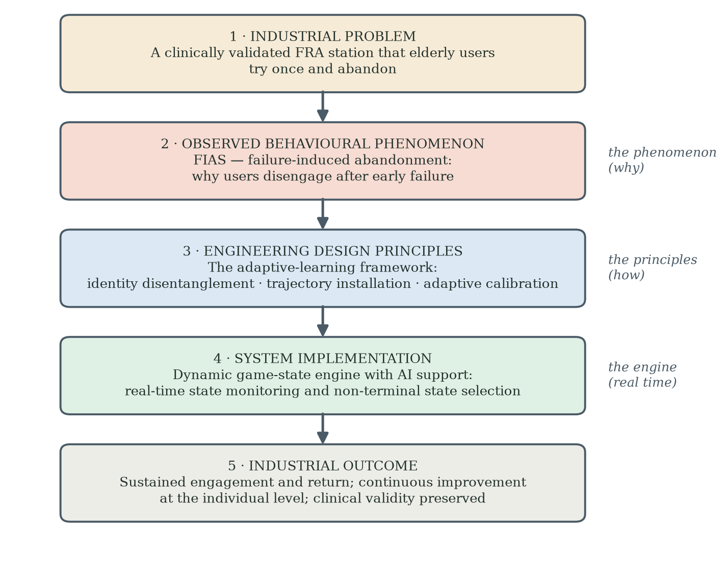
Figure 1.1. The intellectual structure of the thesis: an industrial problem produces an observed behavioural phenomenon (FIAS); the phenomenon motivates engineering design principles (the adaptive-learning framework); the principles are operationalised by the dynamic game-state engine; and the intended industrial outcome is sustained engagement with clinical validity preserved. The three middle layers are stated as one architecture in §7.5A.

1.13 Scope, Boundaries, and What This Thesis Does Not Claim
The empirical claims are restricted to the cohorts and observation windows studied. Stage 2 involved a Southern Chinese residential-facility cohort; Stage 3 involved a Hong Kong network-recruited cohort playing remotely on their own computers. Both were Chinese-cultural in language and cultural context, and cross-cultural generalisation is not asserted. The FRA system is an established commercial assessment platform, but this thesis does not validate its diagnostic accuracy, clinical effectiveness or the clinical significance of short-term score changes. It evaluates engagement behaviour and the engineering design of the user interaction. FIAS is not claimed to explain all non-adoption or abandonment of health technology, and "syndrome" is used as a conceptual, non-diagnostic term. Cross-domain application to glucose monitoring, sleep tracking, cognitive screening and other systems remains a design hypothesis.
The thesis does not claim that adaptive learning is the only design lever capable of reducing failure-associated non-return. Adaptive learning is proposed because trajectory framing, mastery-oriented feedback and calibrated challenge are theoretically suited to changing how failure is interpreted. The 29.3-percentage-point commitment gap does not identify adaptive learning as its sole cause; fatigue, physical capacity, access, session burden and other motivational factors remain viable alternatives. Direct comparison of design levers and controlled evaluation of the complete adaptive-learning framework are therefore required.

1.14 Structure of the Thesis
The research is organised in three progressive parts that follow the hypothesis architecture. Part I builds the test. Chapter 2 assembles the null hypothesis H0 from the acceptance and gamification literatures, names the gap those literatures leave — every Octalysis drive is a designer-side motivation lever, none addresses abandonment — and lays out the behavioural theory (Table 2.1) that will be needed when H0 fails. Chapter 3 declares the methodology: action research carrying a falsifiable hypothesis, the role of each stage (field signal, prospective test, attribution experiment), the hypothesis architecture (Table 3.1) and the confirmation-versus-discovery discipline. Part II executes it. Chapter 4 reports Stage 1, the retrospective field signal; Chapter 5 reports Stage 2, the prospective test that rejects H0; Chapter 6 reports Stage 3, the attribution experiment whose results are consistent with gamification theory, support the coupling boundary condition, and — in the commitment gap — forces the design discovery. Part III claims and bounds it. Chapter 7 formalises adaptive learning as the adaptive-learning framework; Chapter 8 states the contributions in their evidential hierarchy, with alternative explanations, limitations, ethics and reproducibility; Chapter 9 synthesises the five-step arc and sets out the pre-specified confirmatory programme.

Chapter 2 Literature Review and Theoretical Foundation

2.1 The Transformative Logic of the Literature Review
This chapter is organised to do one thing: build a null hypothesis from the existing literature, and then assemble the theory needed to explain why the data of this thesis reject it. It is a progressive argument, not a neutral inventory. Each stage answers a question the previous stage leaves open, and the evidential status of every claim is stated as it is made.
Stages one and two build the null hypothesis. Stage one is the technology acceptance lineage: the Technology Acceptance Model (Davis, 1989), its extensions (TAM2, TAM3, UTAUT) and the Senior Technology Acceptance Model (Chen & Chan, 2014). These models explain how intentions to use a technology form, and they direct the designer to fit the technology to the user's acceptance criteria. Stage two is gamification: Deterding et al. (2011) and Chou's Octalysis Framework (2015), with the An–Cheung studies (An, Cheung & Willoughby, 2024; An, Cheung & Lo, 2025) as the strongest demonstration that gamification lifts elderly intention to use. Put together, these two literatures generate a clear expectation — the null hypothesis H0, stated formally in §2.3.5: a well-designed, gamified FRA should raise acceptance and sustain use. Chapters 4 and 5 test that expectation, and the Stage-2 data reject it.
Stage three asks what the rejection means. Self-efficacy theory (Bandura, 1977, 1997) and the computer self-efficacy literature for older adults (Hawthorn, 2007; Broady, Chan & Caputi, 2010; Tsai et al., 2020) explain why difficulty reduces persistence. They explain dropout. They do not explain why the dropout becomes permanent, and they do not explain why users whose recorded scores improved still never came back.
Stage four assembles the alternative account. Prospect theory and loss aversion (Kahneman & Tversky, 1979), the endowment effect on identity-relevant assets, mental accounting (Thaler, 1985) and stereotype threat (Steele & Aronson, 1995) are organised — in Table 2.1 — as a structured explanation of exactly the observations that the null hypothesis cannot accommodate. This integration is the theoretical contribution of the thesis and is named FIAS. The individual operators were not directly measured in the empirical stages, and the chapter says so wherever it matters.
Stage five turns the account into design. If failure abandons users because of what failure is made to mean, then design can change the meaning: participant-facing decoupling (tested in Stage 3) and learning-oriented adaptation (proposed as the adaptive-learning framework, for prospective testing). The chapter closes with the supporting literature and a synthesis that walks the reader from H0 to its rejection to the design response, with chapter pointers at every step.

2.2 Stage One: The Technology Acceptance Lineage

2.2.1 TAM and the Two-Construct Core
Davis (1989) argued that two constructs predict adoption of an information technology: Perceived Usefulness (PU) and Perceived Ease of Use (PEOU). The model is parsimonious. King and He (2006) confirmed predictive power across 88 studies, with effect sizes that are substantial in workplace settings. The evidence base for TAM is overwhelmingly drawn from instrumental-motivation contexts: office software, e-commerce and mobile banking. In these settings, the user's reason for engaging with the technology is external to the user's identity. Failure to use the technology costs time or money. Failure does not threaten the user's self-concept. Two further limits matter for this thesis. First, TAM's evidence base is calibrated on younger, working-age users; older adults bring different life experiences and learning patterns, so the acceptance criteria the model asks designers to satisfy are not necessarily their criteria. Second, TAM directs attention to fitting the technology's design to the user's acceptance before use begins. It has nothing to say about the user's behavioural response after use begins — least of all after an adverse first experience.

2.2.2 TAM2, TAM3 and UTAUT
Venkatesh and Davis (2000) extended the model to TAM2 by adding social influence and cognitive instrumental processes. Venkatesh and Bala (2008) introduced TAM3 with a richer treatment of individual-difference moderators. Venkatesh, Morris, Davis and Davis (2003) developed the Unified Theory of Acceptance and Use of Technology (UTAUT), integrating eight competing models. Each extension increases predictive power for intention to adopt. None of them contains a construct for the moment of failure that drives permanent disengagement. Each extension contains constructs for anticipated effort, anticipated facilitating conditions and anticipated rewards. None contains a construct for what happens when the technology returns a verdict that the user reads as a verdict on the user's body.

2.2.3 The Senior Technology Acceptance Model (STAM)
Chen and Chan (2014) developed STAM through a study of 1,012 Hong Kong Chinese seniors aged 55 and above. STAM extends TAM with five constructs particularly relevant to older users: gerontechnology self-efficacy (GSE), gerontechnology anxiety (GA), facilitating conditions, behavioural intention, and the dual subjective norms of family and peer influence. Chen and Chan reported that STAM explained 68% of the variance in self-reported gerontechnology use among their sample, a substantial improvement on TAM in the same population. Recent mapping reviews of the factors associated with older adults' intention to adopt digital technologies confirm that these constructs remain central to the field (Schroeder et al., 2023). STAM is therefore the strongest baseline available for elderly technology adoption, and it supplies five of the thirteen binary attributes in the FIAS coding scheme described in Chapter 5 and Appendix B.
STAM is nonetheless silent on the same point as TAM. STAM measures intention, and it measures it better for older users. But it does not address why older users abandon a health technology they had already accepted and begun to use. Failure-Induced Abandonment Syndrome describes a state in which intention has collapsed and stayed collapsed; STAM contains no construct for the failure moment that produces the collapse, and the Stage-2 outcomes in Chapter 5 are not predictable from STAM baseline attributes alone. Stage one of the argument is therefore well established in the literature — and boundary-marked by this silence.

2.3 Stage Two: Gamification, Octalysis and the An–Cheung Demonstration

2.3.1 Defining Gamification
Deterding, Dixon, Khaled and Nacke (2011) defined gamification as the use of game design elements in non-game contexts. The definition is broad on purpose. Game design elements include points, badges, leaderboards, narratives, levels, challenges and feedback structures. The non-game contexts include education, health, productivity, financial services and many others. Within game studies, failure itself is treated as a designed — even valued — part of play (Juul, 2013), an observation that becomes consequential in this thesis when the same failure acquires clinical meaning. The thesis works with a strong-form gamification deployment: not points and badges layered on top of an existing system, but a complete game whose physical mechanic also feeds a measurement pathway. The gameplay and measurement functions share the same sensor stream, but equivalence between game-derived COP metrics and validated clinical FRA outcomes should not be assumed without protocol-level validation.

2.3.2 The Octalysis Framework
Chou (2015) classifies game-design pull into eight motivational drives: D1 Epic Meaning and Calling, D2 Development and Accomplishment, D3 Empowerment of Creativity and Feedback, D4 Ownership and Possession, D5 Social Influence and Relatedness, D6 Scarcity and Impatience, D7 Unpredictability and Curiosity, and D8 Loss and Avoidance. The framework is widely used in gamification design practice. Octalysis is the most cited integrative gamification framework in elderly health and wellbeing applications and is the one against which the present thesis tests its own structural claims. One structural feature of the framework is decisive for this thesis, and it is the key element missing from the gamification literature this review found. All eight drives answer a designer-side question: how do I motivate a player to start playing and keep playing? Not one drive answers the user-side question this thesis confronts: what makes a player — here, an older adult in a clinical setting — stop playing and never come back, and how is that abandonment avoided? Octalysis supplies levers for building engagement; it supplies no lever, and no warning, for failure-induced abandonment. The framework is therefore adopted here as the best available design vocabulary, and simultaneously marked as incomplete for the problem under study. Section 2.6.2C returns to this point with the zero-failure design concept that this research developed in response — a concept that inverts the framework's eighth drive rather than applying it.

2.3.3 An, Cheung and Willoughby (2024): Evidence for TAM-STAM-Octalysis in Elderly Gamification
An, Cheung and Willoughby (2024) studied gamification for elderly mobile-payment adoption with a Hong Kong cohort. Their integrated instrument combined TAM-style measurement with gamification mechanics drawn from Octalysis. The study demonstrated that gamification mechanics, layered on top of a STAM-grounded acceptance instrument, lifted both intention to adopt and short-term engagement among older adults. An, Cheung and Lo (2025) extended the same approach to mobile maps with consistent results. Together the two studies constitute the strongest available demonstration that the TAM-STAM-Octalysis stack works in elderly gamification.
The studies share two boundary conditions that the present thesis treats as load-bearing. First, mobile payments and mobile maps are not clinical or diagnostic technologies. The user's identity asset, in the sense developed at stage four below, is not at stake in the same way. Second, the An et al. studies measured initial adoption and short-term engagement; they did not document the one-way abandonment pattern that characterises FIAS. Stage two of the transformative chain therefore indicates that the TAM-STAM-Octalysis stack is empirically valid for elderly gamification — provided the technology is not attached to an artefact-based health system.

2.3.4 The Boundary: When the Technology is Attached to FRA
The present thesis examines what happens when the same theoretical stack is applied to older users of FRA, a clinical health technology. Two Octalysis drives may operate differently in this setting. D8 (Loss and Avoidance) usually refers to loss of in-game assets; in a diagnostic frame, an adverse event may instead be interpreted as information about personal decline. D5 (Social Influence and Relatedness) may also become double-edged if peer comparison increases age-related self-awareness. These are context-dependent propositions, not universal inversions of the framework. Whether social-comparison framing reduces engagement in this population was not isolated as a test in the present programme; it is registered as a question for the confirmatory study (§8.8).
The Stage-1 baseline survey reported in Chapter 4 supplies the corresponding population-level signature. The working summary indicated that 39% of respondents had previously used the FRA system; among prior users, approximately 74% were coded as having an adverse, unacceptable or unsuccessful first experience and approximately 82% reported no subsequent return. These labels require item-level reconciliation because the reproduced survey item asks whether the first result was understood and accepted rather than directly measuring task failure. The access and perceived-benefit estimates reported in the working table also require source-item and denominator verification. The pattern motivates prospective study of the first experience, but it does not by itself establish task failure, irreversible abandonment or a specific psychological mechanism. Stage two of the transformative chain therefore reaches a boundary and motivates an additional explanatory layer.

2.3.5 The Null Hypothesis Built From Stages One and Two
Stages one and two, taken together, generate a precise expectation, and this thesis treats that expectation as its null hypothesis. The reasoning has two premises. Premise one, from the acceptance lineage: when a technology is designed to fit the user's acceptance criteria, intention to use forms and use follows (Davis, 1989; Chen & Chan, 2014). Premise two, from the gamification literature: layering game mechanics onto an acceptance-compliant design lifts elderly intention and engagement further, as the An–Cheung demonstrations show (An, Cheung & Willoughby, 2024; An, Cheung & Lo, 2025). Applied to the InBody FRA platform, whose clinical value is established and whose deployment motivated this programme, the two premises yield:
H0 — A gamified Fall Risk Assessment that satisfies TAM/STAM acceptance criteria and implements Octalysis motivational drives will, as in the non-clinical demonstrations, improve older adults' acceptance of and intention to use the technology, and adverse first experiences will not produce lasting abandonment.
One design decision protects the test of H0 from a trivial rebuttal. The Stage-2 gamified FRA was engineered with AI assistance (Claude Code; §5.3.9) to a specification that deliberately satisfies each element of the stack: an acceptance-screened entry flow, calibrated challenge, coin rewards, levels and feedback (Octalysis D2, D4), and a natural control mapping. If abandonment nonetheless persists, H0 does not fail because the game was badly made; it fails because the theories behind it are missing something. That is exactly what the data show. Stage 1 (Chapter 4) is retrospectively consistent with the failure of H0 — roughly three-quarters of prior FRA users reported an adverse first experience and the large majority never returned. Stage 2 (Chapter 5) tests H0 prospectively and rejects it: seventy per cent of participants disengaged at or before three cycles, no re-engagement was observed within the study window, and abandonment co-occurred with improving recorded scores. The AI-assisted development vehicle changed the cost of building the game; it did not change the abandonment pattern.
The remainder of this chapter therefore has a single task: to assemble, from literatures the acceptance and gamification models do not draw on, an account of why H0 failed — and to turn that account into design propositions that Chapters 5 to 7 develop and Stage 3 begins to test.

2.4 Stage Three: Self-Efficacy as the First Diagnostic Layer

2.4.1 Bandura's Self-Efficacy
Self-efficacy is a person's belief in their own capacity to succeed at a specific task (Bandura, 1977; Bandura, 1997). Bandura demonstrated that the belief is task-specific, mutable and predictive of behavioural persistence under difficulty. A failure event lowers task-specific self-efficacy, and lowered self-efficacy reduces engagement with the task that produced the failure. Self-efficacy is the canonical cognitive mechanism through which a single bad experience translates into withdrawal.

2.4.2 Computer Self-Efficacy Among Older Adults
Computer self-efficacy, the domain-specific form of the construct developed by Compeau and Higgins (1995), is consistently lower among older adults than among younger users (Hawthorn, 2007; Broady, Chan & Caputi, 2010). The asymmetry has been documented across multiple cohorts and multiple device categories. Lower baseline computer self-efficacy means that elderly users approach a new technology with a smaller reserve of confidence, and a single failure event consumes a larger proportion of that reserve than the same event would consume for a younger user. The same Stage-1 numerical signature documented above is consistent with this account.

2.4.3 The Fear-and-Failure Cycle
Tsai et al. (2020) studied older adults' acceptance of a wearable health device through an extended technology-acceptance model and documented the roles of technology anxiety and resistance to change in suppressing engagement. Anxiety about using the technology reduced intended and actual use, and early difficulty further lowered the confidence with which users approached subsequent attempts. The Tsai et al. findings are the closest published precedent for the withdrawal dynamics the present thesis observes in the F4 cluster of Stage 2, although their study is cross-sectional and does not track whether withdrawal becomes permanent.

2.4.4 What Self-Efficacy Explains and What It Does Not
Self-efficacy provides a plausible mechanism for withdrawal after failure. A user who begins with limited confidence, experiences difficulty and updates their task-specific self-belief downward may be less likely to persist. Importantly, self-efficacy theory also allows recovery through mastery experience, support and successful re-engagement. It therefore does not, on its own, require an irreversible or absorbing state.
The Stage-2 observation that some F4 participants showed positive change in the recorded FRA index and nevertheless did not return is not easily predicted from a simple capability-improves-confidence account. However, the observation is based on six F4 participants, and positive single-session score change is not equivalent to demonstrated mastery or clinical benefit. The pattern therefore motivates an additional explanatory layer; it does not by itself falsify self-efficacy theory.

2.5 Stage Four: Behavioural Science as a Candidate FIAS Account

2.5.1 Why Behavioural Science Is Required
The transition from self-efficacy to behavioural economics is the substantive theoretical move of the thesis, and its structure follows directly from the rejected null hypothesis. Self-efficacy explains reduced persistence after difficulty, and it also allows recovery — so it cannot, on its own, account for what Stage 2 observed. Three observations from the rejection of H0 need explaining: first failure carried far more behavioural weight than the design predicted; exits persisted even when recorded scores improved; and the same gameplay event appears to mean something different under a clinical frame than under a game frame. Table 2.1 maps each observation onto the behavioural theory recruited to explain it, the construct that theory contributes to FIAS, and the testable prediction it generates. The subsections that follow develop each row. The operators were not directly measured in the present studies; the table is the structure that future measurement (§3.6) is designed to fill.
Table 2.1. From the rejected null hypothesis to candidate mechanisms: the structure of the FIAS account.
Observation H0 cannot explain | Behavioural theory | Construct contributed to FIAS | Prediction generated
A single adverse first experience outweighs the design's motivational pull | Prospect theory / loss aversion (Kahneman & Tversky, 1979) | Asymmetric weighting of an adverse result against a valued reference point | First failure is associated with early disengagement (H1, Chapter 5)
Exit persists even when the recorded score improves | Endowment effect (Thaler, 1980; Kahneman, Knetsch & Thaler, 1990) | Identity-relevant endowment: exit protects a valued self-description from revaluation | Objective improvement does not by itself produce return (H4 — the improvement/non-return paradox)
The same event means different things under different frames | Mental accounting (Thaler, 1985) | Clinical framing sorts the session into a high-stakes health account | Removing participant-facing clinical framing increases post-failure return (H5, Stage 3)
Clinical and age-related cues amplify the meaning of failure | Stereotype threat (Steele & Aronson, 1995; Levy et al., 2002) | Salience of age-related decline as the trigger of identity-relevant appraisal | Threat-reduced framing and coaching improve retry and return (the adaptive-learning framework, Chapter 7)
Abandonment persisted although the Stage-2 build had already softened in-game loss (lives, forgiving hits) | Octalysis D8 inverted: zero-failure design (§2.6.2C, from this research's observations) | The operative loss is identity-level, outside the game's ledger; verdict cues, not in-game losses, carry it | Removing terminal failure verdicts (zero-failure states, §5.3.10) plus decoupling increases retry and return (the adaptive-learning framework, Chapter 7; isolated test in §8.8)

2.5.2 Prospect Theory and Loss Aversion
Kahneman and Tversky (1979) introduced prospect theory, in which outcomes are evaluated relative to reference points and losses are often weighted more heavily than equivalent gains. Tversky and Kahneman (1991) extended the framework to riskless choice. In an FRA context, an older user may compare an adverse result with a valued reference point such as continued independence or adequate balance. The thesis hypothesises that this appraisal can increase the subjective weight of failure. The participant-specific reference point and loss valuation were not measured in the present studies.

2.5.3 The Endowment Effect on Identity-Level Assets
Thaler (1980) introduced the endowment effect. Kahneman, Knetsch and Thaler (1990) demonstrated it experimentally through repeated tests of the asymmetry between Willingness To Accept (WTA) and Willingness To Pay (WTP) for the same object. Once a person owns an asset, the WTA they require to give it up is systematically higher than the WTP they would offer to acquire it. The asymmetry is robust, replicates across many object classes and is one of the most reliable findings in behavioural economics.
Applied to identity-relevant self-concepts, the endowment literature suggests a testable possibility. An older user may value a self-description such as "I remain independent" or "my balance is still good" and resist information that appears to threaten it. Exiting the technology could then function as a protective response that avoids repeated confrontation with the threatening interpretation. This extension from ownership of physical goods to identity-relevant health self-concepts is theoretically plausible but requires direct measurement. The present thesis therefore treats identity-level endowment as a candidate operator, not as an established fact about every participant.

2.5.4 Mental Accounting of Health Outcomes
Thaler (1985) introduced mental accounting. People do not pool money or other resources into a single fungible total. People sort resources into separate mental accounts, with different rules for spending and replenishment in each account. The framework was developed for consumer finance. Antonides, de Groot and van Raaij (2011) confirmed the operation of mental budgets in household finance. The thesis adapts the framework to health outcomes.
In the thesis's adapted account, a clinical frame may sort an FRA session into a health-related mental account, making an adverse result more consequential than the same gameplay event under a coordination frame. The objective-score-improvement/non-return pattern is consistent with the possibility that participants evaluated the personal meaning of the session differently from its recorded performance change. The data do not show that the body is "fungible", that an identity asset served as a guarantor, or that an account was literally closed. These terms are theoretical representations that guide the next measurement cycle.

2.5.5 Stereotype Threat as the Trigger
Steele and Aronson (1995) demonstrated that making a negatively stereotyped identity salient can affect performance on identity-relevant tasks. Subsequent work has extended stereotype-threat questions to ageing — self-perceptions of ageing predict long-term health outcomes (Levy et al., 2002), identity salience alters older adults' performance on identity-relevant tasks (McGlone & Aronson, 2006), and age-based stereotype threat about cognitive decline has been reviewed systematically (Barber, 2017) — although effects vary by task, context and measurement. In the present framework, clinical FRA language may increase the salience of age-related decline for some users, thereby changing how failure is interpreted. Stereotype threat is therefore proposed as one possible trigger within the wider frame-sensitive account. The present studies did not measure stereotype activation directly, and the Stage-3 result cannot distinguish lexical threat reduction from other procedural, recruitment or contextual differences.

2.5.6 A Four-Layer Behavioural Integration Proposed for FIAS
The four behavioural-science layers form a coherent candidate explanation. Loss aversion supplies asymmetric weighting of unfavourable information; identity-relevant endowment supplies a possible protected self-concept; mental accounting supplies a possible sorting rule by which clinical framing increases the stakes of the event; and stereotype threat supplies one possible contextual trigger. FIAS is the conceptual label assigned to the resulting pattern of failure-associated active non-return. The integration is theoretically generative because it yields measurable predictions, but it is not yet a validated latent construct or a clinical syndrome. Direct measures of appraisal, identity threat, account framing and WTA-WTP asymmetry are required before the mechanism can be claimed as established.

2.6 Stage Five: Positioning Decoupled Gameplay and Adaptive Learning as Design Responses

2.6.1 The Question Stage Four Leaves Open
Stage four supplies a candidate mechanism but not a tested design solution. If clinical framing increases the identity relevance of failure, three broad responses follow: reduce threat cues, decouple the engagement layer from participant-facing clinical verdicts, or install a learning trajectory that gives failure a different reference point. The first two are partly represented in the Stage-3 decoupling package. The third is developed as the adaptive-learning framework. The key distinction is evidential: Stage 3 evaluates participant-facing decoupling in a separate cohort, whereas the complete adaptive-learning framework remains to be evaluated prospectively.

2.6.2 Productive Failure and Adaptive Learning
Kapur (2008) introduced productive failure as an instructional design principle in which difficulty and unsuccessful attempts can contribute to later learning when appropriately structured. Adaptive learning extends the design logic by adjusting challenge, feedback and pacing to the learner's evolving performance. In the present thesis, a trajectory frame is proposed so that any single event is interpreted relative to change over time rather than as a final judgement. This is a design hypothesis about appraisal; it does not require the user's entire self-concept to be constituted by the trajectory.

2.6.2A The Theoretical Lineage of Adaptive Learning
Adaptive learning is not a single technique but a convergence of four established traditions, and naming them explicitly matters because it fixes what the adaptive-learning framework response in Chapter 7 inherits and what it adds. The first tradition is the flow account of optimal experience (Csikszentmihalyi, 1990). Flow arises when the challenge of an activity is matched to the skill of the person attempting it: too little challenge produces boredom, too much produces anxiety, and the narrow band between the two sustains absorbed engagement. The flow band is the operational target of the Stage-2 Layer-2 difficulty system (§5.3.5), whose 80 per cent and 40 per cent success thresholds are a direct implementation of the challenge–skill match. The second tradition is the zone of proximal development (Vygotsky, 1978): learning is most effective at the frontier between what the learner can already do unaided and what they can do with support, and effective instruction continuously relocates that frontier as the learner advances. A learning curve, in this tradition, is not a metaphor but the object of instructional design. The third tradition is desirable difficulty (Bjork & Bjork, 2011): conditions that slow apparent performance during practice — spacing, interleaving, retrieval under effort — improve durable learning, which reframes within-session failure as a feature of an effective curve rather than as evidence of inadequacy. The fourth tradition is the empirical record of intelligent tutoring systems (VanLehn, 2011), which demonstrates that fine-grained, step-level adaptation of feedback and pacing produces learning gains approaching those of human one-to-one tutoring. The four traditions converge on a single design instruction: present the activity as a curve, calibrate the difficulty so the learner stays on the curve, and treat each failure as information about the curve rather than as a verdict on the learner.
Together, these traditions support treating adaptive learning as more than an adaptive difficulty algorithm. Flow informs moment-to-moment challenge calibration; the zone of proximal development informs the location of the next achievable step; desirable difficulty cautions against removing all challenge; and intelligent tutoring research demonstrates the value of fine-grained adaptation. The thesis combines these ideas into a trajectory-oriented design proposition. Whether this proposition reduces identity threat or non-return in FRA must be tested directly; the Stage-3 decoupling result alone cannot establish that effect.

2.6.2B Self-Determination Theory and Goal-Setting as Motivational Scaffolding
Two established motivation literatures support the trajectory-installation principle that Chapter 7 develops. Self-determination theory (Deci & Ryan, 1985; Ryan & Deci, 2000) identifies competence and autonomy as basic psychological needs. A user who reads performance against an evolving personal capability receives competence feedback; a user who reads performance against a fixed clinical verdict does not. The trajectory frame is therefore a competence-support structure in self-determination terms. Goal-setting theory (Locke & Latham, 2002) adds a second scaffold: specific, proximal and adjustable goals sustain effort better than vague or static ones, and the related distinction between mastery goals and performance goals (Elliot & Murayama, 2008) sharpens the point: a goal defined by personal improvement invites a different reading of failure than a goal defined by demonstrated adequacy. The adaptive calibration principle operationalises exactly this, because the difficulty layer keeps the next goal specific and reachable as capability changes. Motivation-crowding research adds a design caution: extrinsic rewards that are introduced clumsily can displace rather than support intrinsic motivation (Frey & Jegen, 2001), which is why the learn-to-earn philosophy treats rewards as recognition of progress along the curve rather than as payment for compliance. Neither literature predicts the abandonment cliff that FIAS names. Both literatures predict why the trajectory frame, once installed, should hold engagement. They scaffold the design response; they do not substitute for the coupling mechanism that explains the collapse.

2.6.2C Zero-Failure Design: A Research-Generated Concept That Inverts Octalysis D8
Zero-failure design is a supporting design element of this thesis, not a core contribution. It was not found in the literature; it emerged from the field observations, and it became practical to build and test only because AI-assisted development made game-mechanic iteration cheap (§5.3.9). It is stated here because it disrupts an assumption of the framework this chapter reviews, and because the thesis's central design proposition — adaptive learning (§2.6.2A–B) — subsumes it. The concept is simple: in a clinically framed activity for older adults, the game must contain no terminal failure verdict. There is no Game Over screen, no lives-exhausted ending and no fail-state label; a collision or an error becomes an input to adaptation — the environment eases, the run continues — while challenge and truthful performance feedback are preserved. Zero-failure design is not challenge-free design (the desirable-difficulty literature of §2.6.2A warns against that) and it is not concealment (§8.7.2): it removes verdicts, not information.
The concept inverts the eighth Octalysis drive. Chou (2015) treats Loss and Avoidance as a motivational lever the designer should use: fear of losing progress, streaks or assets keeps players playing. The observations of this programme point the other way for older users in clinical frames. The loss that governs their behaviour is not the in-game loss the framework manipulates; it is an identity-level loss — the threatened revaluation of a valued self-description — that sits entirely outside the game's ledger (§2.5.3). Where the framework says amplify loss salience to drive engagement, zero-failure design says remove loss presentation because the player is already carrying a loss the designer cannot see. To the author's knowledge, no elderly-gamification study states this inversion. It is recorded as an observation-driven design element in support of the thesis's central design proposition, adaptive learning, rather than as a headline contribution in its own right.
The evidential status of the concept must be stated carefully, in three steps. First, the Stage-2 build already softened the in-game loss economy substantially — three lives, a neutral first hit, an obstacle-clearing second hit (Table 5.0) — yet retained a conventional terminal Game Over, and FIAS occurred regardless: seventy per cent early disengagement and no observed return (Chapter 5). Softening in-game loss alone was therefore insufficient, which is precisely what the identity-level account predicts. Second, this motivated the complete zero-failure repertoire — non-terminal recovery, mastery, narrative and reframe states — specified at §5.3.10 and implemented in the successor short-run build used for the Stage-3 apparatus lineage. Third, Stage 3 changed the participant-facing frame and the cohort together, so the isolated causal effect of the zero-failure component has not yet been measured; observed non-return fell to 6.7 per cent overall, but a residual non-return and the 29.3-percentage-point commitment gap remained. Zero-failure design is therefore a moderator within the FIAS account and a testable component of the adaptive-learning framework (Chapter 7), not a demonstrated cure; its isolated evaluation is pre-specified in the randomised study of §8.8.

2.6.3 Endowment-Protective and Learning-Trajectory Appraisals as Competing Regimes
The thesis proposes that endowment-protective appraisal and learning-trajectory appraisal compete for interpretive dominance at the moment of failure. Under the first appraisal, an adverse result is read against a valued, relatively stable self-description and may be experienced as a loss. Under the second, the same result is read as information about current position, slope and next action. These appraisals need not be psychologically mutually exclusive: a person may experience both, move between them, or resolve their conflict differently across contexts. The engineering objective is therefore not to "dissolve" identity, but to increase the salience and credibility of the trajectory interpretation while preserving autonomy and truthful disclosure. The WTA-WTP implications are hypotheses for direct elicitation, not quantities estimated in the present studies.

2.6.4 Why Decoupled Gameplay Is a Critical but Non-Definitive Empirical Test
Stage 3 retained the skiing mechanic, session structure and five-attempt rule in an HTML port of the game, but not the pressure-panel apparatus or the supervised setting: the build was distributed by e-mail and played on participants' own computers with a trackpad, arrow keys or, where available, a foot-pad sensor, while the package of participant-facing clinical cues was changed and a separate Hong Kong network cohort was recruited. It is therefore a between-cohort quasi-experimental decoupling comparison, not a single-variable experiment. The increase from 0 of 21 observed Stage-2 re-engagements to 10 of 16 returns among initial dropouts in the Stage-3 65-80 group is a large directional signal. It supports the proposition that framing or related contextual features moderate post-failure return, but it does not isolate the effect of framing from all differences in cohort, setting, platform, input device, supervision, recruitment, prior exposure, staff interaction or observation window. Nor does it directly test the complete adaptive-learning framework.
The five-stage chain therefore closes conceptually rather than through one definitive causal test. Technology acceptance and gamification describe important parts of the engagement surface. Self-efficacy offers a mechanism for withdrawal after difficulty. Behavioural economics supplies candidate explanations for identity-relevant non-return. Stage 3 provides convergent evidence that participant-facing decoupling is associated with substantially greater post-failure return. Adaptive learning and the adaptive-learning framework translate those observations into a falsifiable engineering programme. The later chapters preserve this hierarchy between established literature, observed results, inferred mechanisms and proposed design responses.

2.7 Supporting Evidence and Adjacent Frameworks

2.7.1 Gamification for Older Adults: The Koivisto and Malik Review
Koivisto and Malik (2021) reviewed the gamification-for-older-adults literature systematically across twelve included studies. Three findings from the review bear on the present thesis. First, the field is dominated by short-duration intervention studies; long-term engagement evidence is sparse. Second, attrition — the ‘law of attrition’ by which digital-health evaluations lose a large share of their users (Eysenbach, 2005) — is consistently reported but rarely analysed as a primary outcome; studies report engagement gains in completers but rarely document the structure of dropout. Third, theoretical grounding is uneven; many studies use ad hoc design heuristics rather than coherent theoretical frames. The thesis is positioned to address each of these gaps. Stage 2 documents an eight-week deployment with a complete dropout audit. Stage 3 documents a 120-participant decoupling study with retention as the primary outcome. The theoretical frame is integrated and explicit throughout.
Altmeyer, Lessel and Krüger (2018) studied gamification for users aged 75 and above and found that mechanics borrowed from younger-adult gamification did not transfer cleanly. Their findings reinforce the argument that elderly users in clinical contexts require a different theoretical frame and a different design vocabulary.

2.7.2 The NASSS Framework: Documented Abandonment Without a Mechanism
Greenhalgh et al. (2017) introduced the Non-Adoption, Abandonment, Scale-up, Spread and Sustainability (NASSS) framework for health and care technologies. NASSS catalogues forms of non-adoption and abandonment across condition, technology, value proposition, adopter system, organisation, wider context, and embedding over time. The human-computer-interaction literature makes the complementary point that non-use is itself meaningful behaviour rather than a mere absence of use (Satchell & Dourish, 2009). The present thesis can be read as proposing one candidate micro-mechanism within the adopter-system domain: failure-associated non-return that may be amplified when a clinical frame makes performance identity-relevant. NASSS supplies a macro-level vocabulary; FIAS remains a provisional mechanism-level construct requiring independent validation.

2.7.3 Cross-Cultural Reference: The Korean Comparison
Park et al. (2019) and Kim et al. (2018) are used in this thesis as a cross-cultural reference point for the same FRA technology: the former validates the system against gold-standard balance batteries, the latter establishes its test-retest reliability, and both evidence sustained institutional use in Korea. Neither reports an engagement rate, and no numerical Korean engagement benchmark is carried in this thesis (§4.7). The possibility that Korean implementations incorporate supportive framing or adaptive coaching is a hypothesis for comparative fieldwork, not an inference that can be made from the available sources.

2.7.4 Information Entropy as a Bridge Lens
Shannon entropy (Shannon, 1948) is used here as a bridge metaphor and future measurement proposal, not as a quantity estimated from the present data. Before a first session, a user's beliefs about what the technology means may be uncertain. A salient adverse event could reduce that uncertainty by producing a more definite negative interpretation. The current data do not measure a belief distribution before and after failure, so they cannot establish an entropy collapse at the moment of failure or distinguish individual learning from community narrative effects. Section 3.6 therefore specifies repeated belief elicitation as the instrumentation required to convert the metaphor into a testable information-theoretic claim.

2.8 Synthesis: The Five-Stage Transformative Argument
The argument of this chapter can now be read in five plain steps. Step one: the acceptance literature says that fitting a technology to the user's acceptance criteria produces intention and use, and the gamification literature says game mechanics amplify this for older adults — together they yield the null hypothesis H0 of §2.3.5, that a well-made gamified FRA will be accepted and used, and that failure will not drive abandonment. Step two: the data reject H0 — retrospectively in Stage 1 (Chapter 4) and prospectively in Stage 2 (Chapter 5), where seventy per cent of participants disengaged early and none returned, despite an AI-assisted build that satisfied the stack's design criteria. Step three: self-efficacy explains the dropout but not its permanence, and not the improvement/non-return paradox. Step four: the behavioural-economics account structured in Table 2.1 — loss aversion, identity-relevant endowment, mental accounting, stereotype threat — explains precisely the observations H0 cannot, and is named FIAS. Step five: the account implies a design response whose centre is adaptive learning — challenge calibrated to the individual and failure reframed as information about a personal trajectory (§2.6.2A–B) — the behavioural-change driver this programme regards as its principal design discovery. Two components support it: participant-facing decoupling, for which Stage 3 (Chapter 6) provides between-cohort field evidence, and zero-failure presentation, the observation-driven inversion of Octalysis D8 (§2.6.2C). The adaptive-learning framework (Chapter 7) is the engineering formalisation of the adaptive-learning proposition, and it awaits prospective testing.
No single stage carries the argument alone. The intellectual contribution is the chain itself: a null hypothesis honestly built from the best available models, an empirical rejection unlikely to be attributable to implementation quality, a structured behavioural account of the rejection, and an engineering programme that converts the account into testable design. The empirical contribution is strongest for the Stage-2 disengagement pattern and the substantially higher post-failure return in the separate Stage-3 decoupled cohort. The mechanism and framework claims remain provisional, and they are stated throughout in a form that direct measurement and a within-cohort randomised comparison can falsify.

Chapter 3 Research Methodology

3.1 Action Research as the Methodological Frame
The programme adopts action research (Lewin, 1946; Stringer, 2014; Reason & Bradbury, 2008) and treats cycles of action, observation, reflection and design revision as part of the inquiry. Two things make this the right frame for the present study, and they should be stated plainly. First, the programme is hypothesis-testing and discovery-generating at the same time. A falsifiable null hypothesis, H0, is built from the literature (§2.3.5) and tested prospectively; but the programme's most important outputs — the FIAS construct, the coupling boundary condition and the adaptive-learning proposition — were not presupposed. They were discovered through the cycles, and action research is the methodology that makes such discovery legitimate rather than accidental: each cycle plans an action, executes it in the field, observes what the plan did not predict, and revises the working theory before the next cycle. Second, the frame mirrors the programme topic. Action research is continuous improvement applied to inquiry itself — plan, act, observe, reflect is the researcher's form of the same iterative loop that the thesis ultimately proposes for the individual user (adaptive learning, §6.8) and practised in the artefact's construction (the AI-assisted build, §5.3.9). The documented revisions are: from FIDS toward the provisional FIAS construct after Stages 1 and 2; from a dispositional account toward the coupling account and its boundary condition after Stage 3; and from decoupling alone toward adaptive learning, formalised as the adaptive-learning framework, as the design programme. These revisions are changes in working explanation; they are not independent confirmation of the underlying psychological mechanisms. The programme is best read, and is offered, as exploratory engineering research: it borrows the discipline of hypothesis testing — a null hypothesis stated in advance, an attribution stage, pre-specified confirmatory studies — while claiming the freedom that exploration earns: to notice what the plan did not predict, to name it, and to follow it. At this scale the work does not attempt formal theory building; it maps new territory carefully enough that the confirmatory expedition knows exactly where to dig. That status is declared here, once, so that the discoveries in the chapters that follow can be stated in their own plain terms.

3.2 Three-Stage Design
Stage 1 was a descriptive, retrospective survey at the Poly Group facility in Guangzhou: a six-item Yes/No instrument administered face-to-face by nursing staff. Its methodological role in the architecture is to establish the field signal — a population satisfying every practical precondition of the acceptance models, with a documented pattern of adverse first experiences and non-return — that makes H0 worth testing prospectively (Chapter 4). The facility housed 280 residents at the time of the survey; 200 eligible residents were interviewed about their FRA experience, and all Stage-1 percentages are computed on the interviewed sample of 200.
Stage 2 was a prospective eight-week action-research deployment with thirty residents at the same facility. The intervention was a dual-purpose AI-assisted skiing game on the InBody pressure panel, engineered to satisfy the acceptance and gamification design criteria of Chapter 2, which is what makes Stage 2 the programme's prospective test of H0 under fully provisioned conditions (§5.2). Its analytical outputs are the engagement, failure and non-return characterisation of §5.5, analysed with estimators appropriate to a small single-site sample — Wilson intervals, paired and exact tests — because the archived dataset preserves no timestamps and therefore supports no time-to-event modelling. The study was not designed as a clinical validation of FRA or as a randomised test of the behavioural-economic mechanism. Across all three stages, a Quality Function Deployment (QFD) pipeline (Akao, 1990; Chan & Wu, 2002) is used to translate empirical findings into prioritised design requirements: user needs evidenced by the survey, telemetry and self-report data are mapped onto game features and weighted by the strength of the supporting evidence (§5.5A). QFD structures the translation from evidence to design; it complements, and does not replace, the statistical analysis of the collected data.
Stage 3 was a between-cycle, between-cohort quasi-experimental field study with 120 adults aged 25-80 recruited through the author's Hong Kong-based networks (work contacts, a charity community network, university support channels and working peers in medical centres). The game was ported to an HTML build, distributed by e-mail, and played unsupervised on participants' own computers, with a trackpad or arrow keys, or a foot-pad sensor where one was available. The skiing mechanic, five-attempt rule and session structure were retained in the port, while participant-facing clinical framing was changed through multiple coordinated components: recruitment language, the absence of any pre-session clinical scan, removal of clinical labels and participant-facing clinical outputs, and a coordination-game interface. Because cohort, setting, platform, input device and supervision also differed, Stage 3 estimates the combined association of the decoupled condition and its context with behaviour; it evaluates a participant-facing redesign package in a separate cohort, and it does not isolate a single causal variable. Its methodological role is attribution: the Stage-2 rejection of H0 admits a dispositional reading (gamification does not transfer to older adults) and a coupling reading (the attachment to the clinical technology broke it), and these make opposite predictions for a decoupled game (§6.1). Stage 3 is therefore designed as the programme's positive control for gamification theory, while its multi-component, between-cohort character bounds the causal strength of that attribution. The cohort design serves this purpose deliberately: recruiting three age bands (25-44, 45-64, 65-80) builds the comparison group into the study itself, and licenses a second null hypothesis, H0-age — that under the decoupled condition there is no difference between age groups. Stage 3 nullifies it: initial engagement differs sharply by age (0 of 38 younger versus 16 of 41 older initial dropouts; Fisher's exact p < 0.0001), while non-return converges toward low levels in every band. The pattern is exactly what the identity-level account predicts — the burden that decoupling relieves is concentrated in the group whose identity the technology's purpose touches.
A fourth evidence activity supplements the three stages. After the Stage-3 analysis, a single expert consultation interview was conducted with Dr Sarah C.W. Yuan (Center on the Family, University of Hawai'i at Mānoa), a medical sociologist and demographer of aging whose field of practice is community group falls-prevention programming. The purpose was to test the programme's behavioural interpretation against an independent discipline and an independent field of practice — non-electronic group exercise and physical games for balance — in which none of this programme's apparatus is used. The consultation informs interpretation and design (§6.8A, §7.5.3) and is not treated as participant data; the record and its attribution basis are given in Appendix H.
Table 3.1. The hypothesis architecture of the programme: where each claim originates, is stated, is tested, and stands.
Claim | Origin | Stated | Tested / examined | Status in this thesis
H0 — gamified FRA satisfying TAM/STAM + Octalysis sustains elderly acceptance; failure does not produce abandonment | Literature (acceptance + gamification) | §2.3.5; §5.1 | Stage 1 retrospectively (Ch 4); Stage 2 prospectively (Ch 5) | Rejected
H1, H2 and H4 — directional hypotheses on first failure, re-engagement and the improvement/non-return paradox | Stage-1 observations | §5.1 | Stage 2 (Ch 5) | Directionally supported within a small single-site sample
H5 and the Stage-3 predictions — decoupling is associated with lower non-return and post-failure return | Stage-2 findings (mental-accounting row of Table 2.1) | §5.1; §6.2 | Stage 3 (Ch 6) | Supported as association; attribution bounded by the between-cohort design
Adaptive-learning proposition — individual-level continuous improvement as the behavioural-change driver that can re-attach clinical purpose | Discovery: forced by the H0 rejection and the Stage-3 commitment gap | §6.8; Ch 7 (the adaptive-learning framework) | Not yet tested in isolation | Proposed; isolated evaluation pre-specified in §8.8 and instrumented in §3.6
H0-age — under the decoupled condition, no difference between age groups | Stage-3 cohort design (three age bands as built-in comparison groups) | §3.2; §6.2 | Stage 3 (Ch 6): age-stratified engagement | Nullified: initial dropout 0.0% (25-44) vs 39.0% (65-80), Fisher's exact p < 0.0001; non-return converges low in all bands

3.3 Methodology Overview Infographic
Figure 3.1 summarises the programme as a sequence of empirical stages and theoretical revisions, and it should be read as an action-research logic model rather than as a single causal experiment. In the architecture of Table 3.1: Stage 1 is descriptive and establishes the field signal that motivates the H0 test; Stage 2 is the prospective H0 test and is mechanism-generating; Stage 3 is the attribution experiment that separates the dispositional from the coupling explanation; and Chapter 7 formalises the design discovery for future controlled testing.
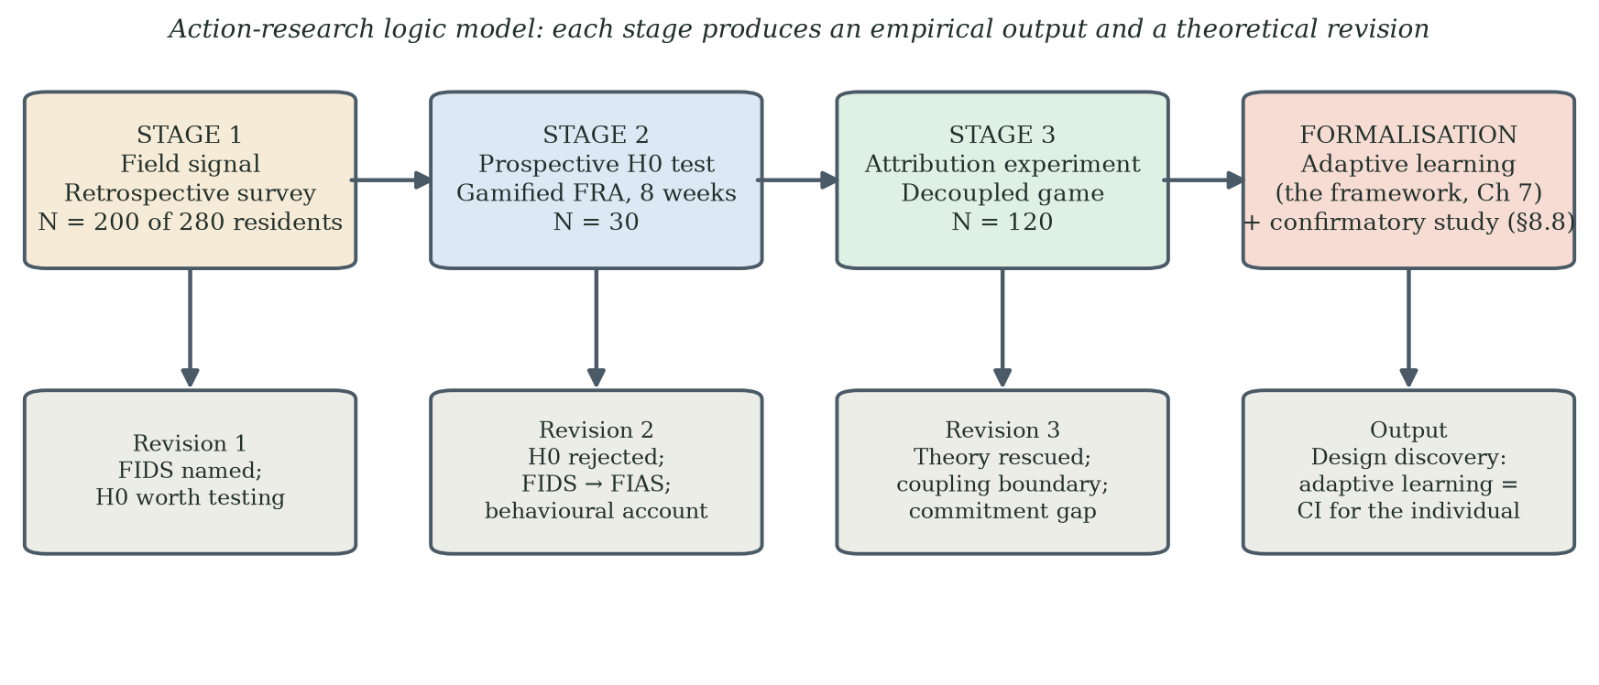
Figure 3.1. Three-stage action research programme as an action-research logic model: Stage 1 supplies the field signal, Stage 2 the prospective H0 test, Stage 3 the attribution experiment; the stages converge on the adaptive-learning formalisation of Chapter 7 and the confirmatory programme of §8.8. Each stage produces an empirical output and a theoretical revision.

3.4 Ethics, Consent, Data Governance
Each stage was conducted under the ethics policy of The Hong Kong Polytechnic University and in accordance with the Declaration of Helsinki. Compliance with the Personal Information Protection Law (PIPL; Standing Committee of the National People's Congress, 2021) was maintained throughout: all data were pseudonymised at collection, and no participant identifiers were transmitted to third-party AI services. Stage 3 did not collect participant-level clinical balance telemetry as part of the decoupling protocol. No adverse events were reported during any stage. The programme was approved by the PolyU Human Subjects Ethics Sub-Committee (application reference HSEARS20260805008; Principal Investigator: Prof. Chi Fai Cheung, Department of Industrial and Systems Engineering; approved August 2026); the application described the procedures of all three stages and the expert consultations as conducted, and the approval memo is held with the programme records. Chapter 8 (§8.7) addresses vulnerability, disclosure, autonomy and the ethical boundary between participant-facing reframing and deception. The expert consultation reported at §6.8A was conducted with a professional in her professional capacity; she is named with her consent, and the written confirmation is held with the consultation record (Appendix H).
Consent in Stage 2 is likewise stated exactly as it operated. The deployment was arranged with, and known to, the facility's operators, nursing team and general manager (gatekeeper consent, recorded at research start), and residents were invited by the facility to try the gamified system as a facility activity, voluntarily and free of charge. Participants were not told during the deployment that play formed part of a research project: the programme's subject matter is assessment fear, and announcing a fall-risk study would have re-imposed the clinical assessment frame whose behavioural effect was under study, so incomplete disclosure was integral to the design rather than incidental to it. Written consent was obtained retrospectively from the sustained participants at the close of the eight-week cycle, at the small recognition presentation for those who completed it; participants who had dropped out did not sign and were not interviewed. These arrangements - the incomplete disclosure and its rationale, the gatekeeper consent, and the retrospective timing of the written instruments - were stated in these terms in the approved ethics application, and their limitations are examined in 8.7.
Consent in the Stage-3 remote deployment operated by informed, implied consent, and the thesis states the procedure exactly as it was. The distribution e-mails explained the purpose of the game and of the accompanying questionnaire and the use that would be made of replies; participation was voluntary and unpaid, and recipients could decline by simply not taking part; returning the game's results file and the questionnaire responses constituted consent to their use in the research. No written consent instrument was administered in Stage 3, and this is acknowledged as a limitation of the remote design. Identities were separated from the analysed records at compilation: the analysis sheets retain only a participant code, age band, gender and education, and the distribution and return e-mails are retained in the author's records, with a de-identified index forming Appendix G, item G.5.

3.5 Methodological Limits and Mitigations
The programme uses a between-cycle, between-cohort comparison across Stages 2 and 3. A within-subject crossover was not selected because prior exposure and failure memory could produce carry-over and order effects, and because repeating a clinically framed task after an adverse experience could create ethical and interpretive complications. These are legitimate design considerations, but they do not make a between-cohort comparison methodologically equivalent to randomisation. The chosen design leaves unmeasured cohort, setting, recruitment and observation-window differences as alternative explanations.
Mitigation is therefore based on transparency, age-matched subgroup comparison, explicit alternative explanations, confidence intervals and a pre-specified next study rather than on claiming that theoretical convergence substitutes for causal control. The three stages provide convergent evidence: Stage 1 identifies a retrospective problem signature; Stage 2 links first failure to observed dropout and documents the score-improvement/non-return pattern; Stage 3 reports substantially greater post-failure return under a participant-facing decoupling package in a separate cohort. Mental accounting, identity-level endowment and stereotype threat remain inferred candidate mechanisms. The decisive confirmation is a within-cohort randomised coupled-versus-decoupled study with harmonised measures and observation windows.
The hypothesis architecture of Table 3.1 keeps confirmation and discovery in separate registers, and the thesis is straightforward about which is which. H0 formalises the expectation that genuinely governed the Stage-2 design when it was built — the game was engineered to satisfy the acceptance and gamification criteria precisely because the programme expected them to be sufficient. The directional hypotheses grew stage by stage in the ordinary rhythm of action research. The adaptive-learning proposition is a discovery, formed when the Stage-3 commitment gap pointed to it, and it is presented with the pride a discovery deserves alongside the confirmatory study it now makes possible (§8.8). This is the exploratory researcher's bargain: findings stated plainly, and their tests specified before anyone is asked to rely on them.
The chronological provenance of each hypothesis is recorded explicitly, so that prospective tests and action-research discoveries cannot be conflated. H0 is a reconstructed prospective hypothesis: the expectation it formalises governed the Stage-2 design ex ante — the build criteria of §5.2 document this — but its formal statement as a null hypothesis was written during the analysis and writing phase, not deposited in advance, and the thesis claims no more for it than that. H1, H2 and H4 originate in the Stage-1 survey and site observations and were held as working hypotheses before the Stage-2 deployment; their wording as printed in §5.1 was likewise fixed at writing. H5 and the Stage-3 predictions of §6.2 were formulated after the Stage-2 analysis and before Stage-3 recruitment, and are the closest the programme comes to stated-in-advance predictions. H0-age was licensed by the Stage-3 cohort design — three age bands recruited as built-in comparison groups — and was examined once the age-stratified data were tabulated. The adaptive-learning proposition is an action-research discovery in the full sense: it was formed after the Stage-3 commitment gap was observed, is claimed only as a discovery, and receives its first genuine test in the pre-specified study of §8.8. No hypothesis in the programme was publicly preregistered; the protections against hindsight restatement are this documented chronology, the confirmation-versus-discovery discipline of §3.5, and the pre-specification of every forward test.

3.6 An Instrumentation Roadmap for the Adaptive-Learning Claim
This section converts the programme's discovery into a confirmable claim. The adaptive-learning proposition of §6.8 and Chapter 7 rests on the hypothesis that learning-trajectory appraisal can reduce the dominance of an endowment-protective interpretation of failure. The present stages support this indirectly through behavioural patterns; they do not measure the proposed mechanism or test the complete adaptive-learning framework. Methodological honesty therefore requires an instrumentation roadmap that converts each inferred operator into a measured variable and pre-specifies what evidence would disconfirm the account.
The first move measures identity-relevant valuation directly through an adapted WTA-WTP elicitation in the tradition of experimental preference measurement (Kahneman et al., 1990; Holt & Laury, 2002), or an alternative validated appraisal task, developed and piloted carefully because extending commodity-based elicitation to identity statements is non-trivial. The second move measures change in interpretation around a failure event through brief repeated appraisal items rather than assuming an entropy collapse. The third move executes a harmonised model comparison using a full STAM instrument, prospectively specified FIAS items, brief validated screeners for cognition, mood and general self-efficacy — such as the Montreal Cognitive Assessment (Nasreddine et al., 2005), the PHQ-4 (Kroenke et al., 2009) and the New General Self-Efficacy Scale (Chen, Gully & Eden, 2001) — and clearly separated predictors and outcomes. This separation is essential to avoid criterion contamination, particularly if non-return or cycle count appears both in the FIAS score and as the outcome to be predicted.
A fourth move instruments the immediate behavioural and affective channel. The existing apparatus records the centre-of-pressure stream and in-game events but not the participant's interpretation at the moment of difficulty. A future cycle could add consented, privacy-governed measures such as reaction time, posture change, voice cues, brief experience sampling or facial-affect estimates in the tradition of affective computing (Picard, 1997; D'Mello & Graesser, 2012), provided their validity and ethical proportionality are established. These signals would be time-synchronised with failure events and evaluated against pre-specified outcomes such as next-attempt behaviour and return within a common observation window. The purpose is not to infer a hidden "cognitive collapse" from one sensor, but to test whether observable reactions improve prediction and whether a safe intervention changes behaviour.
The thesis keeps three registers, and keeping them distinct is what lets each speak with full confidence: observed results are reported as observations; mental accounting, endowment and stereotype threat are the candidate explanations that make the observations intelligible; and the adaptive-learning framework and environment-grounded adaptation are the engineering responses they inspire. Nothing in the first register is diluted by the openness of the second and third — the strength of the observations is exactly why the explanations and designs are worth pursuing.

Chapter 4 Stage 1 — From FIDS to FIAS
Based on Paper 1: Tam, S. K. T., & Cheung, C. F. (2026). Investigating low utilisation of Fall Risk Assessment among elderly users: A critical review through TAM and Octalysis frameworks with gamification approach. Paper SS-293, accepted for presentation and publication at the 10th International Conference on Management Engineering, Software Engineering and Service Sciences (ICMSS 2026), Wuhan, China, 20-22 March 2026; Conference Publishing Services (CPS), submitted to IEEE Xplore (Ei Compendex/Scopus indexing).

4.1 Purpose
Stage 1 had three purposes, and its place in the thesis's argument is fixed by the third. The first purpose was descriptive: to characterise the utilisation and non-return problem at the Poly Group facility. The second was theoretical: to examine whether TAM, STAM and Octalysis explicitly represent the post-contact event that residents' reports suggested, and to generate a provisional construct for prospective investigation. The third follows from Chapter 2: the facility had already deployed exactly the kind of technology the null hypothesis H0 (§2.3.5) says should succeed — a clinically valuable, professionally installed FRA station, free to use, well staffed — and the station stood empty. Stage 1 therefore supplies the retrospective signal that H0 was already failing in the field before this programme began. Stage 1 was not designed to validate FIAS or to identify a causal psychological mechanism.

4.1A What is Fall Risk Assessment (FRA)? Basic System Design and Features
Fall Risk Assessment (FRA), as the term is used throughout this thesis, refers to the multilateral body-balance ability analysis system manufactured by InBody Co., Ltd. (Republic of Korea) and deployed in the Poly Group residential facility in Guangzhou. The reference instrument is the InBody FRA510S, optionally linked to an InBody bioelectrical-impedance station (BIA) and an IB-LS leg-strength dynamometer for full musculoskeletal coverage (InBody Co., Ltd., 2022). FRA is described in the manufacturer’s catalogue as a three-step pipeline whose purpose is not simply to evaluate body balance level but to analyse the performance at each step that maintains the balance, so that the factors which affect overall balance ability are individually identified. Falls are recognised in the catalogue as a phenomenon arising from the inability to maintain balance and from a combination of multiple risk factors rather than a single cause; FRA is the instrumented expression of that view.
The platform lineage is European. According to the author's industry documentation, the InBody FRA line derives from the HUR SmartBalance modular balance solution (HUR Oy, Finland) — balance platform, support rail and touchscreen computer — for which InBody holds the Asian market rights; the Asia-market units used in this programme are modified versions whose software adds a game mode. The vendor brochure supporting this account is held in the study archive (Appendix G, item G.8). Device naming throughout the thesis refers to the InBody-branded instruments as deployed, with the HUR platform as their design origin.
The FRA510S kiosk holds a 19-inch colour touch monitor (kiosk dimensions 580 × 630 × 1620 mm; mass 53.5 kg) and is paired with a separate footplate (832 × 925 × 875 mm; mass 42.5 kg). The footplate is the sensing surface: weight is measured on four load cells, from which the centre-of-pressure (COP) trace is reconstructed. Step 1, conducted on the FRA510S, captures membership and survey data, runs sensory- and nervous-system tests, and produces the integrated balance-capability test. Step 2, on the InBody BIA station, measures left and right leg muscle mass and quantifies left/right muscle-mass balance. Step 3, on the IB-LS dynamometer, measures left and right leg muscle strength and quantifies left/right strength balance. Three subsystems are assessed jointly: whether the sensory system properly receives information from the visual, vestibular and somatic senses; whether the nervous system delivers commands by integrating the information transmitted; and whether the musculoskeletal system operates muscles and joints as ordered. Reportable items include the Shaking Index, sensory-system score and evaluation, somatosensory / visual / vestibular evaluations, response time, posture-holding time, nervous-system score and evaluation, integrated balance capability score, comprehensive score and a fall-risk analysis; when InBody and IB-LS are linked, the result also includes left and right leg muscle mass, mass left/right balance, leg strength, strength left/right balance and a musculoskeletal score (InBody Co., Ltd., 2022).
Two design properties of FRA bear on the present thesis. First, the result sheets grade several domains and present an integrated risk profile. This verdict-like presentation is efficient for clinical interpretation but may also influence how some users understand an unfavourable result. The thesis treats this as a framing hypothesis rather than assuming that every user experiences identity threat. Second, FRA includes balance exercises linked to identified risk factors. The gamified intervention reported in Chapter 5 uses the same pressure-panel signal as a gameplay input while retaining a separate clinical pathway. Whether gameplay-derived COP metrics are clinically interchangeable with validated FRA test outputs is outside the scope of this thesis and should not be assumed.
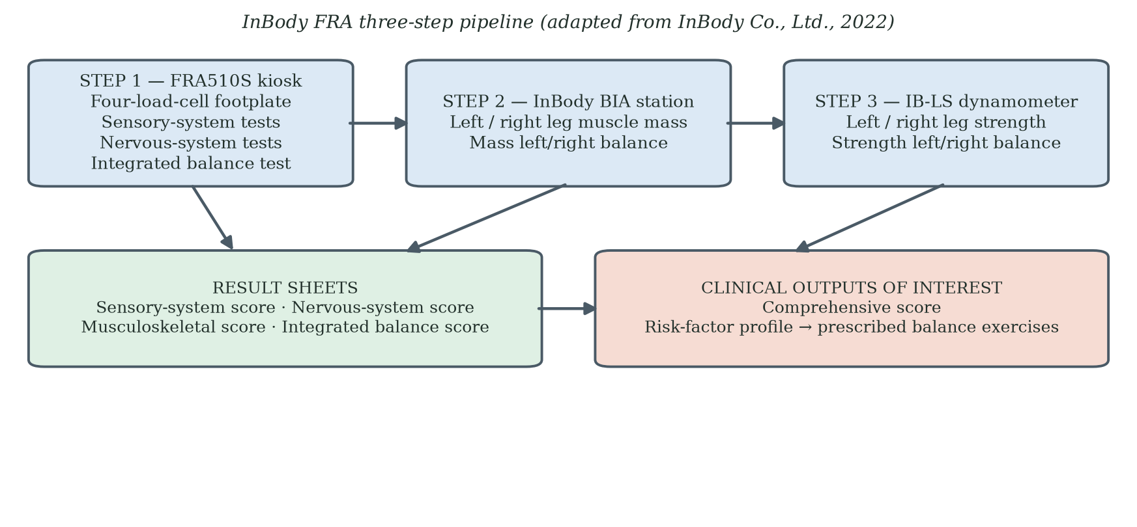
Figure 4.1A. Fall Risk Assessment (FRA) system architecture as deployed at the Poly Group facility (InBody FRA510S). Step 1 captures sensory- and nervous-system tests on the four-load-cell footplate. Steps 2 and 3 add musculoskeletal mass and strength via the InBody BIA station and the IB-LS dynamometer. Four result sheets present sensory-system, nervous-system, musculoskeletal and integrated-balance scores; the comprehensive score and risk-factor profile are the clinical outputs of interest in this thesis. Adapted from InBody Co., Ltd. (2022).
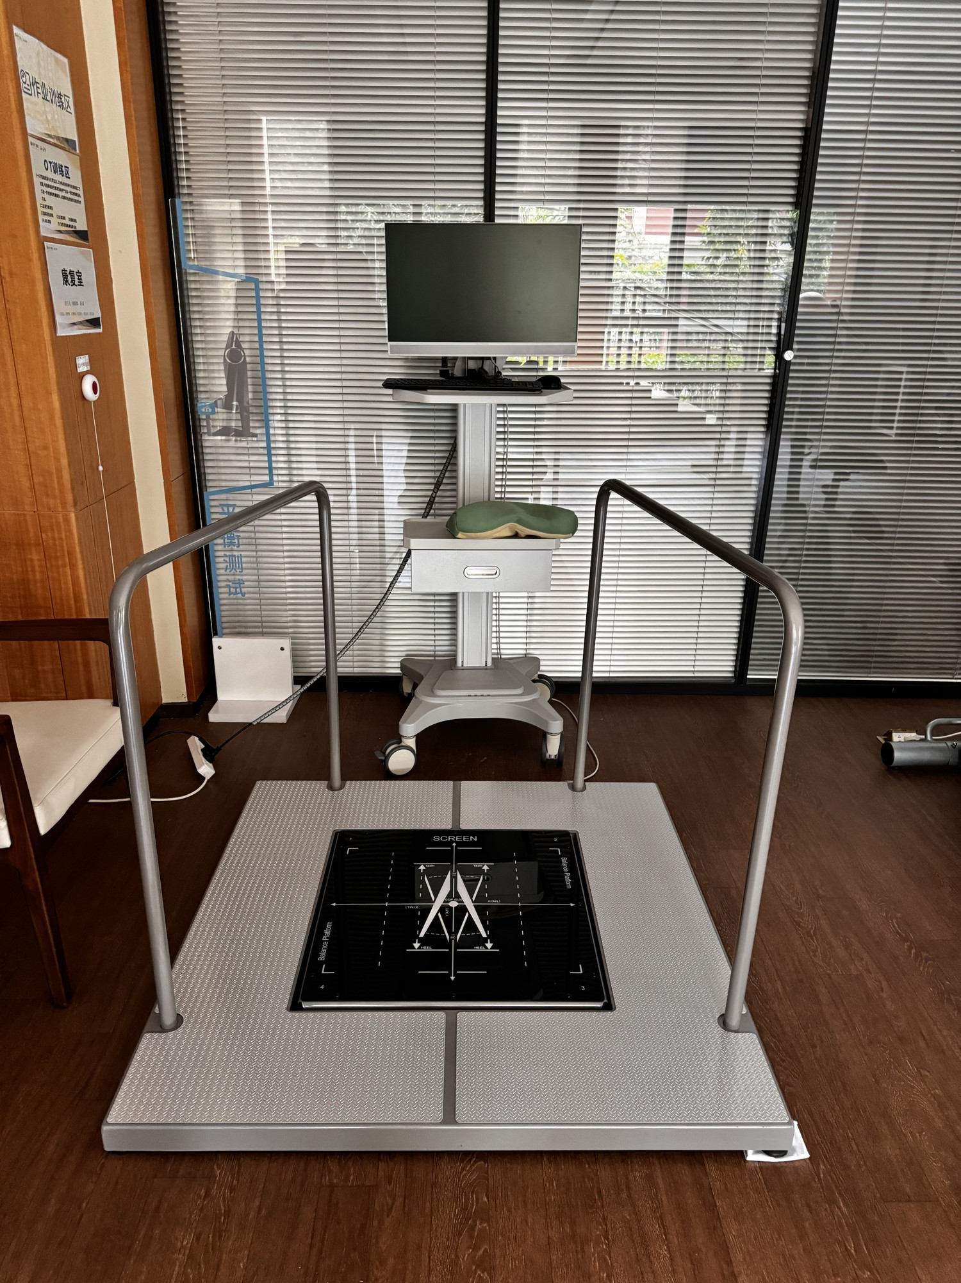
Figure 4.1B. The FRA balance station as deployed in the rehabilitation room of the Guangzhou facility (photograph by the author). The four-load-cell sensing surface — the dark glass panel marked with foot-placement guides — is set into an anti-slip base plate and flanked by support rails; the operator's monitor and keyboard stand on a mobile cart behind the platform. The configuration is the modular arrangement described in §4.1A (platform, support rails, operator computer); facility signage designates the occupational-therapy training area and the balance-test zone. The same platform is shown under game control in Figure 5.1A.
FRA is therefore the sensor-based artefact whose engagement profile is examined. The Stage-1 survey instrument reproduced in Appendix A contains six Yes/No items on awareness, prior use, understanding and acceptance of the first result, subsequent return, discomfort or discouragement, and willingness to use a friendlier version. The figure of 280 that appears in earlier working documents is the facility's resident population at the time of the survey; 200 eligible residents were interviewed, and 200 is the denominator for every Stage-1 result. No separate TAM-based questionnaire block was administered; the six-item form reproduced in Appendix A is the complete Stage-1 instrument, and only results with a traceable item, wording, denominator and data source remain in Table 4.1.

4.2 The Guangzhou Survey (N = 200 of 280 Residents)
Six Yes/No items were administered face-to-face by nursing staff in July and August 2024 to residents aged 65–88 who met the stated eligibility criteria. Face-to-face administration reduced literacy and digital-skill barriers, but it may also have introduced interviewer and social-desirability effects, and this is acknowledged as a limitation in §4.8. Of the facility's 280 residents, 200 who met the eligibility criteria were interviewed; the interviewed sample of 200 is the denominator for all Stage-1 results. The remaining 80 residents were unavailable at the time the interviews were conducted; none were excluded by refusal. Because unavailability is unlikely to correlate strongly with FRA experience, the selection risk is judged modest, though it is acknowledged with the other Stage-1 limitations in §4.8.
Table 4.1. Stage-1 survey results (N = 200 residents surveyed, of a resident population of 280).
Survey item | Result
Ever used FRA | 39%
Never used FRA | 61%
Adverse/unacceptable first experience among prior users (item 3 asks whether the first result was understood and accepted; mapping to task failure is interpretive, §4.8) | ~74%
Self-reported non-return after the adverse first experience | ~82%
The survey indicates a marked gap between prior awareness and actual use, and a high level of self-reported non-return among prior users after an adverse or unacceptable first experience. It does not establish that every respondent experienced task failure, that the decision occurred immediately, or that non-return was irreversible. Working tables from the survey period also suggested favourable physical-access and perceived-benefit estimates; because those figures cannot be traced to items in the archived six-item instrument (Appendix A), they are not reported as survey results. The Stage-1 result is therefore a descriptive problem signature that justifies prospective study of the first adverse experience.

4.3 TAM, STAM and the Limitation for Retired Users
TAM was developed primarily in instrumental technology-use settings, and its Perceived Usefulness construct is usually operationalised through performance gains. For retired older adults, usefulness means something different — safety, independence, confidence, quality of life — because their acceptance criteria are formed by different life experiences and learning patterns (§2.2.1). More important for this thesis, the acceptance models describe beliefs and intentions before and during adoption; they contain no construct for a discrete post-contact failure event and its effect on later use (§2.2.3). The Stage-1 pattern is exactly the pattern such a blind spot would produce: a population that had accepted the technology in the models' terms — aware of it, able to access it, in many cases having tried it — and had then stopped, for reasons the models cannot see. This is what a retrospective failure of H0 looks like. The Stage-1 data motivate explicit study of the failure event; they do not show that positive beliefs never predict use.
Table 4.2. TAM limitations for elderly FRA users.
TAM assumption | Reality for elderly FRA users | Consequence
Usefulness tied to job performance | Users are retired | PU needs redefining
Positive perceptions predict adoption | Reported favourable beliefs coexisted with low prior use | Beliefs alone did not account for observed use
Negative experience reduces acceptance gradually | Reported/observed non-return could occur abruptly within the study window | Standard models do not explicitly represent event-triggered non-return
No construct for failure response | First failure was strongly associated with observed dropout in Stage 2 | Requires a post-contact, time-varying account

4.4 Octalysis and the In-Game Loss Assumption
Chou's Octalysis Framework (2015) organises gamification around eight motivational drives. In clinically framed activities for older users, some mechanics may operate differently from their intended use. Loss and Avoidance can refer not only to in-game points or streaks but also to the perceived personal meaning of an unfavourable result. Social comparison (Festinger, 1954) can motivate some participants while increasing age-related self-awareness for others. The thesis therefore treats D5 and D8 as context-sensitive and potentially double-edged rather than as universally inverted. Chapter 2 locates the underlying reason: all eight drives are designer-side levers for building engagement, and the framework contains no user-side account of abandonment (§2.3.2). Stage 1's contribution to that argument is contextual — Table 4.3 shows how each relevant drive reads differently once the player is an older adult and the frame is clinical — and it prepares the inversion of D8 that the later empirical work motivated (§2.6.2C).
Table 4.3. Octalysis drives contextualised against STAM characteristics.
Octalysis drive | Standard assumption | Context-sensitive possibility in older clinical users
D2 Accomplishment | Achievement challenges motivate | May be undermined by failure
D5 Social Influence | Comparison drives engagement | May motivate some users or increase decline-related self-awareness
D8 Loss and Avoidance | Fear of losing progress sustains play | Adverse performance may be interpreted as personally meaningful rather than only in-game loss

4.5 Behavioural Science Lenses
Bandura's self-efficacy theory offers a plausible within-person pathway: difficulty can reduce task-specific confidence and persistence, particularly when the task is important to the user. Prospect theory suggests that unfavourable information may be weighted more heavily than equivalent favourable information relative to a reference point. Together, these theories generate a candidate explanation for abrupt non-return after an adverse first experience. The Stage-1 survey does not measure self-efficacy change, loss aversion or reference points directly, so the mechanism remains inferential. These lenses are assembled into their full supporting structure — observation, theory, construct, prediction — in Table 2.1.

4.6 Terminological Correction: FIDS to FIAS
The initial label, Failure-Induced Dropout Syndrome (FIDS), was derived from study-attrition vocabulary. "Dropout" can describe non-completion without specifying agency or meaning. The retrospective Stage-1 reports suggested a more active pattern of non-return after an adverse first experience, motivating the term Failure-Induced Abandonment Syndrome (FIAS). The renaming is analytically useful because it shifts design attention from reminders and access alone toward the meaning of the first experience. It should not be read as evidence that the exit was clinically irreversible, psychologically final, or directly observed to occur within hours; those temporal and mechanistic questions were examined prospectively in Stage 2.
The FIDS-to-FIAS revision is therefore a conceptual output of Stage 1 and Stage 2 rather than a validated diagnostic classification. In this thesis, FIAS denotes a proposed behavioural pattern: failure-associated active non-return under conditions where performance may be interpreted as identity-relevant. Its operational definition, reliability, discriminant validity and predictive increment over STAM require further testing.

4.7 Cross-Cultural Reference Point
Korean deployments of the same FRA technology provide a cross-cultural reference point. Park et al. (2019) validated the FRA system against gold-standard balance batteries in community-dwelling older adults, and Kim, Kim and Won (2018) established its test-retest reliability; both studies evidence sustained institutional use of the platform in Korea. A specific sustained-engagement figure quoted in earlier drafts originated in the vendor's catalogue material and is not carried as evidence in this thesis. The Korean comparison is therefore qualitative: whatever design lever supports sustained engagement there has not been identified in the peer-reviewed literature, and this programme is, in part, an investigation of which lever it is.

4.8 Output and Stage-1 Limitations
Stage 1 produces three outputs. First, a documented utilisation and non-return problem signature: awareness without use, and self-reported non-return after adverse first experiences, in a population that satisfied every practical precondition the acceptance models name. Second, the identification of a post-contact event — the adverse first experience — that TAM, STAM and Octalysis do not represent. Third, the provisional FIAS construct and the hypotheses of Chapter 5. In the argument of this thesis, Stage 1 is the retrospective evidence consistent with the failure of the null hypothesis H0 (§2.3.5); Stage 2 provides the prospective test. Stage 1 does not validate FIAS, establish permanence, or identify mental accounting, endowment or stereotype threat as causal mechanisms; those propositions are examined prospectively in Stage 2 and probed through participant-facing decoupling in Stage 3. Its limitations are those of a retrospective staff-administered survey: recall error, interviewer and social-desirability effects, item wording that captures acceptance of a result rather than task failure directly, and the exclusion of 80 of the facility's 280 residents who were unavailable when the interviews were conducted.

Chapter 5 Stage 2 — Action Research with Gamified FRA

5.1 Research Questions and Hypotheses
Stage 2 addressed three questions. RQ1: Can a dual-purpose gamified balance activity sustain engagement while generating interpretable performance and FRA-related records? RQ2: How is first-failure experience associated with observed dropout during an eight-week deployment? RQ3: Which candidate explanations and design principles are suggested by cases in which score change and return behaviour diverge? The hypotheses are directional and should be interpreted within the limits of a small, single-site action-research cohort.
H0 (null hypothesis, from §2.3.5): A gamified FRA satisfying TAM/STAM acceptance criteria and Octalysis motivational drives will improve elderly acceptance and intention to use, and adverse first experiences will not produce lasting abandonment. Stage 2 provides the primary prospective test of H0; H1, H2 and H4 are the directional hypotheses that structure that test.
H1: An adverse or difficult first experience is associated with early disengagement (three or fewer completed game cycles) during the eight-week study window.
H2: Re-engagement after disengagement is uncommon during the Stage-2 observation window under the coupled FRA framing.
H4: A subgroup exists in which positive change in the recorded FRA index and observed non-return co-occur (the objective-score-improvement/non-return paradox).
H5, proposed for Stage 3: a participant-facing decoupling package will be associated with lower observed non-return and higher post-failure return than the Stage-2 coupled condition. Because Stage 3 uses a separate cohort, H5 tests a directional frame-sensitive account rather than a fully isolated causal effect.

5.2 Setting and Action-Research Approach
Stage 2 was conducted at a residential care facility in Southern China with several hundred beds, an InBody FRA system in place for over a decade, sufficient one-to-one staffing, and free-of-charge access to the equipment. The standard logistical and economic explanations for low utilisation were absent. The behavioural pattern was therefore observable in clean form: the dropout was not produced by access friction, cost, or staffing scarcity. This is what makes Stage 2 the clean prospective test of the null hypothesis H0 (§2.3.5): every practical precondition the acceptance models name was satisfied, the gamification layer was added to specification, and whatever happened next could only be attributed to how the participants experienced the gamified FRA itself.

5.2A Integrating the FRA into the Skiing Game: The Dual-Purpose Mechanic in Detail
The dual-purpose mechanic that anchors Stage 2 (and that is preserved through Stage 3) rests on a single observation about the FRA system described in §4.1A: the centre-of-pressure (COP) trace produced by the four-load-cell footplate is sufficient input both for the Step-1 sensory- and nervous-system FRA computation and for a real-time game controller. The same physical action — a balanced shift of body weight on the footplate — can therefore be read twice. From the player’s point of view it is a steering input on a skiing trail. From the clinician’s point of view it is a COP sample on the same instrument that the FRA510S would otherwise drive on its own. Figure 5.0 shows the integration explicitly: the footplate sits at the top, the COP stream branches into a player-facing column on the left and a clinician-facing column on the right, and the questionnaires referenced in §5.4 and Appendix B feed both ledgers through self-report. The two columns meet only at the sensor; the rest of the architecture is deliberately separated.
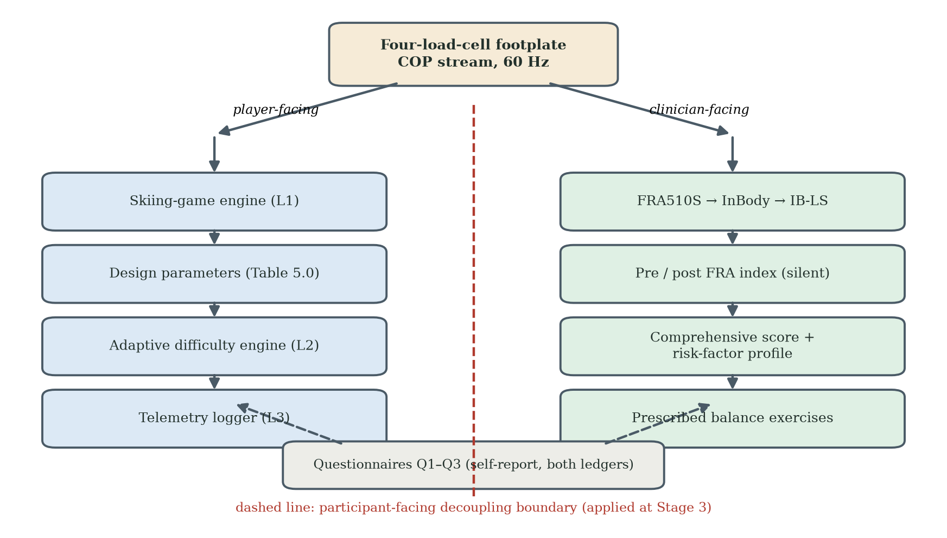
Figure 5.0. Integration of the FRA system into the skiing game. The four-load-cell footplate is shared; the COP stream feeds a player-facing pipeline (skiing-game engine, design parameters, adaptive difficulty engine, telemetry logger) on the left and a clinician-facing pipeline (FRA510S → InBody → IB-LS, pre/post FRA index, comprehensive score and risk-factor profile, prescribed Balance Exercises) on the right. The dashed line is the decoupling boundary applied at Stage 3. Questionnaires Q1-Q3 (Appendix B) feed both ledgers through self-report.
The integration is mediated by a small set of design parameters that have been frozen in a project-internal data file (Game_States_and_Parameters.xlsx; archived alongside this thesis). The state-machine specification has four states — Assessment, Playing, Paused, Game Over — with the transitions used by the Stage-2 build. The Assessment state is a pre-game competency screen on which the participant selects age group, balance ability and rehabilitation goal; clicking “Start Training” transitions to Playing. The Playing state runs the active gameplay: the skier moves down the slope, the player steers to avoid obstacles and collect coins, and the balance meter depletes over time and on turning. The Paused state freezes all movement and timers when the “P” key is pressed. The Game Over state is reached on a third obstacle hit, on balance reaching zero with no lives remaining, or on all lives lost; it shows a final-statistics card and an AI training recommendation, and offers either “Train Again” (back to Playing) or a new Assessment session. The Stage-2 build retained the conventional Game Over verdict; the loss-free, non-terminal state repertoire that replaces it is the secondary contribution introduced at §5.3.10 and discussed at §7.6A and §9.8A.
The numerical parameters that govern the integration are summarised in Table 5.0. The slope is rendered as 30 m wide and 2000 m long with a 12° descent. The skier’s baseline lateral movement speed is 8 m/s and the baseline forward speed is 12 m/s (approximately 45 km/h), capped at 30 m/s. Balance decays at 0.02 per frame and incurs an additional 0.15 per frame turn penalty; balance recovers at 0.08 per frame when the player is not turning, starts at 100 %, and is restored to 40 % when a life is lost from balance depletion. Obstacles are spawned at a base density of 0.4 per metre, 120 m ahead of the player, and despawned 30 m behind; tree collision radius is 0.8 m and rock collision radius is 0.4–1.0 m depending on size. Coins are spawned at 0.3 per metre, 100 m ahead, and each collected coin yields 10 points and restores 3 % balance. Difficulty rises by 0.15 multiplier every 200 m of distance progressed. The lives system is critical to the dual-purpose interpretation: the player starts with three lives; a 1.5-second invincibility cooldown follows each collision; the first hit drops speed to 70 % and is otherwise neutral; the second hit halves the obstacle density to 40 % and clears 60 % of obstacles in the next 60 m; the third hit ends the round. Mouse input uses an 8 % deadzone, gamepad input uses a 15 % deadzone, and combined inputs are clamped at 1.5 × the base move speed. Difficulty adaptation reads three settings: age group (18–35 \× 1.1, 36–55 \× 1.0, 56+ \× 0.7), balance ability (low \× 0.6, medium \× 1.0, high \× 1.3), and a per-200 m additive distance term of +0.15. The combined-example row records that a senior with low balance starts the run at a 0.42 multiplier (0.7 \× 0.6), a young player with high balance starts at 1.43, and a middle-aged player with medium balance reaches a 1.30 multiplier by the 400 m mark. These numbers are the integration: they are the bridge between the COP signal that the FRA510S would otherwise read directly and a gameplay surface in which the same signal is read as movement, success and reward.
Table 5.0. Skiing-game parameters by which the FRA COP signal is integrated into gameplay (extract; full specification in Game_States_and_Parameters.xlsx).
Category | Parameter | Value | Role in FRA-game integration
Slope | slopeWidth / Length / Angle | 30 m / 2000 m / 12° | Field across which lateral COP shifts are read as steering.
Player | baseMoveSpeed / baseForwardSpeed / max | 8 / 12 / 30 m/s | Translation gain from COP shift to skier velocity.
Balance | decay / turn penalty / recovery / on-life-loss | 0.02 / 0.15 / 0.08 per frame; 100 %→40 % | In-game proxy for the COP-derived stability index used by FRA Step 1.
Obstacles | density / spawn / despawn / collision radius | 0.4/m; 120 m / 30 m; 0.4–1.0 m | Forces COP corrections of varying amplitude across the run.
Coins | density / value / balance bonus | 0.3/m; 10 pts; 3 % | Reward signal that supports learn-to-earn over score-floor framing.
Lives | total / cooldown / 1st-hit speed / 2nd-hit obstacle | 3 / 1.5 s / × 0.7 / × 0.4 + 60 % cleared | Soft-fail buffer that supports the loss-free repertoire of §5.3.10.
Difficulty | distance step / age × ability multiplier | \+0.15 / 200 m; 0.42–1.43 | Adaptive layer (L2) that protects the flow band for FRA-aligned cohorts.

Three properties of the integration matter for the rest of the chapter. First, the COP stream that the skiing game consumes at 60 Hz is the same stream that FRA Step 1 consumes; nothing about the integration prevents the FRA510S pipeline from running silently from the same data. The pre/post FRA index reported in §5.5 is computed from this silent pipeline; the comprehensive score and risk-factor profile are stored on the clinician-side terminal and are never displayed on the play screen. Second, the Assessment state is the only point at which the participant is asked, in language they can read, what kind of player they are; that input drives the difficulty multiplier table and is how the system makes itself appropriate for an elderly cohort without rendering a fail-state in the first run. Third, the Game Over state is retained in the Stage-2 build for behavioural-economic measurement: the construct that the thesis names — FIAS — is most cleanly observed in the presence of a verdict-shaped fail-state, which is precisely what the Stage-2 build provides. The loss-free, non-terminal repertoire introduced at §5.3.10 is the design response that the Stage-3 result and the Chapter 7 adaptive-learning prescription motivate; it is the natural successor build, and Figure 5.0 shows where it would be installed in the integration map (the L5–L6 block on the player-facing column).
The participant-side data outputs of the integration are described in detail in §5.3.6 (data structures and telemetry); the clinician-side outputs are the InBody Comprehensive Score and risk-factor profile already specified in §4.1A. Self-report is captured by Questionnaires 2 and 3 (Appendix B): Q2 is administered immediately after the first gamified-FRA session (N = 30) and follows the Octalysis core-drives ordering across ten items; Q3 is the eight-week follow-up that distinguishes continuing users from those who dropped out and identifies the failure-induced exit pathway directly. Together, the COP-derived game telemetry, the silent FRA pipeline, and the three questionnaires provide the three-ledger view (behavioural, clinical, self-reported) on which the Stage-2 analysis in §5.5–§5.7 is built.

5.3 The Gamified Intervention — Skiing Game on the InBody Pressure Panel
Stage 2's central technical artefact is a 2D skiing game running on an InBody pressure panel. The game was developed in Pygame, generated through Anthropic Claude Code, with an automatic difficulty-adjustment subsystem driven by LangChain orchestration over a large-language-model endpoint (the deployed endpoint is recorded in Appendix G, item G.7). The single most important property of the system is the dual-purpose mechanic: the same physical action — a balanced shift of body weight on the pressure panel — both controls gameplay and yields the centre-of-pressure (COP) telemetry from which clinical FRA indices are computed.

5.3.1 The InBody Pressure Panel
The InBody pressure panel is a force-plate balance device deployed in clinical and residential settings. It measures the location and movement of the user's centre of pressure with sub-centimetre spatial resolution and sub-second temporal resolution. The panel was calibrated by InBody engineers as part of installation; the calibration function is treated as a fixed component for this thesis. In Stage 2 the panel served two roles at once. As a clinical instrument, the panel produced the COP traces that yielded the FRA index of balance. As a game controller, the panel translated lateral COP shifts into left/right movement of the on-screen skier and forward/backward COP shifts into trail scrolling speed. Neither role compromised the other.

5.3.2 Game Concept and Gameplay Loop
The skiing game is a 2D arcade-style game in which the user controls a skier descending a snow-covered slope. Three game elements interact: the skier (the user's avatar), obstacles distributed across the trail (trees, rocks), and coins (collectible rewards). The skier moves left and right by lateral COP shifts on the InBody panel; the user's task is to avoid obstacles while collecting coins. The skier's vertical position on screen is fixed; the trail and elements scroll upward to give the visual impression of downhill motion. The game is structured into rounds with a five-attempt rule, after which the system either advances the user to a higher difficulty level (on success) or retains the current level (on failure).
Play proceeds in a single repeating loop. The game polls the panel sensor 60 times per second; updates the skier's location and orientation; generates and updates obstacle and coin positions; detects collisions; updates the score; redraws all game elements; and refreshes the screen at 60 frames per second. The loop continues until the user pauses, stops, or the round ends. A short, clearly framed feedback screen ends each round; clinical numbers are not displayed on this screen.

5.3.3 On-Screen Display
Figure 5.1 illustrates the on-screen display. The play field shows a tapered ski trail framed by green trees, a stylised skier near the centre of the screen, scattered obstacles (brown squares representing rocks or stumps) and gold coins distributed across the trail. Two small heads-up displays are anchored at the top of the screen: a score readout in the top-left and a level readout in the top-right. The colour palette is intentionally low-contrast at the periphery and slightly more saturated at the elements that demand attention (skier, obstacles, coins). No clinical language and no clinical iconography appears on the play screen.
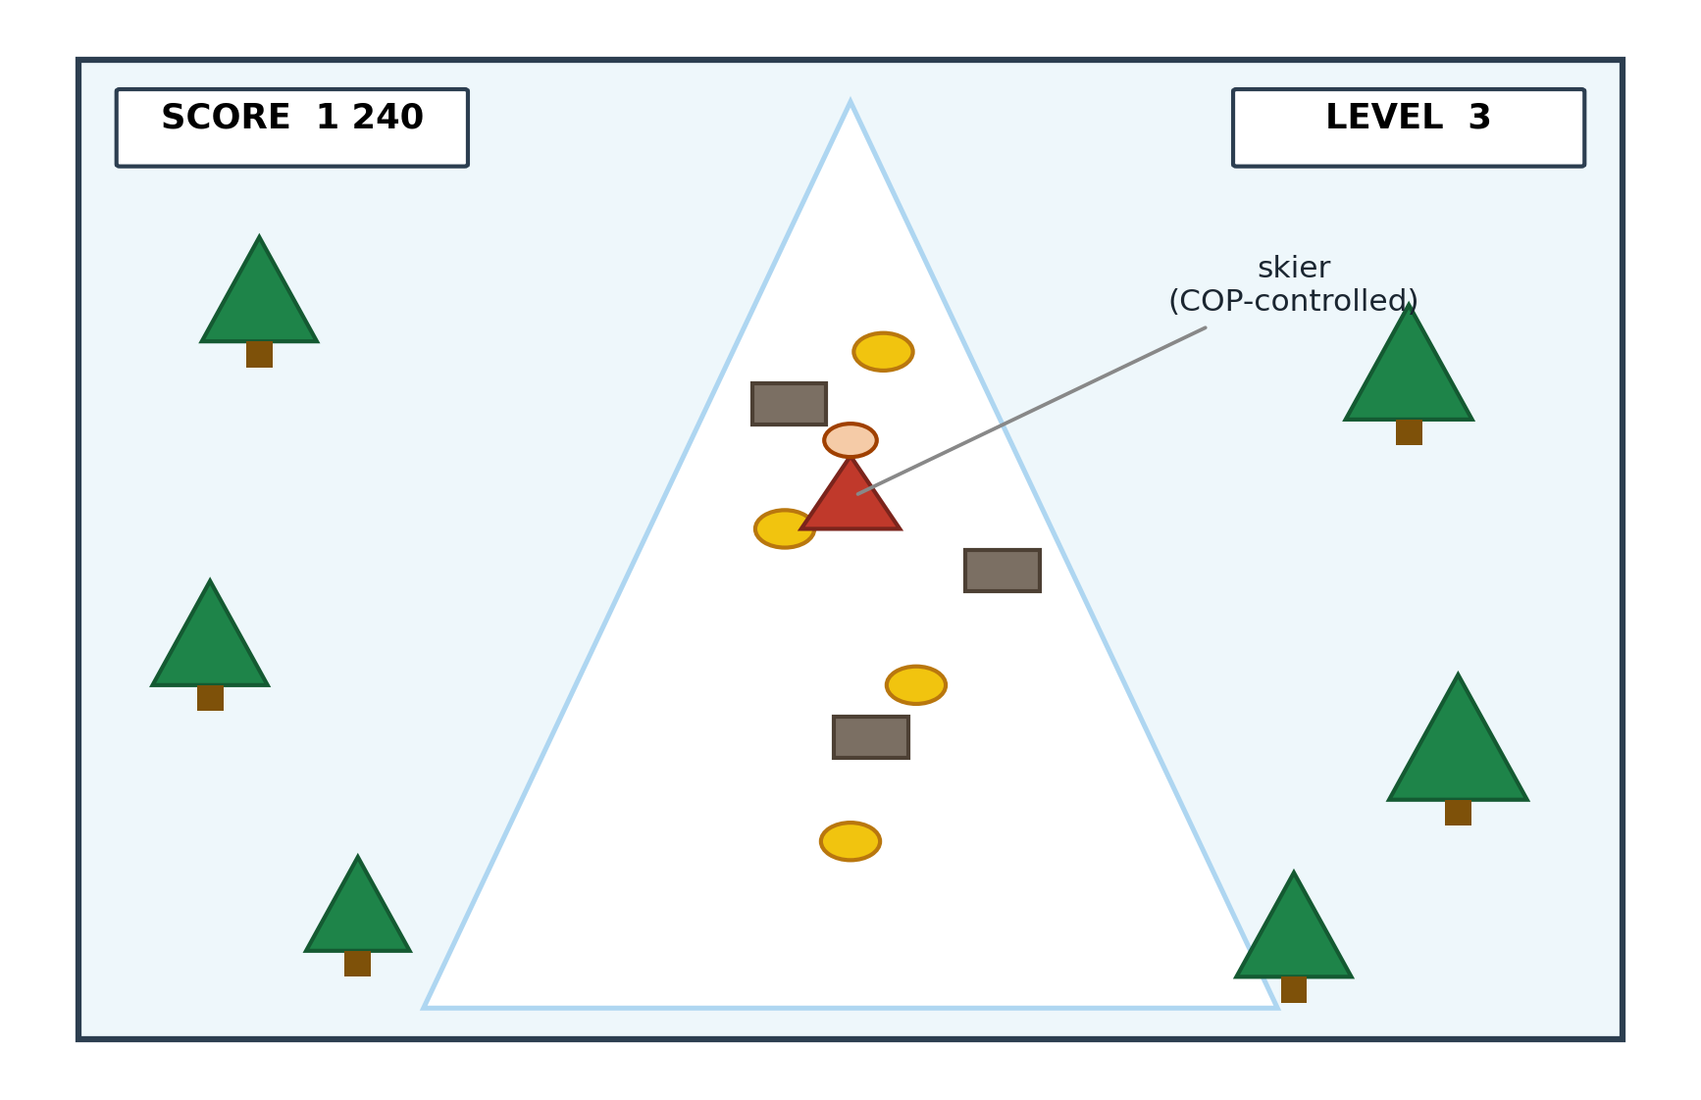
Figure 5.1. Skiing game on-screen display. The skier is controlled through Centre-of-Pressure shifts on the InBody panel; trees and rocks act as obstacles, gold coins reward forward play, and a level-and-score display is anchored to the top of the screen.
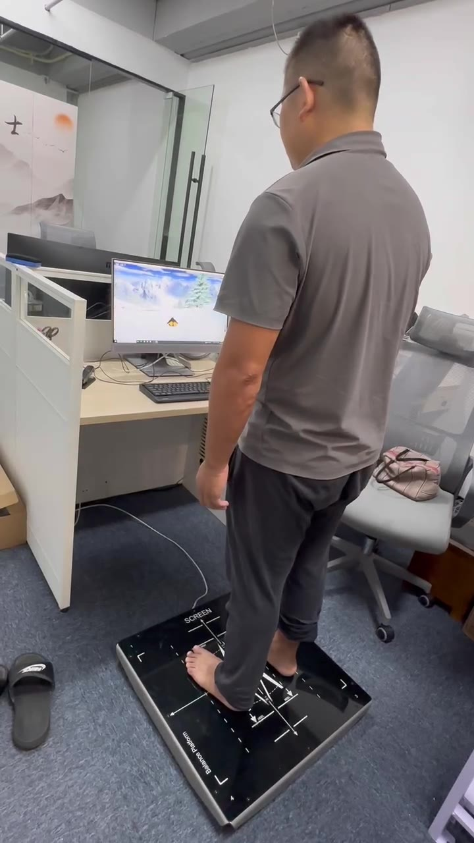
Figure 5.1A. The platform-game coupling demonstrated: one of two control persons steers the skiing-game prototype by weight shift on the balance platform (development office, 27 August 2024; frame from the archived video, Appendix G, item G.8). Photography of study participants was not permitted under the residential facility's privacy rules, so no participant play imagery exists; this development-phase demonstration stands in its place.
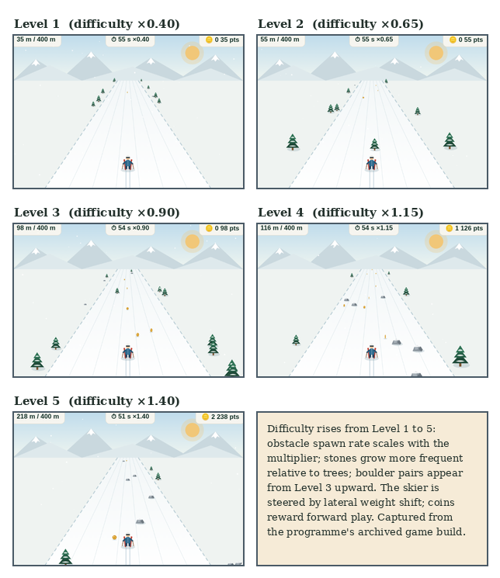
Figure 5.1B. The deployed game artefact across difficulty levels 1–5. Obstacle spawn rate scales with the difficulty multiplier (×0.40 to ×1.40), stones become more frequent relative to trees, and boulder pairs appear from Level 3 upward; the skier is steered by lateral weight shift and coins reward forward play. Screenshots captured from the programme's archived game build — the successor build in the same design lineage as the Stage-2 deployment.

5.3.4 Five-Layer Architecture
The system is organised into five layers, each with a distinct responsibility. Figure 5.2 summarises the architecture. Layer 0 (Sensor Input) is the InBody pressure panel; the layer's output is a stream of COP coordinates. Layer 1 (Game Engine) is the Pygame skiing task; it consumes COP coordinates and produces frame-by-frame game state. Layer 2 (AI Adaptation) is a LangChain runtime calling a large-language-model endpoint that adjusts obstacle density and skier speed at five-minute intervals using a prompt template anchored to the user's recent success rate (raise difficulty above 80%, lower below 40%). Layer 3 (Logging) records cycle counts, COP traces, session-level affect and dropout flags in JSON format. Layer 4 (Clinical Output) computes pre/post FRA indices from the COP stream for clinician review. Layers 1–2 form a self-contained adaptation loop; the clinical layer (L4) runs silently from Layer 0–3 telemetry without interrupting gameplay.
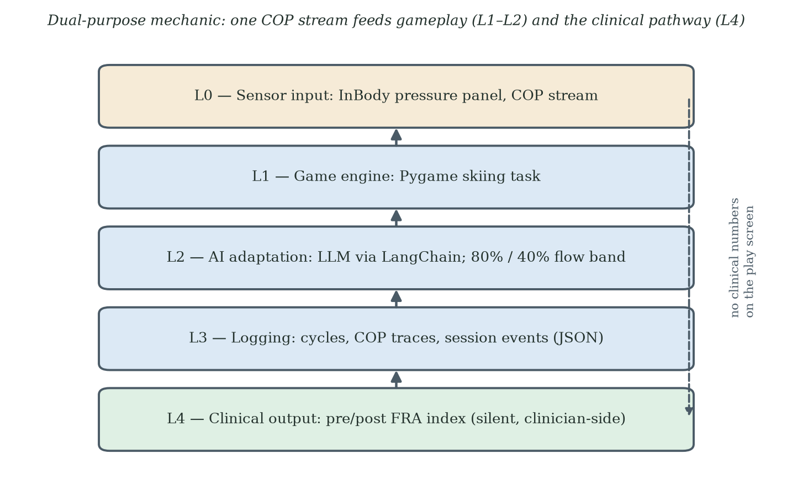
Figure 5.2. Five-layer architecture of the gamified FRA system. The dual-purpose mechanic links Layer 0 (sensor input) and Layer 4 (clinical output) through the gameplay layers without exposing clinical numbers to the user during play.

5.3.5 Automatic Difficulty Adjustment System
The automatic difficulty-adjustment system (Layer 2) adjusts the game in real time so that challenge tracks the user's evolving capability. The system has six stages. First, data collection: historical and within-session game data are gathered (game type, difficulty level, score, accuracy, reaction time, duration, frequency) alongside personal information collected at enrolment (age, sex, physical condition, cognitive screening, game preferences). Second, data processing: collected data are cleaned, structured into JSON, and rendered into a natural-language input string ("User A: age 72, female, memory decline; historical game: skiing, difficulty 3, accuracy 80%, reaction time 1.5 s; current session: skiing, difficulty 1–5"). Third, model use: a pre-trained large language model is invoked through LangChain with a prompt template that asks for an initial difficulty and an adjustment strategy grounded in flow theory and the challenge–skill balance. Fourth, difficulty generation: the model returns a structured response with a recommended difficulty level and a written rationale. Fifth, real-time adjustment: every five minutes during play the system collects the latest session data, re-invokes the model, and applies the updated parameters (skier speed, coin generation interval, coin group size, obstacle density). Sixth, evaluation and optimisation: at the end of each session the user supplies a brief subjective rating, which is stored alongside objective performance for future model fine-tuning.
The thresholds for in-session difficulty change are set at 80% and 40% success rate. Above 80%, difficulty rises to keep the user near the edge of their ability; below 40%, difficulty falls to prevent the user from being pushed into the failure cascade described in Chapter 4. The threshold values are conservative defaults intended to keep the user inside the flow band and remain a tunable component of Layer 2 in any future deployment.

5.3.6 Data Structures and Telemetry
The system records data along three dimensions, summarised in Table 5.1. The user dimension captures stable personal characteristics. The game dimension captures session-level configuration. The result dimension captures session-level outcomes. The combination supports per-user adaptation and supports the Layer 4 clinical output.
Table 5.1. Skiing game data structure summary.
Dimension | Fields
User | Unique device identifier; age; sex; physical condition; vision and hearing status; cognitive function status; medications; lower-limb strength baseline; balance baseline
Game | Session identifier; difficulty level (1–5); game type; session duration; stimulus type (visual, auditory); stimulus presentation speed and frequency; user response type (COP shift)
Result | Correct response rate; average reaction time; maximum and minimum reaction time; left- and right-leg strength; symmetry of leg strength; fatigue rate; game score; star rating

5.3.7 Sample User Profile
As a worked example, the system was tested on a synthetic profile of a 72-year-old female user with average overall physical condition, poor balance, slow reaction speed, weak lower-limb strength, and limited recent exercise. The profile included hypertension and osteoarthritis, antihypertensive and analgesic medication, mild vision and hearing decline, and possible mild cognitive impairment. In-session telemetry showed a 60% correct-reaction rate, an average reaction time of 2.0 seconds, asymmetric leg strength, a 30% fatigue rate, a session score of 50 points and a 2-star rating, with declining performance on recent sessions. Layer 2 returned an initial difficulty level of 1 with a written rationale grounded in flow theory and challenge–skill balance, plus three to five level-up suggestions and three to five personalised practice suggestions covering balance training, reaction-time drills and lower-limb strengthening. The profile illustrates the system's intended behaviour: difficulty calibration is conservative; explanations are grounded in established theory; recommendations are concrete and personalised. The profile is synthetic and was used for pipeline verification, in the same spirit as the synthetic centre-of-pressure traces of §5.3.9; it is not a study participant.

5.3.8 Why a Skiing Game?
The skiing metaphor was selected for three reasons. First, the lateral-shift control mapping is natural: the COP shift required to lean a skier matches the COP shift required to maintain dynamic balance, so the gameplay action and the clinical measurement coincide without translation. Second, the skiing metaphor is culturally accessible across the Stage-2 cohort: every participant had seen winter sports on television, and no participant required a genre-specific tutorial. Third, the trail-scrolling visual provides an intrinsic forward-motion cue that does not require the user to read distance or score, reducing the cognitive load on participants with mild visual or attentional impairment.
The choice of metaphor matters for Stage 3, but the skiing metaphor itself is not the principal design lever under examination. Stage 3 retains the broad skiing mechanic and pressure-panel interaction while changing multiple participant-facing clinical cues. The comparison therefore reduces some artefact-level variation but does not isolate framing from all procedural, interface, cohort and contextual differences.

5.3.9 Development Methodology: The Claude Code-Assisted Workflow
The skiing game was developed using Anthropic Claude Code as the primary engineering assistant. Claude Code is a command-line tool that allows a developer to delegate coding tasks to a Claude model directly from the terminal, with read and write access to the local file system and the ability to execute shell commands. The tool was used in an iterative pair-programming pattern across the design, implementation and tuning phases of the project. The decision to document this workflow follows from action research's commitment to making the methodological vehicle visible. The vehicle is not incidental; it shaped what was built and how quickly the design could be revised.
Before any custom code was written, the platform-to-game input coupling was validated on an off-the-shelf scaffold. In the earliest development phase the balance platform was connected to the open-source Tux Racer skiing game — a 3D title in which a penguin slides belly-down over a snow slope collecting fish — so that weight-shift steering could be demonstrated end-to-end before the study game existed. Two contemporaneous videos, recorded at the development office on 27 August 2024 and held in the study archive (Appendix G, item G.8), show one of two control persons steering this prototype by weight shift alone. The deployed Stage-2 game described in this chapter is a separate implementation: a 2D Pygame build, with the avatar aesthetic moved from the prototype's penguin to a human skier during development. The open-source scaffold contributed no code to the deployed build; its role — proving the input coupling before engineering effort was committed — is recorded here so that the development lineage is complete.
The development cycle had three iterative loops. The outer loop was a design loop. A change in the user-facing experience (a new obstacle pattern, a different visual feedback scheme, a revised five-attempt rule) was first specified in a short natural-language description, refined in dialogue with Claude Code, and then translated into a working Pygame change in a single working session. A change that would have taken half a day to write from scratch typically reached a runnable prototype within thirty minutes. The middle loop was an implementation loop. Within each design change, Claude Code generated the Pygame code, the developer ran it on the test rig, observable problems were reported back to Claude Code, and a revised version followed. Three to five revision cycles per design change were typical. The inner loop was a verification loop. Once the implementation produced visually plausible behaviour, a small set of synthetic centre-of-pressure traces was run through the game logic to verify that the lateral-shift mapping, the obstacle collision detection, and the coin pickup logic responded correctly to known inputs. The synthetic traces themselves were generated by Claude Code from a written specification of expected balance patterns.
Three components of the system benefited particularly from the Claude Code workflow. The first component is the Layer 1 game engine itself. The Pygame skiing task moved through approximately fifteen design iterations between the first runnable prototype and the version deployed in Stage 2. Each iteration was traceable to a specific observation from a test session: scrolling speed too high for older users, obstacle spacing producing impossible gaps, coin reward salience too low against the snow background, and so on. The second component is the Layer 2 prompt template that drives the difficulty-adjustment subsystem. The prompt template was iterated through Claude Code's own prompt-engineering capabilities. Sample user profiles were fed through the template, the model's response was inspected, the prompt was revised to correct under-conservative or over-conservative difficulty recommendations, and the cycle repeated until the system reliably produced flow-theory-consistent recommendations across a range of synthetic user profiles. The third component is the Layer 3 logging schema. Claude Code generated the JSON schema, the writer function and the validation harness in a single session, with the schema then reviewed against the data dimensions specified in Table 5.1. The schema has not required revision since.
Two methodological points follow from this development pattern. First, the use of Claude Code did not change the engineering content of the system. The five-layer architecture, the dual-purpose mechanic, the COP-to-control mapping and the difficulty-adjustment logic are all engineering decisions that an experienced developer would make with or without AI assistance. What Claude Code changed was the speed at which decisions could be tested. The development was empirically driven because the cost of testing a design change was low. Second, the use of an AI agent to build a system that itself uses an AI subsystem (the LangChain plus large-language-model adaptation layer in Layer 2) does not collapse into a circular dependence. The two AI uses are at different layers and have different roles. Claude Code is used at design time, by the developer, to generate code. The Layer 2 model is used at run time, by the system, to recommend difficulty parameters. The two are separable, and the run-time system runs without any further involvement from Claude Code once deployed.
The Claude Code-assisted workflow is documented for reproducibility, not offered as a contribution in its own right: the AI tooling is an enabling technology, and the contribution it enabled is the behavioural design framework. Engineering doctoral programmes increasingly involve software components whose construction is itself an act of design. Documenting the vehicle by which the artefact was built, alongside the artefact itself, makes the action research more reproducible and clarifies which engineering decisions belong to the developer and which were accelerated by tooling.

5.3.10 Dynamic Game States: An Agentic-AI-Driven, Loss-Free Game Mechanic (Secondary Contribution)
The skiing-game specification reported in §5.3.1 to §5.3.9 was sufficient for the empirical Stage-2 deployment, but it retained a conventional terminal "GAME OVER" screen and a difficulty controller updated at scheduled intervals. In response to the theoretical analysis, this subsection proposes a dynamic game-state architecture with non-terminal recovery, mastery, narrative and reframe states. The objective is to reduce verdict-like failure cues while preserving challenge, truthful feedback and the underlying clinical measurement path. This architecture is a prospective secondary design contribution. It was not deployed in Stage 2, and no claim is made here that it prevents FIAS or eliminates non-return. The Stage-2 evidence gives the proposal its force: the deployed build had already softened the in-game loss economy — three lives, a neutral first hit, an obstacle-clearing second hit — yet abandonment persisted, indicating that the loss driving non-return was never the in-game loss. What remained untouched in Stage 2 was the verdict: the terminal Game Over and the clinical frame around it. The zero-failure repertoire below removes the verdict; the theoretical case is §2.6.2C.
Figure 5.3 presents the proposed architecture. L0 is the pressure-panel and in-game event stream. L1 is a performance-state classifier producing variables such as rolling success rate, time-to-fail and a flow proxy. L2 is a policy controller that selects among five non-terminal states: Standard Run, Recovery Run, Mastery Run, Story-Bridge and Reframe Pause. L5 is a user-facing trajectory display that avoids terminal failure labels while preserving informative feedback. L6 is a frame-congruence check intended to prevent accidental reintroduction of contradictory clinical or deficit language. These components are design specifications to be tested. Terms such as "identity-asset guard" describe the design intent, not a verified psychological mechanism.
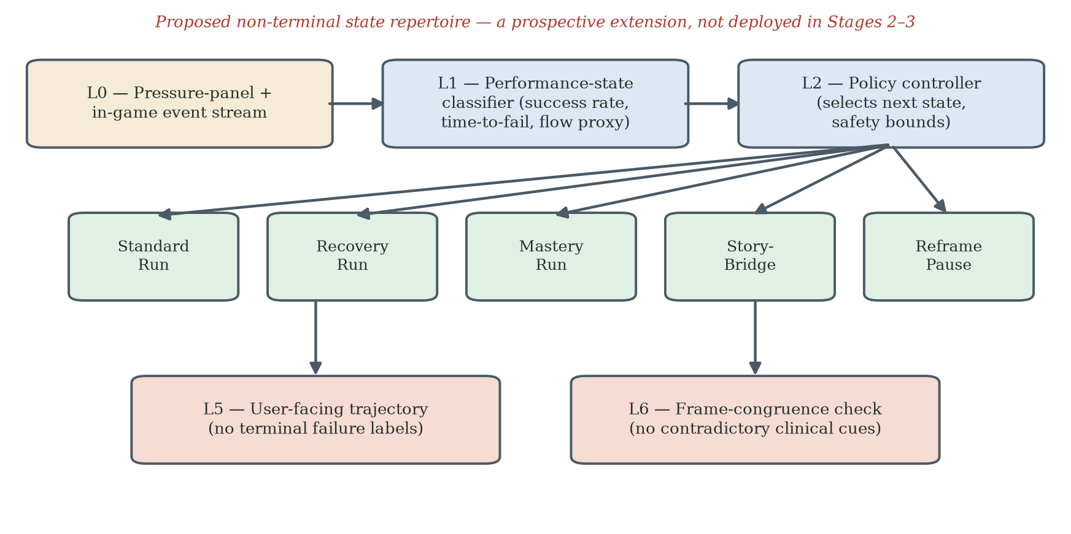
Figure 5.3. Proposed dynamic game-state architecture for the FRA skiing game. The controller (L2) selects among five non-terminal states on the basis of the L1 performance-state vector. The user-facing layer (L5) presents progress as a trajectory, and L6 checks frame congruence across visible cues. L0-L4 retain the existing sensing, game and measurement path. The architecture is a prospective extension and was not evaluated in the Stage-2 or Stage-3 empirical comparisons.
The proposed instruction pattern has three phases. At design time, Claude Code is given a behavioural and safety specification: avoid terminal "GAME OVER" presentation, preserve meaningful challenge, represent failure as information for the next attempt, maintain truthful disclosure and keep the clinical measurement path separate from the user-facing game layer. The agent can generate candidate state repertoires, executable rules and synthetic test traces. At deployment, the policy would operate alongside the difficulty controller, with precedence rules and safety bounds defined in advance. At run time, state selections and outcomes would be logged for audit and evaluation. The developer remains responsible for the specification, validation, governance and final code; AI-generated policy logic is not treated as self-validating.
Three points fix the scope of this contribution. First, it is a design specification, not an empirical result; Stage 2 used the original game-state structure, and Stage 3 did not test a controlled state-repertoire comparison. Second, the proposal preserves the dual-purpose sensing path but requires separate validation of whether gameplay-derived signals are clinically interpretable. Third, the design should be evaluated against pre-specified outcomes, including immediate retry, return within a common observation window, user comprehension, challenge adequacy and unintended concealment of clinically important information. A "loss-free" surface must not become a challenge-free or misleading surface.

5.4 Participants and Data Governance
Thirty residents participated over eight weeks (mean age 71.1 ± 5.9; range 62–84). PIPL compliance was maintained. All data were pseudonymised at collection. Only non-specific aggregate parameters were transmitted to API endpoints; no personally identifying information left the facility's local server.

5.5 Quantitative Findings
The Stage-2 archive (FRA_Raw_Data_N30.xlsx; Appendix G, item G.2) contains one record per participant: gender, age, the recorded FRA index before and after the deployment window, presenting fall-risk symptoms, the number of completed game cycles, self-reported symptom change, satisfaction and a verification flag. Thirty-two records were collected in total; two records from younger control participants (aged 36 and 53) are retained in the archive but not analysed in this thesis, leaving the thirty elderly participants (aged 62–84, mean 71.1 ± 5.9; 17 female, 13 male) analysed here. One record failed verification and is retained with a sensitivity note. Because the archive records cycle counts and pre/post index values but no session dates or timestamps, time-to-event methods are not applicable to it: a Cox proportional-hazards model and a Kaplan-Meier estimator both require an observed time variable that this dataset does not contain. The survival-analysis framing used in earlier drafts, including the previously reported hazard ratio, has therefore been withdrawn, and the analysis below uses estimators suited to a small, single-site sample: Wilson score intervals for proportions, paired t and Wilcoxon signed-rank tests for the pre/post index, Welch and Mann-Whitney tests for between-group contrasts, and Fisher's exact test for categorical associations. A completed game cycle denotes one attended play session at the station under the five-attempt rule (§5.2A); the three-or-fewer-cycles threshold defines the low-engagement group referenced in H1 (§5.1).
The primary outcome answers H0 directly, and negatively. Engagement showed an early drop-off: twenty-one of thirty participants (70.0%, 95% CI 52.1–83.3%) completed three or fewer cycles, eight (26.7%, 95% CI 14.2–44.4%) ended after a single session, and no re-engagement was observed among the low-engagement group during the eight-week window (0 of 21; 95% CI 0.0–15.5%). Neither gender (Fisher's exact p = 0.69) nor age (Spearman ρ = −0.18, p = 0.34) was reliably associated with the number of completed cycles in this small sample.
Table 5.2. Stage-2 engagement pattern (N = 30).
Engagement metric | Value
Low engagement (≤ 3 cycles) | 21/30 (70%)
Sustained (≥ 4 cycles) | 9/30 (30%)
Single-session exits | 8/30 (27%)
Observed re-engagement after disengagement within eight weeks | 0/21 low-engagement participants (0%)

Among the nine sustained participants, the recorded FRA index moved from 42.0 ± 8.3 before the deployment to 48.9 ± 9.4 after it: a mean paired change of +6.9 points (95% CI 4.5–9.3; paired t(8) = 6.67, p < 0.001; Wilcoxon p = 0.004; dz = 2.22, exact 95% CI 0.95–3.46). All thirty participants have recorded pre/post values, so no imputation is required: across the full cohort the paired change was +4.0 points (95% CI 0.5–7.6; t(29) = 2.31, p = 0.028; Wilcoxon p = 0.015; dz = 0.42, exact 95% CI 0.05–0.79), with twenty participants recording an increase, nine a decrease and one no change. The pooled (d = 0.78) and zero-imputation (d = 0.57) estimates quoted in earlier drafts do not reproduce from the archive and have been withdrawn. The difference in index change between sustained and low-engagement participants (+6.9 versus +2.8 points) was not statistically reliable (Welch t = 1.55, p = 0.13; Mann-Whitney p = 0.051). On the InBody FRA system a higher composite score indicates better performance and a lower risk of falling: the composite is calibrated so that the population average lies near 70, and it correlates positively with gold-standard batteries such as the Berg Balance Scale and the Short Physical Performance Battery (InBody Co., Ltd., 2022). The recorded increases therefore indicate improvement. The contrary direction note in the legend accompanying the archived data file has been identified as an error and corrected in the archive documentation. One interpretive constraint remains: single-measurement changes of this size lie within the range of test-retest variability reported for FRA instruments in older adults (Kim et al., 2018), so within-deployment index change should be read as a provisional signal rather than a demonstrated clinical effect.
The self-reported and recorded ledgers diverge in an instructive way. Eighteen of thirty participants (60.0%, 95% CI 42.3–75.4%) reported symptom improvement after the deployment and twenty (66.7%, 95% CI 48.8–80.8%) were satisfied or very satisfied. Satisfaction was strongly associated with sustained engagement: all nine sustained participants were satisfied, against eleven of twenty-one in the low-engagement group (Fisher's exact p = 0.013). Self-reported symptom improvement showed the same direction but did not reach significance (7 of 9 versus 11 of 21; Fisher's exact p = 0.25). Among the eight single-session participants, five recorded a positive index change yet only two reported any improvement and none returned — the archived form of the divergence that Chapter 5 names the objective-score-improvement/non-return paradox, subject to the direction caveat above. Excluding the single unverified record does not alter any of these conclusions.
Withdrawal note. Earlier drafts reported a week-2 motivational-orientation classification (learning-focused versus health-deficit-focused) with a large but very imprecise association with sustained engagement (odds ratio 31.5, 95% CI 2.9–339), presented as Table 5.3. The classification variable does not appear in the archived dataset and its coding records could not be produced, so the classification, its table and its odds ratio are withdrawn from this thesis. The reproducible association in the archive — satisfaction with sustained engagement (nine of nine sustained participants satisfied versus eleven of twenty-one in the low-engagement group; Fisher's exact p = 0.013, reported above) — carries the evidential weight instead.
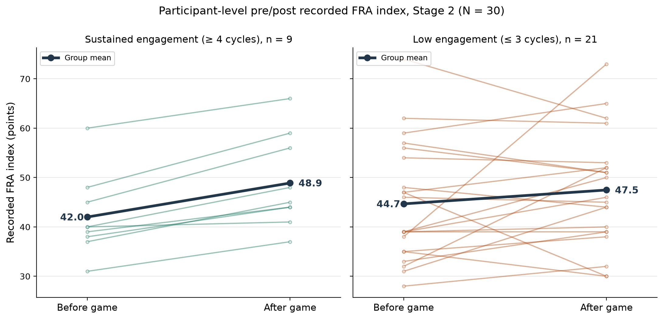
Figure 5.4. Participant-level pre/post recorded FRA index for the Stage-2 cohort (N = 30), by engagement group. Thin lines are individual participants; the bold line is the group mean (sustained: 42.0 to 48.9; low engagement: 44.8 to 47.6). Generated from the archived dataset (Appendix G, item G.2). Higher index values indicate better performance (InBody Co., Ltd., 2022).
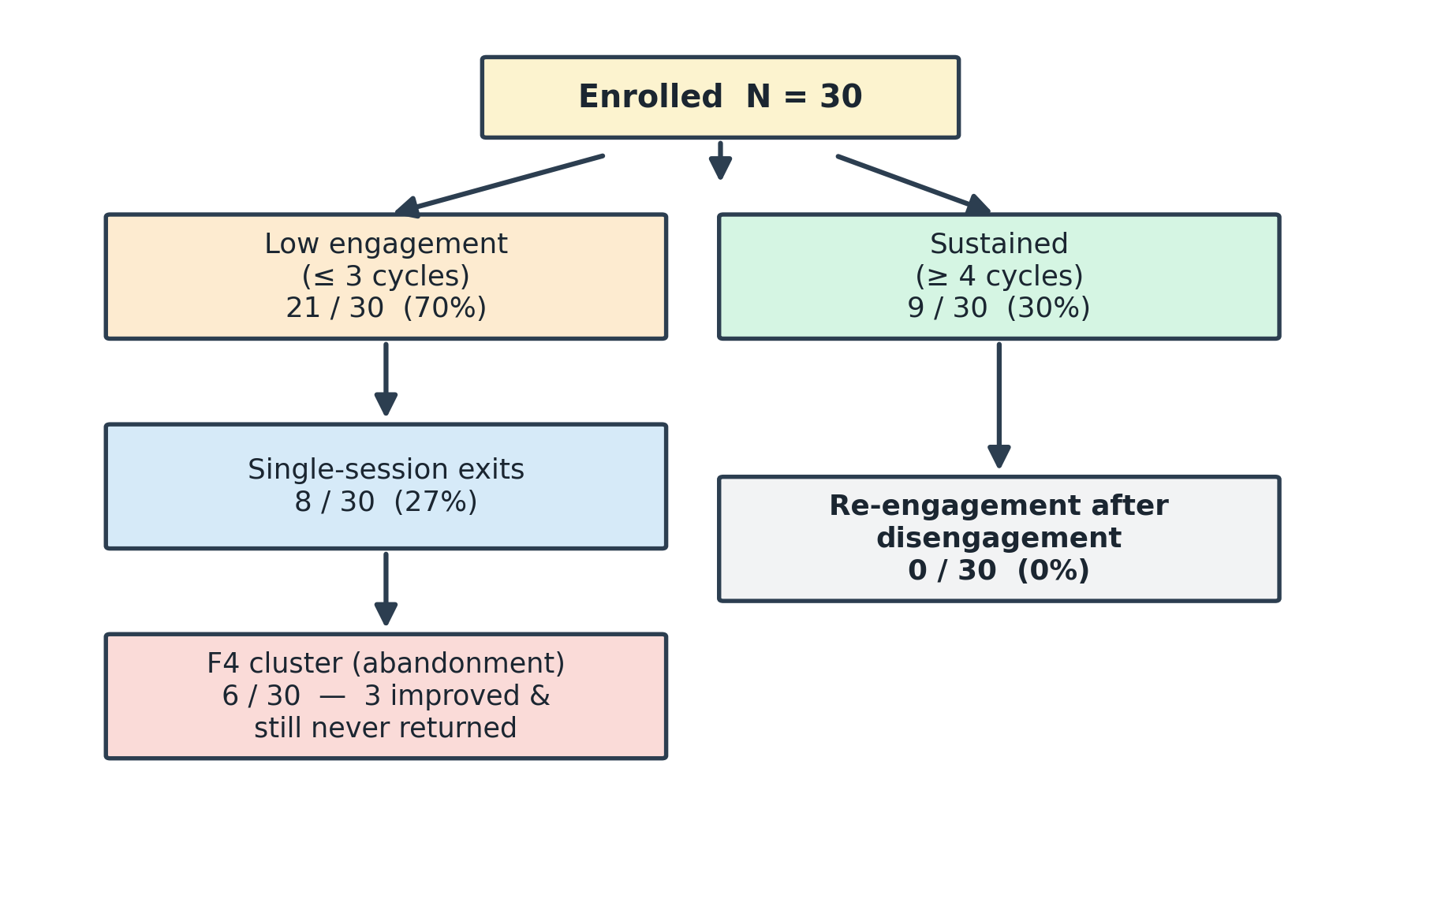
Figure 5.5. Participant flow diagram (Stage 2, N = 30): no re-engagement was observed among the twenty-one low-engagement participants during the eight-week study window.

5.5A Translating the Findings into Design Priorities: A QFD Pipeline
The statistical analysis above establishes what happened; it does not by itself say what the game should do next. Quality Function Deployment (QFD) supplies that translation. QFD is an engineering method that maps the voice of the user — needs expressed in the users' own terms — onto measurable technical characteristics of the product, and weights each mapping by the strength of the underlying evidence (Akao, 1990; Chan & Wu, 2002). It is a requirements-translation tool, not a statistical model: in this thesis QFD consumes the statistical findings and returns design priorities, while the hypothesis tests themselves remain the province of the estimators reported in §5.5.
Table 5.3 presents the deployment matrix. The rows are user needs derived from the Stage-1 survey, the Stage-2 telemetry and the Stage-2 self-reports, each anchored to the empirical finding that evidences it and to the TAM, STAM or Octalysis construct it instantiates. The columns are the game's technical characteristics: the adaptive difficulty layer (§5.3.5), the loss-free dynamic game states (§5.3.10), the trajectory display (L5), the coin-reward loop and the staff coaching protocol (L6). A strong relationship (●) indicates that the feature directly serves the need; a moderate relationship (◐) indicates partial or indirect support; a blank cell indicates no designed relationship.
Table 5.3. QFD deployment matrix: user needs evidenced by the Stage-1 and Stage-2 data, mapped onto the game's technical characteristics. ● strong designed relationship; ◐ moderate or indirect relationship.
User need (voice of the user) | Evidence from the data | Construct | Adaptive difficulty (L2) | Loss-free states | Trajectory display (L5) | Coaching (L6)
Challenge that matches my ability | 70.0% disengaged at ≤3 cycles; satisfaction 9/9 among sustained vs 11/21 (p = .013) | Flow / PEOU (TAM) | ● | ◐ |  | ◐
Failure must not feel like a verdict about me | 0/21 re-engagement after disengagement; Stage-1: ~74% adverse first experience among prior users | Loss aversion / D8 (Octalysis) | ◐ | ● | ◐ | ●
Visible personal progress | Recorded index and self-report diverge (5/8 single-session positive change, 2/8 felt improvement) | Competence (SDT) / D2 |  | ◐ | ● | ◐
Understandable, non-clinical feedback | 60.0% self-reported improvement; satisfaction associated with staying | Gerontechnology anxiety (STAM) |  | ◐ | ● | ●
Reward for effort, not only outcome | Coin loop sustained play in completers (≥4 cycles: 9/30) | Learn-to-earn / D4 | ◐ |  | ◐
A reason to come back | No observed return in Stage 2; Stage-3 decoupled cohort returned 15/23 | Behavioural intention (TAM/STAM) | ◐ | ● | ● | ●
Read column-wise, the matrix states the analysis pipeline's design verdict. The adaptive difficulty layer is the primary carrier of the challenge–skill need that the engagement data make most urgent. The loss-free state repertoire and the coaching protocol are the primary carriers of the verdict-avoidance need evidenced by the zero re-engagement observation. The trajectory display carries the progress-visibility need that the recorded-versus-self-reported divergence exposes. Read row-wise, every need is served by at least two features, which is the redundancy QFD prescribes for needs whose failure modes are severe. The matrix also fixes what the next evaluation cycle must measure: each cell is a testable claim that the feature moves the evidence indicator in its row, and the limitations acknowledged in §5.9 and §8.6 — small sample, short observation window, measurement constraints and self-report bias — bound how far any cell can currently be asserted.

5.6 The F4 Cluster and the Objective-Score-Improvement/Non-Return Paradox
A provisional FIAS composite score was applied to the thirty participants using STAM- and Octalysis-derived attributes. The composite is assembled from thirteen binary attributes drawn from STAM and selected Octalysis drives and is reported on a 0–10 range; the rule that maps the thirteen items onto that range is specified in the codebook in Appendix B. A structural caution applies before any use is made of the distribution: several of the thirteen attributes record engagement and exit behaviour, so a participant who abandoned early necessarily scores high — the clustering of the F4 participants at the top of the scale is therefore partly true by construction, and the composite carries no evidential weight in this thesis. It is retained only as a descriptive case-identification device for referring to the F4 cluster; every evidential statement in this section rests on the directly observed behaviours — single-session exit, non-return during the observation window, and the divergence between recorded score direction and return. Six participants clustered at scores 9-10 (F4). Three of the six recorded positive change in the FRA index during their single session and did not return during the observation period. This is termed the objective-score-improvement/non-return paradox, and it is the single observation that most clearly separates the FIAS account from the acceptance models: a technology that was demonstrably working, by its own measure, was abandoned anyway. It is exactly the pattern that the endowment row of Table 2.1 predicts — exit protects a valued self-description from revaluation, so improvement in the score does not bring the user back. The observation shows a divergence between recorded score direction and return behaviour; it does not by itself establish clinical benefit, mental-account closure or identity protection. The F4 cluster is a subset of the eight single-session exits reported in §5.5; the remaining two single-session participants also recorded a positive change, so across all single-session exits the divergence held in five of eight cases, and none of the eight returned.
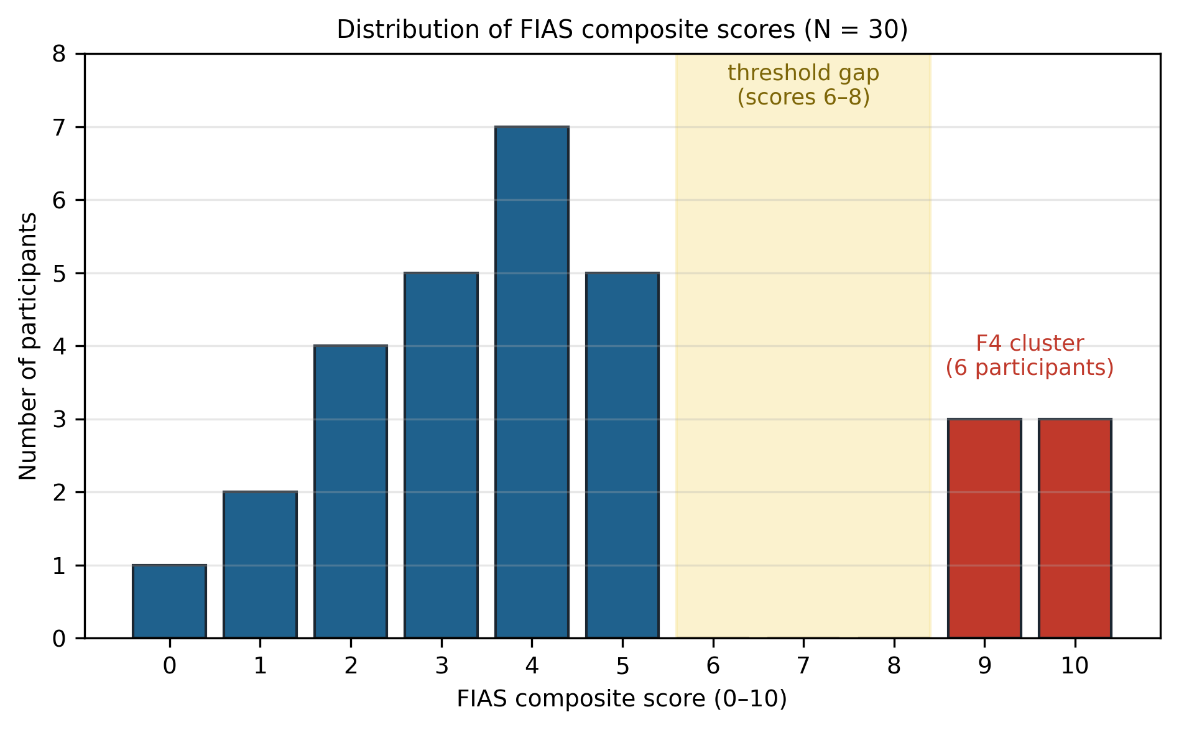
Figure 5.6. Distribution of provisional FIAS composite scores across all 30 participants. The composite includes engagement-outcome attributes, so the separation of the F4 cluster is expected by construction; the figure is descriptive case identification, not evidence (§5.6).
The empty interval between scores 5 and 9 is not read as evidence of a behavioural discontinuity. Given the construction above, it may be a mechanical effect of the scoring thresholds and the outcome-linked items (criterion contamination), or sampling variation in a cohort of thirty. The item-level codebook — all items, weights, decision rules and missing-data handling, with cycle count and non-return excluded from any predictor score that would then be claimed to predict the same outcome — is specified as a deliverable of the confirmatory study (§8.8); pending it, the composite serves only as the descriptive case-identification device described above and carries no evidential weight. The F4 cluster rests on six participants, so every mechanism claim based on it is provisional until two independent coders apply a fixed rubric with reported agreement and the construct is evaluated in an external sample. A nine-question F4 interview protocol was designed (Appendix C) but not administered in Stage 2; no F4 interview data exist, and the protocol is retained for the confirmatory programme (§8.8). The Stage-2 qualitative record instead comprises the after-game questionnaire completed by all participants and post-deployment interviews with the sustained participants (Appendix C).

5.7 Theoretical Extension: Endowment, Stereotype Threat, Domain Reframing
Stage 2 extended the FIAS hypothesis with three candidate theoretical components, each of which occupies a row of Table 2.1. First, identity-relevant endowment (row two) conceptualises resistance to unfavourable revaluation of a valued health self-concept — the paradox of §5.6 is its footprint. Second, stereotype threat (row four) is one possible trigger by which clinical and age-related cues make decline salient. Third, mental accounting (row three) implies the candidate intervention: if the clinical frame is what sorts the session into a high-stakes health account, then presenting the same task as a coordination challenge should change the meaning of failure. That is the prediction Stage 3 was designed to probe. These operators were not directly measured, so H5 was framed as a directional test — whether a participant-facing decoupling package is associated with more post-failure return — not as a definitive test that domain reframing 'prevents FIAS'.
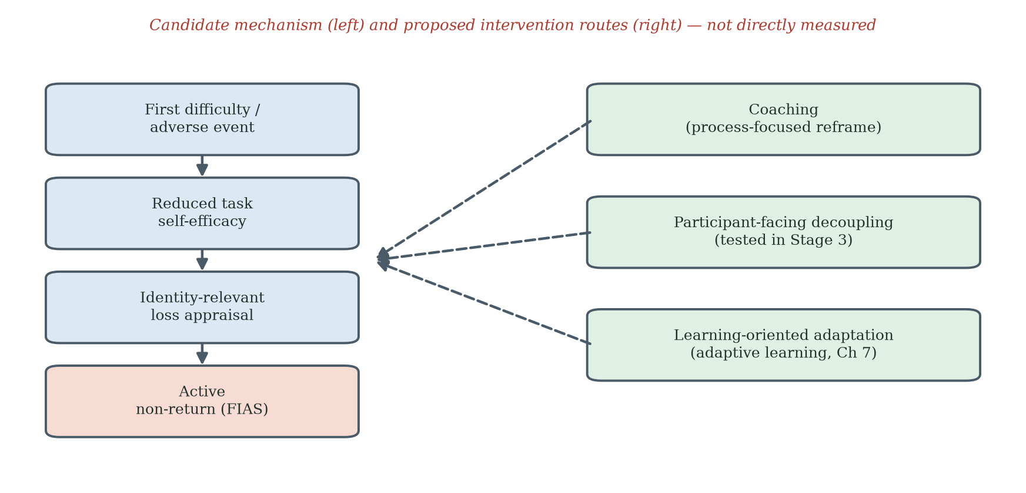
Figure 5.7. Hypothesised FIDS-FIAS mechanism and intervention pathways. The left side presents a candidate sequence from first difficulty through reduced self-efficacy and identity-relevant loss appraisal to active non-return. The right side presents three proposed intervention routes: coaching, participant-facing decoupling and learning-oriented adaptation. The mechanism was not directly measured in the present studies.

5.8 Information-Entropy Lens
The entropy language in this thesis is a bridge model, not a measured result. The archived Stage-2 dataset does not preserve timing between events, so no temporal claim about the interval between first failure and final interaction is made. Whether a belief changed, when it changed, and whether an information-theoretic entropy reduction occurred are propositions that require repeated belief elicitation before and after a failure event.

5.9 Limitations and What Stage 2 Establishes
Stage 2 is an exploratory field study, and its boundaries are part of its design rather than flaws discovered afterwards. The sample is small, single-site and not demographically diverse, which is what allowed an embedded researcher to watch every participant's journey closely; the observation window is eight weeks, long enough to see the abandonment pattern form but too short for claims about sustained use beyond it. The archive holds cycle counts and pre/post scores rather than timestamps, so the temporal structure of disengagement could not be analysed and remains a question for the instrumented next study. The recorded index was measured once before and once after the window on a single instrument whose short-interval test-retest variability is non-trivial (Kim et al., 2018), so within-deployment change is read as a promising signal to be confirmed. Self-reports were gathered by facility staff, whose familiarity put participants at ease but may also have inclined answers toward courtesy, particularly since participants knew the deployment was a facility initiative — both effects are acknowledged. The week-2 motivational-orientation classification was withdrawn when its coding records could not be produced (§5.5); the provisional FIAS composite reuses cycle-count information and awaits its independent codebook; FES-I was not available as a baseline covariate and joins the baseline battery in the confirmatory study; the embedded investigator was not complemented by an independent observer; and the clinical meaning of short-term index change is a question this thesis deliberately leaves to clinical colleagues.
What Stage 2 establishes is narrower and stronger: within the eight-week deployment, first-failure experience was strongly associated with faster observed dropout; no re-engagement was observed among low-engagement participants; and a small subgroup showed positive recorded score change without return. Stage 2 also generated candidate mechanisms and the decoupling hypothesis for Stage 3. It does not validate the FIAS composite, prove permanence, verify mental accounting or stereotype threat, or establish that score improvement was clinically meaningful. In the terms set by Chapter 2, these observations reject the null hypothesis H0 of §2.3.5: a gamified FRA that satisfied the acceptance and gamification design criteria did not sustain acceptance and use, and failure events were followed by abandonment that score improvement did not reverse.

Chapter 6 Stage 3 — Participant-Facing Decoupling: Between-Cohort Evidence for a Frame-Sensitive Account

6.1 Why a Decoupling Stage
The rejection of H0 in Stage 2 was ambiguous between two rival explanations, and Stage 3 exists to tell them apart. The first explanation is dispositional: gamification simply does not work for frail older adults — the acceptance and gamification literatures do not transfer to this population, and the An–Cheung demonstrations do not generalise. The second is the coupling explanation: the gamification stack works exactly as the literature says, and what broke Stage 2 was the attachment of the game to a purpose-based clinical technology whose verdicts strike the identity-level concerns of older users. These explanations make opposite predictions for the same game with the clinical attachment removed. If the dispositional account is right, a decoupled game should fail with elderly users too. If the coupling account is right, a decoupled game should be accepted at roughly the levels the gamification literature predicts. Stage 3 is therefore the programme's attribution experiment — in effect, a positive control for gamification theory itself. Two secondary questions carried over from Stage 2: whether the scarcity of learning-oriented engagement suggested by Stage-2 observation (the formal classification has since been withdrawn, §5.5) was a stable cohort characteristic or a response to the clinical-game context, and whether post-failure return would appear once participant-facing clinical cues were removed. Stage 3 addressed these questions through a separate-cohort field comparison using a coordinated decoupling package. Because cohort, setting and recruitment also changed, the study provides quasi-experimental directional evidence rather than single-variable causal isolation.

6.2 Research Question and Predictions
The two rival accounts frame the predictions. Under the dispositional account, removing clinical cues changes little: elderly non-return stays high and post-failure return stays near zero. Under the coupling account, the decoupled game behaves like the elderly gamification successes in the literature. Within that frame, Stage 3 made three specific predictions. First, observed non-return under the decoupled condition would be lower than the Stage-2 rate. Second, some initial dropouts would return after failure. Third, most participants would recognise the activity as a coordination challenge and a substantial proportion would express regular-use intention. The coordination-endorsement item is treated as a manipulation check for the intended participant-facing frame; it measures frame recognition, not motivational orientation. The multi-age cohort adds a fourth, formally testable prediction: if the identity-level account is right, the engagement burden should differ by age even under decoupling — the second null hypothesis, H0-age (no difference between age groups), should fall. It does (§6.5).

6.3 Methodology: A Participant-Facing Decoupling Package in a Separate Cohort
Stage 3 evaluates a participant-facing redesign package in a separate cohort. Stage 2 used a coupled clinical-game context that included an InBody body-composition scan, clinical pass/fail language, parallel clinical recording and repeated use of the term "assessment". Stage 3 removed these participant-facing clinical cues by moving the game off the clinical apparatus altogether: the game was ported to an HTML build and sent to participants by e-mail, no pre-session InBody scan was conducted, the activity was presented as a purely-fun coordination game, clinical labels were removed, and the interface was re-skinned. The skiing mechanic, five-attempt rule and session structure were retained in the ported build; the pressure-panel apparatus, the clinical setting and in-person supervision were not. These changes constitute a multi-component decoupling package. The design retains the game mechanics but does not isolate lexical framing from procedural, architectural, platform and setting changes, nor from between-cohort differences. The decoupling operated at the artefact level rather than by concealment: the invitation e-mails openly disclosed the doctoral research context, including the programme's fall-risk origin, but the activity itself carried no assessment framing and delivered no health verdict. That participants who knew the origin still returned after failure sharpens the reading rather than weakening it: what changed between the stages was not what participants knew, but what the artefact did with their failures.

6.4 Participants and Apparatus
One hundred and twenty adults aged 25-80 were recruited through the author's Hong Kong-based networks — work contacts, a charity community network, university support channels and working peers in medical centres — in three age bands: 38 aged 25-44, 41 aged 45-64 and 41 aged 65-80. The invitation e-mails disclosed the doctoral research context, including the programme's fall-risk origin, while presenting the activity itself as a purely-fun coordination game; the game and its instructions carried no medical or fall-prevention language and delivered no clinical output. The distributor-tier invitations are archived (Appendix G, item G.5). Each participant received the HTML build by e-mail and played on their own computer, with a trackpad or arrow keys, or a foot-pad sensor where one was available; play was unsupervised. Of the 120 participants, 48 were male and 72 female, and all reported high-school education or above.
Two recruitment decisions were deliberate. First, the Stage-2 facility was not re-used for the decoupled deployment: its residents already carried direct experience of the coupled system, and their prior exposure and attitudes would have contaminated a test of how the decoupled frame is received on first contact. A separate cohort was therefore a design choice, not only a constraint. Second, distribution deliberately extended beyond the author's immediate circle: the organisations and contacts who received the build forwarded it onward, so that a portion of participants were personally unknown to the author. This onward (snowball) distribution reduces, though it does not eliminate, the risk that participation reflected personal obligation to the researcher.
Stage-3 data collection is complete. The participant-level records are the participants' returned materials: each participant e-mailed back the results file logged by the HTML build (a CSV including the session score and game-logged data) together with their questionnaire responses. Three outcome definitions are used throughout this chapter. Initial dropout denotes a participant whose returned logs show disengagement after the first play contact — an incomplete first session, or no second session within the study window. A return denotes a subsequently logged completed session after an initial dropout. Observed non-return denotes an initial dropout with no returned session inside the study window, and retention is its complement over the cohort. The chapter reports the aggregate record compiled from the returned files. The data logbook (Appendix G, item G.3) holds the participant-level compilation from the returned e-mails; its reconciliation sheet recomputes every indicator from the participant-level entries, so the compilation can be verified against the record.

6.5 Findings: A Substantial Behavioural Shift
Table 6.1. Stage-3 overall engagement and dropout (N = 120).
Engagement metric | Count | Percentage
Initial dropout | 23/120 | 19.2
Returned after dropout | 15/23 | 65.2
Observed non-return at end of Stage-3 window | 8/120 | 6.7
Overall retention | 112/120 | 93.3
Return rate among initial dropouts | — | 65.2

Read against the two rival accounts of §6.1, the pattern is one-sided. The decoupled game was accepted by the elderly cohort at levels consistent with what the gamification literature predicts for non-clinical technologies: 85.4% in-session retention in the 65–80 band, voluntary return after dropout in ten of sixteen cases, and majority regular-use intention. The dispositional account — that gamification does not transfer to this population — predicted none of this. The result is therefore consistent with the theory stack of Chapter 2 holding for elderly users, including the An–Cheung demonstration, and with the Stage-2 failure residing in the coupling rather than in the game or the participants. The Stage-2 and Stage-3 results show markedly different observed return patterns, but they should not be described as proof of two discrete behavioural regimes. In Stage 3, post-failure return was common, including in the oldest age band; in Stage 2, no return was observed among the low-engagement group during the eight-week window. The contrast is large and theoretically important. Its causal interpretation remains bounded by separate cohorts, contexts, recruitment channels and potentially different observation structures. The age-stratified comparison sharpens the finding further. All 120 participants, across all three age bands, accepted the decoupled game — the acceptance is general, not an elderly concession. Yet initial dropout climbed steeply with age (0.0%, 17.1%, 39.0%; chi-square across bands p < 0.001), nullifying H0-age and showing that the burden the coupling imposes is age-linked, precisely as an identity-level account predicts; and under decoupling that burden no longer converts into abandonment, because most older dropouts came back. In one design, Stage 3 provides evidence consistent with both readings: that the game itself was not the source of the failure, and that the problem, where it exists, lives at the identity level of the older user.
Table 6.2. Stage-3 age-stratified engagement.
Age band | n | Initial dropout | Returned | Observed non-return | Retention
25–44 | 38 | 0 (0.0%) | 0 | 0 (0.0%) | 100.0%
45–64 | 41 | 7 (17.1%) | 5 | 2 (4.9%) | 95.1%
65–80 | 41 | 16 (39.0%) | 10 | 6 (14.6%) | 85.4%
Total | 120 | 23 (19.2%) | 15 | 8 (6.7%) | 93.3%

The 65-80 band is the primary cross-stage comparison because it is the closest age match to the Stage-2 residential cohort. In this band, 10 of 16 initial dropouts returned (62.5%; 95% CI 38.6-81.5%, Wilson interval). In Stage 2, 0 of 21 low-engagement participants returned within the eight-week observation window (95% CI 0.0-15.5%). The non-overlapping intervals describe a strong difference in observed proportions, but they are not a substitute for a randomised hypothesis test because the samples are independent and contextually different. The pooled Stage-3 65.2% figure is a descriptive summary; the age-matched comparison is the more relevant evidential anchor.
Coordination-challenge endorsement reached 71.7% (86 of 120), indicating that most participants perceived the intended frame. Regular-use intention reached 63.3% overall and 56.1% in the 65-80 band. No comparison is made with the Stage-2 motivational-orientation classification, which has been withdrawn (§5.5). The Stage-3 item is best interpreted as a manipulation check, whereas the regular-use item is a stated intention that may not predict longitudinal use.
Table 6.3. Stage-3 coordination endorsement and regular-use intention by age band.
Item | Younger 25–44 | Middle 45–64 | Older 65–80 | Total
Coordination-challenge endorsement (framing manipulation check) | — | — | — | 71.7%
Would use regularly if accessible | 65.8% | 68.3% | 56.1% | 63.3%
Interpretive note: coordination endorsement tests whether the participant recognised the presented activity as a coordination challenge. It is a frame-recognition measure and is not read as a measure of motivational orientation.
Note on Table 6.3: coordination-challenge endorsement is reported as a total (86 of 120, 71.7%); per-age-band endorsement counts are not reported in this thesis, and no per-band endorsement claim is made.
The strongest Stage-3 behavioural outcome is observed return after initial dropout, particularly the 62.5% return in the 65-80 band. Stated intention and frame endorsement are supportive secondary outcomes, not substitutes for longitudinal behaviour.
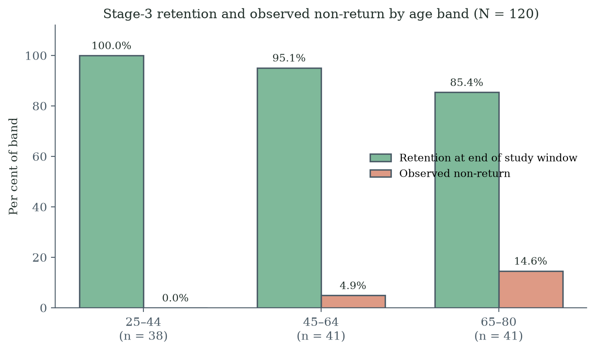
Figure 6.1. Stage-3 retention and observed non-return at the end of the study window by age band (N = 120).
Figure 6.1 was regenerated directly from the counts reported in Table 6.2.
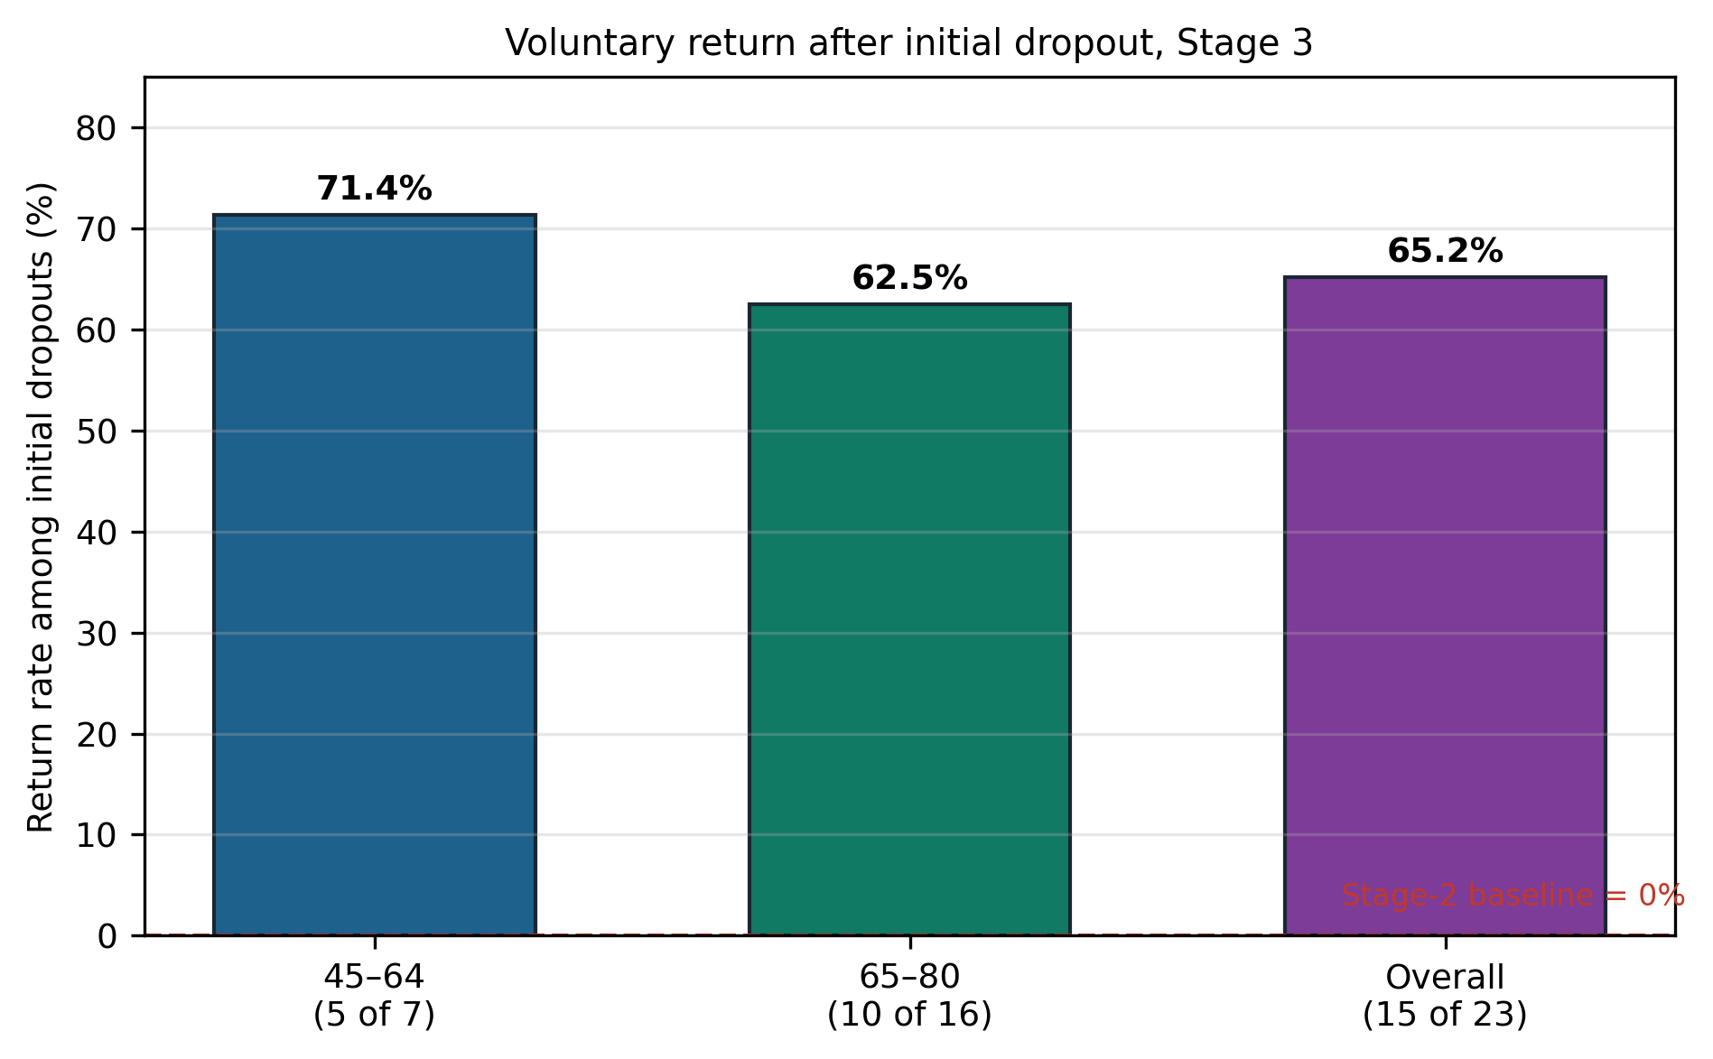
Figure 6.2. Return behaviour after initial dropout, by age band: 62.5% return rate in the 65–80 band.

6.6 The Objective-Score-Improvement/Non-Return Paradox Reconsidered
Stage 3 deliberately did not collect participant-level clinical balance telemetry, so the Stage-2 score-improvement/non-return pattern cannot be replicated directly. What Stage 3 measures is a different outcome: whether participants who initially disengaged returned under a participant-facing decoupled condition. Fifteen of twenty-three did so. This finding is consistent with the proposition that an adverse gameplay event need not become an absorbing non-return state under decoupling. It does not demonstrate that the proposed mental account remained open, that the Stage-2 paradox was "resolved", or that the same individuals would have behaved differently under the coupled condition. What §6.5 adds to the paradox is its other half: under the clinical frame, improvement did not bring users back; under the game frame, even failure did not keep them away.

6.7 Frame-Sensitive versus Dispositional Accounts: Calibrated Inference
The Stage-3 result is inconsistent with the strongest purely dispositional prediction that post-failure return would remain near zero regardless of frame and context. It is consistent with a frame-sensitive account in which participant-facing clinical cues contribute to the meaning of failure. However, the design cannot attribute the difference exclusively to framing because the cohorts differed in setting, recruitment, residential status, age distribution, health profile, prior exposure and potentially staff interaction and observation window. The evidence therefore supports a frame-sensitive interpretation without rejecting every dispositional or contextual contribution. Stated as a scope condition, the combined evidence of the three stages reads: gamification theory holds for older adults — until the gamified activity is attached to a purpose-based technology whose purpose, such as health assessment, touches the identity-level value propositions of the user; at that boundary the theory fails, and FIAS names the mechanism of the failure. This boundary condition is the thesis's central empirical claim — a nullified hypothesis giving the contribution its precise form — and the within-cohort randomised study described below is the confirmation it invites.
The decisive confirmation remains a within-cohort randomised comparison with harmonised eligibility criteria, staff scripts, software, measures and follow-up. Until that study is completed, the thesis's calibrated claim is that participant-facing decoupling was associated with substantially greater post-failure return in a separate cohort, and that the pattern warrants direct causal testing.

6.8 The Commitment Gap and Its Design Implication
In the 65-80 band, observed in-session retention was 85.4% while stated regular-use intention was 56.1%, a difference of 29.3 percentage points. These are different constructs — one is observed session completion, the other a hypothetical future intention — and the difference is a design diagnostic, not a measured causal effect. But it is the diagnostic that forced the programme's principal design discovery, and it deserves to be read carefully. Decoupling removed what was poisoning engagement; it did not add a reason to keep coming back. Half of the older participants who happily completed the session saw no place for the game in their weekly lives. And decoupling faces a deeper limit: the FRA's clinical purpose is the entire point of deploying it, so the purpose must eventually return to the experience — the design question is how it can return without re-igniting the identity threat.
The answer this programme proposes is adaptive learning (§2.6.2A–B): a regime in which the activity visibly improves the person session by session, so that a rising personal trajectory — continuous improvement at the level of the individual user — becomes the reason to return, and eventually becomes the frame within which clinical purpose can be safely re-attached, because a user who reads performance as a curve can tolerate what the curve measures. This is where the discovery is born in the data; it is formalised as the adaptive-learning framework in Chapter 7 and claimed, with its evidential limits, in Chapters 8 and 9. The claim discipline matters: several rival explanations for the gap are plausible — anticipated fatigue, access barriers, scheduling burden, insufficient relevance, motor difficulty, limited enjoyment of repeated play — and a missing trajectory frame is one theoretically grounded possibility among them. The near-term study must therefore combine longitudinal behavioural follow-up with interviews or validated measures of fatigue, perceived competence, autonomy, burden, enjoyment and identity relevance before the design lever is selected.
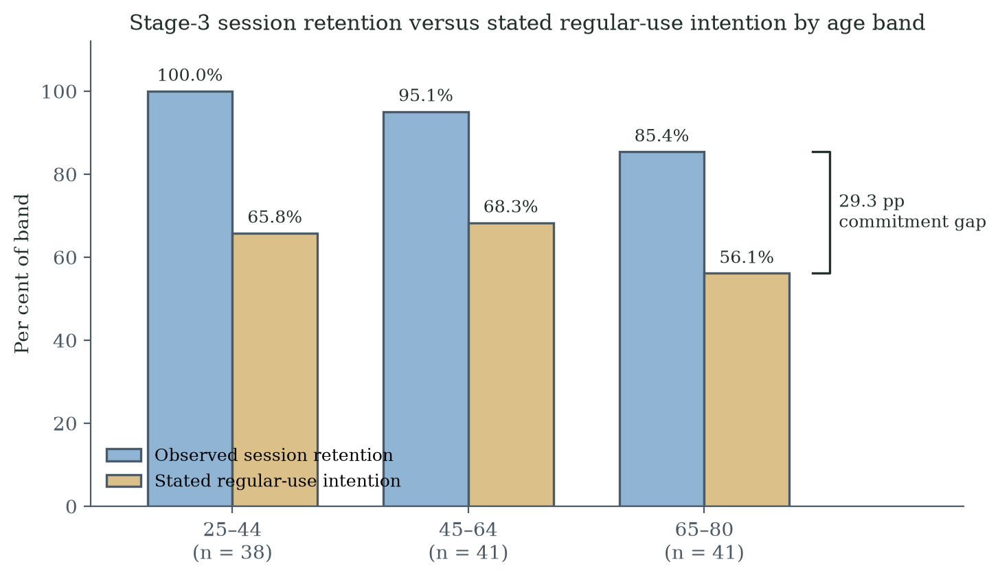
Figure 6.3. Retention versus regular-use intention by age band: the 29.3-pp commitment gap in the 65–80 band.

6.8A The Commitment Gap Read Through Group Dynamics: An Expert Consultation
The interpretation of the commitment gap was examined after the empirical programme through a single expert consultation interview with Dr Sarah C.W. Yuan of the Center on the Family, University of Hawai'i at Mānoa — a medical sociologist and demographer of aging whose work includes the Hawai'i Healthy Aging Partnership and statewide community falls-prevention programming. Her field of practice is deliberately distant from this programme's apparatus: group exercise and physical games for balance, with no electronic game and no clinical instrument attached to the activity. The consultation is reported as interpretive evidence from an independent discipline, not as additional participant data; the record is the author's structured notes, reproduced in Appendix H.
Three of her observations bear directly on this thesis. First, from her programme experience and publications: older adults who join social exercise groups tend to drop out after a failure unless a physician, assistant or coach helps them past the rejection; with a group around them and a coach who leads them to continue, they perform and persist markedly better. Failure-linked dropout therefore appears even in her setting — with no clinical attachment at all — and is recoverable through human support. Second, in her experience older adults intrinsically avoid straight clinically oriented individual assessment of their current health status: they fear facing a negative risk result, and psychologically avoid the clinical evidence that would describe their condition. This is an independent statement, from a sociology of aging perspective, of the identity-level avoidance that the FIAS account proposes. Third, she regards gamification as very effective for promoting health technology — and expects hard rejection precisely when the game or exercise is linked to clinical results. On that basis she explicitly supported the Stage-3 decoupling design, and she supported the FIDS-to-FIAS construction and the adaptive-learning proposition as consistent with the elderly behaviour she has observed.
What the consultation adds to the commitment-gap reading is a social mechanism the programme's own data could not supply. In her account, partnering, group play and a coach who leads the activity reduce initial dropout and, downstream, abandonment of the technology; and the components that support adoption extend beyond engineering excellence and design to the environment, the people using the same technology, and predictable or expected results. The mapping onto the framework is direct: the coach and the group correspond to the staff coaching layer (L6, §7.5.3) and motivate a group-deployment variant of the protocol; predictable or expected results correspond to trajectory installation (P2), since a visible personal trajectory is exactly what makes results expected rather than threatening. Her account also refines the Chapter 2 caution that social influence (Octalysis D5) can be double-edged for older users: structured group dynamics with a leading coach appears protective in her experience, whereas unstructured peer comparison may still threaten identity — a distinction the §8.8 study can operationalise. The evidential limits are stated plainly: this is one consultation, recorded in the author's notes; it is interpretive support from an adjacent discipline, not validation; and its observations concern physical group exercise, so their transfer to electronic games is an argued expectation rather than a demonstrated result.

6.9 Limitations of Stage 3
Stage 3's design choices set the scope of what it can say, and the thesis is comfortable inside that scope. It is a between-cycle, between-cohort comparison, so it speaks in strong associations rather than isolated causes. The decoupling intervention is a coordinated package delivered through a change of platform and setting — an e-mailed HTML build played unsupervised at home — which is how real deployments change frames, but which also means that platform, input device and supervision changed alongside framing. The proposed mechanisms (mental accounting, loss aversion, identity protection, stereotype threat) await their direct measures; volunteers chose to take part, as participants always do; follow-up is short, as first expeditions are; and the cohorts are Chinese-cultural, which makes the cross-cultural replication of §7.7 the natural next journey. The Stage-3 framing item measures frame recognition only, and the complete adaptive-learning framework was not yet deployed. None of this dims the headline signal — post-failure return, absent in Stage 2, became the majority behaviour — it simply names the confirmatory work that signal has earned.

6.10 Quantitative Comparison Against Existing Models
This section specifies a comparison; it does not report one. The comparison has not been executed, and the quantitative advantage of the FIAS-augmented specification is therefore hypothesised, not demonstrated. Every statement in this section should be read as a pre-specified plan. A persistent question is whether FIAS adds incremental explanatory power beyond what TAM, STAM and a simple usage-attrition baseline can already explain. The Stage-2 and Stage-3 datasets do not yet allow a definitive nested-model comparison, but the architecture of such a comparison is specified here as a record of the inferential commitment the thesis makes. The architecture remains available for any future dataset that includes harmonised STAM instrumentation alongside FIAS coding.

6.10.1 Three-Tier Nested Model Specification
The planned comparison is structured as three nested models with an observed non-return outcome defined over a common, pre-specified window and a time-to-observed-dropout outcome. The final protocol must prevent predictor-outcome overlap: any FIAS score used as a predictor must exclude cycle count, return status and other elements that define the outcome.
Table 6.4. Three-tier nested model specification for the FIAS-vs-TAM/STAM quantitative comparison.
Model | Predictors | Construct represented
M0 Demographic baseline | Age band, sex, education, baseline FES-I, fall history | Standard control covariates
M1 STAM-only | M0 + PU, PEOU, gerontechnology self-efficacy, gerontechnology anxiety, social influence, facilitating conditions | Acceptance-model account of intention; predicts initial use
M2 STAM + FIAS operators | M1 + first-failure event, frame condition, prospectively measured identity-threat/appraisal score, WTA-WTP proxy, mental-accounting frame score, and non-outcome FIAS indicators | Prospective frame-sensitive account; outcome-defining variables must be excluded from predictors and the model has not yet been estimated

Comparison M0 versus M1 tests whether the standard senior-acceptance model improves on demographics alone. Comparison M1 versus M2 tests the incremental explanatory power of the FIAS operators specifically.

6.10.2 Statistical Comparison Plan
Three classes of comparison statistic are pre-specified. First, a likelihood-ratio test of M2 versus M1, with degrees of freedom equal to the count of FIAS-specific predictors. Second, an information-criterion comparison using ΔAIC and ΔBIC as descriptive evidence of relative fit. Third, discrimination and calibration, including McFadden's pseudo-R² change, AUC for observed non-return over a common pre-specified window, and appropriate calibration assessment. For time-to-event outcomes — available only once session timestamps are captured, which the Stage-2 archive did not do — the plan uses Cox partial-likelihood ratio tests and Harrell's C-index. Any use of IDI should be justified and interpreted cautiously. No Stage-2 survival estimate is carried forward, because the Stage-2 archive contains no time variable; the Stage-2 anchors are the engagement and paired-change statistics of §5.5.

6.10.3 Decision-Curve Analysis and Practical Significance
Statistical significance is necessary but not sufficient. Decision-curve analysis (Vickers & Elkin, 2006) is included in the architecture to translate model improvement into clinical-decision value. Across a range of threshold probabilities for triggering an intervention (coaching, frame switch), the net benefit of an M2-driven decision rule is compared with the net benefit of an M1-driven rule. Decision-curve analysis bridges the inferential statistics to the engineering recommendation; it weighs true-positive identification of imminent abandonment against false-positive intervention cost.

6.10.4 Pre-Specified Predictions
The pre-specified hypothesis is that FIAS-specific, prospectively measured operators will improve prediction beyond demographics and STAM. This is a genuine future test, not an established result. If the M1-to-M2 likelihood-ratio test is non-significant, information-criterion improvement is small, calibration worsens, or decision-curve net benefit is absent, the FIAS-augmented model will not have demonstrated incremental value. The analysis should also report optimism-corrected or externally validated performance, because a large predictor set in a modest sample can overfit.

6.10.5 Provisional Estimates from the Existing Datasets
The Stage-2 early-disengagement proportion (70.0%, 95% CI 52.1–83.3%) and the Stage-3 observed non-return proportions provide provisional effect-size anchors. A formal pooled or nested analysis is not appropriate until a future dataset uses harmonised recruitment, covariates, measures, outcome definitions and observation windows.

6.11 Consolidated Statistical Results
The key quantitative claims of Stages 2 and 3 are reported in different sections and in different notations. Table 6.5 consolidates them so that the point estimate, the interval, the sample size and the test behind each claim can be assessed at a glance.
Table 6.5. Consolidated statistical results for the key contrasts of Stages 2 and 3.
Contrast or quantity | Estimate | 95% CI | n | Test / source
Early disengagement, ≤ 3 cycles (Stage 2) | 70.0% | 52.1–83.3%* | 30 | Wilson score interval; Table 5.2. (Survival modelling withdrawn: no time variable in the archive; §5.5)
FRA index change, sustained participants (Stage 2) | dz = 2.22 (paired); mean +6.9 points | dz 0.95–3.46; mean 4.5–9.3 | 9 | Paired t and Wilcoxon; §5.5
FRA index change, all participants (Stage 2, archived paired data) | dz = 0.42; mean +4.0 points | dz 0.05–0.79; mean 0.5–7.6 | 30 | Paired t and Wilcoxon; §5.5
Satisfaction association with sustained engagement (Stage 2) | 9/9 vs 11/21 satisfied | p = 0.013 | 30 | Fisher's exact test; §5.5
Re-engagement after dropout (Stage 2) | 0.0% | 0.0–15.5%* | 21 | Wilson score interval; Table 5.2
Return after initial dropout, all bands (Stage 3) | 65.2% | 44.9–81.2%* | 23 | Wilson score interval; Table 6.1
Return after initial dropout, 65–80 band (Stage 3) | 62.5% | 38.6–81.5%* | 16 | Wilson score interval; Table 6.2
Observed non-return, 65-80 band (Stage 3) | 14.6% | 6.9–28.4%* | 41 | Wilson score interval; Table 6.2
Coordination challenge endorsement (Stage 3) | 71.7% | 63.0–79.0%* | 120 | Wilson score interval; Table 6.3
Regular-use intention, 65–80 band (Stage 3) | 56.1% | 41.0–70.1%* | 41 | Wilson score interval; Table 6.3
Descriptive retention-intention difference, 65-80 band (Stage 3) | 29.3 pp | see note | 41 | Difference between distinct outcomes (85.4% retention and 56.1% stated intention); §6.8
Intervals marked with an asterisk are Wilson score intervals computed from the reported counts. Effect-size intervals for the paired changes are exact noncentral-t intervals computed from the archived participant-level data. The earlier pooled (d = 0.78) and zero-imputation (d = 0.57) estimates did not reproduce from the archive and have been withdrawn; the survival-model row has been replaced for the same reason (§5.5). The confidence interval for the 29.3-percentage-point difference should respect the fact that retention and intention are distinct measures and may not represent a simple paired effect. The earlier motivational-orientation odds ratio has been withdrawn (§5.5).

Chapter 7 Discussion: Adaptive Learning as the Behavioural-Change Driver

7.1 Why the Empirical Programme Forces Adaptive Learning
This chapter formalises the programme's principal design discovery. Chapter 6 ended on a dilemma: decoupling removed what was poisoning engagement — post-failure return rose substantially in the decoupled cohort — but it added no positive reason for repeated use, as the 29.3-percentage-point gap between session retention and regular-use intention in the oldest band showed; and decoupling cannot be the final answer in any case, because the FRA's clinical purpose is the point of deploying it and must eventually return to the experience. Adaptive learning is the design discovery that resolves the dilemma (§6.8): make the activity visibly improve the person, session by session, so that a rising personal trajectory becomes the reason to return — and eventually becomes the frame within which the clinical purpose can be re-attached without re-igniting the identity threat. The empirical programme is what makes this discovery visible; whether adaptive learning closes the observed gap is precisely the question the pre-specified confirmatory study is designed to answer, and this chapter builds the framework that study will test.
The proposed relationship among framing, identity-relevant appraisal and adaptive learning has three steps. First, clinical cues may increase the likelihood that performance is interpreted through a health or decline-related frame. Second, an adverse event under that frame may be experienced as more self-relevant than the same event in a coordination game. Third, a visible learning trajectory may offer a competing interpretation in which the event informs the next action. Mental accounting and endowment remain candidate mechanisms, and the complete sequence requires direct measurement. The adaptive-learning framework is therefore an engineering hypothesis built from convergent evidence, not a verified psychological model.

7.2 Adaptive Learning in the Gamification Literature
Adaptive learning has a substantial literature in educational technology and intelligent tutoring systems. Its application to elderly users in gamified health contexts is more limited. Three anchors are relevant. First, the ageing-HCI evidence (Hawthorn, 2007; Lee & Coughlin, 2015) shows that pacing and feedback adaptation matter more for older users than for younger users, and the intelligent-tutoring record (VanLehn, 2011) shows how much fine-grained adaptation can deliver. Second, flow theory and the zone-of-proximal-development tradition (Csikszentmihalyi, 1990; Vygotsky, 1978) provide the mechanism for why adaptive calibration sustains engagement: challenge tracks evolving capability, neither falling below boredom nor rising above frustration. Third, productive failure (Kapur, 2008) reframes failure events as part of the learning curve rather than as evidence of inadequacy. The three anchors converge on the same design move: present the activity as a curve and calibrate the difficulty so that the user remains on the curve.
The Stage-2 system's Layer 2 already contains a partial implementation of adaptive calibration. The 80%/40% threshold rule keeps challenge in the flow band, and the LangChain prompt template grounds the recommendations in flow theory and challenge–skill balance. What Stage 2 did not have was a user-facing trajectory representation; the user could not see the curve. Layer 5 of the adaptive-learning reference stack (§7.5.2) closes that gap.

7.3 Endowment-Protective and Learning-Trajectory Appraisals as Competing Design Regimes
The thesis proposes that a relatively fixed, identity-protective appraisal and a learning-trajectory appraisal place different meanings on the same event. The former can make an unfavourable result feel like a loss of valued self-description; the latter makes it information about current position and next action. These appraisals are not assumed to be mutually exclusive or to eliminate identity. The design objective is to make the trajectory appraisal credible and salient while preserving truthful information, meaningful challenge and user autonomy. Whether this reduces non-return is an empirical question for the controlled the adaptive-learning framework trial.
Bandura's mastery-experience pathway offers one plausible within-person process. Repeated, interpretable successes may strengthen task-specific self-efficacy, while appropriately scaffolded difficulty can support persistence. A moving personal reference point may also reduce over-reliance on a single adverse event. These mechanisms should be measured with validated self-efficacy and appraisal instruments rather than inferred solely from return behaviour.

7.4 Formalising the Discovery: The Adaptive-Learning Framework
The adaptive-learning framework is the engineering formalisation of the adaptive-learning discovery for the gamified FRA domain — the packaging, not the finding. It organises three proposed principles in the discovery's service. P1, Identity Disentanglement, reduces participant-facing clinical-verdict cues; its empirical motivation is the higher post-failure return observed in the separate Stage-3 decoupled cohort. P2, Trajectory Installation, makes change over time and the next achievable step visible; its motivation is the practical difference between session retention and stated regular-use intention, not proof that trajectory absence caused that difference. P3, Adaptive Calibration, adjusts challenge, feedback and pacing to observed capability; Stage 2 contained a partial difficulty-adjustment implementation, but the complete principle and its effect on return were not tested. The framework therefore combines one empirically supported design direction with two prospectively testable extensions. The zero-failure state repertoire (§5.3.10; §2.6.2C) is the supporting element that P1 and P3 share: it removes verdict presentation at the moment of difficulty so that the trajectory interpretation of P2 has room to form.
Why exactly three principles, and not two or four? The number and identity of the principles follow from the structure of the failure-appraisal chain that the FIAS account identifies, which is what makes them one framework rather than three recommendations. A failure event acquires behavioural force in three steps: an event is generated (a fall in the game, a low score); the event is read within a frame (as a verdict on a fixed state, or as a point on a moving curve); and the reading lands on a target (an identity-level asset, or a revisable skill estimate). Each principle intercepts exactly one link. Adaptive calibration (P3) governs the event link: it controls the rate, size and timing of failure events so that difficulty tracks capability. Trajectory installation (P2) governs the frame link: it supplies the moving-curve reading under which a failure is informative rather than conclusive. Identity disentanglement (P1) governs the target link: it detaches the reading from the identity-level asset that endowment protects. Fewer than three principles would leave a link untreated, and the empirical record indicates what happens then: the Stage-2 build already carried a partial calibration implementation, yet non-return occurred while the frame and target links were untreated; and Stage 3 treated the target link alone, which was associated with restored post-failure return but left the commitment gap open. More than three would duplicate a lever rather than add one: the candidate additions the programme examined — zero-failure presentation, social scaffolding, reward scheduling — decompose into presentation-layer or parameter choices within the three links, which is why zero-failure presentation appears above as the element P1 and P3 share rather than as a fourth principle. The framework is therefore jointly exhaustive over the appraisal chain, individually non-redundant, and anchored link by link to the observed failure modes.
Table 7.1. Adaptive-learning principles, function and empirical anchor.
Principle | What it does | Empirical anchor
P1 Identity Disentanglement | Removes the cue that sorts the activity into the user's health account | Motivated by higher post-failure return in the separate Stage-3 decoupled cohort
P2 Trajectory Installation | Makes a dynamic self-concept trajectory the reference point against which performance is read | Motivated by the descriptive retention-intention difference; causal mechanism untested
P3 Adaptive Calibration | Continuously matches challenge, feedback affect and pacing to the user's position | Partial difficulty adaptation in Stage 2; complete principle untested
Status of the framework: The adaptive-learning framework is an engineering specification derived from the empirical programme and relevant learning theory. It should be evaluated as a package and by component in a preregistered, within-cohort trial with common follow-up, process measures and implementation-fidelity checks.

7.5 Prototype Stack: Engineering-Actionable Implementation
This section specifies the technical and protocol stack required to deploy the adaptive-learning framework on existing FRA infrastructure. The stack extends the Stage-2 five-layer architecture with two additional protocol layers (User-Facing Trajectory Layer and Staff Coaching Protocol Layer) and one new instrumentation layer (Adaptive-Learning Telemetry Layer).

7.5.1 Reference Stack
Table 7.2. Adaptive-learning reference stack (L0–L7) mapped to adaptive-learning principles.
Layer | Component | The adaptive-learning framework principle served | Implementation note
L0 Sensor | InBody pressure panel; same hardware as Stage 2 and 3 | P3 | Existing capital; no replacement cost
L1 Game Engine | Pygame skiing task generated through Anthropic Claude Code | P3 | Prompt-driven regeneration; clinician-editable difficulty curves
L2 AI Adaptation | Claude API + LangChain runtime; obstacle density, speed, feedback affect | P3 | Extended from difficulty-only to feedback-affect adaptation
L3 Logging | Cycle counts, COP traces, session affect, dropout flags | P2/P3 | Existing
L4 Clinical Output | Pre/post FRA indices for clinician review (background) | — | Hidden from participant under P1 frame
L5 User-Facing Trajectory | Progress visualisation that emphasises movement; past sessions framed as steps | P2 | New; HTML overlay or device companion screen; no clinical numbers exposed
L6 Staff Coaching Protocol | Mastery-language scripts; reframing scripts; intervention triggers based on L2 telemetry | P1/P2 | New; staff training day required; checklists and language cards
L7 Adaptive-Learning Telemetry | Frame-indicator log; account-closure binary; coaching-trigger log; pre/post entropy measure | — | New; required for the model-comparison plan in §6.10

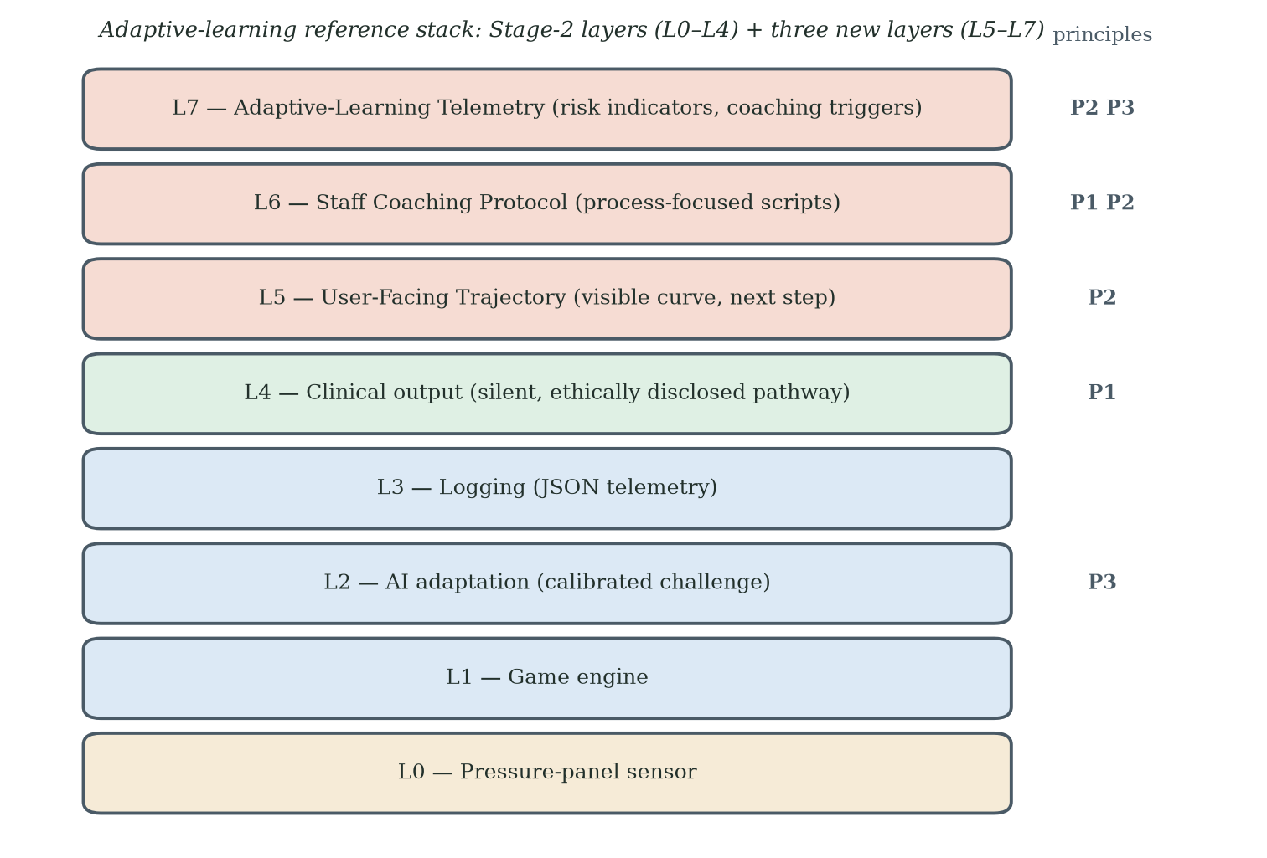
Figure 7.1. adaptive-learning reference stack: existing five-layer FRA architecture (L0–L4) extended with three additional layers (L5 User-Facing Trajectory; L6 Staff Coaching Protocol; L7 Adaptive-Learning Telemetry).

7.5.2 Trajectory Visualisation Specification
The proposed user-facing trajectory affordance (L5) makes progress visible without defaulting to diagnostic rankings. A session-by-session display can show completed sessions, recent change and the next achievable goal. Adverse events should remain visible as part of the record rather than being disguised; the design change is interpretive context, not concealment. No peer rank is required, and clinical information should remain available through an ethically disclosed pathway when relevant. Usability testing should assess comprehension, perceived honesty, competence support and unintended minimisation of risk.

7.5.3 Coaching Protocol Specification
The proposed staff coaching protocol (L6) operationalises trajectory framing through an opening explanation, in-session feedback and a closing summary. The opening script presents the activity accurately as a coordination game that may also contribute to balance research or assessment where applicable. In-session feedback uses specific, process-focused language rather than global praise or deficit labels. The closing summary identifies what changed, what remains challenging and the next step. Scripts must be standardised, culturally adapted and audited for fidelity; coaching should not pressure a participant who chooses not to continue. The expert consultation of §6.8A independently supports this layer from community practice: in Dr Yuan's programmes, a coach or assistant who leads the participant past a failure is what converts failure-linked dropout into continued participation, and partnering and group formats further reduce dropout — grounds for evaluating a group-deployment variant of this protocol in the §8.8 study.

7.5A One Architecture: Phenomenon, Principles, Engine
The programme's outputs are best read as a single behavioural-engineering architecture rather than as three related ideas. FIAS is the phenomenon layer: it names and explains why older users disengage after failure — a post-contact behaviour driven by identity-level appraisal, characterised across Chapters 4–6. The adaptive-learning framework is the principle layer: it states how systems should be redesigned so that the disengagement is not produced, through identity disentanglement, trajectory installation and adaptive calibration (§7.4). The dynamic game-state architecture of §5.3.10 is the engine layer: it operationalises the principles in real time, monitoring the live performance-state vector and selecting among non-terminal states within pre-specified safety limits, so that the design response arrives at the moment the phenomenon would otherwise begin (§7.6A).
The evidence supports each layer to a different degree, and the architecture inherits those gradations rather than smoothing them over. The phenomenon layer rests on the observed Stage-1 and Stage-2 record, and its frame-sensitivity is indicated — not isolated — by the Stage-3 comparison. The principle layer is derived from that record and from the learning-theory literature, and has not yet been evaluated as a package. The engine layer is an implemented specification whose behavioural effect is untested; its evaluation is pre-specified in §8.8. Stating the three as one architecture does not strengthen any single claim — it fixes where each claim lives, and it is what turns a set of findings into a design theory an engineering team can build against.

7.6 Applied Case Studies

7.6.1 Case Study A — FRA Reaction Mode (in development)
Setting: an existing residential care facility using the same broad pressure-panel and skiing-game platform. Proposed intervention: participant-facing decoupling, a visible personal trajectory, process-focused coaching and adaptive challenge calibration. Proposed outcomes: return within a pre-specified window, repeated use over several months, perceived competence, fatigue, burden, enjoyment, comprehension and adverse events. The earlier point targets of below 6% non-return and above 65% regular-use intention should be treated as design aspirations, not evidence-based efficacy thresholds, until a pilot establishes feasible effect sizes.

7.6.2 Case Study B — Continuous Glucose Monitoring (CGM) reframed as a Streak Companion (illustrative)
Setting: older adults using continuous glucose monitoring who may disengage after unfavourable readings. Illustrative design hypothesis: preserve access to accurate clinical data while adding an optional learning-oriented view that links readings to behaviours, uncertainty and next actions over time. A high reading should not be hidden or gamified into triviality. The design would be evaluated for comprehension, self-efficacy, sustained sensor use, clinically appropriate response and the risk of false reassurance. Status: illustrative cross-domain application; no empirical claim is made.

7.6.3 Case Study C — Sleep Tracker reframed as an Adventure Log (illustrative)
Setting: older adults using sleep trackers who may disengage after repeated poor-sleep scores. Illustrative design hypothesis: supplement single-night scores with a longer-term pattern view, uncertainty ranges and modifiable contextual factors. The design should avoid implying that every variation is controllable or that poor sleep is a personal failure. Outcomes would include continued use, sleep-related anxiety, comprehension and appropriate help-seeking. Status: illustrative only.

7.6.4 Cross-Case Synthesis
The case studies share a proposed design pattern: retain accurate measurement and clinically important information at the technical layer while redesigning the default user-facing interaction around trajectory, next action and calibrated challenge. Portability across domains is a hypothesis. Each domain requires its own safety analysis, clinical governance, outcome definition and controlled evaluation; the FRA evidence cannot be transferred automatically.

7.6A Dynamic Game States as a Loss-Free Mechanic: Reflecting the Literature-Review Knowledge Gaps
The dynamic game-state architecture introduced in §5.3.10 is a secondary design proposal motivated by three literature gaps: attrition is often treated as a residual outcome; fail-state mechanics developed for younger users may not transfer cleanly to older cohorts; and macro implementation frameworks do not specify the moment-to-moment interaction that precedes disengagement. The proposed non-terminal state repertoire and frame-congruence checks translate these gaps into an engineering specification. They do not demonstrate that a "GAME OVER" screen caused Stage-2 non-return or that the proposed states will prevent it.
The architecture also addresses a design tension between self-awareness and self-verdict. Users need accurate information about performance and safety, but presentation can emphasise process and trajectory rather than a categorical judgement. The design should not withhold clinically important information or make failure invisible. Instead, it should separate immediate gameplay feedback from formal clinical interpretation, disclose how data are used, and provide appropriate access to results. Whether this balance reduces non-return without undermining comprehension is a testable usability and safety question.
Two cautions belong in the discussion. First, the §5.3.10 architecture is a design specification offered as a secondary contribution; the empirical evidence that anchors this thesis is the FIAS coupling effect and the Stage-3 decoupling result, not a controlled comparison of state-repertoire variants. The natural empirical test of the dynamic-state design is the FRA Reaction Mode case study set out in §7.6.1, in which a five-state policy can be deployed on the existing Stage-3 platform and compared, on a common protocol, against a single-state Standard Run. Second, the agentic-AI controller at L2 inherits the boundary conditions of §7.7: an over-aggressive Recovery Run policy collapses the trajectory by removing challenge, an under-conservative Mastery Run policy reintroduces fail-states by another route, and an inconsistent Story-Bridge or Reframe Pause script breaks the frame-congruence property on which L6 depends. The instruction pattern by which Claude Code generates the policy must therefore include the boundary tests as part of the specification, not as a downstream check; this is how the §5.3.9 design-time workflow is extended into a runtime governance pattern.

7.7 Boundary Conditions and Risks
Three boundary conditions warrant explicit attention. First, over-adaptation: if the adaptive layer reduces challenge so far that failure is impossible, the trajectory loses its meaning and the user disengages from boredom. Second, frame congruence: if the trajectory frame is presented inconsistently — coordination on the screen, fall risk in the staff member's introduction — the user's mental accounting reverts to the dominant framing. Third, cultural fit: trajectory framing presupposes a self-narrative that allows the self to be on a curve; in cultural settings where stoic or collectivist self-narratives dominate, the framing may need adjustment, and Chapter 9 §9.10 identifies cross-cultural replication as the natural test of this boundary condition.
The cultural boundary deserves more than a caveat. The cohorts studied are Guangzhou and Hong Kong Chinese, and the meaning of a fall in later life is culturally loaded in these settings. A fall can signal the loss of independence, the beginning of dependence on adult children, and a change in family obligation. Filial expectation can turn a poor clinical verdict into a family event rather than a private one, which raises the identity stakes of the coupled frame. Stoic self-narratives can suppress the reporting of distress while leaving the abandonment behaviour intact. Each of these frames could strengthen the coupling mechanism, weaken it, or leave it unchanged, and the present data cannot say which. A concrete replication plan follows. The first step repeats the Stage-3 decoupling protocol in one non-Chinese setting with an individualist self-narrative tradition and in one further collectivist setting outside China, using the same hardware and the same instruments. The second step compares the return-after-dropout rates across the settings against the Hong Kong benchmark. The third step adds a short culture-frame instrument so that the self-narrative variable is measured rather than assumed. Until this plan is executed, the generalisability of the framework beyond Chinese-cultural settings is an argued expectation, not a demonstrated result.

7.8 Sequencing of the Three Principles
The three adaptive-learning principles are intended to operate in sequence but are not yet known to be jointly sufficient. Principle 1 reduces participant-facing coupling cues. Principle 2 adds a credible learning trajectory. Principle 3 adapts challenge, feedback and pacing over time. Future evaluation should use a factorial or staged design where feasible, because a package-only trial may show effectiveness without identifying which component is necessary, sufficient or potentially harmful. In the terms of the discovery, P1 is the precondition — it clears the frame, and it is the only principle with field evidence behind it (Stage 3). P2 and P3 together are the adaptive-learning core: the visible curve and the calibration that keeps the user on it. The factorial design matters precisely because the core has not yet been tested with the precondition in place.

7.9 Adaptive Learning as Continuous Improvement: Closing the Loop to the EngD Topic
The EngD programme topic is gamification as a proactive approach for continuous improvement and innovation enhancement, and the adaptive-learning discovery is where the thesis and its topic become the same thing: adaptive learning is continuous improvement operating at the level of the individual user. Each session updates the challenge; each failure is information for the next iteration; the user's capability is the process being improved, with the user's own trajectory as the control chart. The same loop appears at two other levels of the programme — the researcher's action-research cycles (§3.1) and the artefact's AI-assisted build iterations (§5.3.9) — so the thesis practises at every level the principle it proposes for its users. The adaptive-learning framework connects the topic to the empirical programme by treating engagement as a dynamic process rather than a one-time adoption decision. In engineering terms, the user interaction becomes an instrumented loop: observe performance and experience, provide calibrated challenge and feedback, measure subsequent behaviour, and revise the design. The analogy to industrial control is useful, but the user is not a process variable to be optimised without consent. Autonomy, dignity, truthful disclosure and the right not to engage are constraints on the loop, not disturbances to be removed.
The proactive character distinguishes the proposal from remedial campaigns applied after non-use has become established. The intervention is placed at first contact and around the first adverse experience. The target is sustained, voluntary engagement rather than compliance. The current studies identify useful signals - failure timing, retry, return and stated intention - but a mature continuous-improvement programme should also track fatigue, perceived competence, burden, enjoyment, safety and reasons for non-return. The dynamic-state and instant-response extensions are future iterations whose value must be demonstrated rather than assumed.
The unit of innovation is the interface between an existing technology and the person who decides whether to return. This makes the proposal attractive for deployment on installed hardware, but low hardware cost does not imply low implementation risk. Staff training, software validation, data governance, clinical disclosure, accessibility and cultural adaptation all contribute to cost and effectiveness. Cross-domain application should therefore be treated as a family of related design hypotheses, not as automatic generalisation from FRA.
A commercial cross-reference suggests the market has independently converged on parts of this design space. GrandPad — a purpose-built tablet for older adults, sold in the United States on a subscription basis on the order of US$500 per year, with cellular connectivity built in so that no home broadband or technical set-up is required — packages games, video calling and photo sharing behind a radically simplified interface, with family members and a human support service connected around the user (GrandPad, n.d.). Peer-reviewed evaluations of its deployments report high perceived ease of use and connectedness among predominantly homebound users where the device filled a genuine access gap, and markedly weaker adoption where mainstream alternatives already existed — implementation context, not device quality, decided uptake (Perissinotto et al., 2019; Tha et al., 2025); adjacent trials of supported tablet onboarding for homebound elders likewise report increased technology use and directional loneliness reductions when a human scaffold accompanies the device (Gadbois et al., 2022). Three features of the model align with this programme's findings: access and set-up barriers are engineered away wholesale, consistent with the Stage-1 observation that their absence alone does not secure engagement; the games are framed as leisure and connection, never as assessment — a decoupled frame arrived at by commercial instinct; and the engagement scaffold is explicitly social, anticipating the group-dynamics mechanism raised in the §6.8A consultation. What the model does not contain is the layer this thesis contributes: GrandPad avoids threatening frames by carrying no clinical measurement at all, whereas the present programme concerns technologies that must measure while remaining bearable. The comparator therefore marks a boundary in the design space: engagement without clinical purpose is commercially solved; engagement with clinical purpose intact is the open problem the adaptive-learning framework addresses.
The comparator also points to a forward extension of the adaptive-learning proposition itself: from sustaining engagement within one health technology to supporting the acquisition of new technological skills in later life. The learning literature supports the premise that older adults acquire demanding new skills when challenge is sustained and scaffolded: the Synapse Project found that three months of sustained engagement in cognitively demanding novel skills improved episodic memory relative to controls (D. C. Park et al., 2014); the PRISM randomised trial showed that a purpose-designed computer system with training reduced loneliness and increased perceived social support among older adults at risk of isolation (Czaja et al., 2018); and within this programme's own research lineage, gamified learning systems have improved older adults' technology adoption and knowledge transfer in mobile payments and mobile navigation (An et al., 2024, 2025). Read with the model of selective optimisation with compensation (Baltes & Baltes, 1990), these results frame later-life technology learning as an adaptive process that succeeds when tasks are selected, challenge is optimised and support compensates — the same regime the adaptive-learning framework specifies through calibrated challenge, a visible personal trajectory and a coaching scaffold (§7.5). A platform of GrandPad's class — subscription-funded, barrier-free and socially scaffolded — is therefore a plausible carrier for the framework beyond FRA: a curriculum of adaptively calibrated games through which an older user builds the generic capabilities (touch interaction, menu navigation, confidence under initial failure) that transfer to new health technologies. This is stated as a design hypothesis, not a finding: the framework's mechanism-level claims remain untested (§8.8), and any such deployment would need the same measurement-bearability discipline this thesis develops. But it locates the contribution's growth path — adaptive learning not only as a retention mechanism for one clinical device, but as a general onboarding pathway by which older adults learn their way into technologies that benefit their lives.
Read as a boundary case, the comparator also sharpens what commercial gerontechnology has so far left unaddressed, and locates this programme's contribution to gerontology as AI-enabled health technology arrives. Three omissions matter. First, the avoided middle: the market divides into clinical instruments that measure but are abandoned (the FRA of Chapter 4) and consumer platforms that engage but do not measure (the GrandPad class); the technologies that population ageing actually requires — instruments that assess fall risk, cognition and function, repeatedly and acceptably — sit in the middle that both poles avoid. Second, the missing failure model: GrandPad-class design treats disengagement as a usability and access problem and answers it by minimising occasions for failure; it carries no account of what an adverse result does to an older user's self-concept, because it never delivers one. Curated ease also caps challenge, and with it the mastery experiences on which learning and flow depend (Csikszentmihalyi, 1990; Vygotsky, 1978). Third, personalisation without adaptation: content is personalised — family, photographs, curated games — but challenge is not calibrated to the individual and does not move with them, so there is no rising trajectory for the user to read. The arrival of AI raises the stakes on all three counts at once. Adaptive models make individually calibrated challenge inexpensive to implement at scale — the enabling technology for the Chapter 7 framework — but the same wave is filling gerontechnology with continuous monitoring, risk scores and predictions: more verdicts about ageing bodies, delivered more often, to the population this thesis shows may respond to unfavourable verdicts by leaving permanently. Without a behavioural layer, AI-era gerontechnology risks industrialising the abandonment pattern documented here. The programme's contribution to gerontology is that layer: FIAS names the failure mode that verdict-bearing technology must design against; the Stage-3 frame-sensitivity evidence indicates where the leverage lies; and the adaptive-learning framework specifies how a measuring technology can remain bearable — challenge calibrated to the person, results presented as a trajectory, coaching absorbing the failure moment. The gamified FRA is the working demonstration that the middle ground is occupiable: one physical action that plays and measures, made returnable-to by design. In an AI decade, that is the difference between health technologies older adults live with and health technologies that fall silent (§8.6B). Figure 8.1 maps this design space.
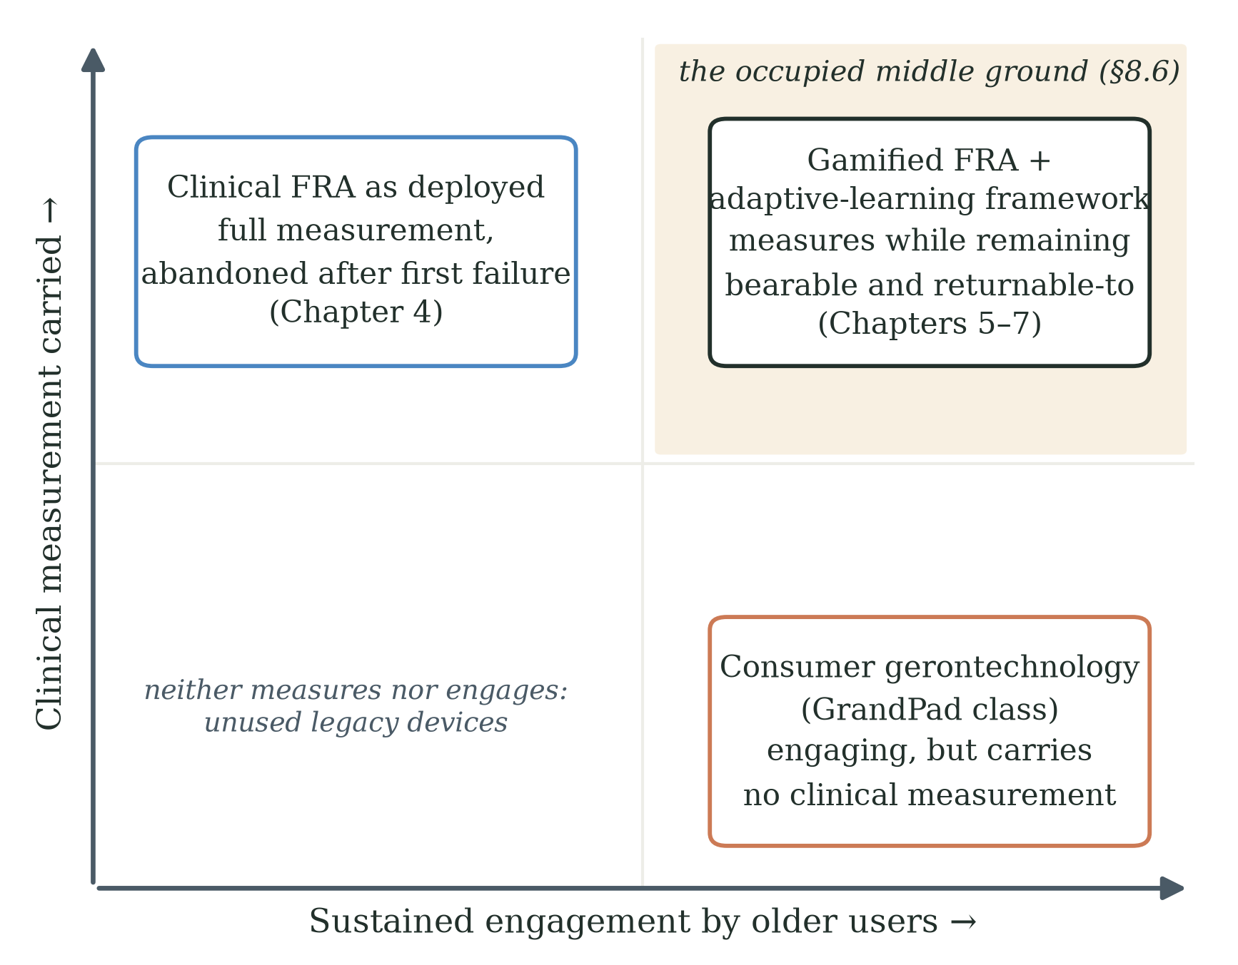
Figure 8.1. The gerontechnology design space. Commercial platforms of the GrandPad class achieve sustained engagement by carrying no clinical measurement; clinical instruments carry full measurement but are abandoned after adverse first experiences (Chapter 4). The programme's contribution occupies the upper right: the gamified FRA and the adaptive-learning framework specify how a technology can measure while remaining bearable and returnable-to for older users (Chapters 5-7, §8.6).

Chapter 8 Contributions, Alternative Explanations, Limitations and Ethics
This chapter states the contributions in four distinct registers and is explicit about which is which, because the four answer to different tests. A scientific contribution is judged by whether it explains observed behaviour and survives attempts to refute it; an engineering contribution by whether a competent team can build from it; an industrial contribution by whether it changes a deployment decision; and a methodological contribution by whether other researchers can reuse the method. Table 8.0 maps the thesis's contributions onto the four registers and the sections that state them; the sections that follow then present each in the hierarchy the evidence supports.
Table 8.0. The four contribution registers and where each is stated.
Register | Contribution | Stated in
Scientific | FIAS as a provisional behavioural construct; the coupling boundary condition for gamification theory; the competing-appraisal account (endowment protection versus learning trajectory) | §8.1, §8.3; Chs 2, 9
Engineering | The adaptive-learning framework — three principles over the failure-appraisal chain — and the dynamic game-state engine that operationalises it in real time | Ch 7 (§7.4, §7.5, §7.5A); §8.4
Industrial | A deployment template on existing FRA infrastructure (decoupled presentation, trajectory layer, staff protocol) and addressable-population evidence for planning | §8.4; §9.8
Methodological | The null-hypothesis-plus-attribution architecture; the dual-purpose mechanic; the QFD evidence-to-design pipeline; the commitment-gap measurement | §8.2; Table 3.1

8.1 Theoretical Contributions
The thesis makes four principal theoretical contributions, stated in the hierarchy the evidence supports. First — the problem finding — it identifies failure-associated non-return (FIAS) as a post-contact behaviour that standard acceptance and gamification models do not represent, and supplies the behavioural pieces those models are missing: loss aversion, identity-relevant endowment, mental accounting and stereotype threat, integrated as a candidate frame-sensitive account with testable predictions (Table 2.1). Second — the scope finding — the evidence supports a boundary condition for gamification theory: the theory holds for older adults, as Stage 3 indicates at literature-predicted acceptance levels, until the gamified activity is attached to a purpose-based technology whose purpose touches the identity-level value propositions of the user; at that boundary the theory fails, and FIAS names the mechanism (§6.7). Third — the design discovery — it advances adaptive learning as the behavioural-change driver for this population: continuous improvement at the level of the individual user, forced as a discovery by the rejection of H0 and by the Stage-3 commitment gap (§6.8), and the only design element on the table that can re-attach clinical purpose safely. Fourth, it formulates endowment-protective and learning-trajectory appraisals as competing interpretive regimes and translates the design discovery into a falsifiable engineering framework, the adaptive-learning framework, which is the packaging of the discovery rather than a finding in its own right. Three questions are deliberately reserved for the confirmatory programme, and reserving them is a strength of the design: the direct measurement of mental accounting and its companion mechanisms, the full resolution of the score-improvement/non-return paradox, and the isolated test of adaptive learning (§8.8). Read together, the contributions form one behavioural-engineering architecture — the phenomenon (FIAS), the principles (the adaptive-learning framework) and the engine (the dynamic game-state architecture) — as set out in §7.5A.

8.2 Methodological Contributions
The methodological contributions are: the null-hypothesis-plus-attribution architecture, in which H0 is built from the literature, tested prospectively under fully provisioned conditions, and its rejection disambiguated by a positive-control stage (Table 3.1); the dual-purpose mechanic linking gameplay and a measurement pathway in one physical action; theory-iterating action research with explicit revision points and an explicit confirmation-versus-discovery discipline (§3.5); the QFD pipeline that translates empirical findings into prioritised design requirements (§5.5A); documentation of the AI-assisted development workflow (recorded as enabling method, §5.3.9); a between-cohort quasi-experimental participant-facing decoupling comparison; and the commitment-gap description separating immediate session behaviour from stated future intention. The decoupling study should not be described as single-variable isolation, because multiple participant-facing cues and the cohort context changed.

8.3 Empirical Contributions
The empirical record yields the following results: 70.0% early disengagement (21 of 30, at or before three cycles) in the Stage-2 cohort with no observed re-engagement during the eight-week window; a paired recorded-index change of +6.9 points among the nine sustained participants (dz = 2.22, 95% CI 0.95–3.46) and +4.0 points across all thirty (dz = 0.42, 95% CI 0.05–0.79); a strong association between satisfaction and sustained engagement (Fisher's exact p = 0.013); the documented withdrawal (§5.5) of an earlier exploratory motivational-orientation classification whose coding records could not be produced; recorded-index increase without self-reported improvement or return among most single-session participants; 65.2% return among Stage-3 initial dropouts overall and 62.5% in the 65-80 band, reported from the Stage-3 aggregate record (§6.4); 71.7% coordination-frame endorsement as a manipulation check; 63.3% regular-use intention overall; and a descriptive 29.3-percentage-point difference between session retention and regular-use intention in the 65-80 band. These results do not constitute a direct correlation across stages because the participants and measures differ.

8.4 Industrial and Practical Contributions
The practical contribution, in order of importance, is the adaptive-learning proposition and then its packaging. Adaptive learning gives practitioners a deployable principle: build health-technology engagement around the visible, calibrated improvement of the individual user, and let the clinical purpose ride on the trajectory rather than on verdicts. The adaptive-learning framework makes that principle engineering-actionable — its components can be specified on existing infrastructure, the reference stack and prototype specification translate principles into components, and the applied case studies illustrate hypotheses for other domains. Its empirical status is that of a proposed framework informed by field evidence and learning theory. Before industrial deployment, the framework requires controlled effectiveness testing, implementation-fidelity assessment, safety and disclosure review, usability testing, longitudinal follow-up and cost analysis.

8.4A A Forward-Looking Contribution: The Language-Mode Boundary and Grounded Adaptive Learning
A forward-looking contribution concerns the gap between the deployed Stage-2 adaptation configuration and a richer person-conditioned system. The deployed system received pressure-panel and game telemetry, with some information rendered into language for model processing; it did not directly measure the participant's immediate appraisal, affect or intention at the moment of difficulty. The thesis therefore proposes an engineering extension — add ethically justified, consented and validated real-time signals, update a person-specific state estimate, and evaluate whether safe, pre-specified interventions improve retry and return without reducing challenge or obscuring important information (§9.8C) — and states the evidential boundary of that extension at §8.6A. This is a limitation of the sensing and control configuration used in the study; it should not be generalised into a claim about language models in general or about artificial general intelligence.

8.5 Alternative Explanations
The credibility of the frame-sensitive account depends on examining alternatives rather than declaring them ruled out. Eight alternatives are considered below; several remain viable because the present design is between-cohort. The expert consultation of §6.8A bears on this examination in both directions: it supplies independent support for the clinical-avoidance reading, and it identifies group and coach support as candidate moderators of post-failure continuation that the future within-cohort study should record and, where feasible, standardise.

8.5.1 Cohort Self-Selection
Concern: Stage-2 and Stage-3 participants may differ because of volunteer selection, residential status, health, education, technology familiarity or recruitment channel. Response: the age-matched Stage-3 return result remains substantially different from the Stage-2 observation and is therefore difficult to ignore. However, the non-equivalent 26.7% and 71.7% measures cannot quantify the size of selection bias, and the present data cannot show that cohort differences are too small to explain part of the effect. Randomisation within one recruited cohort is required.

8.5.2 Novelty Effect
Concern: novelty may increase engagement in a fresh cohort. Response: post-failure return is a stronger outcome than initial participation, but novelty could still affect willingness to retry or return during a short observation period. The study does not eliminate this explanation. Longitudinal follow-up and repeated-session comparison are required.

8.5.3 Demand Characteristics and Hawthorne Effect
Concern: participants may have inferred preferred responses or behaved differently because of researcher attention. Response: the behavioural return outcome is less vulnerable than a self-report item, but staff scripts, contact frequency and researcher involvement should be documented and standardised. A blinded or independent outcome assessor would strengthen the next study.

8.5.4 Regression to the Mean
Concern: the Stage-2 zero return may be an extreme small-sample observation. Response: 0 of 21 over eight weeks is an important field result with an upper 95% Wilson bound of approximately 15.5%, but it is not a metaphysical "regime". Replication with a larger cohort and identical follow-up is required.

8.5.5 Physical Fatigue and Motor-Learning Limits
Concern: age-linked fatigue, balance limitation or motor-learning difficulty may explain some Stage-3 non-return and some of the gap between session retention and regular-use intention. Response: this explanation remains plausible and should be measured directly rather than assigned only to a residual subgroup.

8.5.6 Language and Literacy Confounds
Concern: the Stage-3 effect may be driven by terminology rather than a deeper psychological mechanism. Response: terminology is one operational component of framing, but Stage 3 changed lexical, procedural, interface and recruitment cues together. The design therefore estimates a package effect. Future component testing is required to identify which elements are necessary and whether they interact.

8.5.7 Mechanism-Aspecific Just-Better-Design Alternative
Concern: Stage 3 may have produced better outcomes because the overall experience was simply better in ways not captured by the protocol. Response: the game mechanic, session structure and five-attempt rule were carried into the HTML port, but the platform, input device, setting, supervision, interface, pre-session procedure and recruitment all differed — Stage 3 was played remotely on participants' own computers rather than on the supervised pressure-panel station. "Just better design" and "just a lighter context" therefore remain viable mechanism-aspecific alternatives. Detailed implementation-fidelity records and within-cohort randomisation are required.

8.5.8 Input Modality and Embodied Exposure
Concern: in Stage 2, failure occurred through the body's own balance — weight shifts on the pressure panel — whereas in Stage 3 most participants steered with a trackpad or arrow keys (§6.3). The difference between the stages may therefore reflect not only the changed participant-facing frame but also the changed carrier of failure: a failure produced by one's own balance may speak more directly to bodily decline than a failure produced by one's fingers. Response: this alternative is viable, and the present between-cohort design does not separate it from the framing account. It is, however, partly absorbed into the coupling account itself, because the bodily measurement pathway is precisely what the dual-purpose mechanic couples to the game (§5.2A): removing the pressure panel removed the clinical frame and the embodied exposure together. The within-cohort study of §8.8 treats the game, the input device and the frame as independently manipulable factors, so that the contributions of framing and of input modality can be estimated separately.

8.6 Limitations
The principal limitations are as follows. The Stage-2-versus-Stage-3 comparison is between-cycle and between-cohort; the Stage-3 decoupling package contains multiple changes, including a change of platform, input device, setting and supervision (a remotely played HTML build rather than the supervised pressure-panel station); the proposed mental-accounting, endowment, stereotype-threat and entropy mechanisms were not measured directly; the Stage-2 FIAS composite requires a complete fixed codebook and independent reliability assessment; the clinical significance of short-term FRA-index change is unknown; self-selection and embedded-researcher effects remain possible; observation windows are short; and both cohorts are culturally specific. The nested model comparison is prospective rather than completed. These limitations narrow the claims but do not remove the practical importance of the observed failure-return patterns.

8.6A A Seventh Limitation: The Language-Mode Boundary of the Layer-2 AI
A further limitation concerns the deployed AI and sensing configuration. Layer 2 adapted game difficulty from telemetry and language-rendered summaries on a scheduled cycle. The proposed dynamic-state extension shortens the control loop but still depends mainly on pressure-panel and in-game event data. Neither configuration directly measures the participant's interpretation, affect, hesitation or intention at the moment of difficulty.
The thesis therefore cannot claim that the system observed a "cognitive collapse" or missed a directly established psychological event. What it can say is that the system lacked channels for immediate participant appraisal and affect, while the behavioural outcome of interest may be shaped by reactions occurring close to the failure event. A future person-conditioned system would need validated, ethically acceptable measures and a pre-specified intervention policy. It would also need to demonstrate incremental predictive and behavioural value beyond simple game telemetry.
This limitation belongs first to the study's input architecture, not to language models in general. The intuition that the limits of a system's language may bound the world it can represent has a long philosophical lineage (Wittgenstein, 1922), and the symbol-grounding and embodied-intelligence literatures (Harnad, 1990; Brooks, 1991) provide relevant theoretical context, but they do not establish that text-based models are categorically incapable of contributing to grounded systems. The bounded engineering question is whether adding direct environmental and behavioural inputs improves prediction and safe adaptation in this FRA setting. That question is testable on the existing apparatus and should be separated from broader claims about AGI.

8.6B Extending the Unit of Analysis: Abandonment as a Three-Party Decision
The empirical stages treat abandonment as the older user's decision, and that is where the data are. But the field observations invite a richer and more generous reading, offered here as a discussion extension. In the settings studied, three parties stand around the FRA station: the patient, the family, and the physician or care staff — 患者, 家属, 医生 in the Chinese-cultural context of both cohorts — and each can rationally choose to let the technology go from within its own standpoint. The patient protects an identity-level asset: an unfavourable verdict threatens the self-description that still says independent. The family, moved by protectiveness and filial care, may steer a parent away from an experience that visibly distressed them — abandonment as an act of love. The clinician or care team, managing scarce time across many residents, may reasonably stop promoting a station that residents avoid — abandonment as sensible triage. None of these is a failure of understanding; each is a locally reasonable decision.
Actual abandonment, on this reading, is the sum: the technology falls silent when all three parties, for their separately rational reasons, stop bringing the user back to it. This reframing enriches rather than displaces FIAS — the patient's identity-level appraisal remains the seed, but family and clinician responses can amplify it into permanence, which may be part of why Stage-2 exits were so absolute in a residential setting where family and staff were always nearby. It also widens the design opportunity in an encouraging direction: an adaptive-learning experience that gives the patient a visible rising trajectory simultaneously gives the family something hopeful to support and the clinician something efficient to prescribe, aligning all three standpoints around return rather than retreat. The three-party instrumentation — measuring each party's appraisal and their interactions — is a natural and exciting extension for the confirmatory programme (§8.8), and it connects this thesis to the adopter-system domain of the NASSS framework (Greenhalgh et al., 2017), where precisely such multi-actor dynamics are catalogued but not yet mechanised.

8.7 Ethical Considerations
The programme involves a vulnerable population, an embedded researcher, and a frame manipulation — decoupling — that intentionally changes how participants interpret the activity they are engaging with. The ethical framework has five components.

8.7.1 Vulnerability of Frail Older Adults
Older adults in residential care are vulnerable in several distinct senses: physical, cognitive, social, and identity. Mitigations applied in Stages 2 and 3 included exclusion criteria for cognitive impairment and acute mental-health conditions; immediate stoppage rules for fall, near-fall or dizziness; information sheets in Mandarin and Cantonese; voluntary participation with no consequence for refusal; and difficulty curves calibrated so that even the worst-balance participant could complete an opening session.

8.7.2 Decoupling and the Deception Question
The Stage-3 protocol did not collect clinical balance telemetry from any participant. Any future deployment that reintroduces clinical telemetry alongside decoupled framing must address the deception question directly. The recommended informed-consent script states, in the opening paragraph, that the session is a coordination game whose movements are also recorded for balance research, and that the participant's individual clinical results will not be discussed during sessions but will be available on request. A frame manipulation accompanied by full prior disclosure is not deception in the ethically problematic sense.

8.7.3 Autonomy, Dignity and the Right Not to Engage
The intervention is targeted at the gap between the user's stated intent and the user's subsequent behaviour, not at users who have decided that the technology is not for them. Staff training in any the adaptive-learning framework deployment must include explicit guidance not to use coaching to override a clearly stated preference for non-engagement.

8.7.4 Equity, Access and Deployment Risks
Three risks are flagged: equity (the adaptive-learning framework requires staff training that may not be available in lower-resource settings); paternalism (a system that adapts and reframes can shade into a system that decides for the user what their experience means); surveillance (the dual-purpose mechanic records continuous clinical telemetry). PIPL governance and a participant-accessible data policy are the operational answers; Phase-3 cost-effectiveness work will specify minimum staff-training intensity.

8.7.5 Embedded Researcher Bias
The lead author's embedded role may influence observation, interpretation, participant interaction and theory development. Reflective field notes and pre-specified predictions help but do not eliminate this risk. The next cycle should use standardised scripts, independent coding, blinded or independent outcome assessment where feasible, and an analysis plan registered before outcomes are examined.

8.8 Future Research
The priority extensions are ordered by inferential value. First is a within-cohort randomised comparison of coupled and participant-facing decoupled conditions using the same recruitment, eligibility, staff scripts, software and follow-up. Second is longitudinal follow-up over at least six to twelve months to test sustained voluntary use. Third is direct measurement of the proposed mechanisms through validated or carefully piloted measures of appraisal, self-efficacy, identity relevance, affect and willingness to continue. Fourth is a complete, non-circular FIAS codebook with independent reliability and external validation. Intervention components should be specified against an established behaviour-change taxonomy such as the Behaviour Change Wheel (Michie et al., 2011) so that replication and cross-site comparison are possible. Cross-cultural replication, cross-domain application and community-narrative research should follow after the core causal and construct questions are resolved. The three-party extension of §8.6B adds its own inviting study: instrument the patient, family and clinician standpoints together, and test whether aligning all three around a visible learning trajectory multiplies the return effect.
A further engineering extension is to test person-conditioned adaptation. The existing apparatus already records a body-coupled pressure signal. Additional channels - such as reaction time, posture change, voice cues, brief in-the-moment self-report or facial-affect estimates - should be selected only if they add valid information, are proportionate to the risk, and are acceptable to participants. Signals would be synchronised with game events and used by a pre-specified, auditable policy. The evaluation criterion is incremental benefit: better prediction of retry and return, safer and more appropriate intervention, and no loss of comprehension, autonomy or challenge.
The randomised replication should be treated as the decisive next study. Participants would be recruited into one community sample and assigned to coupled or decoupled conditions, with identical hardware, software, level structure, session length, staff support and follow-up. The primary outcome should be observed return within a fixed window; secondary outcomes should include repeated use, self-efficacy, perceived identity threat, fatigue, enjoyment, burden, comprehension and adverse events. A separate qualitative panel with non-returners would clarify why participants completed one session but did not intend regular use. Because the intervention embeds an AI component, the protocol and report of the randomised study should follow the SPIRIT-AI and CONSORT-AI reporting extensions (Liu et al., 2020).

8.9 Reproducibility and Data Availability
Because the central methodological contribution includes an artefact, reproducibility requires access to both data and implementation records. The record comprises the de-identified Stage-2 and Stage-3 datasets, a data dictionary, the derived-variable code, the fixed game-state specification, the numerical integration parameters, the software version, the analysis scripts and the exact questionnaire versions, bound in Appendix G; where an item cannot be shared openly, its entry states the access procedure and restrictions. File names alone are not sufficient unless the files are deposited with the thesis or in a governed repository accessible to examiners. The Stage-3 dataset was collected in full, and the aggregate results reported in Chapter 6 were compiled from the participant-level records. The archived logbook holds the aggregates together with a reconciliation harness that checks every participant-level entry against them (Appendix G, item G.3).
Three reproducibility boundaries are material and are named here so that replication attempts are not misled. First, the InBody calibration function is a vendor component and is treated as a black box: replication on other hardware requires new calibration and may not reproduce the same signals. Second, third-party model endpoints change over time, so the exact run-time configuration used in Stage 2 is recorded in Appendix G (item G.7). Third, the appendices bind the verbatim language versions of all instruments, the translation procedure, the complete FIAS codebook with inter-coder reliability, the consent materials and the photographic record.

Chapter 9 Conclusion

9.1 What This Programme Set Out to Do
The programme set out to identify and characterise failure-associated non-return to a gamified health technology, examine whether participant-facing clinical framing may contribute to that pattern, and translate the evidence into an engineering design response. FRA provided the working case across a Guangzhou residential setting and a separate Hong Kong community setting. The contribution is positioned as a frame-sensitive engagement model and a testable continuous-improvement framework, not as a general theory of all health-technology abandonment. In the architecture of Table 3.1, the programme built a null hypothesis from the best available acceptance and gamification theory, tested it in the field, and followed the rejection to its discoveries.
The programme was conducted as sequential, exploratory action research. The conclusion keeps its three registers — observed results, the inferences that make them intelligible, and the designs they inspire — and it is the clarity of that separation that lets each register be stated with full confidence.

9.2 The Three-Stage Empirical Arc
Stage 1 used a six-item face-to-face survey to characterise a utilisation and non-return problem. Thirty-nine per cent reported prior FRA use, and a high proportion of prior users reported an adverse or unacceptable first experience and no subsequent return. Because the exact sample denominator and the mapping of survey items to "failure", access and perceived benefit require reconciliation, Stage 1 is treated as descriptive and hypothesis-generating. It suggested that the first experience deserved direct prospective study and motivated the FIDS-to-FIAS conceptual revision.
Stage 2 prospectively studied thirty residents over eight weeks using a dual-purpose AI-assisted skiing game. Seventy per cent of participants disengaged at or before three game cycles, and no re-engagement was observed among the low-engagement group during the study window. Among single-session participants, the recorded index typically improved while self-reported improvement was rare and no one returned. This divergence motivated the behavioural-economic account, but it did not establish clinical benefit or directly measure endowment, mental accounting or stereotype threat. These observations constitute the prospective rejection of H0 (§2.3.5, §5.9).
Stage 3 examined a participant-facing decoupling package in a separate Hong Kong cohort of 120 adults recruited through the author's networks, playing an e-mailed HTML port of the game on their own computers. The skiing-game structure was retained in the port; the pressure-panel apparatus, clinical setting and in-person supervision were not, and clinical recruitment language, pre-session procedure, labels and participant-facing outputs were changed. Observed non-return was 6.7% overall and 14.6% in the 65-80 band. Fifteen of twenty-three initial dropouts returned overall; ten of sixteen returned in the 65-80 band. The result is a substantial behavioural difference and supports a frame-sensitive account, but the between-cohort design does not eliminate cohort and contextual alternatives. Coordination endorsement is interpreted as a manipulation check, not as a direct measure of latent learning orientation.

9.3 The Central Finding: Evidence Consistent with a Coupling or Framing Effect
The central empirical conclusion is that post-failure return differed substantially between the coupled Stage-2 context and the participant-facing decoupled Stage-3 context. The findings are consistent with the proposition that coupling a game to an artefact-based clinical assessment can change the behavioural meaning of failure for some older users. They do not prove that coupling alone caused non-return, that the proposed psychological mechanism operated in every participant, or that decoupling eliminates abandonment.
"Coupling" refers to the design property by which one physical action produces both a gameplay outcome and a clinically interpreted measurement. When these outputs are presented together, an adverse event may be read not only as game difficulty but also as information about the user's body or independence. This is the candidate frame-sensitive mechanism proposed by the thesis. Stages 1 and 2 document the problem signature in the coupled context; they do not directly observe an endowment-protective response or mental-account closure.
In the Stage-3 condition, participant-facing clinical cues were reduced through several coordinated changes. Failure was presented within a coordination-game context, and post-failure return was common. This pattern supports the practical value of separating the engagement layer from immediate diagnostic-verdict presentation. Because Stage 3 used a separate cohort and a multi-component package, the result should be interpreted as strong directional field evidence rather than a purified effect of one variable.
FIAS is therefore advanced as a provisional construct describing failure-associated active non-return under identity-relevant conditions, and the central finding is stated as a scope law: gamification theory holds for older adults until the gamified activity is attached to a purpose-based technology whose purpose — health, decline, life-threat — strikes the identity-level value propositions of the user; at that boundary the theory fails, and FIAS names the mechanism of the failure (§6.7). The thesis's principal theoretical contribution is the identification of this coupling boundary and the specification of a mechanism that can be measured in future work. Construct validity, discriminant validity and incremental prediction over STAM remain to be demonstrated.

9.4 Decoupling Preserves the Viability of Game Theory for Elderly Engagement
A second conclusion is that the Stage-3 results are consistent with gamification theory remaining applicable to elderly engagement. Stage 3 functioned as the programme's positive control (§6.1): the same game mechanics, decoupled from the clinical apparatus and its participant-facing clinical frame (§6.3), were accepted by the elderly cohort at levels the gamification literature predicts — consistent with the theory stack of Chapter 2, including the An–Cheung demonstration, transferring to this population. The findings do not imply that game design theory fails in clinical settings; they locate the failure precisely at the participant-facing relationship between gameplay, assessment language and clinical interpretation. Gamification mechanics should be evaluated together with the frame in which success and failure are understood.
Stage 3 changed decoupling cues at several levels: lexical language, pre-session procedure, participant-facing interface and clinical-output presentation. The observed result is therefore the joint effect of a decoupling package and its context, not the effect of removing one word or one screen. Future component studies should identify which elements are necessary, sufficient and acceptable.
The industry implication is a design principle rather than a universal rule: where sustained engagement is required, measurement and engagement functions may share hardware and sensor data while using carefully separated participant-facing pathways. The design must remain truthful, clinically safe and transparent about data use. Decoupling should reduce unnecessary verdict-like cues, not conceal risk or deny users access to clinically important information.

9.5 Adaptive Learning as the Design Counter
Decoupling did not answer every engagement question. In the 65-80 group, observed session retention was 85.4% and stated regular-use intention was 56.1%. The 29.3-percentage-point difference is descriptive and may reflect fatigue, access, burden, perceived relevance, enjoyment, motor difficulty, novelty or other factors. The present data do not show that the same identity mechanism caused the difference.
Adaptive learning is advanced as the programme's principal design discovery (§6.8; Chapter 7): a regime in which the activity visibly improves the person, session by session, so that a rising personal trajectory — continuous improvement at the level of the individual user — becomes the reason to return, and eventually the frame within which the clinical purpose can be safely re-attached. It can present performance as a trajectory, specify the next achievable step and calibrate challenge, feedback and pacing. The adaptive-learning framework formalises the discovery into three components: identity disentanglement, trajectory installation and adaptive calibration. The framework is not yet empirically validated as a package, the Stage-3 result should not be treated as a test of adaptive learning, and its incremental effect must be evaluated prospectively against decoupling alone and against alternative supports.

9.6 Competing Appraisal Regimes: Endowment Protection and Learning Trajectory
The relationship between identity protection and learning trajectory is a theoretical proposition, not an empirical demonstration of mutual exclusion.
An endowment-protective appraisal treats an adverse result as a threat to a valued, relatively stable self-description. A learning-trajectory appraisal treats the same result as information about present position and next action. Both appraisals can coexist within a person, and their relative influence may vary by context, history, culture, support and task.
The engineering objective is therefore to strengthen a credible trajectory interpretation without denying identity, removing all challenge or obscuring clinically meaningful information. Visible progress, mastery-oriented feedback, appropriate challenge and user choice may shift the balance between appraisals. These effects require direct measurement.
The thesis consequently reformulates its strongest structural claim: endowment-protective and learning-trajectory appraisals are competing interpretive regimes. The adaptive-learning framework is designed to increase the salience of the latter. WTA-WTP asymmetry, identity appraisal and changes in self-efficacy are future measurement targets, not established mediators in the current dataset.

9.7 Theoretical Contributions
The thesis offers four theoretical contributions, in the hierarchy of §8.1. First, FIAS: a provisional, non-diagnostic construct naming the post-contact problem the acceptance models miss, with the behavioural-economics account that structures it (Table 2.1). Second, the coupling boundary condition of gamification theory: where the theory holds for older adults, where it fails, and why. Third, adaptive learning as the design discovery — the behavioural-change driver that converts the boundary's lesson into a buildable response. Fourth, the competing-appraisal formulation (endowment protection versus learning trajectory) and its translation into the falsifiable the adaptive-learning framework packaging. The mechanisms' direct verification, the appraisals' interplay, and adaptive learning's isolated effect are the questions this thesis hands, well-formed and pre-specified, to the studies it proposes.

9.8 Practical Contributions for Industry and Practice
The practical contribution is, first, a deployable principle — build elderly health-technology engagement around adaptive learning, the visible continuous improvement of the individual user — and second, its specification. The adaptive-learning framework can be implemented on existing FRA infrastructure through participant-facing framing, trajectory visualisation, coaching protocols, adaptive challenge and additional telemetry. Existing hardware reduces capital requirements, but implementation still requires software validation, staff training, ethics and disclosure review, accessibility testing, data governance and longitudinal evaluation.
The dual-purpose mechanic is a portable engineering pattern: one physical action can support gameplay and a measurement pathway. The practical lesson is to manage how those outputs are presented and interpreted rather than assuming that a clinically meaningful score automatically motivates continued use. The Claude Code-assisted workflow is documented as a development method that accelerated iteration; reproducibility depends on preserving prompts, model versions, code, tests and human design decisions.
Stage 3 suggests that the addressable population for participant-facing decoupling may be substantial, particularly because 10 of 16 initial dropouts aged 65-80 returned. This is promising for service design, but it is not yet a market-size estimate or evidence of return on investment. The 71.7% coordination endorsement is a manipulation check, and the short follow-up does not establish sustained adoption. Industrial planning should therefore be based on a controlled pilot with longitudinal use, implementation cost and safety outcomes.

9.8A A Secondary Contribution to Gamification: Agentic-AI-Driven Dynamic Game States
A secondary design contribution is the proposed dynamic game-state architecture. It replaces a terminal failure screen with a small repertoire of recovery, mastery, narrative and reframe states selected from observed performance. The design is intended to preserve continuity and challenge while reducing categorical failure cues. It was not evaluated in the empirical programme, so it should be presented as a prototype specification and testable extension rather than as an established "loss-free" mechanic.
The workflow documents how a behavioural and safety specification was translated into candidate state logic, synthetic tests and auditable runtime rules; the AI tooling that accelerated this translation is an enabling technology, and the contribution remains the behavioural design framework the states implement. Human developers remain responsible for design intent, validation and governance. The natural next study is a controlled comparison of the proposed state repertoire with the original game state, measuring retry, return, challenge, comprehension, affect, fatigue and adverse effects.

9.8B Future Research Proposition: From Telemetry-Conditioned to Person-Conditioned Adaptation
This section and §9.8C are bounded future-research implications, not empirical findings of the thesis. The FRA evidence supports claims about framing and post-failure behaviour in the studied cohorts. It does not support a general conclusion about the limits of language models or the nature of artificial general intelligence.
The deployed Stage-2 system adapted difficulty using pressure-panel and game telemetry, with some information rendered into language for model processing. It did not directly observe the participant's immediate appraisal, affect or intention. The next engineering question is whether adding valid, consented, real-time behavioural inputs improves prediction and safe adaptation beyond telemetry alone.
A person-conditioned extension would synchronise game events with carefully selected signals such as reaction time, posture change, voice cues, brief in-the-moment self-report or validated affect estimates. An auditable policy could then select a recovery, reframe or mastery state within defined safety limits. The evaluation should compare prediction, retry, return, user comprehension, autonomy and unintended effects. The aim is not to infer a hidden mental state with certainty, but to improve responsiveness while preserving user control.
The wider embodied and grounded-AI literature provides relevant context because it studies agents that learn from interaction with environments rather than from static text alone. The contribution of this thesis is modest: it specifies one human-centred testbed in which additional sensing, adaptive action and behavioural outcomes can be aligned. Whether lessons from this setting generalise to broader theories of intelligence is outside the empirical scope of the thesis.
This extension also clarifies the adaptive-learning framework Principle 3. Adaptive calibration can operate at two levels: adjustment of the game to observed performance and updating of a person-specific model from ethically collected signals. The Stage-2 implementation addressed the first only partially. The proposed second loop is a future system requirement to be tested against simpler baselines; it is not necessary to accept the main frame-sensitive result of the thesis.

9.8C Bounded Implications for AI Evaluation
The FRA programme suggests a limited evaluation principle for human-adaptive systems: assess not only the plausibility of system outputs but also whether actions improve pre-specified outcomes in a responsive environment. This is an engineering implication from the study architecture, not a criterion for AGI.
The deployed configuration processed game and pressure-panel information, some of which was rendered into language. Its limitation was practical: the available inputs did not include direct measures of the participant's immediate appraisal or affect (§8.6A). The engineering extension is therefore specific and testable: add ethically justified, validated behavioural or experiential inputs; update a person-specific state estimate; and evaluate whether pre-specified, safe interventions improve retry and return without reducing challenge or obscuring important information. For the FRA platform, the operational outcomes are concrete: immediate retry after difficulty, return within a fixed window, repeated voluntary use, perceived competence, fatigue, comprehension, burden, safety and appropriate clinical follow-up. The boundary of this position is explicit: the empirical warrant covers the studied engagement patterns and the limitations of the deployed input architecture, and the proposed person-conditioned system remains an engineering programme to be evaluated (§8.8) — not a claim about language models in general or about artificial general intelligence.
Table 9.2. Deployed Stage-2 adaptation configuration versus a proposed person-conditioned extension. The comparison describes two system architectures for future evaluation; it should not be read as a categorical comparison between all language-based AI and "full" intelligence.
Dimension | Deployed Stage-2 adaptation configuration | Proposed person-conditioned extension
World available to the system | Pressure-panel and game telemetry, partly rendered into language for model processing | Telemetry plus ethically justified, validated behavioural or experiential inputs
Input at run time | Telemetry rendered into a natural-language summary string | Instant physical and behavioural signals, plus telemetry, captured as they occur
Timescale | Scheduled: five-minute adjustment cycle | Continuous: perception at one-second cadence; action within seconds of the event
Object of learning | General model parameters plus session-level telemetry | A person-specific state estimate updated during interaction
Output | A text recommendation: difficulty level plus written rationale | An action in the environment: selection of the next game state
Feedback channel | Delayed and scheduled feedback from session records | Closed-loop behavioural and experiential outcomes with safety constraints
Visibility of the failure moment | Does not directly measure participant appraisal or affect at the event | Tests whether additional signals improve prediction and safe intervention
Theoretical anchors | Human-computer interaction, intelligent tutoring and model-assisted control | Multimodal interaction, affective computing, adaptive control and person-centred design
Evaluation criterion | Accuracy of recommendations, game telemetry and session outcomes | Incremental prediction, retry, return, comprehension, autonomy, burden and safety

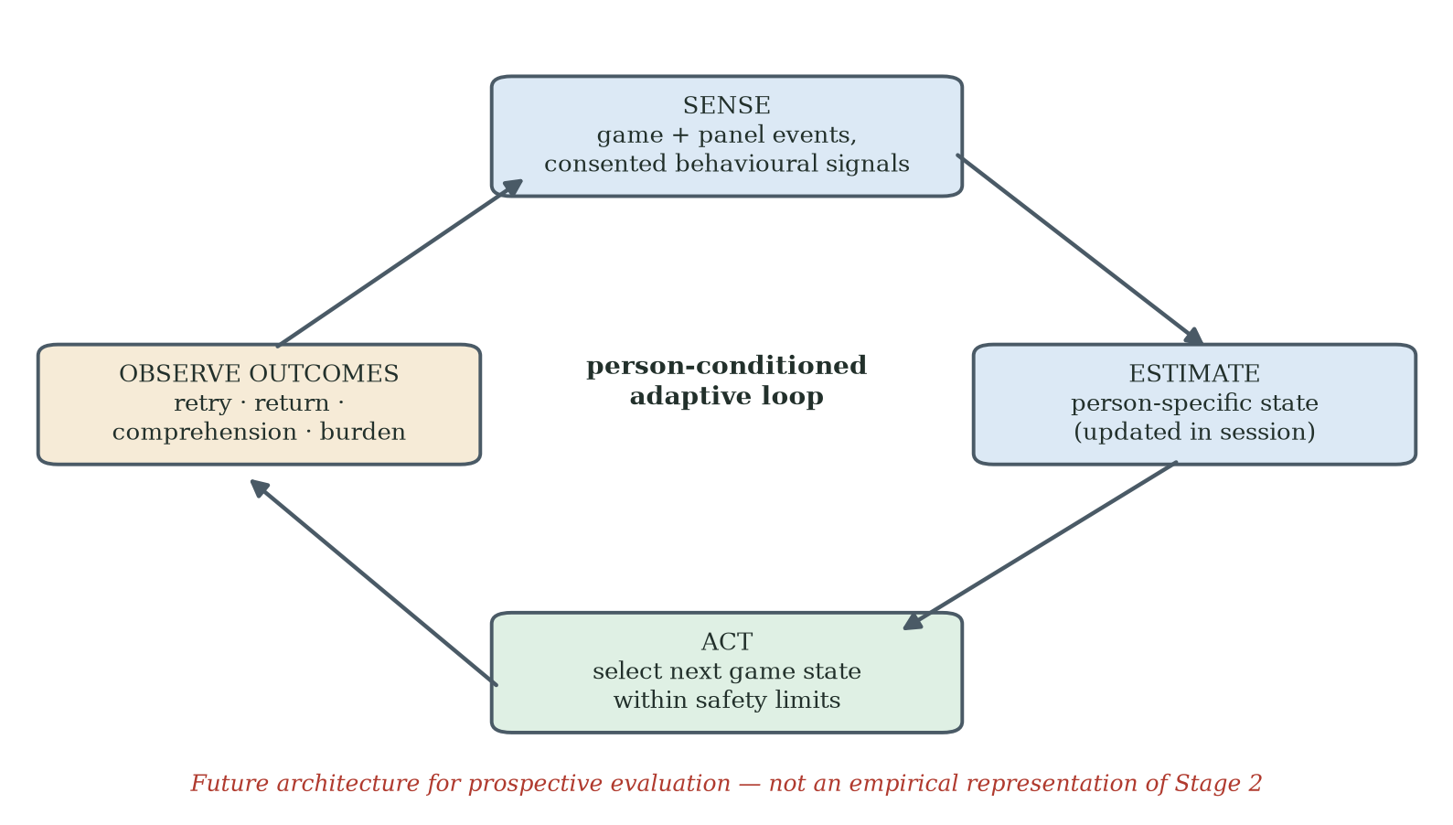
Figure 9.2. Proposed person-conditioned adaptive loop. Game and pressure-panel events are synchronised with ethically justified behavioural or experiential inputs; the system updates a person-specific state estimate and selects the next game state within pre-specified safety limits. Outcomes such as retry, return, comprehension and burden feed the next cycle. The figure is a future architecture, not an empirical representation of Stage 2.

9.9 Limits of What Has Been Shown
The limits are substantial and define the next programme. The empirical claims are restricted to a Southern Chinese residential cohort and a Hong Kong network-recruited cohort playing remotely on their own computers. The Stage-2-versus-Stage-3 comparison is not randomised and does not isolate framing from every concurrent difference. The proposed psychological mechanisms were not measured directly. FIAS requires a complete non-circular codebook, reliability testing and construct validation. The clinical significance of short-term FRA-index change is unknown. The complete adaptive-learning framework, dynamic-state architecture and person-conditioned AI extension have not been tested. Cross-cultural, cross-domain and long-term generalisation therefore remain open.

9.10 Natural Extensions
The highest-priority extension is a within-cohort randomised comparison of coupled and participant-facing decoupled conditions with harmonised recruitment, measures, staff scripts and follow-up. The second is longitudinal evaluation of repeated voluntary use. The third is direct measurement and validation of the proposed FIAS operators, including self-efficacy, identity relevance, appraisal and affect. The fourth is controlled testing of the adaptive-learning framework components and the dynamic-state extension against simpler baselines. Cross-cultural replication, cross-domain application, community-narrative research and person-conditioned adaptive sensing should follow from a stronger causal and construct foundation.

9.11 Returning to the Three F4 Residents
The thesis opened with three F4 residents whose recorded FRA index improved during a single session and who did not return. The observation should be preserved because it reveals that the direction of a measured score and the decision to return are not the same outcome. The present data do not reveal why each individual left. Identity protection and mental accounting are plausible interpretations, but fatigue, discomfort, misunderstanding, scepticism, embarrassment, burden or other factors may also have contributed.
Stage 3 showed that post-failure return was common in a separate decoupled cohort, including among adults aged 65-80. It would be inappropriate to estimate that "roughly two" of the three F4 residents would have returned under decoupling, because the studies are not individual-level counterfactuals and the samples differ. The defensible conclusion is that the Stage-3 pattern makes non-return appear modifiable and justifies a controlled test of the frame-sensitive account.
The practical aspiration remains simple: design the first adverse experience so that it supports learning, preserves dignity and leaves a truthful, safe and voluntary path to the next session. Players may fail levels; the research question is whether the system helps them understand the event, choose what to do next and return when continued participation is useful to them.

9.12 Closing Synthesis
The thesis began with an underused FRA station in a busy rehabilitation hall and ends with a testable engineering programme. Its argument can be walked in five steps. A null hypothesis, built honestly from the acceptance and gamification literatures, said the station's problem was solvable with good design and game mechanics. The Stage-2 field test rejected it — seventy per cent early disengagement, no returns — even though the game satisfied every criterion the theories name. Stage 3, the attribution experiment, showed the theories were never wrong about older adults: decoupled from the clinical attachment, the same game was accepted at the levels the literature predicts. The failure lives at a boundary — where gamification is attached to a purpose-based technology whose verdicts touch who the user believes they are — and FIAS names its mechanism. And at that boundary the programme found its design discovery: adaptive learning, continuous improvement at the level of the individual user, the one response that can carry clinical purpose back into the experience on the strength of a rising personal trajectory.
The contribution is therefore a calibrated chain rather than one mechanism demonstrated at four scales, and the chain practises what it proposes: continuous improvement at the researcher's level (the action-research cycles), at the artefact's level (the AI-assisted build) and — as the design discovery for its users — at the level of the individual person. The survey identified a problem signature; Stage 2 characterised failure-associated non-return and the divergence between score change and return; Stage 3 provided convergent quasi-experimental evidence for a frame-sensitive account; the adaptive-learning framework translated the evidence into an engineering framework; and the proposed adaptive-sensing extension identified the next system experiment. The thesis claims that the engagement problem is important, measurable and potentially modifiable on existing infrastructure. It does not claim that mental accounting has been verified, that decoupling alone is causal, or that the FRA programme resolves the limits of language-based intelligence. Read as one architecture, the chain closes: FIAS supplies the phenomenon, the adaptive-learning framework the design principles, and the dynamic game-state engine the real-time implementation (§7.5A).

References
Akao, Y. (1990). Quality function deployment: Integrating customer requirements into product design. Productivity Press.
Altmeyer, M., Lessel, P., & Krüger, A. (2018). Investigating gamification for seniors aged 75+. In Proceedings of the 2018 Designing Interactive Systems Conference (pp. 453–458). ACM. https://doi.org/10.1145/3196709.3196799
An, S., Cheung, C. F., & Lo, Y. T. (2025). Improving older adults' technology adoption on mobile map: A gamification approach. International Journal of Human–Computer Interaction, 41(15), 9633–9651. https://doi.org/10.1080/10447318.2024.2426914
An, S., Cheung, C. F., & Willoughby, K. W. (2024). A gamification approach for enhancing older adults' technology adoption and knowledge transfer: A case study in mobile payments technology. Technological Forecasting and Social Change, 205, Article 123456. https://doi.org/10.1016/j.techfore.2024.123456
Antonides, G., de Groot, I. M., & van Raaij, W. F. (2011). Mental budgeting and the management of household finance. Journal of Economic Psychology, 32(4), 546–555.
Baltes, P. B., & Baltes, M. M. (1990). Psychological perspectives on successful aging: The model of selective optimization with compensation. In P. B. Baltes & M. M. Baltes (Eds.), Successful aging: Perspectives from the behavioral sciences (pp. 1-34). Cambridge University Press.
Bandura, A. (1977). Self-efficacy: Toward a unifying theory of behavioral change. Psychological Review, 84(2), 191–215.
Bandura, A. (1997). Self-efficacy: The exercise of control. W. H. Freeman.
Barber, S. J. (2017). An examination of age-based stereotype threat about cognitive decline. Perspectives on Psychological Science, 12(1), 62–90.
Bjork, E. L., & Bjork, R. A. (2011). Making things hard on yourself, but in a good way: Creating desirable difficulties to enhance learning. In M. A. Gernsbacher, R. W. Pew, L. M. Hough, & J. R. Pomerantz (Eds.), Psychology and the real world (pp. 56–64). Worth.
Broady, T., Chan, A., & Caputi, P. (2010). Older and younger adults' attitudes towards computers. British Journal of Educational Technology, 41(3), 473–485.
Brooks, R. A. (1991). Intelligence without representation. Artificial Intelligence, 47(1–3), 139–159.
Centers for Disease Control and Prevention. (2023). Facts about falls. U.S. Department of Health and Human Services.
Chan, L.-K., & Wu, M.-L. (2002). Quality function deployment: A literature review. European Journal of Operational Research, 143(3), 463–497.
Chen, G., Gully, S. M., & Eden, D. (2001). Validation of a new general self-efficacy scale. Organizational Research Methods, 4(1), 62–83.
Chen, K., & Chan, A. H. S. (2014). Gerontechnology acceptance by elderly Hong Kong Chinese: A senior technology acceptance model (STAM). Ergonomics, 57(5), 635–652.
Chou, Y. (2015). Actionable gamification: Beyond points, badges, and leaderboards. Octalysis Media.
Compeau, D. R., & Higgins, C. A. (1995). Computer self-efficacy: Development of a measure and initial test. MIS Quarterly, 19(2), 189–211.
Csikszentmihalyi, M. (1990). Flow: The psychology of optimal experience. Harper & Row.
Czaja, S. J., Boot, W. R., Charness, N., Rogers, W. A., & Sharit, J. (2018). Improving social support for older adults through technology: Findings from the PRISM randomized controlled trial. The Gerontologist, 58(3), 467-477. https://doi.org/10.1093/geront/gnw249
Davis, F. D. (1989). Perceived usefulness, perceived ease of use, and user acceptance of information technology. MIS Quarterly, 13(3), 319–340.
Deci, E. L., & Ryan, R. M. (1985). Intrinsic motivation and self-determination in human behavior. Plenum.
Deterding, S., Dixon, D., Khaled, R., & Nacke, L. (2011). From game design elements to gamefulness: Defining gamification. In Proceedings of the 15th International Academic MindTrek Conference (pp. 9–15). ACM.
D'Mello, S., & Graesser, A. (2012). Dynamics of affective states during complex learning. Learning and Instruction, 22(2), 145–157.
Elliot, A. J., & Murayama, K. (2008). On the measurement of achievement goals: Critique, illustration, and application. Journal of Educational Psychology, 100(3), 613–628.
Eysenbach, G. (2005). The law of attrition. Journal of Medical Internet Research, 7(1), e11.
Festinger, L. (1954). A theory of social comparison processes. Human Relations, 7(2), 117–140.
Frey, B. S., & Jegen, R. (2001). Motivation crowding theory. Journal of Economic Surveys, 15(5), 589–611.
Gadbois, E. A., Jimenez, F., Brazier, J. F., Davoodi, N. M., Nunn, A. S., Mills, W. L., Dosa, D., & Thomas, K. S. (2022). Findings from Talking Tech: A technology training pilot intervention to reduce loneliness and social isolation among homebound older adults. Innovation in Aging, 6(5), igac040. https://doi.org/10.1093/geroni/igac040
GrandPad. (n.d.). GrandPad: The tablet for seniors [Product and subscription information]. GrandPad, Inc. https://www.grandpad.net
Greenhalgh, T., Wherton, J., Papoutsi, C., Lynch, J., Hughes, G., A'Court, C., Hinder, S., Fahy, N., Procter, R., & Shaw, S. (2017). Beyond adoption: A new framework for theorizing and evaluating nonadoption, abandonment, and challenges to the scale-up, spread, and sustainability of health and care technologies. Journal of Medical Internet Research, 19(11), e367.
Harnad, S. (1990). The symbol grounding problem. Physica D: Nonlinear Phenomena, 42(1–3), 335–346.
Hawthorn, D. (2007). Interface design and engagement with older people. Behaviour & Information Technology, 26(4), 333–341.
Holt, C. A., & Laury, S. K. (2002). Risk aversion and incentive effects. American Economic Review, 92(5), 1644–1655.
InBody Co., Ltd. (2022). InBody FRA510S: Fall risk assessment system — user manual and product catalogue. InBody Co., Ltd.
Juul, J. (2013). The art of failure: An essay on the pain of playing video games. MIT Press.
Kahneman, D., Knetsch, J. L., & Thaler, R. H. (1990). Experimental tests of the endowment effect and the Coase theorem. Journal of Political Economy, 98(6), 1325–1348.
Kahneman, D., & Tversky, A. (1979). Prospect theory: An analysis of decision under risk. Econometrica, 47(2), 263–292.
Kapur, M. (2008). Productive failure. Cognition and Instruction, 26(3), 379–424.
Kim, M., Kim, S., & Won, C. W. (2018). Test–retest reliability and sensitivity to change of a new fall risk assessment system: A pilot study. Annals of Geriatric Medicine and Research, 22(2), 80–87. https://doi.org/10.4235/agmr.2018.22.2.80
King, W. R., & He, J. (2006). A meta-analysis of the technology acceptance model. Information & Management, 43(6), 740–755.
Koivisto, J., & Malik, A. (2021). Gamification for older adults: A systematic literature review. The Gerontologist, 61(7), e360–e372.
Kroenke, K., Spitzer, R. L., Williams, J. B. W., & Löwe, B. (2009). An ultra-brief screening scale for anxiety and depression: The PHQ-4. Psychosomatics, 50(6), 613–621.
Lee, C., & Coughlin, J. F. (2015). Older adults' adoption of technology: An integrated approach to identifying determinants and barriers. Journal of Product Innovation Management, 32(5), 747–759.
Levy, B. R., Slade, M. D., Kunkel, S. R., & Kasl, S. V. (2002). Longevity increased by positive self-perceptions of aging. Journal of Personality and Social Psychology, 83(2), 261–270.
Lewin, K. (1946). Action research and minority problems. Journal of Social Issues, 2(4), 34–46.
Liu, X., Cruz Rivera, S., Moher, D., Calvert, M. J., Denniston, A. K., & SPIRIT-AI and CONSORT-AI Working Group. (2020). Reporting guidelines for clinical trials evaluating artificial intelligence interventions: The SPIRIT-AI and CONSORT-AI extensions. Nature Medicine, 26(9), 1364-1374.
Locke, E. A., & Latham, G. P. (2002). Building a practically useful theory of goal setting and task motivation: A 35-year odyssey. American Psychologist, 57(9), 705–717.
McGlone, M. S., & Aronson, J. (2006). Stereotype threat, identity salience, and spatial reasoning. Journal of Applied Developmental Psychology, 27(5), 486–493.
Michie, S., van Stralen, M. M., & West, R. (2011). The behaviour change wheel: A new method for characterising and designing behaviour change interventions. Implementation Science, 6, 42.
Nasreddine, Z. S., Phillips, N. A., Bédirian, V., Charbonneau, S., Whitehead, V., Collin, I., Cummings, J. L., & Chertkow, H. (2005). The Montreal Cognitive Assessment, MoCA: A brief screening tool for mild cognitive impairment. Journal of the American Geriatrics Society, 53(4), 695–699.
Park, D. C., Lodi-Smith, J., Drew, L., Haber, S., Hebrank, A., Bischof, G. N., & Aamodt, W. (2014). The impact of sustained engagement on cognitive function in older adults: The Synapse Project. Psychological Science, 25(1), 103-112. https://doi.org/10.1177/0956797613499592
Park, W.-C., Kim, M., Kim, S., Yoo, J., Kim, B. S., Chon, J., Jeong, S. J., & Won, C. W. (2019). Introduction of fall risk assessment (FRA) system and cross-sectional validation among community-dwelling older adults. Annals of Rehabilitation Medicine, 43(1), 87–95. https://doi.org/10.5535/arm.2019.43.1.87
Perissinotto, C., Zhang, C., Oseau, T., Balik, D., Sou, C., Burnight, C., & Burnight, K. (2019). Feasibility of a tablet designed for older adults to facilitate telemedicine visits [Conference abstract]. Innovation in Aging, 3(Suppl. 1), S975. https://doi.org/10.1093/geroni/igz038.3534
Picard, R. W. (1997). Affective computing. MIT Press.
Reason, P., & Bradbury, H. (Eds.). (2008). The SAGE handbook of action research: Participative inquiry and practice (2nd ed.). SAGE.
Ryan, R. M., & Deci, E. L. (2000). Self-determination theory and the facilitation of intrinsic motivation, social development, and well-being. American Psychologist, 55(1), 68–78.
Satchell, C., & Dourish, P. (2009). Beyond the user: Use and non-use in HCI. In Proceedings of OzCHI 2009 (pp. 9–16). ACM.
Schroeder, T., Dodds, L., Georgiou, A., Gewald, H., & Siette, J. (2023). Older adults and new technology: Mapping review of the factors associated with older adults' intention to adopt digital technologies. JMIR Aging, 6, e44564.
Shannon, C. E. (1948). A mathematical theory of communication. Bell System Technical Journal, 27(3), 379–423; 27(4), 623–656.
Standing Committee of the National People's Congress. (2021). Personal information protection law of the People's Republic of China.
Steele, C. M., & Aronson, J. (1995). Stereotype threat and the intellectual test performance of African Americans. Journal of Personality and Social Psychology, 69(5), 797–811.
Stringer, E. T. (2014). Action research (4th ed.). SAGE.
Tha, S. H., Hough, K., Bui, N., Dulaney, S., & Perissinotto, C. (2025). The use of age-friendly technology in the care of older adults: Two implementation case studies. Journal of Applied Gerontology. https://doi.org/10.1177/07334648251343513
Thaler, R. H. (1980). Toward a positive theory of consumer choice. Journal of Economic Behavior & Organization, 1(1), 39–60.
Thaler, R. H. (1985). Mental accounting and consumer choice. Marketing Science, 4(3), 199–214.
Tsai, T. H., Lin, W. Y., Chang, Y. S., Chang, P. C., & Lee, M. Y. (2020). Technology anxiety and resistance to change: Behavioural study of a wearable cardiac warming system using an extended TAM for older adults. PLOS ONE, 15(1), e0227270. https://doi.org/10.1371/journal.pone.0227270
Tversky, A., & Kahneman, D. (1991). Loss aversion in riskless choice: A reference-dependent model. Quarterly Journal of Economics, 106(4), 1039–1061.
VanLehn, K. (2011). The relative effectiveness of human tutoring, intelligent tutoring systems, and other tutoring systems. Educational Psychologist, 46(4), 197–221.
Venkatesh, V., & Bala, H. (2008). Technology acceptance model 3 and a research agenda on interventions. Decision Sciences, 39(2), 273–315.
Venkatesh, V., & Davis, F. D. (2000). A theoretical extension of the technology acceptance model: Four longitudinal field studies. Management Science, 46(2), 186–204.
Venkatesh, V., Morris, M. G., Davis, G. B., & Davis, F. D. (2003). User acceptance of information technology: Toward a unified view. MIS Quarterly, 27(3), 425–478.
Vickers, A. J., & Elkin, E. B. (2006). Decision curve analysis: A novel method for evaluating prediction models. Medical Decision Making, 26(6), 565–574.
Vygotsky, L. S. (1978). Mind in society: The development of higher psychological processes. Harvard University Press.
Wittgenstein, L. (1922). Tractatus logico-philosophicus (C. K. Ogden, Trans.). Kegan Paul, Trench, Trubner. (Original work published 1921)
World Health Organization. (2007). WHO global report on falls prevention in older age. World Health Organization.
World Health Organization. (2023). Falls (Fact sheet). World Health Organization. https://www.who.int/news-room/fact-sheets/detail/falls
World Health Organization. (2024). Ageing and health (Fact sheet). World Health Organization. https://www.who.int/news-room/fact-sheets/detail/ageing-and-health
Yardley, L., Beyer, N., Hauer, K., Kempen, G., Piot-Ziegler, C., & Todd, C. (2005). Development and initial validation of the Falls Efficacy Scale-International (FES-I). Age and Ageing, 34(6), 614–619.

Appendices
This section contains the supporting instruments, coding rules, protocols and reference materials referenced in the main thesis. Each appendix identifies its bound materials and, where an item is held rather than printed, the record in which it is held.

Appendix A · Stage-1 Survey Instrument
Six Yes/No items administered face-to-face by nursing staff at the Poly Group Guangzhou facility between July and August 2024 to 200 eligible residents of the facility's population of 280. Five qualifying criteria were verified by the management office prior to invitation: secondary education or above, no significant cognitive impairment, capable of unsupported standing, sufficient vision for screen reading, and no acute mental-health conditions.

A.1 · Survey Items
The instrument consisted of six closed items with binary Yes/No response. The items moved from awareness through prior exposure to current use intention, in the order shown below.
Item 1 · Awareness: Have you heard of the Fall Risk Assessment (FRA) system available at this facility?
Item 2 · Prior exposure: Have you ever used the FRA system?
Item 3 · First-time outcome: At your first attempt, did the system give you a result you understood and accepted?
Item 4 · Continuation: After your first use, did you ever come back to the FRA system?
Item 5 · Reason for non-return: If you did not come back, was the main reason that you found the experience uncomfortable, embarrassing, or discouraging?
Item 6 · Future intention: If a friendlier version of the same system were offered, would you be willing to try it again?

Appendix B · Stage-2 FIAS Coding Scheme
The Stage-2 coding scheme operationalises the provisional FIAS hypothesis through thirteen binary attributes drawn from STAM and selected Octalysis drives, collapsed onto a 0–10 composite. Five descriptive categories are used: F0 (no failure signal), F1 (mild discomfort), F2 (clear distress), F3 (active disengagement) and F4 (observed non-return under the study definition). Outcome-defining variables such as cycle count and return status must not be embedded in a predictor score that is then claimed to predict the same outcome; the validation analysis is therefore reported separately from the scoring rules. The item-level specification of the scheme — every item, weight, threshold, source, missing-data rule and adjudication procedure — is a deliverable of the confirmatory study (§8.8) and is not reproduced here; per §5.6 the composite is a descriptive case-identification device and carries no evidential weight in this thesis.

Appendix C · Stage-2 Qualitative Record and the F4 Interview Protocol (Designed, Not Administered)
The Stage-2 qualitative record has two genuine components. First, an after-game paper questionnaire was completed by every participant at the end of play; it is the source of the satisfaction data reported in Chapter 5. Second, intensive post-deployment interviews were conducted with all nine persistent participants, one to two days after the close of the eight-week cycle and following the small rewards presentation at which their written consent was recorded. The interviews used a paper interview questionnaire and were conducted in Mandarin or Cantonese at the participant's preference; the author's contemporaneous notes are the primary record. Three further interviews were conducted with centre managers, capturing the operator perspective on the deployment. These conversations informed the learn-to-earn design orientation of §5.2. In addition, a nine-question semi-structured interview protocol was designed for the F4 cluster, to be administered within days of an abandoned session; it was NOT administered in Stage 2 — the F4 residents' negative reaction to the experience made a research interview inappropriate at the time — and no F4 interview data exist. The protocol below is therefore a designed instrument retained for the confirmatory programme (§8.8), not a record of interviews conducted.

C.1 · Question Set
Q1 · Recall: Can you tell me, in your own words, what happened during your first session with the system?
Q2 · Affect: How did you feel at the moment the system gave you the result?
Q3 · Self-attribution: Looking back, who or what do you feel was responsible for the result?
Q4 · Identity: When the result came up, what kind of person did you feel the system was telling you that you are?
Q5 · Comparison: Did you feel the result was about your body, or about you as a person?
Q6 · Decision: When did you decide you would not come back?
Q7 · Counter-factual: Is there anything that could have changed your mind that day?
Q8 · Future framing: If the same activity had been described differently to you, would you have stayed?
Q9 · Open: Is there anything else you would like the research team to understand?

Appendix D · Stage-3 Decoupling Questionnaire
The Stage-3 decoupling design used a short two-item post-session instrument to measure coordination-challenge endorsement and long-term commitment intention. Demographic items (age band, gender, education) were collected at enrolment only. Both post-session items used a five-point Likert scale anchored at 1 (Strongly Disagree) and 5 (Strongly Agree). Endorsement of an item required a response of 4 or 5. In the Stage-3 remote deployment the instrument was distributed with the e-mailed game build, and participants returned their responses by e-mail together with the build's logged results file.

D.1 · Post-Session Items
Item D1 · Coordination endorsement: I would describe the activity I just completed as a coordination and balance challenge.
Item D2 · Commitment intention: I would be willing to come back and do this activity on a regular basis (one or more times per week) over the next three months.

D.2 · Demographic Block (At Enrolment)
Age band: 25–44, 45–64, 65–80.
Gender: Male, Female, Prefer not to say.
Highest completed education: Primary, Secondary, Tertiary.

Appendix E · Five-Layer Architecture and Adaptive-Learning Reference Stack
The Stage-2 deployment ran on a five-layer architecture. The decoupled Stage-3 condition ran a ported HTML build of the L1 game layer on participants' own computers: L0 was replaced by trackpad or arrow-key input (or a foot-pad sensor where available), and the L3/L4 clinical pipeline was absent rather than merely suppressed. L2's in-run difficulty adjustment operated in the ported build as its built-in rule agent only: a distributed HTML file carries no API credentials and browser cross-origin policy blocks direct model calls, so every Stage-3 session ran under rule-based difficulty adaptation — the same fail-safe heuristic that backs L2 in the Stage-2 architecture. No large-language-model call operated in any Stage-3 session. The full adaptive-learning reference stack adds three further layers (L5 User-Facing Trajectory, L6 Staff Coaching Protocol, L7 Adaptive-Learning Telemetry) without altering the underlying signal path.

E.1 · Layers L0–L4 (Stage-2 Operational)
L0 · Input: InBody pressure-panel sensor stream; calibrated by InBody engineers; centre-of-pressure (COP) sampled at vendor-default rate.
L1 · Game Engine: Pygame-based skiing game; physics-driven obstacle and coin scheduling; difficulty parameters exposed through a single configuration object.
L2 · AI Adaptation: LangChain orchestration over large-language-model API calls (deployed endpoint recorded in Appendix G, item G.7); six-stage difficulty-adjustment loop (signal aggregation, user-profile lookup, prompt assembly, model call, response parsing and configuration write-back).
L3 · Logging: Per-session JSON event log including COP samples, level transitions, success/failure events, AI-call telemetry and timestamps.
L4 · Clinical Output: Aggregated COP-derived balance index and category label, exposed to clinical staff in Stage 2; absent in the Stage-3 decoupled condition (the HTML build had no clinical pipeline).

E.2 · Layers L5–L7 (Adaptive-Learning Reference Stack)
L5 · User-Facing Trajectory: Plain-language, learning-anchored progress display that frames the next session against the previous session's calibrated band, never against a clinical norm.
L6 · Staff Coaching Protocol: Standardised post-failure interaction script, triggered by L7 telemetry, designed to absorb the failure event into a learning-oriented reframe before the participant leaves the room.
L7 · Adaptive-Learning Telemetry: Real-time monitoring of risk indicators (consecutive failures, abrupt session abandonment, post-failure latency to next attempt); fires coaching triggers and updates trajectory parameters.

E.3 · AI Safety Provisions
Graceful degradation is in place at all layers: if the model endpoint is unavailable, L2 falls back to a rule-based difficulty heuristic without interrupting gameplay. No participant identifiers are transmitted off-device. All AI calls are logged. A manual override is available at the staff console at all times.

Appendix F · Glossary of Key Constructs
This glossary defines the twelve constructs that carry the theoretical load of the thesis. Each construct is given a one-paragraph operational definition; the corresponding section of the main text is referenced where the construct is introduced.
Construct | Definition
FIDS | Failure-Induced Dropout Syndrome - the initial working label for failure-associated disengagement. It was a hypothesis, not a validated syndrome.
FIAS | Failure-Induced Abandonment Syndrome - a provisional, non-diagnostic behavioural construct describing active non-return after an adverse experience under identity-relevant conditions. Reliability, construct validity and incremental prediction remain to be tested.
Objective-Score-Improvement/Non-Return Paradox | The Stage-2 observation that some participants showed positive change in the recorded FRA index during a single session and did not return during the study window. The pattern does not by itself establish clinical benefit or a specific psychological mechanism.
Decoupling | A multi-component participant-facing intervention that reduces clinical-verdict cues at lexical, procedural and interface levels. Stage 3 evaluated the package in a separate cohort; it was not a single-variable experiment.
Mental Accounting of Health Outcomes | A candidate mechanism by which a clinical frame may increase the personal meaning of an adverse event. Adapted from mental-accounting theory and not directly measured in the present studies.
Frame-Suppression | A frame-sensitive hypothesis supported by the direction of Stage-3 behaviour but not proven because the comparison is between cohorts and includes multiple contextual changes.
Commitment Gap | The 29.3-percentage-point difference in the 65-80 band between observed session retention (85.4%) and stated regular-use intention (56.1%). It is descriptive and does not identify a single cause.
Adaptive-Learning Framework | The thesis's proposed three-principle engineering framework: identity disentanglement, trajectory installation and adaptive calibration. The complete framework has not yet been evaluated.
Entropy Constraint | A future information-theoretic hypothesis that a salient event may reduce uncertainty in the user's interpretation. No entropy distribution was measured in the present studies.
M0 / M1 / M2 | The three nested models specified in §6.10 for quantitative comparison: demographic baseline (M0), STAM-only (M1), STAM augmented with FIAS operators (M2). Compared by LRT, ΔAIC, ΔBIC, McFadden's pseudo-R², Harrell's C-index and decision-curve analysis.
Decision-Curve Analysis | Inferential bridge from a behavioural-science claim to an engineering recommendation; weighs true-positive identification of imminent abandonment against false-positive intervention cost (Vickers & Elkin, 2006).
Adaptive Learning | A proposed design regime that combines trajectory-oriented feedback with calibrated challenge, pacing and support. It is hypothesised to reduce the dominance of fixed-verdict appraisal; structural incompatibility with endowment was not empirically tested.

Appendix G · Raw Data, Photographs and Supplementary Materials
Appendix G binds the raw data, photographs and supplementary materials listed below. Each item is deposited with the thesis or in a governed repository accessible to examiners; where an item cannot be shared openly, the access procedure and restrictions are stated in its entry.
G.1 Cleaned Stage-1 survey response file (CSV).
G.2 Stage-2 participant dataset (FRA_Raw_Data_N30.xlsx; 30 elderly participants plus two younger controls): gender, age, pre/post recorded FRA index, presenting symptoms, completed game cycles, self-reported symptom change, satisfaction and verification flag. Received and archived 12 July 2026; this file is the source for every Stage-2 statistic in §5.5 and for Figure 5.4. Session-level telemetry is bound with this item where retained; its retention status is recorded in §8.9.
G.3 Stage-3 data logbook (Stage3_Data_Logbook_120cases_with_Reconciliation.xlsx): codebook with provenance note, participant/telemetry/questionnaire/outcome sheets for IDs 3001–3120, the aggregate results (Preliminary_Summary sheet) and a live Reconciliation sheet. Stage-3 data collection is complete; participant-level entries are compiled from the primary records of the remote deployment — the participants' returned e-mails, each carrying the HTML build's logged results file (CSV) and the questionnaire responses — with each entry checked by the reconciliation sheet.
G.4 Photographs of the Guangzhou Stage-2 deployment (consented).
G.5 The Stage-3 distribution and return e-mail record (de-identified index of dates, channels and returned files).
G.6 Screenshots of the skiing game at each difficulty level (1–5).
G.7 AI prompt-template archive used in Layer 2 (system and user prompts, versions and settings).
G.8 Synthetic pipeline-test dataset (TestData_Stage3_Pipeline_v1_dates_corrected.xlsx): a simulation-generated workbook of 120 fictitious records (IDs TEST-001 to TEST-120, outside the study ID range) used to verify the Stage-3 logbook structure, formulas and analysis pipeline. Every sheet is watermarked as synthetic, and the workbook deliberately does not match the study aggregates. It is archived solely as a pipeline-verification artifact, in the same spirit as the synthetic centre-of-pressure traces of §5.3.9, and contains no data from any human participant.

Appendix H · Expert Consultation Record
H.1 Expert and scope. Dr Sarah C.W. Yuan, Specialist, Center on the Family, University of Hawai'i at Mānoa; PhD and MA in Sociology (University of Hawai'i at Mānoa), MSc in Applied Social Research (University of Stirling). Research expertise: medical sociology, demography of aging, survey methodology; projects include the Hawai'i Healthy Aging Partnership; recognitions include the Hawai'i Pacific Gerontological Society Research and Teaching Award (2010). Her field of practice relevant to this consultation is community group falls-prevention programming: non-electronic group exercise and physical games whose objective is to improve older adults' balance and reduce fall risk. Credentials verified against her University of Hawai'i faculty profiles at the time of writing.
H.2 Conduct and record. The consultation was a single semi-structured conversation between the author and Dr Yuan, conducted by telephone in English on 25 July 2026 and lasting approximately 35 minutes; her signed consent form is dated 22 July 2026 and its transmittal e-mail is archived with the programme records. The author first presented the three-stage programme, its findings and the null-hypothesis architecture; Dr Yuan then described her own research area and findings, and responded to the programme's constructs. The record is the author's structured notes, summarised at H.3. Dr Yuan is named with her consent; the consultation record and the attribution confirmation are held with the programme records.
H.3 Summary of the consultation (author's notes). (1) The author introduced the research: Stages 1-3, the findings, and the null hypothesis. (2) Dr Yuan's falls-related work concerns non-clinical assessment and group work — exercise and group dynamic physical games, not electronic games — whose objective is to improve balance and avoid fall risk. (3) From her findings, including her publications: when older adults join a social exercise group, they tend to drop out after failure unless a physician or assistant helps them overcome the rejection; they perform better when playing in a group with a coach who leads them to continue, and continuation is difficult otherwise. (4) She agreed that older adults intrinsically reject clinical assessment or diagnosis of their current health status, and psychologically avoid facing the clinical evidence that explains their condition. (5) In her experience, older adults avoid individual assessment when it is straight clinically oriented, for fear of facing negative risk results. (6) She confirmed that gamification is very effective for promoting health technology, but that older adults reject it hard when the game or exercise is linked to clinical results; on this basis she supported the Stage-3 decoupling approach. (7) Speaking from a sociology perspective rather than an engineering one, she shared the same view of elderly behaviour, supported the FIDS-to-FIAS construction and the adaptive-learning proposition, and confirmed that older adults perform better when grouped and building dynamics: partnering and group dynamics reduce initial dropout and, eventually, abandonment of the health technology. She emphasised that the key components extend beyond engineering excellence and design: the environment, the people who are using the same technology, and predictable or expected results are the key components that support older adults in adopting health technologies.
H.4 Use in the thesis. The consultation is cited at §3.2 (method), §6.8A (interpretation of the commitment gap), §7.5.3 (coaching-protocol support) and §8.5 (candidate moderators). It is treated throughout as interpretive evidence from an independent discipline — one consultation, recorded in the author's notes — and not as participant data, validation, or a demonstrated result for electronic games.
H.5 Interview guide (as used). The consultation followed a semi-structured guide (45-60 minutes; archived as Expert_Interview_Guide_2026.docx, Appendix G item G.8), designed to elicit the expert's independent reading before study specifics were revealed. Its sections and questions, in compact form: A. Background — the expert's role and what their discipline sees about falls that other fields miss. B. The engagement problem — after hearing the field observation (adverse first experience, non-return even where measured performance improved): does the pattern match their experience; what is happening inside the non-return; why does the first experience carry so much weight. C. Framing and purpose — after hearing the decoupled-deployment result: why would removing the clinical frame change behaviour; is a "test" socially different from a "game" for this generation. D. The commitment gap — what would explain high session completion with low regular-use intention; what builds the habit rather than the visit. E. The social dimension — asked open-endedly BEFORE revealing that study play was individual: does alone-versus-together change the experience; would group play change engagement and in which direction; when would social play backfire; how does culture shape the answer. F. Adaptive learning and design — reaction to the adaptive-learning proposal; through what channel adaptation would actually operate (private mastery or between people); one measure they would add to a follow-up study. G. Closing — anything not covered; other perspectives to seek; confirmation of attribution preference and quote-approval contact. The guide's post-interview checklist requires the record to be written within 48 hours, the consent filed, and attribution sentences approved before binding.

