THE HONG KONG POLYTECHNIC UNIVERSITY
Department of Industrial and Systems Engineering
Behaviour and Knowledge Engineering Research Centre
Thesis Title

Gamification as Proactive Approach for Continuous Improvement and Innovation Enhancement
Sidney K. T. Tam
A thesis submitted in partial fulfilment of the requirements
for the degree of Doctor of Engineering (EngD)
October 2026

CERTIFICATE OF ORIGINALITY
I hereby declare that this thesis is my own work and that, to the best of my knowledge and belief, it reproduces no material previously published or written, nor material that has been accepted for the award of any other degree or diploma, except where due acknowledgement has been made in the text.
__________________________________ (Signed)
Sidney K. T. Tam (Name of student)

Abstract
This thesis examines how gamification can provide a proactive approach to continuous improvement and innovation enhancement when an initially promising health-technology intervention encounters difficulty. The empirical setting is gamified Fall Risk Assessment (FRA) with older adults. The central problem is continued voluntary engagement after an adverse experience, rather than initial acceptance alone. A three-stage field programme examines this problem and develops a proposed adaptive-learning framework. Gamification supplies the participatory setting and feedback opportunities; adaptation is a candidate design mechanism through which difficulty can inform the next interaction and the next design revision. These roles connect the thesis title to the adaptive system without assuming that adaptation itself establishes improvement.
Stage 1 surveyed 200 residents from a population of 280 at a Guangzhou care facility and identified retrospective accounts of adverse first experiences followed by non-return. Stage 2 prospectively observed thirty residents using an AI-assisted skiing game in which weight-shift control also contributed to FRA measurement. Seventy per cent disengaged at or before three game cycles, and no subsequent re-engagement was recorded among these participants within the reported observation window. Some recorded scores improved despite non-return; this coexistence does not establish durable learning or clinical benefit. Stage 3 used a separate Hong Kong cohort of 120 adults and a decoupled desktop game. End-of-window retention was 93.3% overall and 85.4% in the 65-80 band (returned dropouts counted as retained), with 15 of 23 initial dropouts returning voluntarily. These contrasts motivate a framing hypothesis, but changes in cohort, setting, delivery and input modality prevent causal isolation of clinical coupling.
The principal contribution is an evidence-informed engineering account of how a gamified service should respond when engagement does not improve as expected. Failure-Induced Abandonment Syndrome (FIAS) is proposed as a descriptive, non-diagnostic construct; its identity-related mechanisms and framing boundary remain hypotheses. Three design principles connect the observations to an adaptive-learning framework: identity disentanglement, trajectory installation and adaptive calibration. The framework distinguishes a participant-support cycle from a system-improvement cycle. Credible progress requires comparable task conditions, explicit records of assistance and difficulty, preservation of setbacks, and separate reporting of participation, performance, learning and clinical outcomes. When redesign changes the task, the display must identify the change rather than manufacture a continuous improvement curve. The achieved contribution is problem clarification, iterative design learning and a testable specification. Sustained individual improvement, the effectiveness of the complete framework and clinically acceptable reattachment of assessment remain subjects for prospective evaluation.
Keywords: gamification; continuous improvement; innovation enhancement; older adults; fall risk assessment; failure-induced abandonment; adaptive learning; engagement; design evaluation.

Acknowledgements
I am deeply grateful to my supervisor, Professor Chi Fai (Benny) Cheung, whose intellectual generosity, patience and consistent challenge have shaped every chapter of this thesis. His insistence on theoretical clarity and on engineering-actionable conclusions has set the standard against which every iteration was tested.
I thank the management and care staff of the Poly Group elderly housing facility in Guangzhou for opening their doors to this work, for explaining what they had been seeing for ten years, and for trusting me with their residents during the eight-week Stage-2 deployment. Without their hospitality and operational discipline this programme could not have begun.
I thank the Hong Kong community-recruitment channels who hosted Stage 3, and the participants across both cohorts. Many of them gave their time and their honesty without any direct return; this thesis is one outcome of what they entrusted to the work.
I thank Professor An, Professor Cheung and Professor Willoughby, whose 2024 study set the methodological standard against which Paper 1 was developed and whose work remained the closest precedent throughout. Their generosity in correspondence sharpened many arguments.
I thank the Department of Industrial and Systems Engineering and the Behaviour and Knowledge Engineering Research Centre at The Hong Kong Polytechnic University for the institutional environment in which this work was possible.
Finally, I thank my family, who carried more than their share for the last three years so that this work could be completed. Whatever value this thesis adds is theirs as much as it is mine.

Table of Contents
Abstract iii
Acknowledgements v
List of Abbreviations xiii
Chapter 1 Introduction 1
1.1 The Point of Departure: An Empty Station in a Busy Hall 1
1.2 Why the Empty Station Is an Industry Problem, Not a Local Problem 3
1.3 The Demographic Backdrop 3
1.4 Falls, the Cascade, and the Fall Risk Assessment Technology 4
1.5 The Working Hypothesis Formed Before the Research Began 4
1.6 The Initial Survey: Building the Foundation of the Programme 5
1.7 Stage Two and the Score-Improvement/Non-Return Question 6
1.8 The Learn-to-Earn Philosophy: A Thread Running Through the Journey 7
1.9 The Decoupling Test and the Closure of the Empirical Arc 7
1.10 The Researcher's Position 8
1.11 Aim and Research Questions 9
1.12 Original Contributions 10
1.13 Scope, Boundaries, and What This Thesis Does Not Claim 11
1.14 Structure of the Thesis 12
Chapter 2 Literature Review and Theoretical Foundation 13
2.1 The Transformative Logic of the Literature Review 13
2.2 Stage One: The Technology Acceptance Lineage 14
2.2.1 TAM and the Two-Construct Core 14
2.2.2 TAM2, TAM3 and UTAUT 14
2.2.3 The Senior Technology Acceptance Model (STAM) 15
2.3 Stage Two: Gamification, Octalysis and the An–Cheung Demonstration 15
2.3.1 Defining Gamification 15
2.3.2 The Octalysis Framework 16
2.3.3 An, Cheung and Willoughby (2024): Evidence for Gamified Technology Learning with Older Adults 16
2.3.4 The Boundary: When the Technology is Attached to FRA 17
2.3.5 The Initial Design Expectation from Stages One and Two 17
2.4 Stage Three: Self-Efficacy as the First Diagnostic Layer 18
2.4.1 Bandura's Self-Efficacy 18
2.4.2 Computer Self-Efficacy Among Older Adults 18
2.4.3 Technology Anxiety and Perceived Acceptance 19
2.4.4 What Self-Efficacy Explains and What It Does Not 19
2.5 Stage Four: Behavioural Science as a Candidate Account of Failure-Associated Non-Return 20
2.5.1 Why an Additional Appraisal Account Is Considered 20
2.5.2 Prospect Theory and Loss Aversion 21
2.5.3 The Endowment Effect on Identity-Level Assets 21
2.5.4 Mental Accounting of Health Outcomes 22
2.5.5 Stereotype Threat as the Trigger 22
2.5.6 A Four-Layer Behavioural Integration for Failure-Associated Non-Return 23
2.6 Stage Five: Positioning Decoupled Gameplay and Adaptive Learning as Design Responses 23
2.6.1 The Question Stage Four Leaves Open 23
2.6.2 Productive Failure and Adaptive Learning 23
2.6.2A The Theoretical Lineage of Adaptive Learning 24
2.6.2B Self-Determination Theory and Goal-Setting as Motivational Scaffolding 25
2.6.2C Zero-Failure Design: Non-Terminal Feedback as a Testable Component 25
2.6.3 Endowment-Protective and Learning-Trajectory Appraisals as Competing Regimes 26
2.6.4 Why Decoupled Gameplay Is a Critical but Non-Definitive Empirical Test 26
2.7 Supporting Evidence and Adjacent Frameworks 27
2.7.1 Gamification for Older Adults: The Koivisto and Malik Review 27
2.7.2 The NASSS Framework: A Complementary Multilevel Account 28
2.7.3 Cross-Cultural Reference: The Korean Comparison 28
2.7.4 Information Entropy as a Bridge Lens 28
2.8 Synthesis: The Five-Stage Transformative Argument 29
Chapter 3 Research Methodology 34
3.1 Action Research as the Methodological Frame 34
3.2 Three-Stage Design 34
3.3 Methodology Overview Infographic 37
3.4 Ethics, Consent, Data Governance 39
3.5 Methodological Limits and Mitigations 40
3.6 An Instrumentation Roadmap for the Adaptive-Learning Claim 42
Chapter 4 Stage 1 — From FIDS to FIAS 44
4.1 Purpose 44
4.1A What is Fall Risk Assessment (FRA)? Basic System Design and Features 44
4.2 The Guangzhou Survey (N = 200 of 280 Residents) 48
4.3 TAM, STAM and the Limitation for Retired Users 49
4.4 Octalysis and the In-Game Loss Assumption 50
4.5 Behavioural Science Lenses 51
4.6 Terminological Correction: FIDS to FIAS 51
4.7 Cross-Cultural Reference Point 52
4.8 Output and Stage-1 Limitations 52
Chapter 5 Stage 2 — Action Research with Gamified FRA 54
5.1 Research Questions and Hypotheses 54
5.2 Setting and Action-Research Approach 55
5.2A Integrating the FRA into the Skiing Game: The Dual-Purpose Mechanic in Detail 55
5.3 The Gamified Intervention — Skiing Game on the InBody Pressure Panel 59
5.3.1 The InBody Pressure Panel 59
5.3.2 Game Concept and Gameplay Loop 59
5.3.3 On-Screen Display 60
5.3.4 Five-Layer Architecture 63
5.3.5 Automatic Difficulty Adjustment System 64
5.3.6 Data Structures and Telemetry 65
5.3.7 Sample User Profile 66
5.3.8 Why a Skiing Game? 66
5.3.9 Development Methodology: The Claude Code-Assisted Workflow 67
5.3.10 Dynamic Game States: An Agentic-AI-Driven, Loss-Free Game Mechanic (Secondary Contribution) 69
5.4 Participants and Data Governance 71
5.5 Quantitative Findings 71
5.5A Translating the Findings into Design Priorities: Qualitative Requirements Mapping 75
5.6 The F4 Cluster and the Recorded-Score–Engagement Discrepancy 77
5.7 Theoretical Extension: Endowment, Stereotype Threat, Domain Reframing 79
5.8 Information-Entropy Lens 80
5.9 Limitations and What Stage 2 Establishes 80
Chapter 6 Stage 3 — Participant-Facing Decoupling: Between-Cohort Evidence for a Frame-Sensitive Account 82
6.1 Why a Decoupling Stage 82
6.2 Research Question and Predictions 82
6.3 Methodology: A Participant-Facing Decoupling Package in a Separate Cohort 83
6.4 Participants and Apparatus 83
6.5 Findings: A Substantial Behavioural Shift 84
6.6 The Recorded-Score–Engagement Discrepancy Reconsidered 88
6.7 Frame-Sensitive versus Dispositional Accounts: Calibrated Inference 89
6.8 The Commitment Gap and Its Design Implication 89
6.8A The Commitment Gap Read Through Group Dynamics: The First Interpretive Consultation (Dr Yuan) 91
6.9 Limitations of Stage 3 92
6.10 Quantitative Comparison Against Existing Models 93
6.10.1 Three-Tier Nested Model Specification 93
6.10.2 Statistical Comparison Plan 94
6.10.3 Decision-Curve Analysis and Practical Significance 95
6.10.4 Pre-Specified Predictions 95
6.10.5 Provisional Estimates from the Existing Datasets 95
6.11 Consolidated Statistical Results 96
6.12 The Expert Consultation Panel (March–September 2026) 98
Chapter 7 Discussion of Gamification and Adaptive Improvement 100
7.1 From Engagement Difficulty to a Testable Adaptive Response 100
7.2 Adaptive Learning in the Gamification Literature 100
7.3 Endowment-Protective and Learning-Trajectory Appraisals as Competing Design Regimes 101
7.4 Formalising the Proposed Adaptive Learning Framework 101
7.5 Proposed Reference Architecture and Progress Representation 103
7.5.1 Reference Stack 103
7.5.2 Credible Progress Under Changing Task Conditions 104
7.5.3 Coaching Protocol Specification 106
7.5A Relationships Among the Phenomenon Principles and Engine 107
7.6 Applied Case Studies 107
7.6.1 Case Study A — FRA Reaction Mode (in development) 107
7.6.2 Case Study B — Continuous Glucose Monitoring (CGM) reframed as a Streak Companion (illustrative) 108
7.6.3 Case Study C — Sleep Tracker reframed as an Adventure Log (illustrative) 108
7.6.4 Cross-Case Synthesis 108
7.6A Dynamic Game States as Responses to Difficulty 108
7.7 Boundary Conditions and Risks 109
7.8 Sequencing of the Three Principles 110
7.9 Gamification, Continuous Improvement and Innovation Enhancement 110
Chapter 8 Contributions, Alternative Explanations, Limitations and Ethics 113
8.1 Theoretical Contributions 114
8.2 Methodological Contributions 114
8.3 Empirical Contributions 115
8.4 Industrial and Practical Contributions 115
8.4A A Forward-Looking Contribution: Sensing and Person-Conditioned Adaptation 116
8.5 Alternative Explanations 116
8.5.1 Cohort Self-Selection 116
8.5.2 Novelty Effect 117
8.5.3 Demand Characteristics and Hawthorne Effect 117
8.5.4 Regression to the Mean 117
8.5.5 Physical Fatigue and Motor-Learning Limits 117
8.5.6 Language and Literacy Confounds 117
8.5.7 Mechanism-Aspecific Just-Better-Design Alternative 118
8.5.8 Input Modality and Embodied Exposure 118
8.5.9 Ordinary Discontinuance and Non-Usage Attrition 119
8.5.10 Rational Consequence-Avoidance 119
8.6 Limitations 120
8.6A A Further Limitation: The Deployed Sensing and Adaptation Configuration 120
8.6B Extending the Unit of Analysis: Abandonment as a Three-Party Decision 121
8.7 Ethical Considerations 122
8.7.1 Vulnerability of Frail Older Adults 122
8.7.2 Decoupling and the Deception Question 122
8.7.3 Autonomy, Dignity and the Right Not to Engage 123
8.7.4 Equity, Access and Deployment Risks 123
8.7.5 Embedded Researcher Bias 123
8.8 Future Research 123
8.9 Reproducibility and Data Availability 126
Chapter 9 Conclusion 128
9.1 What This Programme Set Out to Do 128
9.2 The Three-Stage Empirical Arc 128
9.2A The Programme Diary: How the Knowledge and Design Questions Evolved 129
9.3 The Central Finding: Contrasting Engagement Patterns Across Deployment Contexts 133
9.3A From Observations to a Testable Engineering Response 134
9.4 Implications for Gamification in Older-Adult Assessment 136
9.5 Adaptive Learning and Credible Improvement Under Change 137
9.6 Competing Appraisal Regimes: Endowment Protection and Learning Trajectory 138
9.7 Contributions to Engineering and Theory 138
9.8 Practical Contributions for Industry and Practice 139
9.8A A Secondary Contribution to Gamification: Agentic-AI-Driven Dynamic Game States 140
9.8B Future Research Proposition: From Telemetry-Conditioned to Person-Conditioned Adaptation 140
9.8C Bounded Implications for AI Evaluation 142
9.9 Limits of What Has Been Shown 144
9.10 Natural Extensions 144
9.11 Returning to the Three F4 Residents 145
9.12 Closing Synthesis 145
References 148
Appendices 155
Appendix A · Stage-1 Survey Instrument 156
A.1 · Survey Items 156
Appendix B · Stage-2 FIAS Coding Scheme 157
Appendix C · Stage-2 Qualitative Record and the F4 Interview Protocol (Designed, Not Administered) 158
C.1 · Question Set 158
Appendix D · Stage-3 Decoupling Questionnaire 160
D.1 · Post-Session Items 160
D.2 · Demographic Block (At Enrolment) 160
Appendix E · Five-Layer Architecture and Adaptive-Learning Reference Stack 161
E.1 · Layers L0–L4 (Stage-2 Operational) 161
E.2 · Layers L5–L7 (Adaptive-Learning Reference Stack) 162
E.3 · AI Safety Provisions 162
Appendix F · Glossary of Key Constructs 163
Appendix G · Raw Data, Photographs and Supplementary Materials 165
Appendix H · Expert Consultation Record 166

List of Figures
Figure 1.1. Title-aligned structure of the thesis 11
Figure 3.1. Three-stage action-research logic model: Stage 1 supplies the retrospective field signal, Stage 2 examines the original design expectation in deployment, and Stage 3… 38
Figure 4.1A. Fall Risk Assessment (FRA) system architecture as deployed at the Poly Group facility (InBody FRA510S) 46
Figure 4.1B. The FRA balance station as deployed in the rehabilitation room of the Guangzhou facility (photograph by the author) 47
Figure 5.0. Configurations compared across Stages 2 and 3 56
Figure 5.1. Schematic illustration of the skiing-game display 61
Figure 5.1A. The platform-game coupling demonstrated: one of two control persons steers the skiing-game prototype by weight shift on the balance platform (development office, 27… 62
Figure 5.1B. The deployed game artefact across difficulty levels 1–5 63
Figure 5.2. Five-layer architecture of the gamified FRA system 64
Figure 5.3. Proposed dynamic game-state architecture for the FRA skiing game 70
Figure 5.4. Participant-level pre/post recorded FRA index for the Stage-2 cohort (N = 30), by engagement group 74
Figure 5.5. Participant flow diagram (Stage 2, N = 30): no re-engagement was observed among the twenty-one low-engagement participants during the eight-week study window. 75
Figure 5.6. Distribution of provisional FIAS composite scores across all 30 participants 78
Figure 5.7. Observed non-return and candidate explanatory pathways 80
Figure 6.1. Stage-3 retention and observed non-return at the end of the study window by age band (N = 120). 87
Figure 6.2. Observed return after initial dropout by age band in Stage 3, including 62.5% in the 65–80 band 88
Figure 6.3. Retention and regular-use intention by age band 91
Figure 7.1. Proposed adaptive reference architecture 104
Figure 7.2. Two linked improvement cycles proposed for the gamified service 112
Figure 9.2. Proposed person-conditioned adaptive loop 144

List of Tables
Table 2.1. From the unmet design expectation to candidate mechanisms and prospective tests. 20
Table 2.2. The five-stage literature journey: what each stage establishes, the question it leaves open, and where the programme takes it up. 31
Table 2.3. From literature to research design: each empirical activity read against the literature stage it tests 33
Table 3.1. The hypothesis architecture of the programme: where each claim originates, is stated, is tested, and stands. 37
Table 3.1A. Programme timeline: evidence activities in calendar order, July 2024 – October 2026, with the chapter that reports each 39
Table 4.1. Stage-1 survey results (N = 200 residents surveyed, of a resident population of 280). 49
Table 4.2. TAM limitations for elderly FRA users. 50
Table 4.3. Octalysis drives contextualised against STAM characteristics. 51
Table 5.0. Skiing-game parameters by which the FRA COP signal is integrated into gameplay (extract; full specification in Game_States_and_Parameters.xlsx). 57
Table 5.1. Skiing game data structure summary. 65
Table 5.2. Stage-2 engagement pattern (N = 30). 72
Table 5.3. Qualitative requirements mapping (QFD-style): user needs evidenced by the Stage-1 and Stage-2 data, mapped onto the game's technical characteristics 76
Table 6.1. Stage-3 overall engagement and dropout (N = 120). 84
Table 6.2. Stage-3 age-stratified engagement. 85
Table 6.3. Stage-3 coordination endorsement and regular-use intention by age band. 86
Table 6.4. Three-tier nested model specification for the FIAS-vs-TAM/STAM quantitative comparison. 94
Table 6.5. Consolidated statistical results for the key contrasts of Stages 2 and 3. 96
Table 7.1. Adaptive-learning principles, function and empirical anchor. 102
Table 7.2. Adaptive-learning reference stack (L0–L7) mapped to adaptive-learning principles. 103
Table 7.3. Interpreting progress when an adaptive task changes 106
Table 8.0. The four contribution registers and where each is stated. 113
Table 9.1. The programme diary: knowledge evolution in calendar order, 2023 - October 2026 132
Table 9.3. The sequence from empirical observations to candidate explanations and a proposed engineering response 136
Table 9.2. Deployed Stage-2 adaptation configuration versus a proposed person-conditioned extension 142

List of Abbreviations
AI | Artificial Intelligence
AIC / BIC | Akaike / Bayesian Information Criterion
AUC | Area Under the (ROC) Curve
CI | Confidence Interval
COP | Centre of Pressure
FES-I | Falls Efficacy Scale – International
FIAS | Failure-Induced Abandonment Syndrome
FIDS | Failure-Induced Dropout Syndrome
FRA | Fall Risk Assessment
PEOU | Perceived Ease of Use
PIPL | Personal Information Protection Law (PRC)
PU | Perceived Usefulness
STAM | Senior Technology Acceptance Model
TAM | Technology Acceptance Model
UTAUT | Unified Theory of Acceptance and Use of Technology
WTA | Willingness To Accept
WTP | Willingness To Pay

Chapter 1 Introduction

1.1 The Point of Departure: An Empty Station in a Busy Hall
This thesis began with a small observation in a large rehabilitation hall. The hall belongs to a Poly Group elderly housing facility in Guangzhou, in Mainland Southern China. The facility is large by regional standards, with several hundred residents living on a single campus and a dedicated rehabilitation hall furnished with nine on-site physical training systems. Eight of the nine were in regular use during the author's first site visits in 2023. One was not. The Fall Risk Assessment (FRA) station stood in its corner of the hall, switched on, calibrated, and waiting. Residents walked past it on their way to the cardiovascular machines, the resistance trainers and the gait belt. They did not stop.
The pattern was not new. Facility records showed that FRA had been the lowest-utilised system in the hall for ten consecutive years. New touchscreen interfaces had been installed in 2017. Bilingual on-screen instructions had been added in 2019. The nursing team had been briefed on FRA benefits in 2021. Each campaign had produced a brief rise in use, followed by a return to baseline within four to eight weeks. By June 2024, the cumulative campaign effort had not changed the basic shape of the curve. The clinical lead at the facility believed the residual problem was access or instruction. The author, on early site visits, formed a different impression. Residents were not drifting away from the device. They appeared to be actively avoiding it.
Nor is the empty station unique to this hall. The quiet isolation of health technology that users experience as too demanding is documented across three decades of literature: in the classic study of assistive devices, 29.3% were completely abandoned, with devices procured without regard to the user's opinion and poor perceived performance among the strongest predictors (Phillips & Zhao, 1993); in the consumer era, users abandoned some 80% of smart health devices, citing burdensome upkeep, data they could not use — and, notably, devices that did not fit their conception of themselves, a foreshadowing of the mechanism this thesis will pursue (Lazar et al., 2015); and for older adults specifically, the systematic acceptance literature places perceived complexity and usability concerns among the recurring barriers to technology for ageing in place (Peek et al., 2014). What the literature records as rates and factors, the rehabilitation hall displayed as furniture: a validated device, present and switched on, around which daily life had simply learned to flow.
The industrial problem is the gap between an available assessment service and residents’ willingness to use it repeatedly. The field setting offered installed equipment and local support, yet these provisions did not secure sustained use. This case therefore warrants examination of the encounter with assessment and of what follows an adverse experience. It does not establish that access, usability or clinical value are unimportant, or that all subsequent non-use reflects a single psychological mechanism.
The station's own history sharpens the puzzle. The FRA had been installed roughly twelve years before this research began , and its decade of near-silence sat oddly beside the platform's standing in its Korean home market, where the system was introduced with an active clinical research base - a community validation study of 289 older adults at a Seoul senior welfare centre (Park et al., 2019) and a reliability study (Kim et al., 2018). Whether home-market utilisation actually ran higher is not verifiable from the published record - the Korean literature validates the instrument but reports no uptake rates - and this thesis therefore makes no utilisation comparison between the two markets. What the contrast supplied instead was an assumption worth examining: that the station's silence reflected challenges local to its deployment - operational, cultural, or psychological - rather than a defect of the instrument itself. That assumption is examined from Chapter 4 onward, and the cross-cultural reference point is taken up at §4.7.
Nor was gamification foreign to the station. In 2022 InBody's own balance games were installed on the facility's FRA - the line ships a training mode of games tailored to test results (InBody Co., Ltd., 2022) - and the station stayed quiet. The evaluation that became this thesis began in late 2023, when the author - an industrial practitioner responsible for exactly such equipment - started to examine that silence systematically. The first working direction came from the author's supervisor: gamification, done differently, might still help. The direction was credible on the evidence then available - the literature reviewed in Chapter 2 documents game-based engagement effects for older adults - and a year after InBody's games arrived, the author began developing the skiing games for the Poly Group centres, taking InBody's installed games as their starting point (the design is reported in Chapter 5). The industrial signal, in other words, was already concrete before this programme deployed anything: a free, clinically beneficial, accessible station had been given games and was still being left alone. If people still leave such a station after their first failure, then what, exactly, is doing the leaving? The working conjecture formed at this point - failure-induced dropout, stated as the pre-research hypothesis in §1.5 - and what became of it is reported stage by stage in the chapters that follow.

1.2 The Empty Station as a Service-Design Problem
The empty station is, in the first instance, an industrial puzzle rather than a literature gap. For the facility and the technology provider, an assessment system that is rarely used presents a service-design problem. Equipment availability is only one part of an effective offering: users must understand its purpose, find the interaction manageable and decide whether another encounter is worthwhile. This thesis investigates that practical relationship in one bounded programme. Its relevance to other organisations lies in the resulting questions and design propositions, whose transfer must be evaluated in their own settings.
Repeated engagement can create opportunities for assessment, follow-up and appropriate support. It is therefore a relevant service outcome, but it is not a substitute for diagnostic validity or demonstrated reductions in falls. The present programme studies engagement and interaction design; it does not establish the clinical effectiveness of the FRA platform or the health effects of increased use.

1.3 The Demographic Backdrop
Population ageing supplies the scale at which this problem operates. Global estimates anticipate 2.1 billion people aged 60 or older worldwide by 2050 (World Health Organization, 2024). China leads the transition: by 2024, about 297 million Chinese citizens were aged 60 or above, a figure expected to pass 400 million by 2035. Hong Kong sits further along the curve, with one of the highest life expectancies in the world; about one in three Hong Kong residents will be 65 or older by 2046. The pressure on health and care services is structural, not cyclical.
Two features of this transition matter for the present thesis. First, the cohort of older adults entering each new health technology is growing in absolute terms, which means that even modest abandonment rates produce large absolute populations of permanent non-users. Second, the cohort is becoming more demographically and educationally diverse, which means that any explanation of abandonment based on a stereotyped picture of older users will fit fewer of them with each passing year. The Stage-1 survey reported in Chapter 4 is administered to residents who, by the qualifying criteria, are not the popular caricature of older non-users: secondary educated or above, no significant cognitive impairment, capable of unsupported standing, sufficiently sighted to read screen instructions, and free of acute mental-health conditions. Whatever drives their abandonment is operating within a population that the standard non-use framings do not reach.

1.4 Falls, the Cascade, and the Fall Risk Assessment Technology
Falls supply the clinical backdrop. They are the leading cause of injury-related hospital admission among adults aged 65 and above (Centers for Disease Control and Prevention, 2023; World Health Organization, 2023). World Health Organization estimates indicate that approximately 28–35% of people aged 65 and over fall each year, rising to 32–42% for those over 70 years of age (World Health Organization, 2007, 2023). The cascade beyond the fall itself is what makes the problem distinctive. Fear of falling, measured by the Falls Efficacy Scale-International (Yardley et al., 2005), is itself a major risk factor for further falls. After a near-miss or a first fall, older adults often reduce activity, weakening balance further and raising the probability of the next fall. The cascade closes on itself.
FRA technology was developed to identify balance-related risk factors before a fall and to support targeted intervention. The InBody pressure-panel platform used in this programme measures centre-of-pressure shifts through a calibrated force-plate system. The cited validation and field studies provide the technical and clinical context for using the platform; the present thesis does not independently validate the device, its diagnostic accuracy or the clinical significance of short-term score change. Its intervention boundary is behavioural and engineering-focused: how the user experiences, interprets and returns to the technology. Existing FRA systems fail not because they are clinically ineffective, but because the behavioural consequences of early failure are insufficiently considered in system design. This thesis investigates how adaptive interaction design can reduce disengagement while preserving clinical validity.

1.5 The Working Hypothesis Formed Before the Research Began
By late 2023, after several months of site observation and informal conversations with residents, nursing staff and the management office, the author had formed a working hypothesis. The hypothesis preceded the empirical programme. It was not a finding. It was a conjecture that the empirical programme was designed to test. Naming it as a conjecture, rather than presenting it as something the data uncovered, is part of the honest reconstruction of the research journey.
The conjecture had three parts. First, residents who avoided the FRA station might be responding not only to awareness, access or expected benefit, but also to what an unfavourable result could mean about them. Second, the first adverse experience might operate as a discrete behavioural event rather than as one point in a gradual decline in acceptance. Third, the combination of non-use among some never-tried residents and rapid non-return among some prior users appeared to describe a post-contact behaviour that standard adoption models do not represent explicitly. These propositions were hypotheses to be refined, not findings established before data collection.
The initial design expectation was that familiar acceptance and gamification considerations would support participation in the FRA activity. The thesis formalises that expectation retrospectively as H0 (§2.3.5), so that its assumptions and limitations can be examined explicitly. Adverse deployment outcomes challenge the adequacy of that expectation in this setting; they do not constitute a statistical rejection of TAM, STAM or gamification as a whole. The author initially named the conjecture Failure-Induced Dropout Syndrome (FIDS), a label that captured its hypothesised timing and direction; whether the name and definition would survive contact with the field was treated as an empirical question.

1.6 The Initial Survey: Building the Foundation of the Programme
Stage 1 was designed to determine whether the FIDS conjecture was consistent with residents' reports of their own experience. A six-item Yes/No survey was administered face-to-face by nursing staff in July and August 2024. The full instrument is reproduced in Appendix A. Five qualifying criteria were checked by the management office before invitation. Face-to-face administration was selected to reduce literacy and digital-skill barriers. Of the facility's 280 residents, 200 eligible residents were interviewed, and the interviewed sample of 200 is the denominator for all Stage-1 results (§4.2).
The six-item instrument reproduced in Appendix A measured awareness, prior use, whether the first result was understood and accepted, subsequent return, discomfort or discouragement, and willingness to use a friendlier version. The archived headline records from this survey provide the programme's descriptive problem signature; they are reported and analysed in Chapter 4. Working tables from the survey period also suggested favourable physical-access and perceived-benefit estimates; because those figures cannot be traced to items in the archived six-item instrument (Appendix A), they are not reported as survey results in this thesis. The survey's wording does not allow every negative first experience to be treated unambiguously as task failure — a limitation carried into the design of Stage 2.
What the survey could establish, and what it could not, defined the next step. A retrospective instrument cannot establish the timing of a psychological collapse, irreversible abandonment, or the mechanism of non-return; whatever pattern it recorded would require direct prospective investigation. Stage 1's role in the architecture was therefore to test whether residents' reports were consistent with the FIDS conjecture and to generate the questions Stage 2 would examine prospectively; whether the conjecture's own name would require revision in the light of the field evidence is taken up in Chapter 4.

1.7 Stage Two and the Score-Improvement/Non-Return Question
Stage 2 prospectively observed thirty residents over eight weeks in an action-research deployment of a dual-purpose AI-assisted skiing game on the InBody pressure panel. The analysis examines recorded score change alongside subsequent return. These outcomes need not move together: perceived value, enjoyment, burden and appraisal may influence engagement independently of a short-term score. A single-session change may include measurement variation, familiarisation, practice effects or short-term motor adaptation, and is not interpreted as clinical benefit without an appropriate measurement-error and clinical-significance basis. Chapter 5 reports the available scores and behavioural outcomes.
Whether a recorded score increase can coexist with non-return - and what would follow if it does - is examined in Chapter 5; any such coexistence would motivate comparison among appraisal, continuance and practical-burden explanations. It does not establish that conventional acceptance perspectives cannot accommodate the observation. Behavioural economics offers candidate interpretations, but the deployment did not directly measure mental accounting, identity protection, endowment or stereotype threat. Chapter 5 therefore treats the score–engagement discrepancy as a problem requiring explanation rather than a decisive test of a particular mechanism.

1.8 The Learn-to-Earn Philosophy: A Thread Running Through the Journey
The learn-to-earn proposition introduces a possible reason to return: the opportunity to develop a useful skill and recognise what to attempt next. Learning theory motivates feedback, appropriate support and opportunities to revisit difficulty, but short-term success is not equivalent to durable learning (Kapur, 2008; Soderstrom & Bjork, 2015). The design must therefore make participation rewarding without presenting every assisted success as evidence of increased capability. This distinction becomes central when an adaptive system changes the conditions under which performance is observed.
Each stage examined the learn-to-earn philosophy from a different angle: Stage 1 asked whether favourable expectations alone could sustain engagement past an adverse first experience; Stage 2 embedded coins, level progression and adaptive difficulty in the skiing game under the coupled clinical condition; and Stage 3 implemented participant-facing decoupling in a separate Hong Kong cohort, so that the philosophy could be observed with and without the clinical attachment. Because the Stage-2 and Stage-3 cohorts and contexts differ, any between-stage change is interpreted as convergent quasi-experimental evidence rather than a within-cohort causal effect; the stage-by-stage outcomes are reported in Chapters 4 to 6.
The learn-to-earn philosophy is therefore the design orientation that links the prototype to the adaptive-learning framework specification. Adaptive learning is proposed as its theoretical and engineering formalisation: performance is presented as movement on a personal trajectory, and challenge is calibrated to the user's evolving capability. The empirical programme motivates this design response but does not yet demonstrate that the complete adaptive-learning framework can close any gap between what participants endorse and what they sustain; that question is examined from Chapter 6 onward. Its incremental effectiveness is a subject for the next controlled cycle.

1.9 The Decoupling Test and the Closure of the Empirical Arc
Stage 3 examined a decoupled game in a separate cohort and setting. Its purpose in the thesis is to explore whether an engagement pattern consistent with the framing hypothesis appears when participant-facing clinical attachment is reduced. The comparison also changes input, delivery and recruitment conditions, so it cannot determine whether framing, physical demands, selection or other contextual differences account for the contrast. Its contribution is directional evidence for a candidate redesign and a clearer controlled-study question, rather than a test that adjudicates between the validity and failure of gamification theory.
One hundred and twenty adults aged 25-80 were recruited through the author's Hong Kong-based networks — family and personal contacts, work contacts, a charity community network, university support channels and working peers in medical centres. Stage 3 was a remote deployment: the game was ported to an HTML build and distributed by e-mail, and participants played on their own computers, using a trackpad or arrow keys, or a foot-pad sensor where one was available. The skiing mechanic, session structure and five-attempt rule were retained in the ported build; the pressure-panel apparatus, the clinical setting and in-person supervision were not, and in-run difficulty adaptation operated through the build's built-in rule agent rather than the Stage-2 large-language-model layer (Appendix E). Stage 3 thereby changed a package of participant-facing clinical cues: no clinical pre-scan was conducted; the game and its instructions carried no clinical or fall-risk terminology and delivered no participant-facing clinical output; the activity was presented as a purely-fun coordination game; and the interface was re-skinned. The invitation e-mail itself openly disclosed the doctoral research context, including the programme's fall-risk origin — the decoupling operated at the artefact level, not by concealment. The stage's outcomes — participation, dropout and voluntary return by age band, endorsement of the coordination-challenge frame, and stated regular-use intention — are reported in Chapter 6.
Whatever pattern Stage 3 produced would be read against both candidate explanations, with the design's limits stated in advance: a between-cohort quasi-experimental decoupling study cannot rule out cohort self-selection, setting, recruitment, health-status, staff-interaction or observation-window differences, and it is described accordingly rather than as a single-variable experiment. Chapter 6 reports the outcomes; Chapter 7 develops the design response the programme's evidence motivated — adaptive learning, formalised as the adaptive-learning framework, proposed as the driver that can make returning worthwhile and eventually carry the clinical purpose back into the experience.

1.10 The Researcher's Position
This thesis is conducted as action research (Lewin, 1946; Stringer, 2014; Reason & Bradbury, 2008). The researcher's interaction with the field is treated as constitutive of the inquiry. Two features of the author's position bear on how the work was conducted. First, the author is over 60 years of age. The dual researcher-participant perspective is therefore not a methodological pose but a fact of the work. The author played the skiing game on the InBody panel many times during the design phase. The author has personal experience of the threshold moments at which a clinical frame can convert a measurement into a verdict. This experience informed the participant-facing wording of the Stage-3 decoupling package and the design of the F4 interview protocol (designed, not administered; Appendix C).
Second, the action-research relationship with the Poly Group facility was sustained across Stages 1 and 2. The same management office and nursing team supported the work, and some residents contributed across overlapping observation periods. Stage 3, by contrast, was conducted remotely with a separate cohort recruited through the author's Hong Kong-based networks, playing an e-mailed HTML build of the game on their own computers. The action-research cycle therefore involved continuity of problem setting and design learning, not a single repeated cohort across all three stages. The principal theoretical revisions were the renaming and re-specification of the initial FIDS conjecture in the light of the Stage-2 field evidence (Chapter 4), the shift from a predominantly dispositional reading toward a frame-sensitive account after Stage 3, and the formulation of adaptive learning as a design hypothesis expressed through the adaptive-learning framework.

1.11 Aim and Research Questions
The aim of this thesis is to examine how gamification can support proactive continuous improvement and innovation enhancement in an older-adult FRA service that encounters persistent non-use. The inquiry characterises failure-associated non-return, examines a between-cohort decoupling comparison, and translates the findings into a testable adaptive-learning framework. The adaptive system is the proposed means of delivering and evaluating a revised interaction; gamification, engagement and evidence-led service improvement remain the organising subjects. The exploratory action-research programme is guided by four questions, with the retrospectively formalised design expectation H0 providing an explicit account of the expectation challenged by the field observations (§2.3.5; Table 3.1).
RQ1, addressed in Stage 1: What do residents’ accounts of prior FRA encounters reveal about adverse experiences and subsequent non-return, and which features of that pattern are not explicitly represented in acceptance and gamification models?
RQ2, addressed in Stage 2: How does failure-associated non-return manifest during the eight-week gamified FRA deployment with thirty residents, and what design questions arise when recorded score improvement coexists with non-return?
RQ3, addressed in Stage 3: Is participant-facing decoupling associated with lower observed non-return and higher post-failure return in the predicted direction, and how far can that association be distinguished from cohort, delivery and contextual alternatives?
RQ4, addressed in Chapters 7–9: How can the combined evidence inform a gamified adaptive design that responds proactively to difficulty, represents improvement credibly when task conditions change, and makes each subsequent design revision separately evaluable? Which propositions are empirically motivated, and which require prospective validation?

1.12 Original Contributions
The contribution has three connected parts, which Chapter 8 restates in its four contribution registers (engineering; empirical and theoretical; industrial; methodological). First, the field programme characterises failure-associated non-return in a gamified FRA setting and develops a provisional descriptive construct for it, introduced in Chapter 4. Behavioural accounts involving identity, loss appraisal and information avoidance supply competing explanations, rather than mechanisms directly measured by the studies. Second, the between-cohort decoupling findings motivate a candidate boundary concerning clinical framing, while leaving substantial alternative explanations unresolved. Third, the thesis translates these observations into an adaptive-learning framework for gamified service improvement. Its contextual engineering contribution is the integration of truthful trajectory feedback, calibrated challenge and learning from unsuccessful design, rather than the invention of adaptive learning itself. The framework distinguishes participant support from system redesign and specifies how each should be evaluated. The dual-purpose mechanic, staged inquiry, qualitative requirements mapping and descriptive comparison of retention with intention support that translation. The AI-assisted development workflow enables the artefact but is not evidence of behavioural effectiveness. Figure 1.1 links the observed problem, the proposed response and the outcomes that a future evaluation must establish.
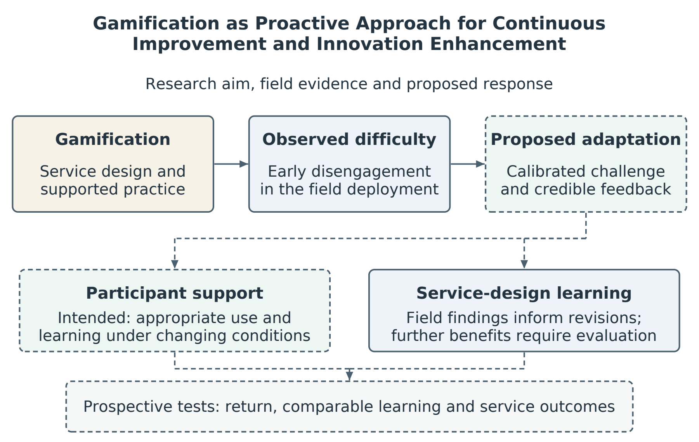
Figure 1.1. Title-aligned structure of the thesis. Observed engagement difficulty motivates a proposed adaptive design within a gamified service. Participant support and system redesign are distinct improvement targets; sustained capability, engagement and clinical benefit require their respective evaluations.

1.13 Scope, Boundaries, and What This Thesis Does Not Claim
The empirical claims are restricted to the cohorts and observation windows studied. Stage 2 involved a Southern Chinese residential-facility cohort; Stage 3 involved a Hong Kong network-recruited cohort playing remotely on their own computers. Both were Chinese-cultural in language and cultural context, and cross-cultural generalisation is not asserted. The FRA system is an established commercial assessment platform, but this thesis does not validate its diagnostic accuracy, clinical effectiveness or the clinical significance of short-term score changes. It evaluates engagement behaviour and the engineering design of the user interaction. The abandonment construct developed in Chapters 4 and 5 is not claimed to explain all non-adoption or abandonment of health technology, and "syndrome" is used there as a conceptual, non-diagnostic term. Cross-domain application to glucose monitoring, sleep tracking, cognitive screening and other systems remains a design hypothesis.
The thesis does not claim that adaptive learning is the only design lever capable of reducing failure-associated non-return. Adaptive learning is proposed because trajectory framing, mastery-oriented feedback and calibrated challenge are theoretically suited to changing how failure is interpreted. Should the field stages observe gaps between what participants endorse and what they commit to, such gaps would not by themselves identify adaptive learning as their cause; fatigue, physical capacity, access, session burden and other motivational factors would remain viable alternatives. Direct comparison of design levers and controlled evaluation of the complete adaptive-learning framework lie beyond this thesis's scope and are specified as future confirmatory work.

1.14 Structure of the Thesis
Chapter 2 reviews acceptance, gamification, continuance and learning perspectives and formalises the initial design expectation retrospectively. Chapter 3 explains the exploratory action-research design and the evidential role of each stage. Chapters 4–6 report the retrospective field signal, prospective deployment observations and between-cohort decoupling comparison. Chapter 7 translates those findings into a proposed adaptive-learning framework, specifies credible progress under changing task conditions and connects participant support to iterative service redesign. Chapter 8 evaluates the contribution alongside rival explanations and limitations. Chapter 9 answers the research questions, distinguishes achieved design learning from untested benefits, and sets out the prospective programme needed to evaluate the framework.

Chapter 2 Literature Review and Theoretical Foundation

2.1 The Transformative Logic of the Literature Review
This chapter develops the theoretical basis for using gamification proactively to support continuous improvement in an assessment service. It begins with a literature-informed expectation that acceptance-sensitive game design should encourage use, examines the limits of transferring that expectation to the present setting, and develops candidate explanations and engineering responses. The argument distinguishes what established theories predict, what the completed studies observed, and what the proposed adaptive system still requires testing.
Stages one and two develop the initial design expectation. Stage one examines the technology acceptance lineage: the Technology Acceptance Model (Davis, 1989), its extensions (TAM2, TAM3 and UTAUT), and the Senior Technology Acceptance Model (Chen & Chan, 2014). These models connect users' perceptions and circumstances with intention and use. Stage two examines gamification through Deterding et al. (2011), Chou's Octalysis Framework (2015), and the An–Cheung studies of older adults' technology adoption (An, Cheung & Willoughby, 2024; An, Cheung & Lo, 2025). These sources motivate the expectation labelled H0 in §2.3.5; they do not jointly guarantee sustained engagement or supply a retention threshold for FRA. Chapters 4 and 5 examine how this expectation fared in the studied deployments.
Stage three considers self-efficacy theory (Bandura, 1977, 1997) and research on older adults' engagement with computers and related technologies (Hawthorn, 2007; Broady, Chan & Caputi, 2010; Tsai et al., 2020). These sources identify perceived capability and anxiety as plausible influences on persistence. A favourable recorded score change need not produce a corresponding change in confidence, satisfaction or willingness to return. Self-efficacy therefore remains a competing or complementary explanation for the observed non-return, rather than a theory excluded by it.
Stage four develops an additional appraisal account. Prospect theory and loss aversion (Kahneman & Tversky, 1979), the proposed extension of endowment to identity-relevant self-concepts, mental accounting (Thaler, 1985), and stereotype threat (Steele & Aronson, 1995) are organised in Table 2.1 as distinguishable candidate mechanisms. Their integration is developed in Chapter 5, alongside the provisional descriptive construct that Chapter 4 introduces. None of these operators was directly measured in the empirical stages, and their explanatory value must be assessed against self-efficacy, satisfaction-based continuance and medical-information avoidance.
Stage five translates these possibilities into a design proposition. Participant-facing decoupling was examined as part of the Stage-3 deployment package; learning-oriented adaptation is proposed for prospective evaluation. The latter links gamification to the thesis title by making difficulty a prompt for support, review and a testable next action. Continuous improvement concerns the refinement of both the service and the participant's opportunities to learn; it does not imply that every participant's scores will rise. The chapter closes by explaining why credible feedback must distinguish changed task conditions from evidence of changed capability.

2.2 Stage One: The Technology Acceptance Lineage

2.2.1 TAM and the Two-Construct Core
Davis (1989) proposed Perceived Usefulness (PU) and Perceived Ease of Use (PEOU) as central determinants of technology acceptance. King and He (2006) reviewed the model across 88 studies, supporting its broad relevance while documenting variation across applications. TAM is useful here because it directs attention to how participants understand the value and effort of the system. It does not, however, provide a detailed event-level account of how an adverse assessment encounter changes subsequent use. This is a question of explanatory granularity, rather than evidence that acceptance models cannot address identity-relevant technologies or post-adoption behaviour. Continuance theory also addresses use after initial acceptance through satisfaction, confirmed expectations and perceived usefulness (Bhattacherjee, 2001; §2.7).

2.2.2 TAM2, TAM3 and UTAUT
Venkatesh and Davis (2000) extended TAM through social influence and cognitive instrumental processes in TAM2. Venkatesh and Bala (2008) developed TAM3, and Venkatesh, Morris, Davis and Davis (2003) integrated eight models in the Unified Theory of Acceptance and Use of Technology (UTAUT). These developments broaden the treatment of intention and use, including effort, social influence and facilitating conditions. They remain relevant to the present programme. The specific question pursued here is how an adverse assessment event may alter perceived competence, anticipated consequences and the personal meaning of continued participation; that sequence is not specified as a distinct mechanism in the models reviewed.

2.2.3 The Senior Technology Acceptance Model (STAM)
Chen and Chan (2014) developed STAM in a study of 1,012 Hong Kong Chinese adults aged 55 and above. Their model explained 68% of the variance in gerontechnology usage and highlighted the relevance of health and ability characteristics, facilitating conditions, anxiety and self-efficacy. STAM therefore supplies an age-sensitive baseline for this thesis, extending attention beyond conventional usefulness and ease-of-use beliefs. Recent mapping reviews likewise identify a broad range of factors associated with older adults' intention to adopt digital technologies (Schroeder et al., 2023). Selected STAM-related attributes inform the coding scheme in Chapter 5 and Appendix B; such coding does not reproduce or independently validate the complete STAM model.
STAM addresses usage as well as intention, so abandonment cannot be positioned as wholly outside its scope. The narrower question is whether an event-specific appraisal of an adverse assessment adds explanatory value beyond the factors STAM already identifies. Chapter 4 introduces a provisional label for the observed pattern of failure-associated non-return; the label describes the pattern and does not itself identify the process producing it. The present stages motivate an appraisal hypothesis but do not demonstrate its incremental predictive value over a fitted STAM or continuance model.

2.3 Stage Two: Gamification, Octalysis and the An–Cheung Demonstration

2.3.1 Defining Gamification
Deterding, Dixon, Khaled and Nacke (2011) defined gamification as the use of game design elements in non-game contexts. Such elements include points, levels, challenges, narratives and feedback structures. A complete game is conceptually distinct from this definition. The present intervention is therefore described more precisely as a serious game, with an embodied exercise component in the pressure-panel configuration, used within a gamified assessment service. The thesis retains gamification as the broader service-design term. Within game studies, failure can be a valued part of play (Juul, 2013); the question here is how its meaning may change when play is associated with assessment. The gameplay and measurement functions can share a sensor stream, but equivalence between game-derived COP metrics and validated clinical FRA outcomes should not be assumed without protocol-level validation.

2.3.2 The Octalysis Framework
Chou (2015) organises Octalysis around eight motivational drives: D1 Epic Meaning and Calling, D2 Development and Accomplishment, D3 Empowerment of Creativity and Feedback, D4 Ownership and Possession, D5 Social Influence and Relatedness, D6 Scarcity and Impatience, D7 Unpredictability and Curiosity, and D8 Loss and Avoidance. The framework supplies a practitioner vocabulary for the present design. Its own guidance recognises that excessive loss-based motivation can demoralise users and cause dropout, and recommends moderation and alternative drives (Beerda, 2015). The thesis therefore does not claim to discover that loss can undermine engagement. Its narrower proposition is that an assessment context may add personally consequential meanings to loss that are insufficiently addressed by manipulating in-game rewards alone. Section 2.6.2C develops non-terminal feedback as one testable response to that contextual problem.

2.3.3 An, Cheung and Willoughby (2024): Evidence for Gamified Technology Learning with Older Adults
An, Cheung and Willoughby (2024) examined a gamification approach to older adults' mobile-payment adoption and knowledge transfer in Hong Kong. Their one-group pre/post study reported gains in knowledge and adoption-related outcomes, providing a relevant example of game-informed technology learning. An, Cheung and Lo (2025) examined a related approach to mobile maps. These studies support investigating gamification with older adults, but their domains and designs do not establish that a selected set of acceptance and game-design features will sustain use in a clinical assessment service.
Two transfer questions are particularly relevant. Mobile payments and mobile maps differ from assessment in their purpose and the possible personal consequences of feedback. Their adoption findings also do not supply a benchmark for the longitudinal non-return examined in this thesis. These differences motivate study of the FRA setting; they do not establish a categorical clinical/non-clinical boundary or imply that identity concerns cannot arise in other technologies.

2.3.4 The Boundary: When the Technology is Attached to FRA
The present thesis examines what happens when the same theoretical stack is applied to older users of FRA, a clinical health technology. Two Octalysis drives may operate differently in this setting. D8 (Loss and Avoidance) usually refers to loss of in-game assets; in a diagnostic frame, an adverse event may instead be interpreted as information about personal decline. D5 (Social Influence and Relatedness) may also become double-edged if peer comparison increases age-related self-awareness. These are context-dependent propositions, not universal inversions of the framework. Whether social-comparison framing reduces engagement in this population was not isolated as a test in the present programme; it is registered as a question for the confirmatory study (§8.8).
The Stage-1 baseline survey reported in Chapter 4 supplies the corresponding population-level signature. The Stage-1 survey, reported in Chapter 4, records a pattern of prior use, adverse first experiences and subsequent non-return that motivated the boundary question; the figures were coded as having an adverse, unacceptable or unsuccessful first experience and approximately 82% reported no subsequent return. These labels require item-level reconciliation because the reproduced survey item asks whether the first result was understood and accepted rather than directly measuring task failure. The access and perceived-benefit estimates reported in the working table also require source-item and denominator verification. The pattern motivates prospective study of the first experience, but it does not by itself establish task failure, irreversible abandonment or a specific psychological mechanism. Stage two of the transformative chain therefore reaches a boundary and motivates an additional explanatory layer.

2.3.5 The Initial Design Expectation from Stages One and Two
The acceptance and gamification literatures motivate an initial design expectation: a useful, accessible and engaging FRA interaction should encourage participation and return (Davis, 1989; Chen & Chan, 2014; An, Cheung & Willoughby, 2024). The H0 notation is retained to connect this expectation with the programme's later discussion, but it denotes a qualitative working proposition formalised retrospectively, not a preregistered statistical null hypothesis. The cited sources provide neither a numerical retention threshold nor a guarantee that adverse experiences will have no effect. Consequently, an unmet expectation identifies a shortfall in this implementation and setting; it cannot by itself falsify TAM, STAM or gamification research.
H0 — The initial design expectation is that an FRA interaction informed by TAM/STAM and selected Octalysis drives will encourage acceptance and sustained participation, including willingness to retry after difficulty. Whether the implemented design meets that expectation is an empirical question for this programme.
The Stage-2 game included an acceptance-oriented entry flow, challenge calibration, coin rewards, levels, feedback and a natural control mapping, with AI assistance used in development (§5.3.9). These features document the intended design response; they do not establish that every participant experienced the corresponding usefulness, ease, competence or motivation. Stage 1 provides retrospective context, while Whether the implemented design realised that expectation is examined prospectively in Chapter 5, including cases with favourable recorded score change. The initial expectation was therefore not realised in this deployment. Implementation quality, task demands and contextual influences remain explanations requiring examination (§8.5.7); AI-assisted construction does not eliminate them.
The remainder of the chapter considers why the implemented intervention may not have sustained participation and develops alternative responses. Established acceptance and continuance explanations remain relevant, while additional appraisal accounts motivate changes to feedback, challenge and support that Chapters 5 to 7 translate into prospective engineering questions.

2.4 Stage Three: Self-Efficacy as the First Diagnostic Layer

2.4.1 Bandura's Self-Efficacy
Self-efficacy is a person's belief in their capacity to succeed at a specific task (Bandura, 1977, 1997). It is task-specific, responsive to experience and relevant to persistence under difficulty. An adverse experience can lower perceived capability and reduce willingness to continue, although its effect depends on how the person interprets the event and the support available. Self-efficacy therefore supplies an established candidate explanation for withdrawal that the present appraisal account must address.

2.4.2 Computer Self-Efficacy Among Older Adults
Computer self-efficacy, developed as a domain-specific construct by Compeau and Higgins (1995), concerns confidence in using computing technology. Research on older users highlights the importance of prior experience, support and perceived capability, while also showing why age alone is an incomplete explanation of engagement (Hawthorn, 2007; Broady, Chan & Caputi, 2010). In the present setting, difficulty may undermine confidence for some participants, but a smaller confidence reserve cannot be inferred from age or non-return alone. The relevant proposition is that perceived capability and its change after the encounter should be measured alongside recorded performance.

2.4.3 Technology Anxiety and Perceived Acceptance
Tsai et al. (2020) examined older adults' perceptions of a wearable cardiac warming system after a demonstration, using an extended technology-acceptance model. Technology anxiety was associated with perceived ease of use and perceived ubiquity in their overall sample, whereas the proposed resistance-to-change relationships were unsupported. The study makes anxiety relevant to the present design problem, but it did not follow repeated adverse encounters or everyday device use. It therefore cannot establish a temporal sequence from early difficulty to declining confidence and permanent withdrawal.

2.4.4 What Self-Efficacy Explains and What It Does Not
Self-efficacy provides a plausible mechanism for withdrawal after failure. A user who begins with limited confidence, experiences difficulty and updates their task-specific self-belief downward may be less likely to persist. Importantly, self-efficacy theory also allows recovery through mastery experience, support and successful re-engagement. It therefore does not, on its own, require an irreversible or absorbing state.
Chapter 5 examines whether recorded index change and return move together; a subgroup in which they diverge is not easily predicted from a simple capability-improves-confidence account. However, the observation is based on six F4 participants, and positive single-session score change is not equivalent to demonstrated mastery or clinical benefit. The pattern therefore motivates an additional explanatory layer; it does not by itself falsify self-efficacy theory.

2.5 Stage Four: Behavioural Science as a Candidate Account of Failure-Associated Non-Return

2.5.1 Why an Additional Appraisal Account Is Considered
The proposed appraisal account extends the questions raised by the unmet design expectation. Three features warrant investigation: the concentration of exits around adverse experiences, non-return alongside favourable recorded score change, and different engagement patterns across the clinically framed and remote gameplay deployments. None uniquely identifies a behavioural-economic mechanism, and self-efficacy remains compatible with non-return even though it allows recovery. Table 2.1 maps these observations to candidate explanations and predictions that could distinguish them in future work. The psychological operators were not directly measured; the table guides the prospective measurement programme (§3.6) rather than reporting a validated causal sequence.
Table 2.1. From the unmet design expectation to candidate mechanisms and prospective tests.
Observation motivating investigation | Behavioural theory | Construct contributed to the account | Prediction generated
An adverse first experience precedes early disengagement | Prospect theory / loss aversion (Kahneman & Tversky, 1979) | Asymmetric weighting of an adverse result against a valued reference point | Reference-dependent appraisal predicts disengagement beyond perceived competence and satisfaction (H1, Chapter 5; prospective measurement)
Non-return coexists with favourable recorded score change | Endowment effect (Thaler, 1980; Kahneman, Knetsch & Thaler, 1990) | Proposed identity-related endowment: avoidance may protect a valued self-description | Identity-related appraisal predicts return beyond recorded performance and perceived capability (H4; prospective measurement)
Engagement differs across assessment and remote gameplay contexts | Mental accounting (Thaler, 1985) | Clinical framing may assign the encounter greater personal stakes | Controlled changes to framing alter appraisals and return; the Stage-3 contrast motivates this test (H5)
Clinical and age-related cues may affect the interpretation of difficulty | Stereotype threat (Steele & Aronson, 1995; Barber, 2017) | Salience of a relevant negative age stereotype as one possible trigger | Measured stereotype activation mediates a framing effect; threat-reduced coaching is a prospective response (Chapter 7)
Abandonment persisted although the Stage-2 build had already softened in-game loss (lives, forgiving hits) | Octalysis loss-moderation guidance (Beerda, 2015); proposed non-terminal feedback (§2.6.2C) | Personally consequential appraisal may outweigh softened in-game loss; mechanism unmeasured | Non-terminal feedback adds benefit beyond decoupling or ordinary coaching; prospective component test (§8.8)

2.5.2 Prospect Theory and Loss Aversion
Kahneman and Tversky (1979) introduced prospect theory, in which outcomes are evaluated relative to reference points and losses are often weighted more heavily than equivalent gains. Tversky and Kahneman (1991) extended the framework to riskless choice. In an FRA context, an older user may compare an adverse result with a valued reference point such as continued independence or adequate balance. The thesis hypothesises that this appraisal can increase the subjective weight of failure. The participant-specific reference point and loss valuation were not measured in the present studies.

2.5.3 The Endowment Effect on Identity-Level Assets
Thaler (1980) introduced the endowment effect, and Kahneman, Knetsch and Thaler (1990) studied differences between Willingness To Accept (WTA) and Willingness To Pay (WTP) for owned goods. These experiments motivate questions about reference-dependent valuation. Their interpretation is sensitive to elicitation procedures: Plott and Zeiler (2005), for example, found no WTA–WTP gap under modified procedures designed to address participant misconceptions. The present thesis therefore avoids treating an identity-relevant preference as an established endowment effect merely because the preference is strongly held.
Applied to identity-relevant self-concepts, the endowment literature suggests a testable possibility. An older user may value a self-description such as "I remain independent" or "my balance is still good" and resist information that appears to threaten it. Exiting the technology could then function as a protective response that avoids repeated confrontation with the threatening interpretation. This extension from ownership of physical goods to identity-relevant health self-concepts is theoretically plausible but requires direct measurement. The present thesis therefore treats identity-level endowment as a candidate operator, not as an established fact about every participant.

2.5.4 Mental Accounting of Health Outcomes
Thaler (1985) introduced mental accounting. People do not pool money or other resources into a single fungible total. People sort resources into separate mental accounts, with different rules for spending and replenishment in each account. The framework was developed for consumer finance. Antonides, de Groot and van Raaij (2011) confirmed the operation of mental budgets in household finance. The thesis adapts the framework to health outcomes.
In the thesis's adapted account, a clinical frame may sort an FRA session into a health-related mental account, making an adverse result more consequential than the same gameplay event under a coordination frame. The objective-score-improvement/non-return pattern is consistent with the possibility that participants evaluated the personal meaning of the session differently from its recorded performance change. The data do not show that the body is "fungible", that an identity asset served as a guarantor, or that an account was literally closed. These terms are theoretical representations that guide the next measurement cycle.

2.5.5 Stereotype Threat as the Trigger
Steele and Aronson (1995) demonstrated that making a negatively stereotyped identity salient can affect performance on identity-relevant tasks. McGlone and Aronson (2006) examined identity salience and spatial reasoning among undergraduates, providing a general example rather than older-adult evidence. Age-related work includes Levy et al.'s (2002) longitudinal association between self-perceptions of ageing and health outcomes, and Barber's (2017) review of age-based stereotype threat. These are distinct forms of evidence. In the present framework, clinical FRA language may increase the salience of age-related decline for some users, changing how difficulty is interpreted. Stereotype threat is one possible trigger, but awareness of an adverse health result is not sufficient evidence of stereotype activation. The present studies did not measure that activation, and the Stage-3 comparison cannot separate lexical cues from other contextual differences.

2.5.6 A Four-Layer Behavioural Integration for Failure-Associated Non-Return
The four behavioural-science perspectives organise a candidate identity-related appraisal account, but they need not operate as a single obligatory sequence. Loss aversion predicts reference-dependent asymmetry; the identity-endowment extension concerns protection of a valued self-description; mental accounting predicts differential treatment of outcomes assigned to distinct accounts; and stereotype threat requires the salience of a relevant negative stereotype. These predictions overlap but are not interchangeable. The provisional descriptive label that Chapter 4 introduces for the observed non-return pattern is not a validated clinical syndrome, nor proof that these operators caused the pattern. Direct measures must establish whether any operator adds explanatory value beyond competence, satisfaction, burden and information avoidance.

2.6 Stage Five: Positioning Decoupled Gameplay and Adaptive Learning as Design Responses

2.6.1 The Question Stage Four Leaves Open
Stage four supplies a candidate mechanism but not a tested design solution. If clinical framing increases the identity relevance of failure, three broad responses follow: reduce threat cues, decouple the engagement layer from participant-facing clinical verdicts, or install a learning trajectory that gives failure a different reference point. The first two are partly represented in the Stage-3 decoupling package. The third is developed as the adaptive-learning framework. The key distinction is evidential: Stage 3 evaluates participant-facing decoupling in a separate cohort, whereas the complete adaptive-learning framework remains to be evaluated prospectively.

2.6.2 Productive Failure and Adaptive Learning
Kapur's (2008) productive-failure approach concerns an instructional sequence in which initially unsuccessful problem solving is followed by support and consolidation that can improve subsequent learning. This thesis borrows the proposition that an unsuccessful attempt can become useful information when followed by an appropriate learning opportunity; it does not claim to reproduce that instructional intervention. Adaptive learning can adjust challenge, feedback and pacing, but easier practice or improved immediate performance does not establish durable learning. Retention and transfer require separate evaluation (Soderstrom & Bjork, 2015). A trajectory display is therefore proposed as a means of communicating evidence and next steps, rather than guaranteeing a rising curve.

2.6.2A The Theoretical Lineage of Adaptive Learning
The adaptive-learning framework draws on four established traditions. Flow theory relates engagement to the relation between challenge and skill (Csikszentmihalyi, 1990). The Stage-2 difficulty system's 80 per cent and 40 per cent success thresholds (§5.3.5) are engineering heuristics inspired by that relation, not thresholds derived from or validated as measures of flow. The zone of proximal development highlights the distinction between unaided capability and performance made possible by support (Vygotsky, 1978). Desirable difficulty shows why some practice conditions that depress immediate performance can support later learning, subject to the learner and task (Bjork & Bjork, 2011). Intelligent tutoring research provides evidence for the value of detailed feedback and adaptive instruction in the domains studied (VanLehn, 2011). Together these traditions justify investigating calibrated support and feedback, while leaving their effectiveness in gamified FRA to be established.
These traditions also expose the measurement problem at the centre of an adaptive system. When difficulty or assistance changes, a higher score may reflect changed conditions rather than improved capability; a lower score on a harder task may coexist with progress. The proposed framework therefore separates adaptive practice from periodic, comparable checks under a specified reference condition and from delayed retention or transfer checks (Soderstrom & Bjork, 2015). Displays should identify the task version, difficulty and assistance associated with each result. If comparability is lost after a design change, a new phase should be shown rather than silently continuing a single improvement curve. This is a prospective engineering requirement developed in Chapter 7, not a retrospective validation of the current scores or a claim that the Stage-3 comparison tested adaptive learning.

2.6.2B Self-Determination Theory and Goal-Setting as Motivational Scaffolding
Self-determination theory identifies competence and autonomy as important motivational needs (Deci & Ryan, 1985; Ryan & Deci, 2000). In the proposed framework, truthful feedback and meaningful choices are intended to support these needs; the effect depends on participants' interpretation rather than the designer's label. Goal-setting theory supports specific goals with appropriate commitment and feedback (Locke & Latham, 2002), while distinctions between mastery and performance goals help clarify whether an attempt is understood as learning or demonstration of adequacy (Elliot & Murayama, 2008). When innovation encounters difficulty, an attainable next action may involve additional practice, reduced assistance, a changed strategy, maintained capability or a revised service design. None requires presenting decline as improvement. Motivation-crowding research further cautions that poorly designed rewards can displace intrinsic motives (Frey & Jegen, 2001). The learn-to-earn proposition consequently recognises evidenced effort and progress while preserving accurate feedback. These literatures support candidate responses to the deployment problem; they do not establish that adaptive learning uniquely resolves it.

2.6.2C Zero-Failure Design: Non-Terminal Feedback as a Testable Component
Zero-failure design is the thesis's term for a proposed interaction policy in which ordinary game errors do not produce a terminal failure verdict. A collision can trigger feedback, support or a change in challenge, while the user retains the option to pause or stop. This is an observation-informed component of the wider adaptive-learning framework, rather than a claim to have invented non-terminal games. The term concerns presentation: it does not mean that errors disappear, that every attempt succeeds, or that safety-related stopping conditions are removed. The intended contribution is to specify how recoverable difficulty and truthful feedback could support continued participation in this assessment context.
This policy is compatible with Octalysis guidance that excessive loss-based motivation can produce demoralisation and exit (Beerda, 2015), rather than an inversion of a universal instruction to amplify loss. The clinically relevant hypothesis is that anticipated personal or assessment consequences may outweigh the in-game resources a designer controls. Non-terminal presentation might reduce one source of evaluative pressure, but it may have little effect if a participant is responding to discomfort, burden or unwanted consequences. Its incremental value should therefore be compared with ordinary coaching and other forms of support.
The Stage-2 design softened in-game loss through lives and forgiving hit responses while retaining a conventional terminal Game Over (Table 5.0). Section 5.3.10 sets out a more extensive repertoire of recovery, mastery, narrative and reframe states. In this theoretical account, that repertoire is treated as a candidate policy whose full behavioural effectiveness remains untested. The Stage-3 comparison changed several aspects of delivery and context, so it does not identify the separate effect of removing terminal verdicts. Chapter 7 incorporates non-terminal feedback into the proposed framework, and §8.8 outlines its prospective evaluation.

2.6.3 Endowment-Protective and Learning-Trajectory Appraisals as Competing Regimes
The thesis proposes that protective and learning-oriented appraisals may compete or coexist when an adverse event occurs. A participant may compare the result with a valued self-description, with prior performance, or with an intended next step. The engineering objective is to make the latter comparison credible without dismissing the first concern. Credibility requires showing what changed in the task and what, if anything, changed under comparable conditions. A plateau can motivate maintenance or further investigation; a decline can prompt a review of support or goals. The display should therefore communicate evidence, uncertainty and an actionable response, rather than promise that a positive slope will always be available. The WTA–WTP implications remain hypotheses for direct elicitation.

2.6.4 Why Decoupled Gameplay Is a Critical but Non-Definitive Empirical Test
Stage 3 retained the skiing mechanic, session structure and five-attempt rule in an HTML port of the game, but not the pressure-panel apparatus or the supervised setting: the build was distributed by e-mail and played on participants' own computers with a trackpad, arrow keys or, where available, a foot-pad sensor, while the package of participant-facing clinical cues was changed and a separate Hong Kong network cohort was recruited. It is therefore a between-cohort quasi-experimental decoupling comparison, not a single-variable experiment. Whether post-failure return differs when the same mechanics are decoupled from the clinical attachment is reported in Chapter 6. A difference in that direction would support the proposition that framing or related contextual features moderate post-failure return, but it does not isolate the effect of framing from all differences in cohort, setting, platform, input device, supervision, recruitment, prior exposure, staff interaction or observation window. Nor does it directly test the complete adaptive-learning framework.
The five-stage chain therefore closes as an engineering argument, rather than a definitive causal test. Acceptance, continuance and gamification research identify factors relevant to participation. Self-efficacy and behavioural-science accounts suggest processes that may contribute to non-return. The separate Stage-3 deployment provides a contrasting engagement pattern consistent with several contextual explanations. The proposed adaptive-learning framework converts these observations into a prospective improvement cycle: recognise difficulty, select a justified change, preserve evidence of the conditions under which performance was measured, and evaluate the result. This domain-specific integration links the thesis's gamification focus to continuous improvement and innovation enhancement while preserving the distinction between observed outcomes and intended benefits.

2.7 Supporting Evidence and Adjacent Frameworks

2.7.1 Gamification for Older Adults: The Koivisto and Malik Review
Koivisto and Malik's (2021) systematic review identifies an emerging evidence base for gamification with older adults, with variation in design, theoretical grounding and evaluation. Sustained use is a relevant concern alongside short-term engagement, and Eysenbach's (2005) account of nonusage attrition provides a complementary basis for treating discontinuance as an outcome requiring explanation. The present programme contributes a detailed local deployment account and a comparison across differing delivery contexts. Its integrated theoretical framework is intended to guide further evaluation; the completeness and strength of each empirical inference are assessed in the relevant methods and results chapters.
Altmeyer, Lessel and Krüger (2018) examined gamification with older users, reinforcing the importance of understanding the target population rather than assuming that preferences transfer unchanged from younger groups. Such evidence supports context-sensitive design, while leaving open which combination of challenge, support and framing is appropriate for the present clinical assessment service.

2.7.2 The NASSS Framework: A Complementary Multilevel Account
Greenhalgh et al. (2017) developed the Non-Adoption, Abandonment, Scale-up, Spread and Sustainability (NASSS) framework to explain difficulties across interacting domains: condition, technology, value proposition, adopter system, organisation, wider context, and embedding over time. This multilevel account directs attention to demands, roles and circumstances that can shape continued use. The human-computer-interaction literature likewise treats non-use as meaningful behaviour (Satchell & Dourish, 2009). The present thesis proposes a narrower, provisional appraisal pathway within this broader setting. It complements NASSS by specifying an event-level design question, while recognising that a response confined to the interface may be insufficient when organisational or practical conditions account for non-return.

2.7.3 Cross-Cultural Reference: The Korean Comparison
Park et al. (2019) and Kim et al. (2018) provide measurement-related reference points for the FRA platform in Korea. Their validation and reliability findings should not be interpreted as evidence of sustained engagement, which is a different outcome. Neither provides an engagement benchmark used in this thesis. Whether other implementations use different support, framing or coaching remains an open question for comparative fieldwork.

2.7.4 Information Entropy as a Bridge Lens
Shannon entropy (Shannon, 1948) is used here as a bridge metaphor and future measurement proposal, not as a quantity estimated from the present data. Before a first session, a user's beliefs about what the technology means may be uncertain. A salient adverse event could reduce that uncertainty by producing a more definite negative interpretation. The current data do not measure a belief distribution before and after failure, so they cannot establish an entropy collapse at the moment of failure or distinguish individual learning from community narrative effects. Section 3.6 therefore specifies repeated belief elicitation as the instrumentation required to convert the metaphor into a testable information-theoretic claim.
Expectation-confirmation theory explains continuance through satisfaction and perceived usefulness, with confirmation shaping those evaluations (Bhattacherjee, 2001). A person can regard an assessment as useful yet remain dissatisfied with the experience; value-affirming non-use therefore does not refute that model. Medical-information avoidance is an equally close comparator. Howell and Shepperd (2012) found that self-affirmation reduced avoidance of medical risk feedback, including when feedback could imply unwanted action. Their experiments show that self-related concerns and anticipated consequences can affect willingness to receive useful health information, and suggest responses beyond adaptive learning. The present contribution is narrower: a contextual account of non-return following gamified assessment and an engineering response designed around that encounter. Any explanatory increment requires testing whether the proposed appraisals predict return beyond satisfaction, perceived capability, burden, usefulness and consequence avoidance.

2.8 Synthesis: The Five-Stage Transformative Argument
The chapter's argument has five steps. First, acceptance and gamification research motivate an expectation that an accessible, engaging assessment interaction can support continued use. Second, the Stage-2 deployment did not realise that expectation, prompting examination of the conditions surrounding disengagement. Third, self-efficacy, satisfaction-based continuance and information avoidance remain plausible explanations for the divergence between recorded performance and return. Fourth, the behavioural perspectives in Table 2.1 organise additional, testable appraisal hypotheses. Fifth, those hypotheses and the contrasting Stage-3 experience motivate a domain-specific adaptive-learning framework: calibrated practice, non-terminal feedback, appropriate contextual framing, and credible evidence of change. Adaptive learning is inherited from established traditions; the proposed contribution is its integration into a proactive improvement process for this service. Chapter 7 specifies that process, including how to evaluate progress when challenge or design changes. Its effects on sustained appropriate use, learning and clinical outcomes require prospective evaluation.
No single stage establishes the complete argument. The completed programme contributes an informative deployment shortfall, a contrasting pattern of engagement in a separate setting, and a specification of how design could respond to difficulty. Its innovation contribution lies in the resulting contextual design knowledge and testable system requirements. Continuous improvement is demonstrated at the level of problem understanding and iterative design development; sustained gains in participant capability or service performance remain intended outcomes. The theoretical mechanisms and the framework's effectiveness are consequently stated as propositions that direct measurement and appropriately controlled comparisons can challenge.

Two tables condense this synthesis. Table 2.2 states, for each stage of the review, what the literature establishes, the question it leaves open, and where the research programme takes that question up. Table 2.3 then reverses the direction of reading: it lists each empirical activity of the programme and traces it back to the literature stage it tests. Together they are the analytical map of this chapter; the prose above supplies the argument behind each row.

Table 2.2. The five-stage literature journey: what each stage establishes, the question it leaves open, and where the programme takes it up.
Literature stage | Core sources | What it establishes | The question it leaves open | Where the programme takes it up
One — Technology acceptance lineage | Davis (1989); TAM2/TAM3/UTAUT; Chen & Chan (2014) | Users' perceptions, capabilities and circumstances help explain intention and use; STAM includes usage | Whether event-specific appraisal adds explanatory value after an adverse assessment encounter | Initial design expectation H0 (§2.3.5); Stage-1 constructs (Chapter 4)
Two — Gamification and Octalysis | Deterding et al. (2011); Chou (2015); An, Cheung & Willoughby (2024); An, Cheung & Lo (2025) | Selected studies support gains in knowledge and adoption intention; Octalysis supplies design guidance | How these findings transfer to sustained use in a clinically framed FRA service (§2.3.4) | Initial design expectation H0; intended Stage-2 design features (Chapter 5)
Three — Self-efficacy | Bandura (1977, 1997); Hawthorn (2007); Broady, Chan & Caputi (2010); Tsai et al. (2020) | Perceived capability and anxiety can affect engagement; score change need not equal mastery | Whether perceived capability explains non-return alongside favourable recorded score change (§2.4.4) | First diagnostic layer for reading the engagement data (Chapters 5–6)
Four — Behavioural science | Kahneman & Tversky (1979); Thaler (1985); Steele & Aronson (1995) | Distinct candidate operators concerning reference points, valuation, account assignment and stereotype salience | Whether these operators add explanation beyond competence, satisfaction and information avoidance | The candidate account of failure-associated non-return (Table 2.1); developed further in Chapter 5
Five — Design responses | Kapur (2008); learning traditions (§2.6.2A); SDT and goal-setting (§2.6.2B); non-terminal feedback (§2.6.2C) | Structured support, calibrated practice and feedback motivate testable responses to difficulty | Whether these responses support sustained appropriate use and credible learning under changing task conditions | Stage-3 contextual comparison (Chapter 6); adaptive-learning framework and comparable progress checks (Chapter 7); prospective test (§8.8)
Supporting evidence and adjacent frameworks | Koivisto & Malik (2021); Greenhalgh et al. (2017); Bhattacherjee (2001); Howell & Shepperd (2012); Shannon (1948) | Older-adult intervention evidence; multilevel abandonment, continuance and information-avoidance accounts; a metaphor for future measurement | How event-level appraisals and service conditions jointly shape this assessment encounter | Competing and complementary explanations; prospective measurement (Chapters 7–8)

Table 2.3. From literature to research design: each empirical activity read against the literature stage it tests. Chapter pointers only; findings are reported in the chapters named.
Research activity | Question carried from the literature | What is instrumented | Literature stage it informs
Stage 1 — retrospective survey (Chapter 4) | How do prior FRA users describe first experiences and subsequent return? | Prior use, adverse-experience recall and reported return behaviour | Stages one–two; context for the initial expectation H0
Stage 2 — gamified FRA deployment (Chapter 5) | Does the implemented acceptance-informed, game-based FRA sustain participation at the assessment site? | Session telemetry, recorded performance, satisfaction and self-report | Stages one–two; stage three offers a competing explanation
Stage 3 — participant-facing decoupling (Chapter 6) | How does engagement differ in the separate remote gameplay context, and which explanations merit controlled testing? | Post-failure return, endorsement and stated intention in a separate cohort | Stages four–five; contextual evidence motivating appraisal and design hypotheses
Adaptive-learning framework and prospective test (Chapter 7; §8.8) | Can calibrated practice and credible feedback support learning and return when difficulty or design changes? | Proposed framework, comparable reference checks and prospective evaluation protocol | Stage five's design propositions; their effects are not established by the completed stages
Figure 2.1 renders the synthesis of this chapter graphically as the author's five-part literature-to-design framework. Parts 1 and 2 state the initial design expectation drawn from technology-acceptance and gamification theory - the origin of H0, formalised retrospectively (§2.3.5). Parts 3 and 4 assemble the competing and complementary explanations that field difficulty brought under examination: self-efficacy on one side, and the behavioural-appraisal candidates - loss aversion, identity-related endowment, mental accounting, stereotype threat - on the other, considered alongside continuance and information avoidance. Part 5 states the design response they inform. The lower band connects the five parts to the three empirical stages and the proposed response, and carries the two caveats this architecture keeps in view throughout: Stage 3 changed cohort, input and context together, so framing effects were not isolated; and credible improvement claims require comparable observations, disclosed task changes and separate reporting of incompatible phases. The figure states structure and argumentative connection only - arrows are not causal claims, and stage outcomes are reported in Chapters 4 to 6.
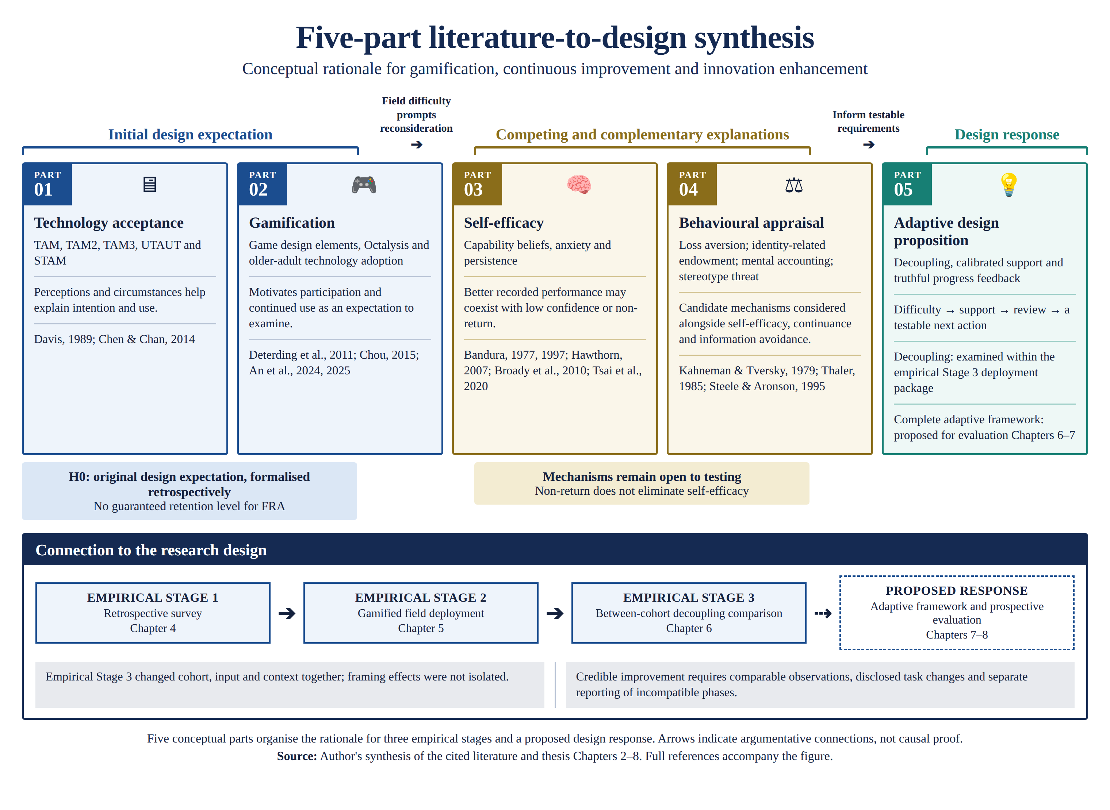
Figure 2.1. The five-part literature-to-design synthesis: conceptual rationale for gamification, continuous improvement and innovation enhancement. Five conceptual parts organise the rationale for the three empirical stages and the proposed design response; arrows indicate argumentative connections, not causal proof. Source: author's synthesis of the cited literature (Chapters 2-8).

Chapter 3 Research Methodology

3.1 Action Research as the Methodological Frame
The programme adopts action research (Lewin, 1946; Stringer, 2014; Reason & Bradbury, 2008), using cycles of action, observation, reflection and design revision to investigate an engineering problem. The initial design expectation, labelled H0 in §2.3.5, was that a gamified FRA informed by technology-acceptance and gamification principles would support sustained engagement. Its formal wording was reconstructed during analysis and writing; it is a working proposition rather than a preregistered statistical null. The field stages examined that expectation and generated further propositions concerning the provisional FIAS construct (introduced at §4.6), participant-facing clinical framing and adaptive learning. Action research provides a structure for documenting these revisions, but does not confer causal confirmation on explanations generated from them. The methodological connection to the thesis title is substantive: continuous improvement operates through the researcher's iterative inquiry and the user's proposed learning process, while innovation enhancement concerns the revision and evaluation of the intervention when the initial design encounters difficulty. The documented changes were from FIDS toward the provisional FIAS construct after Stages 1 and 2; toward a frame-sensitive account after Stage 3; and from decoupling alone toward an adaptive-learning design framework. These are revisions of working explanations and engineering requirements. The programme is therefore offered as exploratory engineering research whose contribution combines a situated empirical problem, bounded explanatory propositions and a design framework for prospective evaluation. An unsuccessful implementation can inform an improved design decision, but that learning must be distinguished from evidence that either users' capabilities or the revised intervention's effectiveness have improved.

3.2 Three-Stage Design
Stage 1 was a descriptive, retrospective survey at the Poly Group facility in Guangzhou: a six-item Yes/No instrument administered face-to-face by nursing staff. Its methodological role in the architecture is to establish the field signal — a setting with substantial practical support for access, yet a reported pattern of adverse first experiences and non-return — that motivates prospective examination of the original design expectation (Chapter 4). The facility housed 280 residents at the time of the survey; 200 eligible residents were interviewed about their FRA experience, and all Stage-1 percentages are computed on the interviewed sample of 200.
Stage 2 was a prospective eight-week action-research deployment with thirty residents at the same facility. The intervention was a dual-purpose AI-assisted skiing game on the InBody pressure panel, engineered to satisfy the acceptance and gamification design criteria of Chapter 2, allowing the original design expectation to be examined during deployment (§5.2), without establishing that every participant perceived the intended benefits or ease of use. Its analytical outputs are the engagement, failure and non-return characterisation of §5.5, analysed with estimators appropriate to a small single-site sample — Wilson intervals, paired and exact tests — because the archived dataset preserves no timestamps and therefore supports no time-to-event modelling. The study was not designed as a clinical validation of FRA or as a randomised test of the behavioural-economic mechanism. Across all three stages, a qualitative requirements mapping informed by Quality Function Deployment (QFD; Akao, 1990; Chan & Wu, 2002) translates empirical findings into proposed design requirements: needs interpreted from survey, behavioural and self-report findings are related to candidate game features (§5.5A). The mapping records the researcher's design rationale rather than measured feature effectiveness or quantitatively validated priorities. It structures the translation from evidence to design; it complements, and does not replace, the statistical analysis of the collected data.
Stage 3 was a between-cycle, between-cohort quasi-experimental field study with 120 adults aged 25-80 recruited through the author's Hong Kong-based networks (family and personal contacts, work contacts, a charity community network, university support channels and working peers in medical centres). The game was ported to an HTML build, distributed by e-mail, and played unsupervised on participants' own computers, with a trackpad or arrow keys, or a foot-pad sensor where one was available. The skiing mechanic, five-attempt rule and session structure were retained in the port, while participant-facing clinical framing was changed through multiple coordinated components: recruitment language, the absence of any pre-session clinical scan, removal of clinical labels and participant-facing clinical outputs, and a coordination-game interface. Because cohort, setting, platform, input device and supervision also differed, Stage 3 estimates the combined association of the decoupled condition and its context with behaviour; it evaluates a participant-facing redesign package in a separate cohort, and it does not isolate a single causal variable. Its methodological role rests on two rival readings of the Stage-2 outcome: a dispositional reading (gamification demonstrations do not transfer to this older population) and a frame-sensitive reading (the attachment to the clinical technology carried the difficulty). The two readings generate opposite directional expectations for a decoupled deployment, which Stage 3 can examine but not decisively separate, given the between-cohort design (§6.1). The three age bands (25-44, 45-64, 65-80) permit exploratory within-cohort comparisons, including H0-age, the equal-proportions null examined after age-stratified tabulation. Age-stratified dropout and return patterns are reported in Chapter 6. Because every age band received the decoupled condition, this gradient identifies an age association within that implementation; it cannot estimate either a clinical-framing effect or an age-by-framing interaction. Identity-related appraisal, motor demands, familiarity, interest and fatigue remain possible explanations for the gradient.
A fourth evidence activity supplements the three stages: a series of four expert consultations (one of which, in its September 2026 follow-up, included a contribution from the expert's doctoral researcher), conducted from March to September 2026 as a distinct data-collection exercise to examine emerging interpretations and design requirements against senior practice and research standpoints. The consultations were semi-structured interviews with: a senior physiotherapist and former chair of a Hong Kong professional physiotherapy body, pseudonymised as Expert P at his election (March 2026, telephone, approximately 25 minutes, Cantonese mixed with English; with a dated follow-up on 5 August 2026 in which he played the decoupled build); Dr Gary Kui-Kai Lau, Assistant Dean (Education Innovations) and Clinical Associate Professor, Division of Neurology, LKS Faculty of Medicine, The University of Hong Kong (June 2026, in person, approximately one hour, Cantonese mixed with English); Dr Sarah C.W. Yuan, Specialist, Center on the Family, University of Hawai'i at Manoa, a medical sociologist and demographer of aging (25 July 2026, telephone, English, approximately 35 minutes); and Dr Philip Choy, certified naturopathic physician (ANMCB) and President of the Hong Kong Academy of Naturopath, with over twenty-five years of clinical practice concentrated in elderly chronic disease (4 August 2026, telephone, approximately 30 minutes, Cantonese and English). Each expert gave written consent on a nine-statement form with an explicit identification election: three authorised named attribution and one elected pseudonymity; where an interview preceded its signed form, the record states both dates plainly. The researcher's notes are the primary records; each consultation summary is returned to its participant for validation (member checking). Analysis is thematic: expert statements are mapped onto the programme's constructs and reported as convergence, divergence or silence (Appendix H; discussed in Chapter 8). Positioning: expert input provides interpretive consultation and design appraisal of the Chapter 7 framework. It contributes practice-based perspectives and rival explanations, but is neither independent replication of the participant findings nor evidence for the hypothesis tests.
Table 3.1. The hypothesis architecture of the programme: where each claim originates, is stated, is tested, and stands.
Claim | Origin | Stated | Tested / examined | Status in this thesis
H0 — original expectation that a gamified FRA designed around acceptance and gamification principles would support continued engagement | Literature-informed design expectation; wording formalised during analysis and writing | §2.3.5; §5.1 | Stage 1 motivates the problem (Ch 4); Stage 2 examines engagement in deployment (Ch 5) | Original expectation not supported in this deployment; no prespecified statistical null or theory-wide rejection
H1, H2 and H4 — working propositions on early disengagement, re-engagement and the recorded-score–engagement discrepancy | Stage-1 observations; formal wording fixed during thesis preparation | §5.1 | Stage 2 (Ch 5) | Engagement, return and score-change co-occurrences described in a small single-site sample; mechanisms remain untested
H5 and the Stage-3 predictions — decoupling is associated with lower non-return and post-failure return | Stage-2 findings (mental-accounting row of Table 2.1) | §5.1; §6.2 | Stage 3 (Ch 6) | Observed direction consistent with a frame-sensitive account; causal attribution not isolated
Adaptive-learning proposition — calibrated challenge and truthful progress feedback as a proposed support for continued participation and improvement | Design hypothesis developed from the field observations, retention–intention discrepancy and relevant theory | §6.8; Chapter 7 | Complete framework not yet evaluated; specified components reserved for prospective testing | Proposed engineering contribution; component effects, credible progress and clinical reattachment require distinct evaluation
H0-age — equal initial-dropout proportions across age groups within the decoupled implementation | Three-band Stage-3 design; exploratory analysis after age-stratified tabulation | §3.2; §6.2 | Stage 3 (Ch 6): age-stratified engagement | Exploratory evidence against equal initial-dropout proportions across age bands; age-stratified results reported in §6.5; no age-by-framing effect estimated

3.3 Methodology Overview Infographic
Figure 3.1 summarises the empirical stages and the revisions they motivated. It is an action-research logic model rather than a single causal experiment. In the architecture of Table 3.1, Stage 1 establishes the retrospective field signal; Stage 2 examines the original design expectation in deployment and generates candidate explanations; Stage 3 provides a non-equivalent-cohort decoupling comparison; and Chapter 7 formalises the proposed adaptive-learning response for prospective evaluation. Each transition changes what the next iteration needs to investigate, without treating a design revision as proof of improved outcomes.
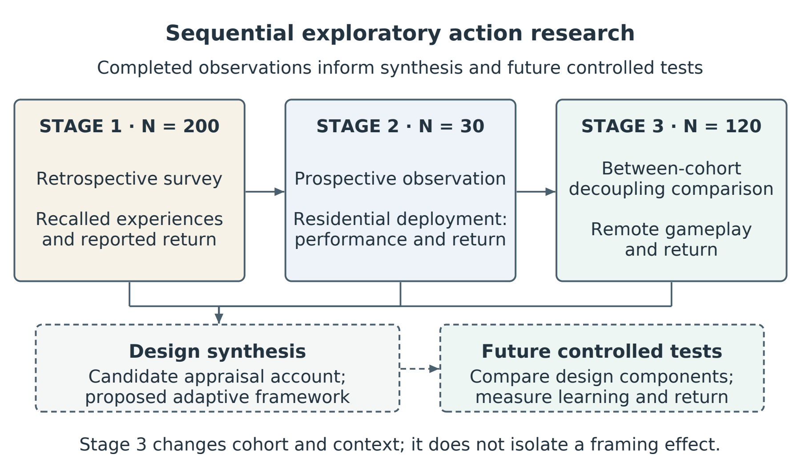
Figure 3.1. Three-stage action-research logic model: Stage 1 supplies the retrospective field signal, Stage 2 examines the original design expectation in deployment, and Stage 3 provides a non-equivalent-cohort decoupling comparison. The stages inform the adaptive-learning framework of Chapter 7 and the prospective studies of §8.8; they do not constitute a single causal test.
Activity | Period | Reported in
Site observation and the FIDS conjecture | 2023 | Chapter 1
Stage 1 — retrospective survey (N=200 of 280) | July–August 2024 | Chapter 4
Game design and platform validation | 2023–2024 | Chapter 5, Appendix G.8
Stage 2 — eight-week facility deployment (N=30) | June–August 2025 (eight weeks) | Chapter 5
Stage 3 — remote decoupled deployment (register N=120) | March–April 2026 | Chapter 6
Expert consultation panel (four consultations + follow-ups) | March–September 2026 | §6.12, Appendix H
Ethics approval HSEARS20260805008 | 6 August 2026 (approval period 16 Jun 2024 – 30 Oct 2026) | §3.4
Stage 3B — pre-registered 2x2 field experiment | August–October 2026 (planned window) | §8.8
Programme close and thesis completion | October 2026 | Chapter 9
Table 3.1A. Programme timeline: evidence activities in calendar order, July 2024 – October 2026, with the chapter that reports each. The research programme closes in October 2026.

3.4 Ethics, Consent, Data Governance
Each stage was conducted under the ethics policy of The Hong Kong Polytechnic University and in accordance with the Declaration of Helsinki. Compliance with the Personal Information Protection Law (PIPL; Standing Committee of the National People's Congress, 2021) was maintained throughout: all data were pseudonymised at collection, and no participant identifiers were transmitted to third-party AI services. Stage 3 did not collect participant-level clinical balance telemetry as part of the decoupling protocol. No adverse events were reported during any stage. The programme was approved by the PolyU Human Subjects Ethics Sub-Committee (application reference HSEARS20260805008; Principal Investigator: Prof. Chi Fai Cheung, Department of Industrial and Systems Engineering; approved 6 August 2026 by the Departmental Research Committee of the Department of Industrial and Systems Engineering on behalf of the PolyU Institutional Review Board, for the approval period 16 June 2024 to 30 October 2026 - a period that covers all of the programme's fieldwork, including the planned Stage 3B window; the approval memo is archived in the ethics record); the application described the procedures of all three stages and the expert consultations as conducted, and the approval memo is held with the programme records. Chapter 8 (§8.7) addresses vulnerability, disclosure, autonomy and the ethical boundary between participant-facing reframing and deception. The expert consultation reported at §6.8A was conducted with a professional in her professional capacity; she is named with her consent, and the written confirmation is held with the consultation record (Appendix H). The chronology is stated plainly: the application was submitted on 6 August 2026, after the field stages had been conducted, and the approval was granted retrospectively, covering the procedures as conducted and described in this section.
Consent in Stage 2 is likewise stated exactly as it operated. The deployment was arranged with, and known to, the facility's operators, nursing team and general manager (gatekeeper consent, recorded at research start), and residents were invited by the facility to try the gamified system as a facility activity, voluntarily and free of charge. Participants were not told during the deployment that play formed part of a research project: the programme's subject matter is assessment fear, and announcing a fall-risk study would have re-imposed the clinical assessment frame whose behavioural effect was under study, so incomplete disclosure was integral to the design rather than incidental to it. Written consent was obtained retrospectively from the sustained participants at the close of the eight-week cycle, at the small recognition presentation for those who completed it; participants who had dropped out did not sign and were not interviewed. These arrangements - the incomplete disclosure and its rationale, the gatekeeper consent, and the retrospective timing of the written instruments - were stated in these terms in the approved ethics application, and their limitations are examined in 8.7.
The provenance of the low-engagement participants' self-report data is stated precisely, because those participants did not sign research consent and were not interviewed by the researcher. All thirty participants were residents of the facility who knew the FRA as part of the house's provision; they joined the gamified sessions at the centre manager's invitation, facilitated by therapists they knew well. The invitation had been extended by the facility to the 200 residents who had taken part in the Stage-1 screening survey; thirty joined. Throughout the eight weeks the therapists spoke with players in the course of ordinary facility practice and reported their observations - including perceived symptom change - to the researcher, who visited or telephoned the facility on a near-daily basis and recorded those reports in field notes. The therapists kept no written per-participant records; the individual attribution of satisfaction and symptom entries in the Stage-2 dataset was therefore performed by the researcher when compiling the field notes. The reconciliation with Appendix C's after-game questionnaire is documented by the deployment logbook's own column provenance (Stage-2 ID register, received 11 September 2026): the satisfaction ratings were collected by the after-game paper questionnaire completed by players, while the presenting symptoms and the symptom-improvement entries are therapist observations relayed to and compiled by the researcher. The satisfaction variable is therefore participant-reported and the symptom variables therapist-observed; the two earlier accounts were each accurate for its own variable. The satisfaction and symptom variables are accordingly therapist-mediated, researcher-compiled observational data, gathered under the facility's routine care relationship and the gatekeeper arrangement described above - not responses to a self-administered research instrument - and §5.5 carries the corresponding measurement caution.
Consent in the Stage-3 remote deployment operated by informed, implied consent, and the thesis states the procedure exactly as it was. The distribution e-mails explained the purpose of the game and of the accompanying questionnaire and the use that would be made of replies; participation was voluntary and unpaid, and recipients could decline by simply not taking part; returning the game's results file and the questionnaire responses constituted consent to their use in the research. No written consent instrument was administered in Stage 3, and this is acknowledged as a limitation of the remote design. Identities were separated from the analysed records at compilation: the analysis sheets retain only a participant code, age band, gender and education, and the distribution and return e-mails are retained in the author's records, with a de-identified index forming Appendix G, item G.5.

3.5 Methodological Limits and Mitigations
The programme uses a between-cycle, between-cohort comparison across Stages 2 and 3. A within-subject crossover was not selected because prior exposure and failure memory could produce carry-over and order effects, and because repeating a clinically framed task after an adverse experience could create ethical and interpretive complications. These are legitimate design considerations, but they do not make a between-cohort comparison methodologically equivalent to randomisation. The chosen design leaves unmeasured cohort, setting, recruitment and observation-window differences as alternative explanations.
Mitigation is therefore based on transparency, comparison with the closest available age band, explicit alternative explanations, confidence intervals and a pre-specified next study rather than on claiming that theoretical convergence substitutes for causal control. The three stages provide convergent evidence: Stage 1 identifies a retrospective problem signature; Stage 2 links first failure to observed dropout and documents the score-improvement/non-return pattern; Stage 3's post-failure return results are reported in Chapter 6 and read against the Stage-2 pattern there in a separate cohort. Mental accounting, identity-level endowment and stereotype threat remain inferred candidate mechanisms. A within-cohort randomised coupled-versus-decoupled study with harmonised measures and observation windows would test the causal effect of that specified intervention contrast; direct appraisal measures would also be needed to evaluate the proposed psychological pathways.
The hypothesis architecture of Table 3.1 separates original design expectations, exploratory findings and prospective tests. H0 expresses the expectation that governed the Stage-2 design, but the absence of a prespecified numerical benchmark or a contemporaneous counterfactual prevents it from functioning as a conventional statistical null for improved acceptance. The directional propositions developed through the action-research cycles. Adaptive learning was proposed after considering the Stage-3 retention–intention discrepancy alongside the earlier field observations and relevant theory. It is a candidate engineering response, whose comparative effectiveness and mechanisms require the prospective evaluation specified in §8.8.
The chronological provenance of each hypothesis is recorded explicitly, so that prospective tests and action-research discoveries cannot be conflated. H0 is a retrospectively formalised design expectation: the expectation it expresses governed the Stage-2 design ex ante — the build criteria of §5.2 document this — but its formal wording was written during analysis and writing and was not deposited in advance. H1, H2 and H4 originate in the Stage-1 survey and site observations and were held as working hypotheses before the Stage-2 deployment; their wording as printed in §5.1 was likewise fixed at writing. H5 and the Stage-3 predictions of §6.2 were formulated after the Stage-2 analysis and before Stage-3 recruitment, and are the closest the programme comes to stated-in-advance predictions. H0-age was licensed by the Stage-3 cohort design — three age bands recruited as built-in comparison groups — and was examined once the age-stratified data were tabulated. The adaptive-learning proposition was formed after the Stage-3 retention–intention discrepancy was observed and is presented as a design hypothesis. The component study in §8.8 can test its specified adaptation and feedback components, while the complete framework and the causal framing account require their own evaluations. No hypothesis in the completed Stages 1–3 was publicly preregistered; the distinction between the original expectations and their later formalisation therefore remains explicit. Prospective tests should fix their hypotheses, outcomes and analysis decisions before the relevant data are examined.

3.6 An Instrumentation Roadmap for the Adaptive-Learning Claim
This section converts the programme's discovery into a confirmable claim. The adaptive-learning proposition of §6.8 and Chapter 7 rests on the hypothesis that learning-trajectory appraisal can reduce the dominance of an endowment-protective interpretation of failure. The present stages motivate this hypothesis through behavioural patterns; they do not measure the proposed mechanism or test the complete adaptive-learning framework. The instrumentation roadmap therefore converts each inferred operator into a measured variable and specifies evidence that would challenge the account. It must also distinguish performance change from changes in task demand, assistance or software configuration. A more favourable score following an easier task cannot, by itself, substantiate continuous improvement. The prospective framework requires comparable reference observations, separate records of challenge and support, and explicit evaluation of each substantive design revision; Chapter 7 specifies how these records can support truthful progress feedback when difficulty or the intervention itself changes.
The first move measures identity-relevant valuation directly through an adapted WTA-WTP elicitation in the tradition of experimental preference measurement (Kahneman et al., 1990; Holt & Laury, 2002), or an alternative validated appraisal task, developed and piloted carefully because extending commodity-based elicitation to identity statements is non-trivial. The second move measures change in interpretation around a failure event through brief repeated appraisal items rather than assuming an entropy collapse. The third move executes a harmonised model comparison using a full STAM instrument, prospectively specified FIAS items, brief validated screeners for cognition, mood and general self-efficacy — such as the Montreal Cognitive Assessment (Nasreddine et al., 2005), the PHQ-4 (Kroenke et al., 2009) and the New General Self-Efficacy Scale (Chen, Gully & Eden, 2001) — and clearly separated predictors and outcomes. This separation is essential to avoid criterion contamination, particularly if non-return or cycle count appears both in the FIAS score and as the outcome to be predicted.
A fourth move instruments the immediate behavioural and affective channel. The existing apparatus records the centre-of-pressure stream and in-game events but not the participant's interpretation at the moment of difficulty. A future cycle could add consented, privacy-governed measures such as reaction time, posture change, voice cues, brief experience sampling or facial-affect estimates in the tradition of affective computing (Picard, 1997; D'Mello & Graesser, 2012), provided their validity and ethical proportionality are established. These signals would be time-synchronised with failure events and evaluated against pre-specified outcomes such as next-attempt behaviour and return within a common observation window. The purpose is not to infer a hidden "cognitive collapse" from one sensor, but to test whether observable reactions improve prediction and whether a safe intervention changes behaviour.
The thesis keeps three registers, and keeping them distinct is what lets each speak with full confidence: observed results are reported as observations; mental accounting, endowment and stereotype threat are the candidate explanations that make the observations intelligible; and the adaptive-learning framework and environment-grounded adaptation are the engineering responses they inspire. Nothing in the first register is diluted by the openness of the second and third — the strength of the observations is exactly why the explanations and designs are worth pursuing.

Chapter 4 Stage 1 — From FIDS to FIAS
Based on Paper 1: Tam, S. K. T., & Cheung, C. F. (2026). Investigating low utilisation of Fall Risk Assessment among elderly users: A critical review through TAM and Octalysis frameworks with gamification approach. Paper SS-293, accepted for presentation and publication at the 10th International Conference on Management Engineering, Software Engineering and Service Sciences (ICMSS 2026), Wuhan, China, 20-22 March 2026; Conference Publishing Services (CPS), submitted to IEEE Xplore (Ei Compendex/Scopus indexing).

4.1 Purpose
Stage 1 had three purposes, and its place in the thesis's argument is fixed by the third. The first purpose was descriptive: to characterise the utilisation and non-return problem at the Poly Group facility. The second was theoretical: to examine whether TAM, STAM and Octalysis explicitly represent the post-contact event that residents' reports suggested, and to generate a provisional construct for prospective investigation. The third follows from Chapter 2: the facility had deployed a professionally installed FRA station with free access and staff support, yet utilisation remained low. Stage 1 therefore supplies a retrospective problem signal that challenges the sufficiency of those practical provisions and motivates examination of the original design expectation (§2.3.5). It does not establish that all acceptance-related beliefs were favourable or that the acceptance models had been falsified. Stage 1 was not designed to validate FIAS or to identify a causal psychological mechanism.

4.1A What is Fall Risk Assessment (FRA)? Basic System Design and Features
Fall Risk Assessment (FRA), as the term is used throughout this thesis, refers to the multilateral body-balance ability analysis system manufactured by InBody Co., Ltd. (Republic of Korea) and deployed in the Poly Group residential facility in Guangzhou. The reference instrument is the InBody FRA510S, optionally linked to an InBody bioelectrical-impedance station (BIA) and an IB-LS leg-strength dynamometer for full musculoskeletal coverage (InBody Co., Ltd., 2022). FRA is described in the manufacturer’s catalogue as a three-step pipeline whose purpose is not simply to evaluate body balance level but to analyse the performance at each step that maintains the balance, so that the factors which affect overall balance ability are individually identified. Falls are recognised in the catalogue as a phenomenon arising from the inability to maintain balance and from a combination of multiple risk factors rather than a single cause; FRA is the instrumented expression of that view.
The platform lineage is European. According to the author's industry documentation, the InBody FRA line derives from the HUR SmartBalance modular balance solution (HUR Oy, Finland) — balance platform, support rail and touchscreen computer — for which InBody holds the Asian market rights; the Asia-market units used in this programme are modified versions whose software adds a game mode. The vendor brochure supporting this account is held in the study archive (Appendix G, item G.9). Device naming throughout the thesis refers to the InBody-branded instruments as deployed, with the HUR platform as their design origin.
The FRA510S kiosk holds a 19-inch colour touch monitor (kiosk dimensions 580 × 630 × 1620 mm; mass 53.5 kg) and is paired with a separate footplate (832 × 925 × 875 mm; mass 42.5 kg). The footplate is the sensing surface: weight is measured on four load cells, from which the centre-of-pressure (COP) trace is reconstructed. Step 1, conducted on the FRA510S, captures membership and survey data, runs sensory- and nervous-system tests, and produces the integrated balance-capability test. Step 2, on the InBody BIA station, measures left and right leg muscle mass and quantifies left/right muscle-mass balance. Step 3, on the IB-LS dynamometer, measures left and right leg muscle strength and quantifies left/right strength balance. Three subsystems are assessed jointly: whether the sensory system properly receives information from the visual, vestibular and somatic senses; whether the nervous system delivers commands by integrating the information transmitted; and whether the musculoskeletal system operates muscles and joints as ordered. Reportable items include the Shaking Index, sensory-system score and evaluation, somatosensory / visual / vestibular evaluations, response time, posture-holding time, nervous-system score and evaluation, integrated balance capability score, comprehensive score and a fall-risk analysis; when InBody and IB-LS are linked, the result also includes left and right leg muscle mass, mass left/right balance, leg strength, strength left/right balance and a musculoskeletal score (InBody Co., Ltd., 2022).
Two design properties of FRA bear on the present thesis. First, the result sheets grade several domains and present an integrated risk profile. This verdict-like presentation is efficient for clinical interpretation but may also influence how some users understand an unfavourable result. The thesis treats this as a framing hypothesis rather than assuming that every user experiences identity threat. Second, FRA includes balance exercises linked to identified risk factors. The gamified intervention reported in Chapter 5 uses the same pressure-panel signal as a gameplay input while retaining a separate clinical pathway. Whether gameplay-derived COP metrics are clinically interchangeable with validated FRA test outputs is outside the scope of this thesis and should not be assumed.
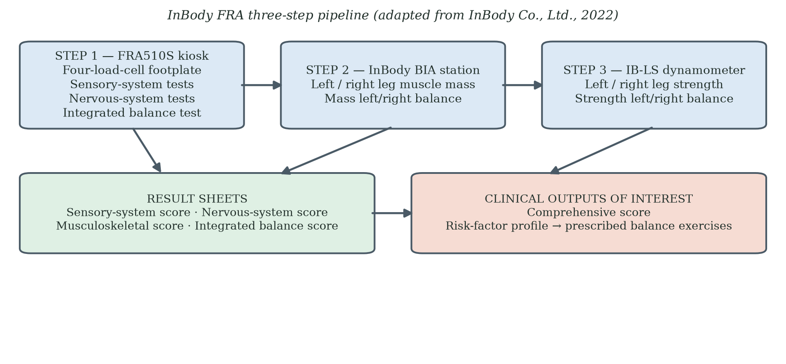
Figure 4.1A. Fall Risk Assessment (FRA) system architecture as deployed at the Poly Group facility (InBody FRA510S). Step 1 captures sensory- and nervous-system tests on the four-load-cell footplate. Steps 2 and 3 add musculoskeletal mass and strength via the InBody BIA station and the IB-LS dynamometer. Four result sheets present sensory-system, nervous-system, musculoskeletal and integrated-balance scores; the comprehensive score and risk-factor profile are the clinical outputs of interest in this thesis. Adapted from InBody Co., Ltd. (2022).
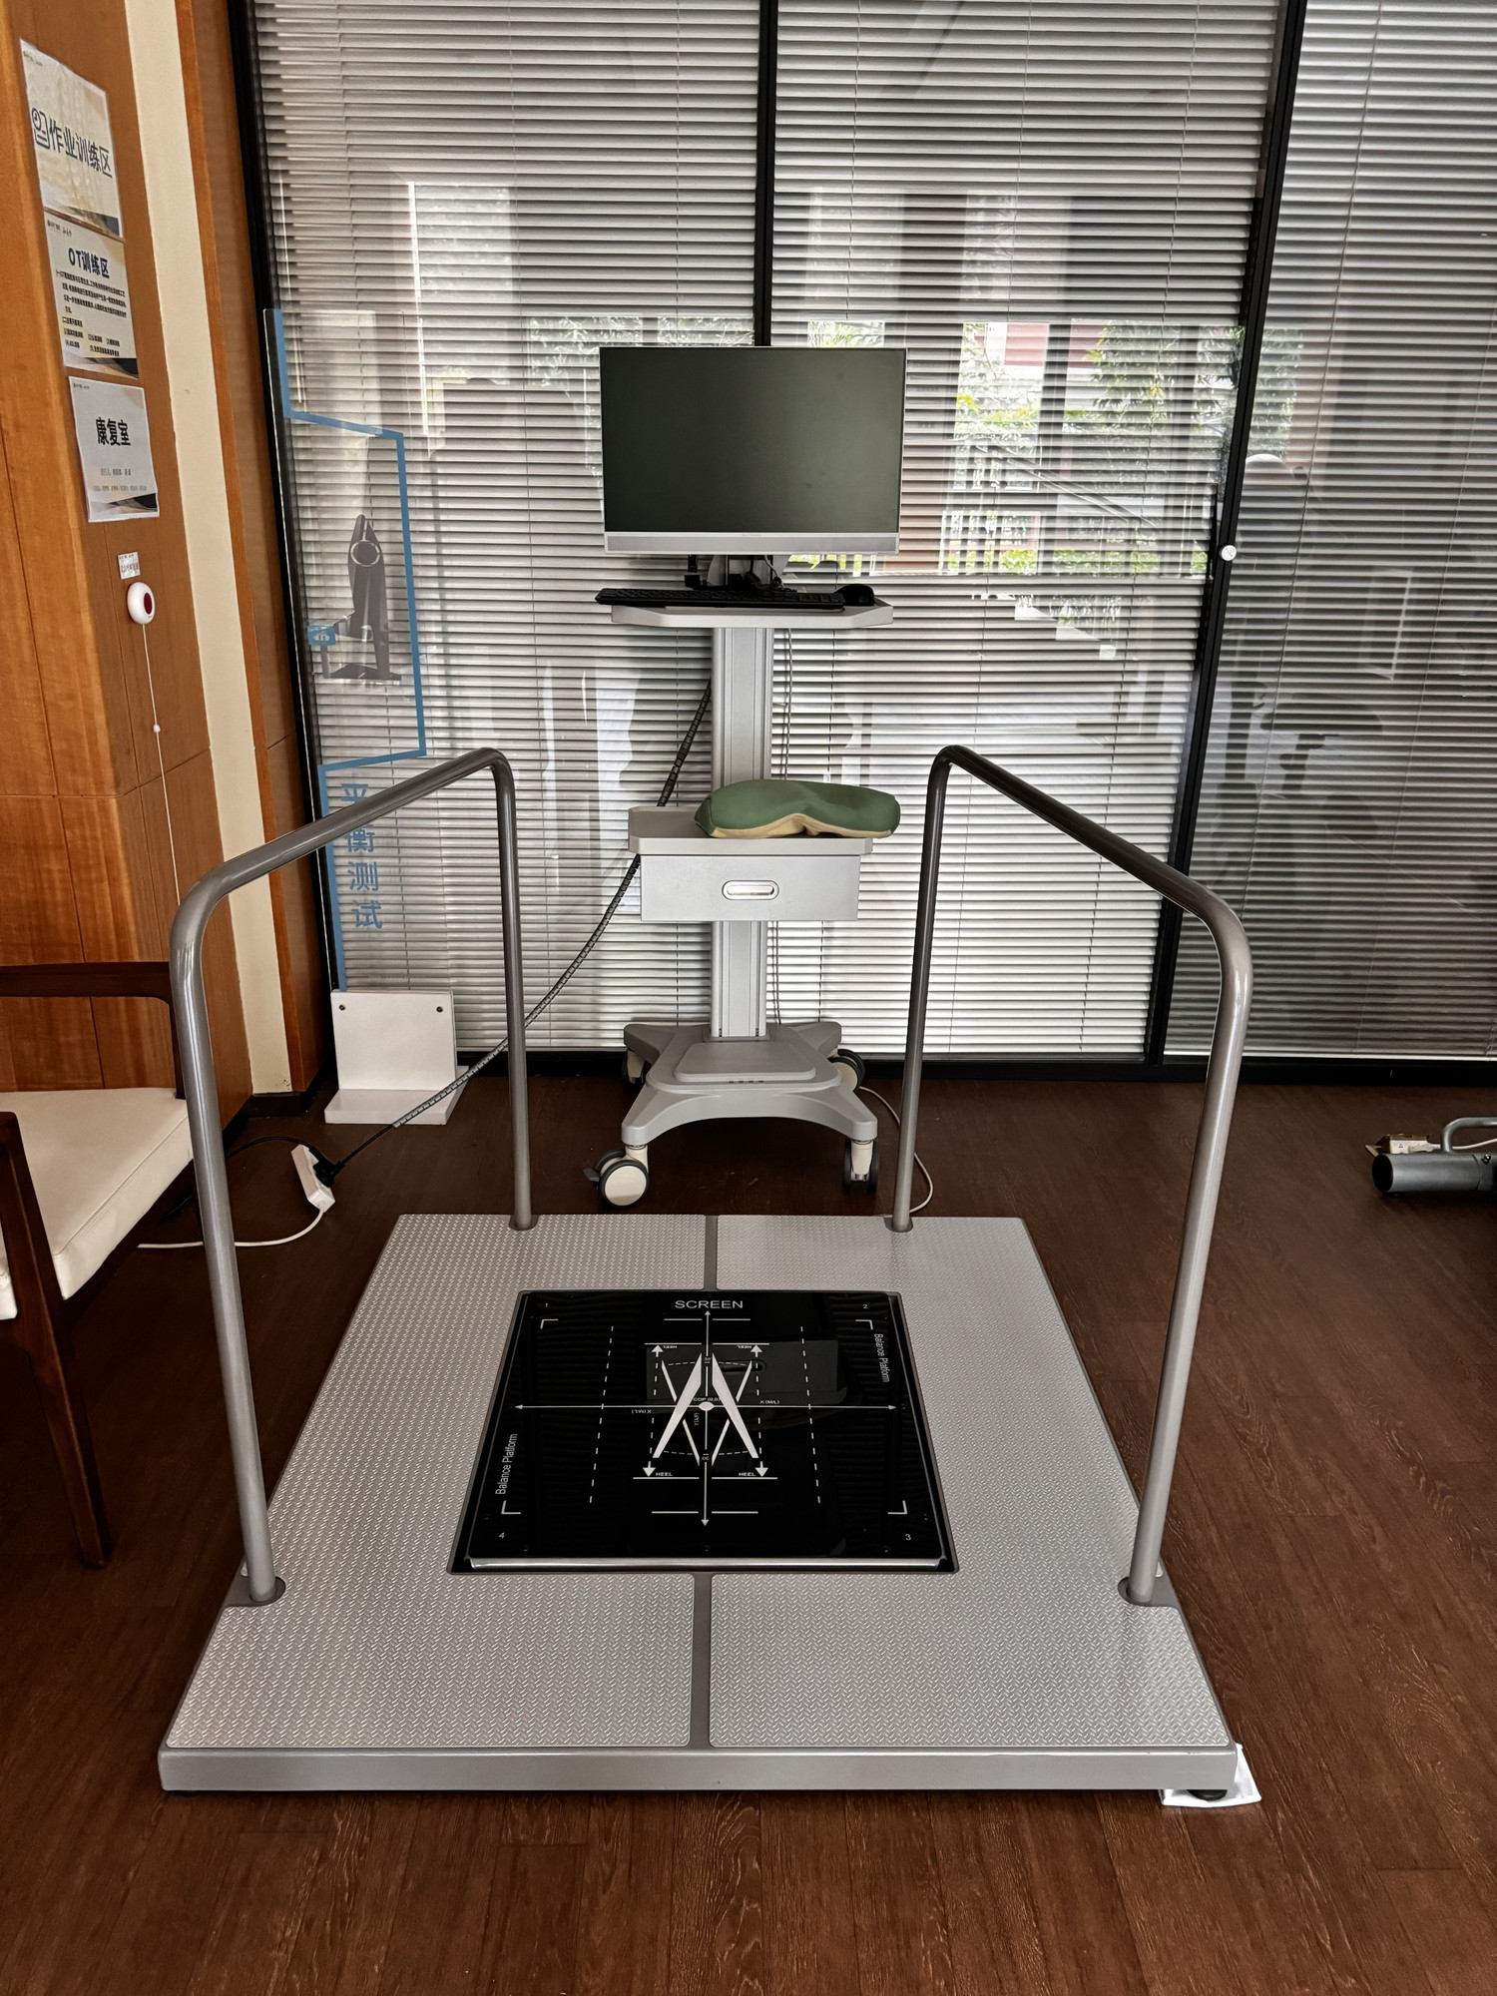
Figure 4.1B. The FRA balance station as deployed in the rehabilitation room of the Guangzhou facility (photograph by the author). The four-load-cell sensing surface — the dark glass panel marked with foot-placement guides — is set into an anti-slip base plate and flanked by support rails; the operator's monitor and keyboard stand on a mobile cart behind the platform. The configuration is the modular arrangement described in §4.1A (platform, support rails, operator computer); facility signage designates the occupational-therapy training area and the balance-test zone. The same platform is shown under game control in Figure 5.1A.
FRA is therefore the sensor-based artefact whose engagement profile is examined. The Stage-1 survey instrument reproduced in Appendix A contains six Yes/No items on awareness, prior use, understanding and acceptance of the first result, subsequent return, discomfort or discouragement, and willingness to use a friendlier version. The figure of 280 that appears in earlier working documents is the facility's resident population at the time of the survey; 200 eligible residents were interviewed, and 200 is the denominator for every Stage-1 result. No separate TAM-based questionnaire block was administered; the six-item form reproduced in Appendix A is the complete Stage-1 instrument, and only results with a traceable item, wording, denominator and data source remain in Table 4.1.
A scoping statement belongs here. The commercial FRA proposition - in the InBody line as in its HUR antecedent - is not assessment alone but an assess-then-train model: measurement identifies fall risk, and a training programme on the same platform is intended to reduce it. This thesis studies the assessment gate only, and does so deliberately: the programme's central finding is that utilisation collapses at that gate, and when older adults refuse or abandon assessment, the training phase never begins. The assessment gate is thus the binding constraint on the entire model's preventive value, and its acceptance is the highest-leverage object of study. The training phase, and the extension of this thesis's framework to it, are addressed as an explicit limitation and as future work (s8.7, s8.8).
Three features of the station's operating practice at the facility complete the picture the Stage-1 survey was fielded into, and each bears on how a resident could rationally regard the FRA before ever stepping onto it. First, the assessment was not self-service: a therapist's support was required to run the protocol, so every assessment was also a supervised, observed performance. Second, the protocol itself was demanding - a full multi-domain assessment rather than a casual check - and its rigour visibly deterred participation. Third, and most consequentially, the verdict had teeth: an unfavourable risk profile led in practice to prescribed balance training on the same platform, and to recommendations against walking alone and freely. An adverse result was therefore not merely unwelcome information; it initiated obligations and restricted the very independence it measured. Word of these consequences circulated among residents ahead of any personal experience. This operating context - authority present, effort demanded, autonomy at stake - is the background against which the Stage-1 pattern of acknowledged benefit without participation, reported in the next section, should be read.

4.2 The Guangzhou Survey (N = 200 of 280 Residents)
Six Yes/No items were administered face-to-face by nursing staff in July and August 2024 to residents aged 65–88 who met the stated eligibility criteria. Face-to-face administration reduced literacy and digital-skill barriers, but it may also have introduced interviewer and social-desirability effects, and this is acknowledged as a limitation in §4.8. Of the facility's 280 residents, 200 who met the eligibility criteria were interviewed; the interviewed sample of 200 is the denominator for all Stage-1 results. The remaining 80 residents were unavailable at the time the interviews were conducted; none were excluded by refusal. The relationship between unavailability and FRA experience was not established, so the direction and magnitude of selection bias cannot be determined from these data; this is acknowledged among the Stage-1 limitations in §4.8.
Table 4.1. Stage-1 survey results (N = 200 residents surveyed, of a resident population of 280).
Survey item | Result
Ever used FRA | 39%
Never used FRA | 61%
Adverse/unacceptable first experience among prior users (item 3 asks whether the first result was understood and accepted; mapping to task failure is interpretive, §4.8) | ~74%
Self-reported non-return after the adverse first experience | ~82%
The survey indicates a marked gap between prior awareness and actual use, and a high level of self-reported non-return among prior users after an adverse or unacceptable first experience. It does not establish that every respondent experienced task failure, that the decision occurred immediately, or that non-return was irreversible. Working tables from the survey period also suggested favourable physical-access and perceived-benefit estimates; because those figures cannot be traced to items in the archived six-item instrument (Appendix A), they are not reported as survey results. The Stage-1 result is therefore a descriptive problem signature that justifies prospective study of the first adverse experience.

4.3 TAM, STAM and the Limitation for Retired Users
TAM was developed primarily in instrumental technology-use settings, with Perceived Usefulness commonly operationalised through performance gains. In preventive health settings involving retired older adults, relevant benefits may include safety, independence, confidence and quality of life (§2.2.1). The present study asks how an adverse first experience relates to subsequent use and whether event-specific appraisal can add explanatory value to acceptance and continuance accounts (§2.2.3). Awareness, physical access and prior trial are not equivalent to measured acceptance, perceived usefulness or ease of use. The Stage-1 pattern therefore motivates prospective investigation of experience and non-return; it does not demonstrate a retrospective failure of TAM or STAM, nor show that positive beliefs cannot predict use.
Table 4.2. TAM limitations for elderly FRA users.
Acceptance-model consideration | Contextual question in elderly FRA use | Implication for this study
Usefulness often operationalised through performance gains | Relevant benefits may include independence, confidence and preventive value | Contextualise the assessment of perceived usefulness
Beliefs and facilitating conditions can predict use | Physical access and awareness do not establish favourable measured acceptance beliefs | Examine beliefs and experience without equating provision with acceptance
Acceptance and continuance accounts link beliefs, experience and subsequent use | The meaning of an adverse first experience may influence continued participation | Evaluate event-specific appraisal alongside satisfaction and perceived usefulness
The baseline models do not provide the specific event-level FIAS account proposed here | Early disengagement and later non-return were observed in Stage 2 | Test whether prospectively measured appraisal adds predictive value

4.4 Octalysis and the In-Game Loss Assumption
Chou's Octalysis Framework (2015) organises gamification around eight motivational drives. In clinically framed activities for older users, some mechanics may operate differently from their intended use. Loss and Avoidance can refer not only to in-game points or streaks but also to the perceived personal meaning of an unfavourable result. Social comparison (Festinger, 1954) can motivate some participants while increasing age-related self-awareness for others. The thesis therefore treats D5 and D8 as context-sensitive and potentially double-edged rather than as universally inverted. Chapter 2 locates the underlying reason: the drives guide engagement design, but their application still requires attention to users' interpretations and context (§2.3.2). The contextual proposition here is that clinical consequences may alter what a loss means; it is not that gamification guidance assumes that loss-based motivation is invariably beneficial. Stage 1's contribution to that argument is contextual — Table 4.3 shows how each relevant drive reads differently once the player is an older adult and the frame is clinical — and it prepares the inversion of D8 that the later empirical work motivated (§2.6.2C).
Table 4.3. Octalysis drives contextualised against STAM characteristics.
Octalysis drive | Intended motivational role | Context-sensitive possibility in older clinical users
D2 Accomplishment | Achievement challenges motivate | May be undermined by failure
D5 Social Influence | Comparison drives engagement | May motivate some users or increase decline-related self-awareness
D8 Loss and Avoidance | Avoiding a perceived loss can motivate continued activity | Adverse performance may be interpreted as personally meaningful rather than only in-game loss

4.5 Behavioural Science Lenses
Bandura's self-efficacy theory offers a plausible within-person pathway: difficulty can reduce task-specific confidence and persistence, particularly when the task is important to the user. Prospect theory suggests that unfavourable information may be weighted more heavily than equivalent favourable information relative to a reference point. Together, these theories generate a candidate explanation for abrupt non-return after an adverse first experience. The Stage-1 survey does not measure self-efficacy change, loss aversion or reference points directly, so the mechanism remains inferential. These lenses are assembled into their full supporting structure — observation, theory, construct, prediction — in Table 2.1.

4.6 Terminological Correction: FIDS to FIAS
The initial label, Failure-Induced Dropout Syndrome (FIDS), was derived from study-attrition vocabulary. "Dropout" can describe non-completion without specifying agency or meaning. The retrospective Stage-1 reports suggested a more active pattern of non-return after an adverse first experience, motivating the term Failure-Induced Abandonment Syndrome (FIAS). The renaming is analytically useful because it shifts design attention from reminders and access alone toward the meaning of the first experience. It should not be read as evidence that the exit was clinically irreversible, psychologically final, or directly observed to occur within hours; those temporal and mechanistic questions were examined prospectively in Stage 2.
The FIDS-to-FIAS revision is therefore a conceptual output of Stage 1 and Stage 2 rather than a validated diagnostic classification. In this thesis, FIAS denotes a proposed behavioural pattern: failure-associated active non-return under conditions where performance may be interpreted as identity-relevant. Its operational definition, reliability, discriminant validity and predictive increment over STAM require further testing.

4.7 Cross-Cultural Reference Point
The Korean studies of the FRA platform provide context for its measurement use (Park et al., 2019; Kim et al., 2018). They do not establish a sustained-engagement advantage or identify a design feature responsible for one. The vendor-derived engagement figure mentioned in earlier drafts is not carried as evidence here. Comparative fieldwork could examine support, framing and use patterns under documented conditions; the current thesis does not infer those patterns from measurement studies.

4.8 Output and Stage-1 Limitations
Stage 1 produces three outputs: a documented utilisation and self-reported non-return problem; a reason to investigate the adverse first experience and its interpretation; and the provisional FIAS construct and working hypotheses developed in Chapter 5. The setting offered substantial practical support for use, but the survey did not establish that all acceptance-model constructs were favourable. Stage 1 consequently motivates prospective examination of the original design expectation rather than a formal rejection of H0 (§2.3.5). It does not validate FIAS, establish permanent non-return, or identify mental accounting, endowment or stereotype threat as causal mechanisms. Stage 2 characterises engagement during deployment, and Stage 3 examines a participant-facing decoupling package in a separate cohort. The Stage-1 limitations are those of a retrospective staff-administered survey: recall error, interviewer and social-desirability effects, item wording that captures acceptance of a result rather than task failure directly, and the exclusion of 80 of the facility's 280 residents who were unavailable when interviews were conducted.

Chapter 5 Stage 2 — Action Research with Gamified FRA

5.1 Research Questions and Hypotheses
Stage 2 addressed three stage-specific questions, distinct from the thesis-level research questions in §1.11. S2-Q1: Can a dual-purpose gamified balance activity sustain engagement while generating interpretable performance and FRA-related records? S2-Q2: How is first-failure experience associated with observed dropout during an eight-week deployment? S2-Q3: Which candidate explanations and design principles are suggested by cases in which score change and return behaviour diverge? The hypotheses are directional and should be interpreted within the limits of a small, single-site action-research cohort.
H0 (original design expectation, formalised retrospectively; §2.3.5): a gamified FRA designed around TAM/STAM acceptance considerations and Octalysis motivational drives would support continued engagement, including after an adverse first experience. Stage 2 examines this expectation prospectively in deployment, but H0 has no prespecified numerical null value or counterfactual for estimating improvement. H1, H2 and H4 are working propositions that organise the exploratory analysis, subject to the chronology in §3.5.
H1: An adverse or difficult first experience is associated with early disengagement (three or fewer completed game cycles) during the eight-week study window.
H2: Re-engagement after disengagement is uncommon during the Stage-2 observation window under the coupled FRA framing.
H4: A subgroup exists in which positive change in the recorded FRA index and observed non-return co-occur (the recorded-score–engagement discrepancy).
H5, proposed for Stage 3: a participant-facing decoupling package will be associated with lower observed non-return and higher post-failure return than the Stage-2 coupled condition. Because Stage 3 uses a separate cohort, H5 examines whether the observed direction is consistent with a frame-sensitive account; the comparison does not isolate a causal framing effect.

5.2 Setting and Action-Research Approach
Stage 2 was conducted at a residential care facility in Southern China with several hundred beds, an InBody FRA system in place for over a decade, one-to-one staffing and free-of-charge access to the equipment. These provisions reduced financial and logistical barriers and made the site suitable for investigating engagement beyond simple availability. They do not establish that access was effortless for every resident, that perceived usefulness and ease of use met a sufficient threshold, or that all contextual explanations were absent. Stage 2 consequently examines whether the design expectation of §2.3.5 was realised under a supported deployment; it cannot attribute subsequent disengagement exclusively to a particular experience of the gamified FRA.

5.2A Integrating the FRA into the Skiing Game: The Dual-Purpose Mechanic in Detail
The Stage-2 dual-purpose mechanic uses a balanced shift of body weight as a steering input for the skiing game and as an input to the FRA measurement pathway described in §4.1A. This links gameplay and assessment at the physical interaction while allowing their outputs to be presented differently. Stage 3 retained a skiing-game concept but used a remote desktop implementation with different input arrangements and no clinical balance-measurement pipeline. Figure 5.0 contrasts these configurations. The comparison therefore concerns a changed deployment package; it does not show that a fixed measurement architecture became more acceptable solely through participant-facing decoupling.
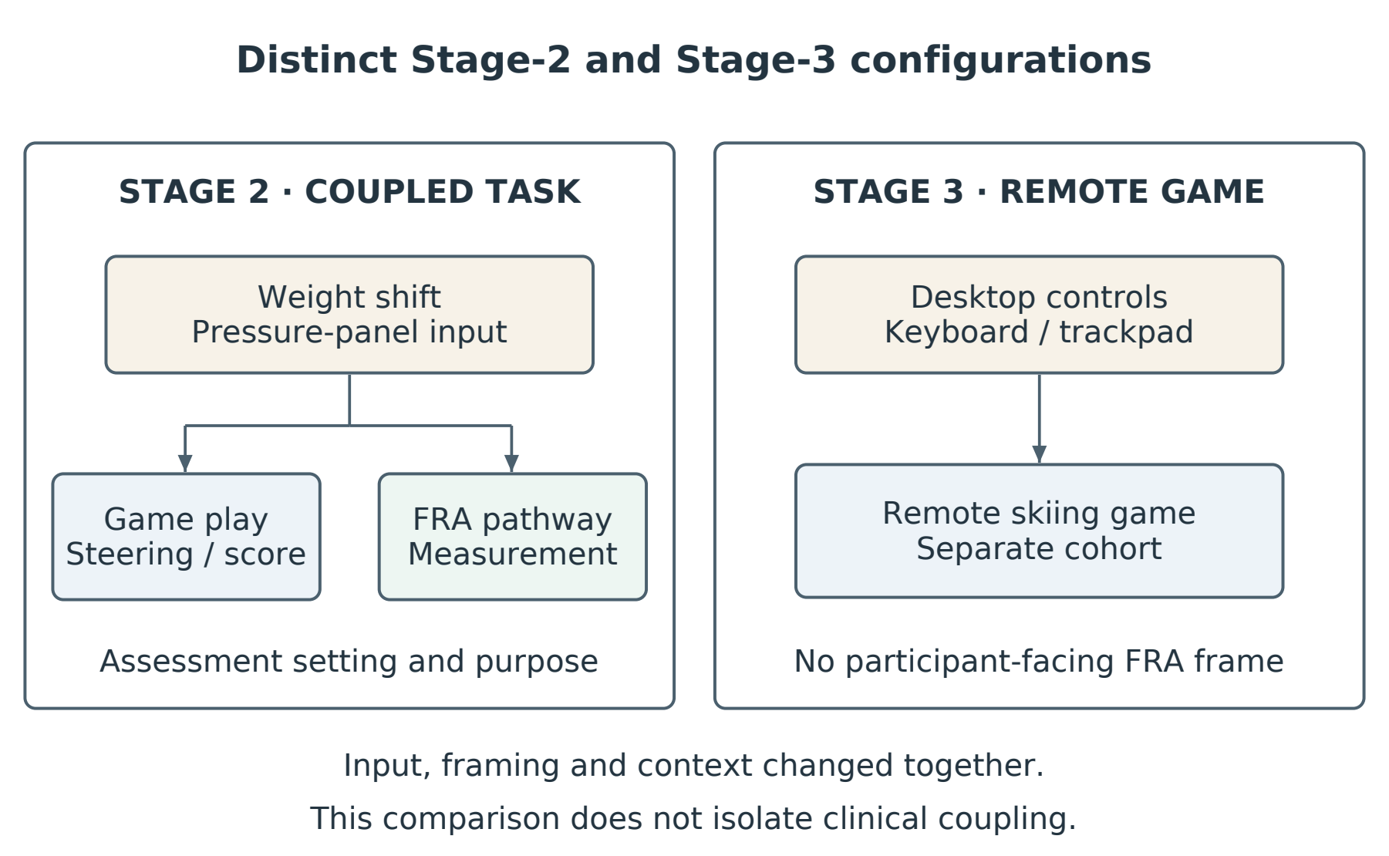
Figure 5.0. Configurations compared across Stages 2 and 3. Stage 2 linked the pressure-panel game with FRA measurement; Stage 3 used a decoupled desktop game in a separate cohort and context. Changes in input and delivery prevent interpretation as an isolated test of clinical framing.
The integration is mediated by a small set of design parameters that have been frozen in a project-internal data file (Game_States_and_Parameters.xlsx; archived alongside this thesis). The state-machine specification has four states — Assessment, Playing, Paused, Game Over — with the transitions used by the Stage-2 build. The Assessment state is a pre-game competency screen on which the participant selects age group, balance ability and rehabilitation goal; clicking “Start Training” transitions to Playing. The Playing state runs the active gameplay: the skier moves down the slope, the player steers to avoid obstacles and collect coins, and the balance meter depletes over time and on turning. The Paused state freezes all movement and timers when the “P” key is pressed. The Game Over state is reached on a third obstacle hit, on balance reaching zero with no lives remaining, or on all lives lost; it shows a final-statistics card and an AI training recommendation, and offers either “Train Again” (back to Playing) or a new Assessment session. The Stage-2 build retained the conventional Game Over verdict; the loss-free, non-terminal state repertoire that replaces it is the secondary contribution introduced at §5.3.10 and discussed at §7.6A and §9.8A.
The numerical parameters that govern the integration are summarised in Table 5.0. The slope is rendered as 30 m wide and 2000 m long with a 12° descent. The skier’s baseline lateral movement speed is 8 m/s and the baseline forward speed is 12 m/s (approximately 43 km/h), capped at 30 m/s. Balance decays at 0.02 per frame and incurs an additional 0.15 per frame turn penalty; balance recovers at 0.08 per frame when the player is not turning, starts at 100 %, and is restored to 40 % when a life is lost from balance depletion. Obstacles are spawned at a base density of 0.4 per metre, 120 m ahead of the player, and despawned 30 m behind; tree collision radius is 0.8 m and rock collision radius is 0.4–1.0 m depending on size. Coins are spawned at 0.3 per metre, 100 m ahead, and each collected coin yields 10 points and restores 3 % balance. Difficulty rises by 0.15 multiplier every 200 m of distance progressed. The lives system is critical to the dual-purpose interpretation: the player starts with three lives; a 1.5-second invincibility cooldown follows each collision; the first hit drops speed to 70 % and is otherwise neutral; the second hit reduces the obstacle density to 40 % (×0.4) and clears 60 % of obstacles in the next 60 m; the third hit ends the round. Mouse input uses an 8 % deadzone, gamepad input uses a 15 % deadzone, and combined inputs are clamped at 1.5 × the base move speed. Difficulty adaptation reads three settings: age group (18–35 × 1.1, 36–55 × 1.0, 56+ × 0.7), balance ability (low × 0.6, medium × 1.0, high × 1.3), and a per-200 m additive distance term of +0.15. The combined-example row records that a senior with low balance starts the run at a 0.42 multiplier (0.7 × 0.6), a young player with high balance starts at 1.43, and a middle-aged player with medium balance reaches a 1.30 multiplier by the 400 m mark. These numbers are the integration: they are the bridge between the COP signal that the FRA510S would otherwise read directly and a gameplay surface in which the same signal is read as movement, success and reward.
Table 5.0. Skiing-game parameters by which the FRA COP signal is integrated into gameplay (extract; full specification in Game_States_and_Parameters.xlsx).
Category | Parameter | Value | Role in FRA-game integration
Slope | slopeWidth / Length / Angle | 30 m / 2000 m / 12° | Field across which lateral COP shifts are read as steering.
Player | baseMoveSpeed / baseForwardSpeed / max | 8 / 12 / 30 m/s | Translation gain from COP shift to skier velocity.
Balance | decay / turn penalty / recovery / on-life-loss | 0.02 / 0.15 / 0.08 per frame; 100 %→40 % | In-game proxy for the COP-derived stability index used by FRA Step 1.
Obstacles | density / spawn / despawn / collision radius | 0.4/m; 120 m / 30 m; 0.4–1.0 m | Forces COP corrections of varying amplitude across the run.
Coins | density / value / balance bonus | 0.3/m; 10 pts; 3 % | Reward signal that supports learn-to-earn over score-floor framing.
Lives | total / cooldown / 1st-hit speed / 2nd-hit obstacle | 3 / 1.5 s / × 0.7 / × 0.4 + 60 % cleared | Soft-fail buffer that supports the loss-free repertoire of §5.3.10.
Difficulty | distance step / age × ability multiplier | +0.15 / 200 m; 0.42–1.43 | Adaptive layer (L2) that protects the flow band for FRA-aligned cohorts.

Three properties of the integration matter for the rest of the chapter. First, the COP stream that the skiing game consumes at 60 Hz is the same stream that FRA Step 1 consumes; nothing about the integration prevents the FRA510S pipeline from running silently from the same data. The pre/post FRA index reported in §5.5 is computed from this silent pipeline; the comprehensive score and risk-factor profile are stored on the clinician-side terminal and are never displayed on the play screen. Second, the Assessment state is the only point at which the participant is asked, in language they can read, what kind of player they are; that input drives the difficulty multiplier table and is how the system makes itself appropriate for an elderly cohort without rendering a fail-state in the first run. Third, the described Stage-2 build retained a Game Over state. The present observations do not identify that state as the cause of non-return or establish that it measures a behavioural-economic mechanism. The loss-free, non-terminal repertoire introduced at §5.3.10 is the design response that the Stage-3 result and the Chapter 7 adaptive-learning prescription motivate; it is a proposed successor configuration whose prospective architecture is described in Chapter 7.
The participant-side data outputs of the integration are described in detail in §5.3.6 (data structures and telemetry); the clinician-side outputs are the InBody Comprehensive Score and risk-factor profile already specified in §4.1A. Self-report is captured by Questionnaires 2 and 3 (Appendix B): Q2 is administered immediately after the first gamified-FRA session (N = 30) and follows the Octalysis core-drives ordering across ten items; Q3 is the eight-week follow-up that distinguishes continuing users from those who dropped out and identifies the failure-induced exit pathway directly. Together, the COP-derived game telemetry, the silent FRA pipeline, and the three questionnaires provide the three-ledger view (behavioural, clinical, self-reported) on which the Stage-2 analysis in §5.5–§5.7 is built.

5.3 The Gamified Intervention — Skiing Game on the InBody Pressure Panel
Stage 2's central technical artefact is a 2D skiing game running on an InBody pressure panel. The game was developed in Pygame, generated through Anthropic Claude Code, with an automatic difficulty-adjustment subsystem driven by LangChain orchestration over a large-language-model endpoint (the deployed endpoint is recorded in Appendix G, item G.7). The single most important property of the system is the dual-purpose mechanic: the same physical action — a balanced shift of body weight on the pressure panel — both controls gameplay and yields the centre-of-pressure (COP) telemetry from which clinical FRA indices are computed.

5.3.1 The InBody Pressure Panel
The InBody pressure panel is a force-plate balance device deployed in clinical and residential settings. It measures the location and movement of the user's centre of pressure with sub-centimetre spatial resolution and sub-second temporal resolution. The panel was calibrated by InBody engineers as part of installation; the calibration function is treated as a fixed component for this thesis. In Stage 2 the panel served two roles at once. As a clinical instrument, the panel produced the COP traces that yielded the FRA index of balance. As a game controller, the panel translated lateral COP shifts into left/right movement of the on-screen skier and forward/backward COP shifts into trail scrolling speed. Neither role compromised the other.

5.3.2 Game Concept and Gameplay Loop
The skiing game is a 2D arcade-style game in which the user controls a skier descending a snow-covered slope. Three game elements interact: the skier (the user's avatar), obstacles distributed across the trail (trees, rocks), and coins (collectible rewards). The skier moves left and right by lateral COP shifts on the InBody panel; the user's task is to avoid obstacles while collecting coins. The skier's vertical position on screen is fixed; the trail and elements scroll upward to give the visual impression of downhill motion. The game is structured into rounds with a five-attempt rule, after which the system either advances the user to a higher difficulty level (on success) or retains the current level (on failure).
Play proceeds in a single repeating loop. The game polls the panel sensor 60 times per second; updates the skier's location and orientation; generates and updates obstacle and coin positions; detects collisions; updates the score; redraws all game elements; and refreshes the screen at 60 frames per second. The loop continues until the user pauses, stops, or the round ends. A short, clearly framed feedback screen ends each round; clinical numbers are not displayed on this screen.

5.3.3 On-Screen Display
Figure 5.1 illustrates the on-screen display. The play field shows a tapered ski trail framed by green trees, a stylised skier near the centre of the screen, scattered obstacles (brown squares representing rocks or stumps) and gold coins distributed across the trail. Two small heads-up displays are anchored at the top of the screen: a score readout in the top-left and a level readout in the top-right. The colour palette is intentionally low-contrast at the periphery and slightly more saturated at the elements that demand attention (skier, obstacles, coins). No clinical language and no clinical iconography appears on the play screen.
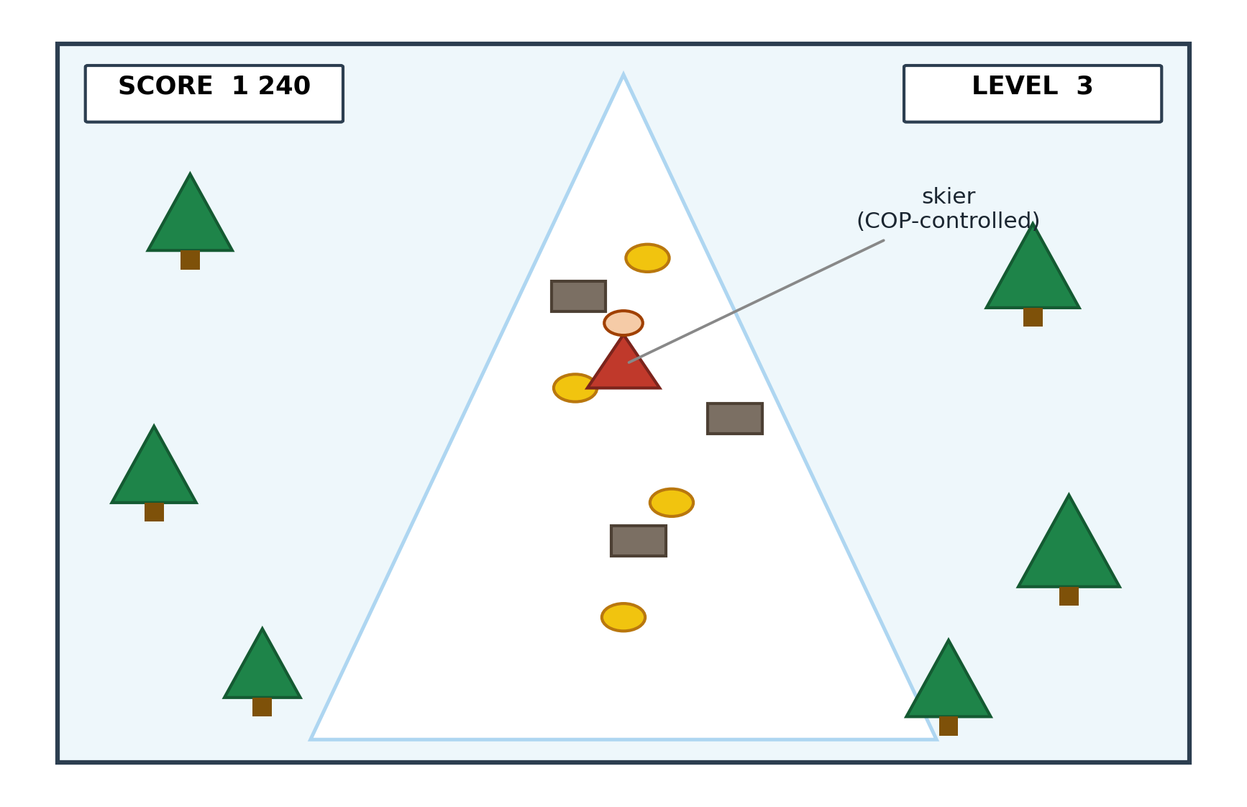
Figure 5.1. Schematic illustration of the skiing-game display. The skier represents Centre-of-Pressure control; trees and rocks represent obstacles, coins reward forward play, and level and score indicators illustrate the intended interface. The drawing is explanatory and is not a captured game screen or a participant outcome record.
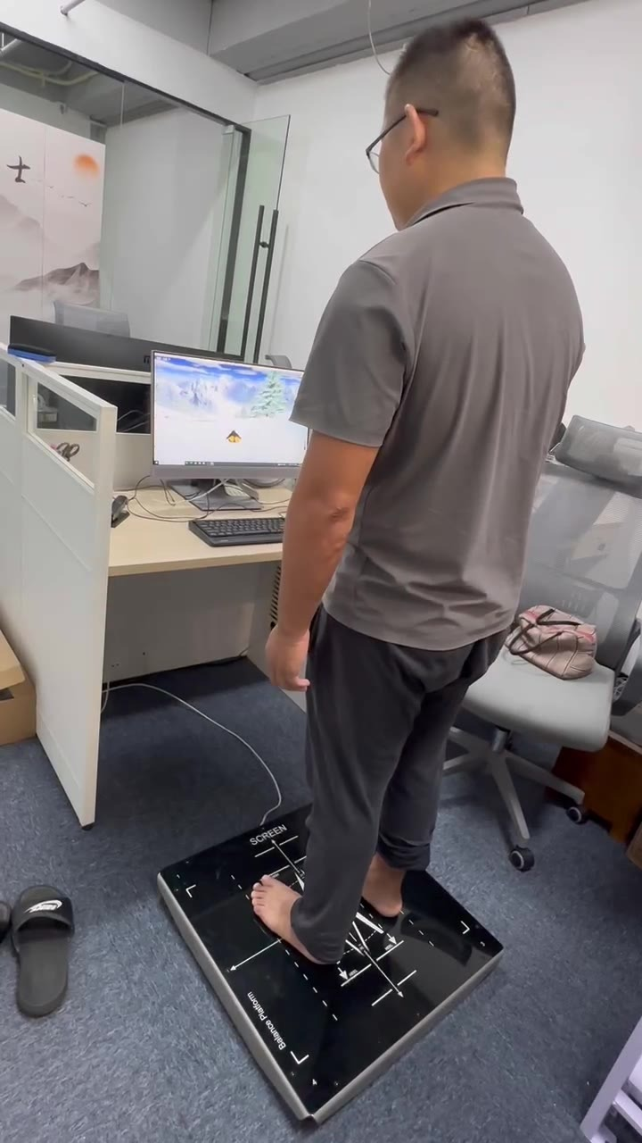
Figure 5.1A. The platform-game coupling demonstrated: one of two control persons steers the skiing-game prototype by weight shift on the balance platform (development office, 27 August 2024; frame from the archived video, Appendix G, item G.10). Photography of study participants was not permitted under the residential facility's privacy rules, so no participant play imagery exists; this development-phase demonstration stands in its place.
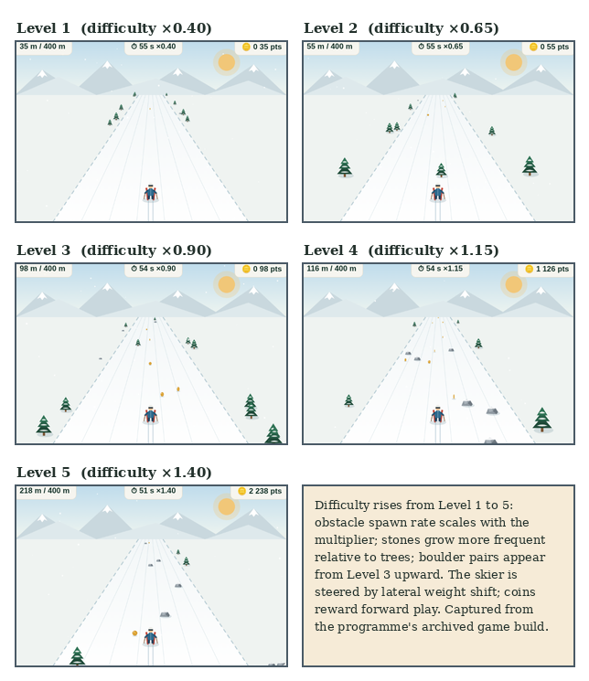
Figure 5.1B. The deployed game artefact across difficulty levels 1–5. Obstacle spawn rate scales with the difficulty multiplier (×0.40 to ×1.40), stones become more frequent relative to trees, and boulder pairs appear from Level 3 upward; the skier is steered by lateral weight shift and coins reward forward play. Screenshots captured from the programme's archived game build — the successor build in the same design lineage as the Stage-2 deployment.

5.3.4 Five-Layer Architecture
The system is organised into five layers, each with a distinct responsibility. Figure 5.2 summarises the architecture. Layer 0 (Sensor Input) is the InBody pressure panel; the layer's output is a stream of COP coordinates. Layer 1 (Game Engine) is the Pygame skiing task; it consumes COP coordinates and produces frame-by-frame game state. Layer 2 (AI Adaptation) is a LangChain runtime calling a large-language-model endpoint that adjusts obstacle density and skier speed at five-minute intervals using a prompt template anchored to the user's recent success rate (raise difficulty above 80%, lower below 40%). Layer 3 (Logging) records cycle counts, COP traces, session-level affect and dropout flags in JSON format. Layer 4 (Clinical Output) computes pre/post FRA indices from the COP stream for clinician review. Layers 1–2 form a self-contained adaptation loop; the clinical layer (L4) runs silently from Layer 0–3 telemetry without interrupting gameplay.
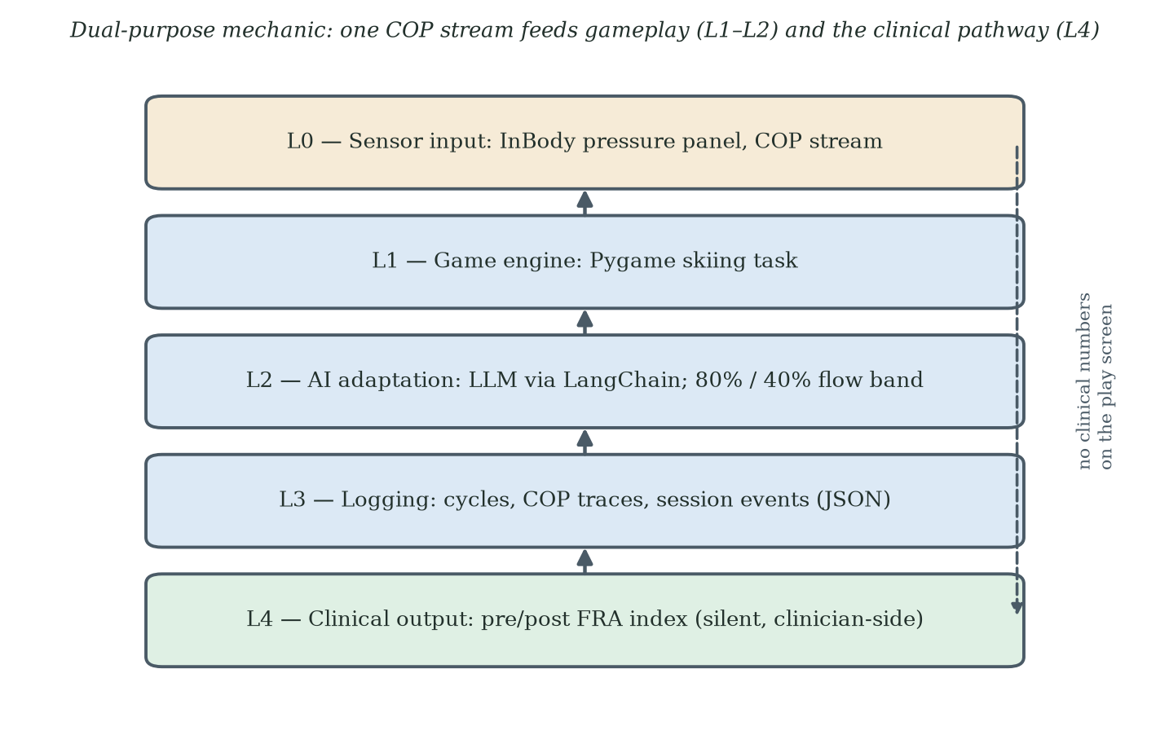
Figure 5.2. Five-layer architecture of the gamified FRA system. The dual-purpose mechanic links Layer 0 (sensor input) and Layer 4 (clinical output) through the gameplay layers without exposing clinical numbers to the user during play.

5.3.5 Automatic Difficulty Adjustment System
The automatic difficulty-adjustment system (Layer 2) adjusts the game in real time so that challenge tracks the user's evolving capability. The system has six stages. First, data collection: historical and within-session game data are gathered (game type, difficulty level, score, accuracy, reaction time, duration, frequency) alongside personal information collected at enrolment (age, sex, physical condition, cognitive screening, game preferences). Second, data processing: collected data are cleaned, structured into JSON, and rendered into a natural-language input string ("User A: age 72, female, memory decline; historical game: skiing, difficulty 3, accuracy 80%, reaction time 1.5 s; current session: skiing, difficulty 1–5"). Third, model use: a pre-trained large language model is invoked through LangChain with a prompt template that asks for an initial difficulty and an adjustment strategy grounded in flow theory and the challenge–skill balance. Fourth, difficulty generation: the model returns a structured response with a recommended difficulty level and a written rationale. Fifth, real-time adjustment: every five minutes during play the system collects the latest session data, re-invokes the model, and applies the updated parameters (skier speed, coin generation interval, coin group size, obstacle density). Sixth, evaluation and optimisation: at the end of each session the user supplies a brief subjective rating, which is stored alongside objective performance for future model fine-tuning.
The described in-session rule increases difficulty above an 80% success rate and decreases it below 40%. These are tunable design defaults intended to balance challenge and support. They do not measure flow or demonstrate prevention of a failure cascade. Future deployment should justify the thresholds against task demands and safety limits and examine their effects on performance, burden and return.

5.3.6 Data Structures and Telemetry
The system records data along three dimensions, summarised in Table 5.1. The user dimension captures stable personal characteristics. The game dimension captures session-level configuration. The result dimension captures session-level outcomes. The combination supports per-user adaptation and supports the Layer 4 clinical output.
Table 5.1. Skiing game data structure summary.
Dimension | Fields
User | Unique device identifier; age; sex; physical condition; vision and hearing status; cognitive function status; medications; lower-limb strength baseline; balance baseline
Game | Session identifier; difficulty level (1–5); game type; session duration; stimulus type (visual, auditory); stimulus presentation speed and frequency; user response type (COP shift)
Result | Correct response rate; average reaction time; maximum and minimum reaction time; left- and right-leg strength; symmetry of leg strength; fatigue rate; game score; star rating

5.3.7 Sample User Profile
As a worked example, the system was tested on a synthetic profile of a 72-year-old female user with average overall physical condition, poor balance, slow reaction speed, weak lower-limb strength, and limited recent exercise. The profile included hypertension and osteoarthritis, antihypertensive and analgesic medication, mild vision and hearing decline, and possible mild cognitive impairment. In-session telemetry showed a 60% correct-reaction rate, an average reaction time of 2.0 seconds, asymmetric leg strength, a 30% fatigue rate, a session score of 50 points and a 2-star rating, with declining performance on recent sessions. Layer 2 returned an initial difficulty level of 1 with a written rationale grounded in flow theory and challenge–skill balance, plus three to five level-up suggestions and three to five personalised practice suggestions covering balance training, reaction-time drills and lower-limb strengthening. The profile illustrates the system's intended behaviour: difficulty calibration is conservative; explanations are grounded in established theory; recommendations are concrete and personalised. The profile is synthetic and was used for pipeline verification, in the same spirit as the synthetic centre-of-pressure traces of §5.3.9; it is not a study participant.

5.3.8 Why a Skiing Game?
The game's lineage is industrial. InBody's own balance games had been installed on the facility's FRA in 2022 (the platform's training mode; InBody Co., Ltd., 2022), and the skiing game was developed by the author in 2023 for the Poly Group centres with those installed games as its starting point - retaining the platform's sensing pathway while replacing the presentation, reward structure and session format with the design described in this chapter.
The skiing metaphor was selected for three reasons. First, the lateral-shift control mapping is natural: the COP shift required to lean a skier matches the COP shift required to maintain dynamic balance, so the gameplay action and the clinical measurement coincide without translation. Second, the skiing metaphor is culturally accessible across the Stage-2 cohort: every participant had seen winter sports on television, and no participant required a genre-specific tutorial. Third, the trail-scrolling visual provides an intrinsic forward-motion cue that does not require the user to read distance or score, reducing the cognitive load on participants with mild visual or attentional impairment.
The choice of metaphor matters for Stage 3, but the skiing metaphor itself is not the principal design lever under examination. Stage 3 retains the broad skiing mechanic while changing the participant-facing clinical cues and the delivery platform; input was through a trackpad or keyboard, or a foot-pad sensor where available (§6.4). The comparison therefore reduces some artefact-level variation but does not isolate framing from all procedural, interface, cohort and contextual differences.

5.3.9 Development Methodology: The Claude Code-Assisted Workflow
The skiing game was developed using Anthropic Claude Code as the primary engineering assistant. Claude Code is a command-line tool that allows a developer to delegate coding tasks to a Claude model directly from the terminal, with read and write access to the local file system and the ability to execute shell commands. The tool was used in an iterative pair-programming pattern across the design, implementation and tuning phases of the project. The decision to document this workflow follows from action research's commitment to making the methodological vehicle visible. The vehicle is not incidental; it shaped what was built and how quickly the design could be revised.
A chronology note is required for the auditability of this account. Development of the skiing games began in 2023, taking the manufacturer's installed games as the starting point (§5.3.8), whereas Claude Code became available as a research preview only in February 2025. The AI-assisted workflow described in this section therefore applies to the build generations engineered from 2025 onward; the earliest prototypes predate it. Per-generation development dates and tooling are recorded in the build-lineage matrix (Appendix G, item G.0A) as it is completed; where a generation's tooling is not yet documented there, no tooling claim is made for it.
Before any custom code was written, the platform-to-game input coupling was validated on an off-the-shelf scaffold. In the earliest development phase the balance platform was connected to the open-source Tux Racer skiing game — a 3D title in which a penguin slides belly-down over a snow slope collecting fish — so that weight-shift steering could be demonstrated end-to-end before the study game existed. Two contemporaneous videos, recorded at the development office on 27 August 2024 and held in the study archive (Appendix G, item G.10), show one of two control persons steering this prototype by weight shift alone. The deployed Stage-2 game described in this chapter is a separate implementation: a 2D Pygame build, with the avatar aesthetic moved from the prototype's penguin to a human skier during development. The open-source scaffold contributed no code to the deployed build; its role — proving the input coupling before engineering effort was committed — is recorded here so that the development lineage is complete.
The development cycle had three iterative loops. The outer loop was a design loop. A change in the user-facing experience (a new obstacle pattern, a different visual feedback scheme, a revised five-attempt rule) was first specified in a short natural-language description, refined in dialogue with Claude Code, and then translated into a working Pygame change in a single working session. A change that would have taken half a day to write from scratch typically reached a runnable prototype within thirty minutes. The middle loop was an implementation loop. Within each design change, Claude Code generated the Pygame code, the developer ran it on the test rig, observable problems were reported back to Claude Code, and a revised version followed. Three to five revision cycles per design change were typical. The inner loop was a verification loop. Once the implementation produced visually plausible behaviour, a small set of synthetic centre-of-pressure traces was run through the game logic to verify that the lateral-shift mapping, the obstacle collision detection, and the coin pickup logic responded correctly to known inputs. The synthetic traces themselves were generated by Claude Code from a written specification of expected balance patterns.
Three components of the system benefited particularly from the Claude Code workflow. The first component is the Layer 1 game engine itself. The Pygame skiing task moved through approximately fifteen design iterations between the first runnable prototype and the version deployed in Stage 2. Each iteration was traceable to a specific observation from a test session: scrolling speed too high for older users, obstacle spacing producing impossible gaps, coin reward salience too low against the snow background, and so on. The second component is the Layer 2 prompt template that drives the difficulty-adjustment subsystem. The prompt template was iterated through Claude Code's own prompt-engineering capabilities. Sample user profiles were fed through the template, the model's response was inspected, the prompt was revised to correct under-conservative or over-conservative difficulty recommendations, and the cycle repeated until the system reliably produced flow-theory-consistent recommendations across a range of synthetic user profiles. The third component is the Layer 3 logging schema. Claude Code generated the JSON schema, the writer function and the validation harness in a single session, with the schema then reviewed against the data dimensions specified in Table 5.1. The schema has not required revision since.
Two methodological points follow from this development pattern. First, the use of Claude Code did not change the engineering content of the system. The five-layer architecture, the dual-purpose mechanic, the COP-to-control mapping and the difficulty-adjustment logic are all engineering decisions that an experienced developer would make with or without AI assistance. What Claude Code changed was the speed at which decisions could be tested. The development was empirically driven because the cost of testing a design change was low. Second, the use of an AI agent to build a system that itself uses an AI subsystem (the LangChain plus large-language-model adaptation layer in Layer 2) does not collapse into a circular dependence. The two AI uses are at different layers and have different roles. Claude Code is used at design time, by the developer, to generate code. The Layer 2 model is used at run time, by the system, to recommend difficulty parameters. The two are separable, and the run-time system runs without any further involvement from Claude Code once deployed.
The Claude Code-assisted workflow is documented for reproducibility, not offered as a contribution in its own right: the AI tooling is an enabling technology, and the contribution it enabled is the behavioural design framework. Engineering doctoral programmes increasingly involve software components whose construction is itself an act of design. Documenting the vehicle by which the artefact was built, alongside the artefact itself, makes the action research more reproducible and clarifies which engineering decisions belong to the developer and which were accelerated by tooling.

5.3.10 Dynamic Game States: An Agentic-AI-Driven, Loss-Free Game Mechanic (Secondary Contribution)
The skiing-game specification reported in §5.3.1 to §5.3.9 was sufficient for the empirical Stage-2 deployment, but it retained a conventional terminal "GAME OVER" screen and a difficulty controller updated at scheduled intervals. In response to the theoretical analysis, this subsection proposes a dynamic game-state architecture with non-terminal recovery, mastery, narrative and reframe states. The objective is to reduce verdict-like failure cues while preserving challenge, truthful feedback and the underlying clinical measurement path. This architecture is a prospective secondary design contribution. It was not deployed in Stage 2, and no claim is made here that it prevents FIAS or eliminates non-return. The Stage-2 evidence gives the proposal its force: the deployed build had already softened the in-game loss economy — three lives, a neutral first hit, an obstacle-clearing second hit — yet non-return persisted. This observation motivates testing whether feedback and clinical framing contribute beyond the game’s existing recovery features, without excluding in-game difficulty or other causes. The proposed repertoire changes the response to difficulty; its behavioural effect remains untested (§2.6.2C).
Figure 5.3 presents the proposed architecture. L0 is the pressure-panel and in-game event stream. L1 is a performance-state classifier producing variables such as rolling success rate, time-to-fail and a flow proxy. L2 is a policy controller that selects among five non-terminal states: Standard Run, Recovery Run, Mastery Run, Story-Bridge and Reframe Pause. L5 is a user-facing trajectory display that avoids terminal failure labels while preserving informative feedback. L6 is a frame-congruence check intended to prevent accidental reintroduction of contradictory clinical or deficit language. These components are design specifications to be tested. Terms such as "identity-asset guard" describe the design intent, not a verified psychological mechanism.
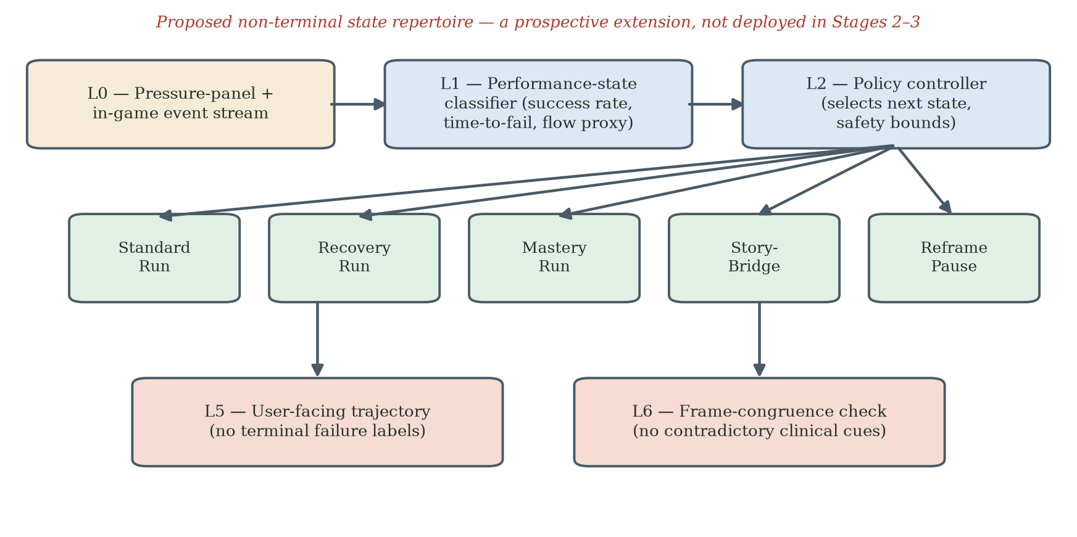
Figure 5.3. Proposed dynamic game-state architecture for the FRA skiing game. The controller selects among five non-terminal states using recorded game information within pre-specified limits. Trajectory feedback and frame-congruence requirements apply across the state repertoire, although selected connections are shown for readability. Trajectories must identify task, difficulty and assistance conditions; they do not establish learning from rising scores alone. The architecture was not evaluated in the Stage-2 or Stage-3 empirical comparisons.
The proposed instruction pattern has three phases. At design time, Claude Code is given a behavioural and safety specification: avoid terminal "GAME OVER" presentation, preserve meaningful challenge, represent failure as information for the next attempt, maintain truthful disclosure and keep the clinical measurement path separate from the user-facing game layer. The agent can generate candidate state repertoires, executable rules and synthetic test traces. At deployment, the policy would operate alongside the difficulty controller, with precedence rules and safety bounds defined in advance. At run time, state selections and outcomes would be logged for audit and evaluation. The developer remains responsible for the specification, validation, governance and final code; AI-generated policy logic is not treated as self-validating.
Three points fix the scope of this contribution. First, it is a design specification, not an empirical result; Stage 2 used the original game-state structure, and Stage 3 did not test a controlled state-repertoire comparison. Second, the proposal preserves the dual-purpose sensing path but requires separate validation of whether gameplay-derived signals are clinically interpretable. Third, the design should be evaluated against pre-specified outcomes, including immediate retry, return within a common observation window, user comprehension, challenge adequacy and unintended concealment of clinically important information. A "loss-free" surface must not become a challenge-free or misleading surface.

5.4 Participants and Data Governance
The facility extended the Stage-2 invitation to the 200 residents who had taken part in the Stage-1 screening survey (Chapter 4); thirty joined, and the remaining 170 declined or did not take up the invitation. Refusal reasons were not individually recorded, but the scale of the non-uptake - among residents who knew the FRA as part of the house's provision - is consistent with the anticipatory-avoidance pattern described in §4.1A, and it is read here as recruitment context, not as evidence for any hypothesis. It also marks the analysed cohort as a self-selecting minority of invitees, a boundary restated among the Stage-2 limitations (§5.9). Thirty residents participated over eight weeks (mean age 71.1 ± 5.9; range 62–84). PIPL compliance was maintained. All data were pseudonymised at collection. Only non-specific aggregate parameters were transmitted to API endpoints; no personally identifying information left the facility's local server.

5.5 Quantitative Findings
The Stage-2 archive (FRA_Raw_Data_N30.xlsx; Appendix G, item G.2) contains one record per participant: gender, age, the recorded 'before' and 'after' FRA index values (their provenance is stated below), presenting fall-risk symptoms, the number of completed game cycles, self-reported symptom change, satisfaction and a verification flag. Thirty-two records were collected in total; two records from younger control participants (aged 36 and 53) are retained in the archive but not analysed in this thesis, leaving the thirty elderly participants (aged 62–84, mean 71.1 ± 5.9; 17 female, 13 male) analysed here. One record failed verification and is retained with a sensitivity note. Because the archive records cycle counts and pre/post index values but no session dates or timestamps, time-to-event methods are not applicable to it: a Cox proportional-hazards model and a Kaplan-Meier estimator both require an observed time variable that this dataset does not contain. The survival-analysis framing used in earlier drafts, including the previously reported hazard ratio, has therefore been withdrawn, and the analysis below uses estimators suited to a small, single-site sample: Wilson score intervals for proportions, paired t and Wilcoxon signed-rank tests for the pre/post index, Welch and Mann-Whitney tests for between-group contrasts, and Fisher's exact test for categorical associations. A completed game cycle denotes one attended play session at the station under the five-attempt rule (§5.2A); the three-or-fewer-cycles threshold defines the low-engagement group referenced in H1 (§5.1). The three-or-fewer-cycles threshold is observation-derived rather than pre-specified: in field observation, some participants declined the after-game conversations and simply walked away, and their cycle counts clustered at three or fewer; the classification operationalises that observed behavioural boundary. It is therefore a descriptive, retrospectively formalised cut - in the same register as the hypothesis provenance of §3.5 - not a pre-registered endpoint. Its relation to the intended three-to-five-play protocol (§5.5) is that three plays met the protocol's lower bound for interpretable index data while still lying inside the observed walk-away cluster: data-sufficiency and engagement are distinct axes, and the threshold tracks the second. One consequence for the hypothesis architecture is stated here: the archived dataset contains no per-participant measure of first-experience adversity, so H1's association could not be directly examined and is carried as a design-stage expectation rather than a tested claim.
A measurement-provenance statement governs how the recorded index values are read, and it rests on a distinction the deployment drew between the game protocol and the measurement. The intended protocol - 'the whole game' - was for each participant to play the skiing game three to five times, both to collect more data and to observe whether players were building up skill across plays. The balancing indexes are a separate product: because the dual-purpose mechanic routes the pressure-panel signal into the FRA measurement pathway (§5.2A), every play produced assessment output, and the system displayed the balance-test indexes whenever a participant's play concluded - by choice, at the end of a run, or at the end of the protocol. A participant who played only one, two or three cycles therefore still generated interpretable index data - within a single session, the five-attempt structure yields multiple measurement points - and the facility's physicians could still read physical performance and its direction of change, interpreting the indexes against the manufacturer's evaluation guidelines. The 'after' value for each participant is the index from that participant's final play, at whatever week it occurred; every one of the thirty participants has a recorded value even though not all completed the intended three-to-five-play protocol. The 'before' value is the index from a standard-mode FRA assessment taken at the participant's first attendance, before game play began: participants first used the FRA without the game link, and then played the FRA through the game, so the archive holds one assessment-mode index and one game-mode index per participant, both generated automatically by the same measurement engine from the same centre-of-pressure pathway (§5.2A). This pairing was the deployment's original verification intent - to examine whether gamified play was associated with improved balance performance - an intent retained here only as description, since a single-group deployment cannot establish efficacy. Three consequences are stated plainly: the post-measurement time varies across participants - it is each participant's last play, not a fixed end-of-window date - so pre/post changes span different exposure durations; for single-session participants the pair spans a single attendance (the standard-mode assessment followed by that one game session); and the two values were produced under different task contexts - an assessment protocol and game play - so the measured change contains any effect of the measurement context itself alongside balance change. If the formal assessment frame depresses performance through assessment-related anxiety, part of the recorded improvement may reflect the change of frame rather than physical change; this direction is consistent with the programme's frame-sensitivity account but is not treated as evidence for it. No claim of uniform eight-week change is made.
A corresponding caution attaches to the symptom variables, which are therapist-observed and researcher-compiled rather than self-administered: therapists reported their observations in ordinary practice, and the researcher attributed values to individuals when compiling near-daily field notes. The satisfaction ratings, by contrast, were collected by the after-game paper questionnaire completed by players (§3.4; Appendix C). A single, unblinded compiler performing individual attribution is a real limitation - recall and expectancy effects cannot be excluded - so the satisfaction-engagement association reported below (Fisher's exact p = 0.013) is read as an observed association in compiled field data, not as an instrumented self-report result; the confirmatory study replaces this pathway with self-administered instruments at pre-specified times. Disengagement itself, by contrast, was directly and behaviourally visible: low-engagement participants typically declined the after-game conversation and walked away, so the engagement classification rests on observed behaviour rather than on the mediated variables this caution concerns.
The principal descriptive outcome did not support the original expectation of sustained engagement. Engagement showed an early drop-off: twenty-one of thirty participants (70.0%, 95% CI 52.1–83.3%) completed three or fewer cycles, eight (26.7%, 95% CI 14.2–44.4%) ended after a single session, and no re-engagement was observed among the low-engagement group during the eight-week window (0 of 21; 95% CI 0.0–15.5%). The reported exploratory gender comparison (Fisher's exact p = 0.69) and the correlation between age and completed cycles (Spearman ρ = −0.18, p = 0.34) did not provide clear evidence of association in this small sample; neither result establishes the absence of an effect. The gender test is not interpreted further because its categorical cross-tabulation is not specified in the present summary.
Table 5.2. Stage-2 engagement pattern (N = 30).
Engagement metric | Value
Low engagement (≤ 3 cycles) | 21/30 (70%)
Sustained (≥ 4 cycles) | 9/30 (30%)
Single-session exits | 8/30 (27%)
Observed re-engagement after disengagement within eight weeks | 0/21 low-engagement participants (0%)

Among the nine sustained participants, the recorded FRA index moved from 42.0 ± 8.3 at the standard-mode baseline to 48.9 ± 9.4 at final play: a mean paired change of +6.9 points (95% CI 4.5–9.3; paired t(8) = 6.67, p < 0.001; Wilcoxon p = 0.004; dz = 2.22, exact 95% CI 0.95–3.46). All thirty participants have recorded pre/post values, so no imputation is required: across the full cohort the paired change was +4.0 points (95% CI 0.5–7.6; t(29) = 2.31, p = 0.028; Wilcoxon p = 0.015; dz = 0.42, exact 95% CI 0.05–0.79), with twenty participants recording an increase, nine a decrease and one no change. The pooled (d = 0.78) and zero-imputation (d = 0.57) estimates quoted in earlier drafts do not reproduce from the archive and have been withdrawn. The difference in index change between sustained and low-engagement participants (+6.9 versus +2.8 points) was not statistically reliable (Welch t = 1.55, p = 0.13; Mann-Whitney p = 0.051). On the InBody FRA system a higher composite score indicates better performance and a lower risk of falling: the composite is calibrated so that the population average lies near 70, and it correlates positively with gold-standard batteries such as the Berg Balance Scale and the Short Physical Performance Battery (InBody Co., Ltd., 2022). The recorded increases therefore indicate improvement. The contrary direction note in the legend accompanying the archived data file has been identified as an error and corrected in the archive documentation. One interpretive constraint remains: single-measurement changes of this size lie within the range of test-retest variability reported for FRA instruments in older adults (Kim et al., 2018), so within-deployment index change should be read as a provisional signal rather than a demonstrated clinical effect.
The self-reported and recorded ledgers diverge in an instructive way. Eighteen of thirty participants (60.0%, 95% CI 42.3–75.4%) reported symptom improvement after the deployment and twenty (66.7%, 95% CI 48.8–80.8%) were satisfied or very satisfied. Satisfaction was associated with sustained engagement: all nine sustained participants were satisfied, against eleven of twenty-one in the low-engagement group, an observed difference of 47.6 percentage points (Fisher's exact p = 0.013). This concurrent association does not establish whether satisfaction caused continued engagement or followed from it. Self-reported symptom improvement showed the same direction, with considerable uncertainty (7 of 9 versus 11 of 21; Fisher's exact p = 0.25). The tests are exploratory and unadjusted for the multiple outcomes and subgroup comparisons reported in this chapter. Among the eight single-session participants, five recorded a positive index change yet only two reported any improvement and none returned — the separate margins underlying the recorded-score–engagement discrepancy, subject to the direction caveat above. These margins do not identify how many participants simultaneously recorded a score increase and reported no symptom improvement. Excluding the single unverified record does not alter any of these conclusions.
Withdrawal note. Earlier drafts reported a week-2 motivational-orientation classification (learning-focused versus health-deficit-focused) with a large but very imprecise association with sustained engagement (odds ratio 31.5, 95% CI 2.9–339), presented as Table 5.3. The classification variable does not appear in the archived dataset and its coding records could not be produced, so the classification, its table and its odds ratio are withdrawn from this thesis. The reproducible association in the archive — satisfaction with sustained engagement (nine of nine sustained participants satisfied versus eleven of twenty-one in the low-engagement group; Fisher's exact p = 0.013, reported above) — remains a descriptive association; it does not replace the withdrawn variable as evidence of a motivational mechanism.
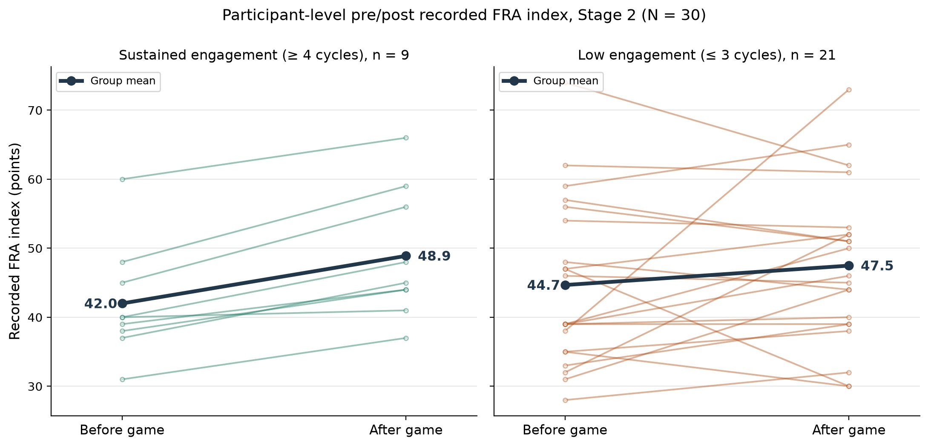
Figure 5.4. Participant-level pre/post recorded FRA index (standard-mode baseline to final play; provenance in §5.5) for the Stage-2 cohort (N = 30), by engagement group. Thin lines are individual participants; the bold line is the group mean (sustained: 42.0 to 48.9; low engagement: 44.8 to 47.6). Generated from the archived dataset (Appendix G, item G.2). Higher index values indicate better performance (InBody Co., Ltd., 2022).
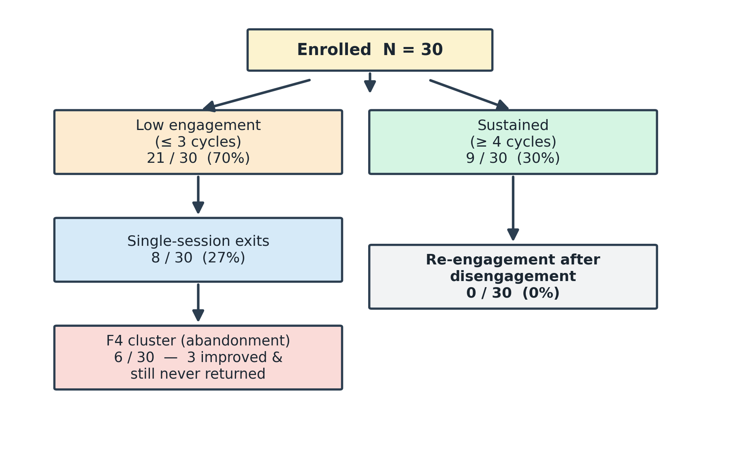
Figure 5.5. Participant flow diagram (Stage 2, N = 30): no re-engagement was observed among the twenty-one low-engagement participants during the eight-week study window.

5.5A Translating the Findings into Design Priorities: Qualitative Requirements Mapping
The statistical analysis describes observed engagement and score changes; it does not determine which design feature will improve subsequent outcomes. Quality Function Deployment (QFD; Akao, 1990; Chan & Wu, 2002) informs the qualitative requirements mapping used here. Findings are translated into candidate user needs and related to technical features through explicit design reasoning. The present mapping is not a completed quantitative House of Quality and does not estimate feature effectiveness. Its purpose is to make the proposed transition from observed difficulty to a revised intervention reviewable and testable.
Table 5.3 presents the deployment matrix. The rows are candidate user needs interpreted from the Stage-1 survey, Stage-2 behavioural records and Stage-2 self-reports, each linked to its motivating finding and a relevant TAM, STAM or Octalysis construct. The columns are the game's technical characteristics: the adaptive difficulty layer (§5.3.5), the loss-free dynamic game states (§5.3.10), the proposed trajectory display (§5.3.10) and the coaching protocol (§7.5). The coin-reward loop enters the matrix as evidence under the reward-for-effort need rather than as a separate column. A strong relationship (●) records an intended direct contribution to the need; a moderate relationship (◐) records an intended partial or indirect contribution; a blank cell indicates no designed relationship. These symbols express the design rationale, not measured causal effects.

Table 5.3. Qualitative requirements mapping (QFD-style): user needs evidenced by the Stage-1 and Stage-2 data, mapped onto the game's technical characteristics. ● strong designed relationship; ◐ moderate or indirect relationship.
User need (voice of the user) | Evidence from the data | Construct | Adaptive difficulty (§5.3.5) | Loss-free states (§5.3.10) | Trajectory display (§5.3.10) | Coaching (§7.5)
Challenge that matches my ability | 70.0% disengaged at ≤3 cycles; satisfaction 9/9 among sustained vs 11/21 (p = .013) | Flow / PEOU (TAM) | ● | ◐ |  | ◐
Failure must not feel like a verdict about me | 0/21 re-engagement after disengagement; Stage-1: ~74% adverse first experience among prior users | Loss aversion / D8 (Octalysis) | ◐ | ● | ◐ | ●
Visible personal progress | Recorded index and self-report diverge (5/8 single-session positive change, 2/8 felt improvement) | Competence (SDT) / D2 |  | ◐ | ● | ◐
Understandable, non-clinical feedback | 60.0% self-reported improvement; satisfaction associated with staying | Gerontechnology anxiety (STAM) |  | ◐ | ● | ●
Reward for effort, not only outcome | Coin loop sustained play in completers (≥4 cycles: 9/30) | Learn-to-earn / D4 | ◐ |  | ◐
A reason to come back | No observed return in Stage 2 (0/21); the cross-stage return contrast is reported in Chapter 6 | Behavioural intention (TAM/STAM) | ◐ | ● | ● | ●

Read column-wise, the mapping proposes candidate responses to the observed difficulties. Difficulty adjustment addresses the hypothesis that challenge and capability were poorly aligned; non-terminal states and coaching address the possible significance of verdict-like feedback; and the trajectory display addresses the question of whether users can recognise meaningful progress. None of these needs is uniquely identified by the engagement results. A trajectory display also creates a measurement obligation: it must distinguish improvement at comparable demand from improved performance produced by easier tasks or greater assistance (§7.4). Read row-wise, the mapping offers more than one potential response, allowing subsequent evaluation to compare alternatives. Each relationship should therefore become a prospective question about feasibility, user experience and outcomes, with the limitations in §5.9 and §8.6 bounding the present claims.

5.6 The F4 Cluster and the Recorded-Score–Engagement Discrepancy
A recorded observation sequence from the deployment gives the discrepancy its field texture, and it is the cause-and-consequence chain from which the FIAS construct was subsequently built. The researcher's field notes record, in this order: several players acknowledged the benefits of the FRA and recorded positive index gains through game play; across their second and third cycles the same players encountered recurring in-game failure events - obstacle hits, falls, low-scoring runs - and gave up despite the recorded gains; and as dropouts accumulated, remaining players saw that many of their peers had stopped attending, and that visible thinning of the group contributed to further abandonment. Provenance is stated plainly: this is the researcher's field-note record, retrieved from the archive in September 2026 during examination-driven verification; it is a recorded qualitative sequence, not an instrumented measure, and no per-participant counts attach to it. Three readings follow, each taken up elsewhere. Failure events outweighing recorded gains in the participants' own weighing is the loss-aversion signature the FIAS account formalises (§5.7). Under the coupled deployment each in-game failure carried the assessment frame's verdict meaning (§5.2A) - the attachment Stage 3 examines by removing it. And the visible-dropout effect is a within-deployment social channel, taken up with the group-narrative account in §8.6B and the panel's group-dynamics interpretation in §6.8A.
The sustained participants' interview record, entered in the author's entry-and-results sheet and archived with the raw data (Appendix C), adds documented texture on the persistence side of the same discrepancy. All nine would play the game again and all nine were willing to continue using the FRA; enjoyment and perceived usefulness were rated high (means 4.3 and 4.7 of 5) with low discouragement (mean 1.9), and self-rated steering and recovery confidence averaged 7.4 and 7.7 of 10 - measures that exist only for the nine and cannot speak to the dropouts' self-appraisals. Two of the nine spontaneously puzzled over the non-participants ('don't know why others don't try') - the sustained side of the visible-participation channel taken up in §8.6B. Four of the nine criticised the game's visuals as weak or childish even while rating the experience highly, an echo of the infantilisation risk raised in the expert consultations; and one record contains an internal contradiction (usefulness disclaimed in one item, endorsed in another), retained as recorded. The exact administered wording of the instrument awaits verification against the paper forms (Appendix C).
A provisional FIAS composite score was applied to the thirty participants using STAM- and Octalysis-derived attributes. The composite is assembled from thirteen binary attributes drawn from STAM and selected Octalysis drives and is reported on a 0–10 range; the rule that maps the thirteen items onto that range is specified in the codebook in Appendix B. A structural caution applies before any use is made of the distribution: several of the thirteen attributes record engagement and exit behaviour, so a participant who abandoned early necessarily scores high — the clustering of the F4 participants at the top of the scale is therefore partly true by construction, and the composite carries no evidential weight in this thesis. It is retained only as a descriptive case-identification device for referring to the F4 cluster; every evidential statement in this section rests on the directly observed behaviours — single-session exit, non-return during the observation window, and the divergence between recorded score direction and return. Six participants clustered at scores 9-10 (F4). Three of the six recorded positive change in the FRA index during their single session and did not return during the observation period. This recorded-score–engagement discrepancy is an engineering problem: positive recorded change did not coincide with continued use in these cases. It does not uniquely distinguish FIAS from acceptance or continuance explanations. A user may improve at an activity while still finding it uninteresting, burdensome, insufficiently relevant or associated with unwelcome consequences. Identity-relevant endowment, as proposed in Table 2.1, is one possible explanation among these alternatives. The observation shows a divergence between recorded score direction and return behaviour; it does not by itself establish clinical benefit, mental-account closure or identity protection. The F4 cluster is a subset of the eight single-session exits reported in §5.5; the remaining two single-session participants also recorded a positive change, so across all single-session exits the divergence held in five of eight cases, and none of the eight returned.
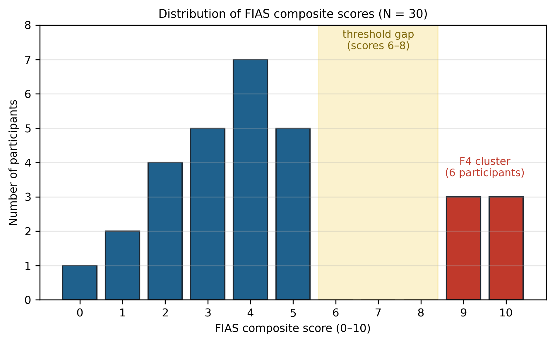
Figure 5.6. Distribution of provisional FIAS composite scores across all 30 participants. The composite includes engagement-outcome attributes, so the separation of the F4 cluster is expected by construction; the figure is descriptive case identification, not evidence (§5.6).
The empty interval between scores 5 and 9 is not read as evidence of a behavioural discontinuity. Given the construction above, it may be a mechanical effect of the scoring thresholds and the outcome-linked items (criterion contamination), or sampling variation in a cohort of thirty. The item-level codebook — all items, weights, decision rules and missing-data handling, with cycle count and non-return excluded from any predictor score that would then be claimed to predict the same outcome — is specified as a deliverable of the confirmatory study (§8.8); pending it, the composite serves only as the descriptive case-identification device described above and carries no evidential weight. The F4 cluster rests on six participants, so every mechanism claim based on it is provisional until two independent coders apply a fixed rubric with reported agreement and the construct is evaluated in an external sample. A nine-question F4 interview protocol was designed (Appendix C) but not administered in Stage 2; no F4 interview data exist, and the protocol is retained for the confirmatory programme (§8.8). The Stage-2 qualitative record instead comprises the after-game questionnaire completed by all participants and post-deployment interviews with the sustained participants (Appendix C).

5.7 Theoretical Extension: Endowment, Stereotype Threat, Domain Reframing
Stage 2 extended the FIAS hypothesis with three candidate theoretical components, each of which occupies a row of Table 2.1. First, identity-relevant endowment (row two) conceptualises resistance to unfavourable revaluation of a valued health self-concept — the discrepancy in §5.6 is compatible with this account but is not a distinctive diagnostic signature. Second, stereotype threat (row four) is one possible trigger by which clinical and age-related cues make decline salient. Third, mental accounting (row three) implies the candidate intervention: if the clinical frame is what sorts the session into a high-stakes health account, then presenting the same task as a coordination challenge should change the meaning of failure. That is the prediction Stage 3 was designed to probe. These operators were not directly measured, so H5 was framed as a directional test — whether a participant-facing decoupling package is associated with more post-failure return — not as a definitive test that domain reframing 'prevents FIAS'.
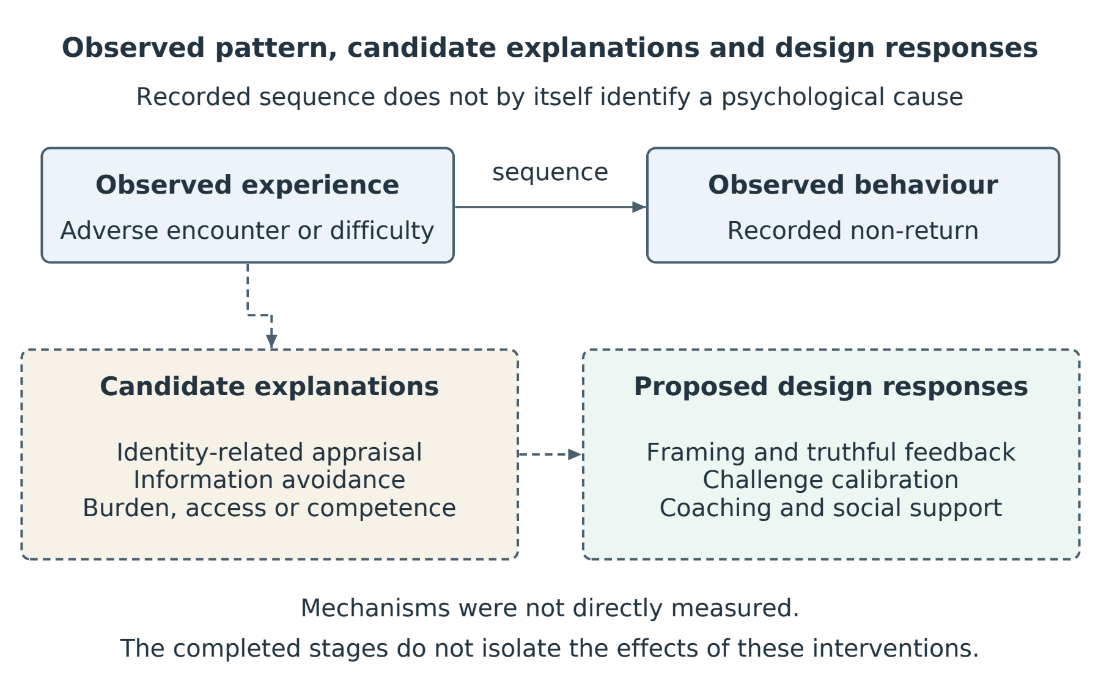
Figure 5.7. Observed non-return and candidate explanatory pathways. Identity-related appraisal, information avoidance and practical burdens remain hypotheses; none was measured as a causal mechanism. The proposed responses require prospective comparison.

5.8 Information-Entropy Lens
The entropy language in this thesis is a bridge model, not a measured result. The archived Stage-2 dataset does not preserve timing between events, so no temporal claim about the interval between first failure and final interaction is made. Whether a belief changed, when it changed, and whether an information-theoretic entropy reduction occurred are propositions that require repeated belief elicitation before and after a failure event.

5.9 Limitations and What Stage 2 Establishes
Stage 2 is an exploratory field study, and its boundaries are part of its design rather than flaws discovered afterwards. The sample is small, single-site and not demographically diverse, which is what allowed an embedded researcher to watch every participant's journey closely; the observation window is eight weeks, long enough to see the abandonment pattern form but too short for claims about sustained use beyond it. The archive holds cycle counts and pre/post scores rather than timestamps, so the temporal structure of disengagement could not be analysed and remains a question for the instrumented next study. The recorded index derives from a baseline value and from each participant's final play (§5.5), on a single instrument whose short-interval test-retest variability is non-trivial (Kim et al., 2018), so within-deployment change is read as a promising signal to be confirmed. Self-reports were gathered by facility staff, whose familiarity put participants at ease but may also have inclined answers toward courtesy, particularly since participants knew the deployment was a facility initiative — both effects are acknowledged. The week-2 motivational-orientation classification was withdrawn when its coding records could not be produced (§5.5); the provisional FIAS composite reuses cycle-count information and awaits its independent codebook; FES-I was not available as a baseline covariate and joins the baseline battery in the confirmatory study; the embedded investigator was not complemented by an independent observer; and the clinical meaning of short-term index change is a question this thesis deliberately leaves to clinical colleagues. The cohort is additionally self-selected: thirty of the 200 invited Stage-1 respondents joined (§5.4), so the sample over-represents residents already willing to approach the station - the observed refusal of the remaining 170 sits outside the analysed data, while the early drop-off reported in §5.5 occurred within this already-willing minority.
What Stage 2 establishes is narrower and stronger: within the eight-week deployment, early disengagement was common (exits clustered at or before three cycles; the archive preserves cycle counts, not timestamps, so no time-to-event claim is made); no re-engagement was observed among low-engagement participants; and a small subgroup showed positive recorded score change without return. Stage 2 also generated candidate mechanisms and the decoupling hypothesis for Stage 3. It does not validate the FIAS composite, prove permanence, verify mental accounting or stereotype threat, or establish that score improvement was clinically meaningful. In the terms set by Chapter 2, these observations did not support the original design expectation labelled H0 (§2.3.5). Designing the intervention around acceptance and gamification principles was insufficient to secure the anticipated engagement in this deployment. That finding motivates refinement of the intervention and its explanatory assumptions; it does not reject the acceptance and gamification literatures or establish that adaptive learning is the only effective response.

Chapter 6 Stage 3 — Participant-Facing Decoupling: Between-Cohort Evidence for a Frame-Sensitive Account

6.1 Why a Decoupling Stage
The engagement observed in Stage 2 did not support the original design expectation and left several explanations open. One was a frame-sensitive account: clinical and assessment-related cues might alter the meaning of difficulty and discourage return. Alternatives included the game's demands or appeal, participants' health and prior experience, practical burdens and the facility context. Stage 3 examined a decoupled implementation in a separate cohort to establish whether return after initial disengagement was possible under that redesigned package. A broad claim that older adults cannot engage with gamified activities would predict little engagement even there, but that universal claim is not the only substantive alternative to the framing account. Stage 3 therefore provides a non-equivalent-cohort comparison that motivates direct causal testing; it does not identify clinical coupling as the cause of the Stage-2 result. Two questions carried over from Stage 2: whether participants would recognise the activity as a coordination challenge and whether post-failure return would occur after the participant-facing clinical cues were removed. Because the formal Stage-2 motivational classification was withdrawn (§5.5), Stage 3 does not test change in that classification. Cohort, setting, platform and recruitment changes remain part of the observed comparison.

6.2 Research Question and Predictions
Stage 3 examined three directional expectations associated with the frame-sensitive account. First, observed non-return under the decoupled implementation would be lower than the Stage-2 rate. Second, some initial dropouts would return. Third, most participants would recognise the activity as a coordination challenge and a substantial proportion would express regular-use intention. The coordination-endorsement item is a check on recognition of the intended participant-facing frame; it does not measure motivational orientation. The multi-age cohort also permits an exploratory test of H0-age, the equal-proportions null examined after the age-stratified data were tabulated (§3.5). An age difference within the decoupled implementation can reveal remaining age-associated barriers, but cannot distinguish identity-related appraisal from other mechanisms or estimate an age-by-clinical-framing interaction.

6.3 Methodology: A Participant-Facing Decoupling Package in a Separate Cohort
Stage 3 evaluates a participant-facing redesign package in a separate cohort. Stage 2 used a coupled clinical-game context that included an InBody body-composition scan, clinical pass/fail language, parallel clinical recording and repeated use of the term "assessment". Stage 3 removed these participant-facing clinical cues by moving the game off the clinical apparatus altogether: the game was ported to an HTML build and sent to participants by e-mail, no pre-session InBody scan was conducted, the activity was presented as a purely-fun coordination game, clinical labels were removed, and the interface was re-skinned. The skiing mechanic, five-attempt rule and session structure were retained in the ported build; the pressure-panel apparatus, the clinical setting and in-person supervision were not. These changes constitute a multi-component decoupling package. The design retains the game mechanics but does not isolate lexical framing from procedural, architectural, platform and setting changes, nor from between-cohort differences. The decoupling operated at the artefact level rather than by concealment: the invitation e-mails openly disclosed the doctoral research context, including the programme's fall-risk origin, but the activity itself carried no assessment framing and delivered no health verdict. The disclosed origin and redesigned activity need to be considered separately: return occurred in a setting where the research origin was disclosed and the activity delivered no health verdict. This observation does not isolate the influence of participants' knowledge, the interface response to difficulty or the other changes between stages.

6.4 Participants and Apparatus
One hundred and twenty adults aged 25-80 were recruited through the author's Hong Kong-based networks — family and personal contacts, work contacts, a charity community network, university support channels and working peers in medical centres — in three age bands: 38 aged 25-44, 41 aged 45-64 and 41 aged 65-80. The invitation e-mails disclosed the doctoral research context, including the programme's fall-risk origin, while presenting the activity itself as a purely-fun coordination game; the game and its instructions carried no medical or fall-prevention language and delivered no clinical output. The distributor-tier invitations are archived (Appendix G, item G.5). Each participant received the HTML build by e-mail and played on their own computer, with a trackpad or arrow keys, or a foot-pad sensor where one was available; play was unsupervised. Of the 120 participants, 48 were male and 72 female, and all reported high-school education or above.
Two recruitment decisions were deliberate. First, the Stage-2 facility was not re-used for the decoupled deployment: its residents already carried direct experience of the coupled system, and their prior exposure and attitudes would have contaminated a test of how the decoupled frame is received on first contact. A separate cohort was therefore a design choice, not only a constraint. Second, distribution deliberately extended beyond the author's immediate circle: the organisations and contacts who received the build forwarded it onward, so that a portion of participants were personally unknown to the author. This onward (snowball) distribution broadened recruitment beyond direct acquaintances, but does not quantify or eliminate selection associated with personal networks, interest or obligation to intermediaries.
Stage-3 data collection is complete. The participant-level records are the participants' returned materials: each participant e-mailed back the results file logged by the HTML build (a CSV including the session score and game-logged data) together with their questionnaire responses. Three outcome definitions are used throughout this chapter. Initial dropout denotes a participant whose returned logs show disengagement after the first play contact — an incomplete first session, or no second session within the study window. A return denotes a subsequently logged completed session after an initial dropout. Observed non-return denotes an initial dropout with no returned session inside the study window, and end-of-window retention is its complement over the cohort: a participant who dropped out initially and later returned counts as retained. The single term end-of-window retention is used throughout this chapter for that construct. The chapter reports the aggregate record compiled from the returned files. The data logbook (Appendix G, item G.3) compiles the participant-level records from the returned files received to date; its reconciliation sheet recomputes every indicator from the participant-level entries, so the compilation can be verified against the record.

6.5 Findings: A Substantial Behavioural Shift
Table 6.1. Stage-3 overall engagement and dropout (N = 120).
Engagement metric | Count | Percentage
Initial dropout | 23/120 | 19.2
Returned after dropout | 15/23 | 65.2
Observed non-return at end of Stage-3 window | 8/120 | 6.7
Overall retention | 112/120 | 93.3
Return rate among initial dropouts | — | 65.2

The older Stage-3 group showed substantial engagement with the decoupled implementation: end-of-window retention was 85.4% in the 65–80 band, ten of sixteen initial dropouts returned, and a majority expressed regular-use intention. These observations show that engagement and return were possible among older participants in this implementation. They are consistent with a frame-sensitive explanation, but do not establish that the game or participants were uninvolved in the Stage-2 difficulty, or that the theory stack was validated. The cross-stage contrast in observed return is substantial, while its causal interpretation remains bounded by separate cohorts, settings, recruitment channels and observation structures. Within Stage 3, initial dropout increased with age (0.0%, 17.1%, 39.0%; chi-square across bands p < 0.001), providing exploratory evidence against equal dropout proportions. Because all three bands received the decoupled condition, this result indicates that age-associated barriers remained despite the redesign. It cannot identify the burden imposed by clinical coupling or locate the explanation specifically at identity level. Motor demands, familiarity, fatigue, interest and identity-related appraisal remain plausible contributors. Participation, retention and regular-use intention are distinct outcomes and should not be collapsed into a claim that every participant accepted the game in the same sense.
Table 6.2. Stage-3 age-stratified engagement.
Age band | n | Initial dropout | Returned | Observed non-return | Retention
25–44 | 38 | 0 (0.0%) | 0 | 0 (0.0%) | 100.0%
45–64 | 41 | 7 (17.1%) | 5 | 2 (4.9%) | 95.1%
65–80 | 41 | 16 (39.0%) | 10 | 6 (14.6%) | 85.4%
Total | 120 | 23 (19.2%) | 15 | 8 (6.7%) | 93.3%

The 65–80 band is the closest available age comparator to the Stage-2 residential cohort; it is not a matched group. In this band, 10 of 16 initial dropouts returned (62.5%; 95% CI 38.6–81.5%, Wilson interval). In Stage 2, 0 of 21 low-engagement participants returned within the eight-week observation window (95% CI 0.0–15.5%). The intervals describe sampling uncertainty around the group-specific proportions, but do not account for cohort differences or establish a causal effect. Return is also conditional on an earlier engagement outcome: the people selected into the dropout subgroup under one implementation need not resemble those selected under another. The pooled Stage-3 65.2% figure and the older-band result are therefore descriptive comparisons. A future causal evaluation should prioritise an outcome measured for all assigned participants and treat return conditional on dropout as a secondary, selection-sensitive analysis.
Coordination-challenge endorsement reached 71.7% (86 of 120), indicating that most participants perceived the intended frame. Regular-use intention reached 63.3% overall and 56.1% in the 65-80 band. No comparison is made with the Stage-2 motivational-orientation classification, which has been withdrawn (§5.5). The Stage-3 item is best interpreted as a manipulation check, whereas the regular-use item is a stated intention that may not predict longitudinal use.
Table 6.3. Stage-3 coordination endorsement and regular-use intention by age band.
Item | Younger 25–44 | Middle 45–64 | Older 65–80 | Total
Coordination-challenge endorsement (framing manipulation check) | — | — | — | 71.7%
Would use regularly if accessible | 65.8% | 68.3% | 56.1% | 63.3%
Interpretive note: coordination endorsement tests whether the participant recognised the presented activity as a coordination challenge. It is a frame-recognition measure and is not read as a measure of motivational orientation.
Note on Table 6.3: coordination-challenge endorsement is reported as a total (86 of 120, 71.7%); per-age-band endorsement counts are not reported in this thesis, and no per-band endorsement claim is made.
The strongest Stage-3 behavioural outcome is observed return after initial dropout, particularly the 62.5% return in the 65-80 band. Stated intention and frame endorsement are supportive secondary outcomes, not substitutes for longitudinal behaviour.
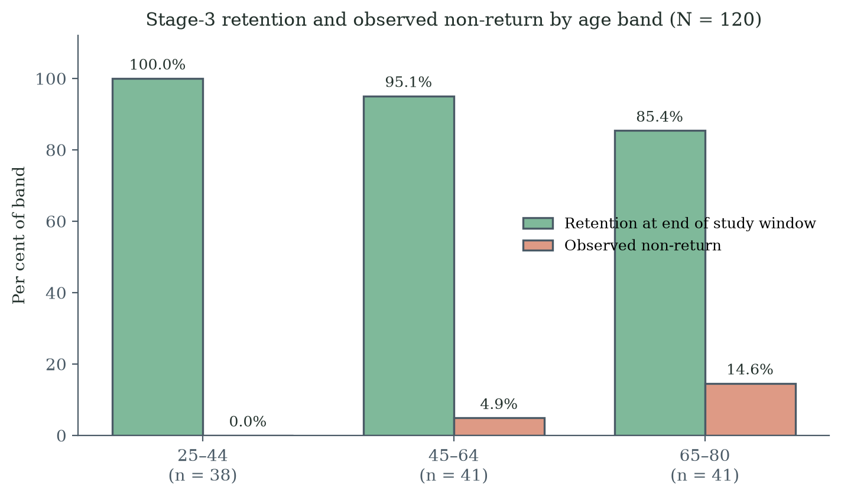
Figure 6.1. Stage-3 retention and observed non-return at the end of the study window by age band (N = 120).
Figure 6.1 was regenerated directly from the counts reported in Table 6.2.
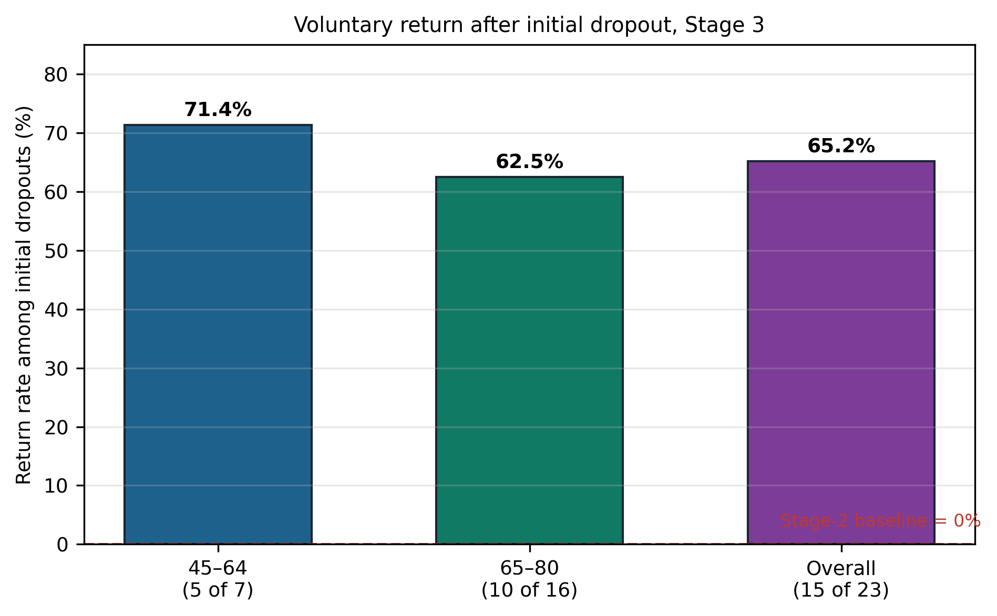
Figure 6.2. Observed return after initial dropout by age band in Stage 3, including 62.5% in the 65–80 band. The zero-return line refers descriptively to the separate Stage-2 cohort; it is not a repeated-measures baseline or an estimate of the causal benefit of the Stage-3 package.

6.6 The Recorded-Score–Engagement Discrepancy Reconsidered
Stage 3 deliberately did not collect participant-level clinical balance telemetry, so the Stage-2 score-improvement/non-return pattern cannot be replicated directly. What Stage 3 measures is a different outcome: whether participants who initially disengaged returned under a participant-facing decoupled condition. Fifteen of twenty-three did so. This finding is consistent with the proposition that an adverse gameplay event need not become an absorbing non-return state under decoupling. It does not demonstrate that the proposed mental account remained open, that the Stage-2 discrepancy was resolved, or that the same individuals would have behaved differently under the coupled condition. The studies document different co-occurrences: some Stage-2 participants recorded positive score change without return, whereas some Stage-3 participants returned after initial disengagement. Their comparison motivates further study of the relation between experience, perceived progress and continued participation, without showing that the same people changed behaviour because of the frame.

6.7 Frame-Sensitive versus Dispositional Accounts: Calibrated Inference
The Stage-3 result is inconsistent with the strongest purely dispositional prediction that post-failure return would remain near zero regardless of frame and context. It is consistent with a frame-sensitive account in which participant-facing clinical cues contribute to the meaning of failure. However, the design cannot attribute the difference exclusively to framing because the cohorts differed in setting, recruitment, residential status, age distribution, health profile, prior exposure and potentially staff interaction and observation window. The evidence therefore supports a frame-sensitive interpretation without rejecting every dispositional or contextual contribution. The combined evidence motivates a candidate scope condition: engagement may depend partly on how a gamified activity communicates consequential judgements about the user. FIAS names one proposed explanation of that relationship. Neither the psychological mechanism nor the proposed boundary of gamification theory has been established by the present comparison. The engineering contribution is to translate this candidate explanation into an explicit redesign and evaluation programme.
The principal causal test proposed is a within-cohort randomised comparison with harmonised eligibility criteria, staff scripts, software, measures and follow-up. Until that study is completed, the thesis's calibrated claim is that participant-facing decoupling was associated with substantially greater post-failure return in a separate cohort, and that the pattern warrants direct causal testing.

6.8 The Commitment Gap and Its Design Implication
In the 65–80 band, end-of-window retention was 85.4% and stated regular-use intention was 56.1%, a difference of 29.3 percentage points. These are marginal proportions for different constructs: observed retention and hypothetical future intention. Because retention as defined includes recovered dropouts (§6.4), the 29.3-point contrast is between end-of-window engagement and stated intention, not between uninterrupted play and intention. They do not reveal which retained individuals intended regular use, so the difference is not an observed within-person conversion loss. It is a design diagnostic that raises questions about continuing value, burden, access and enjoyment. Decoupling was associated with substantial engagement in this cohort, but its effectiveness as a route to regular clinical participation remains untested. The clinical purpose also remains central to the innovation's intended value. The design question is therefore how to communicate that purpose honestly, preserve meaningful challenge and support a reason to return, while maintaining credible evidence of what is improving.
The programme proposes adaptive learning as one response (§2.6.2A–B): challenge and support would be adjusted to the user, and feedback would help the user interpret performance in relation to a developing capability. Such a system must not imply improvement merely because tasks become easier, rewards increase or assistance is added. A credible progress display needs separate information about comparable-task performance, the challenge attempted and the support provided; when a substantial redesign changes what is measured, the comparison must be bridged through evidence or presented as a new baseline (Chapter 7). Within the thesis title, continuous improvement concerns this evidence-guided learning process, and innovation enhancement concerns the evaluated revision of the intervention when the existing design encounters difficulty. Neither requires a continuously rising score: an unsuccessful attempt can identify a limitation and inform a better next step, while remaining an unsuccessful attempt. The present data motivate this design hypothesis but do not establish its efficacy, necessity or ability to make clinical reattachment safe. Anticipated fatigue, access barriers, scheduling burden, insufficient relevance, motor difficulty and limited enjoyment remain plausible explanations for the retention–intention discrepancy. Prospective evaluation must therefore combine longitudinal behaviour with measures or interviews addressing competence, autonomy, burden, enjoyment and identity relevance, and compare adaptive learning with other plausible design responses.
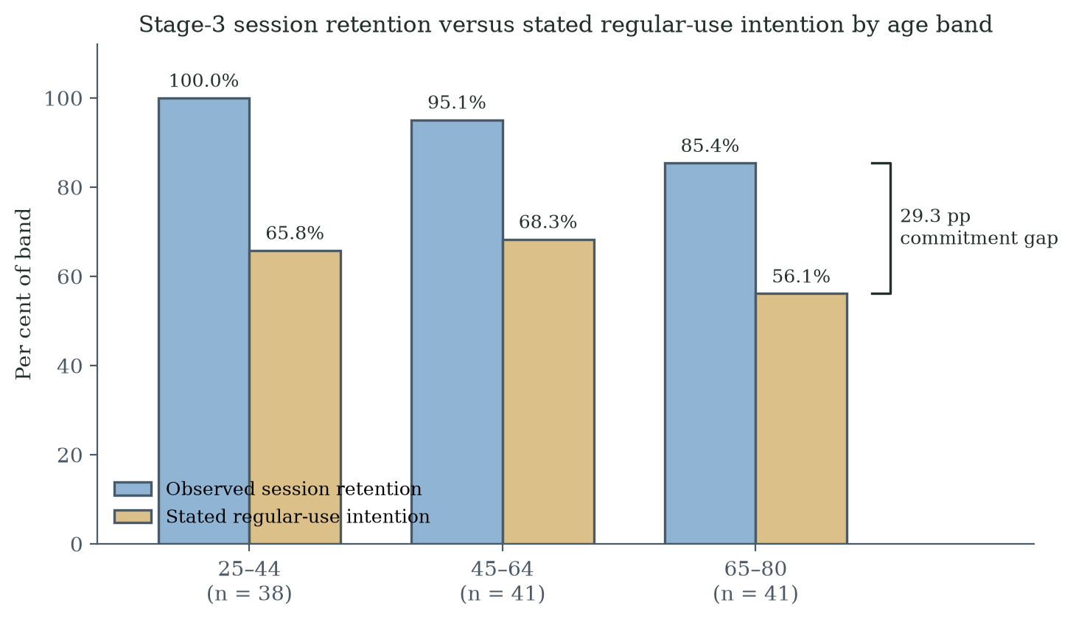
Figure 6.3. End-of-window retention and regular-use intention by age band. In the 65–80 band the marginal proportions differ by 29.3 percentage points; the figure does not show an individual-level transition from retention to intention.

6.8A The Commitment Gap Read Through Group Dynamics: The First Interpretive Consultation (Dr Yuan)
The interpretation of the commitment gap was examined after the empirical programme through expert consultation, beginning with Dr Sarah C.W. Yuan of the Center on the Family, University of Hawai'i at Mānoa — a medical sociologist and demographer of aging whose work includes the Hawai'i Healthy Aging Partnership and statewide community falls-prevention programming. Her field of practice is deliberately distant from this programme's apparatus: group exercise and physical games for balance, with no electronic game and no clinical instrument attached to the activity. The consultation is reported as interpretive evidence from an independent discipline, not as additional participant data; the record is the author's structured notes, reproduced in Appendix H.
Three of her observations bear directly on this thesis. First, from her programme experience and publications: older adults who join social exercise groups tend to drop out after a failure unless a physician, assistant or coach helps them past the rejection; with a group around them and a coach who leads them to continue, they perform and persist markedly better. Failure-linked dropout therefore appears even in her setting — with no clinical attachment at all — and is recoverable through human support. Second, in her experience older adults intrinsically avoid straight clinically oriented individual assessment of their current health status: they fear facing a negative risk result, and psychologically avoid the clinical evidence that would describe their condition. This is a practice-based interpretation consistent with the proposed avoidance account; it does not distinguish identity-related threat from other reasons to avoid unwelcome health information. Third, she regards gamification as very effective for promoting health technology — and expects hard rejection precisely when the game or exercise is linked to clinical results. On that basis she explicitly supported the Stage-3 decoupling design, and she supported the FIDS-to-FIAS construction and the adaptive-learning proposition as consistent with the elderly behaviour she has observed.
The consultation adds a candidate social explanation and design considerations that the programme's participant data did not directly measure. In her account, partnering, group play and a coach who leads the activity reduce initial dropout and, downstream, abandonment of the technology; and the components that support adoption extend beyond engineering excellence and design to the environment, the people using the same technology, and predictable or expected results. The mapping onto the framework is direct: the coach and the group correspond to the staff coaching layer (L6, §7.5.3) and motivate a group-deployment variant of the protocol; predictable or expected results motivate clearer explanation of task demands and feedback in trajectory installation (P2), although a visible trajectory does not necessarily make outcomes predictable or non-threatening. Her account also refines the Chapter 2 caution that social influence (Octalysis D5) can be double-edged for older users: structured group dynamics with a leading coach appears protective in her experience, whereas unstructured peer comparison may still threaten identity — a distinction the §8.8 study can operationalise. The evidential limits are stated plainly: this is one consultation, recorded in the author's notes; it is interpretive support from an adjacent discipline, not validation; and its observations concern physical group exercise, so their transfer to electronic games is an argued expectation rather than a demonstrated result.

6.9 Limitations of Stage 3
Stage 3 is a between-cycle, between-cohort comparison and supports associations rather than isolated causal effects. The decoupling package was delivered through an e-mailed HTML build played without in-person supervision, so platform, input device, setting and supervision changed alongside participant-facing clinical cues; dispersed home play also removed the communal setting in which peers' dropout had been visible in Stage 2 (§5.6), a further component of the package. Volunteer and network recruitment limit representativeness; short follow-up limits conclusions about continued use; and the cultural setting limits transferability. Mental accounting, loss aversion, identity protection and stereotype threat were not directly measured. The framing item measures recognition of the presented activity only, and the complete adaptive-learning framework was not deployed. Return after initial dropout was common in Stage 3 and absent in the reported Stage-2 low-engagement group, but conditional subgroup selection and other cross-stage differences limit causal interpretation. The result motivates a harmonised comparison and direct appraisal measures rather than establishing the mechanism or efficacy of the proposed redesign.

6.10 Quantitative Comparison Against Existing Models
This section specifies a comparison; it does not report one. The comparison has not been executed, and the quantitative advantage of the FIAS-augmented specification is therefore hypothesised, not demonstrated. This section records a prospective analysis architecture; the final executable protocol must be fixed before analysis of a suitable new dataset. A persistent question is whether FIAS adds incremental explanatory power beyond what TAM, STAM and a simple usage-attrition baseline can already explain. The Stage-2 and Stage-3 datasets do not yet allow a definitive nested-model comparison, but the architecture of such a comparison is set out here to make the next evaluation requirements explicit. The architecture remains available for any future dataset that includes harmonised STAM instrumentation alongside FIAS coding.

6.10.1 Three-Tier Nested Model Specification
The planned comparison is structured as three nested models with an observed non-return outcome defined over a common, pre-specified window and a time-to-observed-dropout outcome. The final protocol must define the target population, prediction time, outcome and intended decision, and prevent predictor–outcome overlap: any FIAS score used as a predictor must exclude cycle count, return status and other elements that define the outcome. Appraisals recorded after a first difficulty cannot be treated as baseline predictors; they require an explicitly defined post-event prediction time. Sample-size planning must count predictor parameters, including categorical levels, nonlinear terms and interactions, and justify the expected outcome events and precision. The eight observed Stage-3 non-return events are insufficient for the proposed multivariable architecture, which is accordingly reserved for a separately designed future dataset.
Table 6.4. Three-tier nested model specification for the FIAS-vs-TAM/STAM quantitative comparison.
Model | Predictors | Construct represented
M0 Demographic baseline | Age band, sex, education, baseline FES-I, fall history | Standard control covariates
M1 STAM-only | M0 + PU, PEOU, gerontechnology self-efficacy, gerontechnology anxiety, social influence, facilitating conditions | Senior acceptance and use-related beliefs; incremental prediction to be evaluated
M2 STAM + FIAS operators | M1 + first-failure event, frame condition, prospectively measured identity-threat/appraisal score, WTA-WTP proxy, mental-accounting frame score, and non-outcome FIAS indicators | Prospective frame-sensitive account; predictors must precede the prediction interval and exclude outcome-defining variables; the model has not been estimated

In the proposed comparison, M0 versus M1 assesses the contribution of the senior-acceptance variables beyond the specified baseline covariates. M1 versus M2 then assesses the incremental contribution of the candidate FIAS variables. Neither comparison has been estimated in the present programme.

6.10.2 Statistical Comparison Plan
Three classes of comparison statistic are proposed for the final protocol. First, a likelihood-ratio test of M2 versus M1, with degrees of freedom equal to the added model parameters where the fitted models satisfy the test's assumptions. Second, an information-criterion comparison using ΔAIC and ΔBIC as descriptive evidence of relative fit. Third, discrimination and calibration, including McFadden's pseudo-R² change, AUC for observed non-return over a common pre-specified window, and appropriate calibration assessment. For time-to-event outcomes — available only once session timestamps are captured, which the Stage-2 archive did not do — the plan uses Cox partial-likelihood ratio tests and Harrell's C-index. Any use of IDI should be justified and interpreted cautiously. No Stage-2 survival estimate is carried forward, because the Stage-2 archive contains no time variable; the Stage-2 anchors are the engagement and paired-change statistics of §5.5. Before recruitment, the protocol must also specify the modelling family, missing-predictor handling, any regularisation, and resampling or external validation, with uncertainty reported for performance differences. These decisions should reflect the available event information rather than a nominal total sample alone.

6.10.3 Decision-Curve Analysis and Practical Significance
Statistical significance alone is neither necessary nor sufficient for decision value. Decision-curve analysis (Vickers & Elkin, 2006) is proposed to examine the consequences of using a model to trigger a specified action, such as an offer of coaching. Its use requires an explicit service context, a plausible threshold range, and defensible consequences for missed non-return and unnecessary intervention. Calibration and validation must precede deployment of a decision rule. A favourable comparison of model net benefit would concern the decision rule under those assumptions; it would not establish that the proposed coaching or frame switch causally improves engagement. That intervention effect requires separate evaluation.

6.10.4 Pre-Specified Predictions
The prospective hypothesis is that FIAS-specific appraisals measured before the prediction interval improve prediction beyond demographics and STAM. This remains a future test. Incremental value should be judged against a predefined decision objective using the magnitude and uncertainty of changes in fit, calibration, discrimination and, where justified, net benefit. A non-significant likelihood-ratio test alone does not demonstrate no value, just as a significant test does not establish practical usefulness or construct validity. The analysis should report optimism-corrected or externally validated performance and revise or reject the augmented specification if it fails to meet its predefined performance requirements.

6.10.5 Provisional Estimates from the Existing Datasets
The Stage-2 early-disengagement proportion (70.0%, 95% CI 52.1–83.3%) and the Stage-3 observed non-return proportions provide provisional effect-size anchors. A formal pooled or nested analysis is not appropriate until a future dataset uses harmonised recruitment, covariates, measures, outcome definitions and observation windows.

6.11 Consolidated Statistical Results
The key quantitative claims of Stages 2 and 3 are reported in different sections and in different notations. Table 6.5 consolidates them so that the point estimate, the interval, the sample size and the test behind each claim can be assessed at a glance.
Table 6.5. Consolidated statistical results for the key contrasts of Stages 2 and 3.
Contrast or quantity | Estimate | 95% CI | n | Test / source
Early disengagement, ≤ 3 cycles (Stage 2) | 70.0% | 52.1–83.3%* | 30 | Wilson score interval; Table 5.2. (Survival modelling withdrawn: no time variable in the archive; §5.5)
FRA index change, sustained participants (Stage 2) | dz = 2.22 (paired); mean +6.9 points | dz 0.95–3.46; mean 4.5–9.3 | 9 | Paired t and Wilcoxon; §5.5
FRA index change, all participants (Stage 2, archived paired data) | dz = 0.42; mean +4.0 points | dz 0.05–0.79; mean 0.5–7.6 | 30 | Paired t and Wilcoxon; §5.5
Satisfaction association with sustained engagement (Stage 2) | 9/9 vs 11/21 satisfied; observed difference 47.6 pp | Not estimated | 30 | Fisher's exact p = 0.013 (exploratory, unadjusted); §5.5
Re-engagement after dropout (Stage 2) | 0.0% | 0.0–15.5%* | 21 | Wilson score interval; Table 5.2
Return after initial dropout, all bands (Stage 3) | 65.2% | 44.9–81.2%* | 23 | Wilson score interval; Table 6.1
Return after initial dropout, 65–80 band (Stage 3) | 62.5% | 38.6–81.5%* | 16 | Wilson score interval; Table 6.2
Observed non-return, 65-80 band (Stage 3) | 14.6% | 6.9–28.4%* | 41 | Wilson score interval; Table 6.2
Coordination challenge endorsement (Stage 3) | 71.7% | 63.0–79.0%* | 120 | Wilson score interval; Table 6.3
Regular-use intention, 65–80 band (Stage 3) | 56.1% | 41.0–70.1%* | 41 | Wilson score interval; Table 6.3
Descriptive retention-intention difference, 65-80 band (Stage 3) | 29.3 pp | see note | 41 | Difference between distinct outcomes (85.4% end-of-window retention and 56.1% stated intention); §6.8
Intervals marked with an asterisk are Wilson score intervals computed from the reported counts. Effect-size intervals for the paired changes are exact noncentral-t intervals computed from the archived participant-level data. The earlier pooled (d = 0.78) and zero-imputation (d = 0.57) estimates did not reproduce from the archive and have been withdrawn; the survival-model row has been replaced for the same reason (§5.5). The 29.3-percentage-point end-of-window-retention–intention difference compares distinct marginal measures; no individual-level transition or paired-effect interval is inferred without their joint cross-tabulation. Wilson intervals quantify binomial sampling uncertainty conditional on the model, not uncertainty arising from recruitment, setting or confounding. The reported inferential tests are exploratory and unadjusted; paired t and Wilcoxon analyses describe the same observations under different assumptions, rather than independent replications. The sustained subgroup is selected by engagement, so its paired change is not an intervention effect for all participants; the full-cohort unstandardised change is the broader descriptive anchor. The earlier motivational-orientation odds ratio has been withdrawn (§5.5).

6.12 The Expert Consultation Panel (March–September 2026)
The programme's fourth evidence activity comprised four senior-practitioner and researcher consultations between March and August 2026, extended by a follow-up second consultation in September 2026 under the arrangements described in §3.2 (records: Appendix H.1–H.8). The series overlapped the Stage-3 period and continued after it, so the panel is not collectively described as a post-Stage-3 exercise. Dr Yuan's consultation on the retention–intention discrepancy is reported in §6.8A; the panel-wide analysis below records convergence, divergence and silence in the interpretations and design appraisals offered.
Three further consultations extend the interpretive appraisal across clinical-practice standpoints; their full records are in Appendix H.6-H.8, and the analysis below reports convergence, divergence and silence rather than agreement alone. Dr Philip Choy, drawing on a caseload of more than a thousand elderly chronic-disease patients, was asked the programme's definitional question directly - is the operative failure the game's, or the health result's? He agreed that the game itself does not cause the abandonment syndrome: it arises mainly from users' concerns about their own health performance, a pattern he described as very common among elderly people who have acknowledged a principal health condition. This is a practice-based interpretation consistent with the proposed attribution account. Because the consultation presented the study's problem and sought an explanation, agreement is informed interpretive convergence rather than independent replication of the mechanism. He further located the adopting demographic - educated, financially independent adults from roughly 65-70 upward, engaging only once a concrete benefit is identified - and judged token reward economies insufficient for that segment.
Expert P, the panel's physiotherapist, contributed an abandonment window of two weeks to two months from post-surgical rehabilitation caseloads - an adjacent, clinically supervised population, cited here as analogy rather than corroboration of the FRA timing - together with three design observations: some assessments (balance, fall risk, cognition) cannot be simplified, motivating the proposed balance between informative assessment and manageable engagement in Chapter 7; games pitched too simply read as childish to older players; and, most distinctively, that higher-educated patients who are observed failing will probably stop immediately - he viewed witnessed failure as a stronger stopping trigger than failure alone, motivating future evaluation of privacy and supervision as separate design factors. In a dated follow-up he played the decoupled build itself and judged it suitable for fall-risk assessment, stating he would return to it regularly were it installed - an appraisal of the artefact's perceived suitability and a stated regular-use intention. Playing the build provides direct experience of its interface, but the stated intention is not observed repeated use or clinical validation.
Dr Gary Lau's consultation bears on the framework's costliest element: coaching. In his account, coaching is always the best and most direct approach to sustaining rehabilitation - and it cannot scale: family involvement carries too high a social cost, and professional therapist resources are scarce. Together, these observations motivate the framework's coaching layer and investigation of whether AI-assisted support can extend access within available resources; its affordability, effectiveness and limits require evaluation. His diagnosis that current health technology offers no progressive, positive signs across a long, boring and lonely journey grounds the visible-trajectory element; and his stated position that technology should be embraced but not over-relied upon - care remaining people-centred - independently states the boundary this thesis draws for AI.
A second consultation with Dr Lau followed in September 2026 (approximately thirty minutes, Cantonese and English, audio-recorded), joined by his doctoral researcher in rehabilitation technology. It extended the record on four fronts. First, both visitors independently corroborated the verdict-fear reading from their own practice: patients who decline even free assessments because they prefer not to know, and older adults who become anxious and score-focused the moment an activity is framed as being about their body - pressure created by the framing, not the task. Second, Dr Lau supplied design requirements from clinical experience: information overload is itself a barrier ('the simpler, the better'); reporting for older adults should say healthy-or-not and when to see a doctor rather than exposing indices ('less is more'); guidance must be actionable - dynamic risk with small achievable goals - and must come from a messenger the person trusts. He also pointed to a Hong Kong product screening cognition through mahjong and calligraphy as a strong exemplar of assessment embedded in culturally familiar play. Third, the doctoral researcher articulated, unprompted, the self-referenced baseline: with no pass/fail standard, the player measures progress against their own earlier play - an independent statement of the learning-trajectory appraisal this thesis formalises (§7.3) - while also insisting that game-derived assessment requires validation against therapist-administered instruments before any accuracy claim. Fourth, when the author relayed Dr Yuan's group-play observation (§6.8A), both visitors endorsed it from their own experience - a cross-panel convergence on group play as the stronger engagement form. [AUTHOR INPUT NEEDED: member-check endorsement of the second-consultation summary is in progress (review form issued); the doctoral researcher's attribution election is pending (treated pseudonymously until received); Dr Lau's product-development convergence is withheld pending his sensitivity election; his own played-the-game feedback remains to be recorded; exact session date to confirm.]
The analysis records its own limits. The explicit verdict-attribution interpretation rests on Dr Choy alone - the question was not put to the other experts. Dr Choy's and Expert P's observations share a private-practice sampling frame, and their convergence on the adopter demographic is weighted accordingly. Expert P's abandonment window derives from medically necessary, supervised rehabilitation rather than voluntary preventive assessment. And Dr Lau's honest uncertainty - whether games can change patients' minds and behaviour, he cannot yet be sure - is reported as his position, not resolved away. Expert views contextualise the behavioural evidence; they are not evidence for the hypotheses.

Chapter 7 Discussion of Gamification and Adaptive Improvement

7.1 From Engagement Difficulty to a Testable Adaptive Response
The empirical programme exposed two practical difficulties: substantial non-return in the coupled deployment, and a difference between retention and stated regular-use intention in the decoupled cohort. These observations identify unresolved design needs; they do not uniquely identify adaptive learning as the solution. The proposed response retains gamification as the setting for participation and feedback, while adding mechanisms for interpreting difficulty, adjusting the next task and evaluating whether the adjustment helps. Clinical reattachment remains a separate question because an engaging game is not automatically an acceptable or effective assessment service. This chapter therefore specifies a candidate adaptive response and the evidence required to judge improvement at both participant and system levels.
The design argument proceeds from observation to proposition. First, the decoupling comparison motivates attention to the meaning participants attach to the activity, although it does not isolate a framing effect. Second, repeated-use intentions suggest that an acceptable encounter may still lack sufficient value for ongoing participation. Third, learning-oriented feedback and calibrated challenge offer a theoretically informed way to address that design problem. Their benefit must be tested against alternatives such as simpler tasks, social support, reduced burden or improved access. The framework is valuable only if it makes these claims more testable and its outcomes more interpretable.

7.2 Adaptive Learning in the Gamification Literature
Adaptive learning is established in educational technology and intelligent tutoring systems (VanLehn, 2011). Ageing-HCI research highlights the importance of suitable interaction demands and support (Hawthorn, 2007; Lee & Coughlin, 2015). Flow theory, scaffolded learning and productive failure provide reasons to examine challenge, feedback and opportunities to revisit difficulty (Csikszentmihalyi, 1990; Vygotsky, 1978; Kapur, 2008). These literatures motivate the present design; they do not demonstrate its effect in gamified FRA. Immediate performance under assistance must also be distinguished from learning that persists or transfers (Soderstrom & Bjork, 2015). A credible trajectory can therefore include stable performance, setbacks and uncertain change, rather than a required upward curve.
The Stage-2 description includes a partial difficulty-adjustment implementation. The 80%/40% rule is a design heuristic for changing challenge, not a validated measure that a participant remained in a flow state. Nor does the presence of that rule establish that the complete adaptive-learning framework was evaluated. The proposed trajectory layer adds an interpretive interface, while the prospective evaluation must separately examine adaptation fidelity, comprehension, task performance and subsequent voluntary use.

7.3 Endowment-Protective and Learning-Trajectory Appraisals as Competing Design Regimes
The thesis proposes that an identity-protective appraisal and a learning-oriented appraisal may give different meanings to an unfavourable result. The former may emphasise a threatened self-description; the latter may emphasise current task demands and possible next actions. These interpretations can coexist. The design objective is to support a credible learning interpretation without suppressing accurate information, meaningful challenge or user choice. Whether this changes appraisal and reduces non-return remains an empirical question for a controlled evaluation of the framework.
Bandura's mastery-experience pathway offers one plausible within-person process. Repeated, interpretable successes may strengthen task-specific self-efficacy, while appropriately scaffolded difficulty can support persistence. A moving personal reference point may also reduce over-reliance on a single adverse event. These mechanisms should be measured with validated self-efficacy and appraisal instruments rather than inferred solely from return behaviour.

7.4 Formalising the Proposed Adaptive Learning Framework
The adaptive-learning framework translates the field observations and learning literature into three proposed design principles for gamified FRA. P1, Identity Disentanglement, reduces unnecessary evaluative cues while retaining accurate disclosure of purpose. P2, Trajectory Installation, presents interpretable change and the next task without requiring an upward trend. P3, Adaptive Calibration, adjusts challenge, feedback and pacing within defined limits. P1 is motivated by the Stage-3 association, not established as its cause. P2 responds to a need for credible continuing value, not a demonstrated cause of the retention–intention difference. P3 extends the partial difficulty adaptation described in Stage 2, whose independent effect was not tested. Non-terminal game states are a supporting design option: they can offer another action after difficulty without erasing failure or guaranteeing success.
These principles organise selected intervention points in a candidate appraisal process: task conditions influence the event encountered, feedback influences its interpretation, and framing may influence its personal significance. This is a useful design decomposition rather than proof that exactly three principles are necessary or sufficient. Social support, access, fatigue management and other factors may contribute independently or interact with them. The present evidence justifies evaluating these principles together and separately; it does not establish an exhaustive architecture or rule out a simpler response.
Why exactly three principles, and not two or four? The number and identity of the principles follow from the structure of the failure-appraisal chain that the FIAS account identifies, which is what makes them one framework rather than three recommendations. A failure event acquires behavioural force in three steps: an event is generated (a fall in the game, a low score); the event is read within a frame (as a verdict on a fixed state, or as a point on a moving curve); and the reading lands on a target (an identity-level asset, or a revisable skill estimate). Each principle intercepts exactly one link. Adaptive calibration (P3) governs the event link: it controls the rate, size and timing of failure events so that difficulty tracks capability. Trajectory installation (P2) governs the frame link: it supplies the moving-curve reading under which a failure is informative rather than conclusive. Identity disentanglement (P1) governs the target link: it detaches the reading from the identity-level asset that endowment protects. Fewer than three principles would leave a link untreated, and the empirical record indicates what happens then: the Stage-2 build already carried a partial calibration implementation, yet non-return occurred while the frame and target links were untreated; and Stage 3 treated the target link alone, which was associated with restored post-failure return but left the commitment gap open. More than three would duplicate a lever rather than add one: the candidate additions the programme examined — zero-failure presentation, social scaffolding, reward scheduling — decompose into presentation-layer or parameter choices within the three links, which is why zero-failure presentation appears above as the element P1 and P3 share rather than as a fourth principle. The framework is offered as jointly covering the appraisal chain as this programme has mapped it - a design claim about coverage of the observed chain, not a claim of empirical exhaustiveness or unique necessity - with the principles individually non-redundant, and anchored link by link to the observed failure modes.
Table 7.1. Adaptive-learning principles, function and empirical anchor.
Principle | Proposed function | Rationale and evidential status
P1 Identity Disentanglement | Reduce unnecessary verdict-like cues while preserving truthful clinical information | Motivated by the separate Stage-3 package/context comparison; framing effect not isolated
P2 Trajectory Installation | Display participation and condition-specific performance separately; support comparison only where justified | Motivated by the descriptive retention–intention difference and learning literature; effect untested
P3 Adaptive Calibration | Adjust challenge, support and pacing within defined limits while recording each change | Partial difficulty adaptation in Stage 2; complete principle untested
Status of the framework: The adaptive-learning framework is an engineering specification derived from the empirical programme and relevant learning theory. It should be evaluated as a package and by component in a preregistered, within-cohort trial with common follow-up, process measures and implementation-fidelity checks.

7.5 Proposed Reference Architecture and Progress Representation
The reference architecture specifies how a future implementation could connect the gamified activity, bounded adaptation, truthful feedback and evaluation. It draws on the Stage-2 system description but is a prospective configuration, not a retrospective claim that every component was deployed or logged. Table 7.2 describes functional responsibilities. Implementation-specific provenance remains subject to the documentary records identified elsewhere in the thesis.

7.5.1 Reference Stack
Table 7.2. Adaptive-learning reference stack (L0–L7) mapped to adaptive-learning principles.
Layer | Proposed component | Principle | Prospective implementation requirement
L0 Input | Validated input appropriate to the deployment | P3 | Specify modality; do not treat Stage-2 and Stage-3 inputs as identical.
L1 Game | Versioned task and scoring rules | P3 | Retain the configuration needed to interpret each performance observation.
L2 Adaptation | Bounded challenge, pacing and assistance policy | P3 | Log decisions and limits; verify fallback behaviour and fidelity.
L3 Records | Task conditions, assistance, version and outcomes | P2/P3 | Separate required records from logs actually retained in earlier builds.
L4 Clinical interpretation | Clinically appropriate measurement and reporting | P1 | Disclose purpose accurately; preserve access to relevant results.
L5 Progress display | Practice, comparable checks and phase changes | P2 | Distinguish participation from capability; retain setbacks and uncertainty.
L6 Coaching | Process-focused explanation and support | P1/P2 | Standardise scripts; disclose adjustments and respect a decision to stop.
L7 Evaluation | Comprehension, burden, return and process measures | All | Predefine outcomes; measure candidate appraisals instead of inferring them.

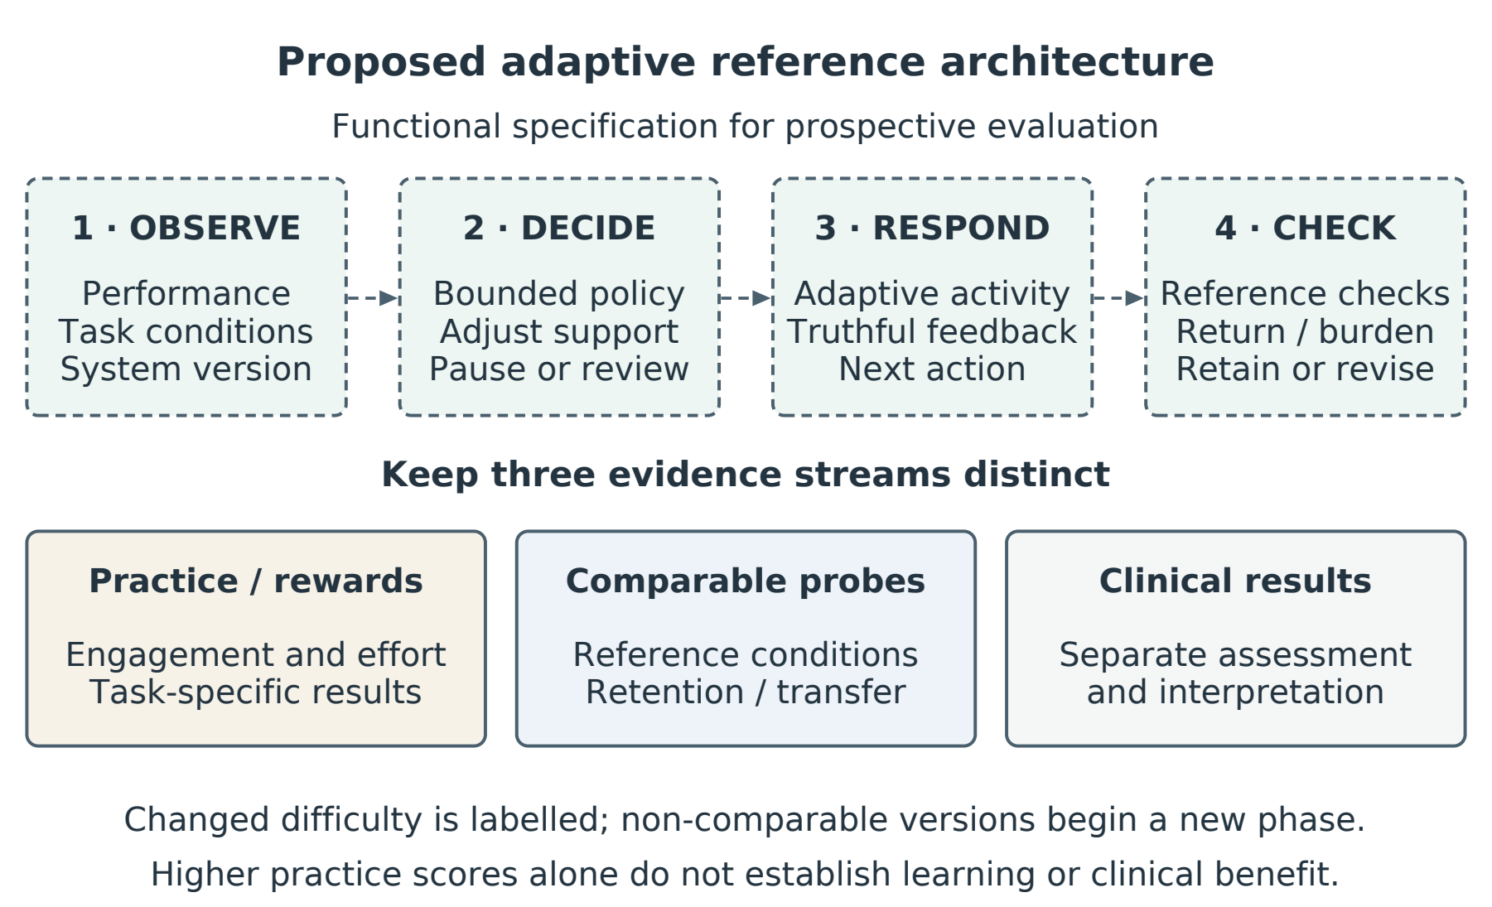
Figure 7.1. Proposed adaptive reference architecture. Task conditions and outcomes inform bounded adaptation and interpretable feedback. Practice rewards, comparable performance checks and clinical interpretation serve different purposes and must not be collapsed into one score. The complete architecture has not yet been evaluated.

7.5.2 Credible Progress Under Changing Task Conditions
An adaptive system can change the conditions that generate its own scores. A higher score may reflect learning, an easier task, greater assistance, a different control method or a revised scoring rule. The proposed trajectory display must therefore state what improved and under which conditions. It should support understanding of an imperfect learning process, not manufacture reassurance through a continuously rising line. The distinction between observable performance and durable learning is central to this requirement (Soderstrom & Bjork, 2015).
The display should separate four outcomes. Participation includes attendance, retries and completed practice; it can be acknowledged without implying learning. Condition-specific performance describes what a person achieved with a stated task, difficulty and level of support. Learning requires evidence that a capability persists or transfers beyond the immediately assisted encounter. Clinical change requires a valid clinical measure and an appropriate interpretation of its uncertainty and significance. A composite engagement score should not stand in for these distinct outcomes.
Each prospective performance observation should retain the task and scoring version, difficulty parameters, input modality, assistance provided and relevant session context. Practice scores may be compared within sufficiently similar conditions, with those conditions visible in plain language. Where adaptation prevents such comparison, the display should describe the supported achievement and the adjustment itself. It should not relabel an improvement in accessibility or comfort as an increase in independent capability.
A future evaluation should include brief, safe reference tasks under predefined comparable conditions, alongside adaptive practice. These reference checks would provide a basis for assessing change without continuously moving the measurement conditions. Their reliability, tolerability and sensitivity must be established for the intended population before firm conclusions are drawn. Delayed checks and suitably chosen transfer tasks are needed for claims of durable or generalisable learning; repeated success in the training game alone is insufficient (Soderstrom & Bjork, 2015).
When a new version changes the task or scoring rule, the display should mark a phase boundary and preserve the earlier history. A continuous comparison across versions requires a justified linking procedure or overlapping reference observations; otherwise the two phases should be reported separately. A fresh baseline can describe the revised task, but it must not erase prior difficulty or imply that the earlier intervention succeeded. Uncertainty, plateaus and deterioration should remain visible, with an explanation of the next available action.
For example, consider an illustrative participant who completes more obstacles after the system slows the game and adds steering assistance. The accurate message is that the participant completed more of a slower, assisted task. If a later reference check shows similar performance with less assistance, the system may report reduced support needs on that task. Neither observation alone warrants a claim of improved balance or reduced fall risk. This example specifies prospective feedback logic; it is not a reconstruction of the Stage-2 data.
The same discipline applies when innovation encounters difficulty. If a revised interface reduces confusion or fatigue but reference-task performance remains stable, the service may have improved in usability or burden. If only the scoring rule changes, a higher score supplies no evidence of benefit. If outcomes worsen or users find the feedback misleading, the revision should be reconsidered or reversed. The progress display should allow these outcomes to be understood without portraying every design change as a success.
Validation of the display should test whether participants can distinguish an easier task from improved capability, identify a change in assistance or version, and understand stable or declining results without false reassurance. These comprehension checks should accompany behavioural follow-up and measures of burden, competence and safety. Improvement is credible when the claim, comparison and measure agree; an appealing trajectory is not sufficient evidence.
Table 7.3. Interpreting progress when an adaptive task changes. These examples are prospective design rules, not observations from the field studies.
Observed change | Defensible interpretation | Evidence still required
Higher practice score after easier settings | More success under easier conditions | Comparable reference check for a capability claim
Similar performance with less assistance | Reduced support on the specified task | Repeated or delayed checks for retained learning
Lower confusion or burden after redesign | Improved usability or experience | Common comparison; sustained use assessed separately
New task or scoring version | A new performance phase | Justified linking before comparing across versions
Stable or declining reference performance | No demonstrated capability gain | Further observation; reconsider the response

7.5.3 Coaching Protocol Specification
The proposed coaching protocol uses an accurate opening explanation, specific in-session feedback and a closing summary. The summary identifies what changed, what remains challenging and what assistance was provided. It should describe an easier task as an adjustment and should acknowledge uncertainty when a capability gain has not been established. Clinical purposes and relevant results remain accurately disclosed. Scripts require cultural adaptation, standardisation and fidelity checks, while preserving the participant’s right to stop. The expert consultation in §6.8A supplies practice-based reasons to examine coaching and group support; it does not independently demonstrate that either converts dropout into continued participation.

7.5A Relationships Among the Phenomenon Principles and Engine
The programme links three kinds of output. FIAS names a provisional behavioural pattern and organises candidate explanations for failure-associated non-return. The adaptive-learning principles translate that problem into proposed changes to framing, feedback and challenge. The dynamic game-state engine specifies one possible implementation of those changes. A fourth requirement connects them to the thesis title: an evaluation record must show whether the response improves a defined participant or service outcome. Neither a plausible explanation nor a functioning controller is sufficient evidence that the intervention prevents abandonment.
The evidential status differs across these outputs. The reported field observations anchor the behavioural pattern; the between-cohort comparison motivates, but does not isolate, frame sensitivity. The principles are derived from that record and relevant theory. The engine and progress display require fidelity, usability and outcome evaluation as a complete configuration. Bringing them into one architecture clarifies the path from problem to testable intervention without raising the evidential status of any individual claim.

7.6 Applied Case Studies

7.6.1 Case Study A — FRA Reaction Mode (in development)
Setting: an existing residential care facility using the same broad pressure-panel and skiing-game platform. Proposed intervention: participant-facing decoupling, a visible personal trajectory, process-focused coaching and adaptive challenge calibration. Proposed outcomes: return within a pre-specified window, repeated use over several months, perceived competence, fatigue, burden, enjoyment, comprehension and adverse events. The earlier point targets of below 6% non-return and above 65% regular-use intention should be treated as design aspirations, not evidence-based efficacy thresholds, until a pilot establishes feasible effect sizes.

7.6.2 Case Study B — Continuous Glucose Monitoring (CGM) reframed as a Streak Companion (illustrative)
Setting: older adults using continuous glucose monitoring who may disengage after unfavourable readings. Illustrative design hypothesis: preserve access to accurate clinical data while adding an optional learning-oriented view that links readings to behaviours, uncertainty and next actions over time. A high reading should not be hidden or gamified into triviality. The design would be evaluated for comprehension, self-efficacy, sustained sensor use, clinically appropriate response and the risk of false reassurance. Status: illustrative cross-domain application; no empirical claim is made.

7.6.3 Case Study C — Sleep Tracker reframed as an Adventure Log (illustrative)
Setting: older adults using sleep trackers who may disengage after repeated poor-sleep scores. Illustrative design hypothesis: supplement single-night scores with a longer-term pattern view, uncertainty ranges and modifiable contextual factors. The design should avoid implying that every variation is controllable or that poor sleep is a personal failure. Outcomes would include continued use, sleep-related anxiety, comprehension and appropriate help-seeking. Status: illustrative only.

7.6.4 Cross-Case Synthesis
The case studies share a proposed design pattern: retain accurate measurement and clinically important information at the technical layer while redesigning the default user-facing interaction around trajectory, next action and calibrated challenge. Portability across domains is a hypothesis. Each domain requires its own safety analysis, clinical governance, outcome definition and controlled evaluation; the FRA evidence cannot be transferred automatically.

7.6A Dynamic Game States as Responses to Difficulty
The dynamic game-state architecture introduced in §5.3.10 is a secondary design proposal motivated by three literature gaps: attrition is often treated as a residual outcome; fail-state mechanics developed for younger users may not transfer cleanly to older cohorts; and macro implementation frameworks do not specify the moment-to-moment interaction that precedes disengagement. The proposed non-terminal state repertoire and frame-congruence checks translate these gaps into an engineering specification. They do not demonstrate that a "GAME OVER" screen caused Stage-2 non-return or that the proposed states will prevent it.
The architecture also addresses a design tension between self-awareness and self-verdict. Users need accurate information about performance and safety, but presentation can emphasise process and trajectory rather than a categorical judgement. The design should not withhold clinically important information or make failure invisible. Instead, it should separate immediate gameplay feedback from formal clinical interpretation, disclose how data are used, and provide appropriate access to results. Whether this balance reduces non-return without undermining comprehension is a testable usability and safety question.
The dynamic-state design is a secondary proposal, and the observed between-cohort association is not a test of its effects. A future evaluation can compare a specified state policy with a common reference configuration, holding the assessment protocol and follow-up constant. The policy must constrain assistance, challenge and safety-relevant actions; record each change; and distinguish successful execution from beneficial outcomes. Excessive assistance may improve practice scores while reducing the information available about independent performance. An AI-enabled controller also requires reproducible decision records and appropriate fallback behaviour. Its presence cannot substitute for evidence that participants understood the feedback or chose to return.

7.7 Boundary Conditions and Risks
The framework has several plausible risks. Excessive adaptation may remove meaningful challenge or make scores difficult to interpret. Inconsistent explanations by the interface and staff may undermine understanding and trust. A trajectory metaphor may be less useful for some users than a simple account of the current task and available support. These are testable possibilities, not universal responses or established cultural differences. Usability work should include participants who struggle, decline assistance or decide not to continue, rather than assessing the display only among successful users.
The cultural boundary deserves more than a caveat. The cohorts studied are Guangzhou and Hong Kong Chinese, and the meaning of a fall in later life is culturally loaded in these settings. A fall can signal the loss of independence, the beginning of dependence on adult children, and a change in family obligation. Filial expectation can turn a poor clinical verdict into a family event rather than a private one, which raises the identity stakes of the coupled frame. Stoic self-narratives can suppress the reporting of distress while leaving the abandonment behaviour intact. Each of these frames could strengthen the coupling mechanism, weaken it, or leave it unchanged, and the present data cannot say which. A concrete replication plan follows. The first step repeats the Stage-3 decoupling protocol in one non-Chinese setting with an individualist self-narrative tradition and in one further collectivist setting outside China, using the same hardware and the same instruments. The second step compares the return-after-dropout rates across the settings against the Hong Kong benchmark. The third step adds a short culture-frame instrument so that the self-narrative variable is measured rather than assumed. Until this plan is executed, the generalisability of the framework beyond Chinese-cultural settings is an argued expectation, not a demonstrated result.

7.8 Sequencing of the Three Principles
The principles can be introduced in a planned sequence, but neither the order nor their joint sufficiency is established. P1 addresses evaluative cues; P2 addresses interpretable feedback; P3 addresses challenge and support. A factorial or staged comparison could examine their independent and combined effects, including burdens or harms. The Stage-3 association gives P1 an empirical motivation, not the status of a necessary precondition. P2 and P3 should not assume that adaptation produces learning or that a displayed curve produces commitment.

7.9 Gamification Continuous Improvement and Innovation Enhancement
The thesis title specifies the purpose of the work: to examine gamification as a proactive approach for continuous improvement and innovation enhancement. The adaptive system is a proposed means of pursuing that purpose within the FRA service. Gamification creates opportunities for voluntary participation, meaningful feedback and repeated encounters with a task. Adaptation uses information from those encounters to select a possible next response. Evaluation determines whether that response improves a defined outcome. This separation prevents the circular claim that a system improves simply because it adapts.
The adaptive-learning discovery is where the thesis and its topic become the same thing: adaptive learning is continuous improvement operating at the level of the individual user. Each session updates the challenge; each failure is information for the next iteration; the user's capability is the process being improved, with the user's own trajectory as the control chart. The same loop appears at two other levels of the programme - the researcher's action-research cycles (§3.1) and the artefact's AI-assisted build iterations (§5.3.9) - so the thesis practises at every level the principle it proposes for its users. In engineering terms, the user interaction becomes an instrumented loop: observe performance and experience, provide calibrated challenge and feedback, measure subsequent behaviour, and revise the design. The analogy to industrial control is useful, but the user is not a process variable to be optimised without consent. Autonomy, dignity, truthful disclosure and the right not to engage are constraints on the loop, not disturbances to be removed.
The proactive proposition concerns timing. Support can be offered at first contact and when difficulty emerges, before a pattern of non-use becomes established. The present programme motivates those intervention points but does not establish the optimum timing or efficacy of the proposed response. The objective is sustained voluntary participation with truthful understanding, acceptable burden and appropriate clinical safeguards. A decision not to return remains an outcome to understand and respect, rather than an error that the controller must eliminate.
Two linked cycles give this proposition an engineering form. The participant-support cycle observes a task encounter, offers a bounded adjustment or feedback, and checks the next experience. The system-improvement cycle examines recurring difficulty, formulates a redesign hypothesis, implements a documented change and evaluates its consequences. The first concerns a person’s interaction under a particular configuration; the second concerns the quality of the service and its design. Both can generate useful learning, but a gain in one does not establish a gain in the other. Figure 7.2 represents their relationship.
Innovation enhancement means improving the process by which a candidate design is developed, implemented and assessed. In the Oslo Manual, innovation concerns an implemented product or process that differs significantly from its predecessors; implementation and novelty do not by themselves establish effectiveness (OECD/Eurostat, 2018). For this thesis, the defensible achieved contribution is the progression from an observed service difficulty to revised problem understanding and a testable design specification. The complete adaptive framework remains a proposed extension whose benefits have yet to be evaluated. Describing unsuccessful iterations honestly strengthens that contribution because it makes the grounds for changing the design inspectable.
Learning from an unsuccessful intervention requires more than changing the software. A revision should state the problem it addresses, the explanation being tested, the component changed and the intended outcome. Evaluation criteria should be set before examining the new results, with a common comparison wherever feasible. Small iterative tests can inform a decision to retain, modify or reverse a change, consistent with the Plan–Do–Study–Act approach to service improvement (Institute for Healthcare Improvement, n.d.). Such cycles support local learning; a causal effectiveness claim still depends on the design and quality of the comparison.
Applied to this programme, the Stage-2 difficulty justified reconsidering the interaction and examining a decoupled configuration. Stage 3 then supplied an encouraging engagement pattern alongside unresolved confounding by cohort, setting, delivery and input modality. The resulting innovation learning is that decoupling is a candidate design direction worth testing under common conditions. It is not evidence that a clinically attached adaptive service has already achieved sustained improvement. Subsequent iterations should preserve that distinction: an unsuccessful feature may yield a more precise requirement, an accessible revision may lower burden without increasing capability, and a capability gain may occur without greater willingness to return. Each result has value when it is reported against its own criterion rather than combined into an unqualified claim of improvement.
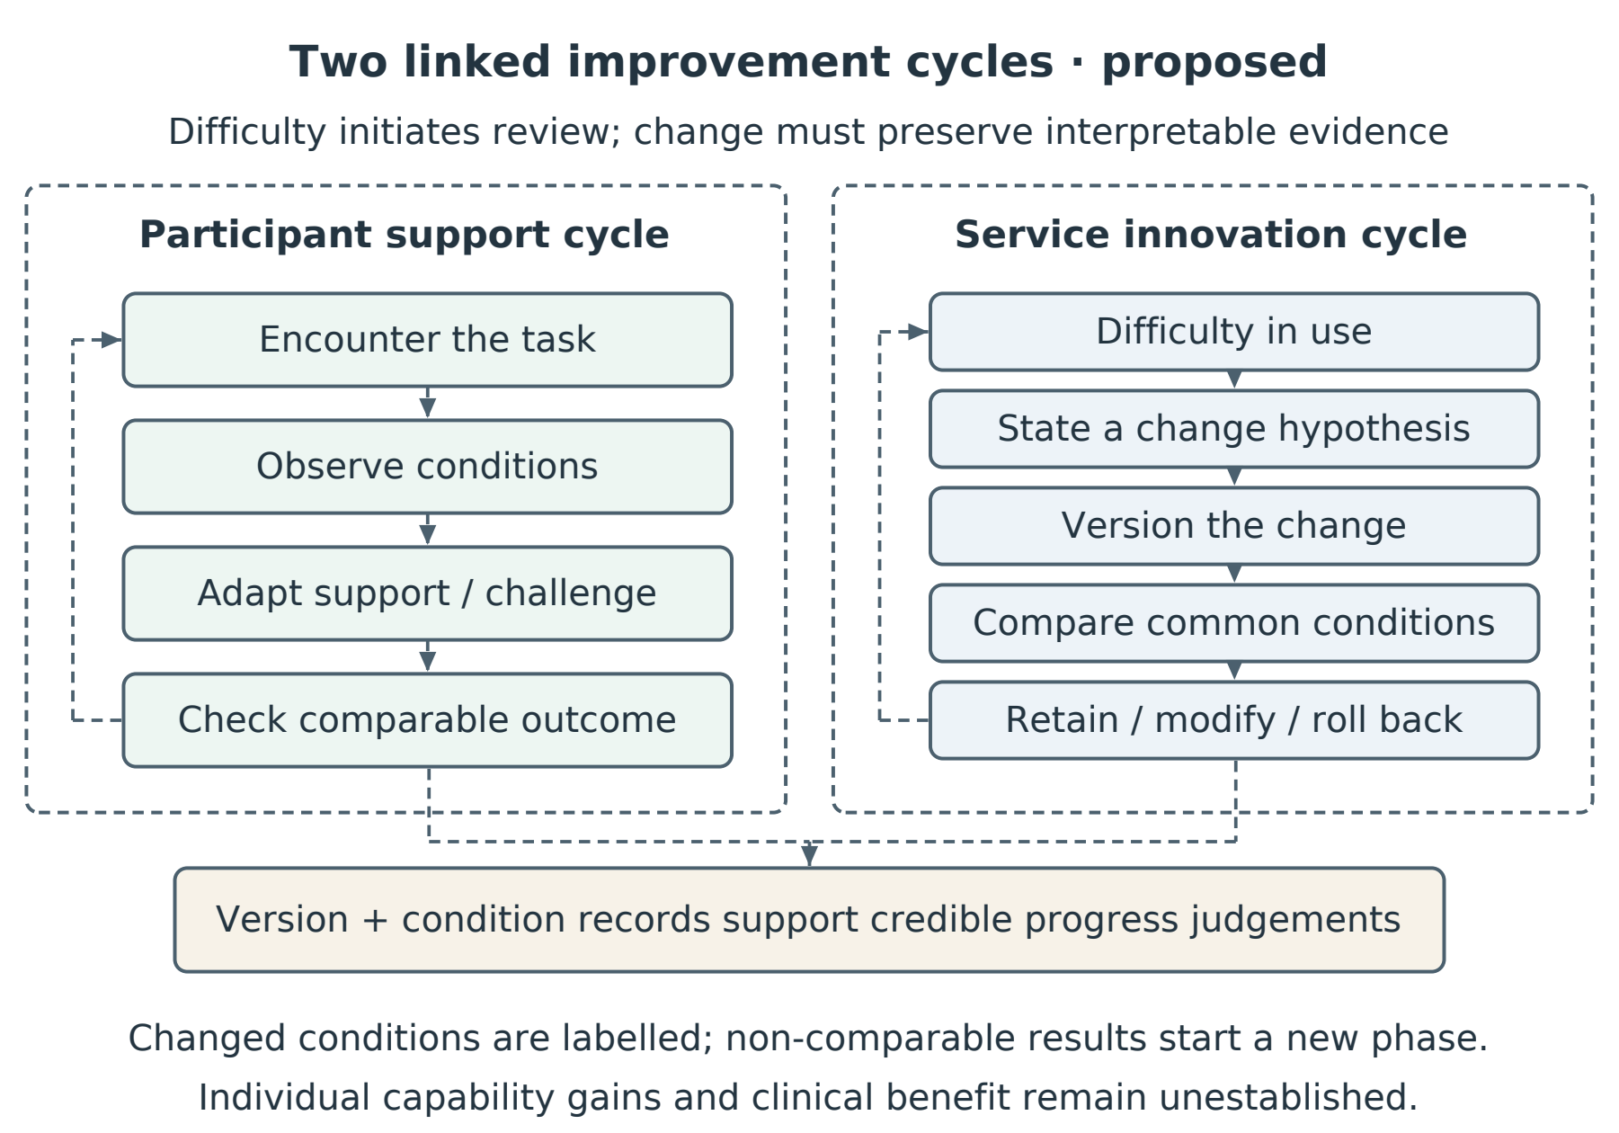
Figure 7.2. Two linked improvement cycles proposed for the gamified service. Participant support responds to an encounter with difficulty; system improvement evaluates a documented redesign. Records of task conditions, assistance and version changes preserve the meaning of reported progress. The figure is a prospective design proposition, not an evaluated outcome model.

A commercial cross-reference suggests the market has independently converged on parts of this design space. GrandPad — a purpose-built tablet for older adults, sold in the United States on a subscription basis on the order of US$500 per year, with cellular connectivity built in so that no home broadband or technical set-up is required — packages games, video calling and photo sharing behind a radically simplified interface, with family members and a human support service connected around the user (GrandPad, n.d.). Peer-reviewed evaluations of its deployments report high perceived ease of use and connectedness among predominantly homebound users where the device filled a genuine access gap, and markedly weaker adoption where mainstream alternatives already existed — implementation context, not device quality, decided uptake (Perissinotto et al., 2019; Tha et al., 2025); adjacent trials of supported tablet onboarding for homebound elders likewise report increased technology use and directional loneliness reductions when a human scaffold accompanies the device (Gadbois et al., 2022). Three features of the model align with this programme's findings: access and set-up barriers are engineered away wholesale, consistent with the Stage-1 observation that their absence alone does not secure engagement; the games are framed as leisure and connection, never as assessment — a decoupled frame arrived at by commercial instinct; and the engagement scaffold is explicitly social, anticipating the group-dynamics mechanism raised in the §6.8A consultation. What the model does not contain is the layer this thesis contributes: GrandPad avoids threatening frames by carrying no clinical measurement at all, whereas the present programme concerns technologies that must measure while remaining bearable. The comparator therefore marks a boundary in the design space: engagement without clinical purpose is commercially solved; engagement with clinical purpose intact is the open problem the adaptive-learning framework addresses.
The comparator also points to a forward extension of the adaptive-learning proposition itself: from sustaining engagement within one health technology to supporting the acquisition of new technological skills in later life. The learning literature supports the premise that older adults acquire demanding new skills when challenge is sustained and scaffolded: the Synapse Project found that three months of sustained engagement in cognitively demanding novel skills improved episodic memory relative to controls (D. C. Park et al., 2014); the PRISM randomised trial showed that a purpose-designed computer system with training reduced loneliness and increased perceived social support among older adults at risk of isolation (Czaja et al., 2018); and within this programme's own research lineage, gamified learning systems have improved older adults' technology adoption and knowledge transfer in mobile payments and mobile navigation (An et al., 2024, 2025). Read with the model of selective optimisation with compensation (Baltes & Baltes, 1990), these results frame later-life technology learning as an adaptive process that succeeds when tasks are selected, challenge is optimised and support compensates — the same regime the adaptive-learning framework specifies through calibrated challenge, a visible personal trajectory and a coaching scaffold (§7.5). A platform of GrandPad's class — subscription-funded, barrier-free and socially scaffolded — is therefore a plausible carrier for the framework beyond FRA: a curriculum of adaptively calibrated games through which an older user builds the generic capabilities (touch interaction, menu navigation, confidence under initial failure) that transfer to new health technologies. This is stated as a design hypothesis, not a finding: the framework's mechanism-level claims remain untested (§8.8), and any such deployment would need the same measurement-bearability discipline this thesis develops. But it locates the contribution's growth path — adaptive learning not only as a retention mechanism for one clinical device, but as a general onboarding pathway by which older adults learn their way into technologies that benefit their lives.
Read as a boundary case, the comparator also sharpens what commercial gerontechnology has so far left unaddressed, and locates this programme's contribution to gerontology as AI-enabled health technology arrives. Three omissions matter. First, the avoided middle: the market divides into clinical instruments that measure but are abandoned (the FRA of Chapter 4) and consumer platforms that engage but do not measure (the GrandPad class); the technologies that population ageing actually requires — instruments that assess fall risk, cognition and function, repeatedly and acceptably — sit in the middle that both poles avoid. Second, the missing failure model: GrandPad-class design treats disengagement as a usability and access problem and answers it by minimising occasions for failure; it carries no account of what an adverse result does to an older user's self-concept, because it never delivers one. Curated ease also caps challenge, and with it the mastery experiences on which learning and flow depend (Csikszentmihalyi, 1990; Vygotsky, 1978). Third, personalisation without adaptation: content is personalised — family, photographs, curated games — but challenge is not calibrated to the individual and does not move with them, so there is no rising trajectory for the user to read. The arrival of AI raises the stakes on all three counts at once. Adaptive models make individually calibrated challenge inexpensive to implement at scale — the enabling technology for the Chapter 7 framework — but the same wave is filling gerontechnology with continuous monitoring, risk scores and predictions: more verdicts about ageing bodies, delivered more often, to the population this programme's record indicates may respond to unfavourable verdicts by leaving permanently. Without a behavioural layer, AI-era gerontechnology risks industrialising the abandonment pattern documented here. The programme's contribution to gerontology is that layer: FIAS names the failure mode that verdict-bearing technology must design against; the Stage-3 frame-sensitivity evidence indicates where the leverage may lie; and the adaptive-learning framework specifies how a measuring technology can remain bearable — challenge calibrated to the person, results presented as a trajectory, coaching absorbing the failure moment. The gamified FRA is the programme's working case that the middle ground can be entered at the artefact level: one physical action that plays and measures (§5.2A); whether such an artefact becomes returnable-to by design is the question the empirical stages examined and the adaptive-learning framework proposes to answer. In an AI decade, that is the difference between health technologies older adults live with and health technologies that fall silent (§8.6B). Figure 8.1 maps this design space.
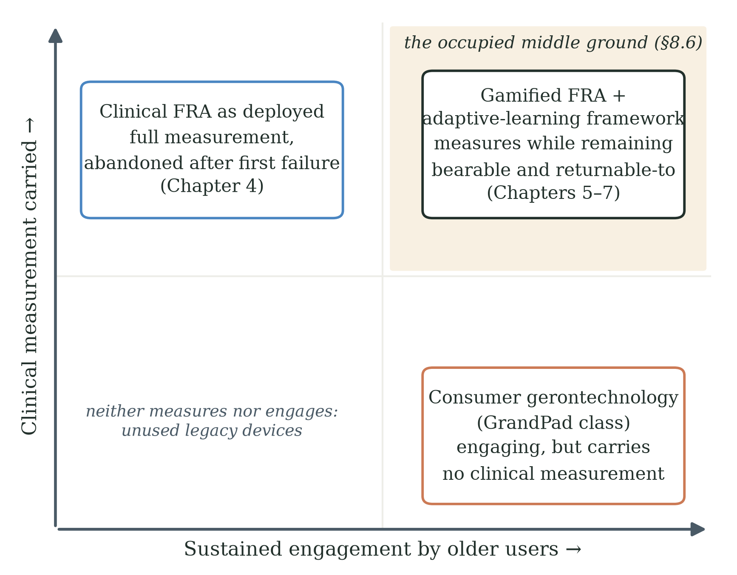
Figure 8.1. The gerontechnology design space. Commercial platforms of the GrandPad class achieve sustained engagement by carrying no clinical measurement; clinical instruments carry full measurement but are abandoned after adverse first experiences (Chapter 4). The programme's contribution occupies the upper right: the gamified FRA and the adaptive-learning framework specify how a technology can measure while remaining bearable and returnable-to for older users (Chapters 5-7, §8.6).

Chapter 8 Contributions, Alternative Explanations, Limitations and Ethics
This chapter distinguishes four contribution registers: engineering, empirical and theoretical, industrial, and methodological. The principal contribution is a domain-specific engineering synthesis that translates observed disengagement into a testable adaptive-learning specification. Its empirical foundation comprises the bounded findings from the completed stages; its psychological interpretation remains provisional. Industrial usefulness depends on whether the specification supports better deployment decisions, while methodological usefulness depends on whether the research and design procedures can be reused. Table 8.0 maps these contributions and their evidential status. The organising question is how gamification can support proactive, continuous improvement when a health-technology innovation encounters difficulty and requires revision.
Table 8.0. The four contribution registers and where each is stated.
Register | Contribution | Stated in
Empirical and theoretical | Provisional FIAS descriptor; candidate frame-sensitive appraisal account; bounded deployment findings and alternative explanations | §8.1, §8.3; Chs 2, 9
Engineering | Domain-specific adaptive-learning synthesis; proposed dynamic-state architecture and credible-progress specification for participant support and system redesign | Ch 7 (§7.4, §7.5, §7.5A); §8.4
Industrial | Proposed service-design specification for existing FRA infrastructure, with evaluation criteria for appropriate use, credible progress, burden and cost | §8.4; §9.8
Methodological | Sequential exploratory action research; dual-purpose mechanic; QFD evidence-to-design pipeline; descriptive separation of participation and intended regular use | §8.2; Table 3.1

8.1 Theoretical Contributions
The theoretical contribution is a contextual problem formulation that supports the engineering synthesis. First, FIAS is advanced as a provisional, non-diagnostic descriptor of failure-associated non-return; it does not itself establish an intention to avoid the device or a psychological cause. Second, the contrast between the studied deployments motivates a candidate boundary to the transfer of selected acceptance and gamification design principles into clinically consequential assessment. Clinical framing is one possible contributor, alongside input modality, setting, recruitment, burden and practical consequences; the comparison does not identify a universal boundary of gamification theory. Third, identity-related appraisal is specified as a candidate account whose proposed operators—loss aversion, endowment protection, mental accounting and stereotype threat—require distinct measures and discriminating predictions (Table 2.1). The account must demonstrate explanatory value beyond perceived competence, satisfaction, continuance and medical-information avoidance, rather than claim that these literatures cannot accommodate the observations (Bandura, 1997; Bhattacherjee, 2001; Howell & Shepperd, 2012). Fourth, the thesis integrates these questions with an adaptive-learning response comprising identity disentanglement, trajectory feedback and adaptive calibration. Adaptive learning is established prior work; the proposed originality is its specification for this dual-purpose assessment context and its connection to credible progress under changing task and system conditions (Chapter 7). The completed programme motivates this synthesis but does not establish its effectiveness or necessity.

8.2 Methodological Contributions
The methodological contribution lies in the combination and documentation of sequential exploratory action research: an initial theory-informed design expectation, prospective field observation, a subsequent between-cohort comparison, and explicit revision of the resulting explanation and design requirements (Table 3.1). The unfulfilled design expectation is not a statistical falsification of TAM, STAM or gamification research, and Stage 3 is neither a positive control nor an isolated attribution experiment. Reusable elements include the dual-purpose mechanic linking gameplay with a measurement pathway, the QFD evidence-to-design pipeline (§5.5A), the documented AI-assisted development workflow (§5.3.9), and the descriptive separation of immediate participation from future-use intention. Their value is practical traceability from observation to engineering decision, rather than a newly validated causal-identification method. The proposed continuous-improvement process extends that traceability to future changes in task, controller and interface by requiring their rationale, version and evaluation conditions to be retained (Chapter 7).

8.3 Empirical Contributions
The empirical record yields the following results: 70.0% early disengagement (21 of 30, at or before three cycles) in the Stage-2 cohort with no observed re-engagement during the eight-week window; a paired recorded-index change of +6.9 points among the nine sustained participants (dz = 2.22, 95% CI 0.95–3.46) and +4.0 points across all thirty (dz = 0.42, 95% CI 0.05–0.79); an association (exploratory, unadjusted) between satisfaction and sustained engagement (Fisher's exact p = 0.013); the documented withdrawal (§5.5) of an earlier exploratory motivational-orientation classification whose coding records could not be produced; recorded-index increase without self-reported improvement or return among most single-session participants; 65.2% return among Stage-3 initial dropouts overall and 62.5% in the 65-80 band, reported from the Stage-3 aggregate record (§6.4); 71.7% coordination-frame endorsement as a manipulation check; 63.3% regular-use intention overall; and a descriptive 29.3-percentage-point difference between session retention and regular-use intention in the 65-80 band. These results do not constitute a direct correlation across stages because the participants and measures differ.

8.4 Industrial and Practical Contributions
The practical contribution is a proposed implementation specification for supporting voluntary engagement with an existing assessment technology. It brings together participant-facing framing, condition-specific progress feedback, staff coaching and adaptive challenge. Under the stated thesis title, the proactive point of intervention is an emerging difficulty or adverse experience; continuous improvement concerns both the participant's opportunity to learn and the engineering team's revision of an unsatisfactory design. Neither a higher adaptive-game score nor a new software version is sufficient evidence of improvement. The proposed evaluation therefore separates participation, performance under stated conditions, retention and transfer of learning, and service outcomes, while documenting the changes that may affect comparability (Chapter 7; Soderstrom & Bjork, 2015). The framework is informed by field evidence and learning theory, but requires controlled evaluation, implementation-fidelity assessment, usability testing, longitudinal follow-up and cost analysis before effectiveness or industrial benefit can be claimed.

8.4A A Forward-Looking Contribution: Sensing and Person-Conditioned Adaptation
A forward-looking contribution concerns the gap between the deployed Stage-2 adaptation configuration and a richer person-conditioned system. The deployed system received pressure-panel and game telemetry, with some information rendered into language for model processing; it did not directly measure the participant's immediate appraisal, affect or intention at the moment of difficulty. The thesis therefore proposes an engineering extension — add ethically justified, consented and validated real-time signals, update a person-specific state estimate, and evaluate whether safe, pre-specified interventions improve retry and return without reducing challenge or obscuring important information (§9.8C) — and states the evidential boundary of that extension at §8.6A. This is a limitation of the sensing and control configuration used in the study; it should not be generalised into a claim about language models in general or about artificial general intelligence.

8.5 Alternative Explanations
The credibility of the frame-sensitive account depends on examining alternatives. Ten are considered below, and several remain viable because the comparison is between cohorts and deployment contexts. The expert consultation of §6.8A contributes an interpretive perspective compatible with clinical avoidance and identifies group and coach support as candidate moderators. Consultation does not establish the cause of the observed behaviour. A future within-cohort study should record and, where feasible, standardise these contextual influences.

8.5.1 Cohort Self-Selection
Concern: Stage-2 and Stage-3 participants may differ because of volunteer selection, residential status, health, education, technology familiarity or recruitment channel. Response: the age-matched Stage-3 return result remains substantially different from the Stage-2 observation and is therefore difficult to ignore. However, the natural comparable pair - the Stage-2 re-engagement outcome (0 of 21) and the Stage-3 return-after-dropout outcome (15 of 23) - spans non-equivalent cohorts and conditions, so it cannot quantify the size of selection bias, and the present data cannot show that cohort differences are too small to explain part of the effect. Randomisation within one recruited cohort is required.

8.5.2 Novelty Effect
Concern: novelty may increase engagement in a fresh cohort. Response: post-failure return is a stronger outcome than initial participation, but novelty could still affect willingness to retry or return during a short observation period. The study does not eliminate this explanation. Longitudinal follow-up and repeated-session comparison are required.

8.5.3 Demand Characteristics and Hawthorne Effect
Concern: participants may have inferred preferred responses or behaved differently because of researcher attention. Response: the behavioural return outcome is less vulnerable than a self-report item, but staff scripts, contact frequency and researcher involvement should be documented and standardised. A blinded or independent outcome assessor would strengthen the next study.

8.5.4 Regression to the Mean
Concern: the Stage-2 zero return may be an extreme small-sample observation. Response: 0 of 21 over eight weeks is an important field result with an upper 95% Wilson bound of approximately 15.5%, but it is not a metaphysical "regime". Replication with a larger cohort and identical follow-up is required.

8.5.5 Physical Fatigue and Motor-Learning Limits
Concern: age-linked fatigue, balance limitation or motor-learning difficulty may explain some Stage-3 non-return and some of the gap between session retention and regular-use intention. Response: this explanation remains plausible and should be measured directly rather than assigned only to a residual subgroup.

8.5.6 Language and Literacy Confounds
Concern: the Stage-3 pattern may reflect terminology or other changes in presentation rather than a specific psychological mechanism. Response: terminology is one component of participant-facing framing, but Stage 3 changed lexical, procedural, interface and recruitment cues together with the deployment context. The observed contrast concerns that combined package and context; it does not estimate an isolated framing effect. Future component testing is required to identify which elements contribute, under which conditions, and whether they interact.

8.5.7 Mechanism-Aspecific Just-Better-Design Alternative
Concern: Stage 3 may have produced better outcomes because the overall experience was simply better in ways not captured by the protocol. Response: the game mechanic, session structure and five-attempt rule were carried into the HTML port, but the platform, input device, setting, supervision, interface, pre-session procedure and recruitment all differed — Stage 3 was played remotely on participants' own computers rather than on the supervised pressure-panel station. "Just better design" and "just a lighter context" therefore remain viable mechanism-aspecific alternatives. Detailed implementation-fidelity records and within-cohort randomisation are required.

8.5.8 Input Modality and Embodied Exposure
Concern: in Stage 2, participants controlled play through weight shifts on the pressure panel, whereas in Stage 3 most steered with a trackpad or arrow keys (§6.3). The contrast may therefore reflect the physical demands and perceived meaning of the input device as well as clinical framing: difficulty involving balance may be interpreted differently from difficulty involving finger control. Response: this is a viable alternative that the present comparison cannot separate from framing. Technical coupling to a measurement pathway, participant-facing clinical meaning, and embodied task demand should remain distinct design dimensions; combining them under one explanatory label would prevent their contributions from being tested separately. The proposed coupled-versus-decoupled comparison holds input modality constant, while a separately designed modality comparison would be needed to estimate embodiment effects.
Stage 3B adds a proposed touch-input component study to a programme that has used standing whole-body input and remote seated hand input. Its adaptive-versus-static and zero-failure-versus-failure-possible contrasts address presentation components within its study context; clinical framing is not a factor in that design. Consequently, Stage 3B cannot by itself identify the clinical-framing effect or separate framing from embodiment across the earlier stages. A graduated route from seated play to standing-panel interaction may be worth testing as a design proposition, but the present observations do not show that input modality functions as an identity-exposure scale, that confidence accumulates along that route, or that clinical reattachment is successful. Those outcomes require their own measures and comparison conditions.

8.5.9 Ordinary Discontinuance and Non-Usage Attrition
Concern: the observed non-return may represent ordinary discontinuance related to dissatisfaction, burden, boredom, limited relevance, competing priorities or changing opportunity. Response: non-usage attrition describes an outcome requiring explanation; it does not necessarily predict gradual decline, occasional return or indifference to context (Eysenbach, 2005). Improving recorded performance can coexist with boredom, low perceived competence or an unsatisfactory experience, so the score–return divergence does not rule these explanations out. The thesis's satisfaction–engagement association makes satisfaction-based continuance a particularly relevant rival (Bhattacherjee, 2001). The concentration of exits early in Stage 2 identifies a useful intervention point, but does not by itself discriminate among these accounts. Likewise, changes in burden, enjoyment and opportunity across the Stage-3 package and context could affect return. A future study should compare explicitly specified predictors and appraisals, including satisfaction, perceived competence, expected benefit, burden and identity relevance. FIAS would add explanatory value only if its proposed account predicts something beyond those alternatives. The retrieved observation sequence of §5.6 adds a further discriminating point: the field notes record players who acknowledged the system's benefits and were recording index gains, yet gave up after recurring in-game failures across their second and third cycles - a profile that boredom, limited-relevance and competing-priority accounts do not naturally produce.

8.5.10 Rational Consequence-Avoidance
Concern: the operating practice described in §4.1A gives an adverse FRA verdict real consequences - prescribed balance training and recommendations against walking alone and freely - so avoidance could be a rational response to those consequences rather than an identity-level appraisal: a resident may stay away simply because a bad result costs freedom and time, no psychology of self-concept required. Response: this rival is conceded as live and unmeasured, and it is partly complementary rather than fully displacing - the consequence pathway still runs through the verdict and its frame, not through difficulty or game design, so it shares the coupling structure of the account this thesis proposes while differing on the mechanism inside it. The present data cannot separate the two: Stage 3 removed the verdict and its practical consequences together, so the between-cohort difference is equally consistent with either reading. Distinguishing them requires instrumentation the confirmatory study should carry - measured perception of consequence risk alongside identity-threat measures - and until then the thesis's mechanism language remains at the candidate level (§6.7).

8.6 Limitations
The principal limitations are as follows. The Stage-2-versus-Stage-3 comparison is between-cycle and between-cohort; the Stage-3 decoupling package contains multiple changes, including a change of platform, input device, setting and supervision (a remotely played HTML build rather than the supervised pressure-panel station); the proposed mental-accounting, endowment, stereotype-threat and entropy mechanisms were not measured directly; the Stage-2 FIAS composite requires a complete fixed codebook and independent reliability assessment; the clinical significance of short-term FRA-index change is unknown; self-selection and embedded-researcher effects remain possible; observation windows are short; and both cohorts are culturally specific. The nested model comparison is prospective rather than completed. These limitations narrow the claims but do not remove the practical importance of the observed failure-return patterns.

8.6A A Further Limitation: The Deployed Sensing and Adaptation Configuration
A further limitation concerns the deployed AI and sensing configuration. Layer 2 adapted game difficulty from telemetry and language-rendered summaries on a scheduled cycle. The proposed dynamic-state extension shortens the control loop but still depends mainly on pressure-panel and in-game event data. Neither configuration directly measures the participant's interpretation, affect, hesitation or intention at the moment of difficulty.
The thesis therefore cannot claim that the system observed a "cognitive collapse" or missed a directly established psychological event. What it can say is that the system lacked channels for immediate participant appraisal and affect, while the behavioural outcome of interest may be shaped by reactions occurring close to the failure event. A future person-conditioned system would need validated, ethically acceptable measures and a pre-specified intervention policy. It would also need to demonstrate incremental predictive and behavioural value beyond simple game telemetry.
This limitation belongs first to the study's input architecture, not to language models in general. The intuition that the limits of a system's language may bound the world it can represent has a long philosophical lineage (Wittgenstein, 1922), and the symbol-grounding and embodied-intelligence literatures (Harnad, 1990; Brooks, 1991) provide relevant theoretical context, but they do not establish that text-based models are categorically incapable of contributing to grounded systems. The bounded engineering question is whether adding direct environmental and behavioural inputs improves prediction and safe adaptation in this FRA setting. That question is testable on the existing apparatus and should be separated from broader claims about AGI.

8.6B Extending the Unit of Analysis: Abandonment as a Three-Party Decision
The empirical stages principally examine the older user's engagement. A wider unit of analysis is nevertheless plausible: the user, family and care staff may each influence opportunities and reasons to return. A user may be concerned about capability, discomfort, time or autonomy; family members may interpret the experience as helpful or distressing; care staff may weigh clinical value against practical workload. These possibilities are hypotheses about the setting, not findings about measured family or clinician decisions. They extend the question from an individual's appraisal to how support, burden and interpretation may be distributed across the care relationship (Greenhalgh et al., 2017).
On this wider reading, non-use may be sustained by interacting decisions and constraints rather than one person's appraisal alone. The study does not establish that all three parties must withdraw support, that an identity appraisal initiates the process, or that these interactions explain the Stage-2 pattern. A prospective adaptive-learning intervention could examine whether truthful progress information, acceptable participation demands and a shared support plan help users and care partners decide whether continued use is worthwhile. Such information must include plateaus, deterioration and uncertainty where present; a rising display cannot be presumed. Measuring the parties' appraisals and interactions would connect the next study to the adopter-system concerns of NASSS while testing the specific relationships proposed here (Greenhalgh et al., 2017).
A related alternative, raised by the industrial partner during draft review, is a shared narrative about the station. Residents, families or staff might circulate interpretations of assessment that influence non-use, including among people without direct experience. The programme collected no sociometric or narrative-circulation data, so it cannot determine the source, content or causal role of such narratives. They might arise from an adverse encounter, institutional practice, general beliefs about ageing or other sources; individual FIAS events are not a necessary starting point. One strand of the account is nonetheless anchored in the deployment record: the researcher's field notes record that, as dropouts accumulated, remaining players saw that many peers had stopped attending, and that visible thinning contributed to further abandonment (§5.6). This is a field-note observation of within-deployment dropout visibility, not sociometric or narrative-circulation data; it documents a social channel operating, while leaving the source, content and causal role of any circulating narrative unmeasured. The next programme could combine interviews and observations across the care network with a carefully specified group-level support intervention. Any group response should be evaluated alongside individual appraisals, rather than assumed to confirm or remedy the proposed identity mechanism.

8.7 Ethical Considerations
This study examines the assessment phase of an assess-then-train product model and does not evaluate the training phase. An underused assessment station is an important service-design problem because it may limit opportunities to offer subsequent support. The proposed framework could be extended to repeated training encounters, but the present research does not establish that the same appraisal processes operate there or that assessment engagement produces training benefit. A training extension would require its own task specification, supervision, outcome measures and longitudinal evaluation. In particular, calibrated training performance must be distinguished from retained capability and clinical benefit; the future programme in §8.8 provides a route to examine these questions.
The programme involves a vulnerable population, an embedded researcher, and a frame manipulation — decoupling — that intentionally changes how participants interpret the activity they are engaging with. The ethical framework has five components.

8.7.1 Vulnerability of Frail Older Adults
Older adults in residential care are vulnerable in several distinct senses: physical, cognitive, social, and identity. Mitigations applied in Stages 2 and 3 included exclusion criteria for cognitive impairment and acute mental-health conditions; immediate stoppage rules for fall, near-fall or dizziness; information sheets in Mandarin and Cantonese; voluntary participation with no consequence for refusal; and difficulty curves calibrated so that even the worst-balance participant could complete an opening session.

8.7.2 Decoupling and the Deception Question
The Stage-3 protocol did not collect clinical balance telemetry from any participant. Any future deployment that reintroduces clinical telemetry alongside decoupled framing must address the deception question directly. The recommended informed-consent script states, in the opening paragraph, that the session is a coordination game whose movements are also recorded for balance research, and that the participant's individual clinical results will not be discussed during sessions but will be available on request. A frame manipulation accompanied by full prior disclosure is not deception in the ethically problematic sense.

8.7.3 Autonomy, Dignity and the Right Not to Engage
The intervention is targeted at the gap between the user's stated intent and the user's subsequent behaviour, not at users who have decided that the technology is not for them. Staff training in any deployment of the adaptive-learning framework must include explicit guidance not to use coaching to override a clearly stated preference for non-engagement.

8.7.4 Equity, Access and Deployment Risks
Three risks are flagged: equity (the adaptive-learning framework requires staff training that may not be available in lower-resource settings); paternalism (a system that adapts and reframes can shade into a system that decides for the user what their experience means); surveillance (the dual-purpose mechanic records continuous clinical telemetry). PIPL governance and a participant-accessible data policy are the operational answers; the cost-effectiveness work of the confirmatory programme will specify minimum staff-training intensity.

8.7.5 Embedded Researcher Bias
The lead author's embedded role may influence observation, interpretation, participant interaction and theory development. Reflective field notes and pre-specified predictions help but do not eliminate this risk. The next cycle should use standardised scripts, independent coding, blinded or independent outcome assessment where feasible, and an analysis plan registered before outcomes are examined.

8.8 Future Research
Stage 3B is described in the forward programme as a 2×2 component experiment crossing adaptive against static presentation with zero-failure against failure-possible modes in a new cohort. Its results are not part of the evidence presented in this thesis. The design can test the specified component contrasts; any interaction claim requires adequate sample size and precision. Because clinical framing is not independently varied, this experiment is distinct from the coupled-versus-decoupled study proposed below. Its learning-theory context includes errorless learning in memory-impaired populations, low-consequence failure in game-based learning and dynamic difficulty adjustment (Baddeley & Wilson, 1994; Plass et al., 2015; Zohaib, 2018). These traditions motivate alternative hypotheses; they do not establish that preventing errors is universally preferable for older adults or that the present design reconciles their effects. Assessment of progress under the component conditions should follow the comparability requirements in Chapter 7.
The described Stage-3B score economy provides a useful distinction between participation incentives and improvement evidence. The earlier builds used distance and coins; the proposed richer economy includes a combo multiplier, skill-dodge bonuses, collection rate and a persistent experience total with skier levels. A reset multiplier reduces future earning opportunities without subtracting accumulated points. That design choice may change the experience of a setback, but the thesis does not establish that opportunity costs are psychologically harmless or that banked points produce a learning-trajectory appraisal. A persistent experience total principally records rewarded participation: it can increase when capability is unchanged or when challenge has been reduced. It should therefore be displayed as activity or experience earned, separately from condition-specific performance and comparable anchor checks. The stated use of the same scoring formula across the experimental conditions helps define the intervention, but it does not make raw scores comparable when task demands, assistance or exposure differ. This distinction protects the motivational purpose of the economy while preventing accumulated rewards from being presented as evidence of learning (Soderstrom & Bjork, 2015).
[AUTHOR INPUT NEEDED - Stage 3B results: this passage is completed when the collection window closes; report all pre-specified outcomes regardless of direction.]
The priority extensions are ordered by the questions they can resolve. A within-cohort randomised comparison of coupled and participant-facing decoupled conditions should harmonise recruitment, eligibility, staff scripts, software, input modality and follow-up. Longitudinal evaluation should then assess repeated voluntary use and retained or transferred learning. Direct measures of appraisal, self-efficacy, identity relevance, affect and willingness to continue are needed to test the proposed explanation, together with independent reliability and construct-validation work. Intervention components can be specified using the Behaviour Change Wheel to support replication (Michie et al., 2011). Evaluation of the adaptive-learning framework must additionally retain task and controller versions, distinguish participation rewards from performance, and use comparable checks or explicitly report discontinuity when a redesign changes what can be measured (Chapter 7). Cross-cultural and cross-domain studies should follow from these foundations. The three-party extension of §8.6B adds a further question: whether measuring and supporting the user, family and clinician perspectives improves appropriate return beyond an individual intervention.
A further engineering extension is to test person-conditioned adaptation. The existing apparatus already records a body-coupled pressure signal. Additional channels - such as reaction time, posture change, voice cues, brief in-the-moment self-report or facial-affect estimates - should be selected only if they add valid information, are proportionate to the risk, and are acceptable to participants. Signals would be synchronised with game events and used by a pre-specified, auditable policy. The evaluation criterion is incremental benefit: better prediction of retry and return, safer and more appropriate intervention, and no loss of comprehension, autonomy or challenge.
A within-cohort coupled-versus-decoupled study is the decisive next test of the clinical-framing hypothesis. Participants would be recruited from one community sample and assigned to conditions with identical hardware, software, level structure, session length, staff support and follow-up. The primary outcome should be observed return within a pre-specified window; secondary outcomes should include repeated use, self-efficacy, perceived identity threat, fatigue, enjoyment, burden, comprehension and adverse events. A separate qualitative panel with non-returners would help distinguish reasons for attending once from reasons for intending regular use. This study should be distinguished from Stage 3B's adaptive and failure-presentation component contrasts. If the intervention includes an AI component, its protocol should use the SPIRIT-AI extension (Cruz Rivera et al., 2020), while its completed trial report should use CONSORT-AI (Liu et al., 2020).
A further proposition addresses the group-level possibility in §8.6B. Simple role-based or cooperative play is one candidate design response: a role might offer distance from a threatening appraisal, participation rewards might give a session value beyond its performance score, and shared goals might provide social support. These effects remain hypotheses. The design also presents costs that should be tested rather than presumed manageable. Unfamiliar role-play conventions may add entry demands; maintaining roles, rules and narratives may impose unwanted cognitive load; and individual clinical activities may not suit a group format. The intervention should therefore begin with a limited, comprehensible design and compare its acceptability and incremental benefit with simpler coaching or social support.
One candidate implementation is system-managed, optional narrative support with low demands on the user. Difficulty adaptation and narrative selection are separate functions: a future system could maintain continuity and offer a simple role while the participant retains control over whether to use that presentation. This proposal does not depend on attributing a particular model or rule-agent configuration to the completed deployments. Narrative content could respond within pre-specified limits to stated preferences and observed interaction, but should not claim knowledge of a participant's hidden identity or affect. Asynchronous contribution to shared goals is one possible way to add a social element without displaying individual clinical results. The design would need to demonstrate that the presentation is comprehensible, dignified and useful to its intended users. Optional narrative support should be compared with simpler alternatives, and its accumulated experience rewards should remain distinct from measures of capability.
The most speculative extension is transfer from role-mediated play to a person's response to difficulty outside the game. A narrative could present a setback as an event with a next action, but repeated rewarded participation is not itself evidence that appraisal habits have changed. The hypothesis has three separable links: a system can provide acceptable role support; that support improves appropriate engagement; and the resulting experience transfers to appraisal or behaviour beyond the game. The thesis supplies no evidence for the third link. Testing it would require measures outside the game, retention or transfer tasks, and observation after narrative support is withdrawn. This extension belongs to the future person-conditioned programme (§9.8B) and should not be used to establish the current framework's learning or innovation outcomes.

8.9 Reproducibility and Data Availability
Because the central methodological contribution includes an artefact, reproducibility requires access to both data and implementation records. The record comprises the de-identified Stage-2 and Stage-3 datasets, a data dictionary, the derived-variable code, the fixed game-state specification, the numerical integration parameters, the software version, the analysis scripts and the exact questionnaire versions, bound in Appendix G; where an item cannot be shared openly, its entry states the access procedure and restrictions. File names alone are not sufficient unless the files are deposited with the thesis or in a governed repository accessible to examiners. The Stage-3 dataset was collected in full, and the aggregate results reported in Chapter 6 were compiled from the participant-level records. The archived logbook holds the aggregates together with a reconciliation harness that checks every participant-level entry against them (Appendix G, item G.3).
Three reproducibility boundaries are material and are named here so that replication attempts are not misled. First, the InBody calibration function is a vendor component and is treated as a black box: replication on other hardware requires new calibration and may not reproduce the same signals. Second, third-party model endpoints change over time, so the exact run-time configuration used in Stage 2 is recorded in Appendix G (item G.7). Third, the appendices bind the verbatim language versions of all instruments, the translation procedure, the complete FIAS codebook with inter-coder reliability, the consent materials and the photographic record.

Chapter 9 Conclusion

9.1 What This Programme Set Out to Do
The programme set out to identify and characterise failure-associated non-return to a gamified health technology, to examine whether participant-facing clinical framing may contribute to that pattern, and to translate the evidence into an engineering design response. Fall-risk assessment provided the working case, across a Guangzhou residential setting and a separate Hong Kong community setting. Under the title Gamification as Proactive Approach for Continuous Improvement and Innovation Enhancement, the proactive intervention point is an adverse or difficult experience before disengagement becomes established; continuous improvement has two distinct objects, the participant's supported learning and the engineering team's revision of the intervention; and innovation enhancement is expressed through the proposed integration of gameplay, measurement, truthful progress feedback and a documented redesign process on an existing technological platform. The contribution is positioned as a frame-sensitive engagement model and a testable continuous-improvement framework, not as a general theory of health-technology abandonment. In the architecture of Table 3.1, the programme formalised an initial design expectation (H0) from the best available acceptance and gamification theory, examined it in the field, and followed its non-confirmation in the deployed configuration to the programme's discoveries. The completed research establishes a field problem and informs this specification; it does not demonstrate continuous gains in capability, preventive effectiveness or increased organisational innovation productivity.
The programme was conducted as sequential exploratory action research. Its conclusion separates observed results, candidate explanations and proposed designs. This distinction is particularly important when an innovation requires change: revision can improve the design rationale without yet demonstrating a better participant or service outcome. The contribution is the resulting domain-specific engineering synthesis together with the bounded evidence from which it was developed.

9.2 The Three-Stage Empirical Arc
Stage 1 used a six-item face-to-face survey to characterise a utilisation and non-return problem. Thirty-nine per cent reported prior FRA use, and a high proportion of prior users reported an adverse or unacceptable first experience and no subsequent return. Because the exact sample denominator and the mapping of survey items to "failure", access and perceived benefit require reconciliation, Stage 1 is treated as descriptive and hypothesis-generating. It suggested that the first experience deserved direct prospective study and motivated the FIDS-to-FIAS conceptual revision.
Stage 2 prospectively studied thirty residents over eight weeks using a dual-purpose AI-assisted skiing game. Seventy per cent of participants disengaged at or before three game cycles, and no re-engagement was observed among the low-engagement group during the study window. Five of eight single-session participants recorded an index increase; two of eight reported symptom improvement; none returned. These are separate descriptive margins and do not imply that the same participants met both improvement criteria. This divergence motivated consideration of appraisal alongside measured performance, but it did not establish clinical benefit or directly measure endowment, mental accounting or stereotype threat. The initial theory-informed expectation of sustained engagement was not realised in this deployment. That outcome identifies a design problem; it does not falsify the acceptance models or the gamification literature (§2.3.5; §5.9).
Stage 3 examined a participant-facing decoupling package in a separate Hong Kong cohort of 120 adults recruited through the author's networks, playing an e-mailed HTML port of the game on their own computers. The skiing-game structure was retained in the port; the pressure-panel apparatus, clinical setting and in-person supervision were not, and clinical recruitment language, pre-session procedure, labels and participant-facing outputs were changed. Observed non-return was 6.7% overall and 14.6% in the 65-80 band. Fifteen of twenty-three initial dropouts returned overall; ten of sixteen returned in the 65-80 band. The result is a substantial behavioural difference and supports a frame-sensitive account, but the between-cohort design does not eliminate cohort and contextual alternatives. Coordination endorsement is interpreted as a manipulation check, not as a direct measure of latent learning orientation.

9.2A The Programme Diary: How the Knowledge and Design Questions Evolved
Table 9.1 records the programme retrospectively, including its working explanations, observations and design revisions. Its purpose is to make the development of the argument visible. An explanation being reconsidered is not equivalent to its falsification: perceived competence, ordinary discontinuance, cohort differences and contextual demands remain viable alongside the proposed frame-sensitive account. Likewise, experience with a particular adaptation configuration does not establish that AI is necessary or unnecessary for every implementation. Future activities in the diary are plans rather than completed evidence. The continuous-improvement contribution lies in making those revisions and their reasons inspectable, while requiring outcome evaluation before a revised design is judged more effective.

Period | Activity | Knowledge position going in | What the activity produced | Interpretation or design revision
2023 | Site observation at the operating facility | Industry experience of FRA operations; abandonment literature | The FIDS conjecture: device-associated discomfort as a candidate driver of non-return | - (starting conjecture recorded)
July-August 2024 | Stage 1 retrospective survey (N=200 of 280) | FIDS conjecture | The utilisation/non-return problem quantified; adverse device experience concentrated among prior users | Prior use did not ensure continued use; non-exposure alone does not describe the non-return reported by prior users
2023–2024 | Game design and platform validation | Gamification and dynamic-difficulty literature | The dual-purpose skiing game as the programme's instrument (early prototypes; the AI-assisted workflow applies to the 2025+ build generations, §5.3.9) | -
June–August 2025 (eight weeks) | Stage 2 eight-week facility deployment (N=30) | Expectation that gamified delivery would sustain engagement | Seventy per cent disengagement at or before three cycles; divergence between recorded score improvement and non-return | Recorded performance alone did not explain return; competence, satisfaction and burden remain viable accounts alongside the provisional FIAS appraisal interpretation
Table 9.1. The programme diary (continued).
Period | Activity | Knowledge position going in | What the activity produced | Interpretation or design revision
March-April 2026 | Stage 3 remote decoupled deployment (register N=120) | FIAS as a provisional description; framing and other participant/context explanations open | Different return behaviour in a separate deployment with changed clinical cues, input modality and context; descriptive retention–intention difference | The contrast motivated a frame-sensitive hypothesis without excluding cohort, modality, burden or other contextual explanations
March–September 2026 | Expert consultation panel (four consultations with follow-ups) | Stage 1-3 findings and the FIDS-to-FIAS transition | Expert interpretations of the observations and proposed design; practical concerns about coaching, context and rewards | The team reconsidered practical support and implementation assumptions; participant mechanisms and comparative cost-effectiveness remained untested
6 August 2026 (approval period 16 Jun 2024 – 30 Oct 2026) | Ethics approval HSEARS20260805008 | - | Formal approval received (exact date and authorised scope per the approval memo, §3.4) | -
Table 9.1. The programme diary (continued).
Period | Activity | Knowledge position going in | What the activity produced | Interpretation or design revision
August–October 2026 (planned window) | Stage 3B pre-registered 2x2 field experiment | The adaptive-learning framework; the errorless-versus-graceful-failure question open | [TO BE REPORTED when the Stage 3B window closes] | [OPEN — planned tests of adaptive/static and failure-presentation components; clinical framing is not a factor]
October 2026 | Planned programme close and thesis completion | - | Planned synthesis of completed observations, candidate explanations and proposed engineering response | AI is treated as an implementation option whose incremental value requires comparison; no general necessity or sufficiency claim follows from a particular configuration
Table 9.1. The programme diary: knowledge evolution in calendar order, 2023 - October 2026. Yellow cells await author input or the close of the Stage 3B window.

9.3 The Central Finding: Contrasting Engagement Patterns Across Deployment Contexts
The central empirical conclusion is that post-failure return differed substantially between the coupled Stage-2 context and the participant-facing decoupled Stage-3 context. The findings are consistent with the proposition that coupling a game to an artefact-based clinical assessment can change the behavioural meaning of failure for some older users. They do not prove that coupling alone caused non-return, that the proposed psychological mechanism operated in every participant, or that decoupling eliminates abandonment.
Technical coupling means that an interaction contributes both to gameplay and to a measurement pathway. Participant-facing framing concerns how that interaction and its outputs are described and understood. Embodied task demand and the practical consequences of assessment are further, distinct dimensions. An adverse game event could therefore be interpreted as information about ability or independence, but this is a candidate appraisal pathway, not an observed mechanism. Stages 1 and 2 document the engagement problem in a clinically consequential setting; they do not directly establish endowment protection or mental-account closure.
In Stage 3, participant-facing clinical cues were reduced through several coordinated changes, and post-failure return was common in the separate coordination-game cohort. This observation motivates testing the practical value of separating engagement feedback from immediate diagnostic-verdict presentation. Because cohort, platform, input device, setting and supervision also differed, the result cannot identify the effectiveness of that separation. It is exploratory field evidence for a contextual question whose causal components remain to be tested.
FIAS is consequently retained as a provisional, non-diagnostic descriptor of failure-associated non-return, with the identity-related appraisal account stated separately. Neither the label nor non-return alone establishes active avoidance or its motive. The findings identify a candidate limit to transferring selected design principles into this assessment context; they do not locate a universal boundary at which gamification theory fails. Theoretical value depends on specifying and testing what the proposed account adds beyond perceived competence, satisfaction-based continuance, information avoidance and practical burden (Bandura, 1997; Bhattacherjee, 2001; Howell & Shepperd, 2012). Construct validity, discriminant validity and incremental prediction remain open questions.
The finding can be stated more narrowly: recorded performance and the decision to return need not move together, and engagement differed across the two deployment contexts. Clinical meaning is a plausible contributor, while difficulty, design, burden, opportunity and participant characteristics remain possible explanations. This is sufficient to motivate a design response that attends to the interpretation of difficulty as well as to task performance.

9.3A From Observations to a Testable Engineering Response
The programme can be read in calendar order (Table 3.1A), through its retrospective research diary (Table 9.1), and as a sequence from evidence to engineering questions (Table 9.3). The latter is a chain of reasoning, not a demonstrated chain of causal effects. It distinguishes observed non-use and non-return, candidate appraisals, viable alternative explanations, and the proposed adaptive-learning response. Stage-1 never-users are not classified as having experienced failure-associated non-return. Facility assessment practices may also give clinical results practical consequences, which should remain distinct from an identity-threat explanation. Participant interpretations can inform the account where supported by documented records, but enjoyment of some game features cannot establish that gameplay or task demands played no part in withdrawal. [AUTHOR INPUT NEEDED - supply the Stage-2 interview/field records for evidence/, so this stance can be anchored to its documented source and reconciled with the Chapter-5 description of the Stage-2 qualitative record.]
Link | Observation, interpretation or proposal | Principal evidence | Status
1 | The studied FRA station was underused despite its intended clinical value | Site observation, 2023; Stage-1 utilisation record (Chapter 4) | Observed
2 | Prior FRA users reported adverse first experiences and non-return; assessment demands and practical consequences are candidate contributors | Stage-1 survey, N=200, plus facility operating practice (Chapter 4) | Observed reports; self-efficacy and consequence-avoidance interpretations remain provisional
3 | The implemented acceptance-informed, gamified FRA did not sustain engagement for most Stage-2 participants | Stage 2: 70% disengaged at <=3 cycles; 0/21 re-engagement (Chapter 5) | Observed
4 | Favourable recorded performance and continued participation need not coincide | Recorded-score/return divergence (§5.6); satisfaction–engagement association; viable discontinuance alternatives (§8.5.9) | Observed divergence; mechanisms not discriminated
5 | Perceived capability may influence continuation even when recorded performance improves | Self-efficacy account (§2.4.4); Stage-2 performance and return observations | Viable explanation requiring direct measurement
6 | Identity-relevant loss appraisal is one proposed explanation of the provisional FIAS pattern | Proposed appraisal account (§5.6–§5.7); expert interpretation (§6.12, Appendix H) | Hypothesised mechanism; construct and incremental explanatory value unvalidated
7 | The remote Stage-3 cohort showed substantial engagement and return under a different package and context | Stage 3: 85.4% end-of-window retention (65-80); observed return in the separate cohort (Chapter 6) | Observed; framing, cohort, modality and design contributions not isolated
8 | A candidate limit to transferring selected gamification design principles into this clinically consequential setting | Stages 2-3 jointly (§8.1) | Contextual interpretation motivating a controlled test
9 | Proposed adaptive-learning framework with non-terminal feedback and credible progress under task or controller changes | Engineering synthesis (Chapter 7); Stage 3B 2×2 component design (§8.8); separate framing comparison proposed | Proposed; complete framework and progress specification not yet evaluated
10 | Habit formation, appraisal transfer and multi-party or group influences | §8.6B concession; §8.8 propositions; §9.8B | Future research hypotheses
Table 9.3. The sequence from empirical observations to candidate explanations and a proposed engineering response. Each entry identifies its evidence and evidential status; the sequence does not establish a causal chain.

9.4 Implications for Gamification in Older-Adult Assessment
Stage 3 showed that many older participants in its cohort engaged with and returned to the coordination game. This is consistent with prior older-adult gamification research, but it is not a replication against a universal literature-predicted retention benchmark. Nor does the contrast locate failure exclusively in clinical language or interpretation. The useful implication is that selected game mechanics should be evaluated within the population, physical task and institutional setting in which success and difficulty acquire meaning. The present programme contributes a specific assessment case and a proposed engineering response to that contextual problem.
Stage 3 altered lexical language, pre-session procedure, participant-facing interface and clinical-output presentation alongside cohort and delivery conditions. Its engagement pattern is therefore an observation under a combined package and context. Future controlled component studies should estimate which changes contribute to outcomes and whether their effects depend on one another.
The industry implication is a design principle rather than a universal rule: where sustained engagement is required, measurement and engagement functions may share hardware and sensor data while using carefully separated participant-facing pathways. The design must remain truthful, clinically safe and transparent about data use. Decoupling should reduce unnecessary verdict-like cues, not conceal risk or deny users access to clinically important information.

9.5 Adaptive Learning and Credible Improvement Under Change
Decoupling did not answer every engagement question. In the 65-80 group, end-of-window retention (returned dropouts counted as retained) was 85.4% and stated regular-use intention was 56.1%. The 29.3-percentage-point difference is descriptive and may reflect fatigue, access, burden, perceived relevance, enjoyment, motor difficulty, novelty or other factors. The present data do not show that the same identity mechanism caused the difference.
Adaptive learning is proposed as an engineering response, informed by established work on learning and adaptive challenge, rather than a newly discovered or uniquely necessary behavioural driver. The adaptive-learning framework combines identity disentanglement, trajectory feedback and adaptive calibration. Its intended role is to make difficulty informative and the next step actionable. Chapter 7 adds the condition that makes the trajectory credible: assistance, difficulty, task and controller changes must be visible in the record, and participation rewards must be separated from performance and evidence of learning. A participant may complete more activity while requiring more support; an innovation may become more usable after redesign while producing outcomes that are no longer directly comparable. In either case, the display should state what changed and what can be compared. Stable anchor checks, where feasible and appropriate, support comparison; an incompatible redesign requires an explicit discontinuity rather than a new baseline that conceals earlier decline. Plateaus, setbacks and uncertainty are legitimate results. Retained or transferred learning requires evidence beyond immediate performance (Soderstrom & Bjork, 2015). The framework and this progress specification remain untested as a complete package; Stage 3 does not establish their effectiveness, and future evaluation should compare them with decoupling alone and with simpler support alternatives.

9.6 Competing Appraisal Regimes: Endowment Protection and Learning Trajectory
The relationship between identity protection and learning trajectory is a theoretical proposition, not an empirical demonstration of mutual exclusion.
An endowment-protective appraisal treats an adverse result as a threat to a valued, relatively stable self-description. A learning-trajectory appraisal treats the same result as information about present position and next action. Both appraisals can coexist within a person, and their relative influence may vary by context, history, culture, support and task.
The engineering objective is to support a credible interpretation of difficulty without denying identity, removing all challenge or obscuring clinically meaningful information. A trajectory may show improvement, stability, increased support needs or deterioration; truthful feedback should help the participant understand those possibilities and choose the next step. Mastery-oriented feedback, appropriate challenge and user choice may influence appraisal, but their effects require direct measurement. Apparent score gains produced by easier tasks or stronger assistance should not be presented as demonstrated capability gains (Chapter 7; Soderstrom & Bjork, 2015).
The thesis consequently reformulates its strongest structural claim: endowment-protective and learning-trajectory appraisals are competing interpretive regimes. The adaptive-learning framework is designed to increase the salience of the latter. WTA-WTP asymmetry, identity appraisal and changes in self-efficacy are future measurement targets, not established mediators in the current dataset.

9.7 Contributions to Engineering and Theory
The principal contribution is a domain-specific engineering synthesis for proactive support and continuous improvement in gamified assessment. It translates an observed engagement problem into an interaction architecture and evaluation requirements that another engineering team can inspect and test. The empirical contribution is the documented non-return pattern, its divergence from recorded performance, and the contrasting engagement observed in a separate deployment. The theoretical contribution is a provisional FIAS description and a frame-sensitive appraisal hypothesis, situated among established explanations of competence, continuance and avoidance. The industrial contribution - the innovation-enhancement element of the title - is the integration of these elements with a two-loop specification: participant support during difficulty, and accountable system revision when the design does not achieve its aims. Adaptive learning itself is prior knowledge; its proposed integration for this assessment problem, including credible progress under task and controller changes, is the thesis's design contribution. The methodological contribution - the sequential exploratory action-research design and the dual-purpose mechanic - is stated in §8.2. Mechanisms, incremental effectiveness, retained learning and transfer remain to be evaluated.

9.8 Practical Contributions for Industry and Practice
For industry, the thesis supplies a proposed route from an underused installed technology to a testable learning-oriented service. Reusing infrastructure may permit integration of framing, coaching, adaptive challenge and progress feedback, but the practical feasibility and cost of doing so require assessment. The specification makes redesign accountable: identify the deployment difficulty, state the intended change, retain the previous configuration and its outcome record, and evaluate the revision against comparable criteria where possible. If the task or outcome definition changes, the discontinuity must be declared. This gives continuous improvement an inspectable engineering meaning and makes innovation enhancement a question of demonstrably better decisions and outcomes, rather than the presence of adaptation or AI alone. Participant benefit, staff burden, longitudinal use and implementation cost remain evaluation targets.
The dual-purpose mechanic is an engineering pattern in which one interaction contributes to gameplay and a measurement pathway. Its transfer to another apparatus or population requires validation; the present case does not establish universal portability. The practical lesson is to examine how outputs are presented and interpreted, since a favourable recorded score does not guarantee continued use. The AI-assisted workflow is documented as a development method; reproducibility depends on preserving the relevant prompts, model and software versions, tests and human design decisions. Claims that the workflow improves development speed, cost or quality require an appropriate comparison.
Stage 3 provides a promising feasibility signal for further service-design work: 10 of 16 initial dropouts aged 65–80 returned in that cohort. It does not estimate a market size, the causal benefit of decoupling, or return on investment. The 71.7% coordination endorsement remains a manipulation check, and the short follow-up does not establish sustained adoption. Industrial planning should therefore proceed through a controlled pilot that measures longitudinal use, participant outcomes, implementation cost and safety under documented configurations.

9.8A A Secondary Contribution to Gamification: Agentic-AI-Driven Dynamic Game States
A secondary design contribution is the proposed dynamic game-state architecture. It replaces a terminal failure screen with a small repertoire of recovery, mastery, narrative and reframe states selected from observed performance. The design is intended to preserve continuity and challenge while reducing categorical failure cues. It was not evaluated in the empirical programme, so it should be presented as a prototype specification and testable extension rather than as an established "loss-free" mechanic.
The workflow documents how a behavioural and safety specification was translated into candidate state logic, synthetic tests and auditable runtime rules; the AI tooling used in this translation is an enabling technology, and the contribution remains the behavioural design framework the states implement. Human developers remain responsible for design intent, validation and governance. The natural next study is a controlled comparison of the proposed state repertoire with the original game state, measuring retry, return, challenge, comprehension, affect, fatigue and adverse effects.

9.8B Future Research Proposition: From Telemetry-Conditioned to Person-Conditioned Adaptation
This section and §9.8C are bounded future-research implications, not empirical findings of the thesis. The FRA evidence supports claims about framing and post-failure behaviour in the studied cohorts. It does not support a general conclusion about the limits of language models or the nature of artificial general intelligence.
The deployed Stage-2 system adapted difficulty using pressure-panel and game telemetry, with some information rendered into language for model processing. It did not directly observe the participant's immediate appraisal, affect or intention. The next engineering question is whether adding valid, consented, real-time behavioural inputs improves prediction and safe adaptation beyond telemetry alone.
A person-conditioned extension would synchronise game events with carefully selected signals such as reaction time, posture change, voice cues, brief in-the-moment self-report or validated affect estimates. An auditable policy could then select a recovery, reframe or mastery state within defined safety limits. The evaluation should compare prediction, retry, return, user comprehension, autonomy and unintended effects. The aim is not to infer a hidden mental state with certainty, but to improve responsiveness while preserving user control.
The wider embodied and grounded-AI literature provides relevant context because it studies agents that learn from interaction with environments rather than from static text alone. The contribution of this thesis is modest: it specifies one human-centred testbed in which additional sensing, adaptive action and behavioural outcomes can be aligned. Whether lessons from this setting generalise to broader theories of intelligence is outside the empirical scope of the thesis.
This extension also clarifies Principle 3 of the adaptive-learning framework. Adaptive calibration can adjust the game to observed performance and, in a proposed extension, update a person-specific state estimate from validated signals. These are control and estimation functions; neither automatically demonstrates participant learning. Both should remain distinct from the system-innovation loop in Chapter 7, which records changes to the design and evaluates their consequences. Additional sensing must show incremental value against simpler baselines and must not alter the meaning of a progress measure without an explicit record of that change.
The role-adaptive proposition in §8.8 extends this future programme from challenge parameters to optional narrative support. Whether it improves engagement or transfers to the person's response to difficulty is an open research question, not an outcome established by the present thesis.

9.8C Bounded Implications for AI Evaluation
The FRA programme suggests a limited evaluation principle for human-adaptive systems: assess not only the plausibility of system outputs but also whether actions improve pre-specified outcomes in a responsive environment. This is an engineering implication from the study architecture, not a criterion for AGI.
The deployed configuration processed game and pressure-panel information, some of which was rendered into language. Its limitation was practical: the available inputs did not include direct measures of the participant's immediate appraisal or affect (§8.6A). The engineering extension is therefore specific and testable: add ethically justified, validated behavioural or experiential inputs; update a person-specific state estimate; and evaluate whether pre-specified, safe interventions improve retry and return without reducing challenge or obscuring important information. For the FRA platform, the operational outcomes are concrete: immediate retry after difficulty, return within a fixed window, repeated voluntary use, perceived competence, fatigue, comprehension, burden, safety and appropriate clinical follow-up. The boundary of this position is explicit: the empirical warrant covers the studied engagement patterns and the limitations of the deployed input architecture, and the proposed person-conditioned system remains an engineering programme to be evaluated (§8.8) — not a claim about language models in general or about artificial general intelligence.
Table 9.2. Deployed Stage-2 adaptation configuration versus a proposed person-conditioned extension. The comparison describes two system architectures for future evaluation; it should not be read as a categorical comparison between all language-based AI and "full" intelligence.
Dimension | Deployed Stage-2 adaptation configuration | Proposed person-conditioned extension
World available to the system | Pressure-panel and game telemetry, partly rendered into language for model processing | Telemetry plus ethically justified, validated behavioural or experiential inputs
Input at run time | Telemetry rendered into a natural-language summary string | Selected validated behavioural or experiential signals aligned with game events, alongside telemetry
Timescale | Scheduled: five-minute adjustment cycle | Illustrative target: perception at one-second cadence and action within seconds; latency and benefit require evaluation
Object of learning | General model parameters plus session-level telemetry | A person-specific state estimate, with uncertainty, updated during interaction
Output | A text recommendation: difficulty level plus written rationale | An action in the environment: selection of the next game state
Feedback channel | Delayed and scheduled feedback from session records | Closed-loop behavioural and experiential outcomes with safety constraints
Visibility of the failure moment | Does not directly measure participant appraisal or affect at the event | Tests whether additional signals improve prediction and safe intervention
Theoretical anchors | Human-computer interaction, intelligent tutoring and model-assisted control | Multimodal interaction, affective computing, adaptive control and person-centred design
Evaluation criterion | Accuracy of recommendations, game telemetry and session outcomes | Incremental prediction, retry, return, comprehension, autonomy, burden and safety; learning assessed with suitable comparable checks

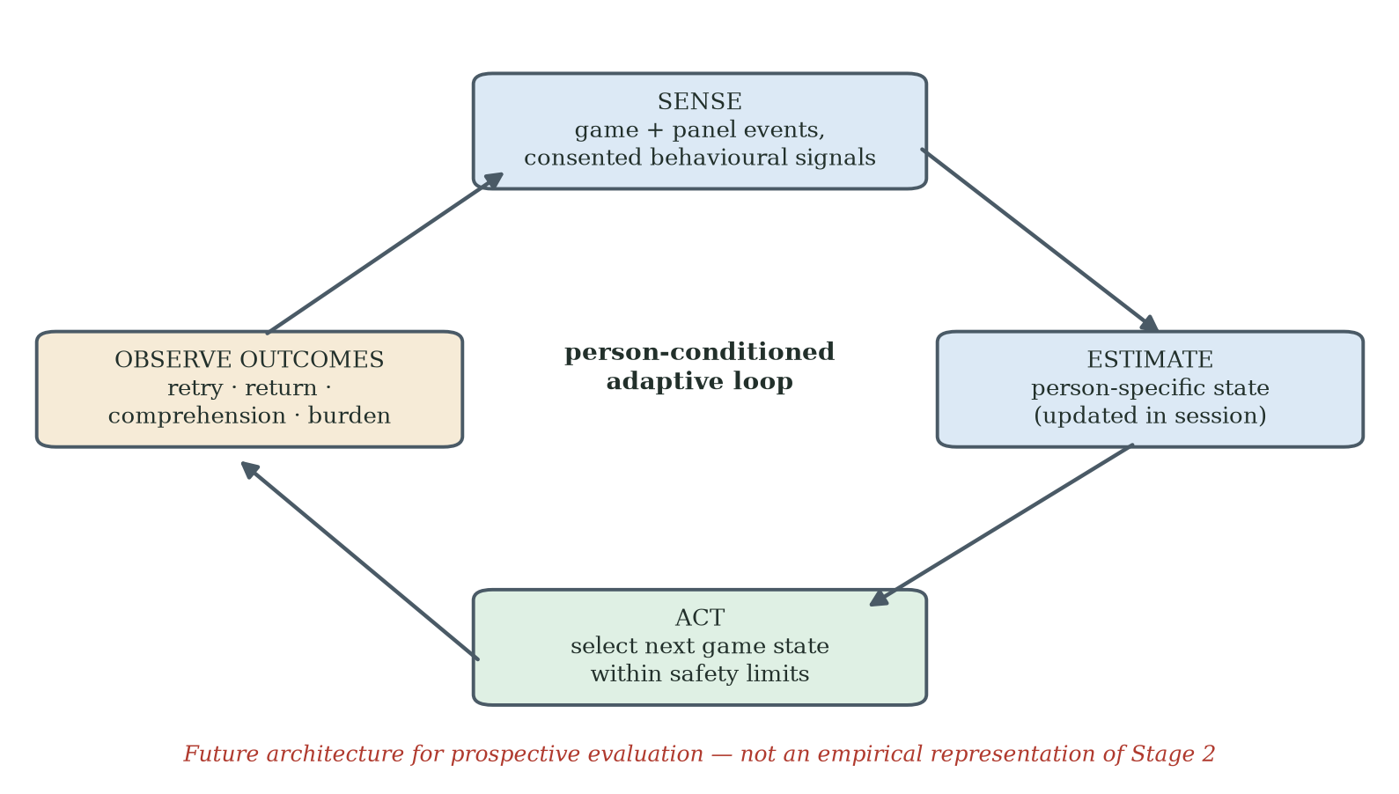
Figure 9.2. Proposed person-conditioned adaptive loop. Game and pressure-panel events are synchronised with ethically justified behavioural or experiential inputs; the system updates a person-specific state estimate and selects the next game state within pre-specified safety limits. Outcomes such as retry, return, comprehension and burden feed the next cycle. The figure is a future architecture, not an empirical representation of Stage 2.

9.9 Limits of What Has Been Shown
The limits are substantial and define the next programme. The empirical claims are restricted to a Southern Chinese residential cohort and a Hong Kong network-recruited cohort playing remotely on their own computers. The Stage-2-versus-Stage-3 comparison is not randomised and does not isolate framing from every concurrent difference. The proposed psychological mechanisms were not measured directly. FIAS requires a complete non-circular codebook, reliability testing and construct validation. The clinical significance of short-term FRA-index change is unknown. The complete adaptive-learning framework, dynamic-state architecture and person-conditioned AI extension have not been tested. Cross-cultural, cross-domain and long-term generalisation therefore remain open.

9.10 Natural Extensions
The highest-priority extension is a within-cohort randomised comparison of coupled and participant-facing decoupled conditions with harmonised recruitment, measures, staff scripts, hardware and follow-up. A distinct component programme should test adaptive calibration and failure presentation against simpler alternatives. Both require the progress-comparability specification in Chapter 7: recorded task and controller versions, separation of rewards from performance, suitable anchor checks, and explicit discontinuities when redesign prevents direct comparison. Longitudinal work should then evaluate repeated voluntary use and retained or transferred learning, while direct appraisal measures test the proposed FIAS account. Cross-cultural replication, cross-domain application, community-narrative research and person-conditioned sensing should follow from a stronger causal, measurement and construct foundation.

9.11 Returning to the Three F4 Residents
The thesis opened with three F4 residents whose recorded FRA index improved during a single session and who did not return. The observation should be preserved because it reveals that the direction of a measured score and the decision to return are not the same outcome. The present data do not reveal why each individual left. Identity protection and mental accounting are plausible interpretations, but fatigue, discomfort, misunderstanding, scepticism, embarrassment, burden or other factors may also have contributed.
Stage 3 showed that post-failure return was common in a separate decoupled cohort, including among adults aged 65–80. It would be inappropriate to estimate that particular F4 residents would have returned under decoupling, because the studies are not individual-level counterfactuals and the samples differ. The defensible conclusion is that return remains a plausible target for intervention, and that the contrast justifies a controlled test of the frame-sensitive account.
The practical aspiration remains simple: design the first adverse experience so that it supports learning, preserves dignity and leaves a truthful, safe and voluntary path to the next session. Players may fail levels; the research question is whether the system helps them understand the event, choose what to do next and return when continued participation is useful to them.

9.12 Closing Synthesis
The thesis began with an underused fall-risk-assessment station and ends with a testable engineering response to an innovation that did not achieve its intended engagement. The initial design expectation was not realised in Stage 2; the recorded performance and return outcomes showed why better task scores alone were insufficient evidence of success. Stage 3 documented a different engagement pattern in a separate deployment with altered clinical cues and context. These observations motivate, but do not isolate, a frame-sensitive explanation. The proposed adaptive-learning framework translates that problem into support around difficulty, actionable feedback and calibrated challenge. Its contribution to Gamification as Proactive Approach for Continuous Improvement and Innovation Enhancement is therefore a specified route from an observed deployment problem to an accountable redesign and evaluation process, rather than proof that gamification theory fails or that adaptive learning guarantees a solution.
Continuous improvement requires two related but separate loops. In the participant loop, the system offers appropriate challenge and support, records the conditions of performance and provides a truthful next step. In the system-innovation loop, the team investigates difficulties, revises a component or its underlying design assumption, and tests the consequences against stated criteria. A change is progress only with respect to an identified outcome and a defensible comparison; adaptation, activity accumulation and software novelty do not suffice. The proposed trajectory display consequently preserves prior observations, marks changes in task and assistance, and uses comparable checks where justified. When a redesign changes the construct or task too far for comparison, it reports the discontinuity and begins a clearly labelled new series without erasing the earlier result. This specification allows setbacks to inform improvement rather than disappear from the record.

The completed contribution is an original integration of a bounded field problem, candidate behavioural explanations and a domain-specific engineering specification. The programme observed failure-associated non-return and a divergence between recorded performance and continuation, then documented a contrasting engagement pattern under a different package and context. It proposes that proactive support and truthful trajectory feedback could help users respond to difficulty, while structured evaluation could help the engineering team improve the innovation. FIAS remains provisional; clinical framing is a candidate explanation; Stage 3B concerns component testing; and the complete adaptive-learning framework, credible-progress specification and longer-term outcomes remain to be evaluated. AI may enable particular forms of adaptation, but neither AI use nor a continuously rising display is the criterion of success. The criterion is whether documented changes produce worthwhile, credible and sustained outcomes for the intended users under stated conditions.

References
Akao, Y. (1990). Quality function deployment: Integrating customer requirements into product design. Productivity Press.
Altmeyer, M., Lessel, P., & Krüger, A. (2018). Investigating gamification for seniors aged 75+. In Proceedings of the 2018 Designing Interactive Systems Conference (pp. 453–458). ACM. https://doi.org/10.1145/3196709.3196799
An, S., Cheung, C. F., & Lo, Y. T. (2025). Improving older adults' technology adoption on mobile map: A gamification approach. International Journal of Human–Computer Interaction, 41(15), 9633–9651. https://doi.org/10.1080/10447318.2024.2426914
An, S., Cheung, C. F., & Willoughby, K. W. (2024). A gamification approach for enhancing older adults' technology adoption and knowledge transfer: A case study in mobile payments technology. Technological Forecasting and Social Change, 205, Article 123456. https://doi.org/10.1016/j.techfore.2024.123456
Antonides, G., de Groot, I. M., & van Raaij, W. F. (2011). Mental budgeting and the management of household finance. Journal of Economic Psychology, 32(4), 546–555.
Baddeley, A., & Wilson, B. A. (1994). When implicit learning fails: Amnesia and the problem of error elimination. Neuropsychologia, 32(1), 53-68.
Baltes, P. B., & Baltes, M. M. (1990). Psychological perspectives on successful aging: The model of selective optimization with compensation. In P. B. Baltes & M. M. Baltes (Eds.), Successful aging: Perspectives from the behavioral sciences (pp. 1-34). Cambridge University Press.
Bandura, A. (1977). Self-efficacy: Toward a unifying theory of behavioral change. Psychological Review, 84(2), 191–215.
Bandura, A. (1997). Self-efficacy: The exercise of control. W. H. Freeman.
Barber, S. J. (2017). An examination of age-based stereotype threat about cognitive decline. Perspectives on Psychological Science, 12(1), 62–90.
Beerda, J. (2015). Never fear gamification again. The Octalysis Group. https://octalysisgroup.com/2015/07/never-fear-gamification-again/
Bhattacherjee, A. (2001). Understanding information systems continuance: An expectation-confirmation model. MIS Quarterly, 25(3), 351-370. https://doi.org/10.2307/3250921
Bjork, E. L., & Bjork, R. A. (2011). Making things hard on yourself, but in a good way: Creating desirable difficulties to enhance learning. In M. A. Gernsbacher, R. W. Pew, L. M. Hough, & J. R. Pomerantz (Eds.), Psychology and the real world (pp. 56–64). Worth.
Broady, T., Chan, A., & Caputi, P. (2010). Older and younger adults' attitudes towards computers. British Journal of Educational Technology, 41(3), 473–485.
Brooks, R. A. (1991). Intelligence without representation. Artificial Intelligence, 47(1–3), 139–159.
Centers for Disease Control and Prevention. (2023). Facts about falls. U.S. Department of Health and Human Services.
Chan, L.-K., & Wu, M.-L. (2002). Quality function deployment: A literature review. European Journal of Operational Research, 143(3), 463–497.
Chen, G., Gully, S. M., & Eden, D. (2001). Validation of a new general self-efficacy scale. Organizational Research Methods, 4(1), 62–83.
Chen, K., & Chan, A. H. S. (2014). Gerontechnology acceptance by elderly Hong Kong Chinese: A senior technology acceptance model (STAM). Ergonomics, 57(5), 635–652.
Chou, Y. (2015). Actionable gamification: Beyond points, badges, and leaderboards. Octalysis Media.
Compeau, D. R., & Higgins, C. A. (1995). Computer self-efficacy: Development of a measure and initial test. MIS Quarterly, 19(2), 189–211.
Cruz Rivera, S., Liu, X., Chan, A.-W., Denniston, A. K., Calvert, M. J., & SPIRIT-AI and CONSORT-AI Working Group. (2020). Guidelines for clinical trial protocols for interventions involving artificial intelligence: The SPIRIT-AI extension. Nature Medicine, 26(9), 1351–1363. https://doi.org/10.1038/s41591-020-1037-7
Csikszentmihalyi, M. (1990). Flow: The psychology of optimal experience. Harper & Row.
Czaja, S. J., Boot, W. R., Charness, N., Rogers, W. A., & Sharit, J. (2018). Improving social support for older adults through technology: Findings from the PRISM randomized controlled trial. The Gerontologist, 58(3), 467-477. https://doi.org/10.1093/geront/gnw249
D'Mello, S., & Graesser, A. (2012). Dynamics of affective states during complex learning. Learning and Instruction, 22(2), 145–157.
Davis, F. D. (1989). Perceived usefulness, perceived ease of use, and user acceptance of information technology. MIS Quarterly, 13(3), 319–340.
Deci, E. L., & Ryan, R. M. (1985). Intrinsic motivation and self-determination in human behavior. Plenum.
Deterding, S., Dixon, D., Khaled, R., & Nacke, L. (2011). From game design elements to gamefulness: Defining gamification. In Proceedings of the 15th International Academic MindTrek Conference (pp. 9–15). ACM.
Elliot, A. J., & Murayama, K. (2008). On the measurement of achievement goals: Critique, illustration, and application. Journal of Educational Psychology, 100(3), 613–628.
Eysenbach, G. (2005). The law of attrition. Journal of Medical Internet Research, 7(1), e11.
Festinger, L. (1954). A theory of social comparison processes. Human Relations, 7(2), 117–140.
Frey, B. S., & Jegen, R. (2001). Motivation crowding theory. Journal of Economic Surveys, 15(5), 589–611.
Gadbois, E. A., Jimenez, F., Brazier, J. F., Davoodi, N. M., Nunn, A. S., Mills, W. L., Dosa, D., & Thomas, K. S. (2022). Findings from Talking Tech: A technology training pilot intervention to reduce loneliness and social isolation among homebound older adults. Innovation in Aging, 6(5), igac040. https://doi.org/10.1093/geroni/igac040
GrandPad. (n.d.). GrandPad: The tablet for seniors [Product and subscription information]. GrandPad, Inc. https://www.grandpad.net
Greenhalgh, T., Wherton, J., Papoutsi, C., Lynch, J., Hughes, G., A'Court, C., Hinder, S., Fahy, N., Procter, R., & Shaw, S. (2017). Beyond adoption: A new framework for theorizing and evaluating nonadoption, abandonment, and challenges to the scale-up, spread, and sustainability of health and care technologies. Journal of Medical Internet Research, 19(11), e367.
Harnad, S. (1990). The symbol grounding problem. Physica D: Nonlinear Phenomena, 42(1–3), 335–346.
Hawthorn, D. (2007). Interface design and engagement with older people. Behaviour & Information Technology, 26(4), 333–341.
Holt, C. A., & Laury, S. K. (2002). Risk aversion and incentive effects. American Economic Review, 92(5), 1644–1655.
Howell, J. L., & Shepperd, J. A. (2012). Reducing information avoidance through affirmation. Psychological Science, 23(2), 141–145. https://doi.org/10.1177/0956797611424164
InBody Co., Ltd. (2022). InBody FRA510S: Fall risk assessment system — user manual and product catalogue. InBody Co., Ltd.
Institute for Healthcare Improvement. (n.d.). Model for Improvement: Testing changes. https://www.ihi.org/library/model-for-improvement/testing-changes
Juul, J. (2013). The art of failure: An essay on the pain of playing video games. MIT Press.
Kahneman, D., & Tversky, A. (1979). Prospect theory: An analysis of decision under risk. Econometrica, 47(2), 263–292.
Kahneman, D., Knetsch, J. L., & Thaler, R. H. (1990). Experimental tests of the endowment effect and the Coase theorem. Journal of Political Economy, 98(6), 1325–1348.
Kapur, M. (2008). Productive failure. Cognition and Instruction, 26(3), 379–424.
Kim, M., Kim, S., & Won, C. W. (2018). Test–retest reliability and sensitivity to change of a new fall risk assessment system: A pilot study. Annals of Geriatric Medicine and Research, 22(2), 80–87. https://doi.org/10.4235/agmr.2018.22.2.80
King, W. R., & He, J. (2006). A meta-analysis of the technology acceptance model. Information & Management, 43(6), 740–755.
Koivisto, J., & Malik, A. (2021). Gamification for older adults: A systematic literature review. The Gerontologist, 61(7), e360–e372.
Kroenke, K., Spitzer, R. L., Williams, J. B. W., & Löwe, B. (2009). An ultra-brief screening scale for anxiety and depression: The PHQ-4. Psychosomatics, 50(6), 613–621.
Lazar, A., Koehler, C., Tanenbaum, J., & Nguyen, D. H. (2015). Why we use and abandon smart devices. In Proceedings of the 2015 ACM International Joint Conference on Pervasive and Ubiquitous Computing (UbiComp '15) (pp. 635-646). ACM. https://doi.org/10.1145/2750858.2804288
Lee, C., & Coughlin, J. F. (2015). Older adults' adoption of technology: An integrated approach to identifying determinants and barriers. Journal of Product Innovation Management, 32(5), 747–759.
Levy, B. R., Slade, M. D., Kunkel, S. R., & Kasl, S. V. (2002). Longevity increased by positive self-perceptions of aging. Journal of Personality and Social Psychology, 83(2), 261–270.
Lewin, K. (1946). Action research and minority problems. Journal of Social Issues, 2(4), 34–46.
Liu, X., Cruz Rivera, S., Moher, D., Calvert, M. J., Denniston, A. K., & SPIRIT-AI and CONSORT-AI Working Group. (2020). Reporting guidelines for clinical trial reports for interventions involving artificial intelligence: The CONSORT-AI extension. Nature Medicine, 26(9), 1364–1374. https://doi.org/10.1038/s41591-020-1034-x
Locke, E. A., & Latham, G. P. (2002). Building a practically useful theory of goal setting and task motivation: A 35-year odyssey. American Psychologist, 57(9), 705–717.
McGlone, M. S., & Aronson, J. (2006). Stereotype threat, identity salience, and spatial reasoning. Journal of Applied Developmental Psychology, 27(5), 486–493.
Michie, S., van Stralen, M. M., & West, R. (2011). The behaviour change wheel: A new method for characterising and designing behaviour change interventions. Implementation Science, 6, 42.
Nasreddine, Z. S., Phillips, N. A., Bédirian, V., Charbonneau, S., Whitehead, V., Collin, I., Cummings, J. L., & Chertkow, H. (2005). The Montreal Cognitive Assessment, MoCA: A brief screening tool for mild cognitive impairment. Journal of the American Geriatrics Society, 53(4), 695–699.
OECD/Eurostat. (2018). Oslo manual 2018: Guidelines for collecting, reporting and using data on innovation (4th ed.). OECD Publishing. https://doi.org/10.1787/9789264304604-en
Park, D. C., Lodi-Smith, J., Drew, L., Haber, S., Hebrank, A., Bischof, G. N., & Aamodt, W. (2014). The impact of sustained engagement on cognitive function in older adults: The Synapse Project. Psychological Science, 25(1), 103-112. https://doi.org/10.1177/0956797613499592
Park, W.-C., Kim, M., Kim, S., Yoo, J., Kim, B. S., Chon, J., Jeong, S. J., & Won, C. W. (2019). Introduction of fall risk assessment (FRA) system and cross-sectional validation among community-dwelling older adults. Annals of Rehabilitation Medicine, 43(1), 87–95. https://doi.org/10.5535/arm.2019.43.1.87
Peek, S. T. M., Wouters, E. J. M., van Hoof, J., Luijkx, K. G., Boeije, H. R., & Vrijhoef, H. J. M. (2014). Factors influencing acceptance of technology for aging in place: A systematic review. International Journal of Medical Informatics, 83(4), 235-248. https://doi.org/10.1016/j.ijmedinf.2014.01.004
Perissinotto, C., Zhang, C., Oseau, T., Balik, D., Sou, C., Burnight, C., & Burnight, K. (2019). Feasibility of a tablet designed for older adults to facilitate telemedicine visits [Conference abstract]. Innovation in Aging, 3(Suppl. 1), S975. https://doi.org/10.1093/geroni/igz038.3534
Phillips, B., & Zhao, H. (1993). Predictors of assistive technology abandonment. Assistive Technology, 5(1), 36-45. https://doi.org/10.1080/10400435.1993.10132205
Picard, R. W. (1997). Affective computing. MIT Press.
Plass, J. L., Homer, B. D., & Kinzer, C. K. (2015). Foundations of game-based learning. Educational Psychologist, 50(4), 258-283.
Plott, C. R., & Zeiler, K. (2005). The willingness to pay–willingness to accept gap, the ‘endowment effect,’ subject misconceptions, and experimental procedures for eliciting valuations. American Economic Review, 95(3), 530–545. https://doi.org/10.1257/0002828054201387
Reason, P., & Bradbury, H. (Eds.). (2008). The SAGE handbook of action research: Participative inquiry and practice (2nd ed.). SAGE.
Ryan, R. M., & Deci, E. L. (2000). Self-determination theory and the facilitation of intrinsic motivation, social development, and well-being. American Psychologist, 55(1), 68–78.
Satchell, C., & Dourish, P. (2009). Beyond the user: Use and non-use in HCI. In Proceedings of OzCHI 2009 (pp. 9–16). ACM.
Schroeder, T., Dodds, L., Georgiou, A., Gewald, H., & Siette, J. (2023). Older adults and new technology: Mapping review of the factors associated with older adults' intention to adopt digital technologies. JMIR Aging, 6, e44564.
Shannon, C. E. (1948). A mathematical theory of communication. Bell System Technical Journal, 27(3), 379–423; 27(4), 623–656.
Soderstrom, N. C., & Bjork, R. A. (2015). Learning versus performance: An integrative review. Perspectives on Psychological Science, 10(2), 176–199. https://doi.org/10.1177/1745691615569000
Standing Committee of the National People's Congress. (2021). Personal information protection law of the People's Republic of China.
Steele, C. M., & Aronson, J. (1995). Stereotype threat and the intellectual test performance of African Americans. Journal of Personality and Social Psychology, 69(5), 797–811.
Stringer, E. T. (2014). Action research (4th ed.). SAGE.
Tha, S. H., Hough, K., Bui, N., Dulaney, S., & Perissinotto, C. (2025). The use of age-friendly technology in the care of older adults: Two implementation case studies. Journal of Applied Gerontology. https://doi.org/10.1177/07334648251343513
Thaler, R. H. (1980). Toward a positive theory of consumer choice. Journal of Economic Behavior & Organization, 1(1), 39–60.
Thaler, R. H. (1985). Mental accounting and consumer choice. Marketing Science, 4(3), 199–214.
Tsai, T. H., Lin, W. Y., Chang, Y. S., Chang, P. C., & Lee, M. Y. (2020). Technology anxiety and resistance to change: Behavioural study of a wearable cardiac warming system using an extended TAM for older adults. PLOS ONE, 15(1), e0227270. https://doi.org/10.1371/journal.pone.0227270
Tversky, A., & Kahneman, D. (1991). Loss aversion in riskless choice: A reference-dependent model. Quarterly Journal of Economics, 106(4), 1039–1061.
VanLehn, K. (2011). The relative effectiveness of human tutoring, intelligent tutoring systems, and other tutoring systems. Educational Psychologist, 46(4), 197–221.
Venkatesh, V., & Bala, H. (2008). Technology acceptance model 3 and a research agenda on interventions. Decision Sciences, 39(2), 273–315.
Venkatesh, V., & Davis, F. D. (2000). A theoretical extension of the technology acceptance model: Four longitudinal field studies. Management Science, 46(2), 186–204.
Venkatesh, V., Morris, M. G., Davis, G. B., & Davis, F. D. (2003). User acceptance of information technology: Toward a unified view. MIS Quarterly, 27(3), 425–478.
Vickers, A. J., & Elkin, E. B. (2006). Decision curve analysis: A novel method for evaluating prediction models. Medical Decision Making, 26(6), 565–574.
Vygotsky, L. S. (1978). Mind in society: The development of higher psychological processes. Harvard University Press.
Wittgenstein, L. (1922). Tractatus logico-philosophicus (C. K. Ogden, Trans.). Kegan Paul, Trench, Trubner. (Original work published 1921)
World Health Organization. (2007). WHO global report on falls prevention in older age. World Health Organization.
World Health Organization. (2023). Falls (Fact sheet). World Health Organization. https://www.who.int/news-room/fact-sheets/detail/falls
World Health Organization. (2024). Ageing and health (Fact sheet). World Health Organization. https://www.who.int/news-room/fact-sheets/detail/ageing-and-health
Yardley, L., Beyer, N., Hauer, K., Kempen, G., Piot-Ziegler, C., & Todd, C. (2005). Development and initial validation of the Falls Efficacy Scale-International (FES-I). Age and Ageing, 34(6), 614–619.
Zohaib, M. (2018). Dynamic difficulty adjustment (DDA) in computer games: A review. Advances in Human-Computer Interaction, 2018, 5681652.

Appendices
This section contains the supporting instruments, coding rules, protocols and reference materials referenced in the main thesis. Each appendix identifies its bound materials and, where an item is held rather than printed, the record in which it is held.

Appendix A · Stage-1 Survey Instrument
Six Yes/No items administered face-to-face by nursing staff at the Poly Group Guangzhou facility between July and August 2024 to 200 eligible residents of the facility's population of 280. Five qualifying criteria were verified by the management office prior to invitation: secondary education or above, no significant cognitive impairment, capable of unsupported standing, sufficient vision for screen reading, and no acute mental-health conditions.

A.1 · Survey Items
The instrument consisted of six closed items with binary Yes/No response. The items moved from awareness through prior exposure to current use intention, in the order shown below.
Item 1 · Awareness: Have you heard of the Fall Risk Assessment (FRA) system available at this facility?
Item 2 · Prior exposure: Have you ever used the FRA system?
Item 3 · First-time outcome: At your first attempt, did the system give you a result you understood and accepted?
Item 4 · Continuation: After your first use, did you ever come back to the FRA system?
Item 5 · Reason for non-return: If you did not come back, was the main reason that you found the experience uncomfortable, embarrassing, or discouraging?
Item 6 · Future intention: If a friendlier version of the same system were offered, would you be willing to try it again?

Appendix B · Stage-2 FIAS Coding Scheme
The Stage-2 coding scheme operationalises the provisional FIAS hypothesis through thirteen binary attributes drawn from STAM and selected Octalysis drives, collapsed onto a 0–10 composite. Five descriptive categories are used: F0 (no failure signal), F1 (mild discomfort), F2 (clear distress), F3 (active disengagement) and F4 (observed non-return under the study definition). Outcome-defining variables such as cycle count and return status must not be embedded in a predictor score that is then claimed to predict the same outcome; the validation analysis is therefore reported separately from the scoring rules. The item-level specification of the scheme — every item, weight, threshold, source, missing-data rule and adjudication procedure — is a deliverable of the confirmatory study (§8.8) and is not reproduced here; per §5.6 the composite is a descriptive case-identification device and carries no evidential weight in this thesis.

Appendix C · Stage-2 Qualitative Record and the F4 Interview Protocol (Designed, Not Administered)
The Stage-2 qualitative record has two genuine components. First, an after-game paper questionnaire was completed by every participant at the end of play; it is the source of the satisfaction data reported in Chapter 5. Second, post-deployment interviews were conducted during August and September 2025, in the weeks following the eight-week cycle and the small rewards presentation at which the persistent players' written consent was recorded. Because the game was coupled to the FRA, the interviews were arranged through the facility therapists, who knew the players from the sessions. Each player was invited to an interview after the games; a very few were interviewed immediately, others deferred, and the therapists completed the remaining interviews as players could be reached over this period — all thirty were sought and twenty-nine could be reached. Nine accepted, and the nine who accepted were the nine persistent participants. The interviews were conducted with the therapists' assistance, some in person and some by telephone, in Mandarin or Cantonese at the participant's preference, using the paper interview questionnaire as the schedule. Responses were recorded by the therapists onto the questionnaire forms and into a logbook kept at the centre — in some cases after, rather than during, the interview — and the researcher received the therapists' summaries and collected the logbook, and the therapists reported when all interviews were done. The researcher did not directly observe the interviews, and their individual timing rests on the dated forms and the therapists' report. The therapist-completed record, not researcher notes, is therefore the primary record, and recorded free-text wording is the therapists' rendering rather than the participants' verbatim words. That twenty reachable players declined is itself part of the record: the interview subgroup is self-selected, and the interviews accordingly speak to persistence only. The interview instrument's structure is now documented from the author's entry-and-results record (received and archived 10 September 2026 with the raw data): nine items - a free-text memorable-experience item; enjoyment, FRA usefulness and discouragement on five-point scales; steering confidence and recovery confidence on 0-10 scales; play-again and FRA-again willingness items; and a free-text reasons item. The entry record holds all nine participants' responses (entered complete, no corrections), and the entry workbook's question guide documents the full bilingual wording of the nine items with their scale anchors (1-5 agreement, strongly disagree to strongly agree; 0-10 confidence, none to complete, the two confidence items assuming the same staff support as at the session; Q7/Q8 offer Yes/Undecided/No and Willing/Undecided/Unwilling), drawn from the researcher's revised-draft pack. A photographic copy of one completed interview form (participant S2-P024, dated 25 August 2025) has been sighted and matches the entry record and the documented wording; archival copies of the completed forms (including that exemplar) and of the after-game questionnaire sheets remain to be filed. Entered ratings: enjoyment mean 4.3 (range 4-5), usefulness 4.7 (4-5), discouragement 1.9 (1-3), steering confidence 7.4 (6-8), recovery confidence 7.7 (6-9); all nine would play again and all nine were willing to continue with the FRA. Three further interviews were conducted with centre managers, capturing the operator perspective on the deployment. These conversations informed the learn-to-earn design orientation of §5.2. In addition, a nine-question semi-structured interview protocol was designed for the F4 cluster, to be administered within days of an abandoned session; it was NOT administered in Stage 2 — the F4 residents' negative reaction to the experience made a research interview inappropriate at the time — and no F4 interview data exist. The protocol below is therefore a designed instrument retained for the confirmatory programme (§8.8), not a record of interviews conducted.

C.1 · Question Set
Q1 · Recall: Can you tell me, in your own words, what happened during your first session with the system?
Q2 · Affect: How did you feel at the moment the system gave you the result?
Q3 · Self-attribution: Looking back, who or what do you feel was responsible for the result?
Q4 · Identity: When the result came up, what kind of person did you feel the system was telling you that you are?
Q5 · Comparison: Did you feel the result was about your body, or about you as a person?
Q6 · Decision: When did you decide you would not come back?
Q7 · Counter-factual: Is there anything that could have changed your mind that day?
Q8 · Future framing: If the same activity had been described differently to you, would you have stayed?
Q9 · Open: Is there anything else you would like the research team to understand?

Appendix D · Stage-3 Decoupling Questionnaire
The Stage-3 decoupling design used a short two-item post-session instrument to measure coordination-challenge endorsement and long-term commitment intention. Demographic items (age band, gender, education) were collected at enrolment only. Both post-session items are reproduced here with the five-point Likert response format of the working record; the as-administered response format (five- or seven-point) and the exact bilingual wording await confirmation against the original instrument (author checklist, item 7). Endorsement of an item required a response of 4 or 5. In the Stage-3 remote deployment the instrument was distributed with the e-mailed game build, and participants returned their responses by e-mail together with the build's logged results file.

D.1 · Post-Session Items
Item D1 · Coordination endorsement: I would describe the activity I just completed as a coordination and balance challenge.
Item D2 · Commitment intention: I would be willing to come back and do this activity on a regular basis (one or more times per week) over the next three months.

D.2 · Demographic Block (At Enrolment)
Age band: 25–44, 45–64, 65–80.
Gender: Male, Female, Prefer not to say.
Highest completed education: Primary, Secondary, Tertiary.

Appendix E · Five-Layer Architecture and Adaptive-Learning Reference Stack
The Stage-2 deployment ran on a five-layer architecture. The decoupled Stage-3 condition ran a ported HTML build of the L1 game layer on participants' own computers: L0 was replaced by trackpad or arrow-key input (or a foot-pad sensor where available), and the L3/L4 clinical pipeline was absent rather than merely suppressed. L2's in-run difficulty adjustment operated in the ported build as its built-in rule agent only: a distributed HTML file carries no API credentials and browser cross-origin policy blocks direct model calls, so every Stage-3 session ran under rule-based difficulty adaptation — the same fail-safe heuristic that backs L2 in the Stage-2 architecture. No large-language-model call operated in any Stage-3 session. The full adaptive-learning reference stack adds three further layers (L5 User-Facing Trajectory, L6 Staff Coaching Protocol, L7 Adaptive-Learning Telemetry) without altering the underlying signal path.

E.1 · Layers L0–L4 (Stage-2 Operational)
L0 · Input: InBody pressure-panel sensor stream; calibrated by InBody engineers; centre-of-pressure (COP) sampled at vendor-default rate.
L1 · Game Engine: Pygame-based skiing game; physics-driven obstacle and coin scheduling; difficulty parameters exposed through a single configuration object.
L2 · AI Adaptation: LangChain orchestration over large-language-model API calls (deployed endpoint recorded in Appendix G, item G.7); six-stage difficulty-adjustment loop (signal aggregation, user-profile lookup, prompt assembly, model call, response parsing and configuration write-back).
L3 · Logging: Per-session JSON event log including COP samples, level transitions, success/failure events, AI-call telemetry and timestamps.
L4 · Clinical Output: Aggregated COP-derived balance index and category label, exposed to clinical staff in Stage 2; absent in the Stage-3 decoupled condition (the HTML build had no clinical pipeline).

E.2 · Layers L5–L7 (Adaptive-Learning Reference Stack)
L5 · User-Facing Trajectory: Plain-language, learning-anchored progress display that frames the next session against the previous session's calibrated band, never against a clinical norm.
L6 · Staff Coaching Protocol: Standardised post-failure interaction script, triggered by L7 telemetry, designed to absorb the failure event into a learning-oriented reframe before the participant leaves the room.
L7 · Adaptive-Learning Telemetry: Real-time monitoring of risk indicators (consecutive failures, abrupt session abandonment, post-failure latency to next attempt); fires coaching triggers and updates trajectory parameters.

E.3 · AI Safety Provisions
Graceful degradation is in place at all layers: if the model endpoint is unavailable, L2 falls back to a rule-based difficulty heuristic without interrupting gameplay. No participant identifiers are transmitted off-device. All AI calls are logged. A manual override is available at the staff console at all times.

Appendix F · Glossary of Key Constructs
This glossary defines the twelve constructs that carry the theoretical load of the thesis. Each construct is given a one-paragraph operational definition; the corresponding section of the main text is referenced where the construct is introduced.
Construct | Definition
FIDS | Failure-Induced Dropout Syndrome - the initial working label for failure-associated disengagement. It was a hypothesis, not a validated syndrome.
FIAS | Failure-Induced Abandonment Syndrome: a provisional, non-diagnostic construct describing failure-associated non-return in the studied setting. Active avoidance, identity-related mechanisms, reliability and incremental prediction remain to be established.
Recorded-Score–Engagement Discrepancy (formerly: Objective-Score-Improvement/Non-Return Paradox) | The Stage-2 observation that some participants showed positive change in the recorded FRA index during a single session and did not return during the study window. The pattern does not by itself establish clinical benefit or a specific psychological mechanism.
Decoupling | A multi-component participant-facing intervention that reduces clinical-verdict cues at lexical, procedural and interface levels. Stage 3 evaluated the package in a separate cohort; it was not a single-variable experiment.
Mental Accounting of Health Outcomes | A candidate mechanism by which a clinical frame may increase the personal meaning of an adverse event. Adapted from mental-accounting theory and not directly measured in the present studies.
Frame-Suppression | A frame-sensitive hypothesis supported by the direction of Stage-3 behaviour but not proven because the comparison is between cohorts and includes multiple contextual changes.
Commitment Gap | The 29.3-percentage-point difference in the 65-80 band between end-of-window retention (85.4%) and stated regular-use intention (56.1%). It is descriptive and does not identify a single cause.
Adaptive-Learning Framework | The thesis's proposed three-principle engineering framework: identity disentanglement, trajectory installation and adaptive calibration. The complete framework has not yet been evaluated.
Entropy Constraint | A future information-theoretic hypothesis that a salient event may reduce uncertainty in the user's interpretation. No entropy distribution was measured in the present studies.
M0 / M1 / M2 | The three nested models specified in §6.10 for quantitative comparison: demographic baseline (M0), STAM-only (M1), STAM augmented with FIAS operators (M2). Proposed for comparison using LRT, ΔAIC, ΔBIC, McFadden's pseudo-R², Harrell's C-index and decision-curve analysis.
Decision-Curve Analysis | A method for evaluating the net benefit of a prediction-guided decision across specified thresholds and relative consequences of true and false positives (Vickers & Elkin, 2006). Proposed here for future decision evaluation, not performed in the present programme.
Adaptive Learning | A proposed design regime that combines trajectory-oriented feedback with calibrated challenge, pacing and support. It is hypothesised to reduce the dominance of fixed-verdict appraisal; structural incompatibility with endowment was not empirically tested.

Appendix G · Raw Data, Photographs and Supplementary Materials
G.0 Source-to-result manifest. [AUTHOR INPUT NEEDED - to be completed when the records arrive: one row per claimed artifact - source file, collection date, anonymised participant IDs covered, cleaning/derivation script, output table it feeds, access location, verification status. Every deposited item must actually be accessible to examiners; results that cannot be reconstructed from a manifest row are withdrawn or qualified. Synthetic pipeline-test records remain labelled and wholly separate (G.8).]
G.0A Build-lineage matrix. [AUTHOR INPUT NEEDED: one version-controlled row per build generation - 2024 control demonstration, deployed Stage-2 build, Stage-3 HTML port, v2.x successor builds, v3.x Stage-3B fleet - recording dates, code version/hash, hardware, input devices, adaptation mechanism (static / rule agent / LLM, with the G.7 endpoint record), logging capability versus retained logs, and which participants used which build. Resolves the s5.3.9 chronology note and the Table 7.2 hardware description.]
Appendix G binds the raw data, photographs and supplementary materials listed below. Each item is deposited with the thesis or in a governed repository accessible to examiners; where an item cannot be shared openly, the access procedure and restrictions are stated in its entry.
G.1 Cleaned Stage-1 survey response file (CSV).
G.2 Stage-2 participant dataset (FRA_Raw_Data_N30.xlsx; 30 elderly participants plus two younger staff test plays; stable pseudonymous IDs S2-P001–S2-P030 and S2-C001/S2-C002 per the Stage-2 ID register, received 11 September 2026): gender, age, pre/post recorded FRA index, presenting symptoms, completed game cycles, self-reported symptom change, satisfaction and verification flag. Received and archived 12 July 2026; this file is the source for every Stage-2 statistic in §5.5 and for Figure 5.4. Session-level telemetry is bound with this item where retained; its retention status is recorded in §8.9.
G.3 Stage-3 data logbook (Stage3_Data_Logbook_120cases_with_Reconciliation.xlsx): codebook with provenance note, participant/telemetry/questionnaire/outcome sheets for IDs 3001–3120, the aggregate results (Preliminary_Summary sheet) and a live Reconciliation sheet. Stage-3 data collection is complete; participant-level entries are compiled from the primary records of the remote deployment — the participants' returned e-mails, each carrying the HTML build's logged results file (CSV) and the questionnaire responses — with each entry checked by the reconciliation sheet.
G.4 Photographs of the Guangzhou Stage-2 deployment (consented).
G.5 The Stage-3 distribution and return e-mail record (de-identified index of dates, channels and returned files).
G.6 Screenshots of the skiing game at each difficulty level (1–5).
G.7 AI prompt-template archive used in Layer 2 (system and user prompts, versions and settings).
G.8 Synthetic pipeline-test dataset (TestData_Stage3_Pipeline_v1_dates_corrected.xlsx): a simulation-generated workbook of 120 fictitious records (IDs TEST-001 to TEST-120, outside the study ID range) used to verify the Stage-3 logbook structure, formulas and analysis pipeline. Every sheet is watermarked as synthetic, and the workbook deliberately does not match the study aggregates. It is archived solely as a pipeline-verification artifact, in the same spirit as the synthetic centre-of-pressure traces of §5.3.9, and contains no data from any human participant.
G.9 HUR SmartBalance vendor brochure (the author's industry documentation supporting the §4.1A platform-lineage account).
G.10 The two development-office demonstration videos of 27 August 2024 (platform-to-game coupling on the off-the-shelf scaffold; source of the Figure 5.1A frame), with the control person's written consent (pending - author checklist, item 9).
G.11 Expert interview guide (Expert_Interview_Guide_2026.docx), the semi-structured guide used across the consultation panel; reproduced compactly as Appendix H.5.

Appendix H · Expert Consultation Record
H.1 Expert and scope. Dr Sarah C.W. Yuan, Specialist, Center on the Family, University of Hawai'i at Mānoa; PhD and MA in Sociology (University of Hawai'i at Mānoa), MSc in Applied Social Research (University of Stirling). Research expertise: medical sociology, demography of aging, survey methodology; projects include the Hawai'i Healthy Aging Partnership; recognitions include the Hawai'i Pacific Gerontological Society Research and Teaching Award (2010). Her field of practice relevant to this consultation is community group falls-prevention programming: non-electronic group exercise and physical games whose objective is to improve older adults' balance and reduce fall risk. Credentials verified against her University of Hawai'i faculty profiles at the time of writing.
H.2 Conduct and record. The consultation was a single semi-structured conversation between the author and Dr Yuan, conducted by telephone in English on 25 July 2026 and lasting approximately 35 minutes; her signed consent form is dated 22 July 2026 and its transmittal e-mail is archived with the programme records. The author first presented the three-stage programme, its findings and the null-hypothesis architecture; Dr Yuan then described her own research area and findings, and responded to the programme's constructs. The record is the author's structured notes, summarised at H.3. Dr Yuan is named with her consent; the consultation record and the attribution confirmation are held with the programme records.
H.3 Summary of the consultation (author's notes). (1) The author introduced the research: Stages 1-3, the findings, and the initial design expectation (H0). (2) Dr Yuan's falls-related work concerns non-clinical assessment and group work — exercise and group dynamic physical games, not electronic games — whose objective is to improve balance and avoid fall risk. (3) From her findings, including her publications: when older adults join a social exercise group, they tend to drop out after failure unless a physician or assistant helps them overcome the rejection; they perform better when playing in a group with a coach who leads them to continue, and continuation is difficult otherwise. (4) She agreed that older adults intrinsically reject clinical assessment or diagnosis of their current health status, and psychologically avoid facing the clinical evidence that explains their condition. (5) In her experience, older adults avoid individual assessment when it is straight clinically oriented, for fear of facing negative risk results. (6) She confirmed that gamification is very effective for promoting health technology, but that older adults reject it hard when the game or exercise is linked to clinical results; on this basis she supported the Stage-3 decoupling approach. (7) Speaking from a sociology perspective rather than an engineering one, she shared the same view of elderly behaviour, supported the FIDS-to-FIAS construction and the adaptive-learning proposition, and confirmed that older adults perform better when grouped and building dynamics: partnering and group dynamics reduce initial dropout and, eventually, abandonment of the health technology. She emphasised that the key components extend beyond engineering excellence and design: the environment, the people who are using the same technology, and predictable or expected results are the key components that support older adults in adopting health technologies.
H.4 Use in the thesis. The consultation is cited at §3.2 (method), §6.8A (interpretation of the commitment gap), §7.5.3 (coaching-protocol support) and §8.5 (candidate moderators). It is treated throughout as interpretive evidence from an independent discipline — one consultation, recorded in the author's notes — and not as participant data, validation, or a demonstrated result for electronic games.
H.5 Interview guide (as used). The consultation followed a semi-structured guide (45-60 minutes; archived as Expert_Interview_Guide_2026.docx, Appendix G item G.11), designed to elicit the expert's independent reading before study specifics were revealed. Its sections and questions, in compact form: A. Background — the expert's role and what their discipline sees about falls that other fields miss. B. The engagement problem — after hearing the field observation (adverse first experience, non-return even where measured performance improved): does the pattern match their experience; what is happening inside the non-return; why does the first experience carry so much weight. C. Framing and purpose — after hearing the decoupled-deployment result: why would removing the clinical frame change behaviour; is a "test" socially different from a "game" for this generation. D. The commitment gap — what would explain high session completion with low regular-use intention; what builds the habit rather than the visit. E. The social dimension — asked open-endedly BEFORE revealing that study play was individual: does alone-versus-together change the experience; would group play change engagement and in which direction; when would social play backfire; how does culture shape the answer. F. Adaptive learning and design — reaction to the adaptive-learning proposal; through what channel adaptation would actually operate (private mastery or between people); one measure they would add to a follow-up study. G. Closing — anything not covered; other perspectives to seek; confirmation of attribution preference and quote-approval contact. The guide's post-interview checklist requires the record to be written within 48 hours, the consent filed, and attribution sentences approved before binding.
H.6 Consultation record - Dr Gary Kui-Kai Lau. Standpoint: stroke neurologist; Assistant Dean (Education Innovations) and Clinical Associate Professor, Division of Neurology, LKS Faculty of Medicine, The University of Hong Kong; founder of the HKU STROKE Research Group (2018); developer of AI-enabled mobile applications for stroke recovery. Prior collaboration with the author on stroke-prevention education games is disclosed. Conduct: June 2026, in person, approximately one hour, Cantonese mixed with English; author's notes primary. Consent: completed 10 August 2026 (nine statements initialled GL; signature image), countersigned 11 August 2026; named attribution elected in writing ('Ok to be identified', WhatsApp, 11 Aug 2026) - the form's tick transcribes that written election, and both artifacts are archived. Substance: patients lack patience with slow-improving health technology; gamification contributes joyful participation; the long recovery journey is difficult, boring and lonely, and current technology shows no progressive positive signs; elderly patients give up easily and many abandon rehabilitation entirely - not a minority group; coaching is the best and most direct approach but cannot scale (family cost; therapist scarcity); whether games change minds and behaviour he cannot yet be sure - 'a good start to find out'.
[AUTHOR INPUT NEEDED - H.6 completion: second-consultation record (game feedback with date and build; Mirror-project paragraph subject to Dr Lau's clearance; member-check outcome).]
H.7 Consultation record - Dr Philip Choy. Standpoint: certified naturopathic physician (ANMCB 06394) and Doctor of Natural Medicine; President of the Hong Kong Academy of Naturopath; over twenty-five years of clinical practice in Hong Kong with more than one thousand elderly patients, concentrated in chronic disease. He practises naturopathic and complementary medicine and is not a registered medical practitioner under the Medical Registration Ordinance; his contribution is practice-based insight into elderly health behaviour. Conduct: 4 August 2026, telephone, approximately 30 minutes, Cantonese and English; not audio-recorded; author's notes primary. Consent: signed the same day (all nine statements initialled; named attribution ticked on-screen, verified in the document's annotation layer; researcher countersigned) - the panel's only record needing no dual-dating; the WhatsApp transmittal chain is archived. Substance: the adopting demographic is educated, financially independent, 65-70 and upward, engaging on identified benefit; short-term visible benefit is critical; gamified health technology can sustain positive mentality where results are slow, with rewarding as the critical part; the failure-driven abandonment syndrome is very possible in his caseload; and - put the definitional question - the game does not cause it: it arises from concerns about one's own health performance. Token rewards do not motivate this educated segment.
[AUTHOR INPUT NEEDED - H.7: member-check outcome (send Dr Choy his summary for validation).]
H.8 Consultation record - Expert P (pseudonymised at his election). Standpoint: senior physiotherapist, over twenty-five years of practice, trained locally; former chair of a Hong Kong professional physiotherapy body; operates his own practice serving clients from professional trainers to stroke-rehabilitation patients. Identity is held in the confidential consent record only. Conduct: March 2026 (the first consultation), telephone, approximately 25 minutes, Cantonese mixed with English; author's notes primary; consent signed and countersigned 4 August 2026 with anonymity elected (dual-dated); a dated follow-up on 5 August 2026 closed identified gaps. Substance: a two-week-to-two-month abandonment window in post-surgical rehabilitation; abandonment driven by reward scarcity, slow visible progress and loss of faith rather than technology difficulty as such, with difficulty acting at entry; necessary complexity of balance, fall-risk and cognitive assessment; an infantilisation warning; the observed-failure effect (higher-educated patients observed failing stop immediately); and the reward contradiction across educated and working-class elderly. In the follow-up he played the decoupled build and judged it suitable for FRA, with a stated regular-return intention; his summary was reviewed and endorsed by him in writing ('Perfect', 5 Aug 2026) - the panel's first member-checked record.

Author completion checklist
V40 CLOSED - 10 September 2026. The examination-driven revision cycle is complete. The remaining yellow marks in this document are confined to: (a) the Stage-2 instrument scans and as-administered wording confirmation (Appendix C; the s3.4 reconciliation and the interview-instrument wording are RESOLVED via the Stage-2 ID register and entry workbook, 11 Sep 2026) and the D1-D2 response scale and bilingual wording (Appendix D); (b) Stage-2 game telemetry and AI-call logs (G.2/G.7 - archive or one disclosed not-retained sentence); (c) consent-gated panel items that close on receipt of the signed member-check and elections (s6.12, H.6, H.7); (d) Stage 3B cells that close when the August-October 2026 window ends (s8.8, Table 9.1); and (e) the Appendix G manifest and build-lineage stubs (G.0, G.0A), which complete as the archive records land. External gates tracked in the working file PENDING_ITEMS.md, outside this document: the SS-293 camera-ready consent check, the supervisor's report and the Stage-3B protocol sign-off. Final production remains as one pass: regenerate the ToC, List of Figures and List of Tables as Word fields (Figure 2.1, Figure 8.1 and the tables added since V37 enter the lists there), regularise figure numbering, remove this page together with every remaining mark, and proofread.

