<https://developer.apple.com/visionos/> Apple frameworks — extended for spatial computing部分

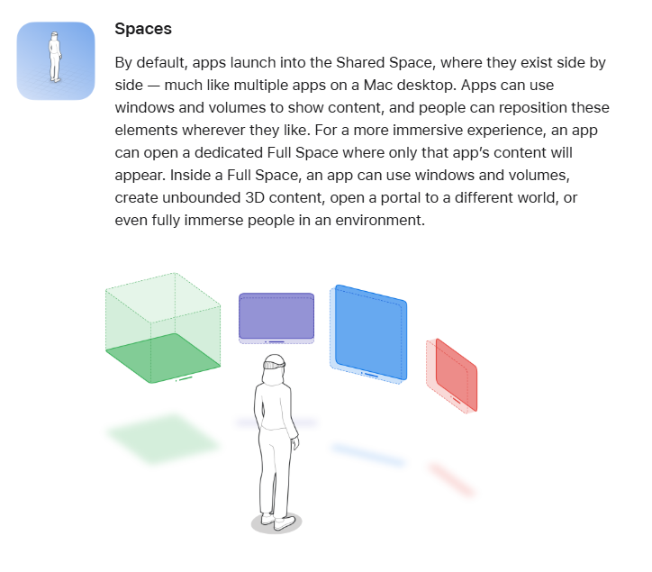

https://developer.apple.com/documentation/visionos/setting-up-access-to-arkit-data

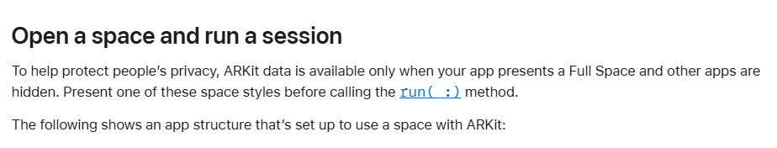

https://developer.android.com/develop/xr/jetpack-xr-sdk

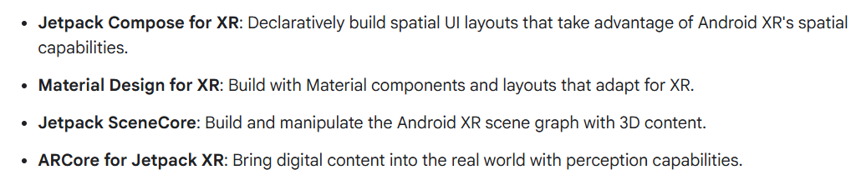

https://developer.android.com/develop/xr/jetpack-xr-sdk/transition-home-space-to-full-space

