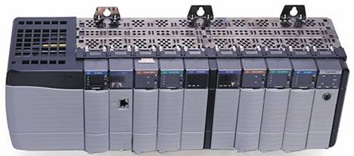

TuxEip

Copyright | Ethernet/IP Library for Linux (TuxEip)  Copyright (C) 2006 http://www.foxinfo.fr  Author : Stéphane JEANNE stephane.jeanne@gmail.com  This program is free software; you can redistribute it and/or modify it under the terms of the GNU General Public License as published by the Free Software Foundation; either version 3 of the License, or (at your option) any later version.  This program is distributed in the hope that it will be useful, but WITHOUT ANY WARRANTY; without even the implied warranty of MERCHANTABILITY or FITNESS FOR A PARTICULAR PURPOSE. See the GNU General Public License for more details.  You should have received a copy of the GNU General Public License along with this program; if not, write to the Free Software Foundation, Inc., 59 Temple Place - Suite 330, Boston, MA 02111-1307, USA.

WARNING | DON'T connect to a PLC unless you are certain it is safe to do so!!! It is assumed that you are experienced in PLC programming/troubleshooting and that you know EXACTLY what you are doing. PLC's are used to control industrial processes, motors, steam valves, hydraulic presses, etc.  You are ABSOLUTELY RESPONSIBLE for ensuring that NO-ONE is in danger of being injured or killed because you affected the operation of a running PLC.  Also expect that buggy drivers could write data even when you expect that they will read only !!!

Purpose | TuxEip is a communications library that facilitates communications to Allen Bradley Controllers, using it, a programmer can write programs to Read/Write controller/program scoped tag data in the following PLC : ControlLogix, PLC5, SLC500, Micrologix, FlexLogix (and probably much more, but that's all i have tested).  These PLC are reachable using Ethernet, ControlNet, DH+. As this library implement misc functions to interact with objects defines by the CIP protocol (Connection Manager, Message router...), you can easily add your own function to act on such devices.

Road map | It remain a lot of things to do, but the most important is to support optimized packet for the Logix platform.(There is a sample of optimized read packet for PLC5 / SLC500 in TuxSql which is an another project of mine).

Trademark | ControlNet is a trademark of ControlNet International, Ltd.  CIP, DeviceNet, are trademarks of Open DeviceNet Vendor Association, Inc.  EtherNet/IP is a trademark of ControlNet International under license by Open DeviceNet Vendor Association, Inc.  Allen-Bradley, ControlLogix, DH+, FlexLogix, PLC-5, Micrologix, and SLC are trademarks of Rockwell Automation.  Ethernet is a trademark of Digital Equipment Corporation, Intel, and Xerox Corporation.  All other trademarks referenced herein are property of their respective owners.

Content
1 Overview 5
1.1 Ethernet/IP 5
1.2 Organisation 5
2 Global Variables 6
2.1 Identity 6
2.1 Send / receive 6
2.2 Connection parameters 6
2.3 Error handling 6
3 Sweeping statement about functions 7
3.1 Functions declaration 7
3.2 Return values 7
4 Standard scheme of communications using TuxEip 8
5 In depth travel inside TuxEip data structures 9
5.1 Session 9
5.2 Connection 9
5.3 LGX_Read 10
5.4 PLC_Read 10
5.5 DHP_Header 10
6 How to Determine Connection Path ,connection and read / write functions 11
6.1 Connection path 11
6.2 Connection function 11
6.3 Read / write functions 12
6.4 Example 13
6.4.1 Example 1 : Accessing ControlLogix (Rack id 1,slot 0) via Ethernet : 13
6.4.2 Example 2 : Accessing Micrologix (Rack id 2) via Ethernet : 14
6.4.3 Example 3 : Accessing PLC5 (Rack id 6) via ControlNet : 15
6.4.4 Example 4 : Accessing PLC5 (Rack id 6) via ControlNet and DH+ : 16
6.4.5 Example 5 : Accessing FlexLogix (Rack id 7) via ControlNet 17

Overview

Ethernet/IP
EtherNet/IP is an encapsulation protocol which use the Control Information Protocol.
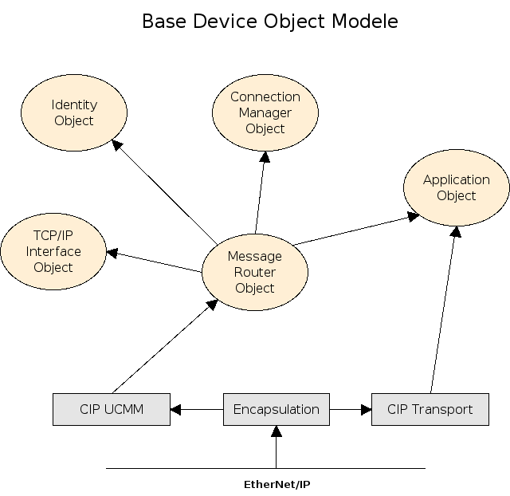Illustration 1: Base device Object Model

Organisation
This library is divide in many files :
- « EIP_Const » define many constant used by EtherNet/IP protocol.
- « CIP_ » prefixed files contain generic CIP constants and misc subroutines.
- « Ethernet_IP » contain implementation of the EtherNet/IP protocol.
- « SendData » is used to send / receive data over Ethernet, the whole library depends on it.
(In fact, TuxEip use function pointer to the send/receive subroutines defined in this file so you can write your own.)
- « MR » contain the Message Router implementation
- « CM » contain the Connection Manager implementation
- « AB » contain generic Allen Bradley data types and subroutines
- « PLC » contain subroutines to access PLC5 and SLC500 controllers ...(controllers which use the PCCC protocol)
- « LGX » contain subroutines to access ControlLogix ...(controllers which use the CIP protocol)

Global Variables

Identity
CM.h
Each device have to provide a vendor Id and a serial number, in TuxEip they are defined like this (you can also overwrite it before accessing the network) :
- (CIP_UINT) _OriginatorVendorID=TuxPlcVendorId;
- (CIP_UDINT) _OriginatorSerialNumber=0x12345678;

Send / receive
SendData.h
As we discuss before, TuxEip use function pointer to send / receive data.
The library define 3 functions :
- int (*CipSendData)(int sock,Encap_Header *header)=&_CipSendData;
- Encap_Header *(*CipRecvData)(int sock,int timeout)=&_CipRecvData;
- Encap_Header *(*CipSendData_WaitReply)(int sock,Encap_Header *header,int sendtimeout,int rcvtimeout)=&_CipSendData_WaitReply;
By this way, you can define your own functions.

Connection parameters
CM.h
When connecting on a device, the Connection Manager use this defaults values
- BYTE _Priority=0x0A;
- CIP_USINT _TimeOut_Ticks=0x05;
- WORD _Parameters=0x43f8; Attention this parameters depend on the network type (ControlNet / DH+)
- BYTE _Transport=0xa3;
- BYTE _TimeOutMultiplier=0x01;

Error handling
ErrCodes.h
TuxEip define many variables for handling and reporting errors (this variables are thread safe).
  - cip_debuglevel = LogError
Possible values are :
    - LogNone (0) : nothing is report
    - LogError (1) : errors are display
    - LogTrace (2) : function entering and exiting are display
    - LogDebug (3) : data frames are display

  - cip_err_type : which kind of error we have :
    - Internal_Error : An error in TuxEip itself (time out, unsupported data type ...)
    - Sys_Error : A system error ( broken pipe, memory error ...)
    - EIP_Error : Ethernet/IP encapsulation protocol error
    - MR_Error : Message router error
    - CM_Error : Connection Manager error
    - AB_Error : error while accessing a Logix base controller (ControlLogix,FlexLogix ...)
    - PCCC_Error : error while accessing a PCCC base controller (PLC5, SLC500,MicroLogix 1100 ...)

  - cip_errno : error number
  - cip_ext_errno : extended error number
  - cip_err_msg : plain text error message

Sweeping statement about functions

Functions declaration
There is two sort of function in TuxEip :
- « _ » prefixed functions are predominantly “privates” functions (internally use by the library) while they are much more complex to use.
- Other functions that we can call “public” functions are in fact macro statement refers to “privates” function, passing adequate arguments and constants. Sometimes these functions are very same.

Return values
Functions can return two types of values
- Pointer :
Attention, if case of error many functions will return you a null pointer, alternatively you will receive a pointer on a data structure (you will have to free it, sometimes there is a special function to do so)
- Numerical value :
In case of error, you will receive a negative value, otherwise a null or positive value.
The signification of the value you receive vary according the function you call.

Standard scheme of communications using TuxEip
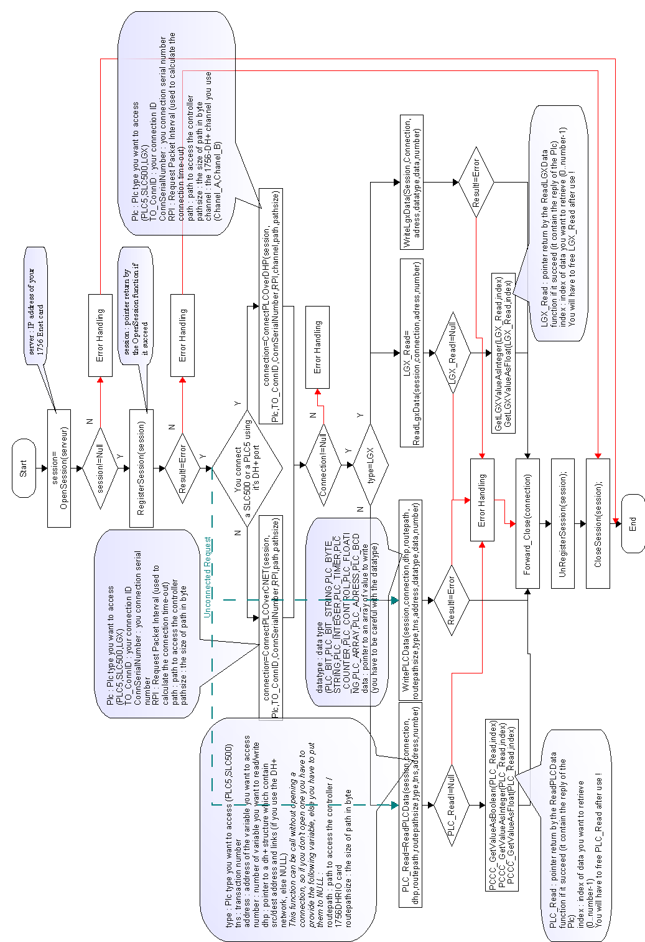Illustration 2: TuxEip communication scheme

In depth travel inside TuxEip data structures

Session

typedef struct Eip_Session;
int sock; | socket open on your 1756-ENET card
CIP_UDINT Session_Handle; | Session handle return by the RegisterSession function if it succeed
CIP_DINT Sender_ContextL,Sender_ContextH; | You can use this to your own usage
int timeout; | Time-out used to send / receive frames
int References; | Not used
void *Data; | You can use this pointer to link a session to personal data

Connection

typedef struct Eip_Connection

Eip_Session *Session; | Pointer to the session use by this connection
int References; | Not used
void *Data; | You can use this pointer to link a connection to personal data
CIP_UINT ConnectionSerialNumber; | All is in the name...
CIP_UINT OriginatorVendorID; | All is in the name...
CIP_UDINT OriginatorSerialNumber; | All is in the name...
CIP_UDINT OT_ConnID; | Originator to Target connection Identifier
CIP_INT packet; | Packet identifier
BYTE Path_size; | Size of the following path (in bytes)
 | Target's path

- ConnectionSerialNumber : be careful, you will have to provide a matchless serial number
- Connection Manager use OriginatorVendorID, ConnectionSerialNumber, and OriginatorSerialNumber to identify an existing connection.

LGX_Read
typedef struct LGX_Read
LGX_Data_Type type; | Data type (LGX_BOOL,LGX_BITARRAY,LGX_SINT,LGX_INT=,LGX_DINT,LGX_REAL ...)
int Varcount; | Number of variable you have read
int totalsize; | Size in byte of the following data
int elementsize; | Size in byte of one variable
 | Data

PLC_Read
typedef struct PLC_Read
PLC_Data_Type type; | Data type (PLC_BIT,PLC_BIT_STRING,PLC_BYTE_STRING,PLC_INTEGER,PLC_TIMER,PLC_COUNTER,PLC_CONTROL,PLC_FLOATING,PLC_ARRAY,PLC_ADRESS,PLC_BCD...)
int Varcount; | Number of variable you have read
int totalsize; | Size in byte of the following data
int elementsize; | Size in byte of one variable
unsigned int mask; | Used for boolean
 | Data

DHP_Header
typedef struct DHP_Header
CIP_UINT Dest_link¹ | 0
CIP_UINT Dest_adress | Address of the destination node
CIP_UINT Src_link¹ | 0
CIP_UINT Src_adress | Address of the source node
- This parameters are used when you need to access physically different s DH+ network (refers to Rockwell documentation) and are not need by TuxEip.

How to Determine Connection Path ,connection and read / write functions

Connection path

The path is a series of port / link address pairs (identical to the Communication Path syntax in RSLogix 5000 Message Configuration dialog) where :
- A port describes a way out of a device via a network or backplane.
- A link address is a destination node ,if the corresponding port is a backplane then the link address is the slot number,else it's a network address.

Interface Module | Port 1 | Port 2 | Port 3
1756- ENET/ENBT | Backplane | Ethernet network | N/A
1756-DHRIO | Backplane | DH+ Network on Ch. A | DH+ Network on Ch. B
1756-CNET | Backplane | ControlNet network | N/A

Note : When using TuxEip the first port is your Ethernet interface, so your path begin with the IP address of your 1756-ENET/ENBT card.

Connection function
Choosing the right function
Processor | Last network segment is DH+ | Last network segment is not DH+
PLC5 | ConnectPLCOverDHP¹ | ConnectPLCOverCNET
SLC500 | ConnectPLCOverDHP¹ | ConnectPLCOverCNET
Micrologix | ConnectPLCOverCNET | ConnectPLCOverCNET
ControlLogix | ConnectPLCOverCNET | ConnectPLCOverCNET
FlexLogix | ConnectPLCOverCNET | ConnectPLCOverCNET
- The Path must target the last 1756-DHRIO you use

Fill in fields with the right values
 | ConnectPLCOverDHP | ConnectPLCOverCNET
session | The session pointer return by the OpenSession function
Plc
TO_ConnID | Originator to Target connection Identifier (for your own use)
ConnSerialNumber | ConnectionSerialNumber : be careful, you will have to provide a matchless serial number
RPI | Request Packet Interval (used to calculate the connection time-out)
channel | Channel of the 1756-DHRIO you use (Channel_A or Channel_B) | NA
path | Path to the last 1756-DHRIO you use | Path to the logic controller
pathsize | Size of the path (in bytes)

Read / write functions
Choosing the right function
Processor | Function to use | Rq
PLC5 | ReadPLCData / WritePLCData¹ | Plc type=PLC
PLC5 | ReadPLCData / WritePLCData¹ | Plc type=SLC
SLC500 | ReadPLCData / WritePLCData¹ | Plc type=SLC
Micrologix | ReadPLCData / WritePLCData | Plc type=SLC
ControlLogix | ReadLgxData / WriteLgxData
FlexLogix | ReadLgxData / WriteLgxData
- In this case, you are not obliged to open a connection

 | ReadPLCData |  | WritePLCData
 | Connected | Unconnected | Connected | Unconnected
session | The session pointer return by the OpenSession function
connection | Connection pointer return by ConnectPLCOver... | NULL | Connection pointer return by ConnectPLCOver... | NULL
dhp | A pointer to a Dh+ structure (if you use the ConnectPLCOverDHP function)else NULL
routepath | NULL | Path to you logic controller | NULL | Path to you logic controller
routepathsize | 0 | Size of the routepath (in bytes) | 0 | Size of the routepath (in bytes)
type | Plc type (refers to the previous notice board)
tns | Transaction number
address | Address to identify the variables in your plc
datatype | NA |  | Data type of what you want to write
data | NA |  | Pointer to your data
number | Number of variables you want to read / write

 | ReadLGXData | WriteLGXData
session | The session pointer return by the OpenSession function
connection | Connection pointer return by ConnectPLCOver
address | Address to identify the variables in your plc
datatype | NA | Data type of what you want to write
data | NA | Pointer to your data
number | Number of variables you want to read / write

Example
Here is a sample factory network, we will use it to explain the connection path.
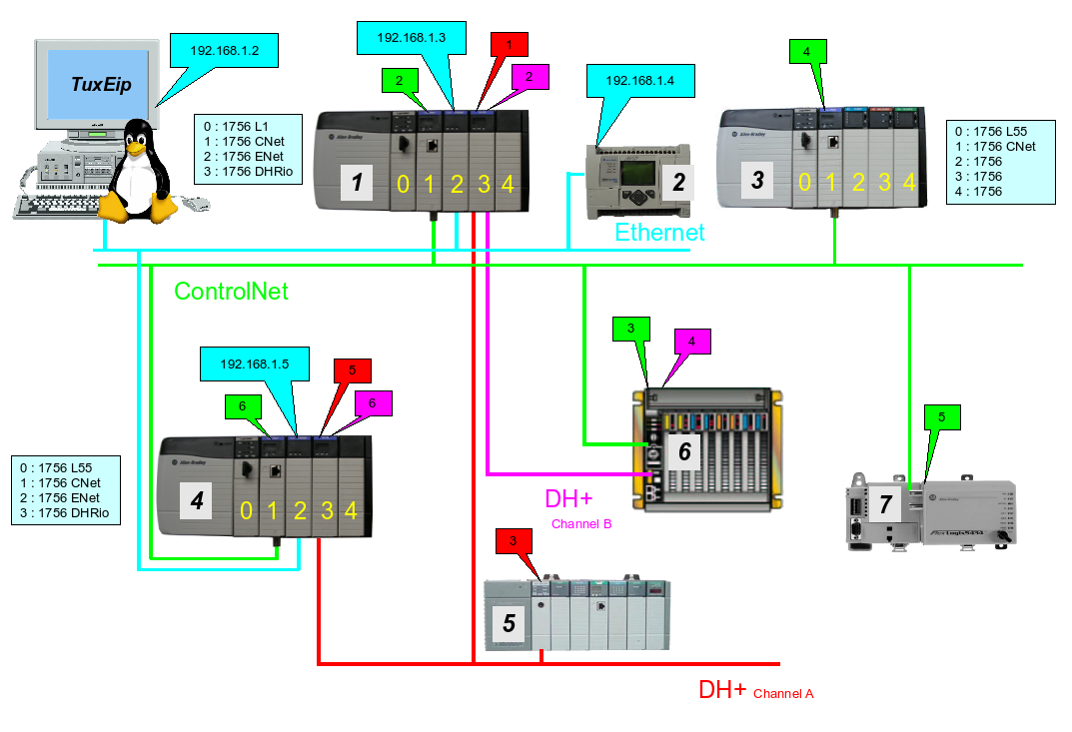Illustration 3: Factory network

Example 1 : Accessing ControlLogix (Rack id 1,slot 0) via Ethernet :
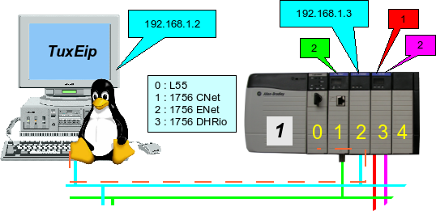Illustration 4: example 1
IP of your 1756 ENET card | 192.168.1.3
Backplane | 1
L55 in slot 0 | 0
Path | 192.168.1.3,1,0
Connection method | ConnectPLCOverCNET
Read / Write function | ReadLgxData / WriteLgxData

Example 2 : Accessing Micrologix (Rack id 2) via Ethernet :
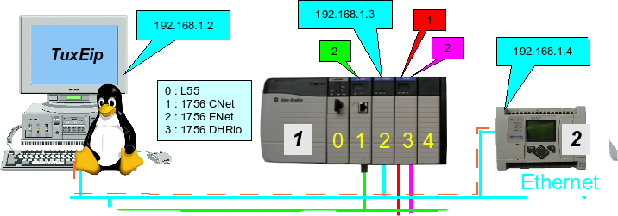Illustration 5: example 2
IP of your Micrologix controller | 192.168.1.4
Backplane | 1
slot 0 (logic controller) | 0
Path | 192.168.1.4,1,0
Connection method | ConnectPLCOverCNET
Read / Write function | ReadPLCData / WritePLCData
Plc type | SLC

Example 3 : Accessing PLC5 (Rack id 6) via ControlNet :
As we can see in chapter 4 "TuxEip communication scheme" there is two way to access PLC5 and SLC500 logic controllers :
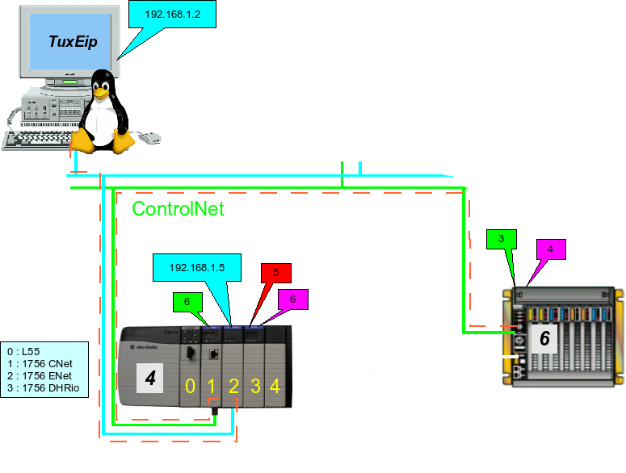Illustration 6: example 3
- Connected way
IP of your 1756 ENET card | 192.168.1.5
Backplane | 1
slot 1 (1756-CNET) | 1
Port 2 (ControlNet network) | 2
Node 3 (PLC5 node address) | 3
Path | 192.168.1.5,1,1,2,3
Connection method | ConnectPLCOverCNET
Read / Write function | ReadPLCData / WritePLCData
Plc type | PLC

- Unconnected way
To Read / Write data, you will have to fill in the "routepath" and "routepathsize" (see section 6.3)

Example 4 : Accessing PLC5 (Rack id 6) via ControlNet and DH+ :
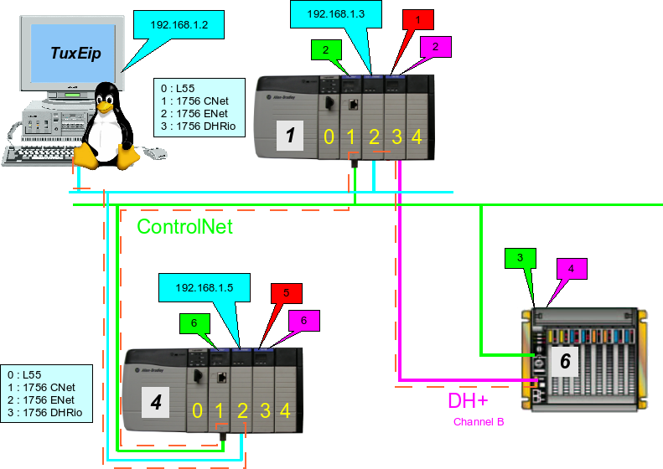Illustration 7: example 4
IP of your 1756 ENET card |  | 192.168.1.5
Backplane |  | 1
slot 1 (1756-CNET) |  | 1
Port 2 (ControlNet network) |  | 2
Node 2 (1756-CNET Rack 1) |  | 2
Backplane |  | 1
slot 3 (1756-DHRIO) |  | 3
Path |  | 192.168.1.5,1,1,2,2,1,3
Connection method |  | ConnectPLCOverDHP (channel= Channel_B)
Read / Write function |  | ReadPLCData / WritePLCData
Plc type |  | PLC
dhp | Dest_link | 0
dhp | Dest_adress | 4
dhp | Src_link | 0
dhp | Src_adress | 2

Example 5 : Accessing FlexLogix (Rack id 7) via ControlNet
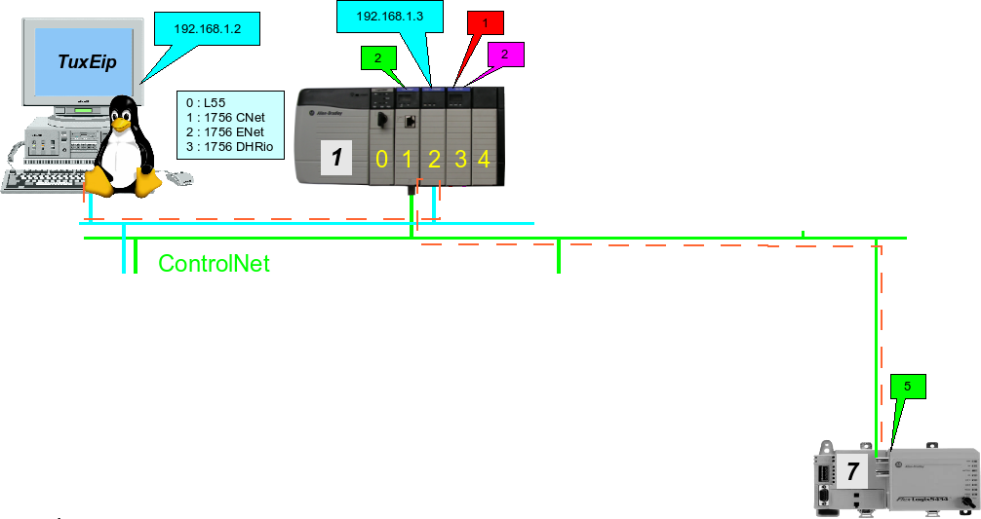
IP of your 1756 ENET card | 192.168.1.3
Backplane | 1
slot 1 (1756-CNET) | 1
Port 2 (ControlNet network) | 2
Node 5 (1788-CNC) | 5
Virtual Backplane of the FlexLogix | 1
Virtual Slot of the FlexLogix UC | 0
Path | 192.168.1.3,1,1,2,5,1,0
Connection method | ConnectPLCOverCNET
Read / Write function | ReadLGXData / WriteLGXData

The whole « Logix » controllers are build using the same scheme, communications card are plug into a backplane (sometime its a real one like ControlLogix's backplane, alternatively it is a virtual one like for Micrologix, FlexLogix)

