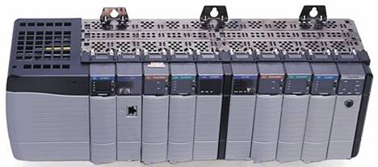

TuxSql
Copyright | TuxSql  Copyright (C) 2006 http://www.foxinfo.fr  Authors :  Stéphane JEANNE  Stéphane LEICHT  This program is free software; you can redistribute it and/or modify it under the terms of the GNU General Public License as published by the Free Software Foundation; either version 3 of the License, or (at your option) any later version.  This program is distributed in the hope that it will be useful, but WITHOUT ANY WARRANTY; without even the implied warranty of MERCHANTABILITY or FITNESS FOR A PARTICULAR PURPOSE. See the GNU General Public License for more details.  You should have received a copy of the GNU General Public License along with this program; if not, write to the Free Software Foundation, Inc., 59 Temple Place - Suite 330, Boston, MA 02111-1307, USA.

WARNING | DON'T connect to a PLC unless you are certain it is safe to do so!!! It is assumed that you are experienced in PLC programming/troubleshooting and that you know EXACTLY what you are doing. PLC's are used to control industrial processes, motors, steam valves, hydraulic presses, etc.  You are ABSOLUTELY RESPONSIBLE for ensuring that NO-ONE is in danger of being injured or killed because you affected the operation of a running PLC.  Also expect that buggy drivers could write data even when you expect that they will read only !!!

Purpose | TuxSql is a modular data logging application.  TuxSql is constituted by a set of applications. Each application is in charge of a particular task : Reading from devices (data acquisition), Data logging, visualization (CGI form)

Todo | I have to improved the automatic reconnection in case of network trouble.

Trademark | ControlNet is a trademark of ControlNet International, Ltd.  CIP, DeviceNet, are trademarks of Open DeviceNet Vendor Association, Inc.  EtherNet/IP is a trademark of ControlNet International under license by Open DeviceNet Vendor Association, Inc.  Allen-Bradley, ControlLogix, DH+, FlexLogix, PLC-5, Micrologix, and SLC are trademarks of Rockwell Automation.  ModbusTM is trademark of AEG Schneider Corporation.  MySQL is trademark of MySQL AB  Apache is a trademark of The Apache Software Foundation  Ethernet is a trademark of Digital Equipment Corporation, Intel, and Xerox Corporation.  All other trademarks referenced here in are property of their respective owners.

Content
1 Overview 5
1.1 TuxSql 5
1.2 Organisation 5
2 Database 6
2.1 Table organisation 6
2.2 Data fields explanation 6
2.2.1 Definition table 6
2.2.2 Histo table 6
2.2.3 PLC table 7
2.2.4 MODBUS table 7
3 Applications explanation 7
3.1 TuxAB 7
3.2 TuxMdb 8
3.3 TuxHisto 8

Overview

TuxSql
TuxSql is a modular data logging application constituted by a set of applications. Each application is in charge of a particular task :
- TuxAB : data acquisition in Allen Bradley logic controllers
- TuxMdb : data acquisition in Modbus devices
- TuxHisto : data logging
- Histochart : this is a CGI (Common Gateway Interface) that return an historical trend of values stored in your database.

Organisation
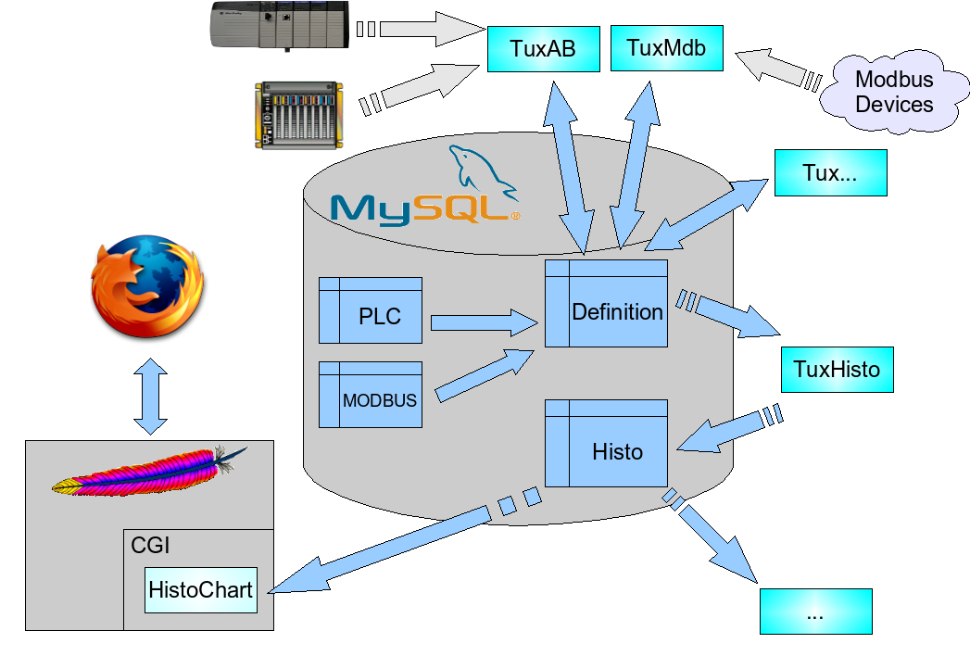

Database

Table organisation
- Definition : contain all your tags definitions (plc, address, scale , last value ...).
- Histo : contain historical values of each tag you want to store.
- PLC and MODBUS : this tables contain the way to access devices used by each data acquisition programs (for example, TuxAB use PLC and TuxMdb use MODBUS).

Data fields explanation

Definition table
Column name | MySql data type | Description
ID | int(11) | Tag ID ( the primary key of this table )
TAGNAME | varchar(30) | The Tag name you give
TAG_DEFINITION | varchar(100) | comment about the tag
ADDRESS | varchar(40) | The tag address (depend on the device you access)
DATA_TYPE | varchar(10) | The data type of the tag ( not used a this time)
PLCNAME | varchar(30) | The name of the Plc you want to access (it must match an entry in an another table)
TIME_SAMPLE | smallint(6) | The frequency at witch you want to read the tag (in second)
TIME_REFRESH | int(6) | Maximum amount of time between two sample in the Histo table
TIME_CLEANING | smallint(6) | How long we store values in the Histo table (in days)
HYSTERESIS | smallint(6) | If the value variation is over the hysteresis percentage then we store this value in the Histo table
I_MIN | double | the input lowest raw value
I_MAX | double | the input highest raw value
O_MIN | double | the output lowest scaled value
O_MAX | double | the output highest scaled value
TAG_UNIT | varchar(20) | the physical unit of the value (if any)
RECORDING | tinyint(4) | Do we record it in the Histo table ? 0 if not else 1
READING | tinyint(4) | Do we read this tag ? 0 if not else 1
SNAPSHOT_VALUE | double | the last raw value of this tag
SNAPSHOT_TIME | datetime | the last time we read this tag
DIGITAL | tinyint(1) | is this tag a boolean ? 0 if not else 1
TAG_SYSTEM | char(2) | In which system do we read this tag ? (AB : Allen Bradley, MB : Modbus ...)

Histo table
Column name | MySql data type | Description
ID | integer | Tag ID ( the primary key of this table )
TIMEVALUE | datetime | time value of this record
DATAVALUE | double | raw value of the tag

PLC table
Column name | MySql data type | Description
PLCNAME | varchar(30) | The plc name you choose (must be unique in this table)
PLC_PATH | varchar(50) | The path to access your plc
PLC_TYPE | varchar(15) | The kind of plc, values are : SLC,PLC,LGX
PLC_NETWORK | varchar(10) | The kind of network : CNET,DHP_A,DHP_B
PLC_NODE | smallint | The node number of your plc
PLC_ENABLE | tinyint | Enable/disable the reading of this plc (0,1)

MODBUS table
Column name | MySql data type | Description
PLCNAME | varchar(30) | The plc name you choose (must be unique in this table)
PLC_PATH | varchar(20) | The path to access your plc
DEVICE_ID | smallint | Device ID according to the Modbus protocol
PLC_ENABLE | tinyint | Enable/disable the reading of this plc (0,1)

Applications explanation

TuxAB
The object of TuxAB is to retrieve data from Allen Bradley plcs, it is based on my TuxEip library. This program needs two table, the first one is “PLC” which describe the way to join the plcs you use (to fill out fields of this table, you can have a look at the TuxEip doc).The second one is the “Definition” table which contain definition of tags you want to read.
usage : tuxab [-d] [-o timeout] [-w wait] [-t] [-l0-3] [-s] [-b] [-u] [-p] [-c controllers,..] [-f pidfile] [-?,h]
- d daemonize tuxab
- o Cip Timeout (default :1000 msec)
- w Time to wait if error before reconnection (default :60 sec)
- t Test (there is no database update)
- l (0-3) Level of messages return by TuxAB (default : 1)
values are :
            - 0 LOG_ERR
            - 1 LOG_WARNING
            - 2 LOG_NOTICE
            - 3 LOG_DEBUG
- s Database host (default : localhost)
- b Database name (default : histosql)
- u Database Username (default : histosql)
- p Database Password (default : histosql)
- c Controller (you can define here the list of plcs you want to read)
- f Pid file (when starting, TuxAb will write his Process ID in this file)

TuxMdb
The object of TuxMdb is to retrieve data from Modbus devices, it is based on a Modbus library of mine. This program needs two table, the first one is “MODBUS” which describe the way to join the plcs you use .The second one is the “Definition” table which contain definition of tags you want to read.
usage : tuxmdb [-d] [-o] [-T] [-t timeout] [-l0-3] [-s] [-b] [-u] [-p] [-c] [-f pidfile] [-?,h]
- d daemonize tuxmdb
- o No read optimization
- T Test (there is no database update)
- t Timeout (default :1 sec)
- l (0-3) Level of messages return by TuxAB (default : 1)
values are :
            - 0 LOG_ERR
            - 1 LOG_WARNING
            - 2 LOG_NOTICE
            - 3 LOG_DEBUG
- s Database host (default : localhost)
- b Database name (default : histosql)
- u Database Username (default : histosql)
- p Database Password (default : histosql)
- c Controller (you can define here the list of plcs you want to read)
- f Pid file (when starting, TuxAb will write his Process ID in this file)

TuxHisto
TuxHisto have two goal, first one is to store « real time values » from the Definition table and to store them in the Histo table. The second one is to remove oldest data value from the Histo table.
usage : tuxhisto [-d] [-l0-3] [-s] [-b] [-u] [-p] [-?,h]
- d daemonize tuxhisto
- l (0-3) Level of messages return by TuxAB (default : 1)
values are :
            - 0 LOG_ERR
            - 1 LOG_WARNING
            - 2 LOG_NOTICE
            - 3 LOG_DEBUG
- s Database host (default : localhost)
- b Database name (default : histosql)
- u Database Username (default : histosql)
- p Database Password (default : histosql)

to fill out this fields, you can have a look at the TuxEip doc

