**GeoReport**

Taylor Mauer, Ian McGinnis, Leif Waldner, Fang Wang

* Project Tracking: <https://trello.com/b/lgHAJYSi/software3308-group1>

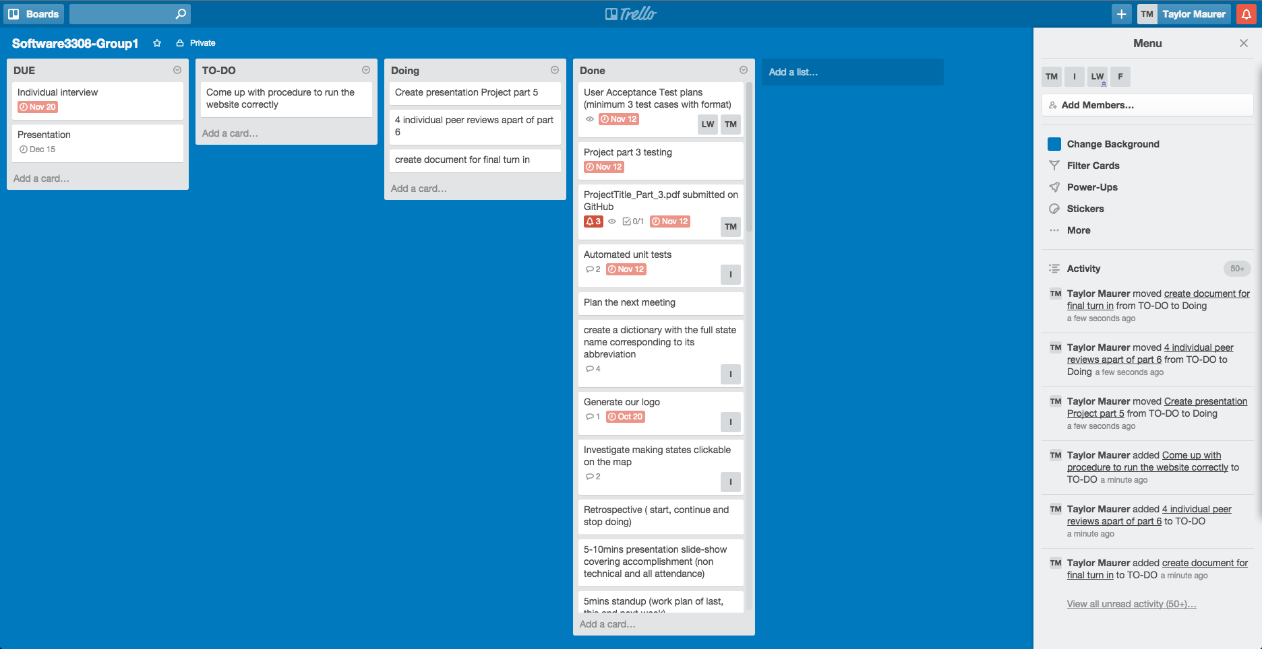

* <https://github.com/leif-waldner/Software3308-Group1/tree/master/ProjectFinal>
  + Video: GeoReport_DemoVideo.mov
* GitRepo: <https://github.com/leif-waldner/Software3308-Group1/>

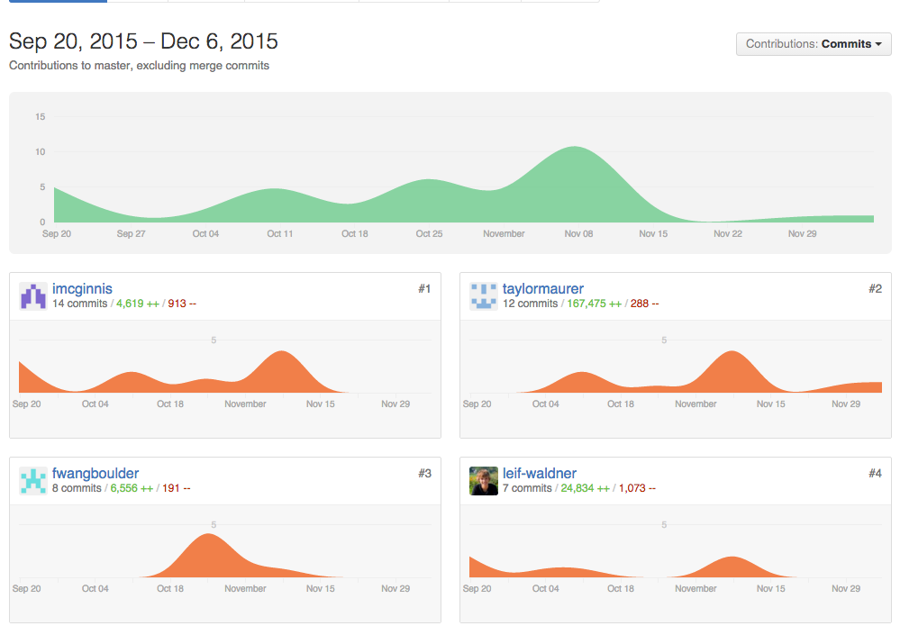

* To Run:
  + Make sure following packages are installed: php5, apache2, libapache-mod-php5.
  + Make sure apache is configured to run php
  + Move to directory GeoReport
  + Add a symlink from web directory (Ubuntu: /var/www/html, Mac OS: /Users/username/sites/) to the current directory
    - Example: sudo ln –s /home/<path-to_current_dir>/GeoReport /var/www/html/GeoReport
    - Mac example: ln –s /Users/username/<path_to_current_dir>/GeoReport /Users/username/Sites/GeoReport
  + Make sure sql is installed or install it:
    - sudo apt-get install php-mysql
    - Note: you may need to add: extension=mysql.so to /etc/php5/apache2/php.ini on line 867
  + username for mysql is: root, password is: pass, or change getrss.php line 8 and 9 to the correct username and password.
  + next go to web browser and go to: localhost/GeoReport/index.php or on a Mac goto localhost/~username/GeoReport
  + Website should display