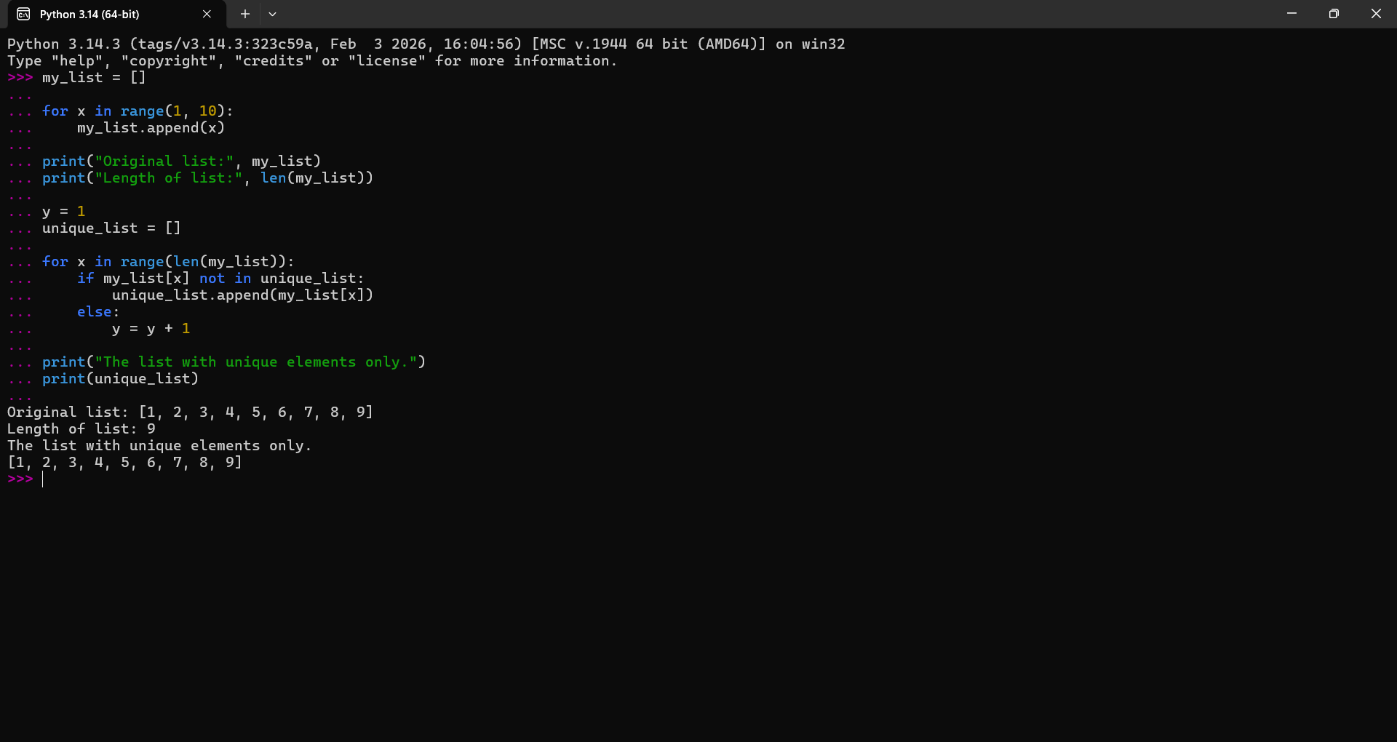
ANALYZE THE FLOWCHART PROGRAM

