Intro to Research Gravitational Waves Project
G. Leigh Harwell and Mason Beaty
Homer L. Dodge Department of Physics and Astronomy, University of Oklahoma, 440 W. Brooks St, Norman, OK 73019, USA

Abstract
For our research, we focused on the initial masses and final mass, chirp signal, energy emitted, r-process elements, and redshift and luminosity of the mergers. We gathered these variables by collecting data from the gravitational event catalogs from LIGO and Virgo, then processed the data with Python, computed quantities like chirp mass and luminosity, and created visualizations to analyze the correlations. Our analysis focused on identifying the merger types, evaluating the mass gap distribution, examining the relationship between chirp mass and both merger type and gravitational wave energy, and investigating how merger frequency changed over cosmic time. By plotting these relationships through data visualization, we aim to gain a better understanding of the evolution of compact object binaries and what their observed properties reveal about the structure and history of the universe. In addition to visualizing these variables collected by gravitational waves, we also analyzed the average values of r-process element production based on other data.

1. Introduction
Gravitational Waves are ripples in the curvature of spacetime, predicted by Einstein's general theory of relativity, caused by massive compact objects, particularly compact object mergers such as Neutron Star-Neutron Star (NS-NS), Neutron star-black hole (NS-BH), or black hole-black hole (BH-BH) events (LIGO Scientific Collaboration). The detection of gravitational waves allows astronomers to get a better understanding of compact objects, such as neutron stars and black holes, and binary evolution. Gravitational waves can also allow cosmologists to learn more about the early universe and enable astrophysicists to test general relativity. The detection of gravitational waves tells us the amplitude and frequency of the spacetime strain, chirp signal, and system properties like the two initial masses and the final mass, the energy that the merger emits, the types of objects that merged, and the location of the gravitational waves source.
Our primary goal for this project was to look at the mass gap distribution of compact object mergers, specifically neutron star-neutron star (NS-NS), neutron star-black hole (NS-BH), and black hole-black hole (BH-BH) systems. To observe the variables of these types of mergers we had to combine data from GWTC-1, GWTC-2, GWTC (KAGRA-inclusive), and the full GWOSC All Events catalog to get a wide variety of mergers or analyze. (LIGO Scientific Collaboration & Virgo Collaboration 2021; LIGO Scientific Collaboration, Virgo Collaboration, & KAGRA Collaboration 2023). Using event catalogs from LIGO and Virgo we observed merger types and mass distributions with Python-based tools. We plotted mass distribution with the lower (2.5-5 M☉) and upper (>50 M☉) mass gaps highlighted, showing few or no observed mergers within these ranges. In addition to the mass gap distribution, we also looked at the chirp mass relation to merger type and energy. By plotting chirp mass versus energy, this showed us that BH-BH mergers make up most of the high-mass regime and are associated with greater gravitational wave energy released. We also looked at the redshift, and luminosity and looked back in time with Python showing us that mergers were more common at the beginning of the universe. Analyzing the redshift and lookback time indicates that merger rates were higher at earlier cosmic times, suggesting that in the early universe, there was a peak in compact binary formations. Finally using average values of ejecta mass of r-process elements, the merger data provides insight into the production of some of the heaviest elements found without our galaxy.

2. Data
Before we could start to look at our data for the mass gap, chirp mass, energy, or luminosity we gathered four different data sets from the LIGO and Virgo gravitational events. With Python, we combined these datasets into one so that we could better analyze the data. This combined data set gave us the initial mass of the objects, final mass, distance, and the redshift.
However, because we didn't know which set of data belonged to which merger type, we first had to add a new column to the datasets that tells us the merger type. With Python, we made a function that could identify the different merger types, do this we made a function of an if-else loop that compared the initial masses to the mass range of a neutron star (1 - 2.5 M☉) and the mass range of a black hole (> 5 M☉). for the lower mass gap, we had to adjust the range due to it being debated among physics (Ye et al.; Xing et al.). With this, we added the column that tells us the merger type to the dataset.
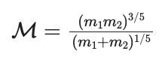
In addition to identifying the merger types we also needed to find the chirp mass produced by each merger type. We used the initial masses (m₁, m₂) in the formula to find the chirp mass (Cutler and Flanagan 2658). Again, we made a function in Python to calculate the chirp mass and added it in a new column to the dataset.
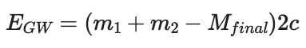
Another piece of data we were missing was the energy released by the mergers. To do this we used the initial masses of the two objects, the final masses of the merger (M_{final}), and the speed of light (3x10^8 or c). When two compact objects spiral into each other, they lose orbital energy via gravitational radiation. This energy comes from their mass meaning the final merged object loses some of its initial mass. To find the energy we used the formula: E_{GW} = (m₁ + m₂ - M_{final}) * 2c. With the energy, we could look at the correlation it has to the chirp mass signal produced and detected by the gravitational waves.
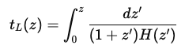
Then we had to find the lookback time, sometimes described in terms of the time light has taken to reach us from a distant object. To find the lookback time we made a code utilizing the redshift data that would give us the time. The code calculated for each redshift value the lookback time (t_{L}), to do this it used the Hubble parameter (H) as a function of redshift (z) in this integral from David W. Hogg’s paper ‘distance Measures in cosmology,’ (Hogg, eq. 30). With the lookback time we wanted it to look at the frequency of mergers over time.
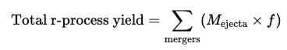
Finally, we evaluated the r-process elements produced by NS-NS and NS-BH mergers. Based on the LIGO/Virgo catalog we estimated the ejected mass (M_{ejecta}) and assuming the fraction of ejected mass that forms the r-processed element is about 10% we can calculate the total r-process yield. With the r-process, we can observe the fraction of mergers that contribute more to the production of heavy elements (i.e. gold, platinum, uranium).
Once we had all these missing data points, we added them as a column to our data set and were prepared to start analyzing the data.

3. Results and Discussion
3.1 Mass Gap Distribution:
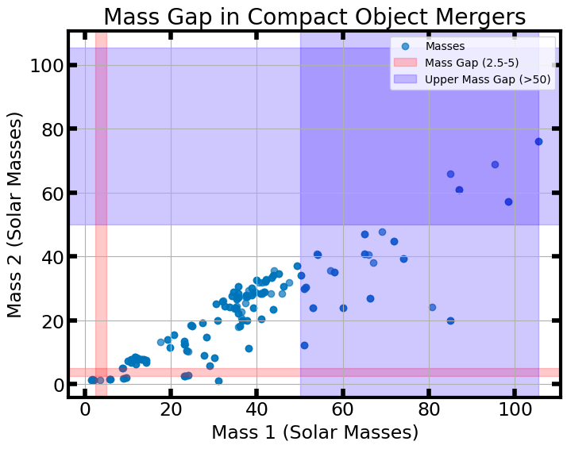
Once we had the merger types identified we went on to make a graph showing the distribution frequency. With Python, we plotted the two initial masses against each other in a scatter plot with the upper and lower mass gaps highlighted.
Figure 1. Initial mass 1 vs initial mass 2 with the highlighted mass gap, with the upper mass gap (> 50 M☉) in blue and the lower mass gap (1 - 2.5 M☉) in red
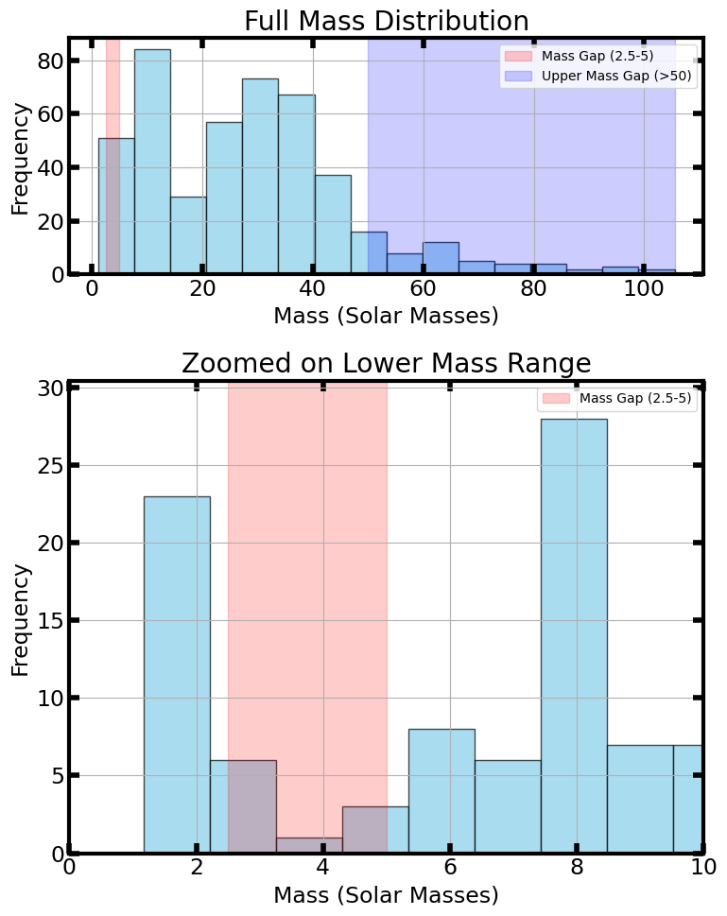
However, Figure 1 didn't show us all that we needed so we made a histogram of the distribution with the highlighted mass gaps. For this histogram we had it have ~20 bins to better see the frequency of mergers around that mass. We made Fig. 2 to show both mass gaps and another that zooms in on the lower mass gap to better observe the lower initial masses that might fall between or near the lower mass gap. For the lower mass gap, some masses were on the edge and are likely the masses from the neutron star mergers but not in the gap. However, for the upper mass gap there seemed to be more mergers in this region. These mergers are likely from two black holes and show how black holes can form in the upper mass gap via hierarchical mergers, where a black hole produced from a merger of two black holes merges with a third black hole.
More importantly, these graphs can show us the possible indication of a failed supernova that produced a low-mass black hole location in the lower-mass gap. However, it can also tell us more about the binary evolution pathways. The upper mass gap portion of the graph can tell us more about merger origins and help us to understand black hole growth over cosmic time. Overall, Fig. 1 and Fig. 2 show that there are some black holes in the upper mass as a result of mergers of mergers and there are likely some failed supernovas due to finding some mergers in the lower mass gap.
Figure 2. A histogram of the full mass distribution and the frequencies of compact objects with the upper mass gap and lower mass gap highlighted (top graph). A histogram of the zoomed in lower mass range to better visualize the lower mass gap (bottom graph).
Figure 2. A histogram of the full mass distribution and the frequencies of compact objects with the upper mass gap and lower mass gap highlighted (top graph). A histogram of the zoomed in lower mass range to better visualize the lower mass gap (bottom graph).

3.2 Chirp Mass and Energy Released:
We also looked at the chirp mass of each merger type. We did this to look at the population distribution of the merger types, spot outliers that are possible in the mass gaps, and look at the evolution patterns in binary systems.
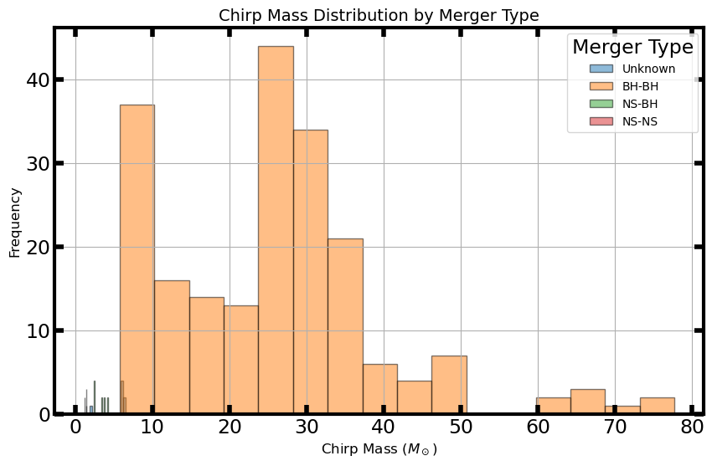
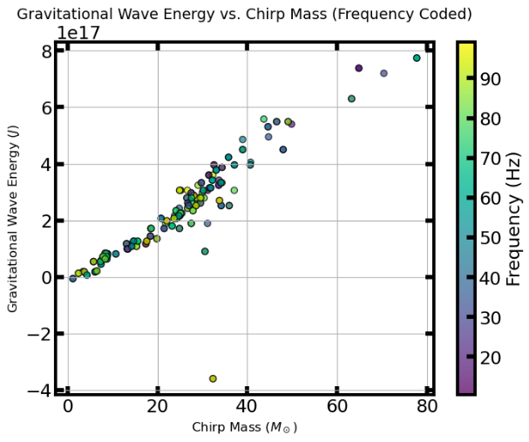
To plot the chirp mass and merger types we made a function in Python to make a plot comparing the two. We had the code look at the merger types and match them with corresponding chirp masses, look at how many merger types had the same chirp masses and then plotted the frequency of the merger types for each. This Fig. 3 shows us that the majority of merger types that produce chirp masses and in turn, gravitational waves are the BH-BH merger types. Because it mostly shows BH-BH merger types it implies that our current detection methods have a bias towards BH-BH mergers because the gravitational waves produced by them are louder and easier to detect this is reinforced by the fact that in our data set, we only have 4 to 5 NS-NS merger types and only slightly more NS-BH merger types. To help improve our distribution of NS-NS merger types to BH-BH merger types we could develop and utilize stronger detection methods to try and pick up more gravitational waves from NS-NS mergers.
Figure 3. Histogram of the chirp mass distribution by merger type, the orange bars are BH-BH mergers, the green bars are NS-BH mergers, the red bars are NS-NS mergers, and the blue bars are Unknowns. NS-BH and NS-NS are very small in the bottom left of the graph.
We also compared the energy released by gravitational waves and the chirp mass. This plot helps to visualize which systems are most energetic. Figure 4 shows a nonlinear increase in energy with increasing chirp mass. Many of the dots with the highest frequency are located in the BH-BH chirp mass region of the graph, which tells us that some of the most energetic systems are produced by BH-BH merger types.
Figure 4. Scatter plot of the gravitational wave energy and the chirp mass with a frequency color bar with dots that are closer to the yellow end having more frequency (Hz) and dots that are closer to the purple end having less frequency (Hz).

Both Fig. 3 and Fig. 4 show that the majority of our data is from BH-BH mergers and that they tend to produce the most powerful gravitational waves. Due to this, we can conclude that BH-BH mergers are easier to detect compared to other types of mergers which is why they make up the majority of our data.

3.3 Lookback Time
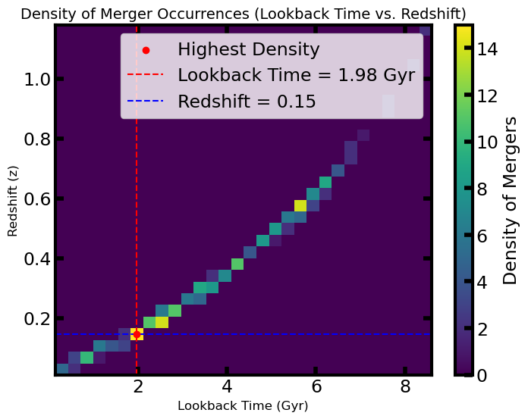
By analyzing the lookback time we can observe the peak merger activity, cosmic evolution of mergers, and insights into astrophysical processes. To do this we evaluated the redshift and luminosity that we had from our datasets to find the lookback time and then compared it to the redshift to see the frequency of mergers along the cosmic timeline. Figure 5 shows that the mergers occurred more recently with our peak in mergers being at a lookback time of approximately 2 billion years ago with a redshift of roughly 0.2. These are likely mergers of binary systems that formed earlier and finally merged after a few billion years which could reflect star formation patterns. Though there are mergers that occur around a lookback time of 9-8 billion years ago with a redshift of 1.1-0.8 showing that mergers that LIGO and Virgo have detected occurred around the same time many galaxies, such as Andromeda and the Milky Way, were forming. The earliest peak that LIGO and Virgo were able to detect was around a lookback time of 6 billion years with a redshift of roughly 0.6 which is near the time as the universe was headed towards a more accelerated expansion.
Figure 5. Histogram of the density of merger occurrences (i.e. lookback time vs. redshift). Red dot is the highest density of the merger occurrences during that lookback time and redshift, with the red line showing the lookback time (1.98 Gyr) and blur dashed line showing the redshift (0.15) at the highest density of mergers.
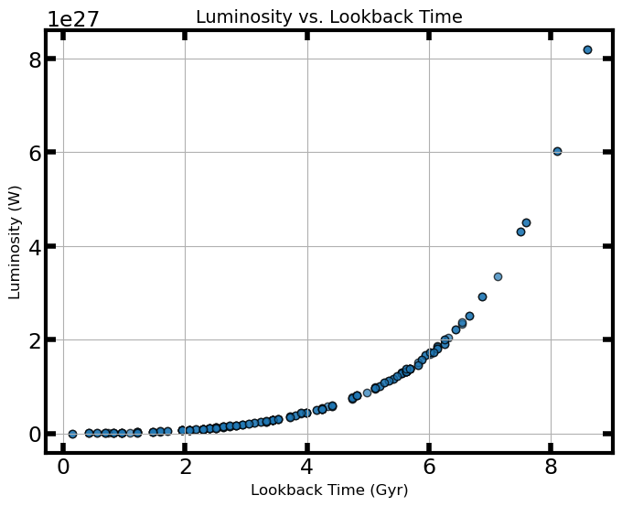
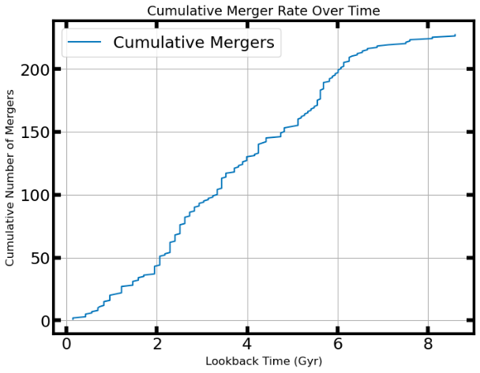
In addition to Fig. 5, we also plotted the cumulative merger rate over time. With, Figure 6 we observed that in the early universe, mergers were not as frequent since the cumulative mergers line plateaus are the lookback time increases. However, it seems that Fig. 5 shows that the rate of mergers was the highest when the lookback time was roughly 2 Gyr. It also shows that around the lookback time of little less than 6 Gyr also has a high merger rate similar to our other graph. Overall, this graph reinforces what was already observed in Fig. 5.
Figure 6. Cumulative number of astrophysical mergers over time as a function of lookback time. The lookback time in billions of years (Gyr), indicates how far back in the universe’s history the mergers occurred. The cumulative count of mergers is the total number of merger events that have occurred up to each time.
Figure 7. Scatter plot of the luminosity (W) vs lookback time (Gyr) shows that the most powerful mergers occurred in the early universe while the weaker mergers produced occurred in the later universe. Each point on the plot corresponds to an individual event, with its position reflecting both its age (how long ago the light was emitted) and it intrinsic brightness.
We also looked at the lookback time with the luminosity of the mergers. We did this by making a scatter plot in Python. This plot showed us the increase of luminosity as the lookback time increases. This suggests that the mergers in the early universe involved more massive objects which implies that these mergers also resulted in a more energetic event producing a more powerful gravitational wave. This also shows us the change in the nature of compact object mergers changes with cosmic time. In the early universe, these more powerful merger types are likely supermassive black holes while overtime as the amount of supermassive black holes in the universe decreases most mergers detected later in the universe are from smaller black holes.
Figure 8. the boxplot displays the distribution of luminosity for different types of astrophysical mergers. Luminosity on the y-axis and merger type on the x-axis with BH-BH, NS-BH, NS-NS, and unknown listed. The box shows the interquartile range (IQR), capturing the middle 50% of luminosity lie and the central line within the box indicates the median luminosity.
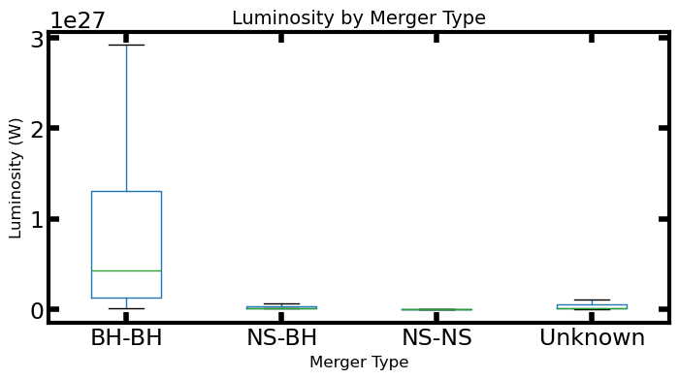
In addition, it is also not surprising to find that some of the most powerful mergers also produce the most luminosity. However, we only have a limited example of these more powerful mergers due to the limits on our current detectors. It also doesn't help that most of our data on the luminosity produced by mergers are from BH-BH merger types, and it is likely that we don't have any examples of other kinds of merger types that formed in the early universe. The only way for us to gather more data on early universe mergers is if we had a stronger gravitational wave detector.

3.4 R-Process Elements:
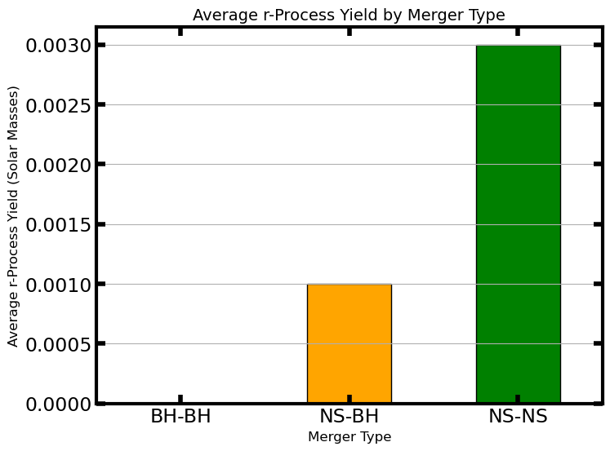
In addition to the lookback time, we analyzed the r-process elements ejected by mergers. These elements are often produced when NS-NS mergers occur but can be produced by NS-BH mergers, but they are less frequent. Figure 9 shows which types of mergers produce r-process elements. With the r-process, we were able to observe that NS-NS produces more heavy elements than the other types of mergers. However, NS-BH mergers do produce r-process elements; they do not eject them as often due to the resulting black hole reabsorbing the ejected material.
Figure 9. Average r-Process yield in solar masses vs merger type. Each bar represents the mean r-process yield for a specific merger type, NS-NS in green and NS-BH in yellow
While NS-NS gravitational waves are hard to detect, it has been observed that the majority of the heavy element material found in our Milky Way is produced by NS-NS mergers (Abbott). This shows us that there are so many more NS-NS mergers that we have yet to be able to detect with our current detectors.

Conclusion
This study aimed to analyze the mass gap distribution, chirp mass, energy output, redshift, and luminosity of compact object mergers using LIGO and Virgo data as well as the r-process material often left behind by NS-NS mergers. We wanted to observe the relationship between the chirp mass and energy output and redshift, luminosity, and lookback time to gain a better understanding of the properties of the compact objects that merge and the formation and evolution of merging binary systems.
With the mass gap distribution, we found that some mergers likely those of BH-BH mergers tend to fall in the upper mass gap (> 50 M☉). This suggests that these black holes are also the result of past merger events. By observing the chirp mass and energy output by gravitational waves we found that these same BH-BH mergers tend to produce more powerful gravitational waves (see Fig. 4). By examining redshift, luminosity, and lookback (see Figs. 5-7), we observed that some of the most powerful BH-BH mergers likely occurred in the early universe. This suggests that these BH-BH mergers are a result of massive black holes formed earlier than previously assumed contributing to detectable signals even at high lookback times.
The dominance of BH-BH detections in the LIGO/Virgo catalog is likely due to their stronger gravitational wave emissions, making them far easier to detect across greater distances. In contrast, NS-NS or NS-BH mergers emit a far weaker gravitational wave signal and are therefore underrepresented in the data. However, many of the r-process materials emitted by mergers in the Milky Way are likely produced by NS-NS mergers (see Fig. 9). Thus, due to our limitations on the sensitivity of our detectors, we can only find the reminisce with the r-process material from the NS-NS or NS-BH mergers.
For future research on gravitational waves, it would be highly profitable to create stronger detectors. These stronger detectors would be able to better pick the signals emitted by NS-NS and NS-BH mergers and give us a better sample size in the data. For example, the Einstein Telescope, a ground based gravitational wave detector, which is being proposed in Europe is meant to be able to detect weaker gravitational waves to help gather more information relating to Einstein's theory of relativity ("Einstein Telescope"; Hild). In addition to the Einstein Telescope there is also the proposed Laser Interferometer Space Antenna (LISA), a space based gravitational wave detector, that is also being proposed in Europe to gain better readings on gravitational waves (He). The development of new detectors could help contribute to the data to better understand NS-NS and NS-BH mergers. These detectors will also allow for detection of mergers far earlier in the universe compared to current detectors. With the additional data that they may collect, astrophysicists and cosmologists would be able to gain a better understanding of binary system evolution, nature of the early universe and relativity.

References:
Datasets
LIGO Scientific Collaboration and Virgo Collaboration. GWTC-1-confident: Gravitational-Wave Transient Catalog of Compact Binary Mergers Observed by LIGO and Virgo during the First and Second Observing Runs. GWOSC. https://gwosc.org/eventapi/html/GWTC-1-confident/, accessed 2025 May 5.
LIGO Scientific Collaboration, Virgo Collaboration, and KAGRA Collaboration. Gravitational-Wave Transient Catalog (GWTC). GWOSC. https://gwosc.org/eventapi/html/GWTC/, accessed 2025 May 5.
LIGO Scientific Collaboration and Virgo Collaboration. 2021, GWTC-2: Compact Binary Coalescences Observed by LIGO and Virgo during the First Half of the Third Observing Run. GWOSC, https://gwosc.org/eventapi/html/GWTC-2/.
LIGO Scientific Collaboration, Virgo Collaboration, and KAGRA Collaboration. 2023, GWOSC All Events Catalog. GWOSC, https://gwosc.org/eventapi/html/allevents/.
Articles
Abbott, B. P., et al. 2020, ApJ, 896, L44. https://iopscience.iop.org/article/10.3847/1538-4357/abae65
Cutler, C., & Flanagan, É. É. 1994, Phys. Rev. D, 49, 2658. https://doi.org/10.1103/PhysRevD.49.2658
He, J.-G., et al. 2023, ApJ, accepted. https://iopscience.iop.org/article/10.3847/1538-4357/ace348
Hild, S., et al. 2008, arXiv:0810.0604. https://ui.adsabs.harvard.edu/abs/2008arXiv0810.0604H
Hogg, D. W. 1999, arXiv:astro-ph/9905116. https://arxiv.org/abs/astro-ph/9905116
LIGO Scientific Collaboration. What Are Gravitational Waves? https://www.ligo.caltech.edu/page/what-are-gw, accessed 2025 May 5.
European Gravitational Observatory. 2020, Einstein Telescope. https://www.et-gw.eu/index.php
Xing, Z., et al. 2024, arXiv:2410.20415. https://arxiv.org/abs/2410.20415
Ye, C. S., et al. 2024, arXiv:2408.00076. https://arxiv.org/abs/2408.00076

