<https://towardsdatascience.com/installing-tensorflow-with-cuda-cudnn-and-gpu-support-on-windows-10-60693e46e781>

<https://blog.quantinsti.com/install-tensorflow-gpu/>

Step 1. Remove all NVIDIA Corporation software from your computer.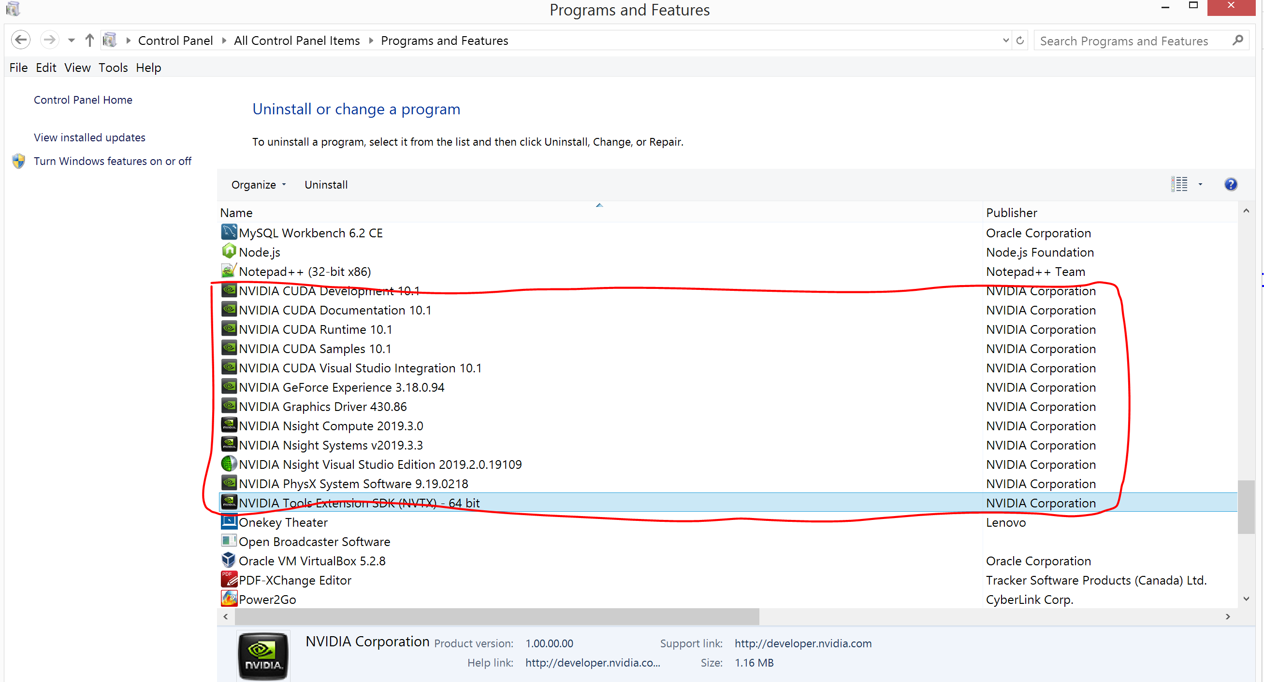

Delete all NVIDIA folders from

C:\Program Files\NVIDIA Corporation

C:\Program Files\NVIDIA GPU Computing Toolkit

C:\Program Files (x86)\NVIDIA Corporation

# Step 2. Download and re-install NVIDIA driver

Download the correct driver from <https://www.nvidia.co.uk/Download/index.aspx?lang=en-uk>

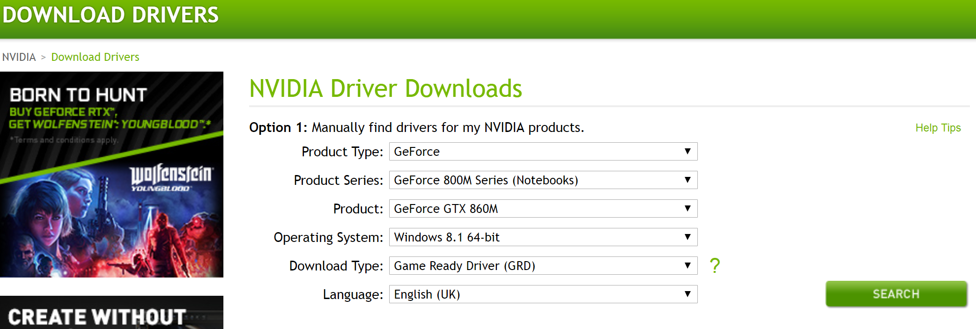

Install NVIDIA Driver

Verify the driver installation

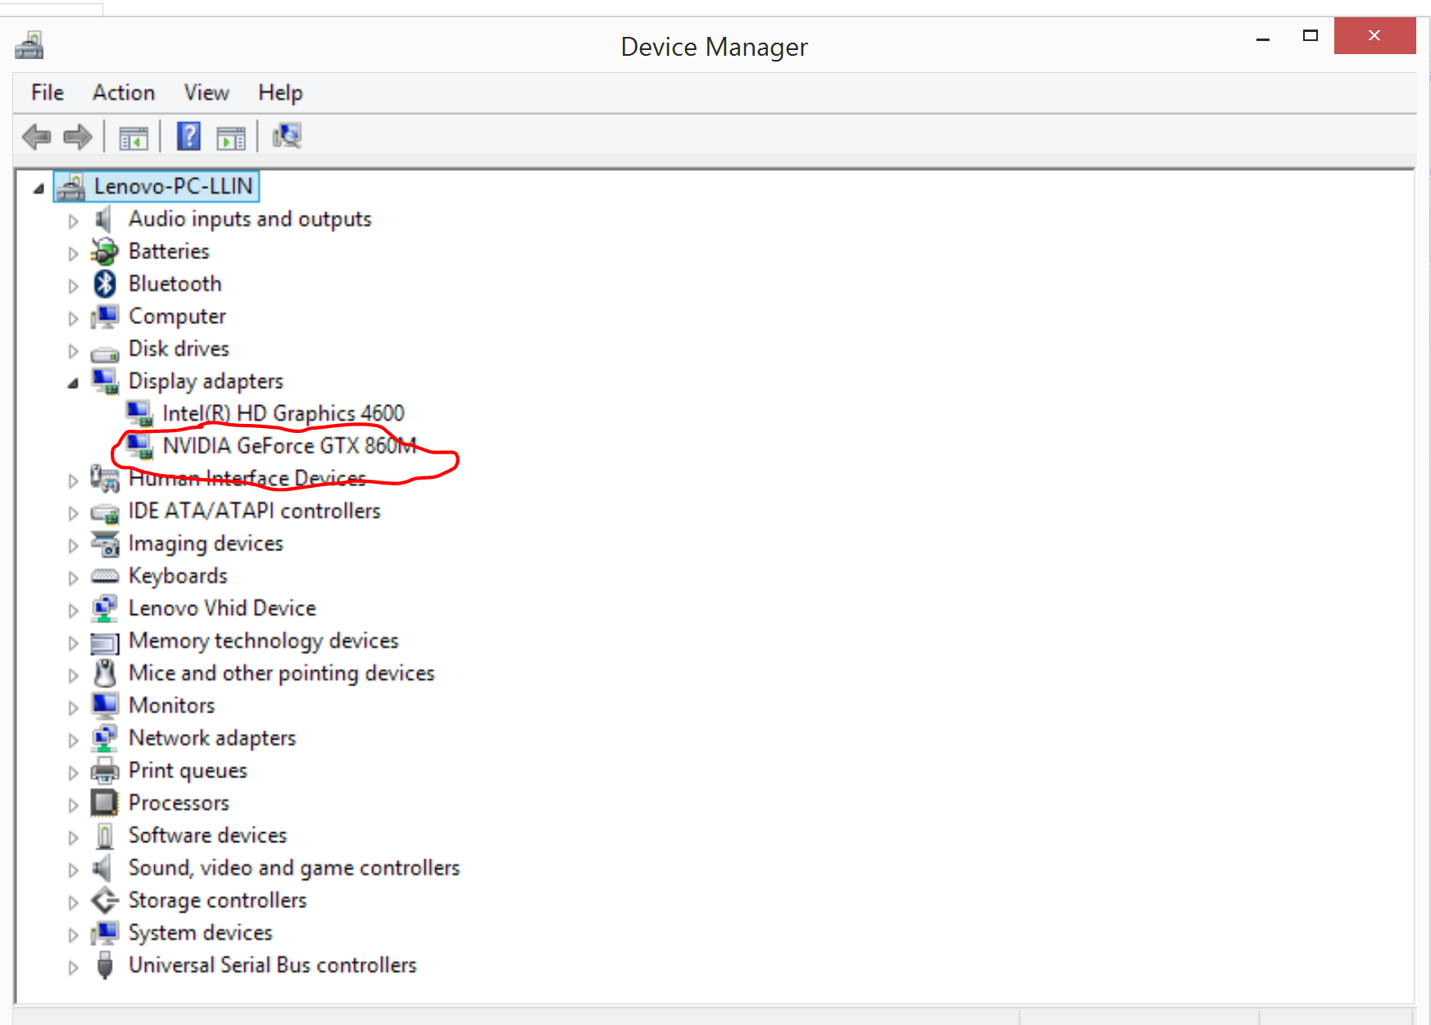

# Step 3. Download and install Visual Studio 2019

<https://visualstudio.microsoft.com/downloads/?utm_medium=microsoft&utm_source=docs.microsoft.com&utm_campaign=button+cta&utm_content=download+vs2017>

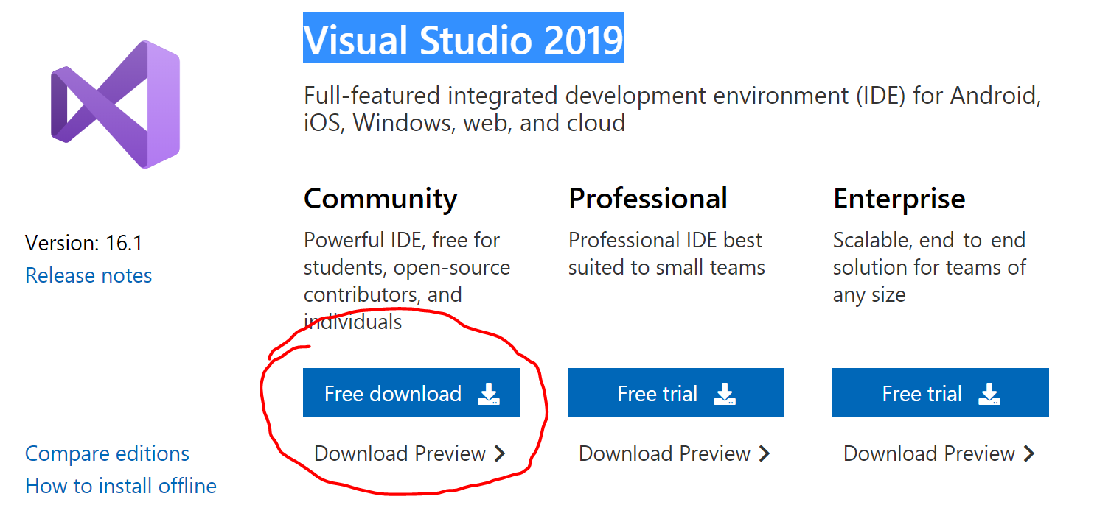

# Step 4. Download and install CUDA Toolkit for Windows 8.1

<https://developer.nvidia.com/cuda-downloads>

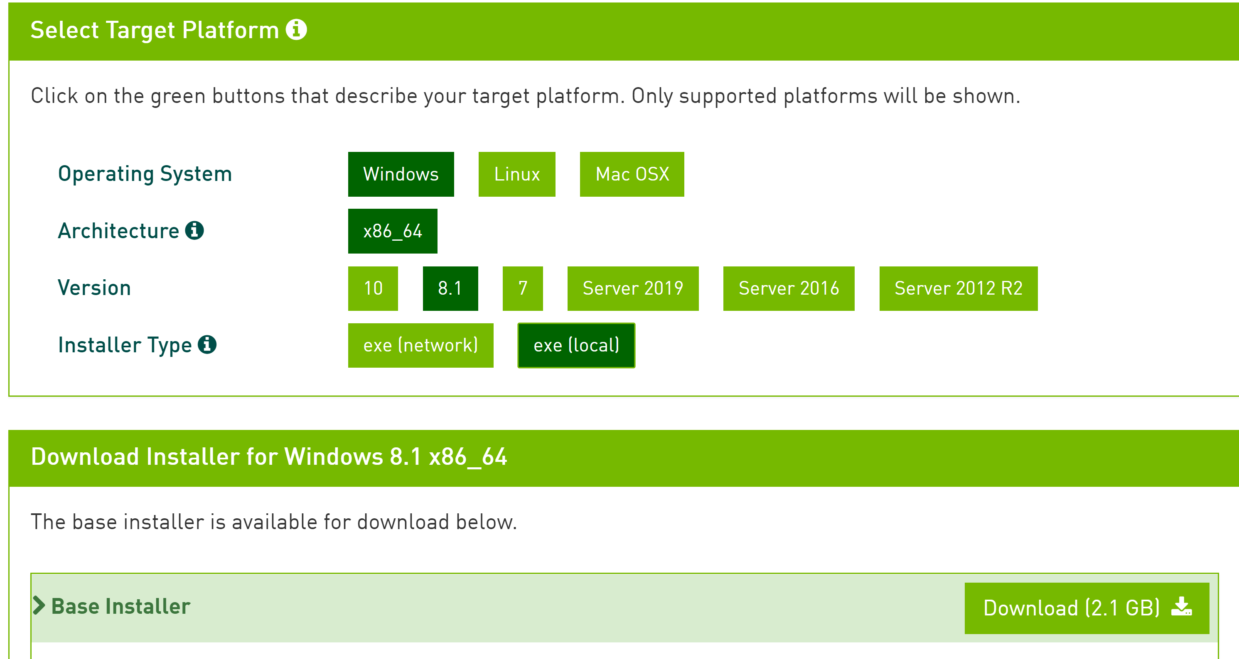

No patch need to be installed

Once installed, check Environment Variables of CUDA_PATH and CUDA_PATH_V10_1(Why we need this path?).

Check PATH has “C:\Program Files\NVIDIA GPU Computing Toolkit\CUDA\v10.1\bin;C:\Program Files\NVIDIA GPU Computing Toolkit\CUDA\v10.1\libnvvp;” as well.

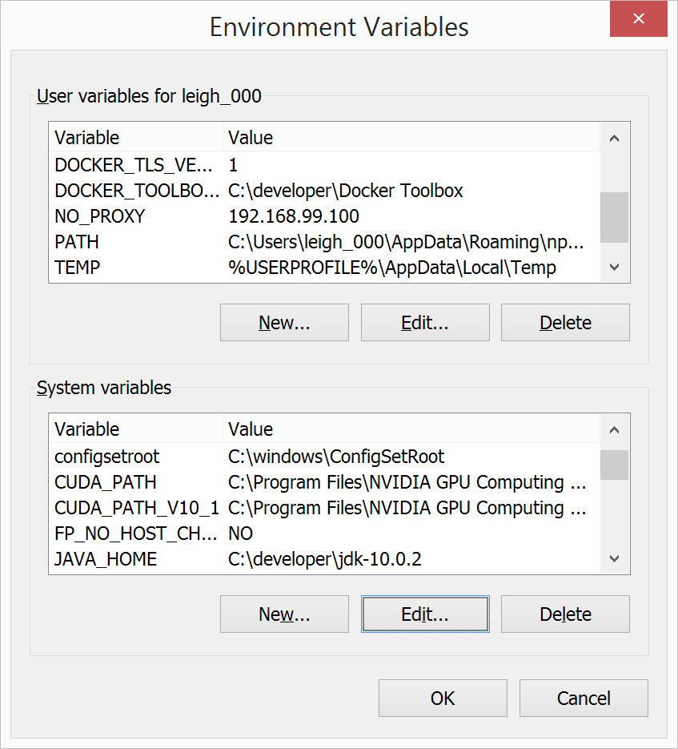

# Step 5. Download and unzip cuDNN

<https://developer.nvidia.com/rdp/cudnn-download>

After sign up and login, download the cuDNN v7.6.0 (May 20, 2019)

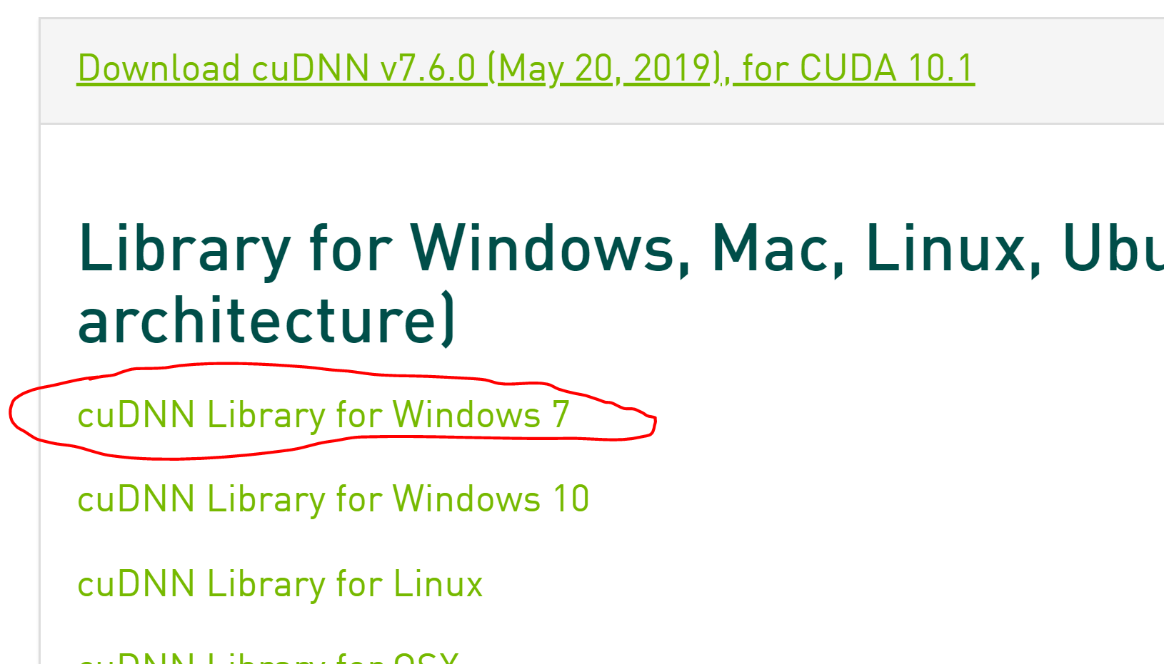

This will download a zip file on to your system. Once you unzip the file, you will see three folders in it: bin, include and lib.

Copy cudnn64_7.dll from unzipped folder ……\Downloads\cudnn-10.1-windows7-x64-v7.5.0.56\cuda\bin into folder C:\Program Files\NVIDIA GPU Computing Toolkit\CUDA\v10.1\bin

“C:\Program Files\NVIDIA GPU Computing Toolkit” is the folder for your computer to install CUDA Toolkit for Windows.

Copy cudnn.h from unzipped folder ……\Downloads\cudnn-10.1-windows7-x64-v7.5.0.56\cuda\ include into folder C:\Program Files\NVIDIA GPU Computing Toolkit\CUDA\v10.1\include

Copy  from unzipped folder ……\Downloads\cudnn-10.1-windows7-x64-v7.5.0.56\cuda\ include into folder C:\Program Files\NVIDIA GPU Computing Toolkit\CUDA\v10.1\include

# Step 6. Install Tensorflow-gpu (using Anaconda)

Use Anaconda with tensorflow-gpu (don’t install keras-gpu)

If “ImportError: DLL load failed: The specified module could not be found” happens, uninstall tensorflow-gpu and re-install it again.

Step7. Verify GPU installation

Run the script

# importing the tensorflow package

**import** tensorflow **as** tf

tf.test.is_built_with_cuda()

tf.test.is_gpu_available(cuda_only=False, min_cuda_compute_capability=None)

If the result is “True”, then the computer is using GPU.

Make sure the GPU is working by checking NVIDIA Control Panel.

