PRESS RELEASE
TaskSquad
Autonomous AI Agent Teams for Software Development

CGI · March 2026
INTERNAL · NOT FOR DISTRIBUTION

Press Release

TaskSquad Enables Software Teams to Run Autonomous AI Agent Workforces That Write Code, Validate Quality, and Close Tickets Without Human Routing

A filesystem-based orchestration framework turns Claude Code agents into self-managing development teams — with a human boss who monitors, not micromanages.

Melbourne, Australia — March 2026

Today, CGI announces TaskSquad, a multi-agent development workflow that coordinates autonomous AI coding agents to implement software stories end-to-end. TaskSquad replaces the manual process of briefing agents one at a time, routing messages between them, and tracking progress across repositories. Instead, a Program Manager agent autonomously dispatches work to ephemeral worker agents, validates their output against acceptance criteria, and closes completed stories — while the human developer monitors the entire operation from a real-time dashboard.
Engineering teams using AI coding assistants today face a coordination bottleneck: each agent session starts from scratch with no memory, requires manual context-loading, and produces output that must be manually verified and integrated. The human becomes a message bus — spending more time managing agents than doing creative work. As the number of repositories and stories grows, this overhead scales linearly with the workload, eliminating the productivity gains the AI was supposed to provide.
TaskSquad solves this by treating AI agents as a managed workforce rather than individual tools. A shared knowledge base (a git repository of markdown files) serves as the single source of truth for architecture decisions, story specifications, coding standards, and project status. A persistent Program Manager agent polls this knowledge base, identifies the next unblocked story, dispatches it to an ephemeral worker agent running in a Kubernetes pod, and validates the worker's completion report against predefined acceptance criteria. The human's role shifts from routing work to making strategic decisions and monitoring progress.
"The key insight is that agents don't need to talk to each other directly. They just need to read and write to shared documents with clear protocols. The filesystem is the message bus — not Slack, not an API, not a human copying messages between chat windows."

How TaskSquad Works

The workflow begins when an Architecture Advisor agent (a long-running session with accumulated project context) validates a design and produces a detailed brief. The Program Manager agent reads the brief, creates GitHub issues, and updates the project backlog. When a story becomes unblocked, the PM writes a dispatch file to the shared repository. A Kubernetes controller detects the dispatch and spins up an ephemeral worker pod.
The worker pod clones the relevant code repository, sets up symlinks to the shared knowledge base, and starts a Claude Code session. The agent reads the project standards, architecture decisions, and story specification — all from markdown files — then implements the story, writes tests, and produces a structured completion report with evidence for every acceptance criterion. The pod pushes its code and completion report, then terminates.
The PM agent detects the new completion report on its next poll cycle, validates the evidence against the story's criteria, and either closes the issue or creates an escalation for human review. The entire cycle runs without human intervention for stories that pass validation.
A purpose-built monitoring dashboard provides real-time visibility into the operation. It shows active dispatches with pod status, a completion feed with pass/fail results, an escalation panel for items requiring human attention, and a live job monitor that streams Claude Code output from any active worker pod. The observer can send prompts to running agents — either as non-blocking background notes or as direct blocking instructions — enabling mid-course correction without interrupting the autonomous flow.
"I went from spending 60% of my time routing work between agents to spending 90% of my time on architecture and design decisions. The agents handle the middle — implementation, testing, completion reporting, and ticket management — and I handle the edges: deciding what to build and reviewing what was built."
TaskSquad is built on open-source components: git for state management, Kubernetes for agent hosting, and Claude Code for AI-assisted development. It requires no proprietary orchestration platform, no chat server, and no custom message broker. The framework is designed for enterprise environments where simplicity, auditability, and security are non-negotiable.
The first project task delivered using TaskSquad will be the monitoring dashboard itself — an approach that validates the entire agent lifecycle before any business-domain work begins.

How It Works

System Architecture
TaskSquad coordinates four types of participants through a shared git repository. The filesystem is the communication layer — no agent talks to another directly.
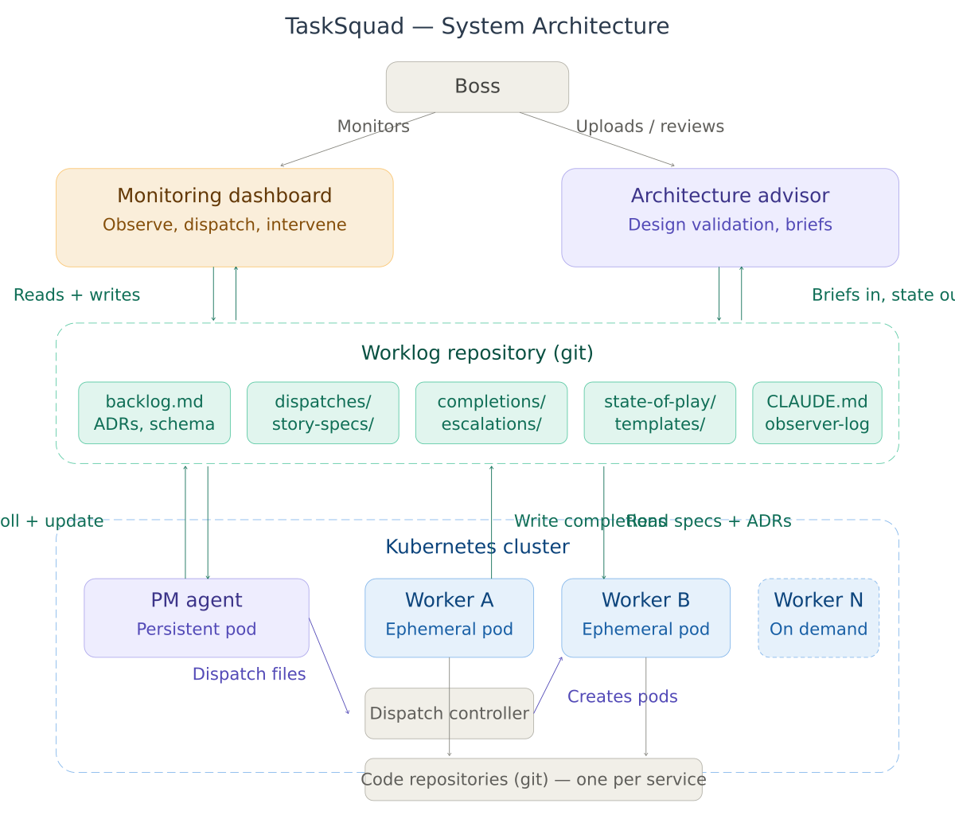

Work Flow: Idea to Code
Every piece of work flows through a defined lifecycle. The Architecture Advisor validates designs. The PM creates stories and dispatches them. Worker agents implement and report. The PM validates completions. Escalations route back to the advisor.
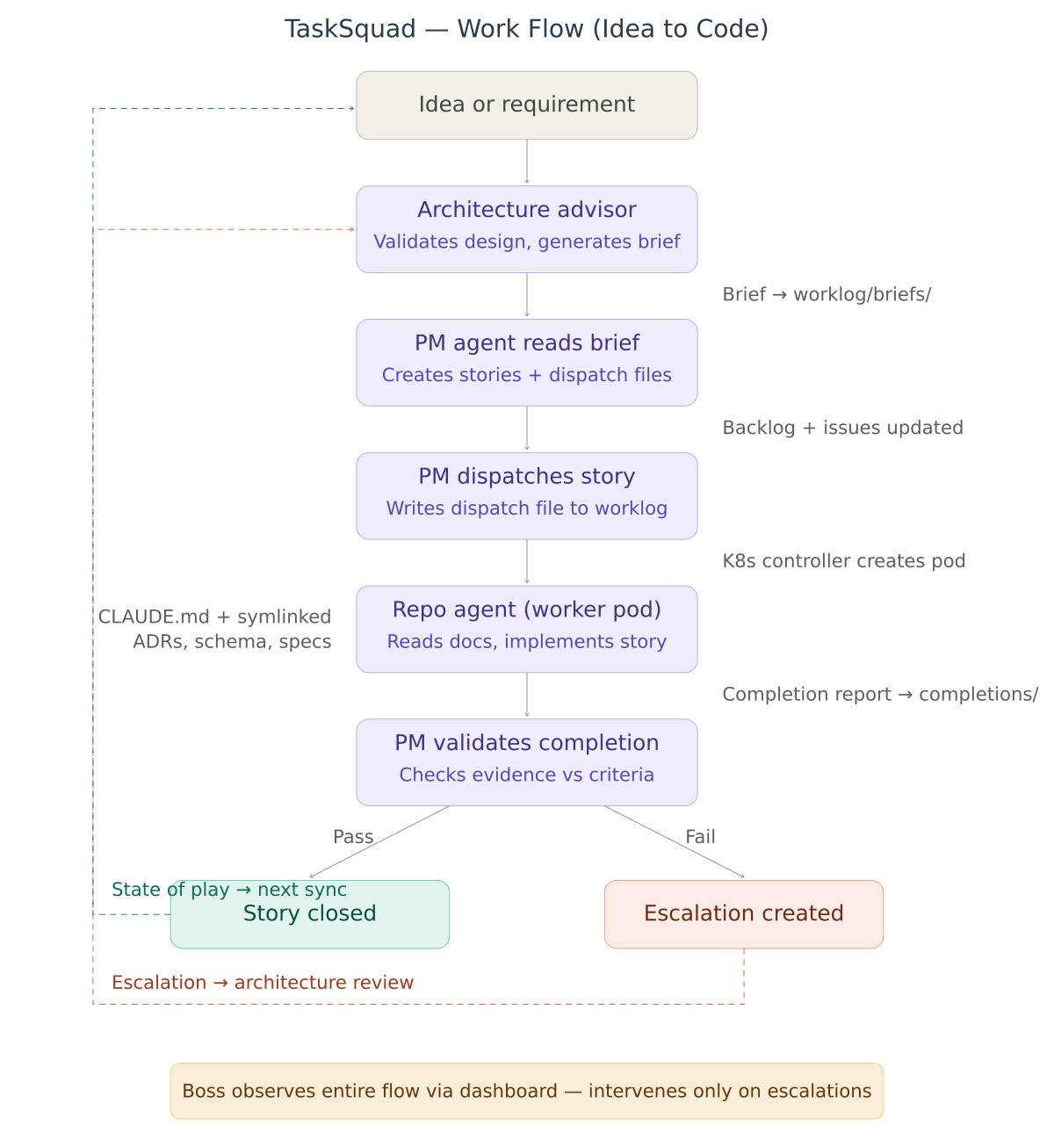

Worker Pod Lifecycle
Each story runs in an isolated, ephemeral Kubernetes pod. The pod bootstraps by cloning repositories and setting up documentation symlinks, then runs a Claude Code session that reads the story spec and implements it. After writing a completion report with evidence, the pod pushes and terminates.
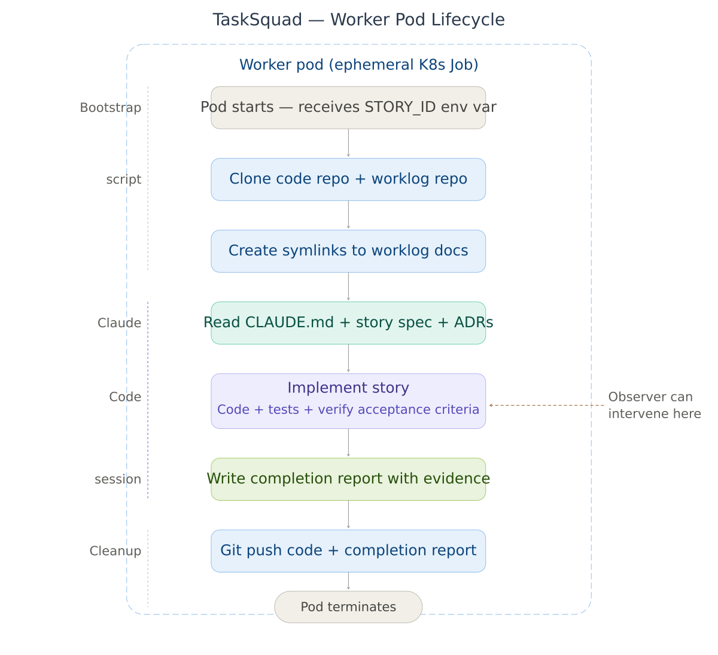

PM Agent Poll Cycle
The PM agent runs autonomously on a 5-minute poll cycle. It checks for completion reports, validates evidence, dispatches new stories, and respects dependency ordering and approval gates — all without human intervention.
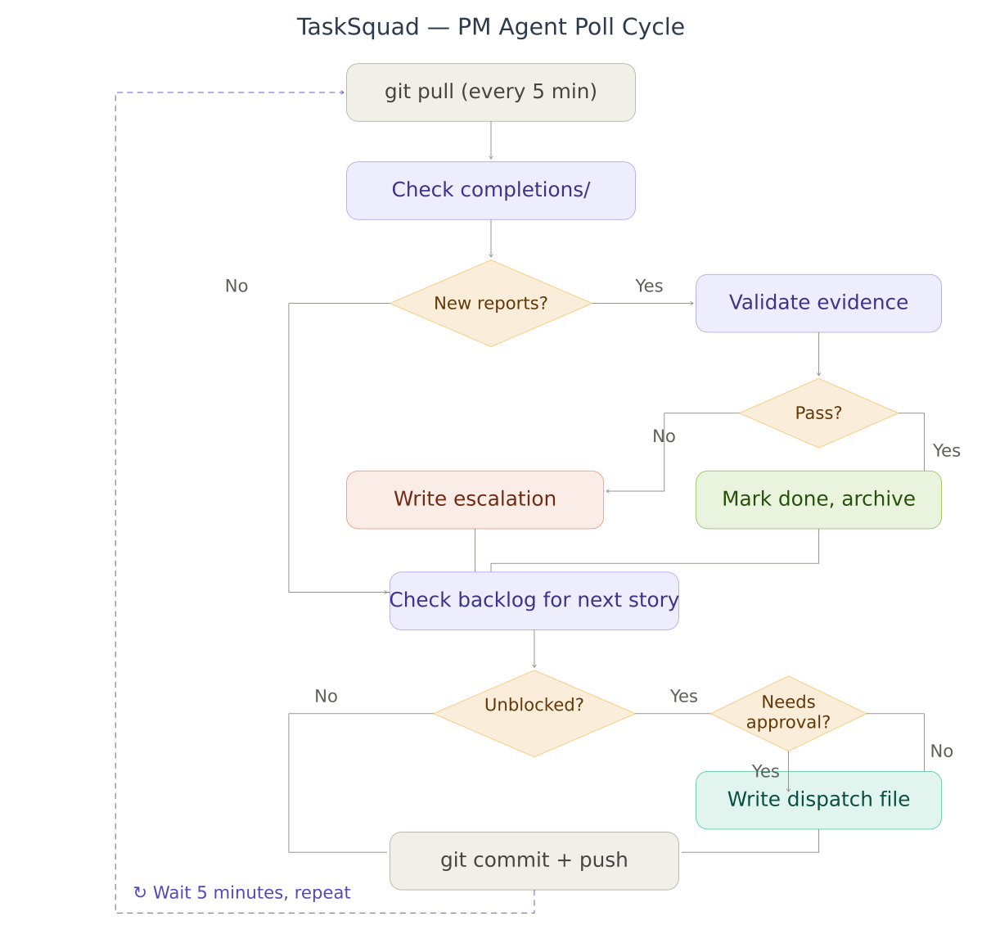

Live Monitor
The dashboard provides real-time observation of any active worker pod via the Kubernetes log API. An intervention channel allows the observer to send prompts to running agents — either as non-blocking background notes or direct blocking instructions. All interventions are logged for audit.
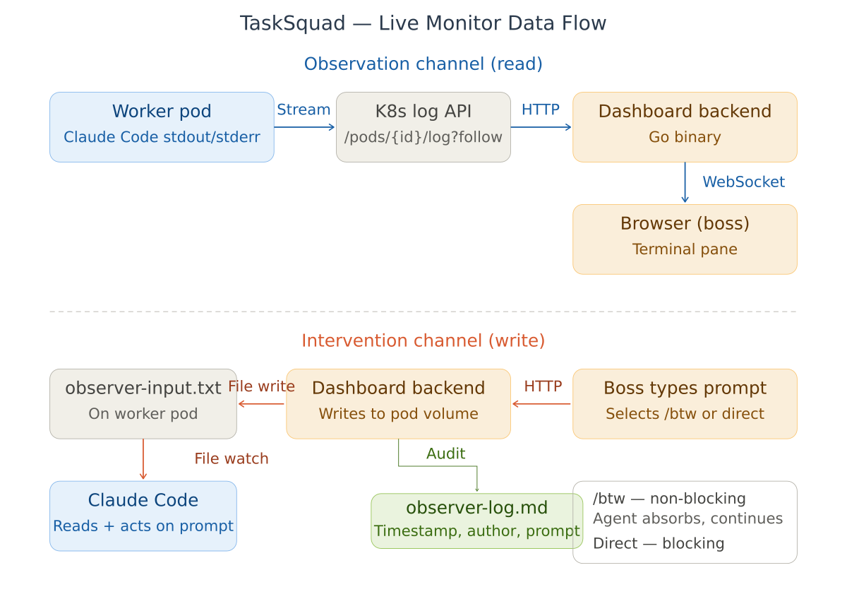

Frequently Asked Questions

Overview
Q: What is TaskSquad?
TaskSquad is a framework for coordinating multiple AI coding agents (Claude Code) as an autonomous development team. A Program Manager agent dispatches stories to worker agents, validates their output, and manages project status — while a human developer monitors and makes strategic decisions.
Q: What problem does this solve?
When using AI coding assistants, the human becomes a message bus: briefing each agent individually, copying context between sessions, routing completed work back to the tracker, and verifying output. TaskSquad automates the coordination layer so the human can focus on architecture and design instead of project management busywork.
Q: How is this different from just using Claude Code?
Claude Code is a single agent working on a single task. TaskSquad is a fleet of agents working on multiple tasks simultaneously, with automated dispatch, validation, and project tracking. Claude Code is the engine; TaskSquad is the fleet management system.
Q: Does this replace developers?
No. TaskSquad replaces the manual coordination overhead of managing AI agents, not the strategic thinking that developers provide. The human decides what to build, validates architecture decisions, reviews escalations, and intervenes when agents get stuck. The agents handle well-specified implementation work.

Architecture
Q: Why use the filesystem instead of a message broker or API?
Markdown files in a git repository provide auditability (every change is versioned), transparency (anyone can read the current state), simplicity (no additional infrastructure), and portability (no vendor lock-in). Agents don't need real-time messaging — they need shared state. Git is shared state with an audit trail built in.
Q: Why Kubernetes pods instead of persistent sessions?
Ephemeral pods provide clean isolation (each story gets its own environment), cost efficiency (pay only for active work), and reproducibility (every pod starts from the same base image). Persistent sessions accumulate stale context and waste resources when idle.
Q: What happens if a worker pod crashes?
If the pod crashes before writing a completion report, the story remains in 'dispatched' status in the dispatch log. The PM agent detects stale dispatches (configurable timeout) and can re-dispatch the story to a new pod. No work is lost because the story spec is still in the shared repository.
Q: Can I run this without Kubernetes?
Yes. The PM agent can run on a VM with a simple cron job. Worker agents can run as local processes. The only requirement is git access to the shared repository. Kubernetes is recommended for scale and isolation, but not required.
Q: How do agents get context about the project?
A shared CLAUDE.md file in the worklog repository is symlinked into every code repository. It contains project standards, coding conventions, and pointers to architecture decision records, schema documentation, and story specifications — all stored as markdown files that Claude Code reads automatically on session start.

The Program Manager Agent
Q: How does the PM decide what to dispatch next?
The PM reads the project backlog and finds the first story where: status is 'ready' (not in-progress, blocked, or done), all dependencies are marked done, the story is not already dispatched, and the target repository does not have an active dispatch. Stories touching the schema or event contracts require human approval before dispatch.
Q: Can the PM make architectural decisions?
No. The PM manages documentation, dispatches work, and validates completions. It never writes application code, approves schema changes, or overrides acceptance criteria. Architectural questions are escalated for human review.
Q: What if the PM validates a completion incorrectly?
Completion reports and the PM's validation decisions are stored as files in the git repository. Every action is auditable. If the PM incorrectly closes a story, it can be reopened by examining the completion report evidence. The PM's validation is a first pass, not the final word — the human reviews escalations and can review any closure.

Worker Agents
Q: What does a worker agent actually do?
A worker agent: (1) clones the code repository and the shared knowledge base, (2) reads the project standards and its assigned story specification, (3) implements the story including writing tests, (4) produces a structured completion report with evidence for every acceptance criterion, (5) pushes its code and report, and (6) terminates. The entire lifecycle is self-contained within the Kubernetes pod.
Q: Can a worker agent modify shared documentation?
Workers can only write to the completions/ directory in the shared repository. They cannot modify the backlog, architecture decisions, schema documentation, or any other shared file. This boundary prevents workers from inadvertently corrupting the knowledge base.
Q: What if a worker gets stuck or goes off track?
The live monitor feature lets the observer watch a worker's Claude Code output in real time. If the agent is going off track, the observer can send a prompt — either as a non-blocking background note (the agent absorbs it without interrupting its current task) or as a direct blocking instruction (the agent must respond before continuing). All interventions are logged.

Live Monitoring and Intervention
Q: How does the live monitor work?
The dashboard streams Claude Code's stdout/stderr from any active worker pod via the Kubernetes log API over WebSocket. The observer sees the agent's reasoning, tool calls, and outputs in real time in a terminal-style pane within the dashboard.
Q: What's the difference between /btw and direct prompts?
A /btw interjection is a background note — the agent sees it but doesn't interrupt its current task. Use it for non-urgent guidance or context that will be useful later. A direct prompt is blocking — the agent must respond before continuing. Use it to unstick a blocked agent, correct course, or request a status update.
Q: Are observer interventions auditable?
Yes. Every prompt sent through the live monitor is appended to observer-log.md in the shared repository with the timestamp, author, target pod, delivery mode, and full prompt text. This provides complete traceability of human interventions.

Security and Governance
Q: What access do agents have?
Access is tightly scoped. The PM agent has read/write to the worklog repository and read-only access to pod status. Worker agents have read/write to their assigned code repository only, write access to the completions/ directory, and optionally read-only database access. No agent has database write access — all database changes happen through the application code the agent writes, which is reviewed via the completion report.
Q: Can an agent create or delete cloud resources?
No. Agents operate under strict MCP safety rules: all cloud integrations are read-only by default. Write, mutate, or destroy operations require explicit human approval and must be logged. AWS MCP is read-only; changes are proposed as CloudFormation templates with cost summaries.
Q: How are secrets managed?
No secrets are stored in the worklog repository or any agent-accessible file. Database credentials are stored in the organisation's secrets manager (Vault, AWS Secrets Manager, or Kubernetes Secrets). Agent API keys are injected via Kubernetes Secrets into pod environment variables. SSH deploy keys are mounted read-only.
Q: What prevents a rogue agent from doing damage?
Multiple layers: (1) Agents can only access their assigned repository, not other agents' repos. (2) No agent has database write access. (3) Cloud resources are read-only. (4) Worker pods are ephemeral and terminate after completion. (5) The PM validates all completion reports before closing stories. (6) Architectural escalations require human review. (7) All actions are auditable via git history and observer logs.

Getting Started
Q: What do I need to get started?
A git hosting service (GitHub, GitLab), a Kubernetes cluster (or a VM for the PM agent), Claude Code access, and a code repository you want agents to work on. The initial setup takes about two hours spread across a few days: create the worklog repository, write the shared standards and templates, configure the PM agent, and set up worker pod infrastructure.
Q: What's the first thing TaskSquad builds?
Its own monitoring dashboard. The first story dispatched through the workflow is the dashboard itself — validating the entire agent lifecycle (dispatch, implementation, completion, validation) before any business-domain work begins. If the workflow has problems, you discover them while building your own tooling, not while building something for a client.
Q: How much does it cost to run?
The infrastructure cost is minimal: a small persistent pod for the PM agent and ephemeral pods for workers (which only run while implementing a story). The primary cost is Claude Code API usage, which scales with the volume and complexity of stories being dispatched. Since worker pods terminate after each story, there is no idle compute cost.
Q: Can I use this with models other than Claude?
The framework is model-agnostic in principle — any AI coding agent that can read markdown files, write code, and produce structured output could serve as a worker. In practice, Claude Code's filesystem access, tool use capabilities, and instruction-following make it the best current fit. The CLAUDE.md standard file could be adapted to other agent frameworks.

