# BAY ORDERLY DAILY CHECKLIST

Please ensure you have received the Bay Orderly Briefing and have acknowledged understanding by initialing the sign in sheet. **This entire checklist will be completed for each building. The highlighted areas are primary responsibilities, while the remainder of the week can be spent on the additional listed tasks or any special tasks assigned**. Check each box when complete and the assigned Detail Lead will be responsible for verifying tasks completion**.**  **Once tasks are complete a Dorm Leader will walk the campus with detailers to verify.**

**\*ALL CLEANING SUPPLIES ARE LOCATED IN EACH DORM BUILDING IN DESIGNATED LOCATION. DETAIL LEAD WILL BE ISSUED THE KEY TO GAIN ACCESS\***

|  |  |  |  |  |  |
| --- | --- | --- | --- | --- | --- |
| **BAY ORDERLY DUTIES** | **DETAIL LEADER:** | | | | |
| **EXTERIOR & STAIRWELLS/WALKWAYS** | **DORM #** | | **1624** | **1631** | **1657** | **1691** | **1692** |
| Collect trash and debris from all parking lots surrounding the dorms | | |  |  |  |  |  |
| Collect trash and debris in a 100 yard radius surrounding your building | | |  |  |  |  |  |
| Sweep & Collect trash and debris in dumpster containment areas | | |  |  |  |  |  |
| Sweep and remove debris from exterior hallways | | |  |  |  |  |  |
| IF ANY RESIDENTS HAVE LEFT PERSONAL TRASH OUTSIDE THEIR DOOR, NOTIFY DORM MANAGEMENT | | |  |  |  |  |  |
| Sweep exterior stairwells ensuring trash, debris and/or cigarette butts are removed | | |  |  |  |  |  |
| Sweep exterior balconies ensuring trash, debris and/or cigarette butts are removed | | |  |  |  |  |  |
| Sweep exterior sidewalks ensuring trash, debris and/or cigarette butts are removed | | |  |  |  |  |  |
| Remove spider webs from exterior stairwells, balconies and gazebos | | |  |  |  |  |  |
| Sweep gazebos ensuring trash, debris and/or cigarette butts are removed | | |  |  |  |  |  |
| Collect trash and debris from the gazebos | | |  |  |  |  |  |
| Clean grills and remove ashes | | |  |  |  |  |  |
| Remove trash and debris then sweep bike storage areas | | |  |  |  |  |  |
| REMOVE all outdated signage for dorm/event advertisements | | |  |  |  |  |  |
| **DAY ROOMS** | **DORM #** | | **1624** | **1631** | **1657** | **1691** | **1692** |
| Collect and dispose of all litter and debris | | |  |  |  |  |  |
| Empty all trash receptacles and replace liners | | |  |  |  |  |  |
| Clean windows, interior and exterior | | |  |  |  |  |  |
| Clean wall surfaces | | |  |  |  |  |  |
| Inspect for and remove all spider webs | | |  |  |  |  |  |
| Clean, polish, dust and straighten all furniture and equipment | | |  |  |  |  |  |
| Vacuum Entry Door Area and wipe all glass | | |  |  |  |  |  |
| Sweep and mop or vacuum the floors as applicable to type of floor | | |  |  |  |  |  |
| Clean TV and electronics (game systems, DVD players, etc) | | |  |  |  |  |  |
| Dust and clean all wall art | | |  |  |  |  |  |
| Refill Brochure rack and notify Dorm Management if more needed | | |  |  |  |  |  |
| Clean interior light fixtures, replace light bulbs as needed | | |  |  |  |  |  |
| Inspect and clean vents on HVAC units, replace filters as needed | | |  |  |  |  |  |
| **COMMON AREA BATH ROOMS** | | **DORM #** | **1624** | **1631** | **1657** | **1691** | **1692** |
| Clean and sanitize toilets | | |  |  |  |  |  |
| Clean and sanitize sinks | | |  |  |  |  |  |
| Clean and sanitize soap, paper towel and toilet paper dispensers | | |  |  |  |  |  |
| Replace soap, paper towels and toilet paper as needed | | |  |  |  |  |  |
| Inspect for and remove all spider webs | | |  |  |  |  |  |
| Clean mirrors | | |  |  |  |  |  |
| Clean interior light fixtures, replace light bulbs as needed | | |  |  |  |  |  |
| Clean and sanitize walls | | |  |  |  |  |  |
| Sweep and mop floors | | |  |  |  |  |  |
| **UTILITY ROOMS** | | **DORM #** | **1624** | **1631** | **1657** | **1691** | **1692** |
| Neatly organize cleaning supplies | | |  |  |  |  |  |
| Sweep and mop floors | | |  |  |  |  |  |
| Clean and sanitize sinks | | |  |  |  |  |  |
| Clean walls as needed | | |  |  |  |  |  |
| **LAUNDRY ROOMS** | | **DORM #** | **1624** | **1631** | **1657** | **1691** | **1692** |
| Clean washers and dryers inside and out, report noted damage to UH management | | |  |  |  |  |  |
| Remove lint from lint traps on dryers | | |  |  |  |  |  |
| Dust furniture | | |  |  |  |  |  |
| Sweep floors daily and mop floors as indicated | | |  |  |  |  |  |
| Sweep and mop floors behind washers and dryers | | |  |  |  |  |  |
| Clean wall surfaces | | |  |  |  |  |  |
| Clean interior light fixtures, replace light bulbs as needed | | |  |  |  |  |  |
| Clean and sanitize sinks and counters | | |  |  |  |  |  |
| Inspect and clean vents on HVAC units, replace filters as needed | | |  |  |  |  |  |
| Clean windows and doors, interior and exterior | | |  |  |  |  |  |
| Dust and clean all shelves and exposed pipes | | |  |  |  |  |  |
| **KITCHENS** | | **DORM #** | **1624** | **1631** | **1657** | **1691** | **1692** |
| Clean and sanitize all appliances and dishes | | |  |  |  |  |  |
| Clean and sanitize sinks | | |  |  |  |  |  |
| Run Dishwasher if needed | | |  |  |  |  |  |
| Clean and sanitize countertops and wall surfaces | | |  |  |  |  |  |
| Remove burners from oven top and wipe out drip pans as needed | | |  |  |  |  |  |
| Remove oven racks and soak/clean as needed | | |  |  |  |  |  |
| Clean out oven removing all grease from inside oven. If using the self- cleaning portion you must check on periodically (takes 4 hours). **\*\*CLEAN OVEN OUT ONCE PROCESS IS COMPLETE** | | |  |  |  |  |  |
| Clean Cabinets, Tables, Chairs | | |  |  |  |  |  |
| Clean refrigerators, removing old food with guidance | | |  |  |  |  |  |
| Clean interior light fixtures, replace light bulbs as needed | | |  |  |  |  |  |
| Inspect and clean vents on HVAC units, replace filters as needed | | |  |  |  |  |  |
| Sweep and mop floors | | |  |  |  |  |  |
| Take out trash | | |  |  |  |  |  |

**DETAIL LEAD/PRINT NAME/SIGN:**

**DL VERIFICATION SIGNATURE:**

**COMMENTS:**

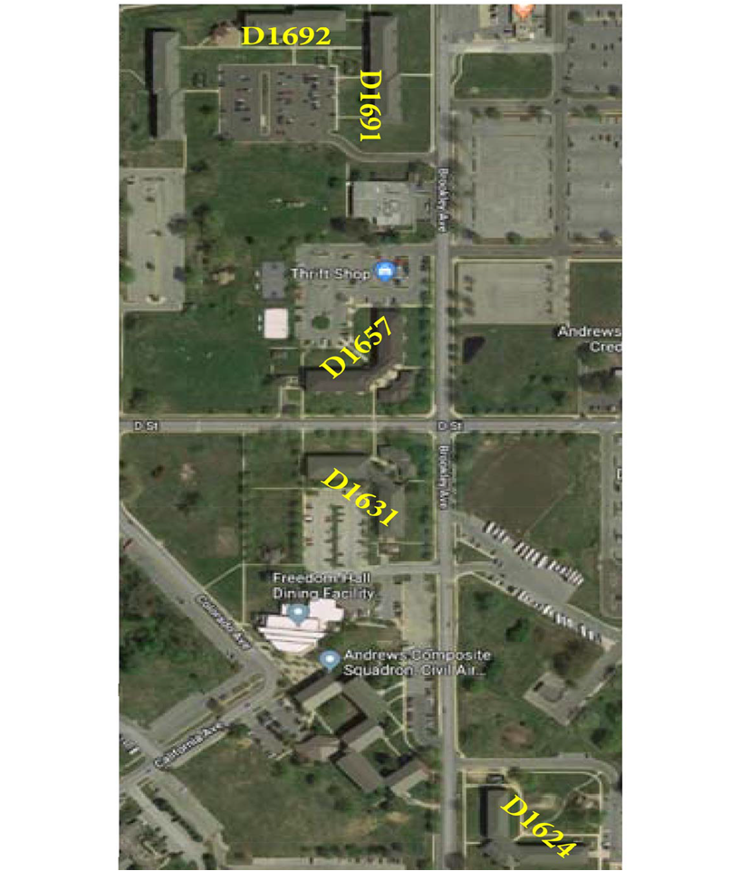

**JBA Unaccompanied Housing Campus Map**