**COMP 473 / COMP 6731**

**Assignment 2:**

Due date: as indicated on Moodle

**Must work individually or in pairs**

There are four proposed projects, each of which runs for 3 years and has the following characteristics.

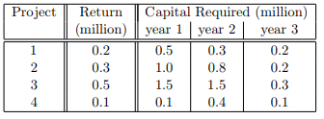

The available budget is 3.1 million for year 1, 2.5 million for year 2 and 0.4 million for your 3. The problem is to decide which projects to invest in order to maximize the total return.

You need to develop a genetic algorithm program in Java to solve this problem.

You also need to provide a write up explaining:

* The encoding of the problem (given in the hints below)
* The crossover mechanism used
* The mutation used
* The fit function used
* The selection of each generation
* The stopping criteria

Once you are done, you need to submit you code along with your write up. The write up should contain some screenshots of the output of your program and the final optimized solution. If working in pairs, you must specify the names of the group members.

**No late submissions are accepted.**

**Hints:**

**Variables:** x1, x2, x3 and x4 are binary variables, representing the investment decisions of project 1, 2, 3, and 4. A value 1 indicating invest while a value 0 indicating don’t invest.

**Representation:** Binary string







**Have fun ☺**