Chapter II
Review of Relevant Literature
As the air transportation network navigates a period of expansion that threatens to outpace the physical limitations of existing infrastructure, the impractical expectation of immediate structural capacity expansion has pivoted operational priorities toward refining asset distribution. Traditional optimization methods often rely on static, deterministic approaches – which operate on the premise of predictable, non-random outcomes – but intrinsically fail to account for the stochastic nature of real-time terminal activity. To address these gaps, researchers are developing models designed to optimize resource allocation, such as staffing and throughput management, while maintaining efficient, high-quality service. Integrating advanced predictive frameworks offers the potential to build the robust, resilient, and generalizable tools necessary to manage variability and balance competing operational demands under uncertainty. Historically, literature on airport passenger flow modeling has prioritized statistical fit and throughput optimization. The unprecedented systemic shocks of the COVID-19 pandemic exposed the limitations of relying solely on historical data for predictive accuracy. Consequently, this review traces the evolution of flow prediction from static operational models to advanced deep learning architectures, ultimately highlighting a recent paradigm shift toward frameworks that prioritize systemic resilience and robustness in the face of extreme disruptions.
The literature review is structured as follows: first, traditional approaches to airport capacity and passenger flow are reviewed; second, the shift from static to dynamic modeling is explored; third, advanced predictive models and artificial intelligence are analyzed regarding their strengths and limitations; and finally, hybrid architectures are discussed as a synthesis to achieve both predictive power and transparency. This trajectory illustrates a critical shift from rigid observations toward dynamic predictive models that link theory with real-time operations.
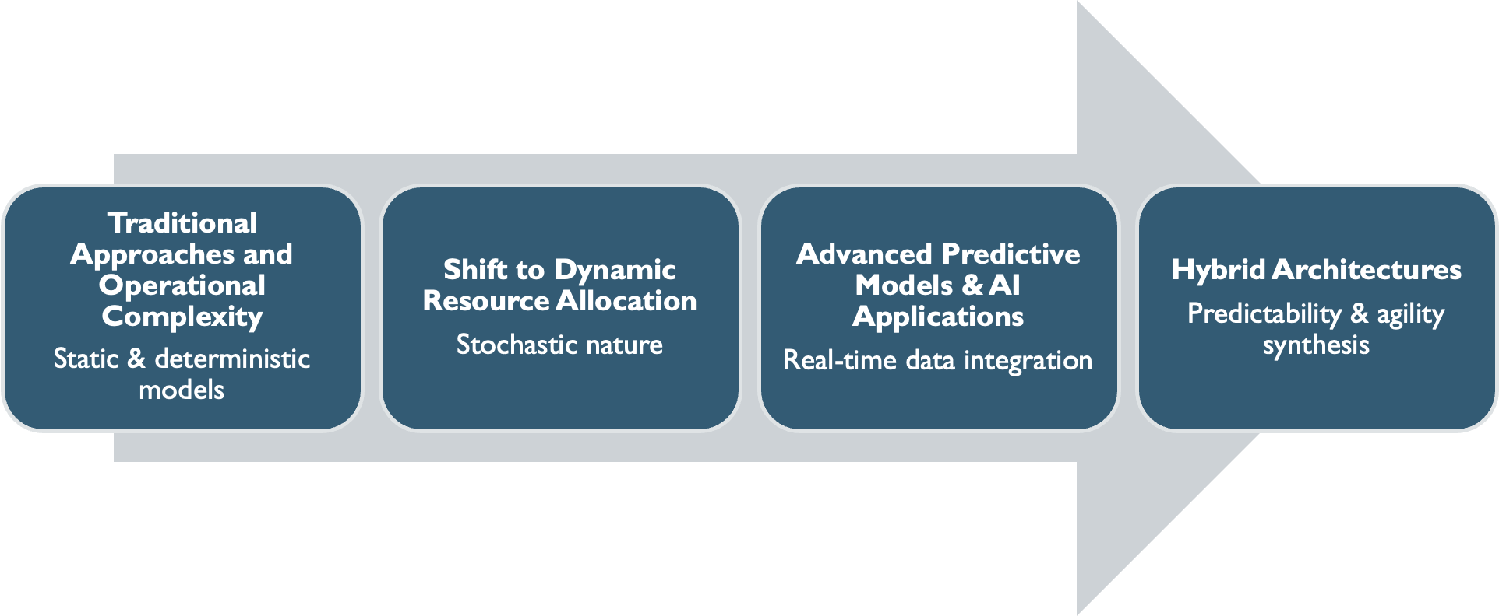
Figure 1. Literature Review Outline
1. Traditional Approaches and Operational Complexity
Mounting demand for air transport has resulted in an operational environment in which traditional infrastructure can no longer keep pace with escalating passenger volumes, as noted in industry analyses (Ozores, 2026). While domestic passenger demand in the US is projected to grow by 2.4% annually, airport capacity is forecasted to increase by only 0.8%, yielding a critical and widening gap that is unlikely to be resolved by physical expansion alone (IATA, 2026; FAA, 2024). This discrepancy is further complicated by the high levels of uncertainty inherent in long-term demand forecasting, a factor that consistently renders large-scale capital investments in terminal capacity both risky and slow to respond to immediate surges (Solak et al., 2009). As structural expansions lack the agility required for near-term solutions, the industry must pivot toward maximizing existing assets through advanced resource optimization (Balliauw & Onghena, 2020; Zhang et al., 2012). Araujo & Repolho (2015) argue that due to the stochasticity and interdependence of terminal subsystems – namely check-in, security, and boarding queues - managing their complexity requires the identification and reduction of the superfluous operations that lead to bottlenecking. To achieve sustainable capacity, terminal functional areas must maintain a specific Level of Service (LOS) without the prohibitive capital expenditure of hard infrastructure expansion (Di Mascio et al., 2020; AlKheder et al., 2024).
The delicate interdependency of airport subsystems further complicates operational shifts, as localized failures in one segment are particularly vulnerable to time-related constraints, potentially triggering a systemic collapse of flow (Orhan & Orhan, 2020; Bießlich et al., 2014; Brown & Madhavan, 2011). Systemic fragility is exacerbated by the interlocking nature of landside and airside events, where a delay in one sector propagates a cascade of congestion across the entire airport ecosystem (Nazir et al., 2022). Furthermore, congestion does not occur linearly; traffic frequently occurs in high concentrations – "starving" capacity for hours before suddenly "saturating" it in minutes – transforming flow optimization into a moving target that outpaces nominal capacity growth (Chiti, Fantacci & Rizzo, 2018). Even when a facility remains under its total daily limits, unexpected arrival fluctuations create "ripples" of upstream congestion, inevitably disrupting downstream processes like security screening (Adacher & Flamini, 2020; Marzuoli et al., 2019). This operational friction is intensified by a persistent temporal lag: a systemic mismatch in which the time required to detect a surge forces additional resources to become available only after the peak has subsided. Ultimately, these bottlenecks are rooted in the unpredictable, stochastic nature of passenger behavior, making resource allocation a complex balancing act between operational costs and quality service levels (Birolini & Jacquillat, 2023).
1.1 Stochasticity and Batch Behavior
Understanding modern airport capacity and the corresponding resource allocation crisis requires looking beyond the simple reality of demand exceeding supply (Fernandes & Pacheco, 2002). Historically, airport landside management relied on deterministic models which assumed that fixed passenger volumes would result in linear, predictable service requirements (Lemer, 1988; Parizi & Braaksma, 1994). In contrast, contemporary operations are more appropriately understood as a network of interconnected queues, characterized by intricate, non-linear movements. While transitioning toward probabilistic models allows for a more nuanced approximation of system behavior, the unpredictable variables of the terminal environment continue to make fluctuating dynamics notoriously difficult to capture.
The stochastic nature of passenger flow and “batch” behavior further compounds modeling difficulties, highlighting that spatial capacity increases alone cannot resolve modern convolutions. In airport operations, stochasticity – random variables such as varying arrival times and individual walking speeds – renders human movement inherently unpredictable despite fixed flight schedules (Schultz & Fricke, 2011). This randomness frequently manifests as “batch” behavior, where passengers do not arrive in a steady stream, rather in concentrated bursts that overwhelm localized infrastructure (Guo et al., 2022). Even with perfect flight data, arrival patterns remain a non-deterministic system due to interacting operational and behavioral factors. Models must be designed not just for volume, but also to schedule resources around these bursts without incurring the cost of constant over-staffing.
1.2 Queuing Theory Foundations and Limitations
To translate unpredictable passenger movements into quantifiable system states, traditional landside optimization methods utilize Queuing Theory. Queuing Theory models how stochastic arrival patterns and concentrated "batches" of passengers interact with various service points throughout the terminal (Wang, 2017). In this framework, every terminal process – from check-in to security screening – is treated as a "server" processing "entities." Early iterations of these models utilized a Poisson process distribution to calculate the probability of specific arrival rates within fixed intervals to account for the inherent uncertainty of passenger demand (Horie, 1985; Odoni, 1986). This established a vital mathematical foundation by demonstrating that wait times do not increase linearly, allowing for a calculated trade-off between operational costs and a target Level of Service (LOS) (Araujo & Repolho, 2015).
Because the standard Poisson distribution assumes a constant arrival rate, it consistently struggles to reflect non-linear dynamics and dramatic fluctuations triggered by flight banks (Wang, 2018). Within an operational context, flight banks - the temporal compression of multiple flight schedules into narrow windows - act as the primary driver of "batch behavior" in terminal queues (Peterson et al., 1995). Concentration of demand forces the system to process massive, non-linear surges that can saturate capacity far more rapidly than a steady, continuous stream. To address this, researchers transitioned toward Non-Homogeneous Poisson Processes (NHPP), effectively treating the terminal as a multiphase network where the output of one process becomes the variable, time-dependent input for the next (Brunetta et al., 1999). One approach to expanding terminal flow efficiency involves modeling the airport as a multiphase single-server queuing system, which allows for the prediction of congestion and unused capacity by calculating performance indicators like traffic intensity and average wait times across sequential service points (Hess & Grbčić, 2019).
Data-driven queueing approaches have been used to bridge the gap between theoretical flight schedules and actual passenger surges (Nikoue et al., 2015). Alnowibet et al. (2022) demonstrate the utility of queuing theory to identify specific bottlenecks at Cairo International Airport, noting that server utilization often exceeds capacity in the check-in and security sub-systems during peak hours. Virtual queuing theory and bottleneck detection algorithms have frequently identified security checkpoints as the primary decelerators of terminal throughput (Liu, 2018; Lu et al., 2018). Beyond identification and basic flow, optimization models utilizing Generalized Stochastic Petri Nets (GSPN) have been employed to specifically reduce the “dead time” between security screening stages, thereby increasing the overall service rate of the checkpoint (Wei, 2017; Zhang et al., 2017).
Even as network-centric approaches were refined through likelihood-free inference for dynamic queuing networks to better estimate time-varying surges, they remained conceptually limited (Ebert et al., 2021). By relying on the independence assumption of the Poisson process, the ability of traditional models to account for critical elements is fundamentally limited in two ways: the correlation between passengers on the same flight and the “batch” behavior inherent in modern hub-and-spoke operations (Guo et al., 2022). As Adeke (2018) demonstrates, while queuing theory provides a foundational framework for modeling passenger flow, its simplifying assumptions limit its ability to capture the full complexity of real-world terminal dynamics.
2. From Analytical Queuing Models to Dynamic Simulation and Real-Time Management
To navigate the inherent uncertainty of terminal operations, researchers have advocated for a stochastic planning approach that redefines terminal management as a probabilistic system (Verki et al., 2013). Central to this shift is Discrete Event Simulation (DES), a modeling method which – unlike a static spreadsheet – views terminal processes as a sequence of discrete events where every action, such as a passenger finishing check-in or entering a security lane, is recorded within a time-indexed framework (Brown & Madhavan, 2011). To resolve analytical gaps, researchers utilize DES to capture spatial, temporal, and behavioral variability that static models cannot represent (Leone & Liu, 2011). By acting as the underlying engine, DES provides the simulation capabilities necessary for a broader Digital Twin framework: a continuously updated virtual replica that mirrors physical infrastructure in real-time (Edwards, 2026). By utilizing DES to calculate the stochastic nature of processes like fluctuating TSA throughput, a Digital Twin becomes a dynamic, data-fed model that learns how assets behave under real operating loads to predict future performance and potential failures. The corresponding high-fidelity granularity is essential for resource allocation because it allows for the integration of human unpredictability (Perez, 2021).
In practice, these allocation models have proven highly effective. Guizzi et al. (2009) demonstrate a strong correlation between check-in throughput and security demand, providing a framework for more rational resource management. The resulting paradigm shift is further supported by event-based allocation methods that utilize empirical data to dynamically schedule check-in counters in response to fluctuating demand (Parlar et al., 2016). Nwofia and Chung (2013) underscore the utility of probabilistic simulations by demonstrating the ability to build a link between architectural design and financial accountability. Ultimately, the "digital twin" approach enables the testing of hypothetical flight schedules that can reduce peak terminal density and assess if optimization models meet real-world service levels under uncertainty (Araujo & Repolho, 2015; Ateş et al., 2021).
2.1 The Limitations of DES
Despite its high fidelity, Discrete Event Simulation (DES) remains constrained by predefined logic structures, making it highly sensitive to parameter assumptions and less adaptable to real-time deviations (Takakuwa & Oyama, 2004). Brown and Madhavan (2011) illustrate this vulnerability, showing how checkpoint throughput can be disproportionately skewed by baggage alarm rates; such minor fluctuations in human or machine performance can significantly distort outputs when the underlying logic is unable to pivot. Furthermore, Alodhaibi et al. (2017) argue that using a fixed logical sequence treats passengers as passive entities rather than proactive decision makers. The resulting behavioral and structural rigidity creates a modeling gap during terminal disruptions, where the methodology struggles with the computational intensity required to simulate highly stochastic, unfolding events (Bießlich et al., 2014). Consequently, the limitations of rule-based fidelity under rapidly changing conditions motivate a transition in the research landscape toward data-driven systems that can actively learn from operational data, rather than merely following static scripts.
2.2 Recontextualizing Poisson
Poisson arrival processes have traditionally served as a foundational cornerstone of queueing theory; however, recent research – as seen in the MATLAB-based algorithm – recontextualizes these distributions within more advanced predictive frameworks (Palaşcă & Stăncel, 2025). By utilizing Poisson models as the stochastic core for real-time data processing, airports can achieve significant gains in operational efficiency. The purpose of such integration is to identify congestion hotspots and enable dynamic resource adjustment, effectively reducing the excess operating hours and salary costs associated with fixed staffing.
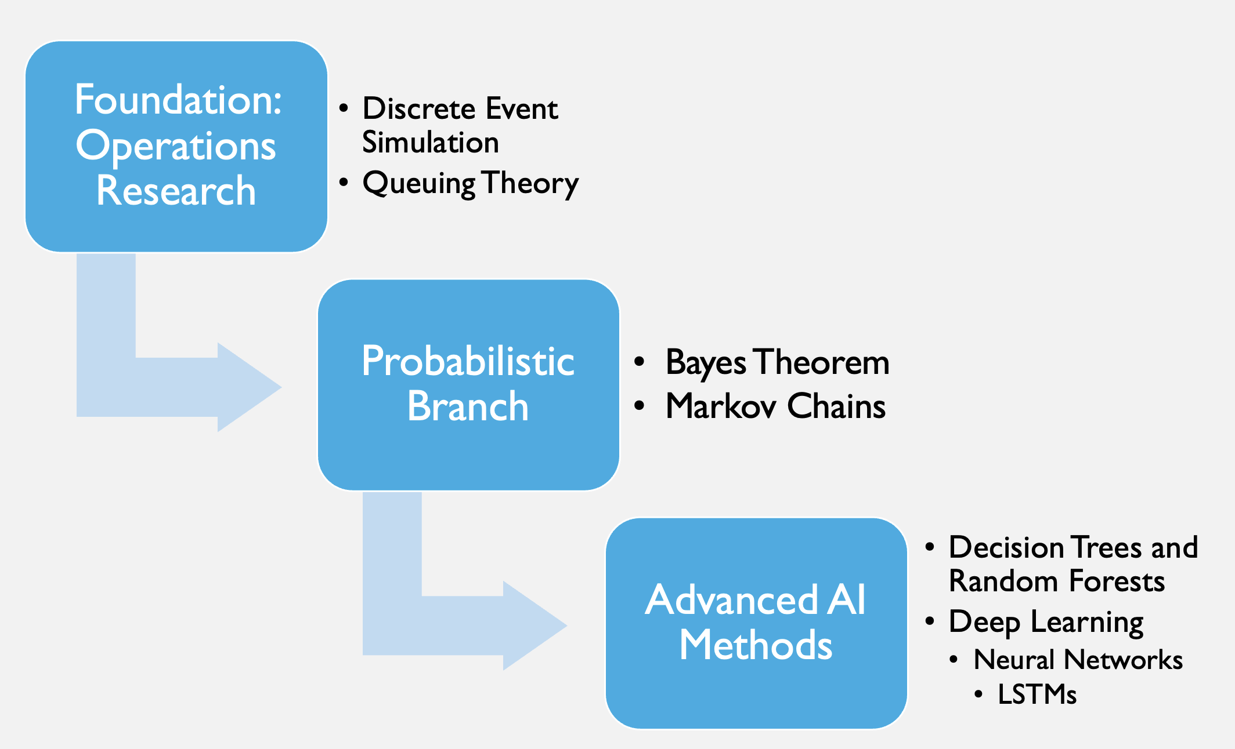
Figure 2. Methodological Hierarchy

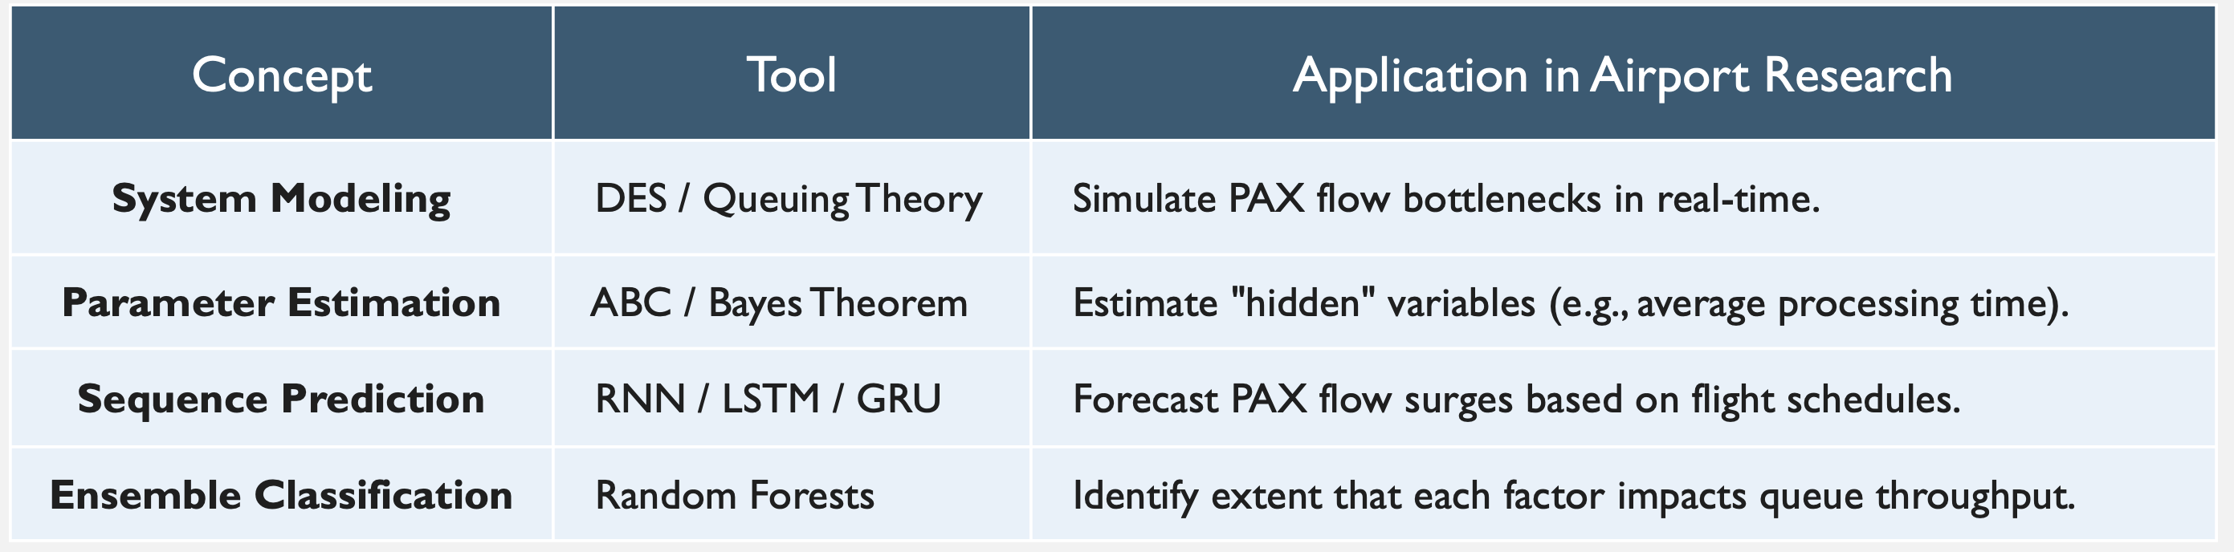
Figure 3. Concept Comparison
3. Advanced Predictive Models and Artificial Intelligence
The limitations of traditional simulation have necessitated a shift toward advanced predictive architectures that prioritize operational flexibility and real-time responsiveness over static process logic. Unlike the rigid nature of early discrete event simulations, these modern architectures serve as the foundation for robust resource allocation by absorbing vast streams of real-time data to forecast emergent behaviors. This evolution represents a fundamental move toward probabilistic reasoning, where the objective is to model the likelihood of various outcomes rather than relying on a single deterministic path.
3.1 Time-Series Analysis and Statistical Foundations
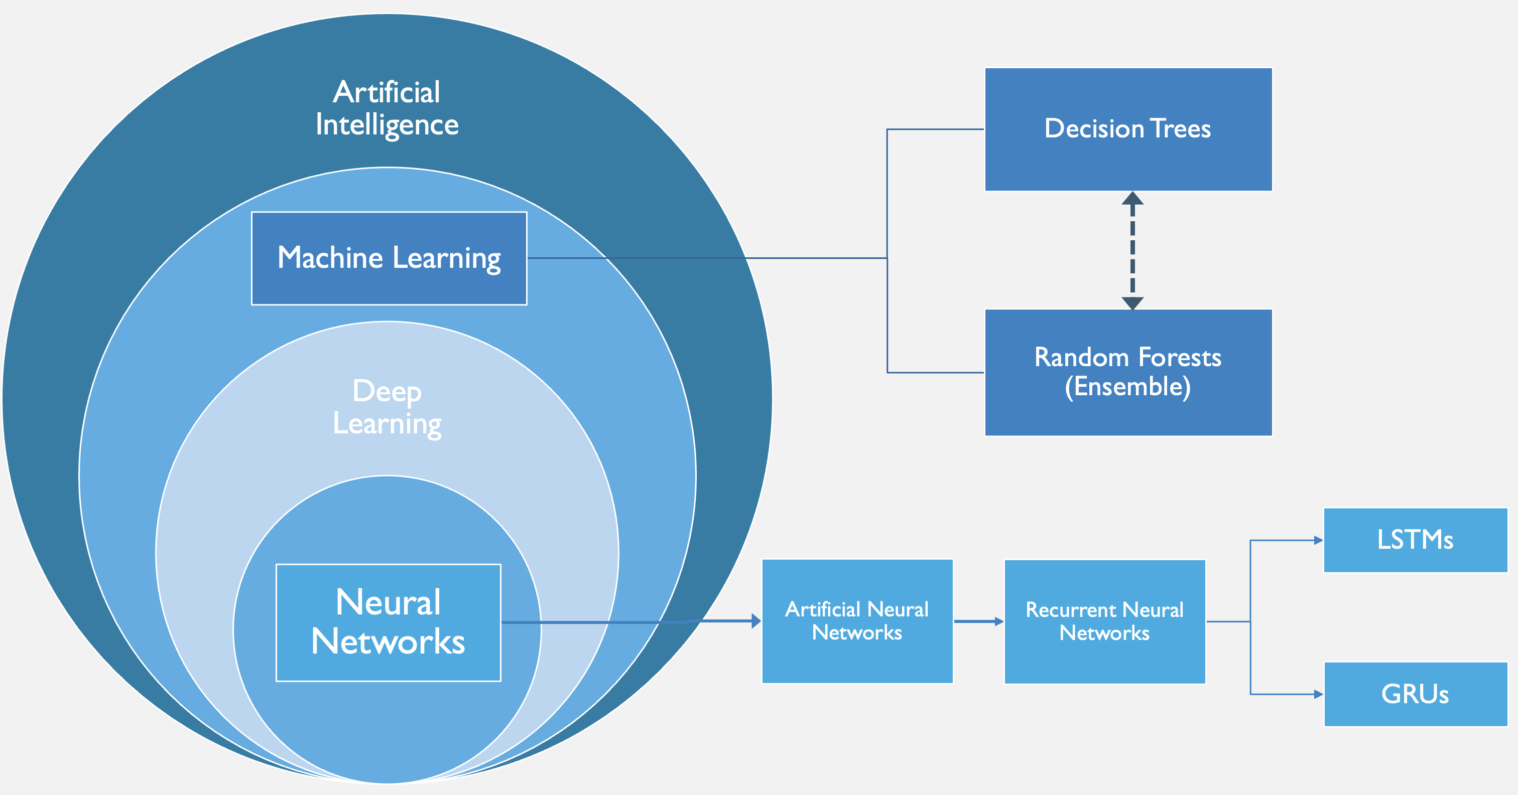
Figure 4. Artificial Intelligence Hierarchy
The adoption of Artificial Intelligence (AI) represents the technical realization of this shift through Machine Learning (ML), a subset of AI that moves beyond pre-programmed rules to serve as a pattern-recognition tool capable of managing the stochastic "noise" of passenger behavior (Saki & Soori, 2026). Traditionally, SARIMA (Seasonal Autoregressive Integrated Moving Average) models have been used to identify recurring patterns by analyzing the internal properties of a univariate time series, such as the autocorrelation of past arrival waves and daily seasonal cycles. By mathematically 'averaging' its own historical errors and trends, SARIMA effectively captures the predictable rhythms of flight banks and holiday travel (Babu, 2014). However, while SARIMA excels at internal pattern recognition, high-fidelity forecasting must also account for the direct correlation between fluctuating passenger volumes and specific, real-time flight arrangements (Lin et al., 2023). Because SARIMA’s predictive power is derived entirely from its own historical data, it remains fundamentally unable to incorporate these external shocks directly into the univariate time series (Li et al., 2017).
3.2 Neural Networks and High-Dimensional Data
To account for non-linear temporal dependencies that statistical models cannot represent, models such as Long Short-Term Memory (LSTM) networks are particularly effective. Unlike traditional SARIMA models, LSTMs can learn complex, non-linear long-term dependencies between past arrival waves and future terminal surges, effectively reflecting the external influences that statistical models tend to overlook (Hewamalage et al., 2021). While Orsini et al. (2019) highlight the necessity of the recurrent nature of LSTMs for predicting real-time passenger journeys, the computational demands of such models limit their strategic application. Consequently, dense neural networks provide a computationally efficient alternative for capturing the non-linear surges inherent in airport traffic; a compact, dense architecture achieves high-fidelity forecasting with minimal overhead. Simulation data farming underpins the enhancement of robustness in these predictive tools, offering a pathway to generate the vast datasets necessary for training machine learning models within elaborate security subsystems (Patrón et al., 2021).
3.3 Behavioral Modeling and Active Control
Recent work extends beyond passive flow prediction by modeling passengers as adaptive agents capable of dynamic decision-making within terminal environments. To better simulate proactive decision-making, multi-agent reinforcement learning has been utilized to model how autonomous passenger "agents" navigate and adapt to terminal constraints (Li & Gao, 2023). However, the practical application of these systems reveals a functional gap, as models frequently underestimate actual flow even when utilizing high-resolution distributional forecasts (Anagnostopoulou et al., 2024). To bridge the gap between prediction and operational execution, recent research has moved toward structured control frameworks. Diaz-Gutierrez et al. (2025) demonstrate this evolution by introducing Model Predictive Control (MPC) algorithms that integrate stochastic airport dynamics into an automated optimization loop. This marks a critical evolution from pure prediction toward active control, where dynamic rescheduling strategies are used to balance congestion across multiple departure areas in real time (Lee et al., 2025). Together, these approaches demonstrate that although predictive accuracy has improved significantly, challenges remain in the interpretability and operational integration, formerly facilitated by simpler, deterministic methods. This transition necessitates the adoption of the hybrid models explored in the following section.
4. Hybrid Architectures: Integrating Determinism and Interpretability
To resolve the "black-box" challenge – where the internal logic of deep learning models is not easily interpretable – researchers increasingly advocate for hybrid architectures (Adadi & Berrada, 2018). In these architectures, neural networks act as predictive engines that generate flow estimates, which are then passed to a secondary optimization layer – notably Simulated Annealing or Integer Linear Programming (ILP) – to align with real-world operational constraints and staffing buffers (Brun et al., 2025). The subsequent need for integration is reflected in approaches that combine Random Forest predictions with deterministic queue-length models to produce actionable, flight-level insights (Had et al., 2025). By linking probabilistic forecasting with constraint-based optimization, hybrid architectures provide a more adaptable and scalable framework for managing airport operations across varying conditions (Jenčová et al., 2025).
4.1 Fusion and Deep Learning Stability
Early hybrid approaches focused on improving predictive stability by integrating deep learning with statistical methods. Hopfe et al. (2024) show that combining Gated Recurrent Units (GRU) with regression and gradient boosting improves accuracy by incorporating external variables such as weather, search behavior, and mobility patterns. Similarly, Ribeiro et al. (2025) find that embedding queuing-theoretic features into Gradient Boosting Machines (GBM) enhances the model’s ability to capture non-linear congestion dynamics compared to purely data-driven or analytical approaches.
This integration strengthens the representation of physical system constraints while preserving the predictive power of machine learning. More recent work extends the idea through multi-layered architectures designed to capture patterns at different scales. For example, the Fusion Intelligence Network Model (FINM) proposed by He et al. (2024) combines Convolutional Neural Networks (CNN) for local feature extraction, Bidirectional Long Short-Term Memory (BiLSTM) for temporal context, and GRUs for computational efficiency. By distributing tasks across specialized components, these architectures improve stability under rapidly changing traffic conditions, although they still depend on data quality and model calibration.
4.2 Causal Transparency: Transitioning to “Glass-Box” Models
Multi-layered models possess considerable predictive power, yet they commonly remain difficult to interpret (Wang et al., 2025). This lack of transparency is a critical hurdle for operational deployment, where understanding the 'why' behind a prediction is as vital as the prediction itself (Viaña et al., 2024). Bayesian Networks (BNs) offer a potential solution by representing probabilistic dependencies in a transparent, causal structure (the ‘why’). Guo et al. (2025) extend this framework by integrating BNs with the Best-Worst Method to quantify interdependencies among terminal resilience factors. Quantifying these variables allows models to move beyond static throughput metrics and incorporate both technical constraints and human-driven variability. Similarly, Hybrid Queue-based Bayesian Networks (HQBN) combine queuing theory with probabilistic reasoning to identify the causes of congestion within terminal processes. By linking prediction with causal interpretation, these models support more informed and explainable decision-making in resource management (Wu et al., 2014).
4.3 Stochastic Optimization
An additional requirement for effective hybrid systems is the ability to manage uncertainty through stochastic optimization. Metaheuristic methods—such as Particle Swarm Optimization with Back Propagation (PSO-BP)—are widely used to tune neural network parameters, improving performance on non-linear variables like baggage flow and waiting times (Naji et al., 2020; Jiang et al., 2024; Wu, 2024). These approaches provide near-optimal solutions without requiring exhaustive search, making them suitable for complex, high-dimensional systems (Sörensen, 2015).
To maintain performance under noisy or incomplete data, likelihood-free inference methods can be used to estimate system behavior during unpredictable disruptions (Ebert et al., 2021). Nonlinear Autoregressive with Exogenous Input (NARX), a complementary model, incorporates external variables like weather, improving forecast transparency compared to purely deep learning approaches (Anupam & Lawal, 2024). These predictive components are commonly validated within simulation environments (e.g., ARENA), linking learned behavior back to operational testing (Olusanya et al., 2020; Oprea et al., 2024).
Additional interpretability can be introduced through Fuzzy Logic systems, which model decision-making under uncertainty, and ensemble methods such as Random Forests, which improve robustness by aggregating multiple decision pathways (Xia et al., 2020; Blasco-Puyuelo et al., 2023). These methods support applications like dynamic passenger routing, where real-time guidance directs travelers toward underutilized resources (Yang et al., 2022). Despite their power, many non-linear models still trade interpretability for accuracy, highlighting the necessity of hybrid approaches that balance performance with transparency (Wu et al., 2024).
Ultimately, the evolution of airport passenger flow predictive modeling represents a distinct shift toward architectures that prioritize robustness and resilience over mere statistical fit. Evidence from Hopfe et al. (2024) suggests that deep learning models, particularly multivariate LSTMs, better capture non-linear interactions during periods of disruption when used in conjunction with additional deterministic models. Although forecasting technologies have significantly advanced in predicting passenger flow and baseline volatility, COVID-19 pandemic served as an unprecedented system disruption that exposed the profound vulnerabilities of static operational models.
5. Impact of COVID-19
While predictive modeling for airport passenger flow utilizes probabilistic methods capable of processing both pre-pandemic and pandemic data, the unprecedented operational shocks of COVID-19 revealed a critical vulnerability in how these models are evaluated (Sun et al., 2022). Existing frameworks proved ill-equipped to account for extreme, abrupt disruptions in the commercial air traffic industry. The pandemic fundamentally altered terminal operations as airports were driven to restructure passenger handling, shifting priorities away from speed-centric throughput toward the minimization of public health risks (Mota et al., 2021). As even highly sophisticated models struggled to accurately forecast flow amidst these profound spatial and procedural changes, it became evident that raw predictive accuracy could no longer serve as the sole benchmark for a model's efficacy (Li et al., 2023). Consequently, the systemic disruptions of COVID-19 drove a paradigm shift in airport passenger flow operations, prioritizing robustness, resilience, and generalizability as primary evaluation criteria.
Robustness to Procedural Volatility (Performance Under Perturbation)
The rapid adoption of digital and self-service processes initially introduced highly volatile processing times, transforming automation from a reliable accelerator into a potential operational bottleneck (Lin, 2022). Consequently, predictive models must now be evaluated on their robustness—their capacity to adapt to sudden shifts and treat these dynamic, unpredictable processing times as active variables rather than stable baselines.
Resilience to Systemic Shocks (Capacity to Absorb and Recover from Disruption)
Terminals witnessed the emergence of decentralized queue structures, physical barriers, and curtailed staffing levels to align with diminished and unpredictable passenger demand (Schultz et al., 2021; Kazda et al., 2022). This structural upheaval necessitates an emphasis on resilience, ensuring models can withstand severe systemic shocks and accurately map extreme demand fluctuations alongside sudden physical capacity constraints.
Generalizability Across Environments (External Validity)
The pandemic revealed that ostensibly "similar" airports harbored drastically different underlying structural vulnerabilities, demonstrating that comparable variables could not uniformly explain the volatility of passenger flow across different hubs (Güner & Seçkin Codal, 2024). Moreover, confounding factors - such as simultaneous capacity-altering construction at specific airports or industry-wide shifts in flight schedules - proved that evaluating raw throughput without contextualizing infrastructure changes leads to flawed assumptions. As a result, models must be highly generalizable across structurally diverse terminal environments to effectively decouple the relationship between flight schedules and actual operational throughput (Tang et al., 2023).
Ultimately, the lessons of the pandemic underscore that a model's utility is no longer defined merely by its baseline accuracy, but by its capacity to adapt to structural and procedural volatility. Integrating robustness, resilience, and generalizability into future predictive frameworks is therefore not just an enhancement, but an operational necessity. Only by embracing these criteria can the industry develop adaptive systems capable of navigating the complex, unpredictable realities of modern terminal environments.

