Chapter III
Methodology
This chapter details the approach and analytical framework to evaluate and optimize passenger flow forecasting, specifically at airport security checkpoints. To provide a structural roadmap for this investigation, the methodology is organized into five components:
- Research Approach: Establishes the theoretical framework, research variables, hypotheses, experimental design, and the technical apparatus utilized.
- Sample: Outlines the multi-tiered macro and micro sampling frameworks used to categorize physical checkpoint environments and terminal architectures.
- Sources of Data: Identifies the primary authorized data repositories supplying the longitudinal datasets.
- Validity: Addresses and controls internal and construct threats, specifically related to passenger flow bias and screening lane heterogeneity.
- Treatment of Data: Details the sequential pipeline used to ingest, clean, standardize, and align the data sources.
Research Approach
The study uses an exploratory, sequential, quantitative design to systematically assess the predictive accuracy and operational utility of distinct forecasting approaches for passenger flow forecasting at airport security checkpoints. While this study evaluates a broad range of frameworks – including static deterministic baselines – it asserts that to truly optimize checkpoint flows, terminal subsystems (i.e., check-in, security, boarding) must ultimately be treated as a stochastic queuing network capable of absorbing dynamic, schedule-driven variability (De Neufville & Odoni, 2014). The primary objective is a comparison of three model families (Figure 1): deterministic baselines, probabilistic and data-driven models, and hybrid frameworks. Deterministic baselines serve as reference cases based on historical averages and scheduled operations. Probabilistic and data-driven models include methods such as SARIMA, LSTM, and random forest models that are designed to capture temporal variation. Hybrid frameworks combine queueing theory with exogenous operational data to reflect both system structure and observed schedule effects.
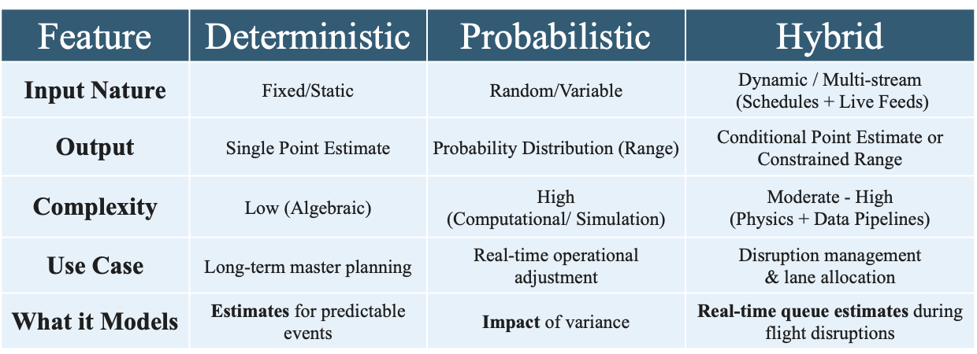
Figure 1. Forecasting Model Family Comparison
The predictive capabilities of each model configuration focus on performance measures: robustness, resilience, and generalizability. In this chapter, robustness refers to consistency under routine operating conditions, resilience refers to recovery after disruption, and generalizability refers to performance across different airports or terminal layouts.
Core Research Variables. Independent variables include scheduled flight departures, actual flight performance data, terminal structure categories, and origin-and-destination ratios. Dependent variables include TSA checkpoint throughput, queue wait times, and bottleneck formation rates. Model performance will also be evaluated as a secondary outcome.
Research Hypothesis. Distinct modeling frameworks and hybrid combinations thereof will exhibit asymmetric performance strengths across robustness, resilience, and generalizability. Probabilistic models are expected to outperform deterministic baselines under highly variable demand conditions, while hybrid models may perform better under disruption scenarios, as they combine system structure with operational data.
Hypothesis₁: Of the three different approaches to volatility forecast modeling (deterministic, probabilistic, and standard hybrid), no individual approach will prove superior across all three performance measures (resilience, robustness, and generalizability).
Design and Procedures. The execution of this research is structured into four sequential, iterative phases (Figure 2) designed to translate raw aviation data streams into comparative model performance results:
- Phase 1: Data Collection & Preprocessing (ETL)
  - Pull origin-and-destination estimates, load factor, TSA throughput & On-Time Flight Performance data from 2019-2025.
  - Filter 2019-2025 to preserve baseline operational validity.
  - Define metrics to evaluate each framework’s robustness, resilience, and generalizability.
- Phase 2: Model Development
  - Construct and calibrate static deterministic baselines queue structures to establish an operational control group.
  - Train probabilistic and data-driven time-series architectures (e.g., SARIMA and LSTM) to capture stochastic variance.
  - Program hybrid frameworks that dynamically integrate queuing theory with real-time flight schedule data.
- Phase 3: Evaluation Framework
  - Run model inferences against standardized baseline historical testing datasets.
  - Stress-test frameworks under simulated scenarios, such as peak asset constraints and operational failures.
  - Compute distinct metrics to evaluate each framework’s robustness, resilience, and generalizability.
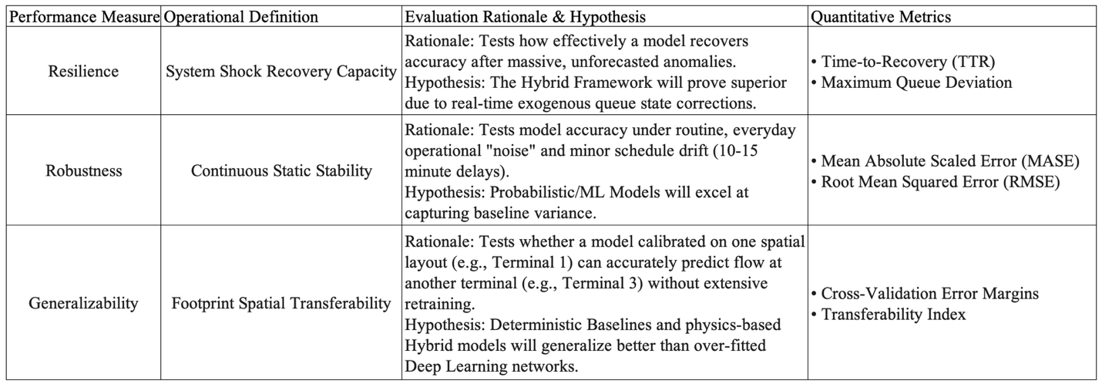
Figure 2. Evaluation Metric Definition
- Phase 4: Analysis and Interpretation
  - Map empirical performance outputs to initial foundational literature alignment.
  - Segment predictive insights into system-wide trends (both macro and micro) to deliver actionable recommendations.
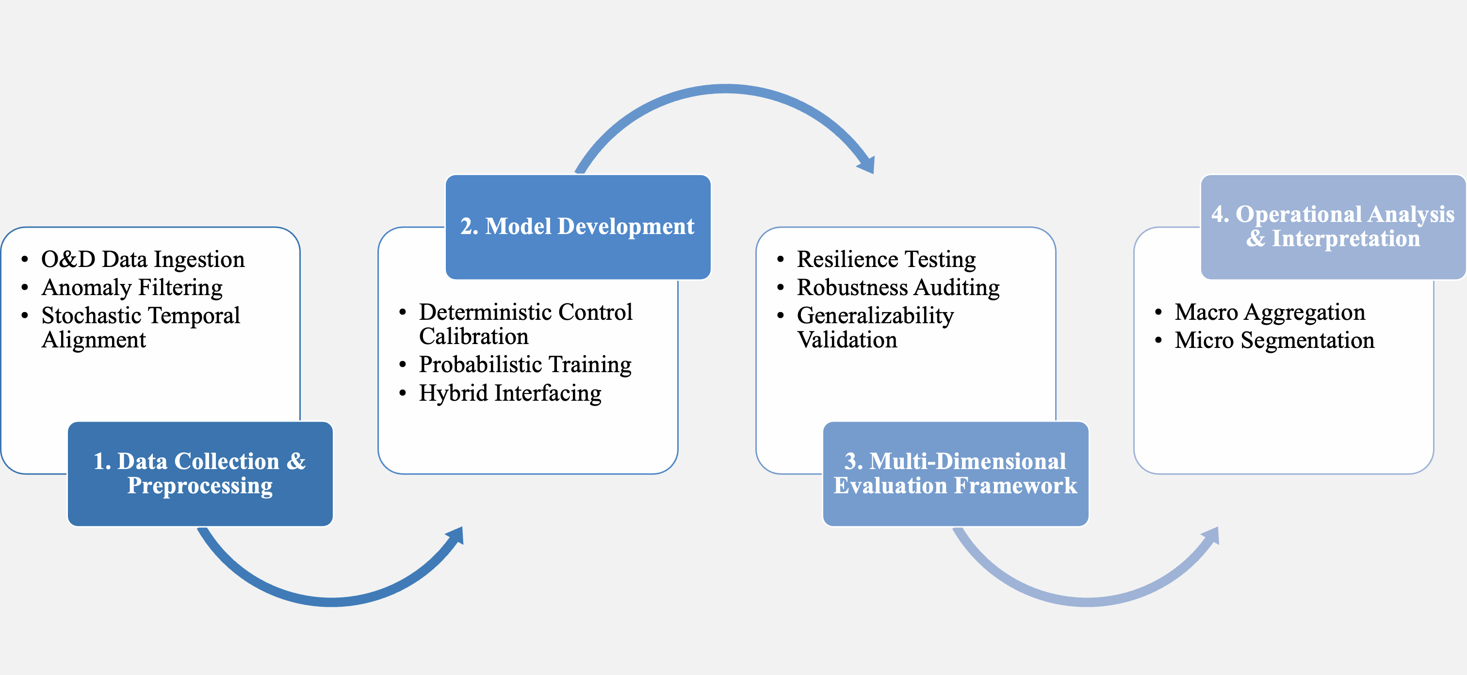
Figure 3. Design and Procedure Phases
Apparatus and Materials. To manage, parse, and evaluate the large data sets required for this study, the following software and computing resources are used:
- Google Antigravity and Python: Utilized as an integrated agentic framework and primary data ingestion engine to manage high-volume government data dumps during the ETL process. To ensure data integrity at this scale, custom scripts handled automated data pulling, unzipping, and parsing workflows in the data pipeline for downstream predictive modeling.
- Microsoft Excel for Mac & Microsoft Power BI: Deployed locally for advanced data transformation and visual validation.
- Vega High-Performance Computing (HPC) Cluster: The remote institutional environment used to execute the resource-intensive Python algorithms, filtering large-scale raw data down to determine airport and airline parameters.
Sample
The sample consists of airport checkpoint environments selected to reflect variation in terminal structure and airline dominance. Airports are grouped into structured categories (Figure 3, Figure 4) to account for how physical layout influences passenger distribution and checkpoint use (OAG, 2026). This strategy is intended to support comparison across terminal types and carriers rather than to claim complete uniformity across airports and airlines.
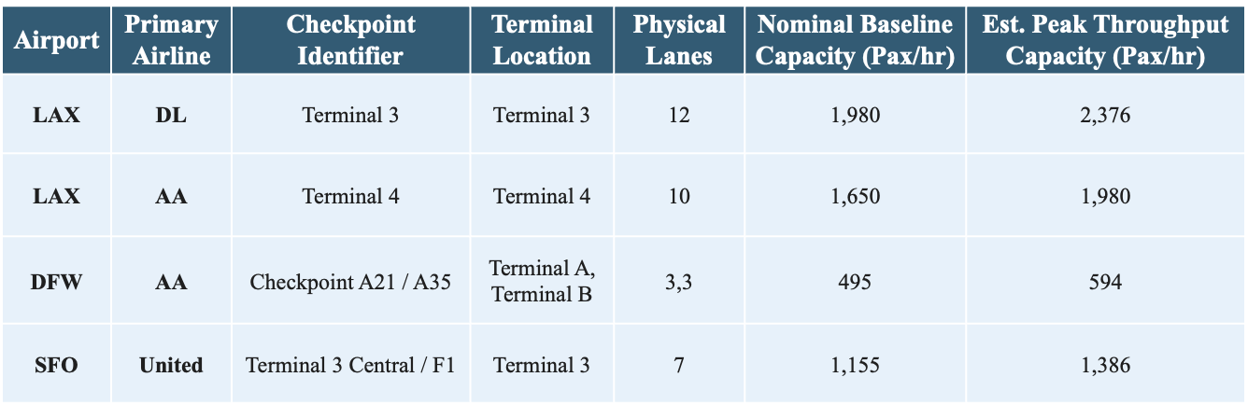
Figure 4. Sample Framework for Terminal Capacity and Checkpoint Configuration
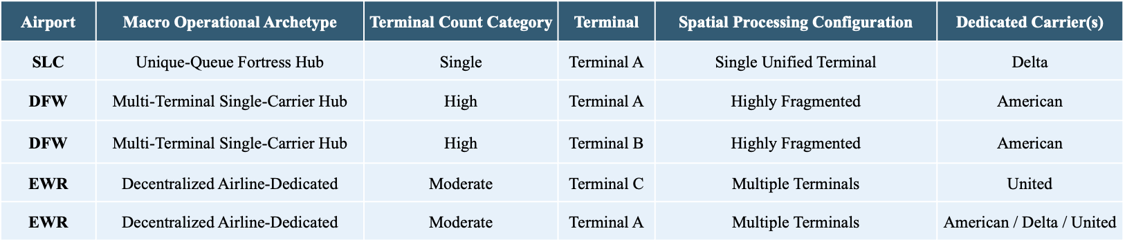
Figure 5. Airport Operational Archetypes and Terminal Configuration
Macro Categorization: Terminal-to-Airline Distribution. Airports are first classified into four structural archetypes to control for how airline market share impacts terminal distribution, with structural archetypes outlined below:
- Mega Hubs with No Dedicated Terminals (e.g., ATL, CLT, DEN): Sprawling operations where major legacy carriers share linear concourses or central ticketing, distributing passenger volume across shared screening areas.
- Decentralized Airline-Dedicated Terminals (e.g., LAX): Dispersed multi-terminal airports where distinct physical buildings are allocated exclusively to individual legacy carriers, isolating an airline's passenger wave to specific physical checkpoints.
- Single-Carrier Dedicated Mega-Terminals (e.g., DTW): Single-carrier "fortress" environments where a single dominant airline channels its entire domestic and international operation through one massive mega-terminal (e.g., Delta’s exclusive hold on the McNamara Terminal).
- Airports with Multiple Terminals Dedicated Exclusively to One Airline (e.g., DFW): Large-scale regional hubs requiring a single dominant carrier to distribute hub-and-spoke operations across multiple independent terminal buildings (e.g., American Airlines utilizing Terminals A, B, C, and E) to scale its operations.
Micro-Level Refinement: Checkpoint Co-Location and Isolation. While macro terminal assignments establish an operational baseline, localized checkpoint-level configurations ultimately determine queue characteristics. American Airlines, Delta Air Lines, and United Airlines are selected for analysis. The explicit criterion for inclusion is a domestic enplanement market share exceeding 10% at major United States hub airports (BTS, 2026). Recent reporting suggests Southwest’s boarding and carry-on system is both distinctive and inconsistent: the airline still relies on a differentiated low-fare brand, but its newer assigned-seating and baggage-fee policies have increased carry-on pressure and created boarding congestion (Boston 25 News, 2026). It is therefore not included in the study. To isolate the effects of low-cost carriers and unaligned traffic from legacy airline operations, the following terminal and checkpoint characteristics are defined to account for the impact of extenuating variables.
Shared Checkpoints with Limited Carrier-Level Separation (Centralized). In centralized hub models like Salt Lake City (SLC), a dominant carrier may hold the majority market share (70%), but a single consolidated terminal channels 100% of passengers through one primary security checkpoint. In these environments, it is not readily possible to isolate carrier-specific passenger flows using the available data structures.
Isolated Three Checkpoints (Decentralized). To find checkpoints highly unlikely to see Delta, American, or United traffic, the methodology prioritizes decentralized layouts with extreme carrier polarization, such as the following:
- DCA (Terminal 1): Consisting of Gates A1–A9, this terminal exclusively serves Air Canada, Frontier, and Southwest. American, Delta, and United are completely segregated into Terminal 2, creating a strong comparison setting for low-cost and regional carrier processing behaviors.
- SEA (Decentralized Main Terminal): Utilizing five separate security checkpoints across a footprint dominated by Alaska Airlines (52% market share). Checkpoints feeding Alaska-heavy gates or dedicated satellite concourses offer a high statistical probability of isolating non-Big Three passenger flows.
- CLT (Extreme Dominance Isolation): Where American Airlines controls 90% of the market share. Because Delta (2.5%) and United (2%) maintain a negligible footprint across the airport's 5 checkpoints, nearly any selected lane acts as a functional monoculture for a single legacy carrier's hub behavior.
Temporal Scope and Boundary Definition. To ensure structural modeling integrity, the temporal boundaries of this sample exclude the systemic operational volatility induced by the COVID-19 pandemic (Sun et al., 2021; Gao, 2022). While a baseline 'post-pandemic' operational era is provisionally considered as beginning January 1, 2023, an exploratory analysis is performed during data preprocessing to refine this demarcation due to varying definitions of ‘post-pandemic’ (ICAO, 2024; Centre for Aviation, 2025). This preprocessing step evaluates pre-pandemic baseline patterns against longitudinal 2019–2025 data to pinpoint the empirical inflection point where system throughput and schedule deviations returned to steady-state normalization. Restricting the active dataset to this verified window enables the forecasting models to more effectively capture contemporary queue dynamics and schedule-driven variability without being skewed by transient, historic anomalies.
Sources of the Data
Secondary operational data will be compiled from three primary repositories covering the 2019 to 2025 period. TSA checkpoint throughput data is obtained from TSA FOIA resources, on-time flight performance data, origin and departures, and load factors are drawn from the Bureau of Transportation Statistics, and origin-and-destination ratios are used to support passenger flow estimation from selected monthly airport reports, such as LAX Statistics (TSA, 2026; BTS, 2026; LAWA, 2026).
Validity
A threat to internal model validity is the presence of connecting passengers who remain airside and do not pass through a public checkpoint in load factor data. Including them in checkpoint demand estimates inflates predicted originating demand. To reduce this bias, origin-and-destination data is used to estimate and remove connecting traffic from passenger flow calculations. Construct validity is also affected by checkpoint heterogeneity, as the raw lane counts obtained from TSA Throughput data combine different screening modes, such as TSA PreCheck, and their corresponding processing rates.
Treatment of the Data
Extract:
- Download TSA Throughput files from FOIA reading room (PDFs) 2019-2026.
- Parse PDFs into tabular format (csv).
- Download TSA Throughput PDFs and CSVs 2022 – 2025 from GitHub Repository - https://github.com/mikelor/TsaThroughput.
- Cross-reference TSA datapoints to identify temporal gaps, duplicates and inconsistencies.
- Download On-Time Flight Performance data (CSVs) 2019-2026 for all domestic flights in the United States.
- Download T-100 Segment Airline Traffic Data and calculate monthly load factors.
- Perform an audit the 7-year sequence to identify missing data.
Transform
- Standardize timestamps to a uniform operational clock.
- Map and resolve typographical errors, airport names, data mismatches, and checkpoint errors.
- Normalize airport codes, checkpoint prefixes, and common terms (Checkpoint CKPT).
- Separate schedule flights from actual flights.
- Estimate seat capacities using flight distance, carrier and tail-name characteristics.
- Scale seat counts using load factor data to estimate passenger count.
- Merge datasets to determine terminal-specific connecting passengers within target dataset.
- Align Flight departure times with passenger lead-time assumptions and merged with hourly TSA throughput intervals to create a final modeling dataset.
Load
- Load master copies to OneDrive.
- Build analytics and lookup tables.
- Automate verification audits for validity and row preservation.

