Chapter IV
Results
Findings/results
- Descriptive Statistics
- Narrowing down results (4 tiered purposive filtering pipeline) summary and analysis
- Findings on any particular clusters, outliers, notable trends
- Results for defining post-pandemic time to start using data and determining which dates for training, testing, using 2025 to compare etc.
- What is notably statistically significant, particularly in regard to validating that using only exclusive checkpoints are used vs others (there will need to be a model with all checkpoints will need to be performed to confirm that there is a difference between that and exclusive ones, may it be rsquared or another measure of significance/confidence)
- Model Development
  - Training/feature engineering/testing results
  - List of models created
  - Model Evaluations
Analysis & Discussion
- For discussion of descriptive statistics, what was found about chec
- Analysis of results for initial training
- Analysis of results for key performance metrics
- Discussion on indications for models and how well suited they are for robustness, resilience, and generalizability

Methodology
Phase 1: Data Collection & Preprocessing (ETL)
- Pull O&D, load factors, TSA throughput & On-Time Flight Performance data
- Filter 2019-2025 to preserve baseline operational validity.
- Define metrics to evaluate each framework’s robustness, resilience, and generalizability.
Phase 2: Model Development
- Construct and calibrate static deterministic baselines queue structures to establish an operational control group.
- Train probabilistic and data-driven time-series architectures (e.g., SARIMA and LSTM).
- Program hybrid frameworks that dynamically integrate queuing theory with real-time flight schedule data.

Control Group
Test and Train
Phase 3: Evaluation Framework
- Run model inferences against standardized baseline historical testing datasets.
- Stress-test frameworks under simulated scenarios, such as peak asset constraints and operational failures.
- Compute metrics to evaluate each framework’s robustness, resilience, and generalizability.
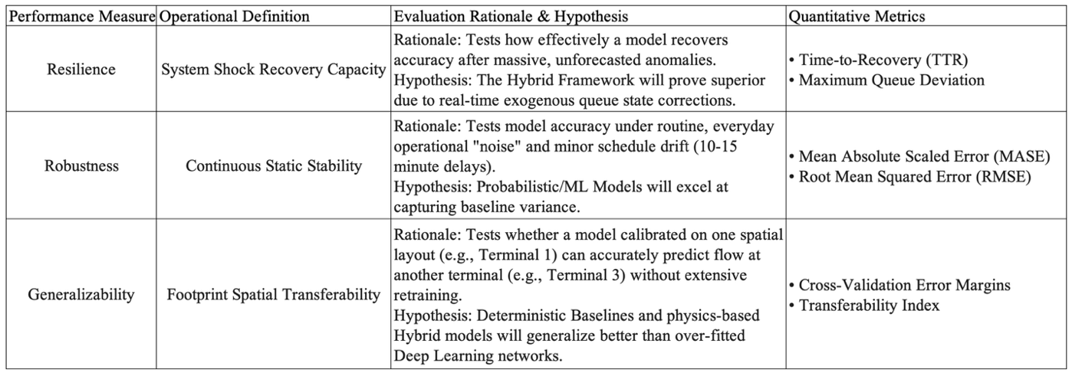
Figure 2. Evaluation Metric Definition
Phase 4: Analysis and Interpretation
- Map empirical performance outputs to initial foundational literature alignment.
- Segment predictive insights into system-wide trends (both macro and micro) to deliver actionable recommendations.
Sample
The sample consists of airport checkpoint environments selected to reflect variation in terminal structure and airline dominance. Airports are grouped into structured categories (Figure 3, Figure 4) to account for how physical layout influences passenger distribution and checkpoint use (OAG, 2026). This strategy is intended to support comparison across terminal types and carriers rather than to claim complete uniformity across airports and airlines.
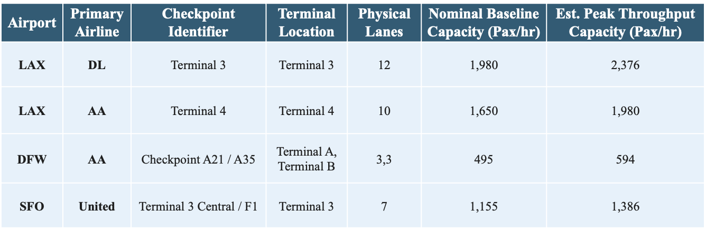
Figure 4. Sample Framework for Terminal Capacity and Checkpoint Configuration
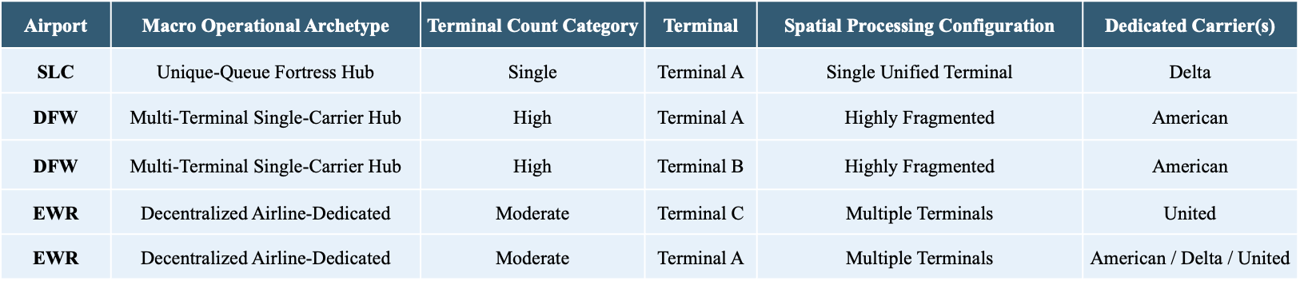
Figure 5. Airport Operational Archetypes and Terminal Configuration
Macro Categorization: Terminal-to-Airline Distribution. Airports are first classified into four structural archetypes to control for how airline market share impacts terminal distribution, with structural archetypes outlined below:
- Mega Hubs with No Dedicated Terminals (e.g., ATL, CLT, DEN): Sprawling operations where major legacy carriers share linear concourses or central ticketing, distributing passenger volume across shared screening areas.
- Decentralized Airline-Dedicated Terminals (e.g., LAX): Dispersed multi-terminal airports where distinct physical buildings are allocated exclusively to individual legacy carriers, isolating an airline's passenger wave to specific physical checkpoints.
- Single-Carrier Dedicated Mega-Terminals (e.g., DTW): Single-carrier "fortress" environments where a single dominant airline channels its entire domestic and international operation through one massive mega-terminal (e.g., Delta’s exclusive hold on the McNamara Terminal).
- Airports with Multiple Terminals Dedicated Exclusively to One Airline (e.g., DFW): Large-scale regional hubs requiring a single dominant carrier to distribute hub-and-spoke operations across multiple independent terminal buildings (e.g., American Airlines utilizing Terminals A, B, C, and E) to scale its operations.
Micro-Level Refinement: Checkpoint Co-Location and Isolation.
Shared Checkpoints with Limited Carrier-Level Separation (Centralized).
Isolated Three Checkpoints (Decentralized).
DCA (Terminal 1): Consisting of Gates A1–A9, this terminal exclusively serves Air Canada, Frontier, and Southwest. American, Delta, and United are completely segregated into Terminal 2, creating a strong comparison setting for low-cost and regional carrier processing behaviors.
SEA (Decentralized Main Terminal): Utilizing five separate security checkpoints across a footprint dominated by Alaska Airlines (52% market share). Checkpoints feeding Alaska-heavy gates or dedicated satellite concourses offer a high statistical probability of isolating non-Big Three passenger flows.
CLT (Extreme Dominance Isolation): Where American Airlines controls 90% of the market share. Because Delta (2.5%) and United (2%) maintain a negligible footprint across the airport's 5 checkpoints, nearly any selected lane acts as a functional monoculture for a single legacy carrier's hub behavior.
Sources of the Data
Secondary operational data will be compiled from three primary repositories covering the 2019 to 2025 period. TSA checkpoint throughput data is obtained from TSA FOIA resources, on-time flight performance data, origin and departures, and load factors are drawn from the Bureau of Transportation Statistics, and origin-and-destination ratios are used to support passenger flow estimation from selected monthly airport reports, such as LAX Statistics (TSA, 2026; BTS, 2026; LAWA, 2026).
Treatment of the Data
ETL (outline)

