Arduino Job2
En fonction des informations suivantes, calculer les valeurs nécessaires à la résistance pour obtenir un courant de 10 milliampères à travers la LED.
- La tension de seuil de la LED est de 2 volts
- La tension d’alimentation de l’Arduino est de 5 volts
- Le courant maximal que peut supporter la LED est de 20 milliampères
- Le port de sortie de l’Arduino peut fournir une tension de 5 volts et un courant max de 40 milliampères

Based on the following information, calculate the resistor values required to obtain a current of 10 milliamps through the LED.
- The LED's threshold voltage is 2 volts
- The Arduino's supply voltage is 5 volts
- The maximum current the LED can withstand is 20 milliamps
- The Arduino's output port can supply a voltage of 5 volts and a max current of 40 milliamps

R = V / I
R = (5V -2V) / 0.02A

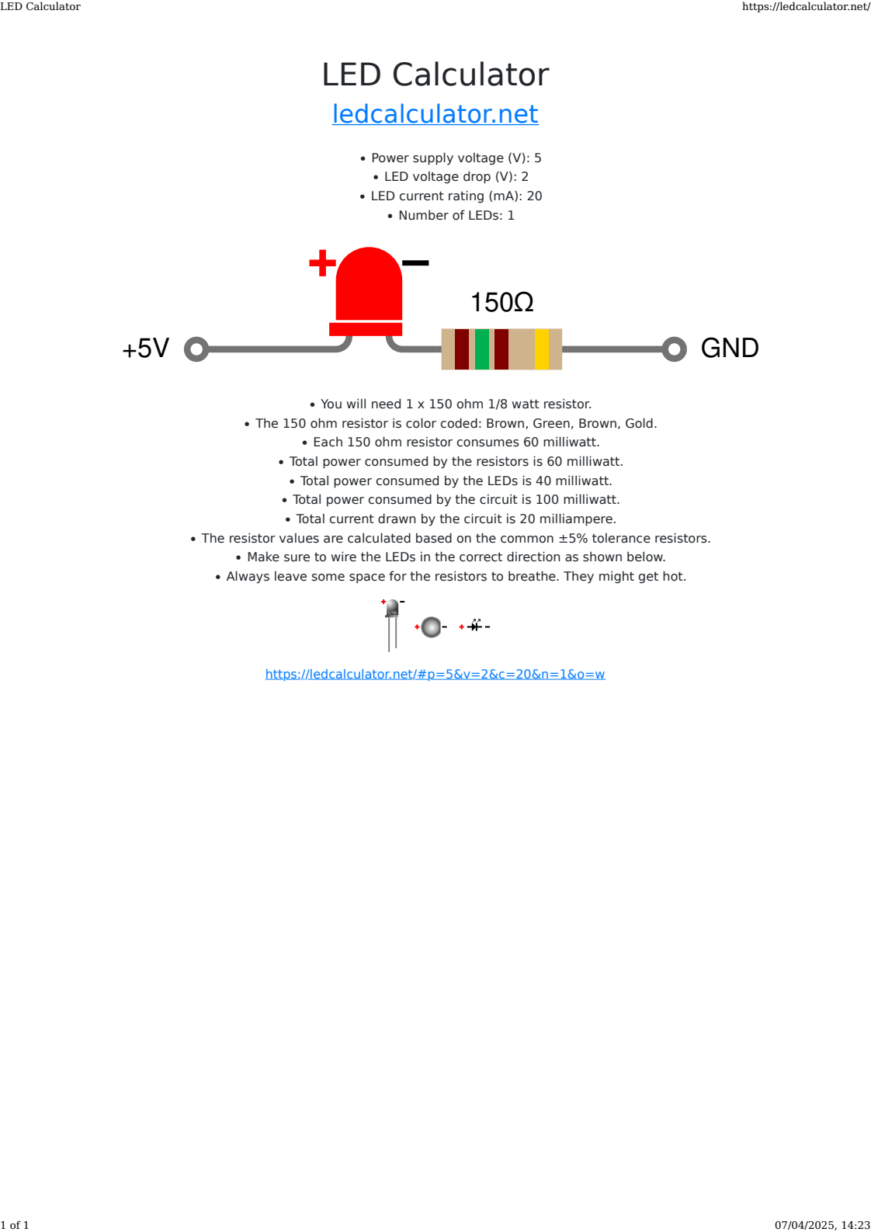

“The resistor is essential for safe operation as it limits the current flowing through the LED, preventing damage to both the LED and the Arduino's output pin. You can choose the resistor value based on the desired current using Ohm's Law (V = IR) where V is the voltage of your board (5V or 3.3V) minus the forward voltage for the LED you are using (typical for red would be 1.8 to 2.2 volts). In this case, using a 220-ohm resistor with an Arduino UNO R3 (a 5V board) limits the current to a safe level for both the LED and the Arduino pin. Adjusting the resistor value allows you to control the LED's brightness while ensuring safe operation. For 5V boards you can expect the LED to be visible to a resistor value of up to 1K Ohm.”
https://docs.arduino.cc/built-in-examples/basics/Blink/
