Kickstarter Analysis

Outcome analysis of Theatrical Plays.

Leila Morvari

Khaled Karman

January 9, 2022

Data Analytics Boot Camp, UC Berkeley

# The primary goal for analysis.

The main goal of analysis for this project is to compare and analyze theater production campaigns based on specified information of these campaigns. This data will predict the outcome of new campaigns that match the specified information. The data includes launch dates of the production, the set goal of the production, the genre of the production, the production's success rate after being launched. All this compiled data will promote a more in-depth analysis of the trajectory of a future campaign. This can provide guidelines or recommend specific strategies for a successful campaign. Such as releasing the production within a specific month or maintaining a specified goal amount.

Challenges.

The analysis was performed through visual charts that manifested with a specific date compiled together. This included creating pivot tables to compare launch dates with a success rate.

## Results and Methods

Analysis of outcomes based on the launch date

Based on the data presented, the months of May through July have a high success rate, which may correlate to activity during this season.

The additional conclusion is that the ratio between successful regardless of the month is still positive even though the graphic one has negative trends at some points. This means that the total number of Theater campaigns in any given month did not have more failed campaigns than successful campaigns. 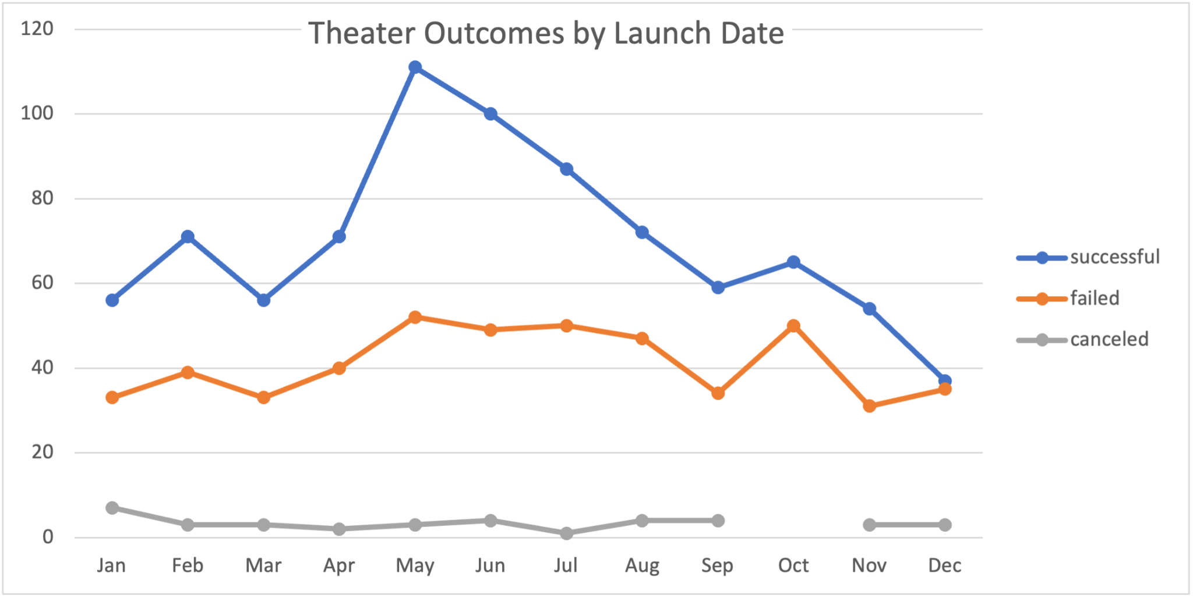

Analysis of outcomes based on goals

## Based on the data presented, campaigns with a goal between 1,000 to 4,999 dollars had the highest success rate. There is a dramatic drop in the success rate of a campaign once the Goal increases, and this suggests that campaigns with a goal of less than 5,000 will have a success rate between 75%-72%.

## Limitations of the dataset.

This dataset, through expansive, has some limitations. These limitations include outliers, data formats that are difficult to interpret, and biased based filters.

Outliers present in a dataset cause comparative analysis to be skewed, and this can distort visuals that aid readers in processing the data being represented.

Any category in the dataset that describes a real moment in time is displayed awkwardly. Timestamps are not easily displayable in the data set and require steps outside of Excel's capabilities to interoperate the time in a digestible way.

Finally, categories such as “staff picked” provide more qualitative data that may not be useful in this specified analysis. This data is based on personal preference, and this category does not clearly explain which staff it is referencing and highlights biased opinions. The Analysis style for this specific project is geared towards more quantitative data.

### Future analysis

Further analysis can occur with this data set by creating a table that displays Outcomes based on pledged amount. By placing the pledged amount in ranges and listing the plays' possible outcomes, we can display a similar line chart as graphic 2.