In partial fulfillment of the requirements for the

ITE121 – Intermediate Programming

**“Show Calendar”**

Presented to:

Dr. Unife O. Cagas

Professor

Prepared by:

Leila Habagat

BSCS – 1B2

**Description**

This project is a Show calendar system designed for personal use . It retrieves the year and month entered by the user, and generates the calendar data. Leveraging Tkinter modern and customizable, the interface offers enhanced interaction for users. Personalized for both students and working adults, this show calendar not only displays the current year and month but also allows users input the month and year to scheduling appointments, events or deadlines.

* **Benefits**
* User-Friendly Interface: A calendar GUI offers an intuitive and familiar way for users to interact with dates and schedules, making it user-friendly for tasks such as scheduling appointments, events, or deadlines.
* Visualization of Time: Seeing dates laid out in a calendar format provides users with a clear visual representation of time, helping them plan and organize their activities effectively.
* Convenient Date Selection: Users can easily select dates by clicking on them in the calendar, which is more convenient and error-prone compared to manually typing dates.
* Improved Productivity: By having a calendar within the GUI application, users can quickly reference dates and plan their activities without switching to external calendar tools, thereby improving productivity.
* Customization Options: Depending on the application's requirements, developers can customize the calendar display to include specific features like highlighting important dates, displaying events or reminders, or allowing users to navigate between months and years.
* Integration with Other Features: A calendar GUI can be integrated with other features of the application, such as scheduling tasks, setting reminders, or managing appointments, providing a comprehensive solution for users' needs.
* Enhanced User Experience: Providing a calendar feature enhances the overall user experience of the application, as it adds functionality and convenience, making the application more valuable and appealing to users.
* **OBJECTIVE**
* To provide date selection, setting reminders, or any other task that involves specifying a date.
* Visual time to plan their activities and upcoming events and deadlines .
* Enhance User Experience It adds functionality, convenience, and familiarity, making the application more user-friendly and appealing to users.
* Integrate with Other Features allowing users to schedule tasks directly from the calendar interface.
* Customization and Personalization users might be able to customize the calendar display, set preferences, or define recurring events.
* **Purpose**

The purpose of the Show Calendar is making it easier for users to choose a date is one of the main goals. When a calendar is displayed, it makes it simple and accurate for users to select dates for any time-related action within the program, such as setting deadlines or organizing events. Giving consumers a visual picture of time is achieved by displaying a calendar. It facilitates their ability to envisage future events or appointments, manage their activities efficiently, and comprehend the chronological order of dates. Planning and scheduling users can easily plan and schedule their appointments, events, and projects with the help of a calendar tool. The calendar helps users effectively manage their schedules and organize their time by showing dates and enabling them to add, update, or remove events.

* + **SIGNIFICANCE**
* Time Management: A calendar helps users manage their time efficiently by providing a visual overview of dates, events, and appointments.
* Organization: It assists in organizing tasks, events, and deadlines, allowing users to prioritize and plan their activities effectively.
* User Experience: Including a calendar enhances the user experience by offering a familiar and intuitive interface for managing schedules within the application.
* Productivity: By enabling users to schedule tasks and allocate time effectively, the calendar contributes to increased productivity and efficiency.
* Integration: It can be integrated with other application features such as task management, reminders, and notifications, providing a comprehensive solution for users' needs.
* **FEATURES**
* Date Display the calendar displays dates for the selected month, typically organized in a grid format with days of the week and dates.
* Event Display events or appointments can be displayed within the calendar, providing users with an overview of their schedule.
* Search and Filter users may have the ability to search for specific events or filter the calendar display based on criteria such as event type or date range.
* **Code**

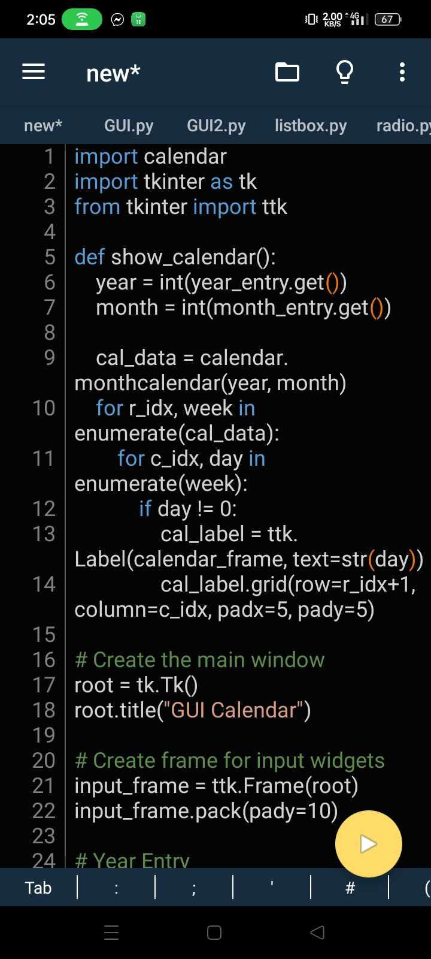

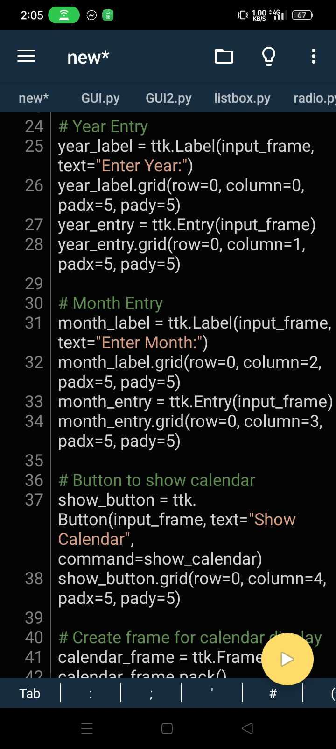

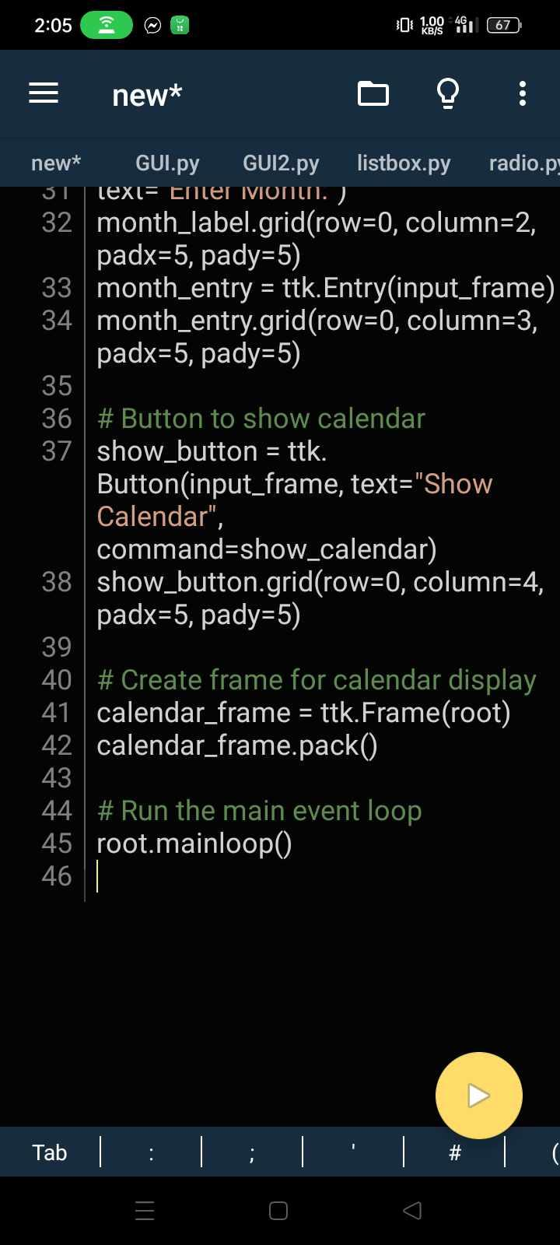

* + **OUTPUT**

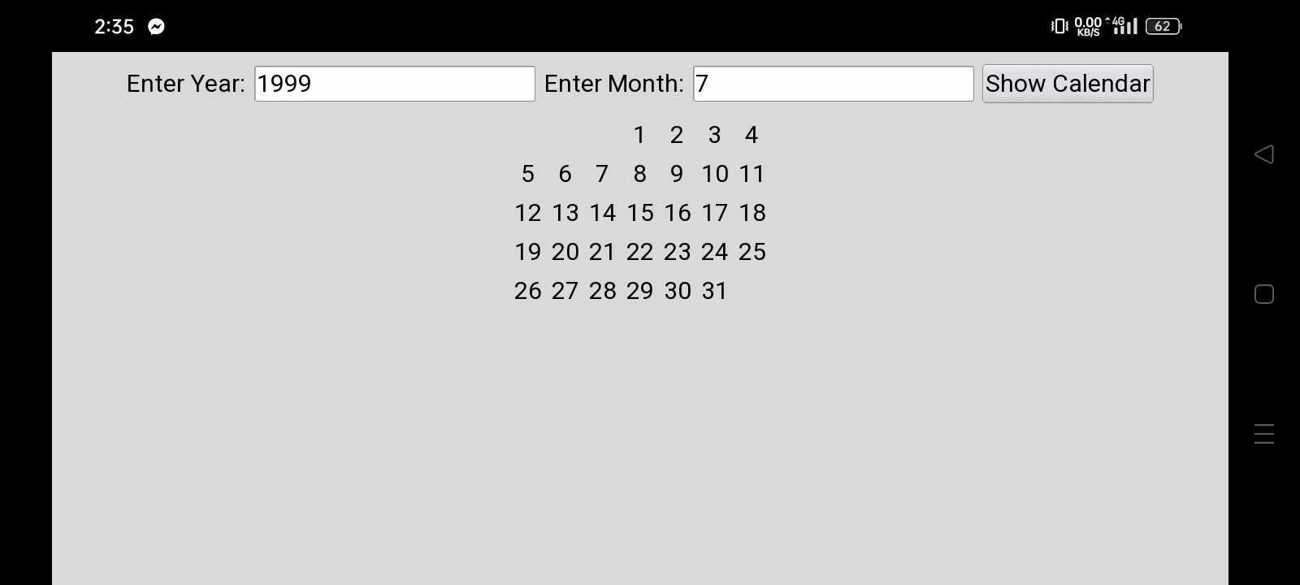



**CRRICULUM VITAE**

**PERSONAL INFORMATION**

Name: Leila Habagat

Age: 23

Conract Details: 09187049322

Email Address: lhabagat@ssct.edu.ph

Date Of Brith: August 27, 2000

Address: Bacuag Poblacion Surigao del Norte

Nationality: Filipino

Civil Status: Single

Religion: Catholic

**EDUCATIONAL BACKGROUND**

Elementary: Bitaog ElementarySchool

Bacuag SDN

Junior High School: St.Jhon’s School Bacuag Incorporated

Bacuag SDN

Senior High School: St.Jhon’s School Bacuag Incorporated

Bacuag SDN

College: Surigao del Norte State University

Narciso st. Surigao city