Details on using ggMatch to find orthologs
ggMatch relies on reciprocal best hit searches, whereby a pair of proteins (p,p’) are the best matches for each other in a bi-directional search, based on the bitscore from a query between species s and s’ (equations 1 and 2).
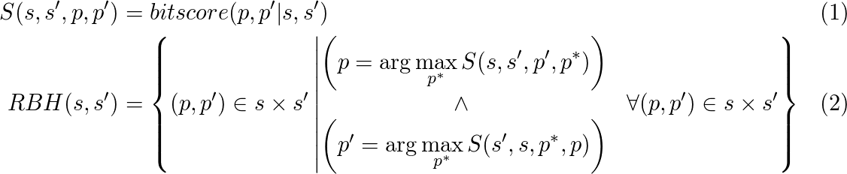,
where p and p’ are proteins originating from species s and s’, respectively.
The user specifies a number of queries. Each query corresponds to a seed set of protein sequences that are known to be orthologous. For simplicity, we will explain the procedure for the case when there is only one query seed set S₀, containing only one protein p₀, from a species s₀, i.e. 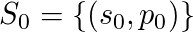. In the first iteration, we perform a reciprocal best hit search (RBH) between species s₀ and all other species of interest. For each species where we found a reciprocal best hit, we add the matching protein sequence to S₀, producing a new seed set S₁. i.e. . In each iteration n following this, for each (s,p) in S_{n-1}, we perform all reciprocal queries between s and all other species s’ for which no hit has yet been found. As in the first iteration, we select the highest scoring reciprocal best hit to the other species, and add them into the seed set S_{n} (equation 3).
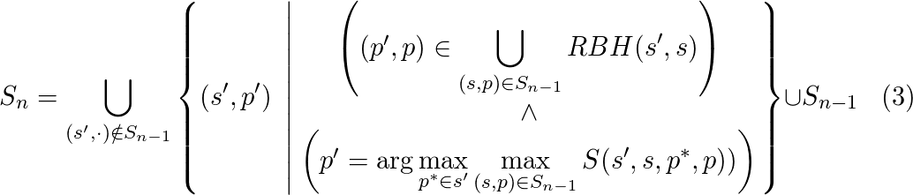
We stop iterating after a maximum number of iterations, or until S_{n} = S_{n-1}.

