- Formulation:
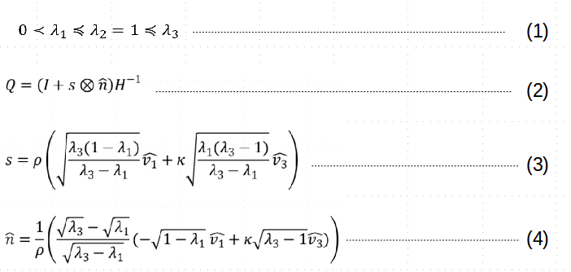

- Identify all possible twin configurations

- Identify an admissible range of µ_{ij} .
- Compute the twinned lattice vectors g_{i} .
- Compute deformation gradient F and right Cauchy-Green tensor C .
- for all µ_{ij} forming C satisfying Equation (1) do
- Compute the twinning shear s using Equation (2).
- Compute the twinning normal n O using Equation (3).
- Compute the associated rotation matrix Q using Equation (4).
- Store: s; n; g_{i}

