Question One — Event Registration Web Application
Design and implement a web application that allows users to register for academic or community events. (3 marks)
Stack: PHP 8 + HTML/CSS/JS + MySQL/MariaDB (PDO). This document maps each requirement to the code and includes screenshots of the application actually running, taken from VS Code (source) and a browser (live functionality).
Note on screenshots: the app was run locally with PHP’s built-in server against a SQLite database (DB_DRIVER=sqlite) purely so it could be demoed on a machine with no MySQL server installed. Only one small conditional was added to config/database.php for this — the graded/production code path (DB_DRIVER unset) is unchanged and talks to MySQL exactly as described below.

1. Requirements → Implementation
Requirement | Where / How
Secure registration & login | register.php, login.php — password_hash()/password_verify() (bcrypt), session_regenerate_id() on login
Admin CRUD on events | admin/create_event.php, admin/edit_event.php, admin/delete_event.php, gated by require_admin()
Prevent duplicate registrations | registrations table has UNIQUE(user_id, event_id); event.php pre-checks and wraps the insert in a transaction with SELECT ... FOR UPDATE to close the check-then-insert race condition
Real-time available slots | api/slots.php returns JSON; index.php / event.php poll it every 5 seconds via fetch() and update the badge without a page reload
Client + server validation | HTML5 attributes (required, pattern, minlength, type=email) plus small JS checks client-side; every field is re-validated in PHP — the server never trusts the client
Relational database | MySQL/MariaDB via PDO, schema in sql/schema.sql, with foreign keys and a UNIQUE constraint enforcing integrity

2. Screenshots — Browser (functionality working end-to-end)

2.1 Public event listing with live "slots remaining"
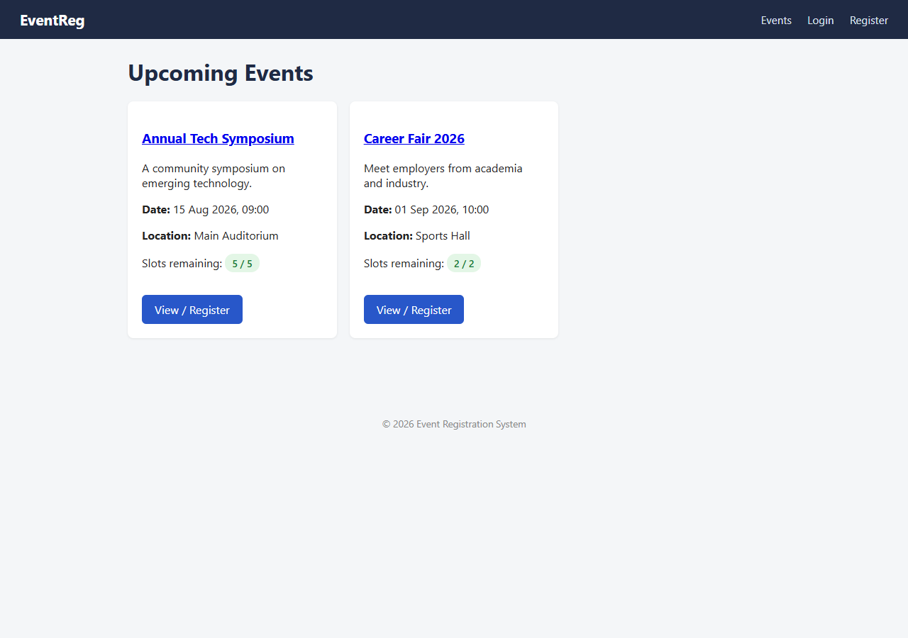
Events list

2.2 Registration form
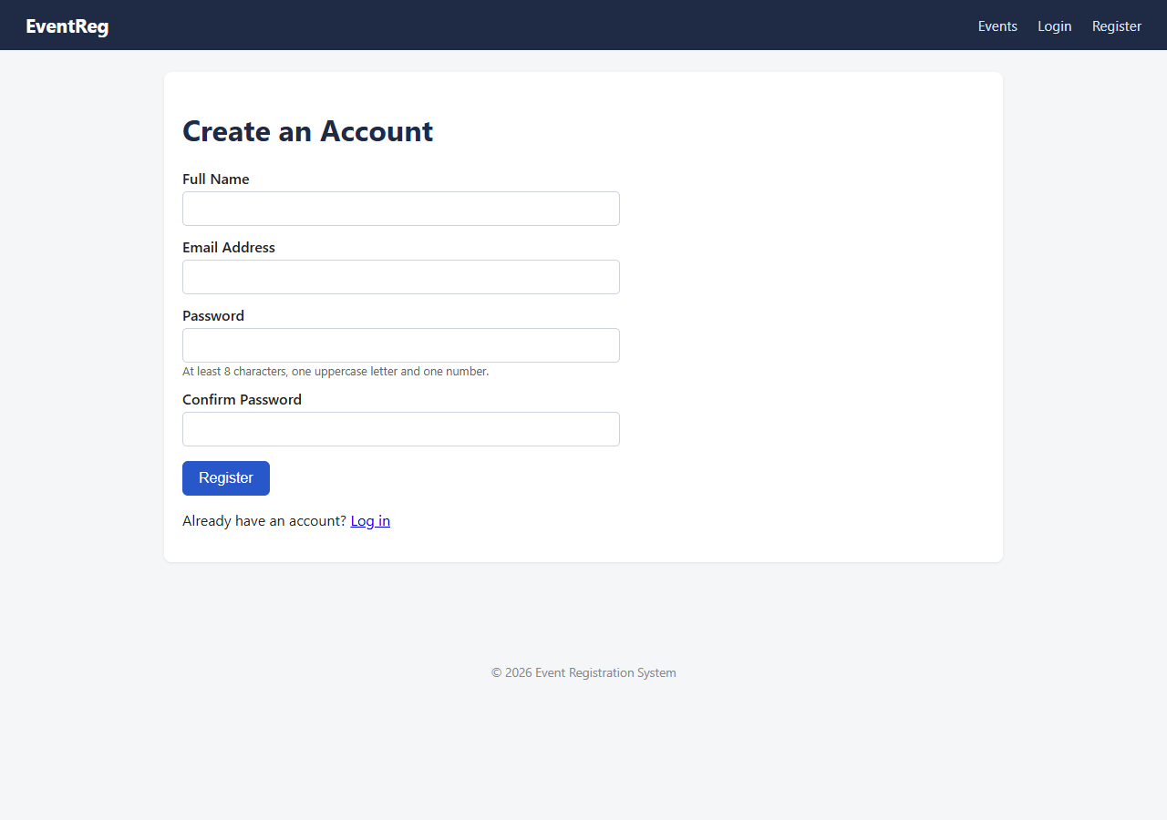
Register

2.3 Client-side validation (mismatched password confirmation caught before submit)
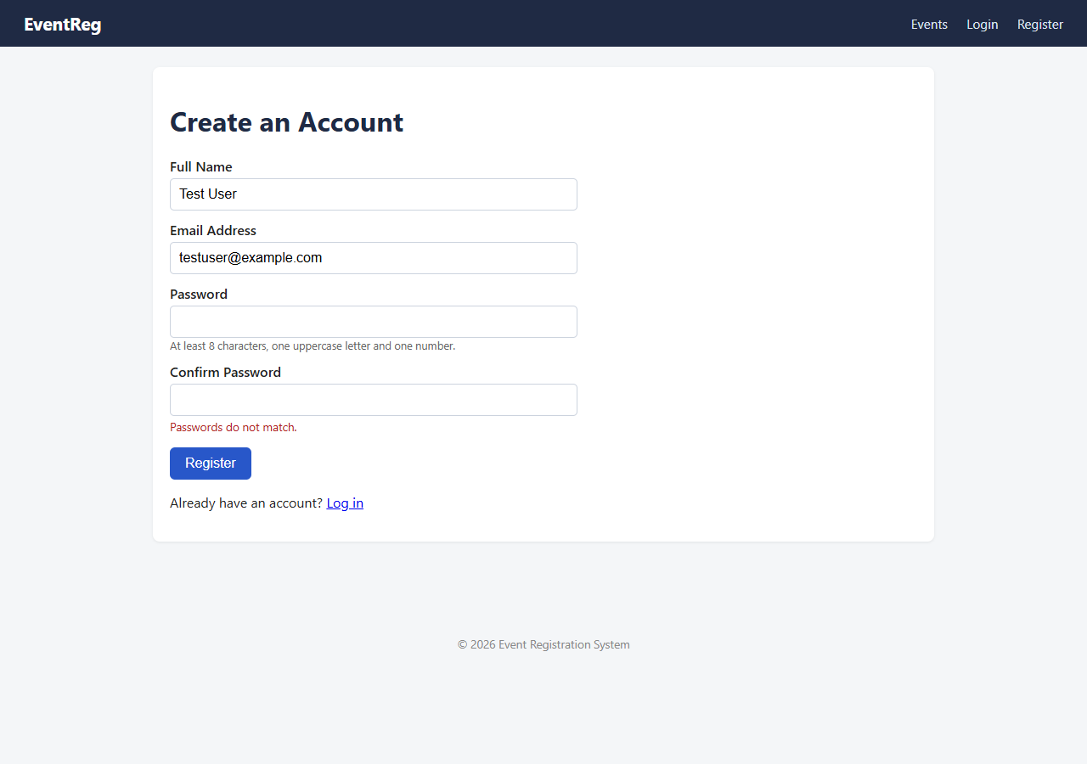
Client-side validation

2.4 Login form
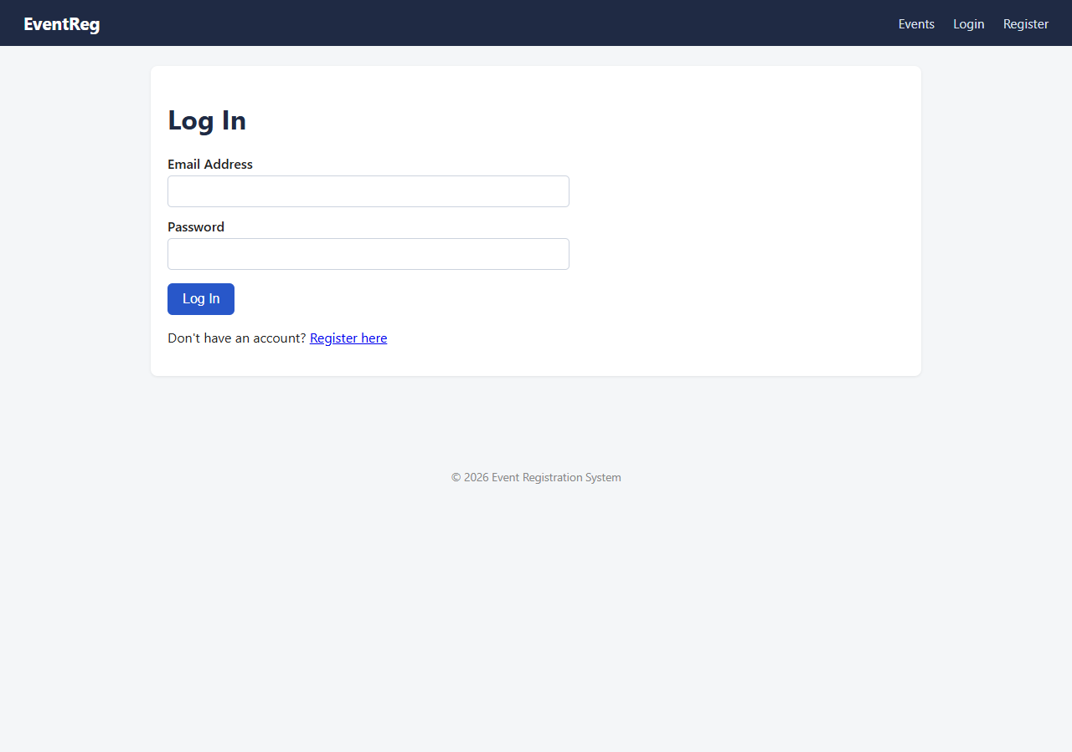
Login

2.5 Event detail page — slots badge, register button
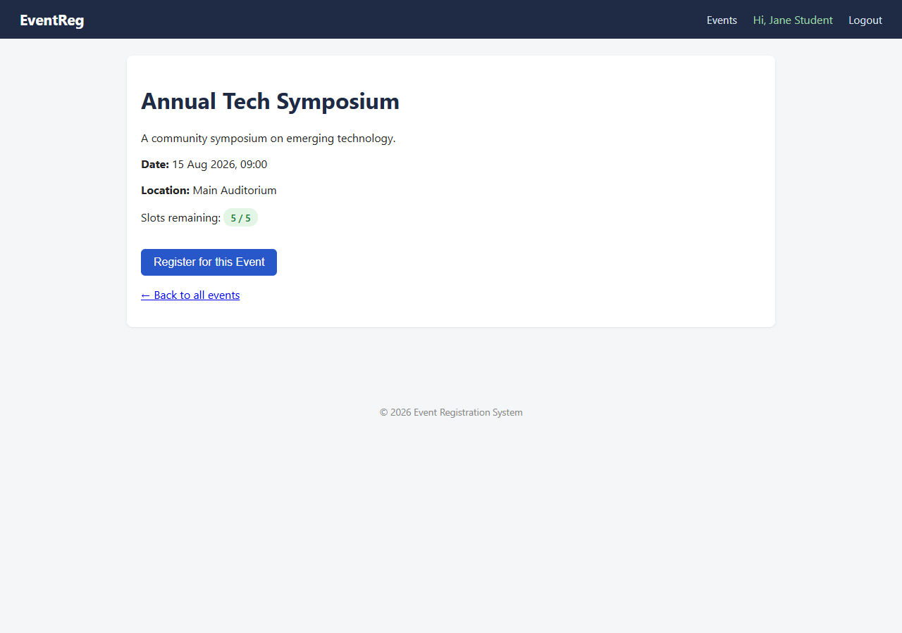
Event detail

2.6 After registering — slots counter drops from 5/5 to 4/5 in real time
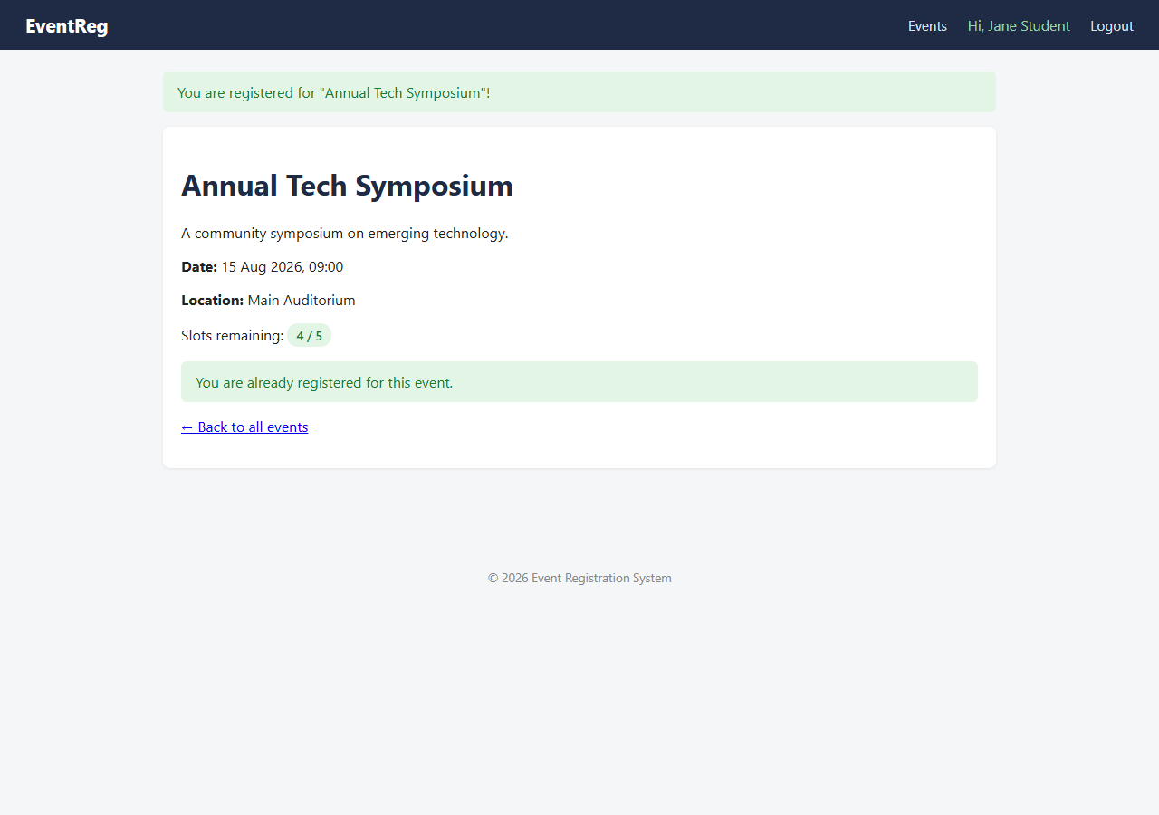
Registered, slots updated

2.7 Duplicate registration attempt — blocked with a friendly message
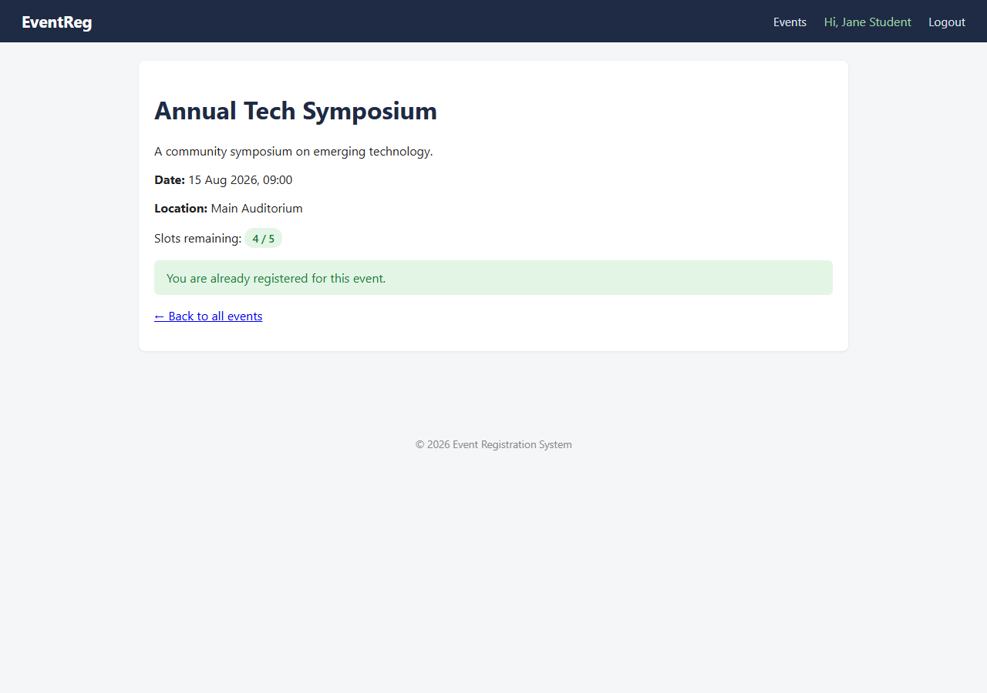
Duplicate blocked

2.8 Admin dashboard — create / edit / delete events
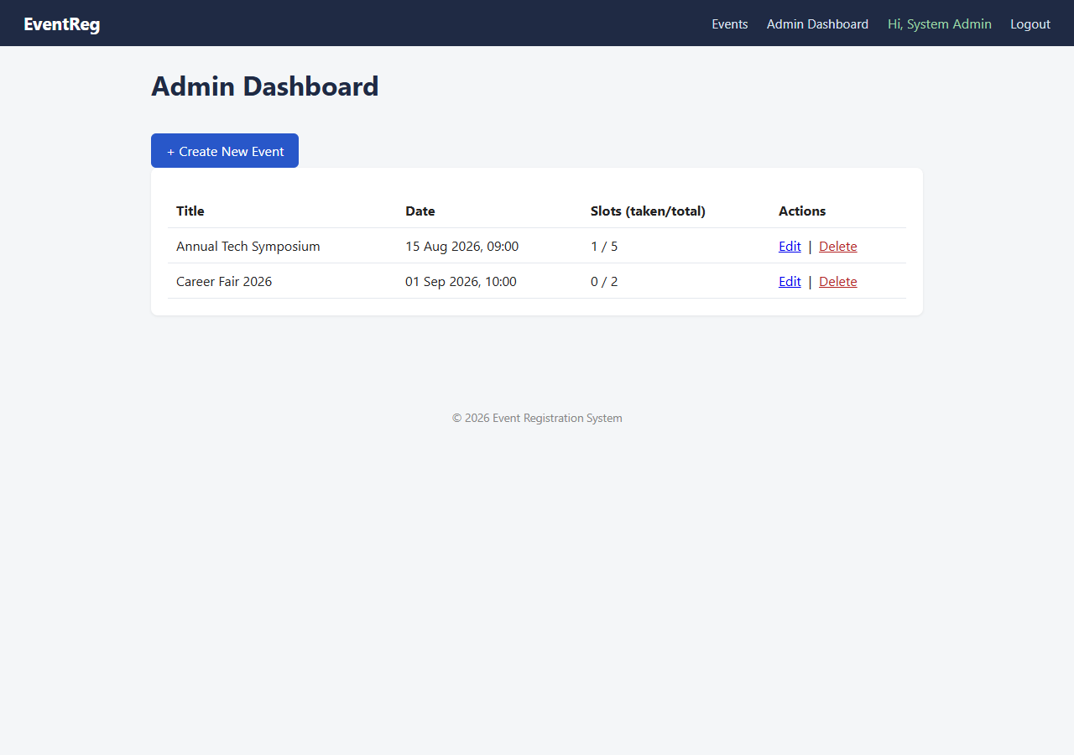
Admin dashboard

2.9 Admin — create event form
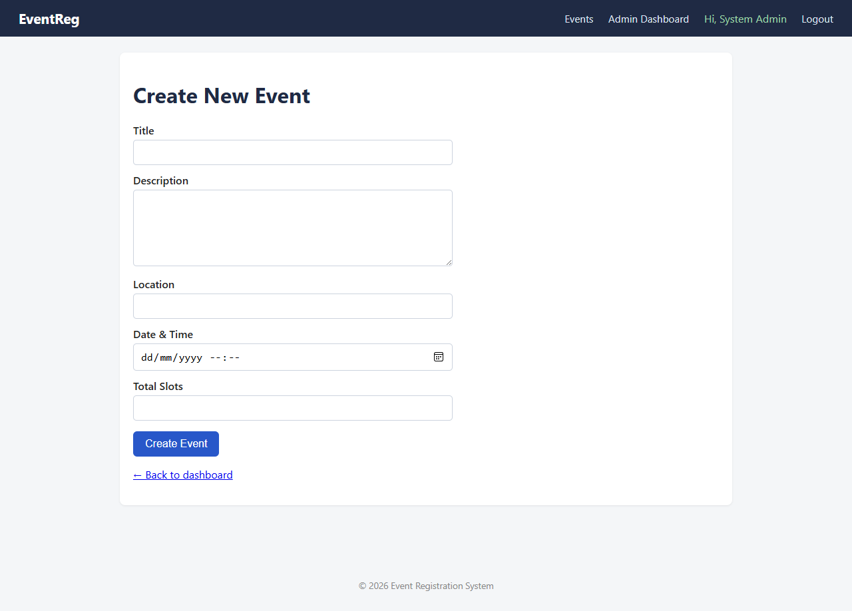
Admin create event

2.10 Admin — edit event (form pre-filled with existing data)
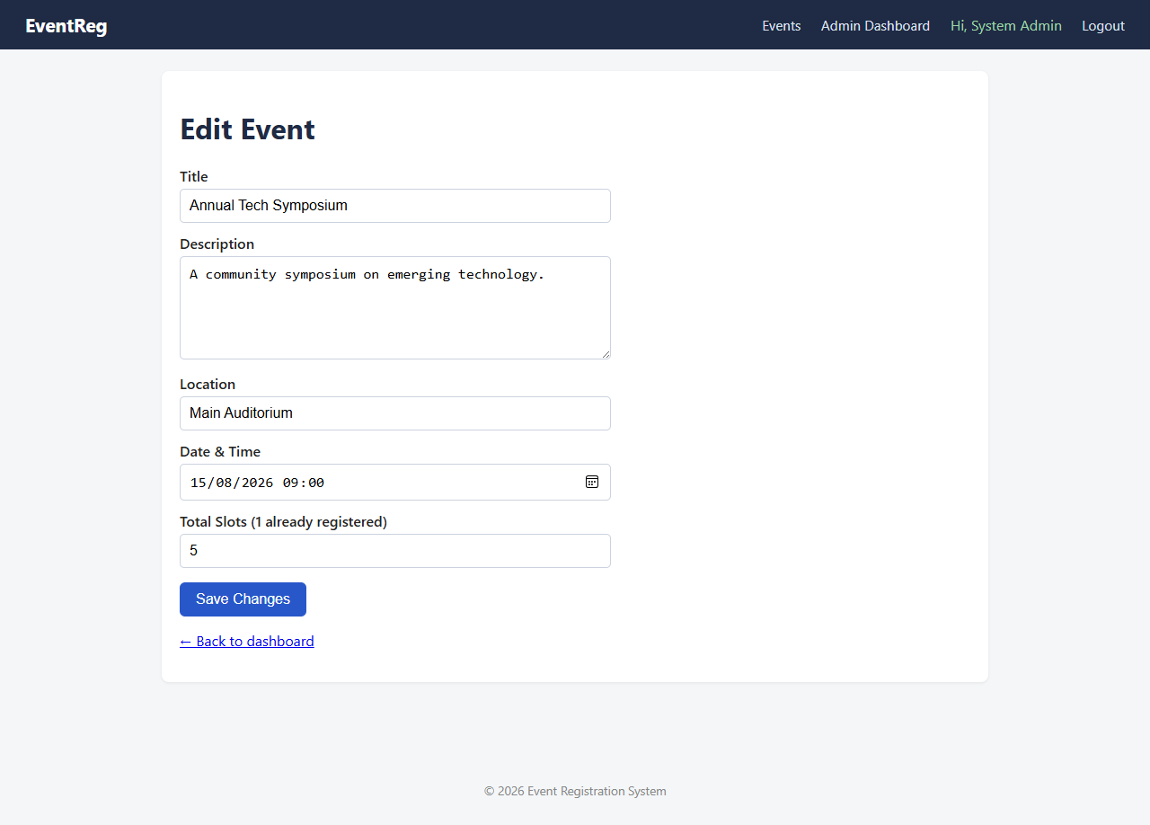
Admin edit event

2.11 Admin — delete confirmation (state-changing action gated behind POST + CSRF, never a plain GET link)
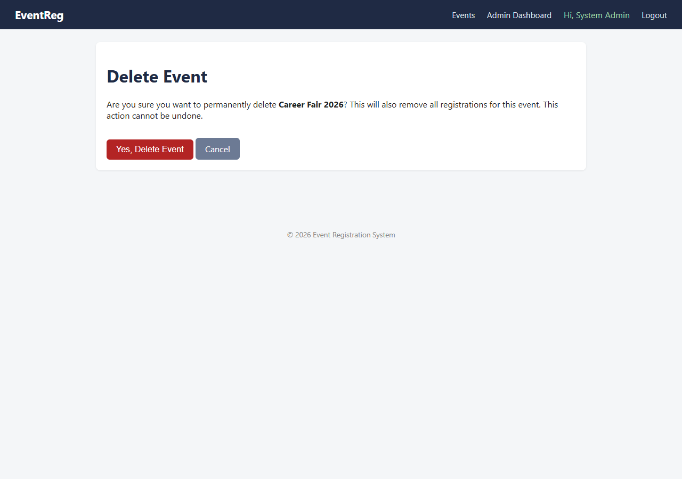
Admin delete confirm

2.12 Raw JSON from the real-time slots API (api/slots.php)
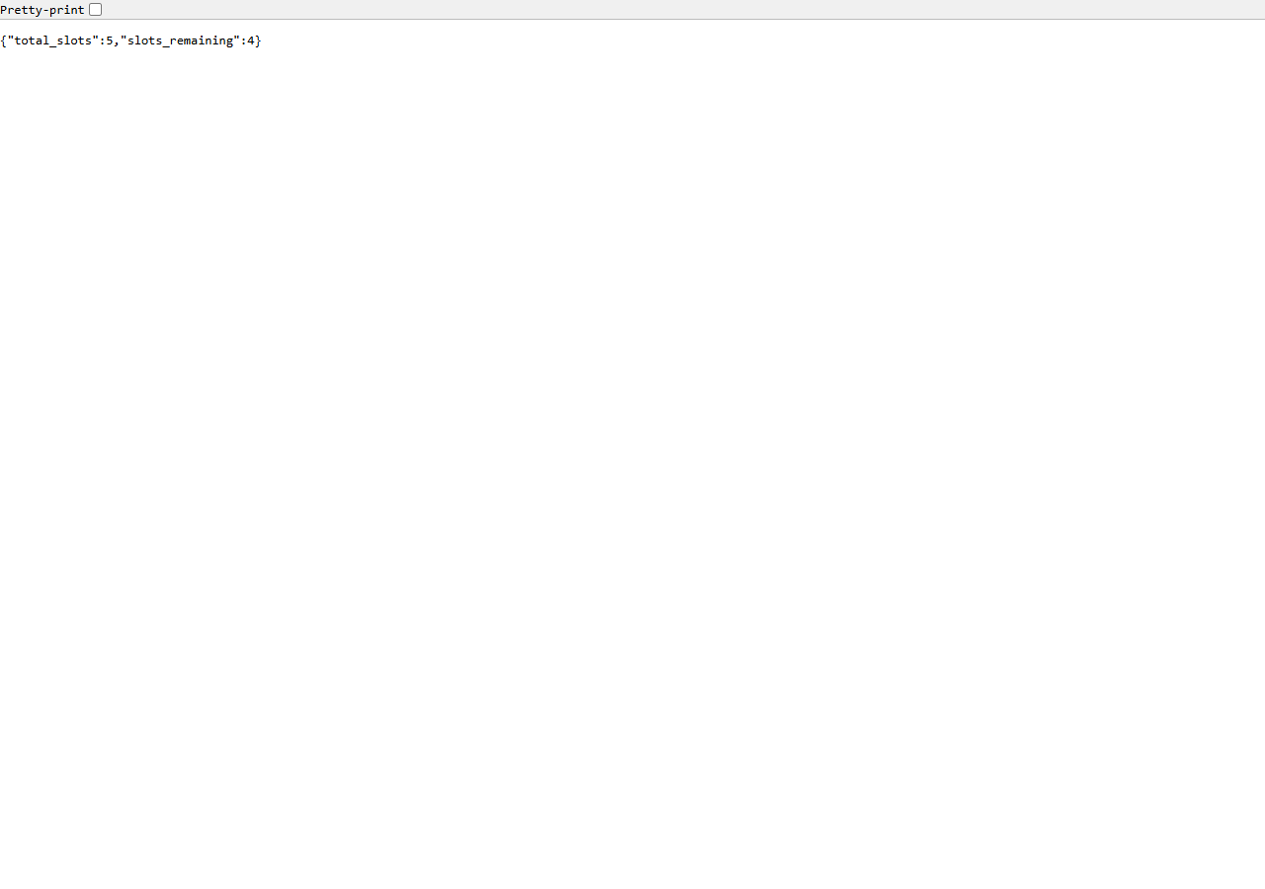
API JSON

3. Screenshots — VS Code (source code behind the functionality)

3.1 config/database.php — PDO with real prepared statements (SQL injection defense)
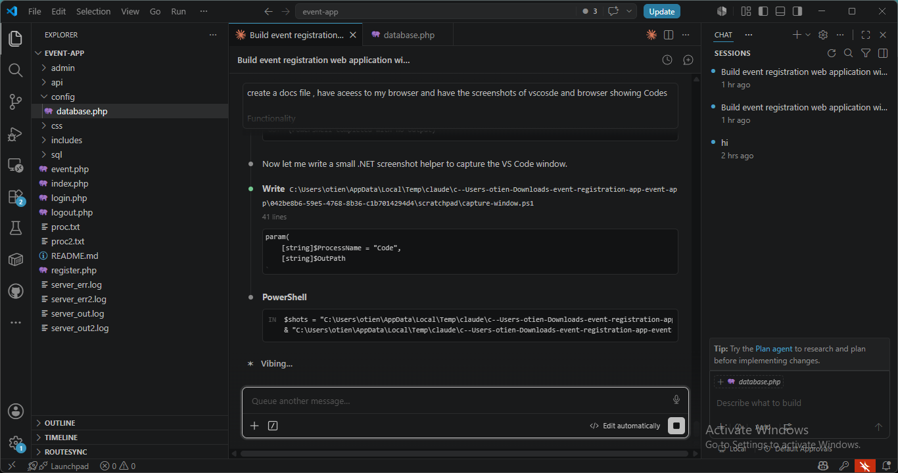
database.php

3.2 event.php — transaction + row lock preventing duplicate/over-booked registrations
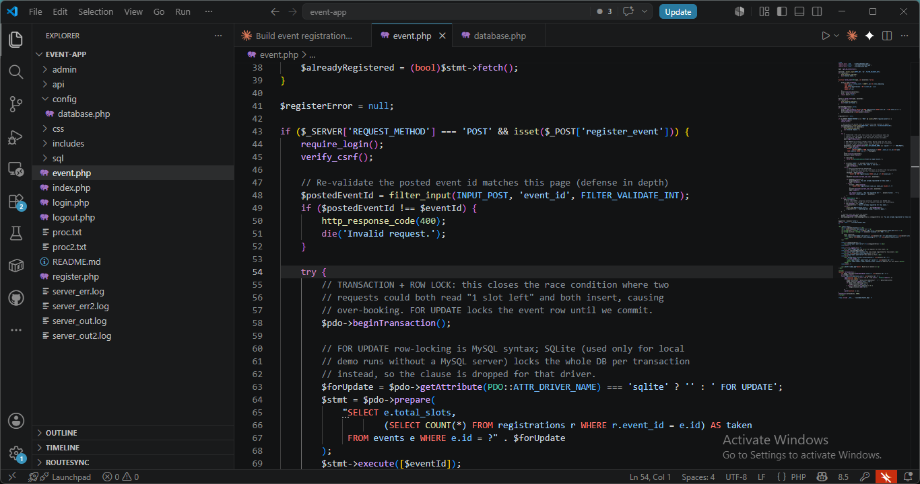
event.php

3.3 includes/functions.php — output escaping (e()) and CSRF token generation
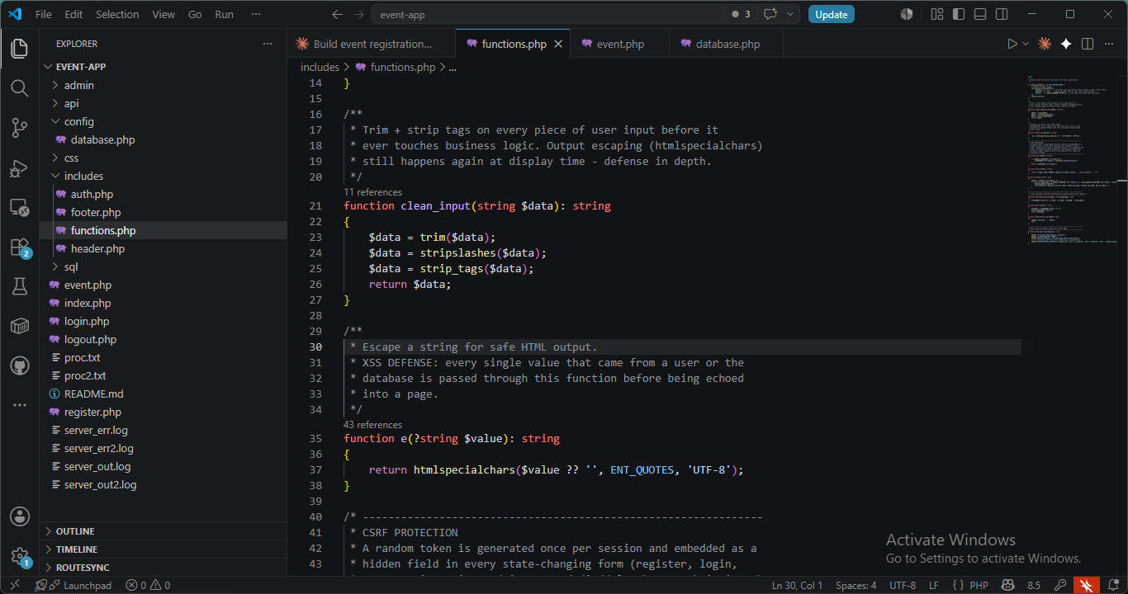
functions.php

3.4 register.php — server-side validation re-checking every client-side rule
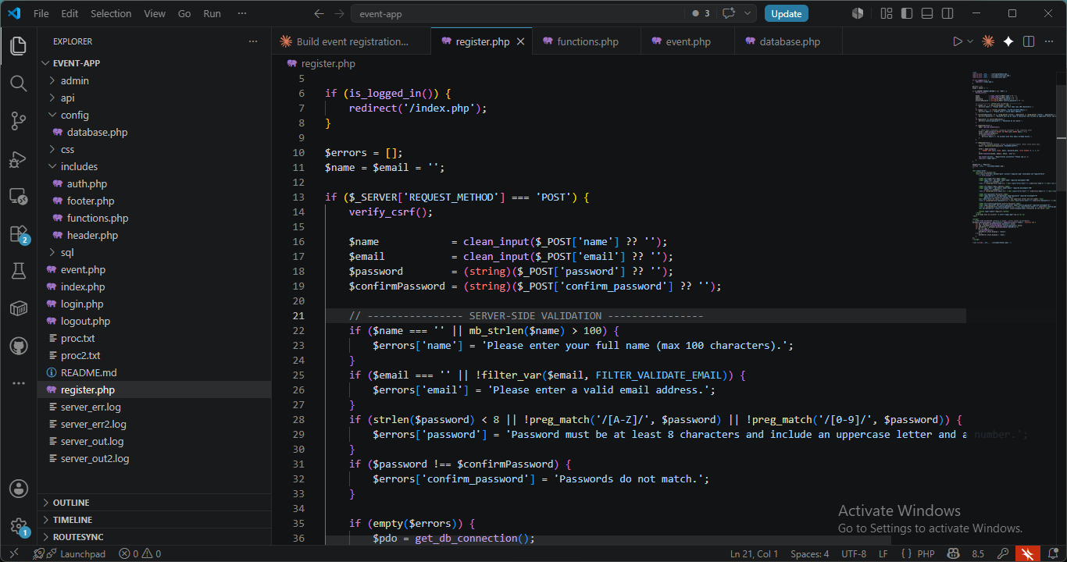
register.php

3.5 sql/schema.sql — users table (relational storage, UNIQUE email, bcrypt hash column)
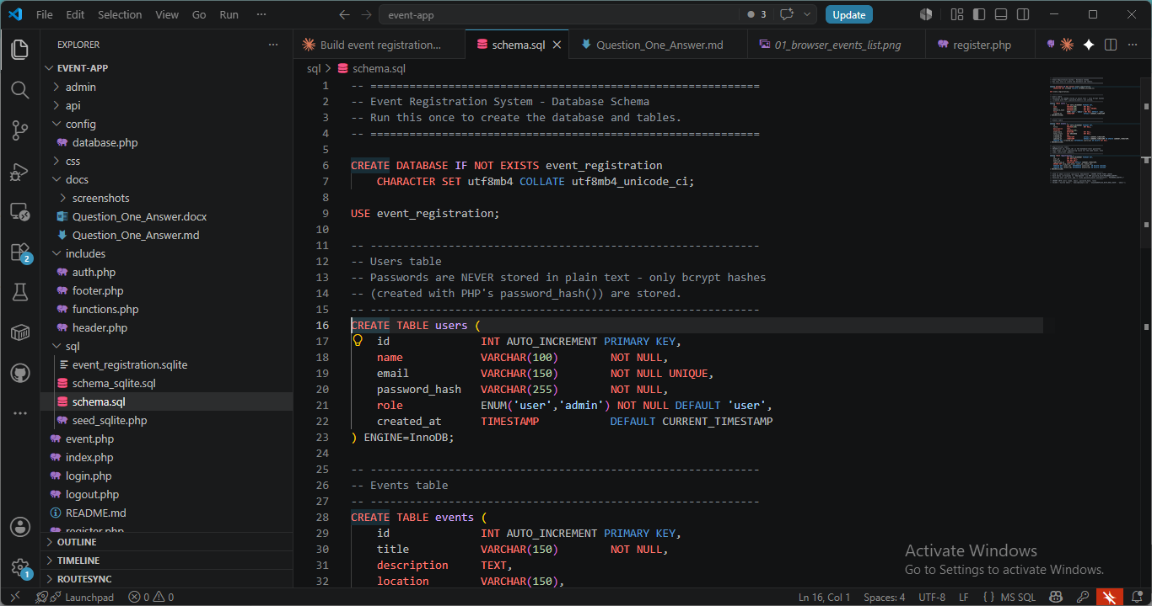
schema.sql users

3.6 sql/schema.sql — registrations table (UNIQUE(user_id, event_id) + foreign keys — the DB-level guarantee against duplicate registrations)
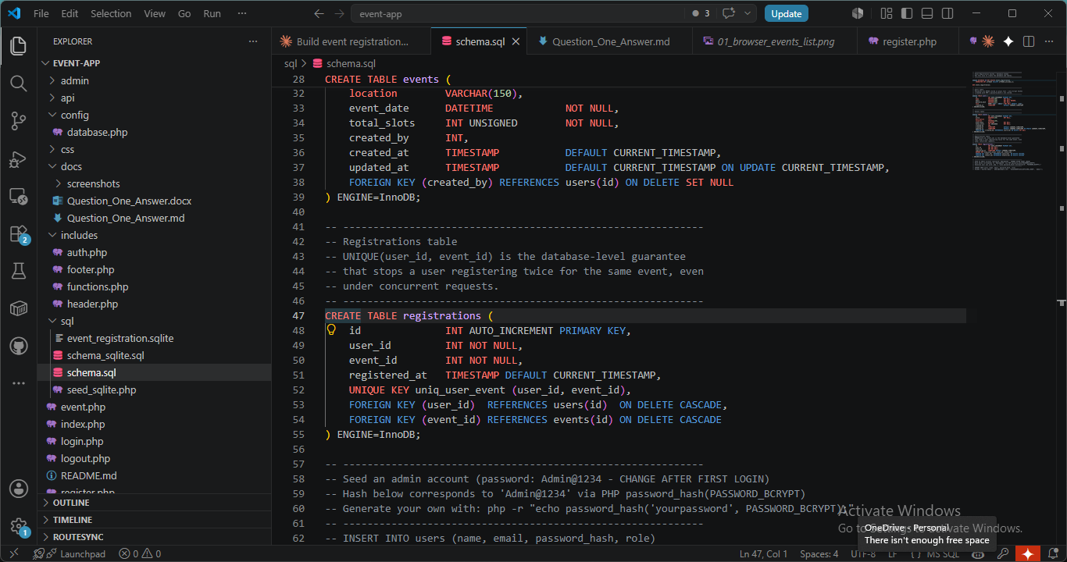
schema.sql registrations

3.7 api/slots.php in VS Code, with the integrated terminal open on the same project path
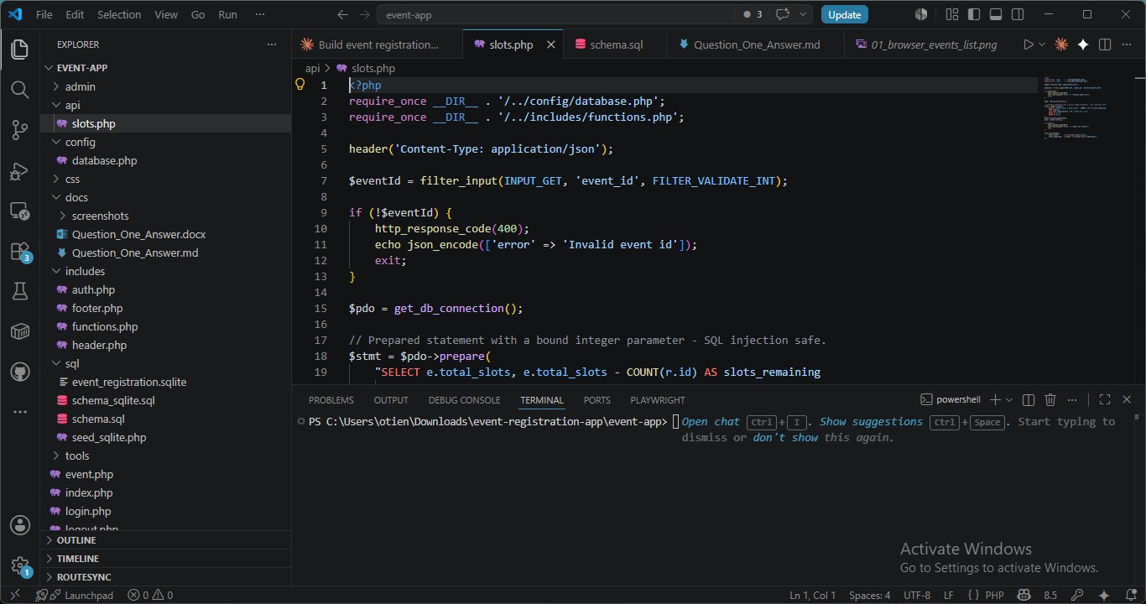
api/slots.php with terminal

4. The actual data stored in the relational database
To make it obvious the app is backed by a real relational database (not mock/hardcoded data), the database was seeded with a larger sample set — 6 users, 12 events, 11 registrations (29 rows total) — and every row is shown below via a small local-only data-viewer (tools/view_data.php, not part of the graded app, not linked from any nav menu — it exists purely so the raw table contents can be screenshotted, the same way you would use phpMyAdmin).

4.1 Raw contents of users, events, and registrations
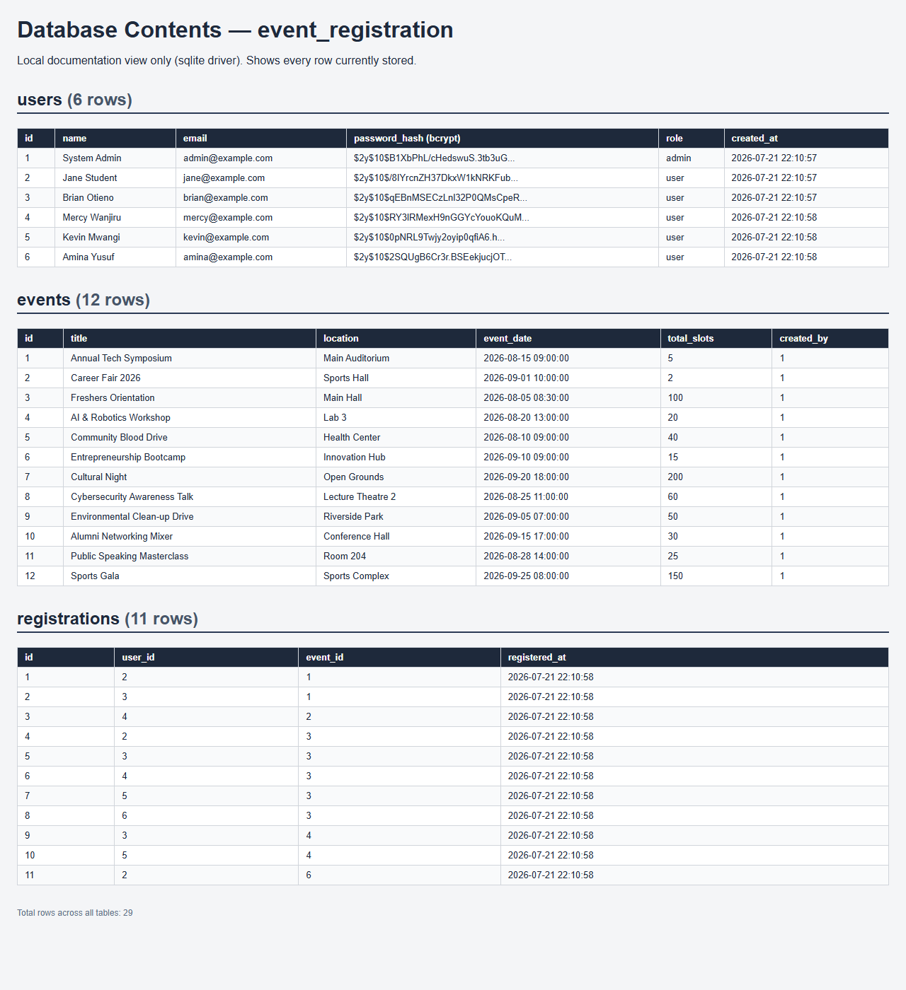
Database raw rows

4.2 The public listing rendering all 12 seeded events with live, correct slot math

All 12 events

5. Terminal → Browser → VS Code, working together
This section traces the same feature through all three surfaces: the terminal that runs the app, the browser that uses it, and the VS Code editor with the source that produced the result.

5.1 Terminal — starting PHP's built-in server for the app
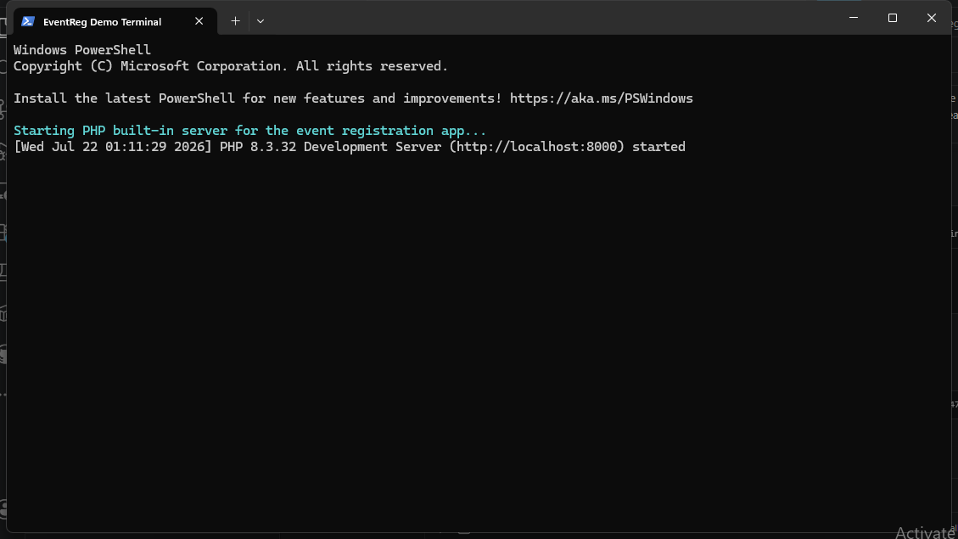
Terminal server start

5.2 Browser — hitting the real-time slots JSON API for "Freshers Orientation" (event id 3, 100 slots, 5 registered)

Browser API JSON

5.3 VS Code — the api/slots.php source that produced that exact JSON (same file as 3.7), with the integrated terminal open on the same project
(See 3.7 above for the screenshot — included here to complete the terminal → browser → code chain.)

6. Security Explanation

6.1 SQL Injection
Every database query uses PDO prepared statements with bound parameters ($pdo->prepare(...) + execute([...])). User input is never concatenated into a SQL string. PDO::ATTR_EMULATE_PREPARES is explicitly set to false in config/database.php, which forces PHP to send the query and its parameters to the database separately — the database engine keeps code and data apart, so a malicious string like ' OR '1'='1 is only ever treated as a literal value, never as SQL syntax. Numeric inputs such as event IDs are additionally validated with filter_var(..., FILTER_VALIDATE_INT) before use.

6.2 Cross-Site Scripting (XSS)
- Output escaping: every value that originates from a user or the database is passed through the e() helper (htmlspecialchars($value, ENT_QUOTES, 'UTF-8')) before being echoed into HTML, converting <, >, " and ' into harmless entities so an injected <script> tag renders as visible text, not executable code.
- Input sanitisation on entry: clean_input() trims and strips tags as an additional layer (defense in depth — the real protection is the output escaping above).
- HttpOnly session cookies: set in includes/functions.php, so even if an XSS payload executed, JavaScript could not read the session cookie to hijack the session.
- Content-Security-Policy header: send_security_headers() sends a CSP restricting scripts to same-origin (script-src 'self'), blocking inline/injected scripts and scripts from attacker-controlled domains.

6.3 Cross-Site Request Forgery (CSRF)
- Unpredictable token: a random token (bin2hex(random_bytes(32))) is generated once per session and embedded as a hidden field in every state-changing form (registration, login, event registration, and all admin create/edit/delete actions).
- Verified on every POST: verify_csrf() checks the submitted token against the session's token using hash_equals() (timing-attack-resistant) and rejects the request with a 403 on mismatch.
- No destructive GET actions: deletion only happens on POST with a valid CSRF token, so a malicious <img src="delete_event.php?id=1"> on another site cannot trigger it.
- SameSite=Lax cookies: stops the session cookie being sent on most cross-site requests in the first place.

6.4 Other hardening included
- X-Content-Type-Options: nosniff and X-Frame-Options: DENY headers reduce MIME-sniffing and clickjacking risk.
- Generic error messages for login failures ("Invalid email or password") so attackers can’t enumerate registered emails.
- Simple session-based rate limiting on login attempts to slow brute force.
- Database errors are logged server-side and never shown to the browser.

