1. Request from client is sent to server.. This request contains of name of the image. After receives that request by server, the image will be passed to the model which is classifies the image into one of these three classes: Rock, Paper, Scissors, information regards the image of the class along, current date of the system, user’s full name will be sent to client and then client prints these written values.

b) Testing the Web Server and Clients: issued successful massage

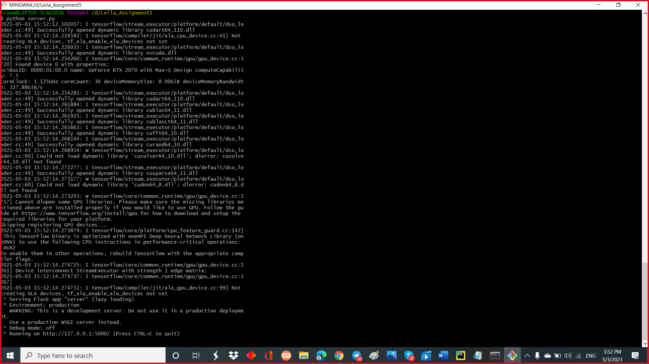

proper output in client side (response back to the server) 