CIS 1202 Programming Assignment #6

Structured Data 1
A sports team plays games at home and away. Write a program to keep track of a team's win/loss record at home, away, and their total. Use nested structures as you develop this program.

Requirements
- Data structures:
  - Define a WinLoss structure with wins and losses members (int).
  - Define a Team structure with the team name, containing a WinLoss structure variable for total wins/losses, a WinLoss structure variable for home wins/losses, and a WinLoss structure variable for away wins/losses.
  - Declare an array of type Team.
- Build a menu-driven program with these options:
  - Enter a new team
  - Display all teams
  - Display a particular team
  - Exit the program
- Define these functions according to these prototypes:
  - int menu();
Shows the menu
Gets the user selection
Validates the menu selection
Returns a valid menu selection
  - WinLoss getWinLoss(string);
Gets wins and losses from the keyboard for the location indicated by the string parameter ("home" or "away") and returns a WinLoss structure containing the input.
  - void displayWinLoss(WinLoss);
Displays a string containing the win and loss members in the format of "wins-losses".
  - Team getTeam();
Inputs the team name
Inputs home wins and losses using getWinLoss()
Inputs away wins and losses using getWinLoss()
Stores the home wins/losses in the appropriate team structure
Stores the away wins/losses in the appropriate team structure
Calculates the total wins/losses and stores those in the appropriate structure
Returns all of this in a single Team structure
  - void displayTeam(Team);
Displays the team name, total wins and losses, home wins and losses, and away wins and losses. Use the displayWinLoss function described above.
  - void findTeam(Team[], int);
Prompt the user for the team name
Search the array for a match
If there is a match, display the team information using the displayTeam function described above.
If there is no match, display an error message.
- Functions must pass parameters and return values as needed, using only local variables. Global variables are not allowed.
- Create any other functions or variables as you see fit.
- Use comments to document your program as you see fit. Include comments at the beginning of your program with your name, the class (with section), and the date.
// Josh Junior
// CIS 1202 101
// January 31, 2021
- Submit your source code and screen shots of your program output to the dropbox.

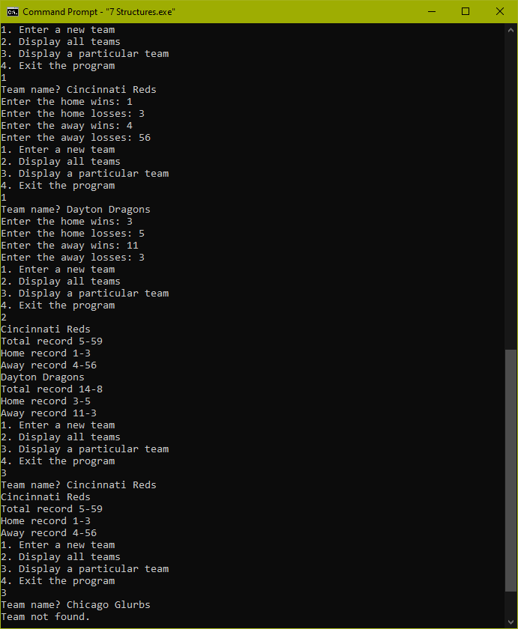
Sample Output

