//Lei Zhang
//Dice Roller
//10/15/2025

AI Tip 1. Research how to calculate the exact dimensions of the array.
Anwser: I didn’t use AI on this question, I write this code on my own:
“ mySumRolls = new int[this.myNumberOfSides*this.myNumberOfDice-this.myNumberOfDice+1]”

AI Tip 2. Research how to clone an array in Java
Anwser: I searched this question in YouTube, and write this:
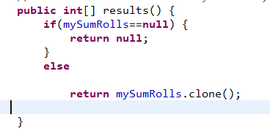
Resource: https://www.youtube.com/watch?v=6uemeqwFNeQ

AI Tip 3. Inspect the Integer class for a constant that is useful in the cases where we don’t care about the maximum value.
Anwser: I asked Gemini: in java, how to define positive int infinite.
Gemini:
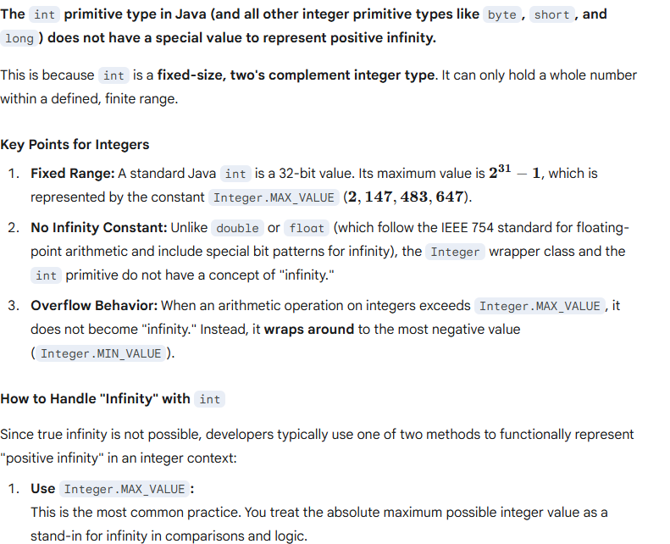

So I go with: Integer.MAX_VALUE

Here are other questions that I asked AI:
1. In Java, how to print an array to string.
Anwser:
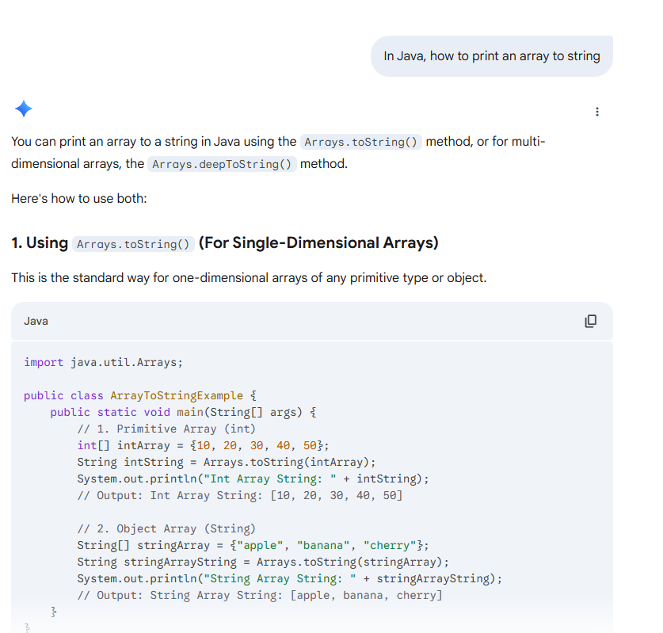
I go with first answer “Arrays.toString()”.

2. How can I save printf into a string variable?
Anwser:
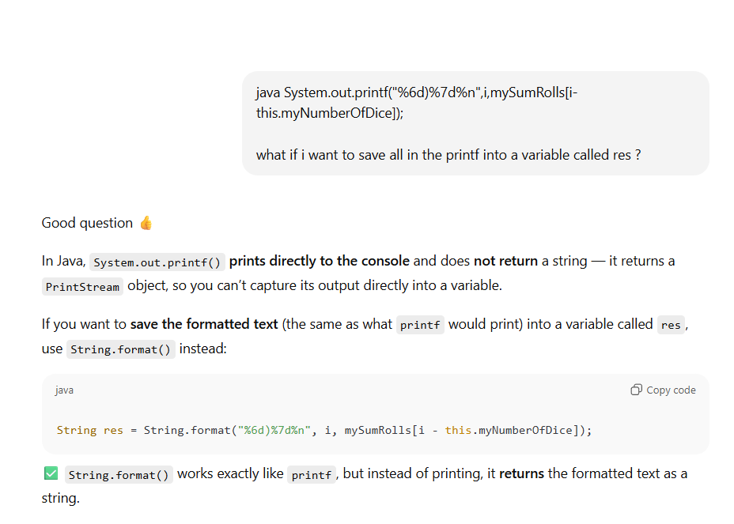

That is all! Thank you!

