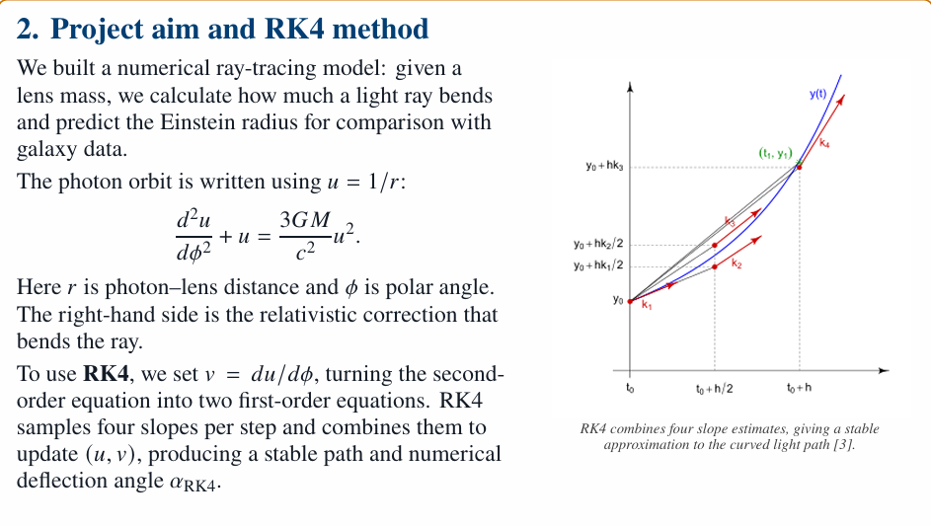
Now that we know light bends, how can we model this mathematically?
[point at blackboard] Now this is the differential equation that describes the path of light around a mass. [talk about U, phi]. But this is only a differential equation: it tells us how the path of the light changes, but not the exact path it will take. Although an exact solution exists, it’s in the form of complicated elliptic integrals that are hard to evaluate.

But before we tackle einstein rings, we first decided to recreate Einstein’s 1919 predictin. Einstein predicted that a light ray that grazes the surface of the sun will be deflected by exactly 1.75 arcseconds [or about 0.000486 degrees vid caption]
So instead, we used RK4, a method of computationally estimating solutions to differential equations. For example if you want to estimate the change in x for a light beam, you could naively just do dx = v * dt. But this method will not be accurate, because the velocity in the x direction could be not constant. RK4 just takes the weighted average of 4 different velocities at 4 different times to find a more accurate estimate for dx.

[separate scene: explaining rk4, naive euler method, spring animations from other video, talk about how RK4 is just averaging 4 slopes weighted]
But to predict the path that a light beam will take, we need to know its initial position and the initial angle that it’s travelling at. ‘r’ and ‘phi’ alone are sufficient to find the initial position in x, y coordinates [insert animation], but how do we communicate the initial direction of travel? The answer is through the quantity dU/d phi in our equation.

Hence, we set v = du/dphi. It combines four slopes per step and combines them to update (u,v) producing an accurate and stable path. The increment of phi was chosen to be 10^-6 radians because the deflection angle of deflection of light grazing the sun predicted by einstein in 1919 is 1.75 arcseconds which is of the same order of magnitude ensuring the code won’t break. By setting the initial conditions to phi = 0, u = 1/R_sun and v = 0, we were able to computationally solve the differential equation using RK4 to produce a plot of the trajectory a light beam takes as it grazes the sun, by converting from polar to cartesian coordinates at each increment and plotting a graph of x against y where x = rcosphi and y = rsinphi. The deflection angle was produced by determining the angle between the trajectory and x axis using the gradient at the start and end of the graph and was confirmed to be 1.75 arcseconds.

