- Simulated a code that would cause a crash:
let array = [];
while (true) {
array.push("some value");
}
When running this code, miniapp does not immediately crash, and you can continue to operate the current page. However, if you jump to another page and then jump back to the current page, the applet will automatically exit(Crashed)

8.PASS

9.PASS

10.Android app file size:
Total size(include armeabi and arm64-v8a)：6M->60M
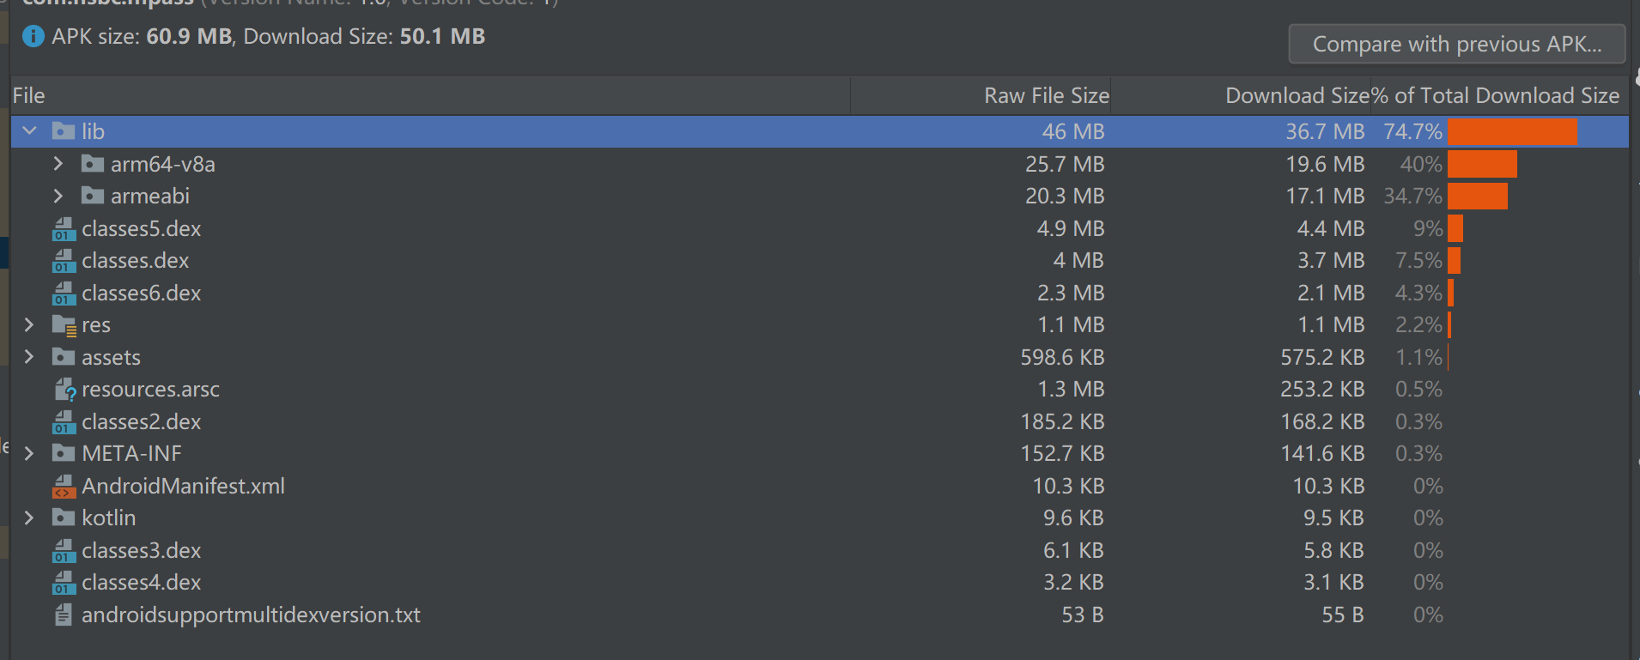
When installed on an Android device, the amount of storage space consumed increases as the number of mini app increases
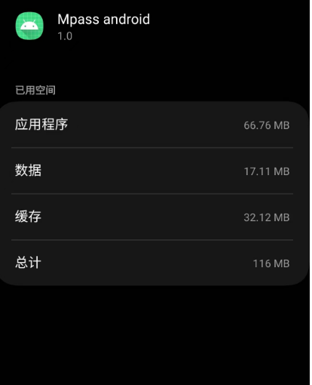

11.
Only luanch native app：119M
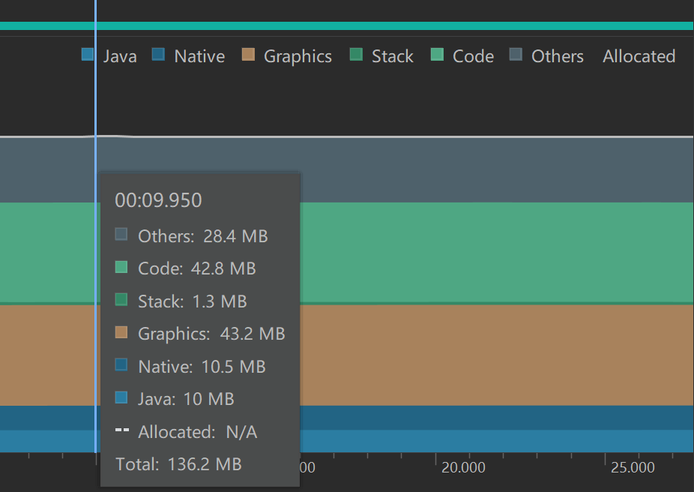
When luanch native app and Deposits miniapp：218.6M
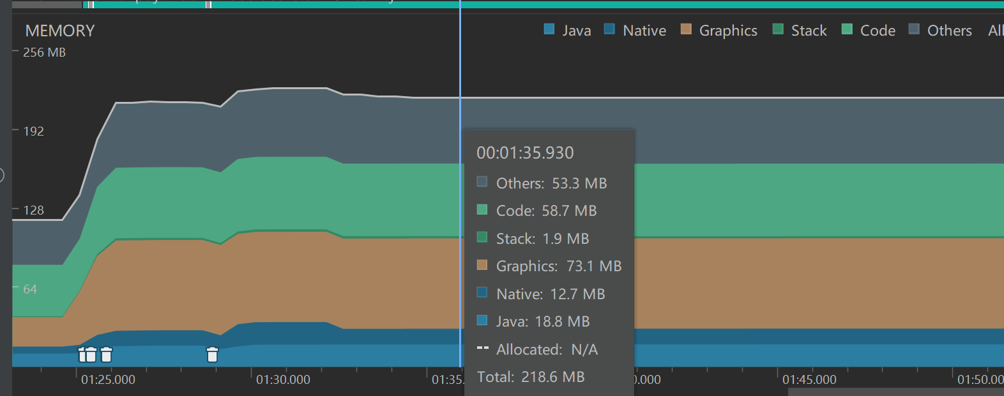
After close Deposites miniapp:200M
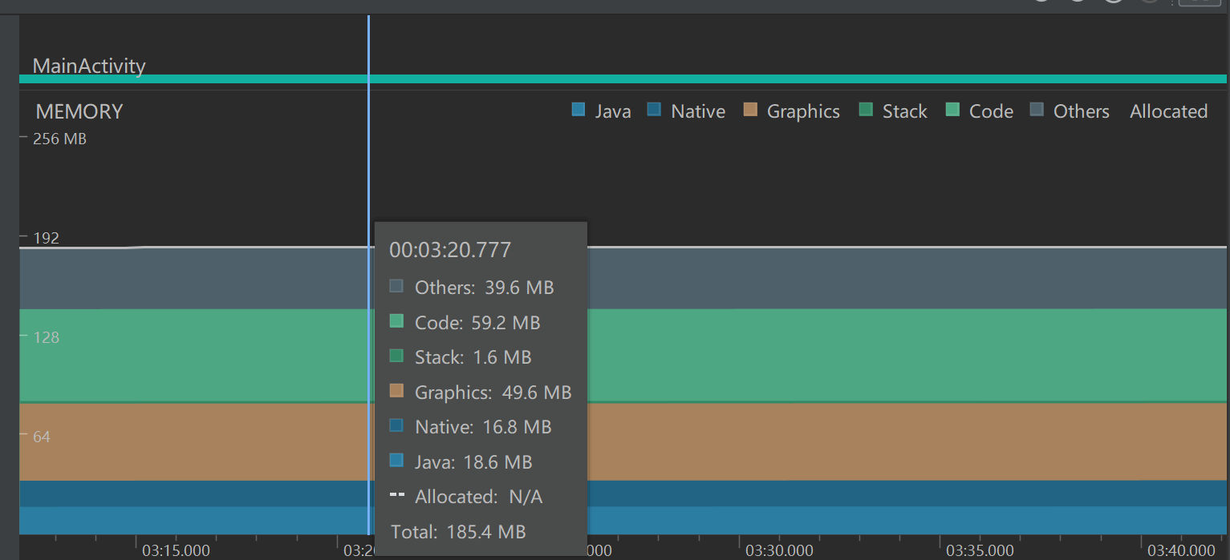

Summarize:
1.When you open an miniapp, the memory will increase by a constant value, which varies depending on the actual memory usage of the miniapp
2.Closing miniapp reduces memory by a certain amount, but is higher than opening only native apps

12.Same as IOS

