**CoCoTest Guide**

To be able to apply CoCoTest to generate test inputs for a given closed-loop controller Simulink model, the following steps need to be performed. We illustrate the steps using an example Simulink model (DC-Motor Controller). This Simulink model is included in the CoCoTest-Package. This model has been originally designed and developed by Mathworks and is available at: http://www.mathworks.com/matlabcentral/fileexchange/11587-dc-motor-model-simulink

1. When you want to test a closed-loop controller model, you need to first ensure that the desired value input comes from a “from workspace” block and the actual value output goes to a “to workspace” block. For example, **Figure 1** shows our example close-loop controller model (DC-Motor). The desired value is deisredSpeed, comes from a “from workspace”, and the actual value is actualSpeed, goes to a “to workspace”.

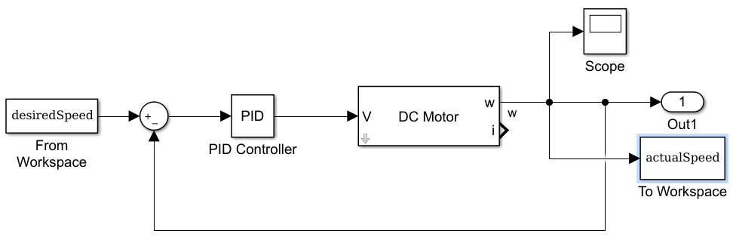

Figure1- Simulink model of a DC motor controller

1. To run the CoCoTest tool, .NET framework should be installed. We have tested CoCoTest on Windows 7 and with .NET framework 4.0 and with Matlab 2015b.
2. After executing the CoCoTest.exe, create a new test workspace, as shown in Figure 2:

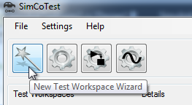

Figure 2- New test workspace wizard

1. At the first step of the wizard, select “Closed-loop Controller”:

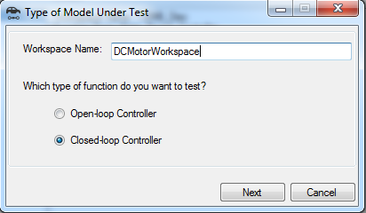

Figure 3- Type of model under test form

1. At the next step of the wizard, select the Matlab executable path, the Simulink model path, the paths to be added to Matlab paths, e.g., the folder paths that contain the s-functions called by the model, and the scripts to be run before running the model, e.g., the scripts that initialize the configuration parameters of the model. Figure 4 shows the model settings form which contains this information.

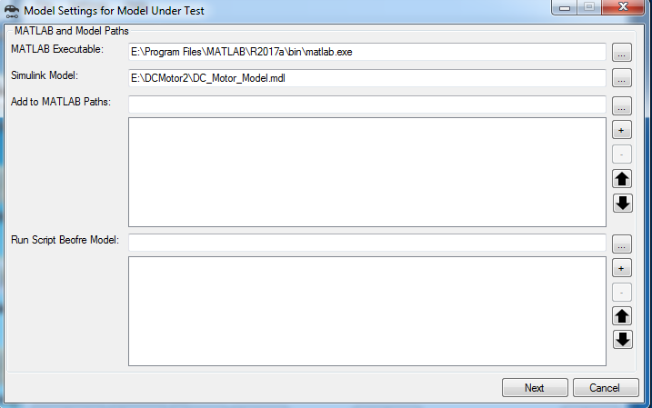

Figure 4- Model settings for model under test

1. At the next step, fill in the information in the Closed-loop Controller Model Parameters form. Figure 5 shows this form filled for the DC Motor model. This information includes the names and the ranges of the desired and actual value variables and the model simulation time. The Run the model using the Run Model button to make sure that the given information is correct. After running the model, the Next button becomes enabled.

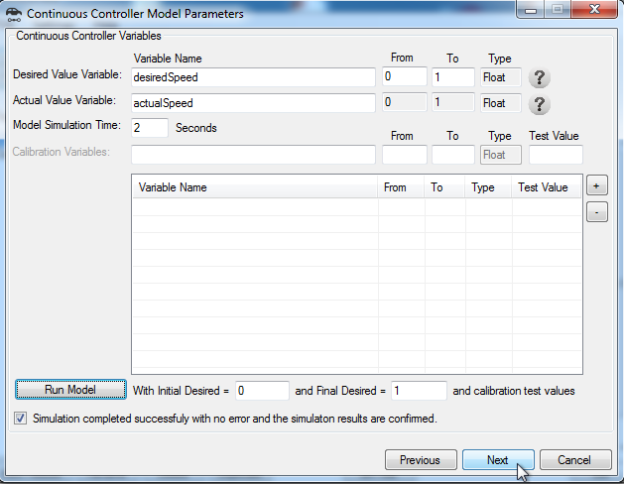

Figure 5- Closed-loop Controller Model Parameters form

1. At the next step, select the configurations of the HeatMap diagrams including the number of divisions, the number of tests to be run in each region, the number of worst-case scenarios to be reported by the program, the regions that should be included or excluded in the search, and finally the properties to be tested by SimCoTest. Now we are ready to generate test cases by pressing the “Start Test” button:

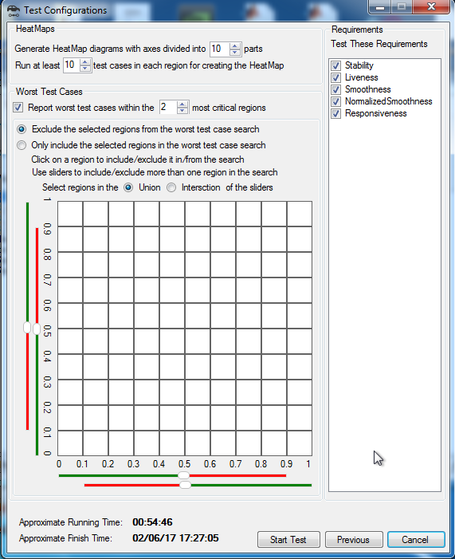

Figure 6- Test Configurations form

1. Monitor the test generation in the test generation progress form:

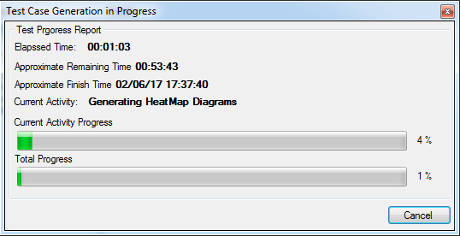

Figure 7- Test Generation Progress form

1. When the test generation is finished, check the results in the test generation results form. Figure 8 shows an example of the test generation results form including the HeatMap diagrams and the worst-case test scenarios of the model:

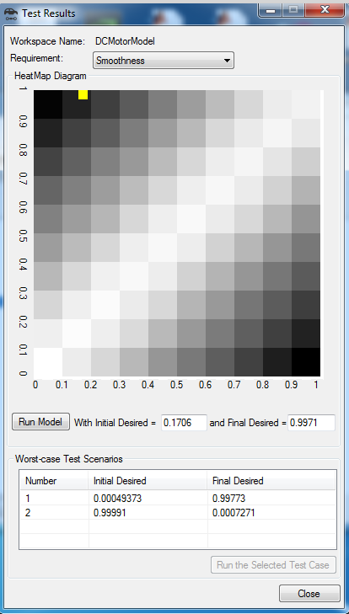

Figure 8- Test Generation Results form

1. Run any of the worst-case test scenarios generated for the model or any other test case from the Heatmap, and check the test case input/output:

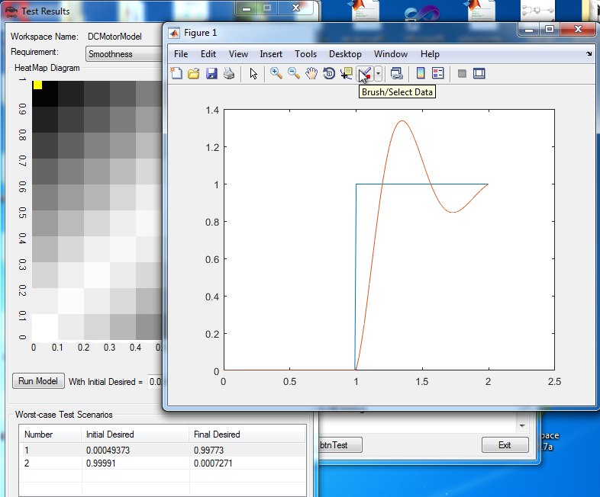

Figure 9- An example of a test case for Smoothness property