**SimCoTest Guide**

To be able to apply SimCoTest to generate test inputs for a given Simulink model, the following steps need to be performed. We illustrate the steps using an example Simulink model (Emergency Braking System or EMB). This Simulink model is included in the SimCoTest-Package (see the EMB directory). This model has been originally designed and developed by Bosch Research and is available at http://cps- vo.org/node/20289. To open the EMB model, we have used Matlab 2015b. If you want to open the model using an older version of Matlab, you need to export the model so that it can be opened using that version of Matlab. The model can be exported from “Export Model To -> Previous Version” menu.

1. When you want to test a Simulink model, you need to first ensure that the model inputs come from the input ports and the model outputs go to the output ports. For example, **Figure 1** shows our example Simulink model (EMB). It has three inputs (R, L and x_noise) and one output (x), all of which are connected to Simulink ports. Further, the model should be configured so that the input data is imported from the Matlab workspace and the output data is exported to the Matlab workspace. To do so, from the **Simulation menu** pick **Model Configuration Parameters** and in the **Data Import/Export** tab set the input to “**externalinputdata**” and set the Time and Output to **tout** and **yout**, respectively (as shown in **Figure 2**).

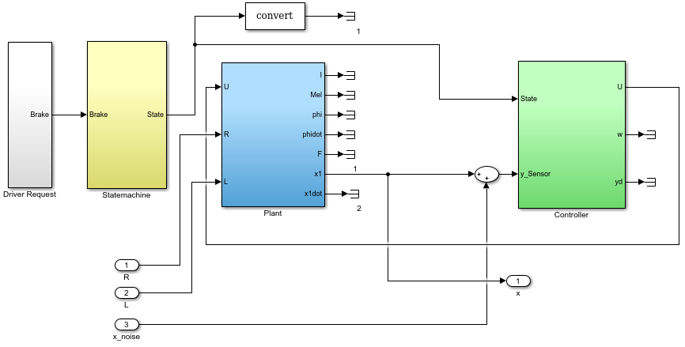

Figure1- Simulink model of the EMB Model

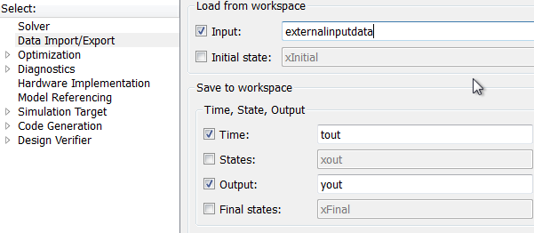

Figure2- Data Import/Export Tab

1. Create a folder next to the model with the name **[model_name]-Files**. For example, if name of the model is **EMB**, the folder’s name must be **EMB-Files (see an example is already provided in the EMB directory)**.



Figure 3-The folder created next to the model

1. In the **[model_name]-Files** directory, create an XML file named “ExtractInfo.xml” and store the following information in that file: Indicate the model simulation time and the names, data types and data ranges of input variables, configuration parameters and output variables of the model in that XML file. For input and output variables identify the port numbers, as well. The data types are “float” for float, “enum” for enumeration and “boolean” for boolean. Figure 4 shows an example of the ExtractInfo.xml file. This file is available in the EMB-Files directory.

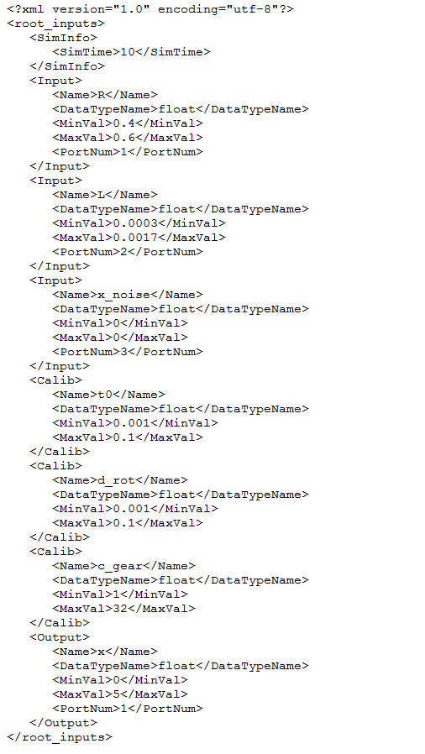

Figure 4- An example of ExtractInfo*.*xml file

1. To run the SimCoTest tool, .NET framework should be installed. We have tested SimCoTest on Windows 7 and with .NET framework 4 and with MATLAB 2015b.
2. Make sure the SimCoTest.exe file is located next to the MiLTesterFiles folder.
3. After executing the SimCoTest.exe, create a new test workspace, as shown in Figure 5:

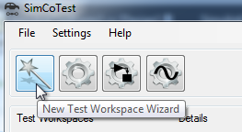

Figure 5- New test workspace wizard

1. At the first step of the wizard, select “Open-loop Controller”:

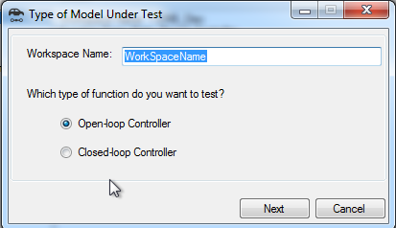

Figure 6- Type of model under test form

1. At the next step of the wizard, select the Matlab executable path, the Simulink model path, the paths to be added to Matlab paths, e.g., the folder paths that contain the s-functions called by the model, and the scripts to be run before running the model, e.g., the scripts that initialize the configuration parameters of the model. Figure 7 shows the model settings form which contains this information.

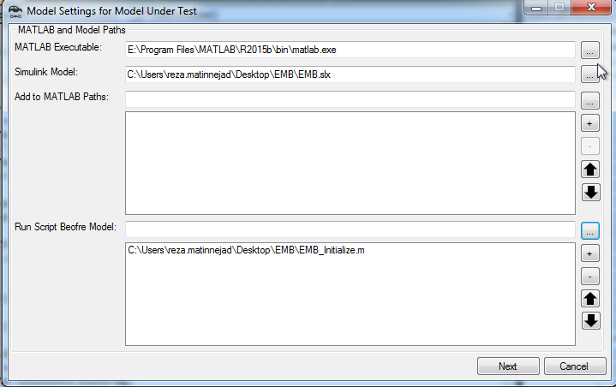

Figure 7- Model settings for model under test

1. At the next step, the information in the *ExtractInfo.xml* file is extracted and shown to the user. Figure 8 shows the data extraction results form for the EMB model.

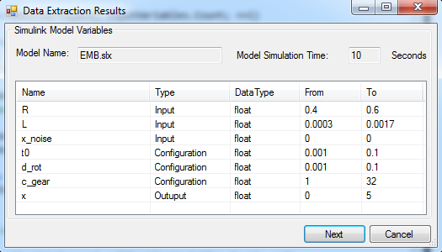

Figure 8- Data extraction results form

1. Finally, select the size of test suites for different test generation algorithms (output diversity and failure-based). Now we are ready to generate test cases by pressing the “Start Test” button.

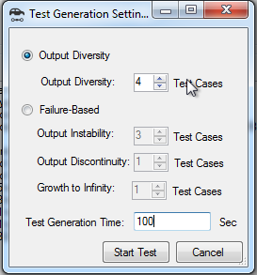

Figure 9- Test Generation Settings form

1. A test generation progress bar appears to show the progress of test generation.

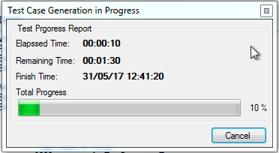

Figure 10- Test Generation Progress form

1. When the test generation is finished, access the results in the test generation results form. Figures 11 and 12 show two examples of the test generation results form for the output diversity and failure-based test generation algorithms:

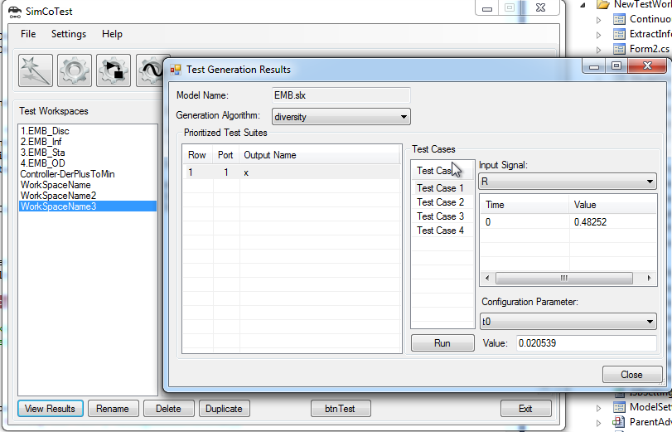

Figure 11- Test Generation Results form

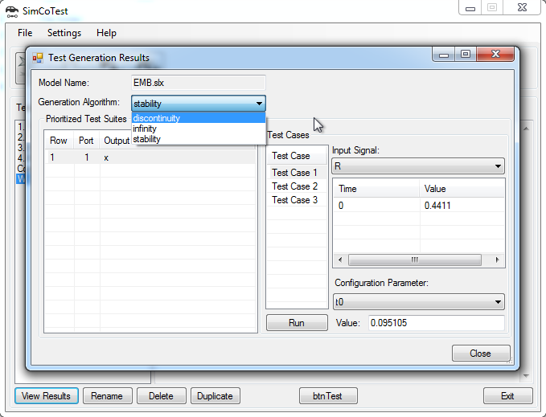

Figure 12- Test Generation Results form (2)

1. It is possible to run any of the generated test cases from the test generation results form. It runs the test cases and plots the model output for which the test case was generated (output x for the EMB model):

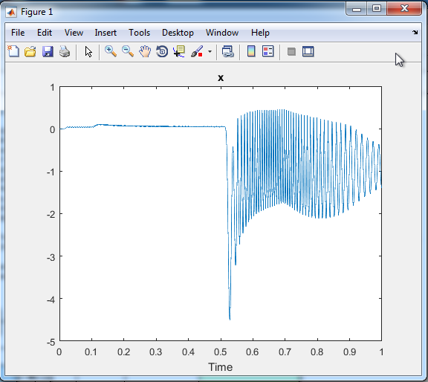

Figure 13- Test Generation Results form (2)