The Model which is already fitted:

**TN - True negatives:** we predicted a costumer would not churn and they did not churn.

**FP - False positives:** We predicted a costumer would churn, but they did not.

**FN - False negatives:** we predicted a costumer would not churn and they churn.

**TP - True positives:** we predicted a costumer churn, and they actually churn.

**Precision**

Another way to analyze a classification algorithm is by calculating precision, which is basically obtained by dividing true positives by the sum of true positive and false positive, as shown below:

image

**Recall**

Recall is calculated by dividing true positives by the sum of the true positive and false negative, as shown below:

image

**F1 Measure**

F1 measure is simply the harmonic mean of precision and recall and is calculated as follows:

image

**Accuracy**

Accuracy refers to the number of correctly predicted labels divided by the total number of observations in a dataset.

image

**Precision** = 2495/ (2495 + 2270) = 0.52

**Recall/Sensitivity** = 2495/ (2495 + 175) = 0.93

**F1 Score** = 0.67

**Accuracy** = (2495 + 1338)/ (2495+1338+2270+175) = 0.61

**Specificity** = 1338/ (1338 + 2270) = 0.37

The existing model is pretty good because of the following reason

1. The model will catch 93% of the customers who will actually churn.
2. Overall all accuracy is 61%

But there is still scope to achieved better accuracy with other ML deep learning models.

I have tested:

|  |  |
| --- | --- |
| **Model Tested** | **Accuracy** |
| Primal logistic regression | 72% |
| Logistic Regression with pol 2 Kernel | 78% |
| SVM with RBF Kernel | 80% |
| Random Forest classifier with GINI index | 82% |
| Extreme Gradient Boost | 77% |

With Random Forest I got better accuracy and F1 Score:

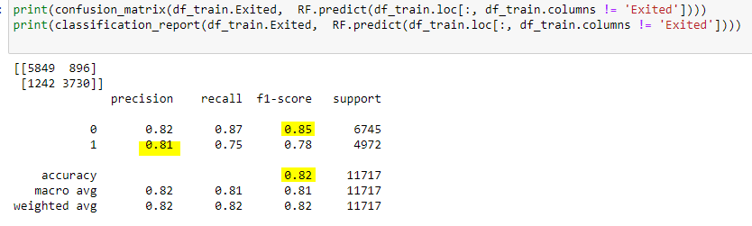

The Confusion Matrix shows that for 82 percent of the records in the test set, Random Forest correctly predicted whether a customer will leave the bank.