Import o365 Script

Implementation Guide

# About this document

This document describes implementation of office365-script (<https://community.checkpoint.com/docs/DOC-3013>)

# How to implement

Copy Script to file system (e.g. create a folder under root “scripts” or so)

Edit script at the header (only)

Define variables where needed

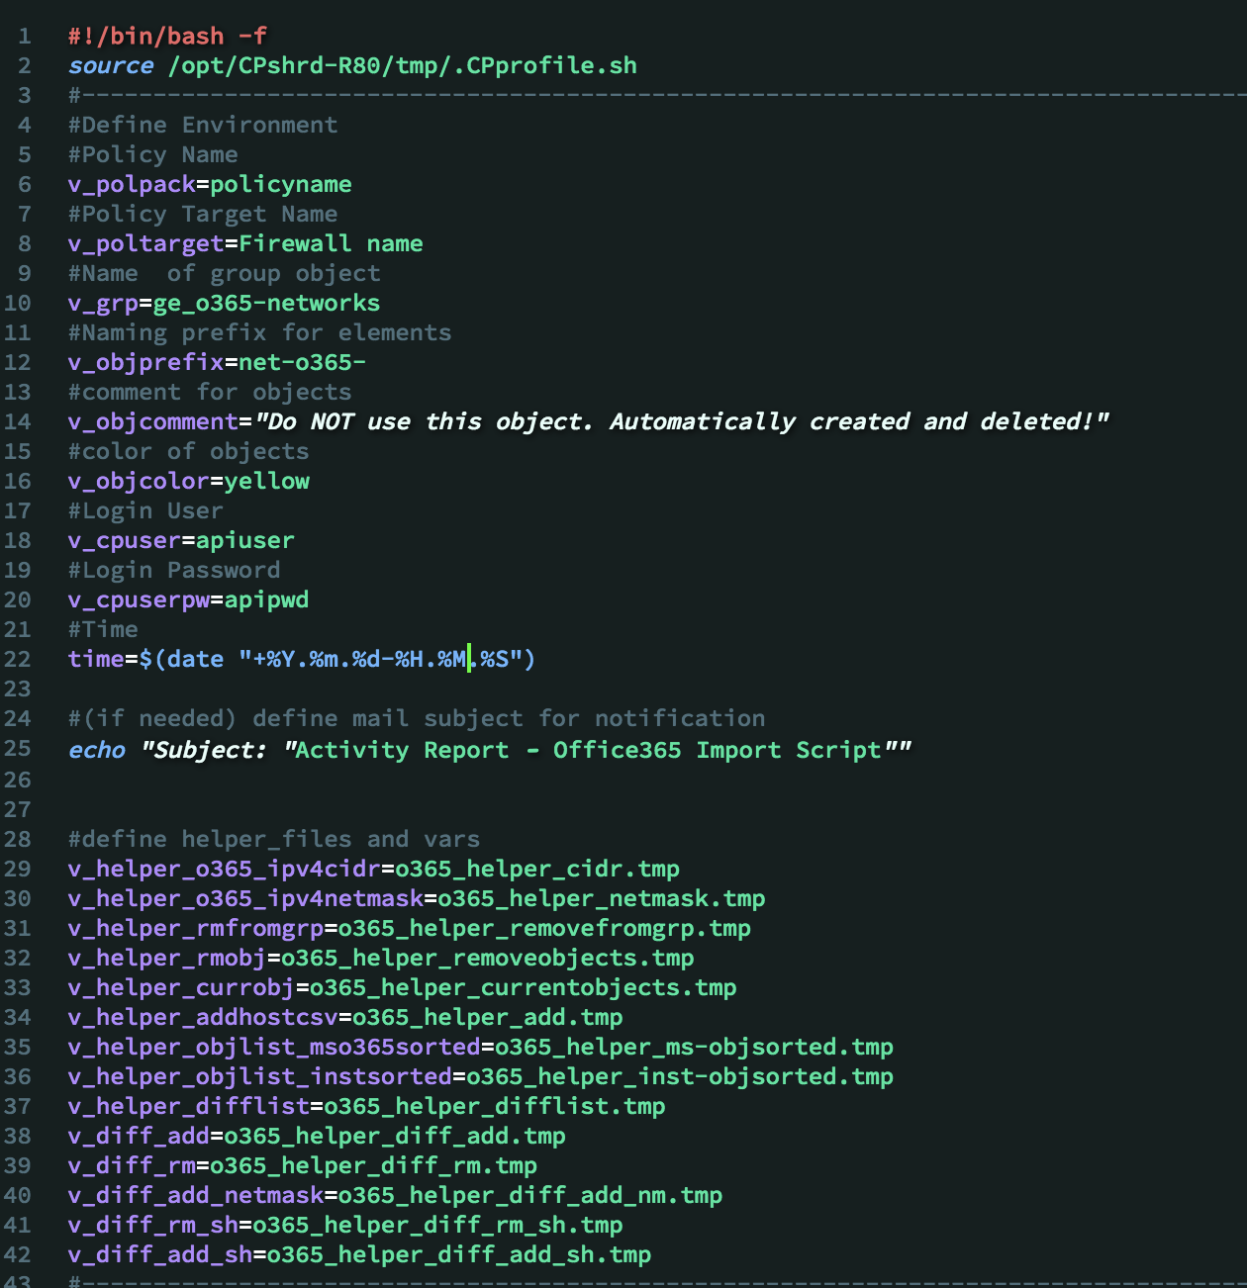

(most important: upper half, lower half can remain, as this are temporary files only – created during script runtime and deleted at the end)

In GAiA Web UI just add Job Schedule for this:

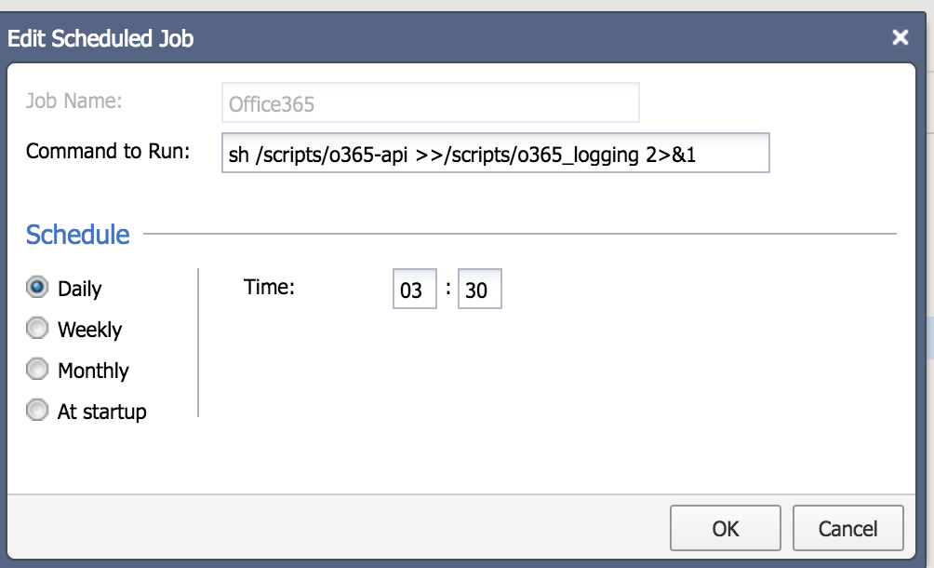

Example shown above adds a file o365_logging.log and writes all output in it.

As the script starts with  and ends with  you can check, if the script had any errors or other output.

Example command for cron job. Executing script, adding logs to logfile and sending activity log to mail recipient (mail subject is defined in header (#define mail subject here))

*sh /scripts/o365-api | /usr/bin/tee -a /scripts/o365_logging 2>&1 | /usr/sbin/sendmail --domain=<mail domain> -f <sender address> -v <recipient address> --host=<mail relay> 2>&1*

# Adapting

Script can be used for any other feed, where network addresses are in CIDR format.



Basically you just need to change the url to download and the variables set at the top of the file. The grep command extracts IP Addresses in CIDR format. Other parts are working with content of this ouput.