LDA topic-number selection and stability report
Similarity metric throughout: cosine between aligned P(day-type | topic) distributions (Hungarian matching to the published reference).

0. Provenance — training lock vs audited follow-up
Two related corpora are distinguished:
 | Published LDA reference | This report (K sweep + stability)
Role | Frozen model used in the manuscript (not re-trained here) | Coherence check of K and stability replicates at fixed K=6
Behavioural daily data | PMP data lock (11 September 2025) | Audited DB1 follow-up (reconciled clinical date ranges)
Patient document | Full day-type sequence available under that lock | Full day-type sequence under audited DB1 spans
Purpose | Training of the published topic model | Inference-side verification on the revised audited calendar
Date alignment. For the 175 patients shared by both extracts, start date, end date, and number of observed days differ by a median of 0 days. In 160/175 patients the absolute difference in day count is ≤ 7 days; in 171/175 it is ≤ 30 days. Across the cohort, only on the order of ~1 000 patient-days appear only in audited DB1 and ~450 only in the lock extract. Thus the two calendars are practically the same span, with small per-patient edits from the audit and a few outliers with larger differences.
Reconciliation does not rewrite the published reference weights. It updates the documents used for the present K sweep, stability replicates, and downstream inference relative to the lock training corpus.

1. Unsupervised selection of K
The coherence-versus-K figure in this report shows the coherence sweep run on audited DB1 day-type embeddings (current inference / analysis corpus).
This sweep recapitulates the original topic-number search on the training corpus: it does not replace or re-train the published LDA. It only checks that, on this audited inference database, validation coherence again supports K = 6.
Sweep settings: candidate K in {2, 6, 10, 14, 18}; 5 random initializations per K; 50 passes; 70%/30% train/validation split by patient.
Rule: maximise mean validation coherence (c_v) → K = 6 (validation peak ≈ 0.588). Same K as the published model.
Coherence vs K
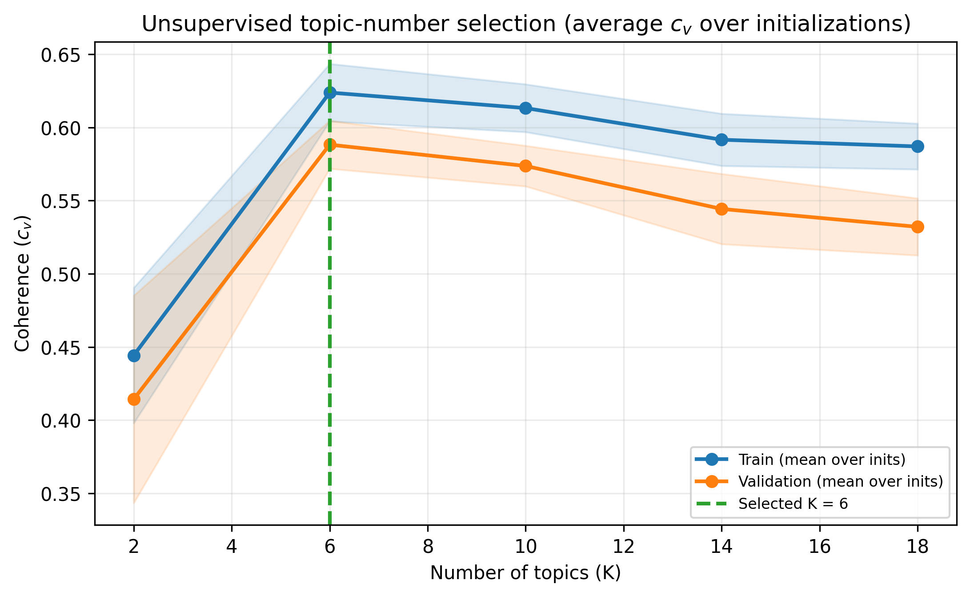
The published LDA was trained at K = 6 with a large number of passes (~100 000) on the PMP lock corpus.

2. Level 1 — Stability to random seed
Re-fit LDA 50 times at K = 6 (all patients; different seeds), on the audited DB1 documents. Align topics to the published reference; report cosine similarity of topic–profile distributions and patient pUF concordance.

Headline (cosine)
Summary |  | Value
Median cosine (all topic–replicate pairs) |  | 0.915
IQR |  | [0.844, 0.962]
Median of per-replicate mean cosine (6 topics) |  | 0.884
IQR of per-replicate mean cosine |  | [0.840, 0.902]
Favourable hypertopic cosine (median) |  | 0.960
Unfavourable hypertopic cosine (median) |  | 0.916
Global document pUF Pearson r (median [IQR]) |  | 0.849 [0.795, 0.890]
Topic | Hypertopic |  | Cosine median [IQR]
T0 | favourable |  | 0.981 [0.976, 0.984]
T1 | favourable |  | 0.914 [0.880, 0.940]
T2 | favourable |  | 0.957 [0.936, 0.967]
T3 | unfavourable |  | 0.875 [0.846, 0.923]
T4 | unfavourable |  | 0.884 [0.843, 0.935]
T5 | unfavourable |  | 0.691 [0.633, 0.737]
Level 1 cosine
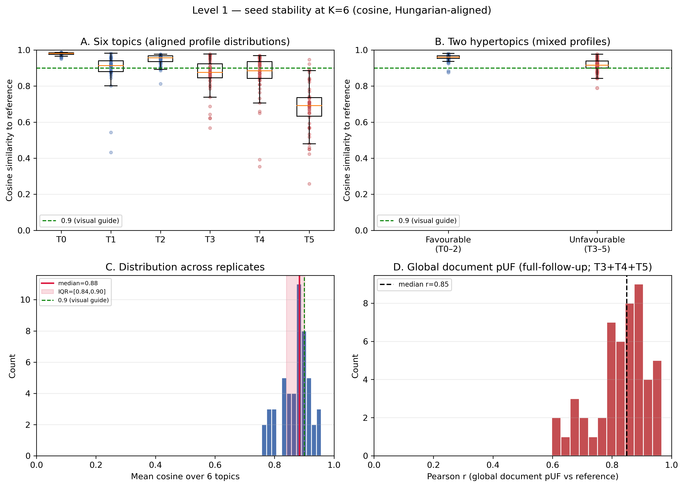
Similarity panels use the full 0–1 axis range. The dashed 0.9 line is a visual guide only, not a validation criterion. Panel D is the Pearson correlation of global document pUF (one scalar per patient over the full follow-up document, T3+T4+T5 after alignment)—not the monthly-block / alarm operating-point analysis, which is reported separately.
Level 1 profile heatmap
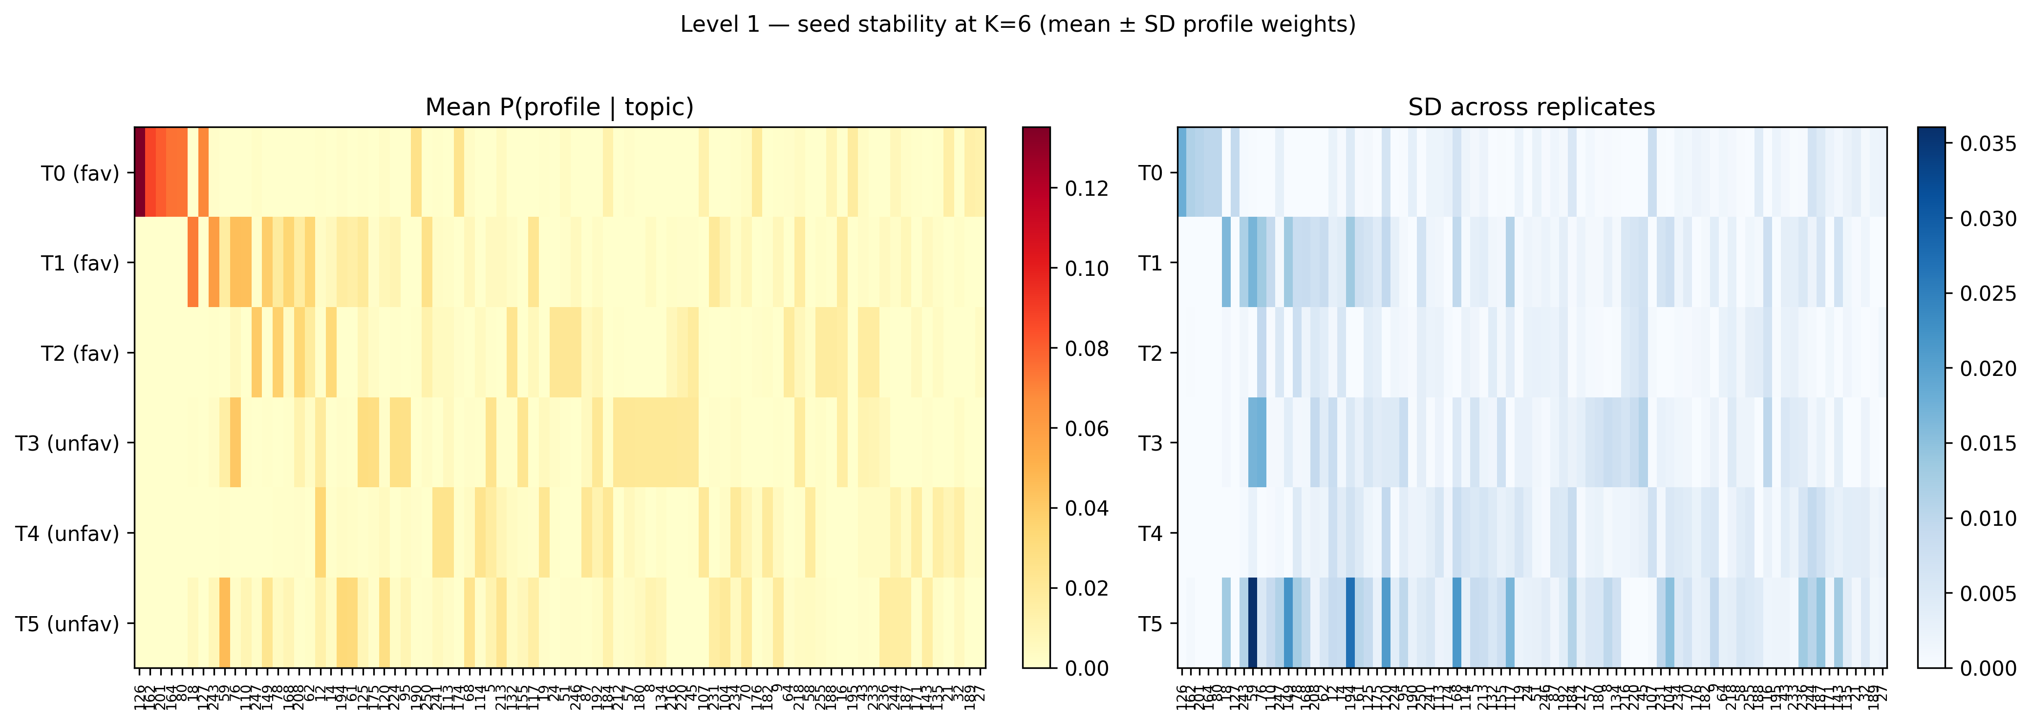

3. Level 2 — Stability to data (leave-20%-out)
Same K = 6 and cosine alignment on audited DB1, but each replicate drops 20% of patients at random (n = 50 replicates) and re-fits LDA on the remainder.

Headline (cosine)
Summary |  | Value
Median cosine (all topic–replicate pairs) |  | 0.867
IQR |  | [0.723, 0.931]
Median of per-replicate mean cosine |  | 0.794
Favourable / unfavourable hypertopic cosine (median) |  | 0.937 / 0.885
Global document pUF Pearson r (median [IQR]) |  | 0.772 [0.675, 0.858]
Topic | Hypertopic |  | Cosine median [IQR]
T0 | favourable |  | 0.965 [0.953, 0.970]
T1 | favourable |  | 0.882 [0.825, 0.919]
T2 | favourable |  | 0.909 [0.860, 0.937]
T3 | unfavourable |  | 0.815 [0.699, 0.871]
T4 | unfavourable |  | 0.797 [0.611, 0.889]
T5 | unfavourable |  | 0.668 [0.579, 0.753]
Level 2 cosine
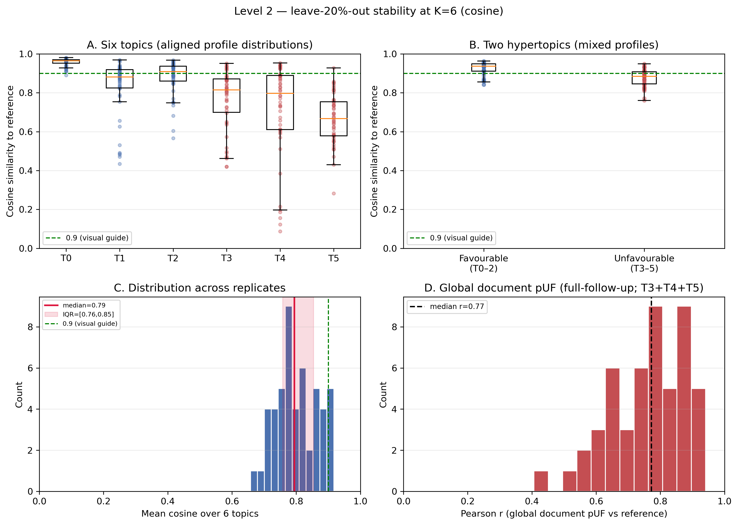
Level 2 profile heatmap
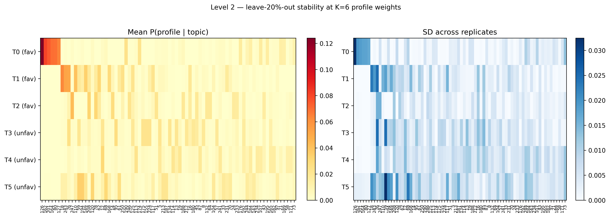

4. Passes vs iterations — why replicates use 100 passes
In gensim LDA:
- passes: how many times the optimiser sweeps the entire corpus.
- iterations: how many E-step updates are allowed per document within each pass.
These are different parameters. The published reference and the stability replicates share the same per-document E-step budget; they differ only in how many full corpus sweeps are run:
 | Published reference | Stability replicates
passes | 100 000 | 100
iterations | 50 | 50
The large passes value on the reference is intentional for the frozen published model. Replicates use a smaller budget because the stability battery requires many independent fits (50 seeds + 50 leave-20%-out fits). The choice of 100 passes is therefore primarily computational (runtime / cost of that comparison grid), provided the fit has already stabilised.
Training objective. We monitor gensim’s corpus variational bound (ELBO-style objective for variational LDA; higher is better). We also track topic–profile distributions and patient-level posterior mass on the unfavourable hypertopic (pUF).
Fixed a-priori check (same audited DB1 documents and initialisations; not used to tune clinical metrics):
- 5 fixed random seeds on the full cohort;
- 5 fixed leave-20%-out masks;
- train from scratch at 100, 1000 and 5000 passes;
- compare the variational bound, topic–profile cosine (Hungarian-aligned) and patient pUF between budgets.
Variational bound (ELBO) by pass budget (from-scratch fits; median over the 10 fixed jobs):
Passes | Median bound | Min | Max
100 | −232 312 | −254 896 | −197 914
1000 | −232 205 | −254 620 | −197 616
5000 | −232 195 | −254 610 | −197 579
(Relative change 100 → 1000/5000 is on the order of 0.05%.)
Topic / pUF agreement between pass budgets (100 vs higher; Hungarian-aligned):
Comparison | Median topic cosine | Min topic cosine | Median pUF Pearson | Min pUF Pearson
100 vs 1000 | 0.993 | 0.941 | 0.991 | 0.957
100 vs 5000 | 0.992 | 0.939 | 0.991 | 0.955
Pass-budget agreement
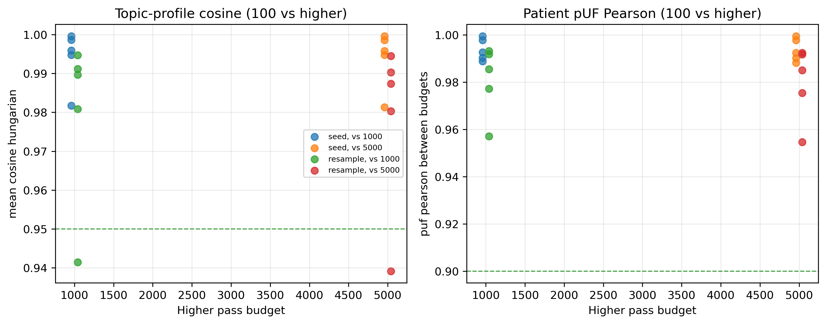
Justification for 100 passes. The decision rests on these from-scratch comparisons: the variational bound changes only by ~0.05%, and topic profiles / patient pUF already agree with 1000–5000 budgets (median cosine and pUF r > 0.99). We therefore keep 100 passes as the computational budget for the multi-replicate battery and do not refresh the full 50-replicate set for under-training.
- K = 6 maximises mean validation coherence among the candidates evaluated on audited DB1 embeddings. This verifies the original choice; the published reference remains the PMP-lock model.
- Level 1 (seed): topic–profile cosine and hypertopics remain highly concordant; global document pUF tracks the reference well under re-initialisation.
- Level 2 (leave-20%-out): cosine remains high for most topics/hypertopics under patient subsampling; heatmaps show which day-type profiles stay dominant (mean ± SD).
- Lock vs audited DB1 calendars are close for most patients (median difference 0 days); a minority of patients have larger span edits after audit.
- Monthly-block / alarm (§5): locked to base_analysis 1019 collapsed landmarks and Youden θ ≈ 1.0596 (same as granularity_report.docx §2). Seed load r ≈ 0.83; leave-20% ≈ 0.75; flips ≈ 16% / 20%; AUROC medians ≈ 0.66–0.68 near the reference ~0.70.

5. Monthly-block pUF and alarm operating-point stability
Locked to results/alarm/base_analysis/granularity_report.docx (§2) and
decision_points_collapsed.csv.
Day-types (VQ-VAE) and the dictionary stay frozen. Topics are Hungarian-aligned by cosine of P(day-type | topic) without using outcomes. After alignment, favourable = T0–2, unfavourable = T3–5, pUF = posterior mass on the unfavourable hypertopic. Score S_m = sum of the last three monthly pUF (= AUC_W).
Item | Value
Evaluable monthly-collapsed landmarks | 1019 (pos/neg 159/860)
Clock | Tiempo_obs digital / t_evento_eb2 (labels in CSV target)
Window / horizon | W = 3 months, H = 120 days
Alarm cut S_m | θ = 1.0596384140662845 (θ/3 ≈ 0.3532128047; Youden on prior 1013; not re-tuned per replica)
Reference AUROC / sens / spec at this θ | 0.701 / 0.881 / 0.450 (TP/FN/FP/TN = 140/19/473/387; matches updated granularity_report.docx table)
Leave-20%-out metrics are reported separately for landmarks from the 140 in-fit and 35 held-out patients (inference allowed on held-out; within-DB1 stability only).
Headline (median [IQR] over replicates)
Panel | Monthly-block pUF r | 3-block load r | Decision-flip fraction | AUROC | Sens | Spec
Seed (all 1019) | 0.819 [0.763, 0.859] | 0.832 [0.777, 0.870] | 0.155 [0.130, 0.174] | 0.679 [0.660, 0.689] | 0.805 [0.781, 0.824] | 0.435 [0.415, 0.464]
Leave-20% (in-fit) | 0.735 [0.639, 0.797] | 0.755 [0.650, 0.810] | 0.210 [0.165, 0.254] | 0.658 [0.635, 0.686] | 0.774 [0.746, 0.800] | 0.443 [0.391, 0.501]
Leave-20% (held-out) | 0.721 [0.621, 0.817] | 0.755 [0.633, 0.851] | 0.194 [0.151, 0.255] | 0.665 [0.605, 0.739] | 0.841 [0.726, 0.911] | 0.429 [0.330, 0.491]
Column legend. Panel: which replicates and patients (Seed = 50 full-cohort fits, n=175; Leave-20% in-fit = landmarks from the 140 patients used to fit; Leave-20% held-out = landmarks from the 35 excluded patients, with inference allowed). Monthly-block pUF r: Pearson correlation of monthly-block pUF (replica vs reference), median [IQR] over 50 replicates. 3-block load r: same for the three-block load S_m (sum of three monthly pUF). Decision-flip fraction: fraction of landmarks where the 0/1 alarm differs from the reference at the fixed θ. AUROC: discrimination of the replica score at that θ. Sens / Spec: sensitivity and specificity at that θ. All numeric cells are median [IQR] across replicates.
Monthly / alarm stability
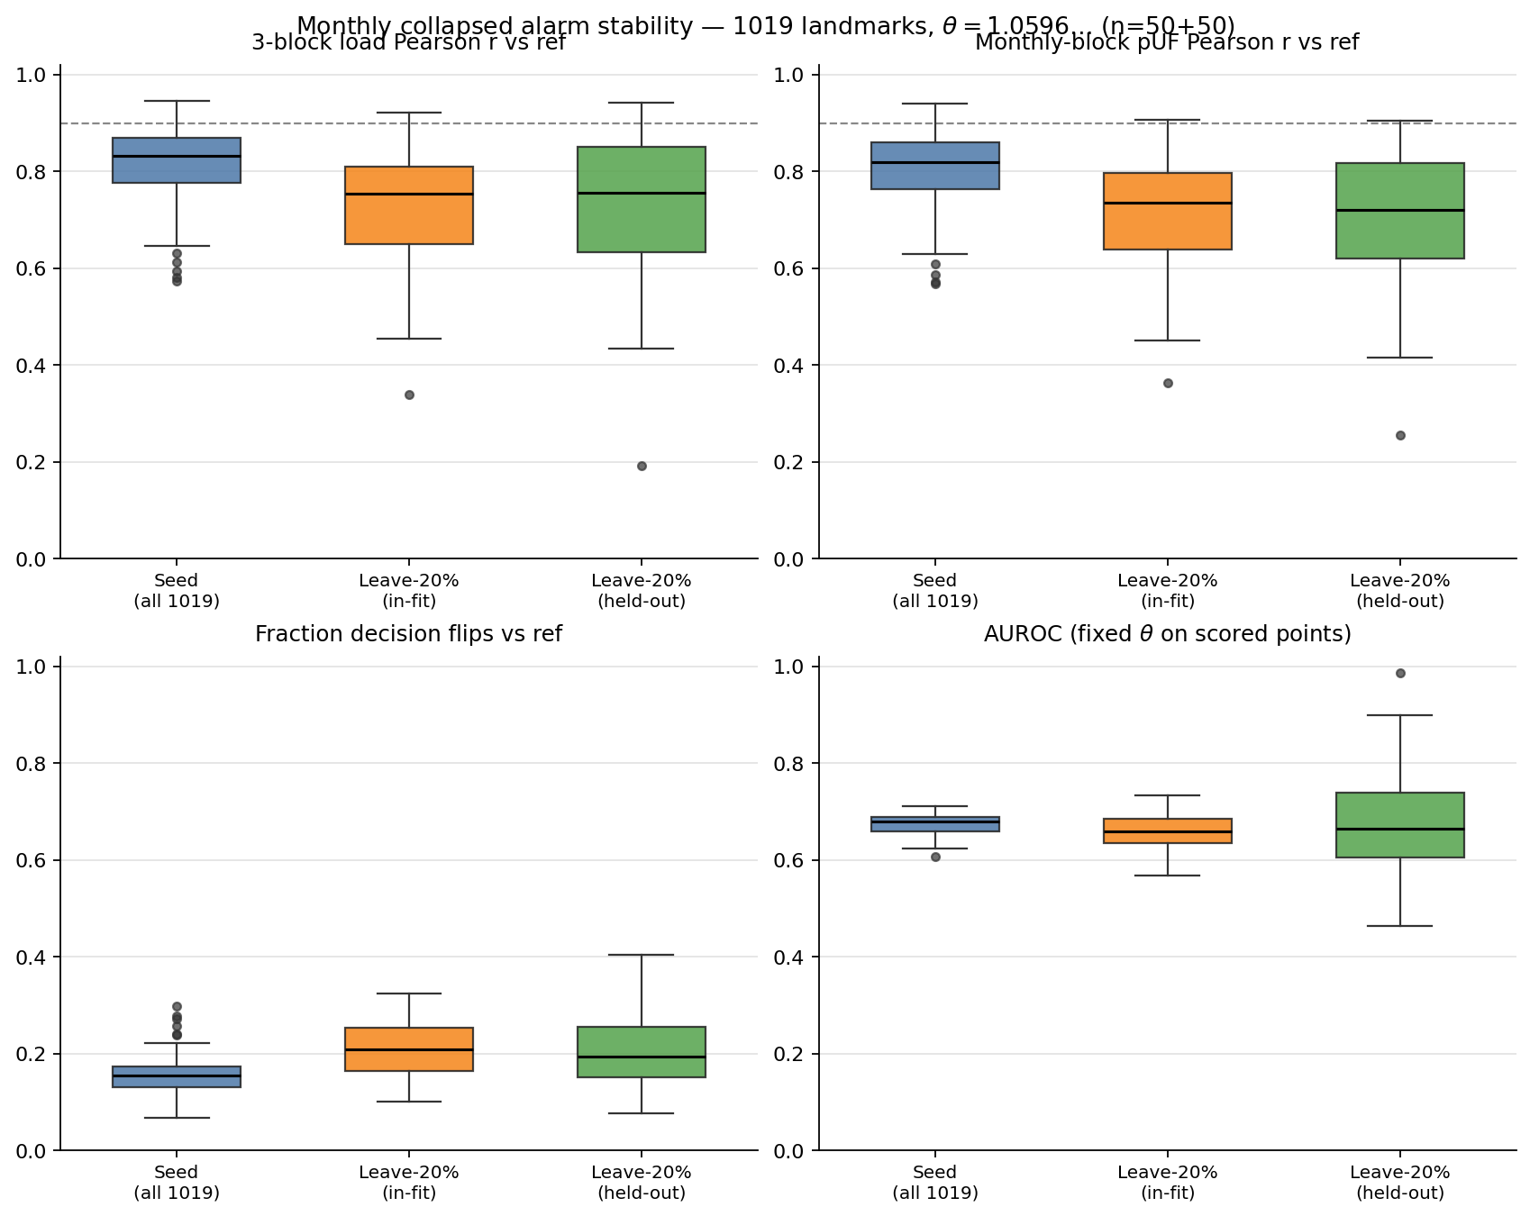
Reading. Seed re-fits keep load concordance high (median r 0.832). Leave-20%-out lowers it (~0.75) and raises flips (~20% vs ~16% seed). AUROC under the same fixed θ stays near the reference (~0.70). The operating point is not re-optimised.
Files. csv/monthly_alarm/ (headline_summary.json, per_replica_summary.csv, base_landmarks_1019_collapsed.csv, design_meta.json); figure: figures/lda_stability_monthly_alarm.*

6. Interpretation
- K = 6 maximises mean validation coherence among the candidates evaluated on audited DB1 embeddings. This verifies the original choice; the published reference remains the PMP-lock model.
- Level 1 (seed): topic–profile cosine and hypertopics remain highly concordant; global document pUF tracks the reference well under re-initialisation.
- Level 2 (leave-20%-out): cosine remains high for most topics/hypertopics under patient subsampling; heatmaps show which day-type profiles stay dominant (mean ± SD).
- Lock vs audited DB1 calendars are close for most patients (median difference 0 days); a minority of patients have larger span edits after audit.
- Monthly-block / alarm (§5): locked to base_analysis 1019 collapsed landmarks and Youden θ ≈ 1.0596 (same as granularity_report.docx §2). Seed load r ≈ 0.83; leave-20% ≈ 0.75; flips ≈ 16% / 20%; AUROC medians ≈ 0.66–0.68 near the reference ~0.70.

