Granularity on complete months, with the initial-shift adjustment of follow-up time
1. How the topic probabilities are obtained
Frozen LDA, six topics. pUF = P(3)+P(4)+P(5). No retraining.
Collapsed monthly. Non-overlapping blocks of 30 days. Month m ends on day T = 30m and is one LDA document.
pUF_m = P_m(3) + P_m(4) + P_m(5)
If the profile ends before T, the last month uses the last 30 profile days, which may overlap the previous month. The decision stays at T = 30m.
Daily series: densified, consecutive from the first daily day to the last. No gaps inside the profile. This is not an original measurement every day.
q(t) = pUF of days (t−30, t]
q(t) exists only when those 30 days are in the profile. First q at day 30. No zero-fill and no substitution by a neighbour.
B(t) is then the mean of three such posteriors, on contiguous windows that do not overlap:
B(t) = [ q(t−60) + q(t−30) + q(t) ] / 3
All three q must exist. If one is missing, that decision is dropped. The calendar is not shifted.
Granularity only chooses the reading days, from day 90: daily 90, 91, …; every 7 days 90, 97, …; every 14 days 90, 104, …; every 30 days 90, 120, …. A day past the end of the profile is left out.
fecha_inicio and fecha_fin come from clock_bbdd.xlsx. fecha_fin is the progression date if evento = 1 and the censoring date if evento = 0. In some patients the first day in DB1 is not the first day of digital data collection. Profiles and topics start on the first digital day. Day 1 is that day; day n is that date plus n−1. Labels, coverage, alerts and anticipation use this clock. The decision stays on day T.
Initial-shift adjustment of follow-up time. Tiempo_obs_DB1 counts from fecha_inicio to fecha_fin. Where digital collection starts later, that count includes days before the profile exists. t_evento_eb2 = Tiempo_obs_DB1 − (first daily day − fecha_inicio) = (fecha_fin − first daily day).days. When the two start dates coincide, t_evento_eb2 equals Tiempo_obs_DB1.
Day 1 is the first daily day, so the event falls on study day t_evento_eb2 + 1. The horizon uses that study day: the event enters if t_evento_eb2 + 1 ≤ T+120, which is at most 120 calendar days from the decision date to fecha_fin. A decision on or after the event's study day is excluded. Of the 116 patients who enter this report, 15 have this initial shift. The median shift in those 15 is 3 days.
2. Collapsed monthly analysis
Score: the last three monthly blocks.
B_m = (pUF_m−2 + pUF_m−1 + pUF_m) / 3 (m ≥ 3)
S_m = 3 B_m T = 30 m
Alarm if S_m ≥ θ, that is B_m ≥ θ/3. y = 1 if evento = 1 and t_evento_eb2 + 1 ≤ T+120; y = 0 if t_evento_eb2 + 1 ≥ T+120; otherwise the point is not included. Collapsed landmarks with a resolved outcome on Tiempo_obs_digital: 1,019, including the six end-of-profile months. Without those six: 1,013. The threshold and the discrimination rows below were fit on a previous collapsed set of 1,013 landmarks (114 patients, 155 positive and 858 negative, 45 events). They are not refit on the 1,019.
θ = 1.0596384140662845 θ/3 = 0.3532128046887615
Youden on that previous set of 1,013 landmarks. Single maximum, the value above. Bootstrap: 2,000 patient resamples, seed 20261020, cut fixed.

 | Value
Landmarks | 1,019
Without the six end-of-profile months | 1,013
Patients | 116
Positive / negative points | 159 / 860
Events | 47
AUROC | 0.702 (0.632–0.774)
Sensitivity | 0.884 (0.797–0.956)
Specificity | 0.451 (0.360–0.536)
PPV | 0.225 (0.170–0.289)
NPV | 0.956 (0.922–0.984)
TP / FN / FP / TN | 137 / 18 / 471 / 387

3. Same day: collapsed monthly score and daily series
The comparison uses the same decision day T = 30 × month (day 90, 120, 150, …). On that day the daily score is B(T) = [q(T−60) + q(T−30) + q(T)] / 3, and the three windows have to exist.
Collapsed landmarks with a resolved outcome on Tiempo_obs_digital are 1,019 (159 positive, 860 negative, 116 patients, 47 events), including six end-of-profile months. Those six have no daily B(T): 22001, 31003, 31005, 41022, 51008 and 71005. The profile ends before T. The collapsed month still has a score, because it uses the last 30 profile days and keeps the decision at T. q(T) does not exist. Removing them leaves 1,013, the same points as the every-30-day row (157 positive, 856 negative, 115 patients, 46 events). 22001 is positive only on that incomplete month. 71009 also ends before T. Its event study day is 79, so day 90 is not among the 1,019.
id | T | Last profile day | Days short of T | Interval used | Date of T | Date of last profile day
22001 | 420 | 408 | 12 | 379–408 (2024-07-25 to 2024-08-23) | 2024-09-04 | 2024-08-23
31003 | 360 | 347 | 13 | 318–347 (2024-12-29 to 2025-01-27) | 2025-02-09 | 2025-01-27
31005 | 360 | 357 | 3 | 328–357 (2025-03-22 to 2025-04-20) | 2025-04-23 | 2025-04-20
41022 | 150 | 132 | 18 | 103–132 (2024-11-17 to 2024-12-16) | 2025-01-03 | 2024-12-16
51008 | 180 | 179 | 1 | 150–179 (2025-01-17 to 2025-02-15) | 2025-02-16 | 2025-02-15
71005 | 90 | 83 | 7 | 54–83 (2024-06-18 to 2024-07-17) | 2024-07-24 | 2024-07-17
B(30m) = B_m

 | Value
Optimal threshold | 1.0902742012403903 θ/3 = 0.3634247337467968
Days with both scores | 1,013
Same points as every 30 days | 1,013
Maximum |monthly score − B(t)| | 1.7 × 10−9
AUROC, sensitivity, specificity | 0.700, 0.873, 0.458
TP / FN / FP / TN | 137 / 20 / 464 / 392

On these 1,013 days the two scores differ only by numerical noise; the maximum is in the table. The Youden cut in the table applies to both scores. It was not refit on these 1,013 days. Later sections use that cut and the event study day.
4. Granularity
Reading days from day 90, steps of 1, 7, 14 and 30. No calendar shift. Cut = the Youden cut above, not re-fit on the daily points. H = 120 on the event study day. These rows are decision points, not alerts. Values and intervals are in the tables.
Intervals: patient bootstrap, 2,000 resamples, seed 20261020, cut fixed, percentiles 2.5 and 97.5. Same draws across cadences.
Cadence | Evaluable | Patients | Events | Sens. | Spec. | TP / FN / FP / TN | AUROC
Daily | 28,632 | 115 | 47 | 0.843 (0.746–0.926) | 0.466 (0.381–0.550) | 3718 / 690 / 12929 / 11295 | 0.700 (0.618–0.770)
Weekly | 4,155 | 115 | 47 | 0.847 (0.749–0.931) | 0.464 (0.378–0.546) | 543 / 98 / 1885 / 1629 | 0.700 (0.618–0.769)
Every 14 days | 2,107 | 115 | 46 | 0.852 (0.759–0.931) | 0.461 (0.376–0.543) | 276 / 48 / 961 / 822 | 0.702 (0.621–0.770)
Every 30 days | 1,013 | 115 | 46 | 0.873 (0.786–0.947) | 0.458 (0.372–0.540) | 137 / 20 / 464 / 392 | 0.700 (0.622–0.768)

PPV and NPV at the same cut, with the same resamples.
Cadence | PPV | NPV
Daily | 0.223 (0.165–0.287) | 0.942 (0.903–0.974)
Weekly | 0.224 (0.166–0.286) | 0.943 (0.904–0.976)
Every 14 days | 0.223 (0.166–0.285) | 0.945 (0.907–0.975)
Every 30 days | 0.228 (0.171–0.292) | 0.951 (0.915–0.980)

ROC for the four cadences, same B(t), H = 120. AUC stays near 0.70: granularity changes how often the score is read.
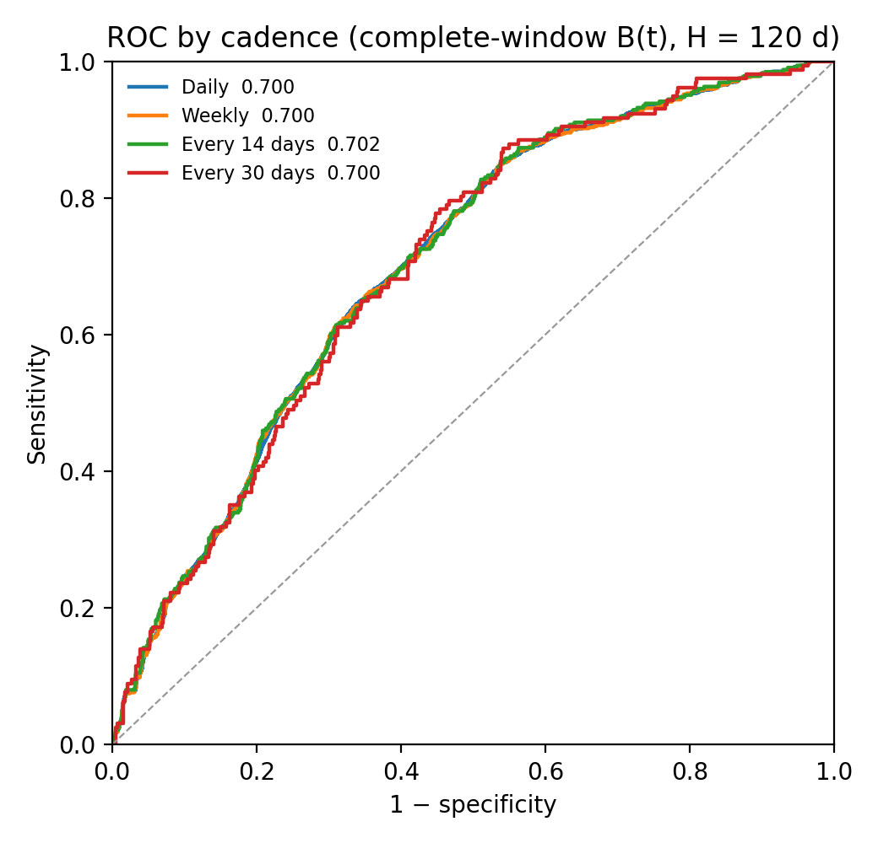
Figure. ROC by cadence for complete-window B(t), H = 120 days.
5. Coverage
The counts follow section 1. A missing window drops that decision.
Cadence | Calendar | A q is missing* | With B(t) | Unresolved outcome | In the metrics | Patients | Events
Daily | 40,142 | 2,288 | 37,854 | 9,222 | 28,632 | 115 | 47
Weekly | 5,820 | 335 | 5,485 | 1,330 | 4,155 | 115 | 47
Every 14 days | 2,950 | 170 | 2,780 | 673 | 2,107 | 115 | 46
Every 30 days | 1,414 | 83 | 1,331 | 318 | 1,013 | 115 | 46

Missing q: the profile has already ended. The densified series has no internal gaps; this is not an original measurement every day. Unresolved: B(t) exists, follow-up ends before T+120 and no event falls inside. Those points are not in the metrics. Events inside an evaluable horizon: 47 daily and weekly, 46 every 14 days and every 30 days. Section 6 uses the 47 progressions whose event study day is after day 90 and whose profile reaches day 90. 31010, 63003 and 91002 progress later, but the profile ends on days 54, 24 and 55, so they are not evaluable and are not in that denominator. 22001 is in the 47, and in the daily and weekly horizon, but not at a 14-day or month-end point.
6. Issued alerts, fixed 30-day block
Issued alert: a scheduled day in the profile with B ≥ 0.3634247337467968. It opens at the first such day a. Block [a, a+30). From a+30 the next scheduled day that is still positive opens another alert, even if the score never fell below the cut. Days 90, 97 and 104 are one alert; the next is day 120 on the daily and every-30-day cadences, and day 125 on the weekly cadence. A missing day on the densified series does not open an alert and does not cancel the block.
Judged from day a, horizon a+120. TP: event on or before a+120. FP: follow-up reaches a+120 and the event does not. NE: follow-up ends before a+120, with no event inside. NE is not an FP.
Each column is a separate count. NE stays in its column: not an FP, and not one of the 47. Clinical burden per 100 openings = (TP+FP+NE) / openings × 100. Every issued alert is included, because an NE alert would also have been reviewed. Evaluable-alert rate per 100 openings = (TP+FP) / openings × 100. NE stays out of that rate. Events detected: each of the 47 evaluable progressions once. The profile must reach day 90. No false-negative row, because a day below the cut does not open an alert. Specificity and NPV stay in section 4.
Opening: a scheduled day in the profile, with B(t) available, at least 30 days after the previous opening, and before observation ends. First opening at day 90; on the daily and every-30-day cadences the next is day 120. Openings are 1,331 daily, 1,159 weekly, 972 every 14 days and 1,331 every 30 days. Clinical burden = (TP+FP+NE) / openings × 100. Evaluable-alert rate = (TP+FP) / openings × 100. NE is not a false positive. Counts are in the table.
Intervals: the same patient bootstrap as in section 4, same draws on every cadence, on the evaluable-alert rate and on events detected. NE stays out of that rate and out of event detection. It is included only in the clinical burden.
Cadence | Total | TP | FP | Not evaluable | Clinical burden / 100 openings | Evaluable alerts / 100 openings | Events detected
Daily | 832 | 137 | 494 | 201 | 62.5 | 47.4 (40.8–54.2) | 43/47; 0.915 (0.830–0.979)
Weekly | 718 | 120 | 424 | 174 | 61.9 | 46.9 (40.4–53.6) | 43/47; 0.915 (0.830–0.979)
Every 14 days | 599 | 100 | 353 | 146 | 61.6 | 46.6 (40.2–53.2) | 42/47; 0.894 (0.787–0.979)
Every 30 days | 791 | 137 | 464 | 190 | 59.4 | 45.2 (38.5–52.0) | 43/47; 0.915 (0.830–0.979)

23003 has t_evento_eb2 = 206, so the progression falls on study day 207, with true-positive issued alerts on days 90, 120, 150 and 180: four TP rows, one detected event. The denominator is the 47 progressions with t_evento_eb2 + 1 after day 90 and a profile that reaches day 90.
7. Anticipation
Lead = (t_evento_eb2 + 1) − t_alarm. That equals the calendar days from the alarm date to fecha_fin. It is defined for the 47 progressions with t_evento_eb2 + 1 after day 90 and a profile that reaches day 90. An alarm more than 120 calendar days before the event is not a true positive.
First alarm: first scheduled day with B at or above the cut. It can sit outside the horizon. First true positive: first of those days with the event on or before t+120. The same two dates are read on issued alerts after the 30-day block. The first alarm does not move, because it opens the block. The first true positive can move later. Another alert can open at a+30 even if the score stayed positive.
Cell: median lead (IQR) and n. Of the 47 evaluable progressions, 45 have a first alarm. 23003 is detected on day 90 on every cadence: one lead of 117 days. 23004 and 71008 do not cross the cut.
 | Daily | Weekly | Every 14 days | Every 30 days
First alarm, any type | 152 (79–279), n=45 | 152 (79–279), n=45 | 152 (79–274), n=45 | 152 (79–274), n=45
First true positive | 120 (73–120), n=44 | 115 (73–117), n=44 | 109 (72–116), n=43 | 94 (72–112), n=43
First true-positive issued alert | 94 (72–115), n=43 | 93 (72–113.5), n=43 | 93 (68.5–106), n=42 | 94 (72–112), n=43

Paired by progression, on those detected by both cadences. For each progression, Δ = lead(first) − lead(second). Positive: the first cadence is earlier. Bootstrap: 2,000 resamples, same patients for both cadences, seed 20261020.
Comparison | Detected by both | Only the first | Only the second | First true positive | First true-positive issued alert
Daily − weekly | 42 | 53001 | 22001 | 0 (0–3) | 0 (0–2.5)
Daily − every 14 days | 42 | 53001 | — | 0.5 (0–5.5) | 0 (0–2.5)
Daily − every 30 days | 43 | — | — | 3 (1–11) | 0 (0–0)
Weekly − every 14 days | 42 | 22001 | — | 0 (0–0) | 0 (0–0)
Weekly − every 30 days | 42 | 22001 | 53001 | 1 (0–7.5) | 0 (0–0)
Every 14 − every 30 days | 42 | — | 53001 | 0 (0–5) | 0 (0–0)
Note. The last two columns are Δ = lead(first) − lead(second), only for progressions detected by both. First true positive: before the block. First true-positive issued alert: after the 30-day block. Another alert can open at a+30 even if the score stayed positive. Only the first and only the second are patient ids, not counts.

22001 is detected weekly, on day 405, and not daily: the alert opened on day 390 blocks until day 420, and the profile ends on day 408. A decision point on day 400 is a true positive and is not emitted. 53001 is detected daily and every 30 days, not weekly or every 14 days: day 118 falls inside the block opened on day 90.

8. Example trajectories (TP, FP, TN, FN)
One patient per class, monthly landmarks, B ≥ 0.3634. Green: the alarm used for the class. For TP, the first true-positive alarm with progression within 120 days, not an earlier alarm outside the horizon. Black: progression. An incomplete last month is drawn at the follow-up day.

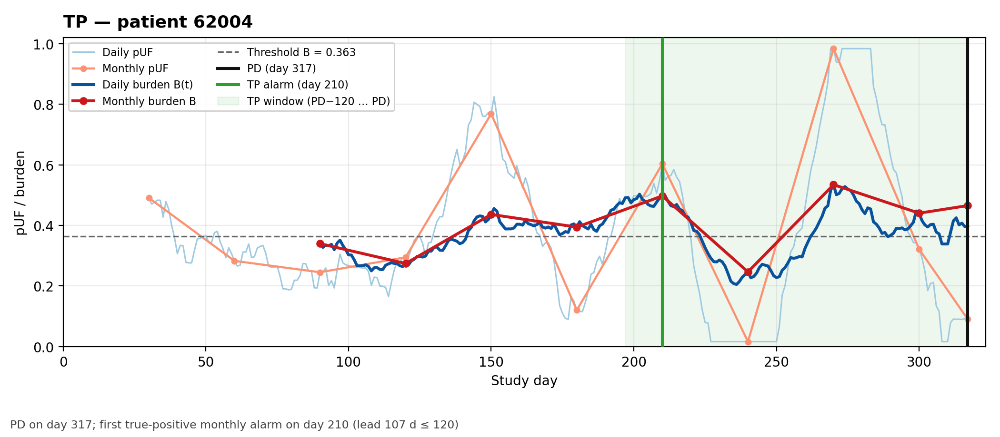
Figure. TP — patient 62004. t_evento_eb2 = 317, so the progression is study day 318; first true-positive monthly alarm on day 210 (lead 108 calendar days)
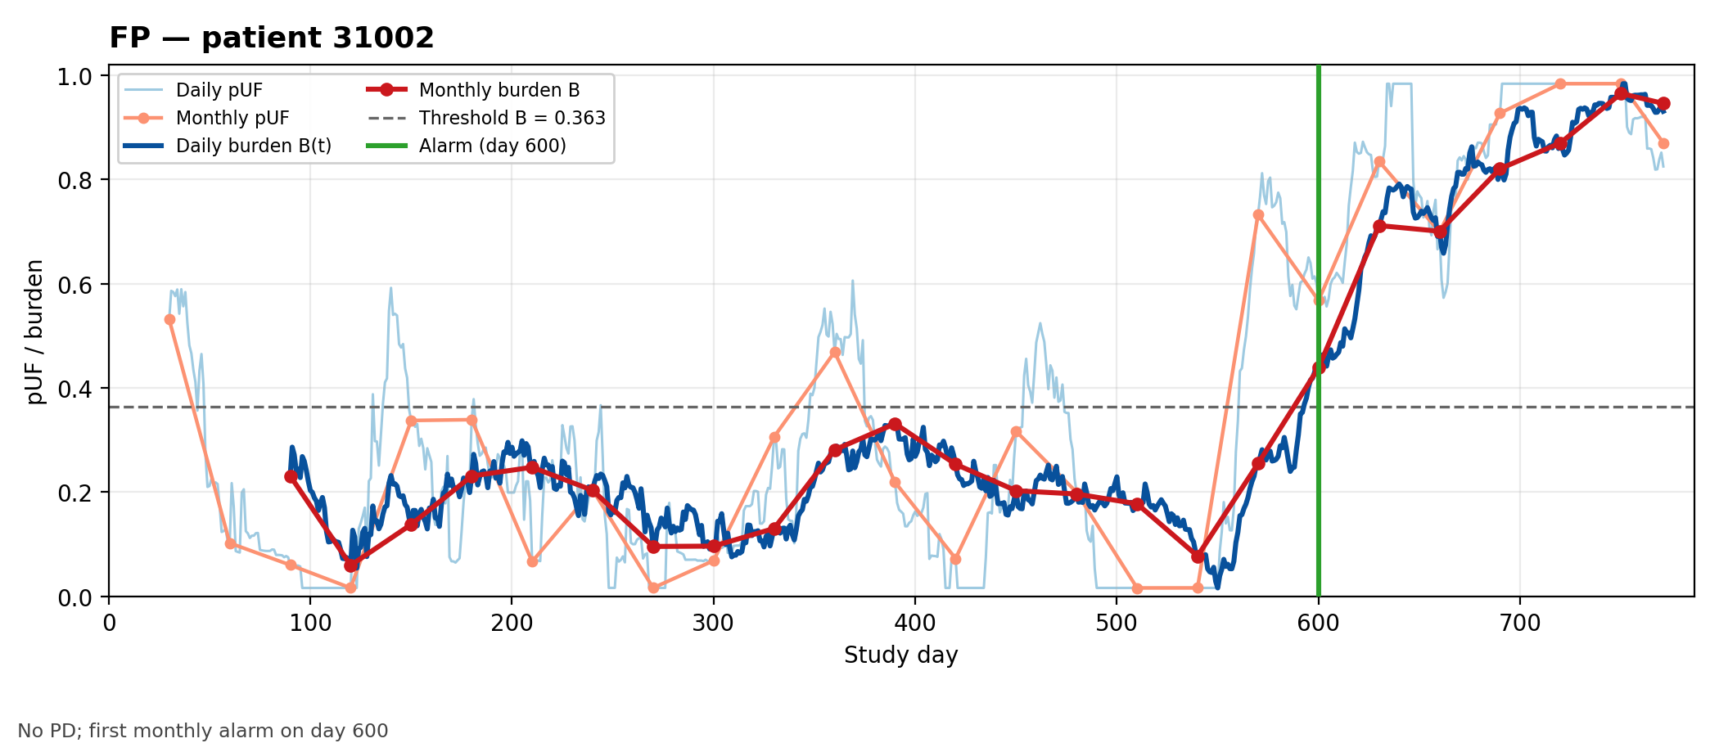
Figure. FP — patient 31002. No PD; first monthly alarm on day 600
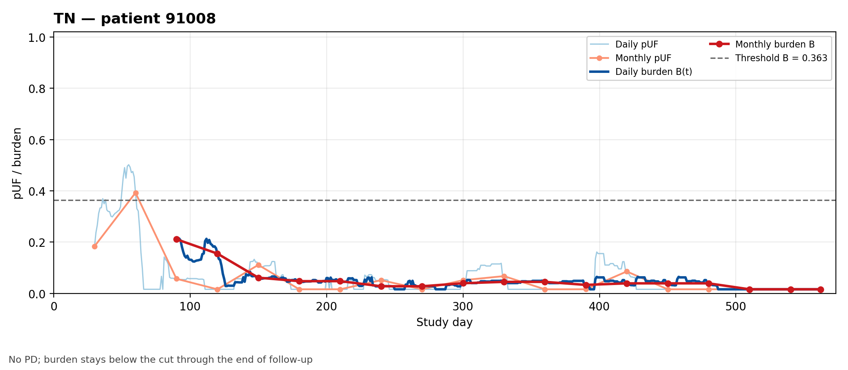
Figure. TN — patient 91008. No PD; burden stays below the cut through the end of follow-up
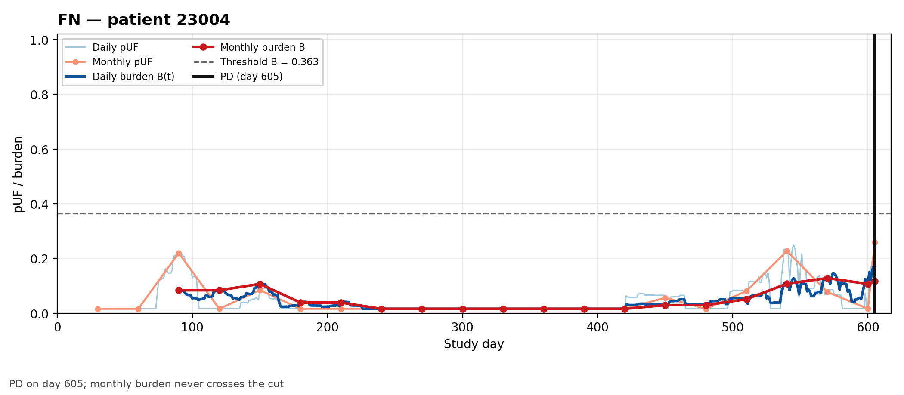
Figure. FN — patient 23004. t_evento_eb2 = 605, so the progression is study day 606; monthly burden never crosses the cut

9. Alternative pUF metrics on the 1,013 evaluable monthly landmarks
Descriptive metrics for the previous collapsed set named in section 2 (1,013 landmarks, 155 positive, 858 negative, 114 patients). Only the last three monthly pUF values; no extra windows. Descriptive: definition, mean, SD and AUROC. No Mann–Whitney test. A comparison of these repeated points would have to account for clustering by patient.
Metric | Mean event | Mean no-event | SD event | SD no-event | AUROC
auc | 0.652 | 0.435 | 0.262 | 0.305 | 0.702
std | 0.119 | 0.113 | 0.093 | 0.085 | 0.512
slope | -0.002 | 0.004 | 0.138 | 0.140 | 0.499
n_changepoints | 1.000 | 0.983 | 0.000 | 0.131 | 0.509
n_threshold_crossings_0.5 | 0.239 | 0.195 | 0.428 | 0.396 | 0.522
n_threshold_crossings_0.6 | 0.245 | 0.188 | 0.432 | 0.391 | 0.529
n_threshold_crossings_0.7 | 0.277 | 0.179 | 0.449 | 0.384 | 0.549
n_threshold_crossings_0.8 | 0.245 | 0.143 | 0.432 | 0.351 | 0.551
auc = mean(pUF_a, pUF_b, pUF_c) = AUC_W/3 = B_m. On a complete month this is B, up to numerical noise. Changepoint: at most one split of the three values, and only if it explains at least 10% of the variance.
Metric definitions
- auc. Mean of the three monthly pUF values (AUC_W/3). This is the monthly burden B_m.
- std. Dispersion of the three monthly pUF values.
- slope. Linear slope over the three months.
- n_changepoints. At most one split of the three values, only if it explains ≥ 10% of the variance.
- n_threshold_crossings_τ. Upward crossings of τ ∈ {0.5, 0.6, 0.7, 0.8} between consecutive months.
auc has the highest AUROC. The other values are in the table. The changepoint row is the three-value indicator above.

