Granularity on complete months
1. How the topic probabilities are obtained
The same frozen LDA is used throughout. It assigns six topic probabilities. pUF is the sum of topics 3, 4 and 5. No model is retrained.
Collapsed monthly. Time from the start of the study is split into fixed blocks of 30 days. Complete months do not overlap. Month m is the block that ends on day T = 30m. That block is one document, and the LDA returns one set of topic probabilities for it.
pUF_m = P_m(3) + P_m(4) + P_m(5)
If the profile ends before day T, that last month is kept. Its block is the last 30 days of the profile. Days missing from that month are taken from the previous month, so the window has 30 days. The decision stays at T = 30m. This is the window used for the monthly probabilities.
Daily series. The series used here is the processed one. Inside the profile, days run consecutively from the first day with data to the last. There are no gaps in that densified series. This does not mean an original measurement was available every day. q(t) is the pUF of the 30 days ending at t, from the same LDA.
q(t) = pUF of days (t−30, t]
q(t) is calculated only when those 30 days are in the profile. The first possible q is at day 30. If the window is not complete, q(t) is not calculated: nothing is filled with zeros and the day is not replaced by a neighbour.
B(t) is then the mean of three such posteriors, on contiguous windows that do not overlap:
B(t) = [ q(t−60) + q(t−30) + q(t) ] / 3
All three must exist. If one is missing, B(t) is not calculated and that decision is dropped. The calendar is not shifted.
Granularity does not change this score. It only chooses the days on which B(t) is read, starting at day 90: every day (90, 91, 92, …), every 7 days (90, 97, 104, …), every 14 days (90, 104, 118, …) and every 30 days (90, 120, 150, …). On the sliding series, B(t) is calculated only for days on which the three windows are present. A scheduled day past the end of the profile is left out.
Study day 0 is fecha_inicio in data/revision/clock_bbdd.xlsx (Fecha_inicio_actualizada). Study day t is that calendar date plus t days. fecha_fin is the progression date if evento = 1 and the censoring date if evento = 0. t_evento = (fecha_fin − fecha_inicio).days. A decision on day T is the clinical date fecha_inicio + T days, which is not moved to the last day of the profile.
2. Collapsed monthly analysis
One LDA block per month, with no overlap between months. The score uses the last three blocks.
B_m = (pUF_m−2 + pUF_m−1 + pUF_m) / 3 (m ≥ 3)
S_m = 3 B_m T = 30 m
B_m is the score. An alarm is raised if S_m ≥ θ, that is if B_m ≥ θ/3. The horizon is 120 days. y = 1 if an event falls within those 120 days; y = 0 if follow-up covers them. If follow-up ends earlier, the point is not included. The 1,016 points include the 7 incomplete final months.
θ = 1.0596384140662845 θ/3 = 0.3532128046887615
A single maximum. Intervals are a 2,000-resample patient bootstrap, with the cut held fixed.
 | Value
Points | 1,016
Patients | 116
Positive / negative points | 156 / 860
Events | 45
AUROC | 0.700 (0.620–0.773)
Sensitivity | 0.878 (0.792–0.952)
Specificity | 0.450 (0.361–0.534)
PPV | 0.225 (0.171–0.288)
NPV | 0.953 (0.917–0.981)
TP / FN / FP / TN | 137 / 19 / 473 / 387

3. Same day: collapsed monthly score and daily series
On a complete month, day T = 30m of the monthly score is day t of B(t): day 90 uses q(30), q(60) and q(90); day 120 uses q(60), q(90) and q(120). Seven of the 1,016 months end before day T, so they have no daily B(t). The comparison is the other 1,009.
Those seven stay in the 1,016. The interval used for each one is the last 30 profile days, and the decision stays at T. They are excluded from B(t) because study day T is not in the profile, so q(T) does not exist. No day after the end of the profile is added.
For 71009, fecha_inicio is 2024-12-30. Study day 79 is 2025-03-19 and study day 90 is 2025-03-30. Both are before the profile, so the landmark stays excluded. The 79 profile days run from 2025-06-25 to 2025-09-11, and the probabilities for that month use 2025-08-13 to 2025-09-11.
id | T | Last profile day | Days short of T | Interval used | Date of T | Date of last profile day
22001 | 420 | 408 | 12 | 379–408 (2024-07-25 to 2024-08-23) | 2024-09-04 | 2024-08-23
31003 | 360 | 347 | 13 | 318–347 (2024-12-29 to 2025-01-27) | 2025-02-09 | 2025-01-27
31005 | 360 | 357 | 3 | 328–357 (2025-03-22 to 2025-04-20) | 2025-04-23 | 2025-04-20
41022 | 150 | 132 | 18 | 103–132 (2024-11-17 to 2024-12-16) | 2025-01-03 | 2024-12-16
51008 | 180 | 179 | 1 | 150–179 (2025-01-17 to 2025-02-15) | 2025-02-16 | 2025-02-15
71005 | 90 | 83 | 7 | 54–83 (2024-06-18 to 2024-07-17) | 2024-07-24 | 2024-07-17
71009 | 90 | 79 | 11 | 2025-08-13 to 2025-09-11 | 2025-03-30 | 2025-09-11
B(30m) = B_m
 | Value
Optimal threshold | 1.0902742012403903 θ/3 = 0.3634247337467968
Same days | 1,009
Maximum |monthly score − B(t)| | 1.7 × 10−9
AUROC, sensitivity, specificity | 0.699, 0.870, 0.457
TP / FN / FP / TN | 134 / 20 / 464 / 391

On 973 points the difference is zero. On the other 36, one of the three blocks differs in the last digits of the pUF: the same 30-day block and the same LDA model, inferred twice. There are 24 such blocks. After averaging, the score moves by at most 1.7 × 10−9. The optimal threshold on these 1,009 points is θ = 1.0902742012403903, that is B ≥ 0.3634247337467968. It applies to both series.
4. Granularity
The same B(t) is read every day, every 7 days, every 14 days and every 30 days, starting at day 90. The calendar is not shifted when a day is missing. The cut is not re-estimated: B ≥ 0.3634247337467968. This value is the Youden cut on the 1,009 complete monthly points. It is applied unchanged to the daily, weekly, every-14-day and every-30-day readings. It is not re-estimated on the daily points. The horizon is 120 days from that decision. These metrics count decision points, not alerts.
Intervals are a 2,000-resample patient bootstrap, seed 20261020, with this cut held fixed. The reported interval is the 2.5 and 97.5 percentiles. Comparisons between cadences use the same resamples.
Cadence | Evaluable | Patients | Events | Sens. | Spec. | TP / FN / FP / TN | AUROC
Daily | 28,603 | 114 | 45 | 0.842 (0.744–0.928) | 0.465 (0.375–0.547) | 3696 / 692 / 12951 / 11264 | 0.700 (0.626–0.776)
Weekly | 4,140 | 114 | 45 | 0.845 (0.748–0.932) | 0.462 (0.372–0.544) | 534 / 98 / 1886 / 1622 | 0.700 (0.627–0.775)
Every 14 days | 2,101 | 114 | 44 | 0.850 (0.757–0.930) | 0.459 (0.370–0.540) | 271 / 48 / 964 / 818 | 0.702 (0.629–0.776)
Every 30 days | 1,009 | 114 | 44 | 0.870 (0.781–0.943) | 0.457 (0.368–0.540) | 134 / 20 / 464 / 391 | 0.699 (0.628–0.772)

Positive and negative predictive values at the same fixed cut. The intervals use the patient resamples above.
Cadence | PPV | NPV
Daily | 0.222 (0.165–0.288) | 0.942 (0.903–0.975)
Weekly | 0.221 (0.163–0.286) | 0.943 (0.904–0.976)
Every 14 days | 0.219 (0.164–0.284) | 0.945 (0.908–0.976)
Every 30 days | 0.224 (0.169–0.289) | 0.951 (0.917–0.980)
Difference, first cadence minus second. A positive value means the first cadence is higher. Discrimination resamples the 114 patients who have an evaluable point. Event detection resamples the 48 progressions. Burden resamples the 137 patients who have at least one possible opening. Within each column the four cadences use the same draws. The burden here is the one in section 6: true positives plus false positives, per 100 possible openings. Issued alerts that cannot be judged are not in that numerator.
Comparison | Δ AUROC | Δ sensitivity | Δ PPV | Δ events detected | Δ burden / 100 openings
Daily − Weekly | 0.000 (-0.002–0.003) | -0.003 (-0.012–0.006) | 0.001 (-0.001–0.004) | 0.000 (-0.062–0.062) | 0.3 (-0.4–0.9)
Daily − Every 14 days | -0.001 (-0.007–0.004) | -0.007 (-0.020–0.005) | 0.003 (-0.003–0.008) | 0.021 (0.000–0.062) | 0.4 (-0.5–1.4)
Daily − Every 30 days | 0.001 (-0.011–0.012) | -0.028 (-0.048–-0.008) | -0.002 (-0.010–0.006) | 0.000 (0.000–0.000) | 2.3 (1.5–3.2)
Weekly − Every 14 days | -0.002 (-0.006–0.003) | -0.005 (-0.015–0.006) | 0.001 (-0.003–0.006) | 0.021 (0.000–0.062) | 0.2 (-0.7–1.1)
Weekly − Every 30 days | 0.001 (-0.011–0.011) | -0.025 (-0.047–-0.003) | -0.003 (-0.011–0.004) | 0.000 (-0.062–0.062) | 2.0 (1.1–3.0)
Every 14 days − Every 30 days | 0.002 (-0.008–0.013) | -0.021 (-0.040–-0.002) | -0.005 (-0.012–0.002) | -0.021 (-0.062–0.000) | 1.8 (0.9–2.8)
At every 30 days, the evaluable points are the 1,009 complete months. Daily and weekly decisions are not taken at month end: a case dropped there can still enter on an earlier day or week, if the profile is still open and progression falls within 120 days. A profile that does not reach day 90 enters no cadence.
ROC curves for the four cadences (same B(t) and horizon of 120 days). The AUCs stay near 0.70; granularity mainly changes how often the score is read, not discrimination.
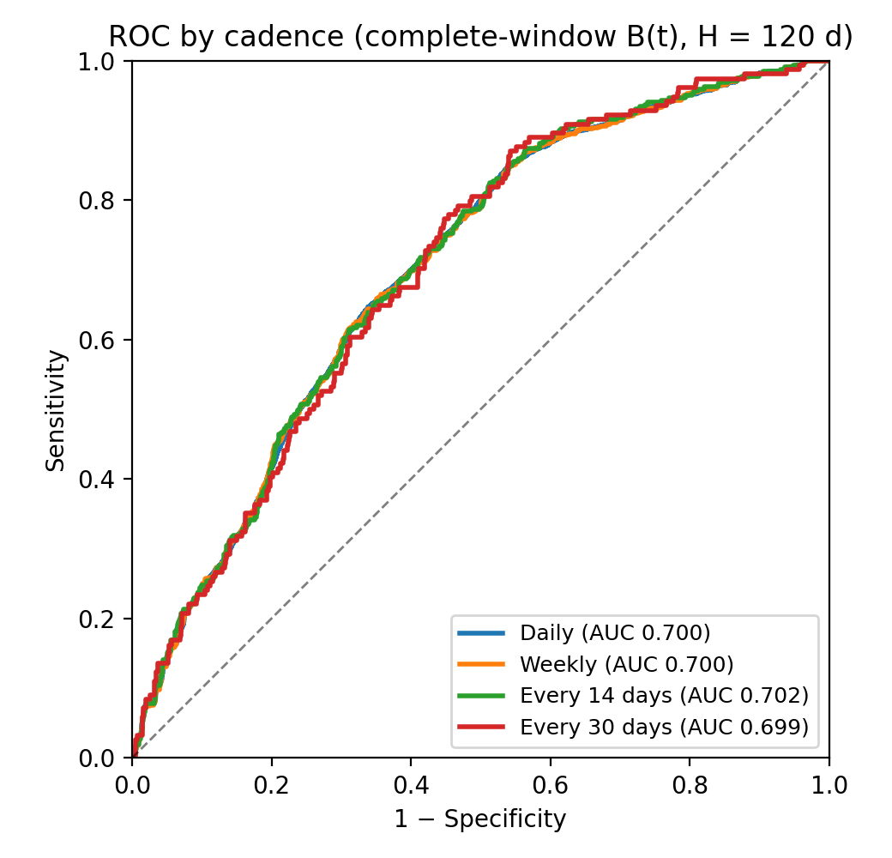
Figure. ROC by cadence for complete-window B(t), H = 120 days.
5. Coverage
The counts below apply the restrictions in section 1. q(t) requires its 30-day window. B(t) requires the three windows. A missing window drops that decision.
Cadence | Calendar | A q is missing* | With B(t) | Unresolved outcome | In the metrics | Patients | Events
Daily | 40,424 | 2,671 | 37,753 | 9,150 | 28,603 | 114 | 45
Weekly | 5,845 | 384 | 5,461 | 1,321 | 4,140 | 114 | 45
Every 14 days | 2,959 | 194 | 2,765 | 664 | 2,101 | 114 | 44
Every 30 days | 1,421 | 94 | 1,327 | 318 | 1,009 | 114 | 44

* A q is missing only because the profile has already ended while the calendar continues. There are no missing days inside the profile. That statement refers to the densified series, not to an original measurement on every day. Unresolved outcome: B(t) exists, but follow-up ends before 120 days and no event falls inside that window. Those points are not included in the metrics. The event count here, and in section 4, is the number of progressions that fall inside the horizon of an evaluable point: 45 on the daily and weekly cadences, 44 every 14 days and every 30 days. The 48 in section 6 are all progressions after day 90. Four of them are not in the 44: 22001, whose event falls inside a daily and a weekly horizon but not inside a complete month-end, and 63003, 91002 and 31010, whose profiles end before day 90 and so never have an evaluable point.
6. Issued alerts, fixed 30-day block
An issued alert opens only on a scheduled day with an alarm, B ≥ 0.3634247337467968, and only when that day is in the profile. The first such day, a, opens it. The block is fixed at 30 days: no other alert opens during [a, a+30). From day a+30, the next scheduled day that is still positive opens another one, even if the score never fell below the cut. Days 90, 97 and 104 are one issued alert. If the score remains positive, the next is day 125 on the weekly cadence and day 120 on the daily cadence and on the every-30-day cadence. A missing day on the densified series does not open an alert and does not cancel the block.
Each issued alert is judged from its opening day a, with its own horizon of 120 days. True positive: the event falls on or before day a+120. False positive: follow-up reaches day a+120 and the event does not fall inside. Not evaluable: follow-up ends before day a+120, with no event inside. That issued alert is not a false positive.
Each column is a separate count. Total is every issued alert that opens. True positive: the event falls on or before day a+120. False positive: follow-up reaches day a+120 and the event does not fall inside. Not evaluable: follow-up ends before day a+120, with no event inside. Those issued alerts stay in that column. They are not added to the false positives. They come from censored patients, so none of them is one of the 48 progressions. Burden per 100 openings uses only the issued alerts that can be judged. Its numerator is true positives plus false positives. Its denominator is every opening the cadence could place, whether or not the score is above the cut. Events detected counts each progression once. The denominator is the 48 progressions after day 90. The numerator is how many of those 48 have at least one true-positive issued alert. A day below the cut does not open an issued alert, so there is no false-negative row. Specificity and NPV stay with the decision points in section 4.
A possible opening is a scheduled day in the profile, with B(t) available, at least 30 days after the previous opening, and before observation ends. Clinical days after the profile has closed are not openings. Reaching day 90 assigns the first one. On the daily cadence and on the every-30-day cadence the next is day 120. There are 1,327 possible openings on those two cadences, 1,152 on the weekly cadence and 966 on the every-14-day cadence. Burden = (true positives + false positives) / possible openings × 100. Daily: (135 + 493) / 1,327 × 100 = 47.3. The 203 not-evaluable issued alerts are not in the 628. Weekly: (118 + 424) / 1,152 × 100 = 47.0. The 174 not-evaluable issued alerts are not in the 542. Every 14 days: (98 + 355) / 966 × 100 = 46.9. The 143 not-evaluable issued alerts are not in the 453. Every 30 days: (134 + 464) / 1,327 × 100 = 45.1. The 191 not-evaluable issued alerts are not in the 598.
The interval on the burden and the interval on events detected come from the same patient bootstrap, 2,000 resamples, seed 20261020, with the same draws on every cadence. The reported interval is the 2.5 and 97.5 percentiles. Event detection resamples the 48 progressions. Burden resamples the 137 patients who have at least one possible opening. The not-evaluable issued alerts stay out of both.
Cadence | Total | TP | FP | Not evaluable | Burden / 100 openings | Events detected
Daily | 831 | 135 | 493 | 203 | 47.3 (40.5–54.0) | 42/48; 0.875 (0.771–0.958)
Weekly | 716 | 118 | 424 | 174 | 47.0 (40.5–53.7) | 42/48; 0.875 (0.771–0.958)
Every 14 days | 596 | 98 | 355 | 143 | 46.9 (40.4–53.5) | 41/48; 0.854 (0.750–0.938)
Every 30 days | 789 | 134 | 464 | 191 | 45.1 (38.4–51.8) | 42/48; 0.875 (0.771–0.958)

Events detected counts each progression once. Patient 23003 progresses on day 209 and has true-positive issued alerts on days 90, 120, 150 and 180: four rows in the TP column, one detected event. The cohort has 60 progressions. Twelve fall on day 90 or earlier, before an issued alert can open, and are excluded. The other 48 are the denominator. A detected event is one of those 48 with at least one true-positive issued alert. An event whose issued alerts all fall more than 120 days before progression is not detected. These 48 are not the event counts in sections 4 and 5. Those keep only a progression that falls inside an evaluable point. Every 30 days that leaves 44. The other four are 22001, caught on a daily and a weekly day but not at a complete month-end, and 63003, 91002 and 31010, whose profiles end before day 90.
7. Anticipation
Lead time is t_event − t_alarm, in days. It is defined for the 48 progressions after day 90. An alarm more than 120 days before the event does not become a true positive if the patient progresses later.
Three dates are kept apart. First alarm of any type: the first scheduled day with B at or above the cut. It describes the trajectory, and it can sit far outside the horizon. First true positive: the first of those days with the event on or before day t+120. The same two dates are then read on the issued alerts that remain after the fixed 30-day block. The first alarm of any type does not move: that alarm is what opens the block. The first true positive can move later, or disappear, when the block covers the first positive day inside the horizon. Another issued alert can open at day a+30 even if the score stayed positive.
The figure in each cell is the median lead time, the interquartile range, and the number of progressions that have that date. Of the 48, 44 have a first alarm. Patient 23003 is detected on day 90 on every cadence, so the four true-positive issued alerts in section 6 are one lead time of 119 days.
 | Daily | Weekly | Every 14 days | Every 30 days
First alarm, any type | 163 (82–281), n=44 | 161 (82–281), n=44 | 161 (82–277), n=44 | 159 (82–277), n=44
First true positive | 120 (76–120), n=43 | 115 (76–118), n=43 | 109 (74–115), n=42 | 94 (74–113), n=42
First true-positive issued alert | 94 (74–114), n=42 | 93 (74–113), n=42 | 94 (69–105), n=41 | 94 (74–113), n=42

Anticipation is compared on the progressions detected by both cadences. A detected progression has a true-positive issued alert. Events detected by only one cadence are listed apart and are not in the difference. For each shared event the difference is the lead time on the first cadence minus the lead time on the second, in days. A positive value means the first cadence alarms earlier. The table gives the median of those paired differences, and the denominator is the progressions detected by both cadences. That paired median is not the first cadence's median minus the second cadence's median, and it is not the gain of one patient. On the decision points the daily median is 120 days and the every-30-day median is 94 days. Subtracting them gives 26 days. The paired median on the shared events is 4.5 days (1.5–10.5). Intervals are a 2,000-resample bootstrap that draws the same patients for both cadences, seed 20261020.
Comparison | Detected by both | Only the first | Only the second | First true positive | First true-positive issued alert
Daily − weekly | 41 | 53001 | 22001 | 1 (0–1) | 0 (0–4)
Daily − every 14 days | 41 | 53001 | — | 1 (0–5) | 0 (0–5)
Daily − every 30 days | 42 | — | — | 4.5 (1.5–10.5) | 0 (0–0)
Weekly − every 14 days | 41 | 22001 | — | 0 (0–0) | 0 (0–0)
Weekly − every 30 days | 41 | 22001 | 53001 | 2 (0–8) | 0 (0–0)
Every 14 − every 30 days | 41 | — | 53001 | 0 (0–8) | 0 (0–0)
Note. The last two columns are not the absolute lead time. They are the paired difference in lead time (t_event − t_alert) between the first and the second cadence, only for progressions detected by both: Δ = lead(first) − lead(second). A positive value means the first cadence alerts earlier. The cell is the median and a bootstrap interval (2,000 resamples). That paired median is not the subtraction of the two marginal medians, and it is not one patient's gain. On the decision points the daily median is 120 days and the every-30-day median is 94 days. Subtracting them gives 26 days. The paired median is 4.5 days (1.5–10.5). First true positive: the first true-positive alert on the calendar, before the block. First true-positive issued alert: the first true positive after the fixed 30-day block. Another alert can open at day a+30 even if the score stayed positive. Only the first / only the second: patient ids detected by one cadence only. They are not counts.

Detected only by one cadence: 22001 is detected weekly, on day 405, and not daily, because the issued alert opened on day 390 blocks until day 420 and the profile ends on day 408. A decision point on day 400 is a true positive and is not emitted. 53001 is detected daily and every 30 days, and not weekly or every 14 days, because the positive day 118 falls inside the block opened on day 90. On the shared events, the issued-alert lead times differ by a median of 0 days. On the decision points, the paired daily true positive is 4.5 days earlier than the every-30-day one (1.5–10.5).

8. Example trajectories (TP, FP, TN, FN)
One patient per confusion class (B ≥ 0.3634 on monthly landmarks). Curves: daily/monthly pUF and burden. Green = alarm used for the class (for TP: first true-positive alarm with PD within H = 120 d, not an earlier alarm outside the horizon); black = PD. Incomplete last month is drawn at the follow-up day.
Class | Patient | Why this case
TP | 62004 | PD on day 317; first true-positive monthly alarm on day 210 (lead 107 d ≤ 120)
FP | 31002 | No PD; first alarm on day 600
TN | 91008 | No PD; never crosses the cut through the end
FN | 23004 | PD day 605; never crosses the cut

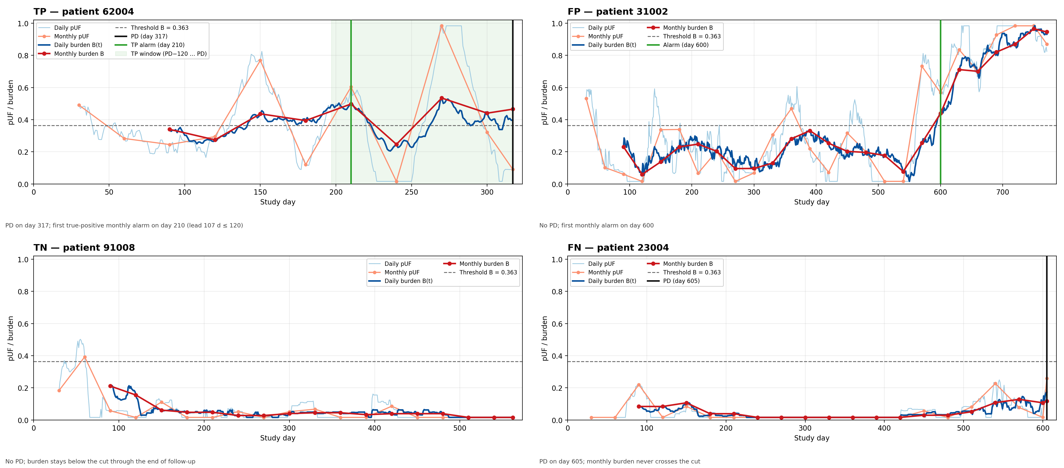
Figure. TP / FP / TN / FN — for TP the green line is the first alarm inside the 120-day horizon.
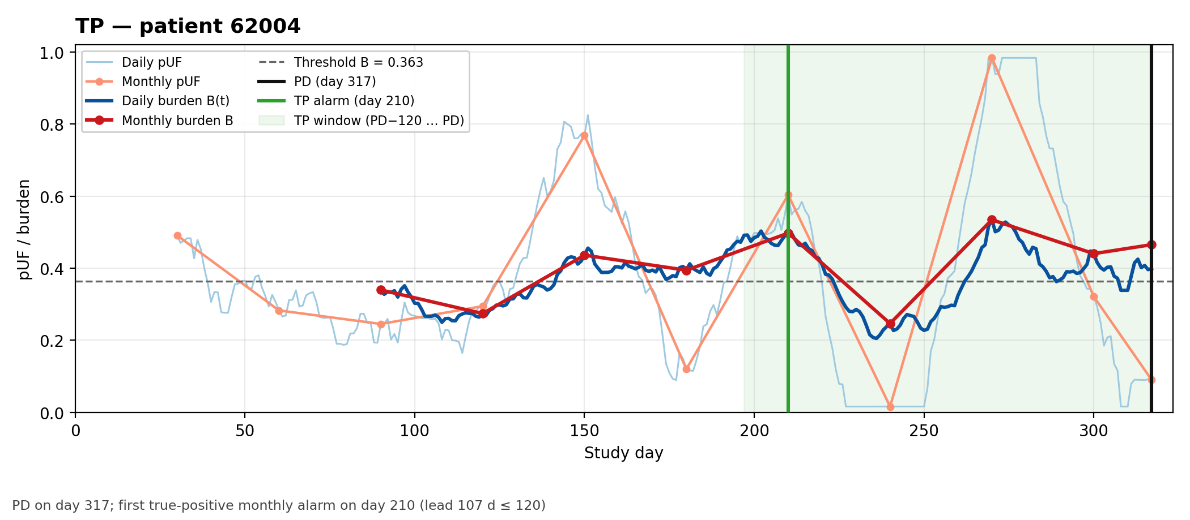
Figure. TP — patient 62004. PD on day 317; first true-positive monthly alarm on day 210 (lead 107 d ≤ 120)
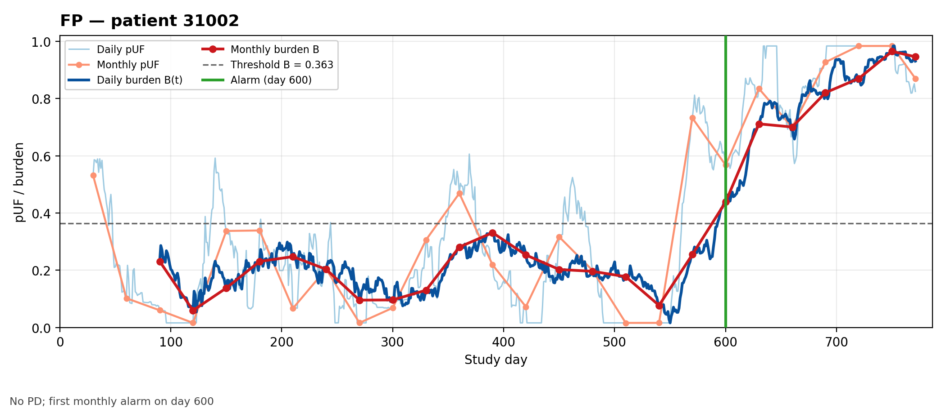
Figure. FP — patient 31002. No PD; first monthly alarm on day 600
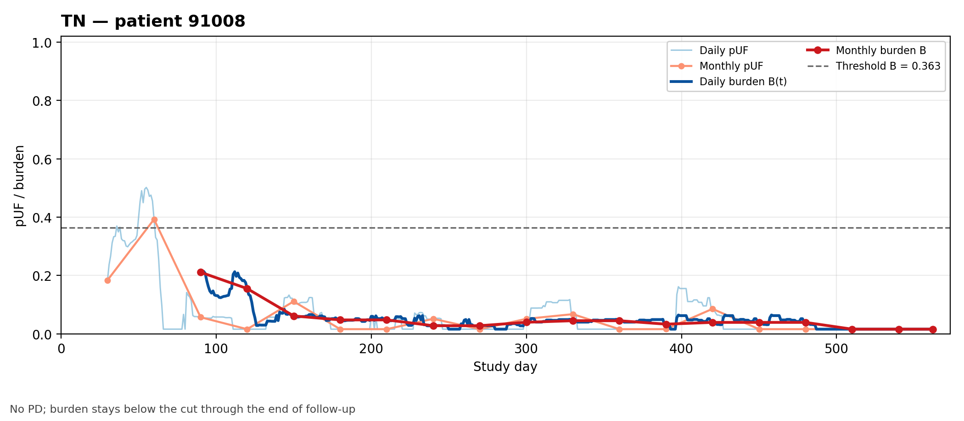
Figure. TN — patient 91008. No PD; burden stays below the cut through the end of follow-up
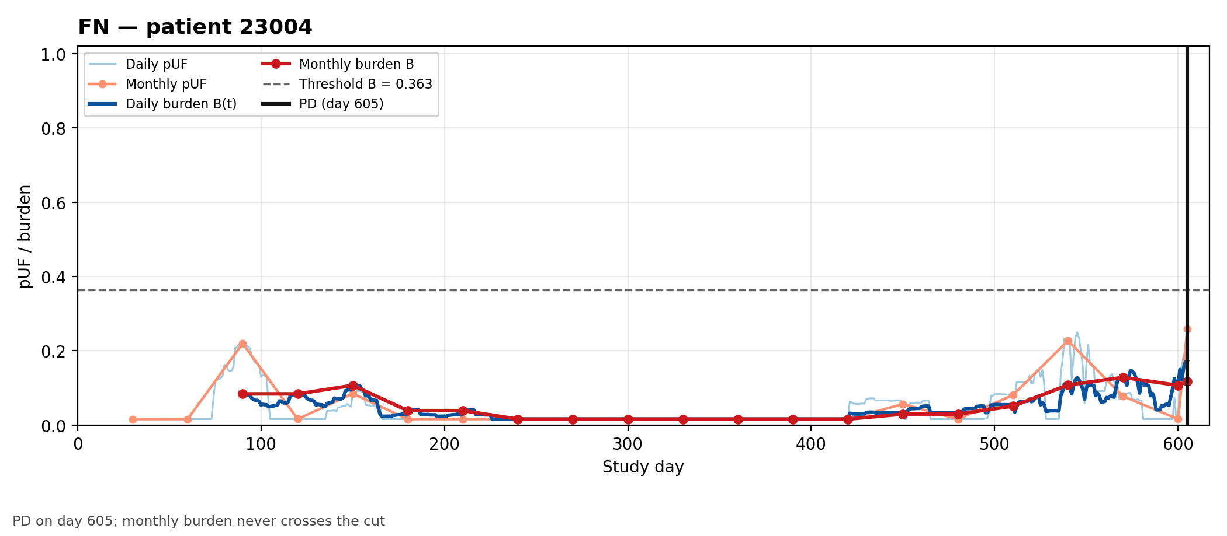
Figure. FN — patient 23004. PD on day 605; monthly burden never crosses the cut

9. Alternative pUF metrics on the same 1,016 monthly landmarks
Same decision points as the monthly W = 3 / H = 4 analysis (n = 1,016; 156 positive, 860 negative). No extra calendar windows (no “first 60/90 days”): at each landmark only the last three monthly pUF values are turned into different scalars. This block is descriptive. It keeps the definition of each scalar, the mean and the standard deviation on event and no-event points, and the AUROC of that scalar on the same labels. Mann–Whitney p-values and significance stars on these repeated points are not reported. Any inferential comparison of these metrics would have to account for clustering by patient. The granularity comparison is not extended here.
Metric | Mean event | Mean no-event | SD event | SD no-event | AUROC
auc | 0.650 | 0.435 | 0.262 | 0.306 | 0.700
std | 0.119 | 0.113 | 0.093 | 0.085 | 0.512
slope | -0.001 | 0.004 | 0.138 | 0.140 | 0.502
n_changepoints | 1.000 | 0.983 | 0.000 | 0.131 | 0.509
n_threshold_crossings_0.5 | 0.237 | 0.194 | 0.427 | 0.396 | 0.521
n_threshold_crossings_0.6 | 0.244 | 0.187 | 0.431 | 0.390 | 0.528
n_threshold_crossings_0.7 | 0.276 | 0.179 | 0.448 | 0.384 | 0.548
n_threshold_crossings_0.8 | 0.244 | 0.143 | 0.431 | 0.350 | 0.550
On these landmarks auc is the monthly burden itself: mean(pUF_a, pUF_b, pUF_c) = AUC_W/3 = B_m. It is the same quantity as B on complete months (small numerical noise if B is rebuilt from daily q). The changepoint indicator is read only as defined on these three values: at most one split, and only when that split explains at least 10% of the variance.
Metric definitions
- auc (mean pUF). Mean of the three monthly pUF values in the lookback (AUC_W/3). This is the monthly burden B_m used in the alarm; cumulative “dose” of unfavourable behaviour.
- std. Dispersion of the three monthly pUF values. Volatility inside the window.
- slope. Linear-regression slope over the three months. Direction of change in the window.
- n_changepoints. At most one L2 changepoint on the three-point series if a split explains ≥10% of the variance.
- n_threshold_crossings_τ. Upward crossings of τ ∈ {0.5, 0.6, 0.7, 0.8} between consecutive months in the window.
Among these summaries, auc (mean pUF) has the highest AUROC, 0.700. The AUROCs of slope, standard deviation, changepoints and threshold crossings lie between 0.502 and 0.550. The changepoint row is the three-value indicator defined above.

10. Summary table
One-page takeaway of the main numerical results in this note (complete-month / W = 3, H = 120 d setting unless stated).
A. Score and monthly equality
Item | Result
Score | B = mean of three non-overlapping 30-day pUF windows
Monthly vs daily on complete months | Equal after dropping incomplete last months (n = 1,009)
Reference Youden cut (1,016 points) | B ≥ 0.3532… (3B ≥ 1.0596…)
Youden on complete months (1,009) | B ≥ 0.3634… (3B ≥ 1.0903…)

B. Discrimination by cadence (same B(t), H = 120 d)
Cadence | Evaluable points | AUROC
Daily | 28 603 | 0.700
Weekly | 4 140 | 0.700
Every 14 days | 2 101 | 0.702
Every 30 days | 1 009 | 0.699
AUROCs stay ≈ 0.70 across cadences; granularity mainly changes how often B(t) is read.

C. Anticipation (paired lead-time difference, shared events)
Comparison | Δ first true positive (days) | Δ first TP issued alert (days)
Daily − Weekly | 1.0 (0.0–1.0) | 0.0 (0.0–4.0)
Daily − Every 14 days | 1.0 (0.0–5.0) | 0.0 (0.0–5.0)
Daily − Every 30 days | 4.5 (1.5–10.5) | 0.0 (0.0–0.0)
Median paired difference (bootstrap interval). Positive = first cadence earlier. This is not the difference of the two marginal medians. Issued-alert differences are ≈ 0 after the 30-day block.

D. Alternative pUF summaries on the same 1,016 landmarks
Metric | AUROC
auc | 0.700
std | 0.512
slope | 0.502
n_changepoints | 0.509
n_threshold_crossings_0.5 | 0.521
n_threshold_crossings_0.6 | 0.528
n_threshold_crossings_0.7 | 0.548
n_threshold_crossings_0.8 | 0.550
Mean pUF (auc) has AUROC 0.700. The AUROCs of slope, standard deviation, changepoints and threshold crossings lie between 0.502 and 0.550. The changepoint count is the indicator defined on the three monthly values.

E. Example trajectories (§8)
Class | Patient | Profile
TP | 62004 | PD on day 317; first true-positive monthly alarm on day 210 (lead 107 d ≤ 120)
FP | 31002 | No PD; first monthly alarm day 600
TN | 91008 | No PD; never crosses the cut
FN | 23004 | PD day 605; never crosses the cut

Bottom line. On the same B(t) construction, reading the score daily, weekly, every 14 days or every 30 days leaves AUROC ≈ 0.70; anticipation gains of finer cadences are small once issued alerts are blocked for 30 days. Among pUF-window summaries on the 1,016 monthly landmarks, the mean level (auc / burden) dominates dynamic alternatives.

