Remote monitoring of behavioral–physiologic trajectories predict progression and reflect biologic host state in metastatic cancer in women

Authors: Leire Paz^{1*}, Leonardo Garma^{2*}, Sonia Pernas^{3, 4}, Juan Antonio Guerra⁵, Rosario García-Campelo⁶, Jacobo Rogado⁷, David Vicente-Baz⁸, Josefa Terrasa⁹, Begoña Bermejo¹⁰, Ruth Vera¹¹, Santiago González Santiago¹², Sandra Gallach^{13, 14, 15}, Berta Nasarre⁵, Bartomeu Fullana³, Desirée Jiménez², Cristina Reboredo-Rendo⁶, Oscar Padilla³, Rodrigo Oliver¹, Cristina Simarro⁸, Antonia Perelló⁹, Berta Hernández-Martín¹⁰, Aída Morillas², Silvana Mourón², María J. Bueno², Antonio Lopez², Pablo Martínez Olmos¹, Silvia Calabuig^{13, 14, 15}, Ramon Colomer^{7, 16}, Antonio Artes¹, Miguel Quintela-Fandino^{2, 7}.

Affiliations
1: Communications and Signal Theory
Escuela Politécnica Superior
Universidad Carlos III
Leganés (Madrid), Spain
2: Breast Cancer Clinical Research Unit
CNIO – Spanish National Cancer Research Center
Madrid, Spain
3: Breast Cancer Unit
Department of Medical Oncology
Institut Català d’Oncologia
L’Hospitalet de Llobregat (Barcelona), Spain
4: Institut d’Investigació Biomèdica de Bellvitge (IDIBELL)
L’Hospitalet de Llobregat (Barcelona), Spain
5: Medical Oncology
Hospital Unversitario de Fuenlabrada
Fuenlabrada (Madrid), Spain
6: Medical Oncology
Complejo Hospitalario Universitario de A Coruña – CHUAC
A Coruña, Spain
7: Medical Oncology
Hospital Unversitario de La Princesa
Madrid, Spain
8: Medical Oncology
Hospital Unversitario Virgen de la Macarena
Sevilla, Spain
9: Medical Oncology
Hospital Unversitari Son Espases
Palma, Spain
10: Medical Oncology
Hospital Clínico Unversitario
Valencia, Spain
11: Medical Oncology
Hospital Universitario de Navarra
Navarra, Spain
12: Medical Oncology
Hospital San Pedro de Alcántara – Complejo Hospitalario Universitario de Cáceres
Cáceres, Spain
13: Department of Pathology
Universitat de Valencia
Valencia, Spain.
14: Centro de Investigación Biomédica en Red Cáncer-CIBERONC
Madrid, Spain.
15: Molecular Oncology Laboratory
Fundación Investigación Hospital General Universitario de Valencia
Valencia, Spain.
16: Roche Endowed Chair or Precision and Personalized Medicine
Universidad Autónoma de Madrid
Madrid, Spain
*: LP and LG equally contributed to this manuscript

Corresponding Author
Dr. Miguel Quintela-Fandino
Director, Clinical Research Program
CNIO – Spanish National Cancer Research Center
Melchor Fernandez Almagro, 3
Madrid, 28029
Spain
Phone: +34917328000
Email: mquintela@cnio.es

Running Title: Digital phenotyping, host state and disease progression in cancer.

Funding: This study was funded with the following grant: Instituto de Salud Carlos III – Fondos Next Generation EU PMP22/00032 (awarded to MQF).

Keywords: remote patient monitoring, high-definition oncology, breast cancer, lung cancer, colorectal cancer, behavioral markers, consumer wearables, ctDNA, early warning signals, digital phenotyping, wearable sensors, passive monitoring, host state.

Abstract
Precision oncology remains largely tumor-genomics– and drug-centric, yet outcomes vary widely among patients with similar tumor type, genotype and therapy, suggesting that under-measured host factors also shape trajectories. Digital phenotyping and non-tumor multi-omics can quantify this host-state layer, but oncology efforts have largely emphasized electronic patient-reported outcomes or isolated signals. In the prospective High-Definition Oncology (HDO) initiative, we monitored 178 women with treatment-naïve metastatic breast (HR+ CDK4/6 inhibitor plus endocrine therapy), lung or colorectal cancer from treatment start using passive smartphone–smartwatch streams together with PROs, electronic health records and serial tumor, blood and stool multi-omics. Event-anchored analyses around early progression (<6 months) revealed marked digital differences, including elevated wearable heart-rate indices, reduced mobility and altered device-use rhythms. We integrated nine low-burden variables, discretized daily behavior into “day types” (vector-quantized variational autoencoder, VQ-VAE) and applied topic modeling to derive 6 interpretable disease-control–associated behavioral patterns (DCABPs), grouped into favorable (0–2) and unfavorable (3–5) hyper-DCABPs. Longitudinal hyper-DCABP occupancy and switches stratified PFS (median not reached vs 415 days; hazard ratio for progression, 0.35; log-rank P = 1.3×10⁻⁴) and tracked quality of life evolution (measured with EORTC QLQ30), whereas month-1 DCABP assignment was non-prognostic. U→F trajectories resembled persistently favorable disease courses, whereas F→U trajectories converged with persistently unfavorable courses, suggesting that DCAPs trajectories mirror dynamic treatment effects. A prospective alarm based on rolling unfavorable burden predicted progression within 4 months (NPV 0.92; sensitivity 0.70). PBMC RNA-seq (n = 133) showed immune correlates of favorable versus unfavorable states, whereas interim tumor DNA-seq suggested limited tumor-intrinsic explanation. In a proof-of-concept EGFR-mutant lung cancer subset with serial plasma EGFR digital-PCR, ctDNA burden co-varied with hyper-DCABP shifts, providing orthogonal molecular anchoring. Together, passive digital phenotyping yields interpretable, biologically grounded host-state trajectories that complement molecular precision and advance toward high-definition oncology.

Introduction
Precision oncology (i.e., the effort of matching each patient with the right treatment regimen according to the molecular makeup of his/her tumor¹) remains largely gene- and drug-centric. Even in paradigmatic settings—such as oncogene-addicted lung cancers treated with highly effective targeted agents²⁻⁴—patients show inter-individual heterogeneity in outcomes, implying that determinants beyond tumor genomics and drug exposure shape clinical trajectories. Many of these determinants reside in the host: physiology, behavior, environment, or psychosocial state. Yet they are difficult to measure objectively and longitudinally in routine care, so they seldom inform day-to-day decisions at the bedside
Traditional instruments underscore these constraints. Performance status scales (e.g., ECOG) and quality-of-life questionnaires are useful for guiding care and for interpreting benefit–risk in trials and real-world studies. Tools that evaluate aspects such as sleep, activity or mood patterns of the cancer patient are, at best, semi-quantitative and mediated by subjectivity—filtered through patient perception and recall, clinical conversation, and clinician interpretation, and sensitive to the contingencies of a single clinic day⁵⁻⁷. Moreover, they provide episodic snapshots separated by weeks, forcing us to infer trajectories from sparse points. Augmenting precision oncology with high-frequency, real-world sensing would address this gap⁵: continuous, passive streams of behavioral and physiologic data can establish within-person “you-versus-you” baselines, surface meaningful deviations early, and complement molecular profiles with a dynamic host-state layer aligned with the High-Definition Medicine (HDM) framework⁸. In practice, this means coupling standard molecular and clinical features with objective measures of daily life—mobility, sleep, autonomic tone, and context – to yield interpretable, actionable markers that are measured between visits rather than only at them.
Recent advances enable a shift from snapshots to streams. Consumer-grade wearables and smartphones can now capture continuous or near-continuous time series of heart rate, sleep, mobility, and geolocation-derived context, while modern analytics translate those streams into interpretable summaries. These tools newly expose dimensions that routine visits miss: 24/7 heart-rate dynamics, mobility and home-out of-home footprints, and other rea-world signatures of daily function. The physician is essentially blind to patients’ real-world physiology and activity, even though changes in sleep, mobility, or autonomic tone likely reflecting biology—systemic inflammation, metabolic burden, stress—relevant to tumor control and treatment tolerance. Tackling such variables with consumer-grade devices has already shown clinical value in cardiology^{9,10} or neurology^{11,12}. By contrast, cancer care has only begun to adopt comprehensive, largely passive digital phenotyping^{13,14}. Establishing an interpretable, low-burden behavioral–physiologic layer to complement molecular precision is therefore both timely and feasible.
Here we aim to establish a passive digital phenotyping layer that refines disease understanding and complements the resource-intensive molecular taxonomies used to guide treatment¹⁵⁻²¹. We use passive sensing to capture disease trajectories—defined as the lived arc from treatment initiation to progression, with heterogeneity in duration, quality of life, and acute care events—at high temporal resolution. This framework could enable: (i) stratification into functional subgroups defined by real-world physiology and behavior; (ii) discovery of phenotypes that cut across tumor histologies; and (iii) earlier identification of clinically meaningful deviations that could prompt timely assessment or supportive interventions. Conceptually, this extends precision oncology by pairing molecular classes with a dynamic host-state layer grounded in HDM—establishing personal baselines, flagging deviations, and informing decisions on trajectories rather than snapshots.
Within the High-Definition Oncology (HDO) initiative, we operationalize this vision in a prospective multi-cancer cohort of women with treatment-naïve metastatic breast, lung, and colorectal cancer, monitored from treatment start with smartphone–smartwatch passive data streams, patient-reported outcomes, electronic health records and serial tumor, blood and fecal multi-omics. Here, in the first 178 consecutively enrolled participants, we derive six interpretable behavioral patterns from daily multimodal passive streams (Disease Control-Associated Behavioral Patterns; DCABPs) and show that they associate with disease control, have multi-omic correlates, and provide a prospective signal of near-term treatment failure—supporting a path toward real-time, low-burden digital biomarkers that complement molecular precision in oncology.

Results

Cohort description and data-capture architecture.
Women with treatment-naïve metastatic breast (mBC), colorectal (mCRC), or lung cancer (mLC) initiating first-line systemic therapy were invited to participate. In the mBC cohort, eligibility was restricted to hormone receptor–positive disease treated with endocrine therapy plus a CDK4/6 inhibitor; no regimens were mandated or excluded in mCRC or mLC. To reduce sex-related heterogeneity in physiologic and behavioral baselines, this study focused on women. The first dose of systemic therapy was defined as Day 1. The data-capture architecture and study schedule are summarized in Figures 1A and 1B; detailed procedures are described elsewhere (ref pending). Participants were monitored using consumer smart-devices and a background smartphone app. Passive streams included 24-hour and sleep-segment heart-rate time series, sleep metrics, step counts, smartphone-based geolocation, and device-use rhythms; the smartwatch also recorded nightly oxygen saturation (the list and definition of the captured or computed variables is included in Supplementary Table 1). The app additionally administered scheduled patient-reported outcomes (PROs: EORTCQ30, GHQ28 and PRO-CTC-AE), daily pain ratings (VAS: Visual Analog Scale), and emotion check-ins from a pre-defined list of 20.
From January 2023 to August 2025, 202 patients were screened and 184 were enrolled; 178 were eligible for passive-signal/feature analyses, and 164 for DCABP analyses requiring ≥30 days of monitoring at database lock (CONSORT diagram; Figure 1C). Twenty-two participants withdrew, most (N=12; 55%) within the first 100 days; the most common reasons were device-related issues (N=12) and attrition (N=10; 45%). For the present report, follow-up was truncated at first RECIST v1.1 progression or death, withdrawal without progression, or database lock (censoring). Median follow-up was 279 days (range, 8–939) (Fig. 1D), and 329 (14–939), 218 (22–655), and 189 (8–734) days for mBC, mCRC, and mLC, respectively. Baseline characteristics are shown in Table 1. Median PFS was 605 days overall (95% CI, 446–734), not reached in mBC, 272 days in mLC (95% CI, 181–699), and 363 days in mCRC (95% CI, 217–520) (Fig. 1E)

Table 1: Baseline patients’ characteristics

 | All | Breast | Lung | Colorectal
N | 178 | 111 | 43 | 24
Sex  (% female) | 100% | 100% | 100% | 100%
Age  Median (range) | 61 (28 – 88) | 58 (28 – 82) | 66 (48 – 88) | 58.5 (30 – 77)
Treatment type*  -CDKi + endocrine  -Chemo + IT  -IT  -TT  -Chemo + TT  -Chemo | 111 (62.4%)  25 (14.1%)  5 (2.8%)  13 (7.3%)  14 (7.9%)  10 (5.6%) | 111 (100%)  0 (0%)  0 (0%)  0 (0%)  0 (0%)  0 (0%) | 0 (0%)  25 (58.1%)  4 (9.3%)  13 (30.2%)  0 (0%)  1 (2.3%) | 0 (0%)  0 (0%)  1 (4.2%)  0 (0%)  14 (58.3%)  9 (37.5%)
Smoking status  -Current  -Former  -Never  -Missing | 34 (19.1%)  69 (38.8%)  69 (38.8%)  6 (3.4%) | 16 (14.4%)  55 (49.5%)  34 (30.6%)  6 (5.4%) | 14 (32.6%)  8 (18.6%)  21 (48.8%)  0 (0%) | 4 (16.7%)  6 (25%)  14 (58.3%)  0 (0%)
Ethnicity  -Caucasic  -Caucasic hispanic  -Black  -Asian  -Others/non-reported | 144 (80.9%)  6 (3.4%)  0 (0%)  0 (0%)  28 (15.7%) | 83 (74.8%)  2 (1.8%)  0 (0%)  0 (0%)  26 (23.4%) | 40 (93.0%)  3 (7.0%)  0 (0%)  0 (0%)  0 (0%) | 21 (87.5%)  1 (4.2%)  0 (0%)  0 (0%)  2 (8.3%)
Body Mass Index  -<20  -20-25  -25-40  -30-35  ->35  -Missing | 12 (6.7%)  59 (33.1%)  58 (32.6%)  32 (18.0%)  9 (5.1%)  8 (4.5%) | 6 (5.4%)  43 (38.7%)  31 (27.9%)  22 (19.8%)  6 (5.4%)  3 (2.7%) | 4 (9.3%)  8 (18.6%)  18 (41.9%)  7 (16.3%)  1 (2.3%)  5 (11.6%) | 2 (8.3%)  8 (33.3%)  9 (37.5%)  3 (12.5%)  2 (8,3%)  0 (0%)
Comorbidities  -0-1  -≥2 | 124 (69.7%)  54 (30.3%) | 84 (75.7%)  27 (24.3%) | 22 (51.2%)  21 (48.8%) | 18 (75.0%)  6 (25.0%)
Menopausal status  -Pre  -Menopausal | 52 (29.2%)  126 (70.8%) | 32 (28.8%)  79 (71.2%) | 11 (25.6%)  32 (74.4%) | 9 (37.5%)  15 (62.5%)
ECOG  -0  -1  -2  -3-4  -Missing | 97 (54.5%)  71 (39.9%)  1 (0.6%)  0 (0%)  9 (5.0%) | 60 (54.1%)  46 (41.4%)  0 (0%)  0 (0%)  5 (4.5%) | 19 (44.2%)  21 (48.9%)  1 (2.3%)  0 (0%)  2 (4.6%) | 18 (75.0%)  4 (16.7%)  0 (0%)  0 (0%)  2 (8.3%)
*Treatment types: IT: immunotherapy; TT: targeted therapy.

Figure 1: Study architecture, cohort disposition and digital data completeness. (A). Overview of the HDO data-capture and analysis pipeline. Consumer smart-devices and the eB2 smartphone app capture continuous passive streams (e.g., heart rate, sleep, steps, geolocation, and device-use rhythms), which are integrated with electronic health records and serial biospecimens (tumor, blood, feces) for multi-omic profiling. Passive streams are transformed into daily features and discretized into day types, which are then summarized into Disease-Control–Associated Behavioral Patterns (DCABPs) and hyper-DCABPs (favorable vs unfavorable), enabling longitudinal state tracking and a prospective alarm construct. (B) Study schedule. Devices were deployed prior to systemic therapy initiation (Day 1), followed by longitudinal passive monitoring, scheduled patient-reported outcomes, and serial biospecimen collection at prespecified intervals until RECIST V.1.1 progression, death, withdrawal, or database lock. (C) CONSORT diagram describing patient screening, enrollment, and analysis populations. The passive-signal feature analysis cohort included 178 participants; DCABP analyses required ≥30 days of monitoring and included 164 participants. (D) Swimmer plot summarizing time on study from treatment start to first RECIST v1.1 progression (PD), death, withdrawal, or censoring at database lock. (E) Kaplan–Meier estimates of progression-free survival (PFS) in the whole cohort and by tumor type (mBC, mLC, mCRC). (F) Completeness of passive digital capture across key streams, shown as the percentage of observed days meeting stream-specific “valid day” criteria, summarized for days 1–90 and 91–180. (G) Time to first 48-hour gap without valid data, shown as Kaplan–Meier curves for selected passive streams. (H) Patient-level heatmap (“lasagna plot”) illustrating daily validity of a representative passive stream (steps per day) across days 1–90 and 91–180. Rows (patients) are ordered by overall validity; shorter follow-up reflects censoring due to PD/death, withdrawal, or database lock. Patients are listed in the same order in the left and right panels, which explains why the right-hand side panel is not ordered by overall validity.

Digital capture Coverage
Study coordinators monitored adherence via a web dashboard (Figure S1). Passive data capture and app adherence were high. Across the first two 90-day periods on study (days 1–90 and 91–180), the percentage of observed days yielding valid data showed no evidence of time-dependent decay across key passive streams (Figures 1F and S2A; definitions of “valid day” are provided in Methods). Nevertheless, multi-day gaps were not uncommon; time-to-first 48-hour gap is summarized in Fig. 1G. Patient-level examples of daily stream validity are shown in Fig. 1H (additional examples and active-entry engagement in Supplementary Figures S2B-S2D). Overall, among 55,359 observed patient-days, at least one valid day for a digital parameter was recorded on 51,396 days (92.8%).

Associations between passive digital signals and disease control.
Advanced malignancy and systemic therapy have systemic effects that extend beyond radiographic findings, including inflammation and changes in daily function, sleep, and affect. We therefore hypothesized that continuous, passive digital streams could capture early divergence between patients following more favorable trajectories (disease control) and those experiencing early treatment failure, enabling event-anchored monitoring rather than visit-anchored snapshots. Thus, we compared patients with early RECIST v1.1 progression (<6 months from treatment start; N=26) with all other participants. For each individual, we summarized an early on-treatment baseline as the median value over days 1–15, and an event-anchored window as the 15 days immediately preceding progression. For controls, we used matched 15-day windows anchored to the same relative time on study. To reduce confounding by tumor type and follow-up time, each early progressor was randomly matched to up to five non-early participants within the same tumor type (breast, colorectal, lung) with follow-up at least as long as the case’s time-to-progression, yielding 26 cases and 107 unique controls (156 case–control records; some lung-cancer controls were reused across matches due to a smaller eligible pool).
Results are summarized in Figure. 2A and Table S1. Figure. 2A displays relative changes (normalized to the early-progressor baseline mean for each parameter) across groups and time windows, whereas Table S1 reports absolute values, P values, and feature definitions (“Variable Dictionary”). The tested features span mobility, context, sleep, device use, affect, and physiologic signals; accordingly, not all directions were predictable a priori. Below we highlight the most informative associations and provide context for why these signals may be clinically relevant.
Mobility and context signals differentiated early progressors near the event. Daily step counts are a tractable proxy of functional capacity; physical activity has been linked to lower cancer risk²² and improved outcomes in survivors from breast cancer²³. In advanced lung cancer, wearable-derived step counts have been reported to classify the functional state more robustly than physician-assessed ECOG performance status, with implications for survival²⁴. In our multi-cancer cohort, steps were similar between groups during days 1–15, but diverged in the pre-event window, with non-progressors walking ~50% more steps per day than early progressors (P=4.3×10⁻⁸; Figure. 2A; Table S1). A more granular view of step distributions (histogram per period/group) and daily longitudinal step trajectories per day and group is shown in Figure 2B, illustrating the emergence of group separation closer to progression.
Location-derived features also shifted in early progressors approaching progression. “Time at home” differed between groups in the pre-event window (P=0.007; Table S1), with early progressors spending ~1.5 hours/day less at home than matched controls, while daily displacement (“location distance”) increased markedly within early progressors from baseline to pre-progression (from ~1.9 km/day to ~9 km/day; P=9.6×10⁻⁶; Fig. S3A); no such increase was observed in matched controls. In contrast, the number of distinct location clusters did not discriminate groups (median 2 in both groups), consistent with location patterns that may reflect increasing healthcare contacts (e.g., home↔hospital) rather than continuation of a routine activity (e.g., home↔work) in progressors. Together with the step-count decrease, these signals point to altered real-world routines as progression approaches.
Additional behavioral and patient-reported signals were also associated with early progression. Self-reported sport practice decreased among early progressors in the pre-event window (P=6.2×10⁻⁴; Fig. 2A; Table S1). Early progressors also reported a higher frequency of negative emotions than controls in both windows, with further worsening approaching progression (P=3.3×10⁻⁵; Fig. 2A; Table S1). Prior reports have linked baseline emotional status with immunotherapy outcomes in melanoma²⁵ and lung cancer patients²⁶; our results suggest that continuously sampled affective state may carry prognostic information in a broader, multi-cancer setting when captured longitudinally. Sleep duration decreased as progression approached; although statistically significant, the absolute difference in the pre-event window was modest (<30 minutes; Figure 2A; Table S1), with concordant shifts across sleep-phases estimates (Table S1). Digital device-use rhythms differed as well: total phone use was ~20 minutes/day higher in controls during days 1–15 and ~1 hour/day higher in controls in the pre-event window (Figure 2A; Table S1). Differences were also observed in communication time and non-social app use, which were approximately two-fold higher in controls near the matched pre-event windows (both P<10⁻⁸; Table S1).
Physiologic streams showed relevant associations as well. Wrist-derived nocturnal SpO2 was associated with early progression but in the opposite direction to an intuitive expectation: mean and maximum SpO2 were higher in early progressors (Figure 2A; Table S1), a finding that should be interpreted cautiously given potential confounding by unmeasured domiciliary oxygen therapy and the known variability of wrist-based SpO2. In contrast, heart rate was the stronger and most consistent marker of early disease failure. Across all heart-rate summaries—mean, minimum, and maximum over 24 hours and during sleep—early progressors had higher values than controls in both time windows, with differences of ~4–9 bpm and P values spanning ~10⁻⁷ to 10⁻²³ (Fig. 2A; Table S1). Fig. 2C illustrates this pattern for mean heart rate, including distributions and daily trajectories per group. Unlike point-in-clinic measures that mix early- and late-stage disease contexts^{27,28}, continuous passive sensing captures persistent differences in ambulatory heart-rate indices using event-anchored windows rather than visit-anchored snapshots.
To contextualize the heart-rate signal, we examined baseline host factors that could plausibly co-vary with autonomic tone. Baseline hemoglobin was numerically lower in early progressors but not significant (median 12.85 vs 13.10 g/dL; P=0.16; Fig. 2D). In contrast, systemic inflammation indices were higher in early progressors, including neutrophil-to-lymphocyte ratio (NLR; median 3.33 vs 2.42; P=0.019; Fig. 2E) and systemic immune-inflammation ratio (SII; median 876 vs 617; P=0.015; Fig. 2F), both well-established prognostic markers across solid tumors²⁹⁻³³, whereas albumin did not differ (median 4.18 vs 4.30 g/dL; P=0.26; Fig. 2G). Self-reported pain (VAS) showed only modest, non-significant differences early on (Figure S3B). Regarding medications, notably, baseline corticosteroid and opioid use were enriched among early progressors (corticosteroids: 72.7% vs 33.1%, OR=5.39, P=6.8×10−4; opioids: 59.1% vs 26.5%, OR=4.01, P=0.005; Table S2; Fig. 2H), whereas beta-blocker use was comparable (13.6% vs 12.5%; P=1.0). Together, these findings are consistent with early progression being accompanied by higher systemic inflammatory burden and higher symptom-directed medication use—factors that may contribute to, or act as proxies for, the physiologic substrate captured by passive heart-rate monitoring. In parallel, a companion report by Snyder and colleagues describes reduced heart-rate variability in progressors, consistent with autonomic imbalance and supportive of the wearable-derived cardiac physiology signal.
Taken together, passive remote monitoring captured reproducible differences in real-world physiology and behavior between early progressors and controls, several of which become more apparent in event-anchored windows approaching progression. These associations motivate subsequent composite representations and prospective monitoring constructs. However, this analysis is observational and does not establish causality or directionality between digital features and clinical outcomes.

Figure 2: Passive digital signals and baseline host factors associated with early progression. Early progression was defined as first RECIST v1.1 progression within 6 months from treatment start. Each early progressor was matched to up to five control participants within tumor type and with lack of documented progression during a follow-up time at least as long as the case time-to-progression, and digital features were summarized over two time windows: an on-treatment baseline window (days 1–15 from treatment start) and an event-anchored window (days −15 to 0 relative to progression for cases, and time-matched windows for controls). (A) Violin plot heatmap summarizing standardized differences in passive digital features between early progressors and controls across the two time windows. For each feature and window, Δ is defined as the difference in percentage compared to the average of the patients with early PD in each window. In each violin plot, for each group the median and the IQR are represented in the overlaid boxplot. Non-significant comparisons are gray/dark grey-colored, while significant comparisons are orange/green-colored for early-PD and non-early-PD groups. (B) Step counts (median steps/day) in early progressors versus controls, shown as distributions and daily trajectories in the baseline (days 1–15) and event-anchored (days −15 to 0) windows. (C) Wearable-derived heart-rate metric (median of daily average, in bpm) in early progressors versus controls, shown as distributions and daily trajectories in the baseline and event-anchored windows. Shaded areas in (B) and (C) represent standard error. (D–G) Baseline laboratory markers comparing early progressors and controls: (D) violin plot of hemoglobin concentration (P=0.16), (E) NLR (P=0.019), (F) SII (P=0.015), and (G) serum albumin concentration (P=0.26). In all cases, horizontal bars represent the median value. (H) Forest plot summarizing associations between baseline concomitant medication use and early progression (odds ratios with 95% confidence intervals), including corticosteroids, opioids, and beta-blockers.
Abbreviations: PD: disease progression; IQR: interquartile range; NLR: neutrophil-to-lymphocyte ratio; SII: systemic immune-inflammation index; bpm: beats per minute; *: P<0.05; NS: non-significant.

Building disease control-associated behavioral patterns from passive data streams

While single-stream associations are informative, they provide an incomplete and partially redundant view of patient state: several signals co-vary (e.g., steps, time at home, heart rate), relationships can be non-linear, and strong person-specific baselines limit the usefulness of universal cutoffs. We therefore sought a composite representation that integrates daily multi-stream context while remaining clinically interpretable. To favor parsimony and future scalability, we prioritized features broadly available from consumer smartphones and wearables, assuming smartphones are ubiquitous whereas smartwatches may be optional. The resulting feature space captures sleep timing (sleep onset time on a 24‑h circle), sleep duration, mobility and activity (steps and walking activity), location-derived context (location distance, time at home, and number of location clusters), phone-use time, and one low-burden binary indicator of self-reported sport practice. The overall workflow is summarized in Fig. 3A.
We first discretized daily behavior into a small vocabulary of “day types” using a vector‑quantized variational autoencoder (VQ‑VAE) trained on an independent, heterogeneous eB2 digital phenotyping corpus (5,532 participants across 39 cohorts spanning eight clinical programs; Table S3). The encoder maps each day to one of 256 discrete day types that capture joint configurations of mobility, sleep, location context, and phone use. This quantization yields daily sequences that are robust to device heterogeneity and missingness, while remaining interpretable at the level of recurring routines. Two examples are shown in Fig. 3B, illustrating that some participants express a diverse repertoire of day types with similar frequencies, whereas others exhibit a dominant day type with occasional deviations.
Next, we summarized patient-level sequences up to the first on‑treatment assessment using a topic model (Latent Dirichlet Allocation, LDA), which learned six recurrent behavioral patterns (DCABPs). Each DCABP is a probability distribution over the 256 day types (a mixture rather than a hard cluster), capturing the prevalence of specific daily configurations (e.g., high time-at-home with low steps; more active profiles with earlier sleep onset). Fig. 3C displays the top day-type contributors to each DCABP, and Fig. 3D translates these patterns into interpretable differences in the underlying variables (for example, compared with DCABP 0, DCABP 3 is characterized by greater time at home, shorter sleep duration, and lower mobility). Variable summaries across all DCABPs are provided in Supplementary Figure 4.
DCABP prevalence was broadly similar across tumor types (χ² P = 0.07), suggesting that these patterns are predominantly host-driven; standardized Pearson residuals indicated only modest deviations from independence (all |residuals| < 2), with DCABP 5 enriched in colorectal and depleted in breast cancer, and lung cancer showing relatively higher frequencies of DCABPs 4–5 and lower frequencies of DCABPs 0 and 2 (Fig. 3E). By contrast, DCABP prevalence varied with age (χ² P = 1.5×10⁻⁵): tertiles (<54, 54–66, >66 years) showed an enrichment of DCABP 2 among younger participants and DCABP 5 among older participants (Fig. 3F), consistent with an age-related shift in baseline occupancy of generic behavioral/physiologic states. Regardless, age dispersion in this cohort was relatively limited (IQR 51–68 years; CV = 0.18).

Figure 3: Derivation and characterization of disease-control-associated behavioral patterns (DCABPs): (A) Overview of the behavioral-pattern pipeline. Daily passively captured signals are summarized into discrete “day types” using a vector-quantized variational autoencoder (VQ-VAE) trained on an independent digital-phenotyping corpus. Each study day is mapped to one of 256 day types capturing joint configurations of mobility, sleep, location context, and phone use. Latent Dirichlet Allocation (LDA) applied to patient-level day-type sequences up to the first on-treatment assessment yields six DCABPs, each defined as a probability distribution over day types. This representation is robust to device heterogeneity and missingness while remaining interpretable at the level of underlying variables. (B) Most frequent day types in two representative participants (IDs 11001 and 23001), illustrating heterogeneous “day-type repertoires” across individuals. Rare day types are grouped into a single “others” category for display. (C) Day-type composition of each DCABP (DCABP 0–5), shown as the probability distribution over day types (top-10 type contributors displayed). (D) Interpretable variable signatures of DCABPs. Constituent behavioral/context variables are summarized as standardized values (z-scores) to facilitate comparison across variables with different scales; numbers annotate the most prevalent contributing day types. (E) DCABP prevalence by tumor type. Stacked bar plots show within-group proportions, and standardized Pearson residuals highlight over- or under-representation relative to independence (|residual| ≥ 2 denotes notable deviations). (F) DCABP prevalence by age group (age tertiles), shown as within-group proportions and standardized Pearson residuals relative to independence.
Abbreviations: VQ-VAE: vector-quantized variational autoencoder; LDA: Latent Dirichlet Allocation; DCABP: disease-control–associated behavioral pattern; IQR: interquartile range.

Longitudinal DCABP trajectories and switches are associated with PFS
We next related longitudinal DCABP dynamics to disease course. For each participant and day, we applied the trained LDA model to a rolling 30-day window of observations, yielding a six-element probability vector over DCABPs (summing to 1) that quantifies how strongly recent behavior matches each pattern. On each day, the DCABP with the highest probability was defined as the dominant DCABP for that day. Figure 4A illustrates two representative participants and highlights inter-individual variability in DCABP stability: in some patients, the dominant DCABP remains stable over time, whereas in others it switches across patterns as treatment unfolds.
We aimed to test whether DCABP fluctuations reflect underlying disease evolution. For interpretability, we summarized each participant’s dominant DCABP within two time horizons: (i) the first month on study, and (ii) the overall follow-up interval considered in this report. As shown in Fig. 4B, progression-free survival (PFS) differed across DCABPs when grouped by the dominant pattern over follow-up, with median PFS ranging from 352 days (DCABP 4) to not reached (DCABPs 0–2). One-year disease control rates (DCR1Y) were 84.7% (95% CI 50–96%), 80% (54–92%), 83% (67–92%), 58% (31–78%), 45% (23–65%), and 62% (38–79%) for DCABPs 0, 1, 2, 3, 4, and 5, respectively. Given these associations with disease control, we refer to the six patterns as Disease-Control–Associated Behavioral Patterns (DCABPs). For practical applications, we further grouped DCABPs into two hyper-DCABPs: favorable (F-DCABP; DCABPs 0–2) and unfavorable (U-DCABP; DCABPs 3–5). Patients with F-DCABP had longer PFS than those with U-DCABP (median PFS not reached vs 415 days, 95% CI 304–525; log-rank P = 0.00013; Fig. 4C), with a protective hazard ratio for progression of 0.35 (95% CI 0.2–0.6; P = 0.00025). DCR1Y was 83% for F-DCABP and 55% for U-DCABP.
Because DCABP membership evolves over time (Fig. 4A), we asked whether an early digital snapshot would be sufficient for stratification. The predominant DCABP during the first month on study did not predict PFS (Figure S5A; overall log-rank P = 0.175), suggesting that early digital behavior reflects a composite of pretreatment status and heterogeneous early effects of treatment initiation (effective, ineffective, and/or treatment-related). We therefore focused on longitudinal trajectories rather than the month-1 assignment alone.
Thus, to summarize trajectory evolution, we compared the month-1 hyper-DCABP (U vs F) with the hyper-DCABP predominating over follow-up and defined four categories: (1) persistently unfavorable (U→U), (2) improving (U→F), (3) persistently favorable (F→F), and (4) deteriorating (F→U). The Sankey diagram in Fig. 4D summarizes these transitions, with a more granular month-1 to overall DCABP view in Figure S5B. Most participants remained within their initial hyper-DCABP (U→U: 36.6%; F→F: 42.1%), indicating that early hyper-DCABP status tends to persist (χ² = 51.4; P = 7.6×10⁻¹³). But regardless of this dominant trend, a substantial subset switched (U→F: 10.4%; F→U: 11.0%), consistent with clinically intuitive courses under active systemic therapies. These trajectory categories carried clear prognostic implications (Fig. 4E). Participants improving from U→F had long-term PFS comparable to those persistently favorable [median PFS not reached (NR–NR) vs 734 days (95% CI 549–820); P = 0.46]. Conversely, participants deteriorating from F→U had outcomes converging toward those persistently unfavorable [median PFS 520 days (95% CI 345–613) vs 386 days (95% CI 285–487)].
Together, these results indicate that DCABP switches provide a quantitative readout of evolving patient state: beyond baseline status, the direction and timing of transitions between favorable and unfavorable hyper-DCABPs are strongly associated with disease course. Consistent with this interpretation, patient-reported quality of life (EORTC QLQ-C30) was higher in participants remaining in or switching to favorable hyper-DCABPs and lower in those remaining in or switching to unfavorable hyper-DCABPs (Figure S5C), supporting that DCABPs track both observable behavior and patients’ lived experience.

Figure 4: Longitudinal DCABP dynamics and trajectory switches track disease course. MODIFICAR AL PONER PANELES DE ALARMAS Longitudinal DCABP dynamics and a prospective rolling-burden alarm for near-term progression.
(A) Time-resolved DCABP probabilities for two representative participants (IDs 11003 and 21002). For each day on study, a rolling 30-day window of daily passive features was encoded into day types (VQ-VAE) and mapped by the LDA model to a six-element probability vector over DCABPs. Lines show daily DCABP probabilities; the dominant DCABP at each day is defined as the DCABP with the highest probability. The vertical dashed line marks the first progression event. (B) Kaplan–Meier estimates of progression-free survival (PFS) stratified by each participant’s overall dominant DCABP (defined as the most frequently dominant daily DCABP across the observation period). Tick marks denote censoring. Median PFS was not reached for DCABPs 0–2, and was 386 days (95% CI 296–475), 352 days (95% CI 197–506), and 482 days (95% CI 328–635) for DCABPs 3, 4, and 5, respectively. (C) Kaplan–Meier estimates of PFS stratified by overall dominant hyper-DCABP (F-DCABP vs U-DCABP). Tick marks denote censoring. (D) Sankey diagram summarizing transitions between month-1 hyper-DCABP (left; dominant hyper-DCABP during days 1–30) and the overall hyper-DCABP over follow-up (right). Stream widths are proportional to the number of participants in each transition category. (E) Kaplan–Meier estimates of PFS stratified by hyper-DCABP trajectory categories defined by month-1 and overall hyper-DCABP status: persistently unfavorable (U→U), improving (U→F), persistently favorable (F→F), and deteriorating (F→U). Tick marks denote censoring. (F) Month-level heatmap of dominant hyper-DCABP per participant over follow-up. Each tile represents one month on study (white, not observed/not available). Participants are grouped by progression status and ordered by follow-up. (G) Schematic definition of the rolling-burden alarm. Monthly probabilities of being in an unfavorable state, pUF(m) (blue; sum of LDA probabilities for U-DCABPs, i.e., DCABPs 3–5), are integrated over a rolling window of W months to compute AUC_W (area under pUF over the last W months). For visualization, the rolling burden is shown normalized by window length (AUC_W/W, orange), so both curves share a 0–1 scale. An alarm is triggered when AUC_W ≥ θ (equivalently, AUC_W/W ≥ θ/W), and is evaluated against subsequent progression within a prespecified prediction horizon H months. (H) ROC curves for predicting progression within H months using rolling unfavorable burden AUC_W across alternative parameterizations (W = 3–4 months; H = 3–4 months). The legend reports the Youden-optimal threshold for each curve. (I) Representative participant-level examples of the rolling alarm (H = 4 months). Blue, pUF; orange, rolling AUC_W/W (W = 3); horizontal dashed line, alarm threshold (θ = 1.61; shown as θ/W = 0.54); vertical line(s) indicate first alarm; where applicable, the progression time is marked (red). Examples include a persistently favorable course without progression (ID 41006), true-positive alarms preceding progression (IDs 23003 and 62004), and examples with alarm threshold crossings without progression before database lock (IDs 51003 and 31002).

Abbreviations: DCABP: disease-control–associated behavioral pattern; F-DCABP: favorable hyper-DCABP (DCABPs 0–2); U-DCABP: unfavorable hyper-DCABP (DCABPs 3–5); LDA: Latent Dirichlet Allocation; VQ-VAE: vector-quantized variational autoencoder; PFS: progression-free survival; CI: confidence interval; AUC_W: rolling AUC over W months; pUF: probability of unfavorable state; NR: not reached

A prospective alarm signal based on rolling U-DCABP burden

While the overall dominant hyper-DCABP provides a summary of each participant’s longitudinal digital phenotype and yields prognostic separation, it is inherently retrospective and therefore not suitable for real-time monitoring. We therefore sought a prospective, digitally observable marker of near-term deterioration that can be computed at time “T” using only information available up to T, and evaluated for its ability to anticipate radiographic progression over a future horizon. In particular, we aimed to estimate whether an “alarm” event precedes RECIST progression with actionable lead time, potentially enabling intensified monitoring or biologically sampling before radiographic failure.
We first examined patient-level month-level hyper-DCABP occupancy (Fig. 4F; patient-level monthly DCABPs in Figure S6). Each month was labeled as favorable or unfavorable according to the dominant hyper-DCABP within that month. Participants without progression during the observation period spent a greater fraction of months in the favorable hyper-DCABP (756 favorable vs 519 unfavorable months out of 1,275; 59.3% vs 40.7%), whereas participants who progressed accumulated more and earlier months dominated by the unfavorable hyper-DCABP (204 favorable vs 327 unfavorable months out of 531; 38.4% vs 60.6%; χ² P < 1×10⁻⁵). However, transient month-to-month switching between hyper-DCABPs was common in both groups (106 F→U switches in non-progressors vs 42 in progressors; 8.3% vs 7.9%; χ² P = 0.15), and some progressions occurred without an obvious preceding “switch” because patients were already persistently unfavorable. These observations motivated moving from categorical switch detection to a continuous alarm construct that captures both sustained unfavorable occupancy and abrupt transitions.
For each day, we computed the probability of being in an unfavorable state, pUF(T), defined as the sum of the LDA-derived probabilities of all DCABPs classified as unfavorable (DCABPs 3–5). We then summarized recent burden by integrating pUF(T) over the preceding W months, yielding a rolling area-under-the-curve metric AUCW(T) (schematized in Fig. 4G). Candidate alarm metrics were screened (Table S4), including threshold crossings of pUF(T), slopes of pUF(T), and change-point counts; the rolling burden AUC performed best. At each monthly decision point, AUCW(T) was computed from prior data only, and we asked whether it predicts a RECIST progression within a future horizon of H months (i.e., progression occurring in the interval (T, T+H]). Decision points after progression were excluded, and only months with non-missing pUF(T) were considered.
In a decision-point analysis across 178 participants and 1,015 monthly decision points, a 3‑month rolling burden (W = 3) with a 4‑month prediction horizon (H = 4) achieved sensitivity 0.70 and specificity 0.63 at the Youden-optimal threshold (AUC3m ≥ 1.61; equivalently, mean pUF over the preceding 3 months ≥ 0.54), with PPV 0.26 and NPV 0.92. Thus, approximately one in four alarms corresponded to a true near-term progression, whereas sustained low unfavorable burden reliably identified participants unlikely to progress over the subsequent months. Performance was stable across adjacent parameterizations (W = 3–4 months; H = 3–4 months), supporting robustness of the signal. For example, using W = 4 and H = 4 increased sensitivity (0.85) and NPV (0.94) at the expense of specificity (0.47). Receiver-operating-characteristic (ROC) curves across parameter choices are shown in Fig. 4H. These operating points can be tuned to favor sensitivity or specificity depending on clinical use-case, and could support proactive triage (e.g., earlier clinical assessment, imaging, and/or biologically anchored sampling such as ctDNA) while minimizing missed near-term progressions.
Representative patient-level examples are shown in Fig. 4I. Participant 41006 (metastatic breast cancer, AI + CDK4/6 inhibitor) followed a persistently favorable trajectory without progression beyond 25 months; the rolling burden remained below threshold and no alarms were triggered. Participant 23003 (metastatic lung cancer, chemo-immunotherapy) followed a persistently unfavorable trajectory, with an alarm as early as month 3 and a lead time of 119 days before progression. Participant 62004 (metastatic colorectal cancer, FOLFOX + bevacizumab) exemplifies a deteriorating course, with a true alarm at month 7 and a lead time of ~3.5 months. We also observed false-alarm examples (e.g., participants 51003 and 31002), in which the rolling burden transiently crossed threshold but progression was not observed before database lock, raising the possibility that some alarms reflect longer lead times or non-progression-related perturbations.
Together, these results support the feasibility of a longitudinal, digitally observable early-warning construct that can be computed prospectively from passive data streams and evaluated against future progression horizons.

Biological correlates of hyper-DCABPs
Digital behavioral–physiologic patterns could reflect noise, or alternatively, systematic host responses to disease and treatment. Having observed that hyper-DCABP occupancy tracks disease course longitudinally, we asked whether participants classified by their predominant hyper-DCABP also differ in molecular and immune features. Specifically, we tested whether hyper-DCABPs are primarily associated with tumor-intrinsic genomic differences or instead reflect host-level systemic states and treatment–host interactions.
(interim analysis). Somatic mutational landscapes are inherently multivariate, and the net functional effect of co-occurring alterations is often unclear. Nonetheless, individual alterations have been linked to adverse clinical course or treatment resistance in specific contexts (e.g., TP53 in breast and lung cancer, and KRAS in colorectal cancer and resistance to EGFR inhibitors)³⁴⁻³⁸. We therefore compared tumor DNA alterations between participants with a predominant F-DCABP versus U-DCABP over follow-up using the currently available DNA-seq subset (n = XX; interim; additional samples pending). Figure 5A shows the top mutated genes in this multi-cancer cohort stratified by predominant hyper-DCABP. PLEC alterations were enriched among participants with predominant F-DCABP (Fisher’s exact test P = 0.0015; OR = 7.15, reported as odds in F vs U), whereas TP53 showed a non-significant trend toward enrichment among U-DCABP participants (P = 0.17; OR = 0.34, F vs U). The clinical interpretation of PLEC alterations in this context remains unclear, whereas TP53 associations with adverse prognosis are well established. Kaplan–Meier comparisons by mutation status are shown in Supplementary Figure 7A. Additional analyses of tumor mutational burden (TMB), mutational signatures, and homologous recombination deficiency (HRD) are summarized in Fig. 5B–D, significantly/non-significantly higher in F/U-DCABP patients, which is/is not congruent with the aggregation of lung cancer patients receiving immunotherapy in the F/U-DCABP (Fig 5B). Similarly, mutational signature analysis (Fig 5C)… HR analysis… Fig 5D. Overall, these tumor DNA results suggest that hyper-DCABPs are not primarily driven by baseline tumor genomics, motivating a focus on host-level systemic correlates.
We profiled baseline peripheral-blood mononuclear cells (PBMCs) by RNA-seq (n = 133) and compared transcriptomic programs and inferred immune-cell states between participants with predominant F-DCABP versus U-DCABP over follow-up. Because both DCABP prevalence and immune composition vary with age, we adjusted analyses by age tertile. Differential expression results are summarized in Figure 5E and Supplementary Table S5. Among the few genes significantly upregulated in F-DCABP participants with >2-fold change were FASLG and GATD3. FASLG is a protein of the TNF family expressed in activated T-lymphocytes and NK cells that induces apoptosis in infected cells or tumor cells upon binding FAS^{39,40}; GATD3 is a protein de-glycase that prevents from protein advanced glycation products buildup, a condition that builds up with age and bad glucose control related with the immune deficits observed in diabetic patients⁴¹. Together, the findings are consistent with activated cytotoxic lymphocyte programs and cellular stress-handling pathways. In U-DCABP participants, differential expression was broader and included many non-canonical transcripts (Table S5); we therefore focused on complementary analyses at the immune-cell and module/pathway levels.
Immune-cell deconvolution revealed a modest but significant myeloid skew in U-DCABP participants (Fig. 5F). In particular, U-DCABP participants had an increased fraction of circulating intermediate CD14+CD16+ monocytes (0.25% vs 0.06%; FDR P = 0.019; Fig. 5G), consistent with a pro-angiogenic and an inflammatory/stress-associated state^{42,43}. To interpret PBMC differences beyond single genes, we performed gene-set enrichment using blood transcriptional modules (BTMs). F-DCABP participants showed enrichment in modules related to antigen presentation, T-cell activation, and TLR7/TLR8 activation, broadly consistent with preserved adaptive immune competence (Fig. 5H). In contrast, U-DCABP participants displayed signatures compatible with a humoral/plasma-cell–skewed response, concordant with the observed myeloid shift. A complementary enrichment analysis using Reactome pathways provided orthogonal support for these findings, including enrichment of antigen processing and MHC class I peptide loading pathways in F-DCABP participants (Figure S7B).
Together, these data support the biological plausibility that hyper-DCABPs capture coherent systemic host states linked to immune composition and transcriptional programs, rather than being predominantly explained by baseline tumor genomic differences in this cohort.
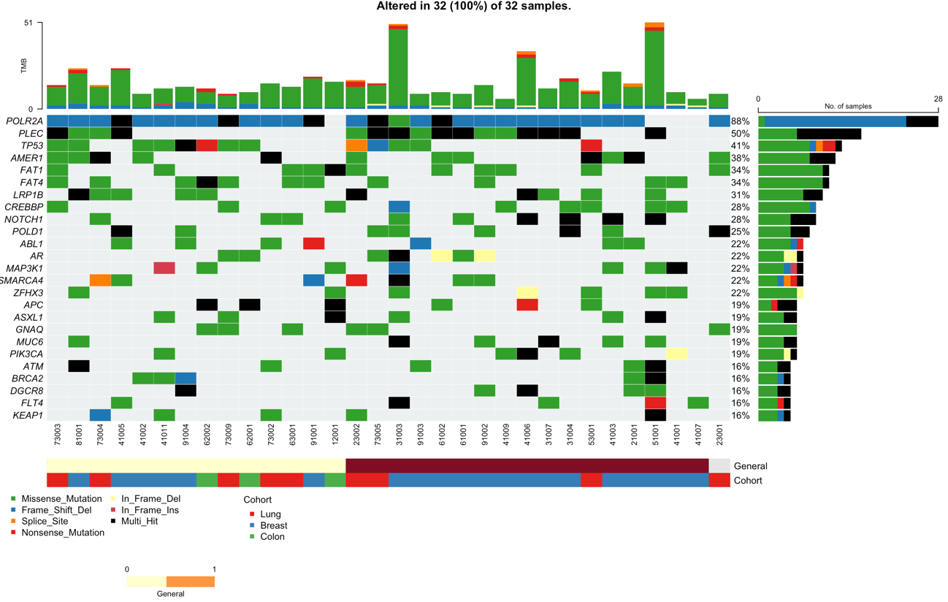
Figure 5A
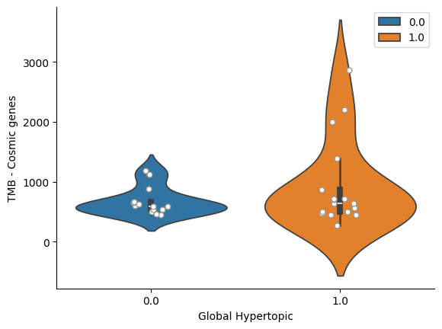
Figure 5B: TMB
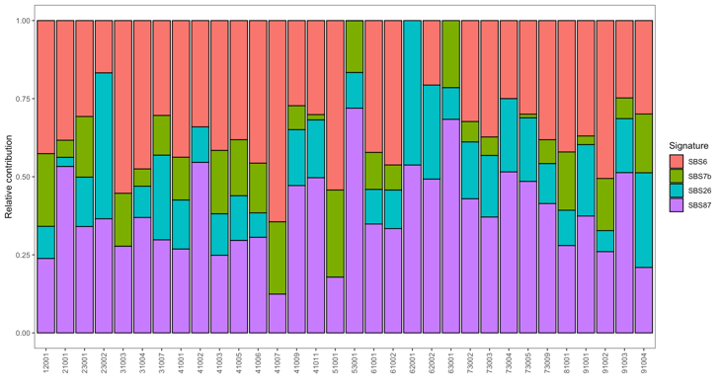
Figure 5C: Signatures
Figure 5D: HRD score
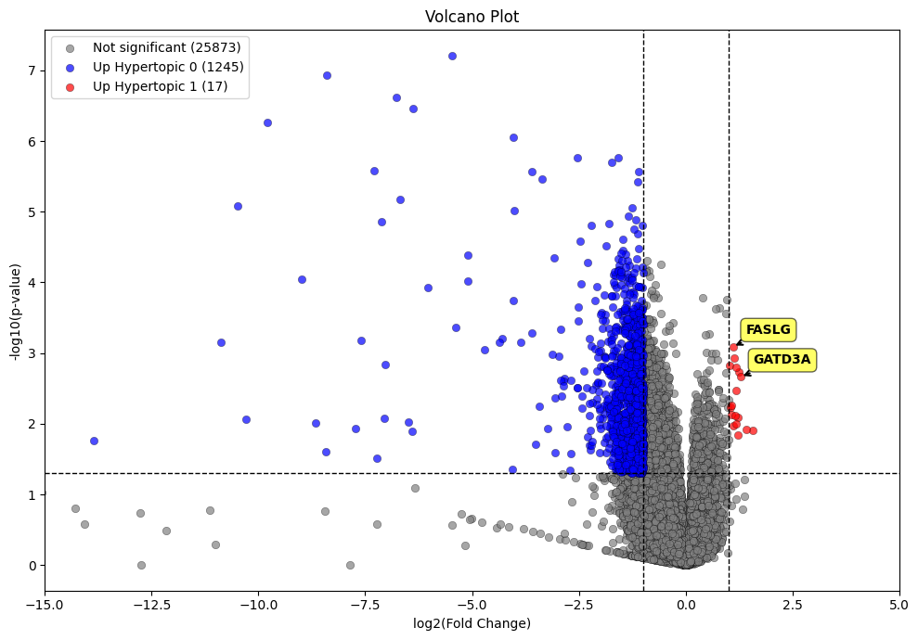
Figure 5E

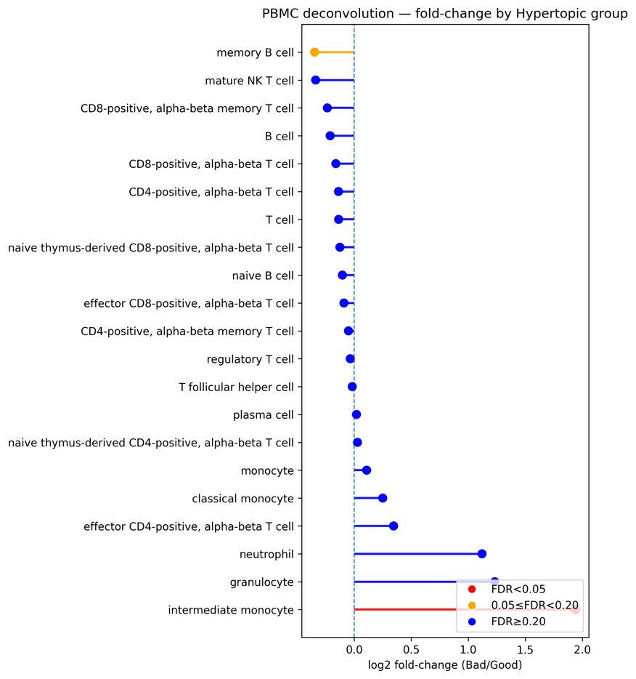
Figure 5F

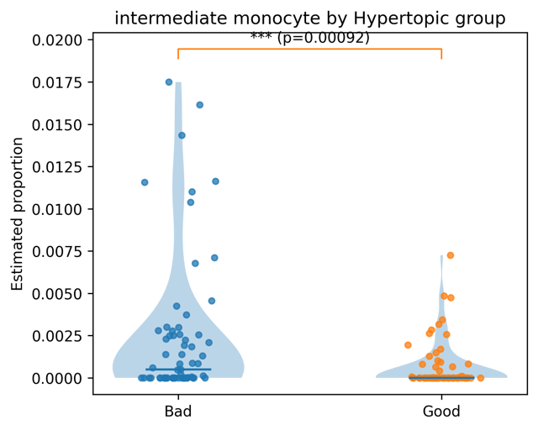
Figure 5G

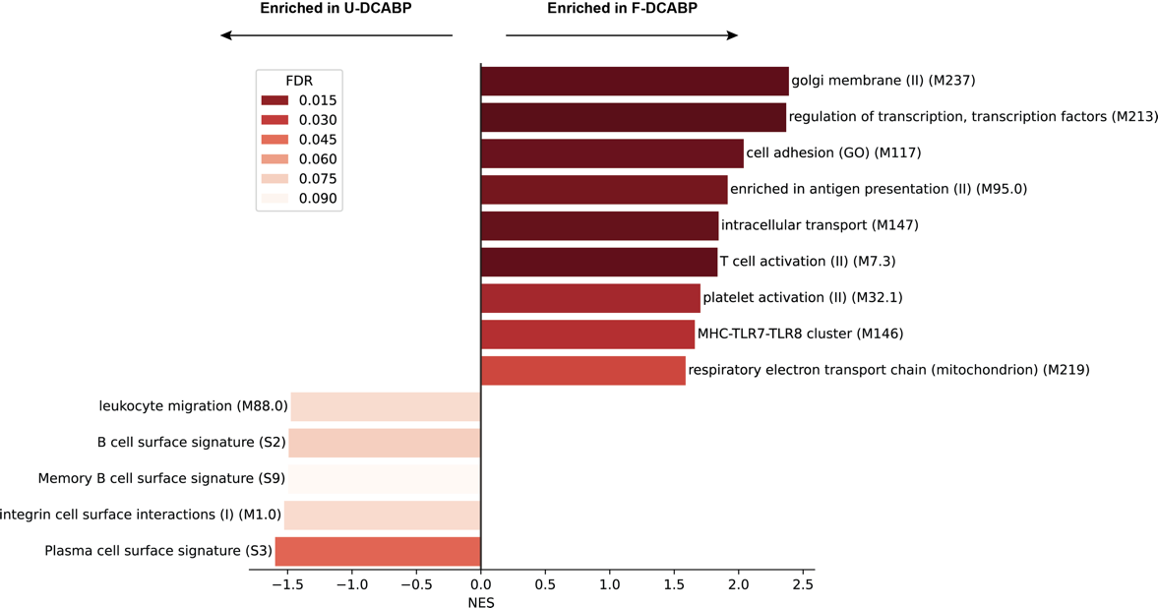
Figure 5H

Figure 5: Tumor genomic and PBMC transcriptomic correlates of hyper-DCABPs. (A) Oncoprint of the most frequently altered tumor genes in the DNA-seq subset (n = XX; interim) stratified by predominant hyper-DCABP over follow-up (F vs U). Columns represent participants; annotation tracks indicate predominant hyper-DCABP (gray, no assignment) and tumor type/cohort. (B) Tumor mutational burden (TMB) stratified by predominant hyper-DCABP (analysis to be finalized once DNA-seq is complete). (C) Tumor mutational signature exposures stratified by predominant hyper-DCABP (interim; to be updated). (D) Homologous recombination deficiency (HRD) score stratified by predominant hyper-DCABP (interim; to be updated). (E) PBMC RNA-seq differential expression at baseline between participants with predominant F-DCABP versus U-DCABP over follow-up (n=133), adjusted by age tertile; volcano plot with significantly differentially expressed genes highlighted (F) Immune-cell deconvolution from PBMC transcriptomes showing relative abundance estimates of major immune lineages stratified by hyper-DCABP. (G) Difference in CD14+CD16+ monocytes proportions between F- and U-DCABP; *: P=0.0009. (H) Blood transcriptional module enrichment analysis contrasting F-DCABP versus U-DCABP PBMC transcriptomes; the plot shows significantly enriched modules and effect direction (FDR threshold as indicated).
Abbreviations: DCABP: disease-control–associated behavioral pattern; hyper-DCABP: favorable (F-DCABP; DCABPs 0–2) vs unfavorable (U-DCABP; DCABPs 3–5); PBMC: peripheral-blood mononuclear cell; TMB: tumor mutational burden; HRD: homologous recombination deficiency; BTM: blood transcriptional module; FDR: false discovery rate.

Discusion

The present study demonstrates the feasibility of adding a largely passive, longitudinal “host-state” layer to precision oncology by combining consumer-device sensing with interpretable modeling. In a prospective, multi-cancer cohort monitored from treatment initiation, we show that individual passive signals differentiate early progressors in event-anchored analyses (Figure 2; Table S1), and that daily multimodal streams can be summarized into interpretable DCABPs whose longitudinal occupancy and switches are strongly associated with PFS and patient-reported quality of life (Figures 3, 4 and S5). We also show how a rolling-burden construct derived from unfavorable DCABP probability can function as a prospective early-warning signal for near-term progression over clinically meaningful horizons (Figures 4F-I). Importantly, these digital phenotypes are biologically anchored, in light of the DNA/RNAseq and cfDNA data (Figure 5). These findings address a persistent gap in precision oncology: outcomes vary widely even when tumor genotype and therapy selection are optimized, implying that determinants beyond tumor genomics and drug exposure shape clinical trajectories¹. Host physiology, behavior, and psychosocial context plausibly contribute to disease tolerance, treatment resilience, and the timing of decompensation, yet are typically measured through infrequent, subjective, and visit-anchored instruments. By shifting from episodic snapshots to continuous “streams,” passive sensing provides objective, high-frequency readouts of daily life that can be analyzed within-person, enabling detection of deviations from a patient’s own baseline rather than reliance on universal cutoffs. In doing so, this approach complements the current tumor-gene- and drug-centric paradigm and advances toward HDO: a dynamic, multi-layer view of health that integrates molecular biology with real-world physiology and behavior⁸.
At the single-signal level, our event-anchored comparisons highlight that several domains—mobility, location-derived context, device-use rhythms, affect, sleep and physiology—exhibit measurable differences between early progressors and matched controls, with heart-rate indices emerging as particularly robust (Figure 2). These associations should not be interpreted as causal; rather, they emphasize that passive monitoring can capture clinically meaningful changes that may reflect evolving systemic burden (e.g., inflammation, symptom load, medication effects, or treatment toxicity), often outside the clinic. Importantly, the use of event-anchored windows (rather than visit-anchored measures) aligns digital trajectories to clinically relevant endpoints and helps separate baseline inter-individual variability from temporal changes nearer to progression.
Beyond univariate signals, a central contribution of this work is an interpretable composite representation of daily behavior and physiology. We discretized multimodal daily features into “day types” using a VQ-VAE trained on an independent, heterogeneous digital phenotyping corpus, and then used topic modeling to derive six recurrent DCABPs (Figures 3 and S4). This two-step representation has practical advantages: it reduces redundancy across correlated streams, improves robustness to missingness and device heterogeneity, and yields patterns that remain explainable in terms of underlying variables (e.g., time at home, mobility, sleep timing/duration, phone use). DCABP prevalence was broadly similar across tumor types, while showing an age gradient, suggesting that these patterns capture generic host states that cut across cancer sites and therapies, with predictable shifts related to functional reserve and technology-use behavior (Figures 3E and 3F).
The longitudinal dynamics of DCABPs provide a clinically intuitive framing of disease course. While grouping patients by their overall dominant DCABP (or hyper-DCABP) yields strong separation in PFS, this summary is retrospective and cannot by itself support real-time monitoring (Figures 4A-4C and S5). Instead, the key insight is that DCABP membership evolves over time and that trajectory direction matters (Figures 4D-4F and S5): the month-1 assignment alone did not predict PFS, whereas persistent favorable/unfavorable occupancy and switches between hyper-DCABPs carried clear prognostic implications. Concordant differences in EORTC QLQ-C30 over time further support that DCABP dynamics track not only observable behavior but also patients’ lived experience, strengthening interpretability and face validity as a “functional phenotype” rather than a purely technical construct (Figure S5).
To bridge from retrospective summarization to prospective monitoring, we implemented an alarm construct based on rolling unfavorable hyper-DCABP burden. Specifically, we computed the probability of unfavorable state as the sum of LDA probabilities for unfavorable DCABPs (pUF), and integrated this probability over recent months to obtain a rolling AUCW burden (Figure 4G). In a decision-point framework, a 3-month window (W=3) and a 4-month prediction horizon (H=4) achieved sensitivity 0.70 and specificity 0.63 at the chosen operating point, with PPV 0.26 and NPV 0.92, illustrating a rule-out/triage profile: sustained low unfavorable burden identifies patients unlikely to progress in the near term, while alarms can prioritize individuals for closer assessment, imaging, or additional testing (Figures 4H-I). These operating points are not “one-size-fits-all”; they should be calibrated prospectively to match clinical intent (e.g., maximize sensitivity for safety vs maximize specificity to limit false alarms, according to the tumor type and clinical niche under study), and evaluated for unintended effects such as alarm fatigue or anxiety. integrate ctDNA/liquid-biopsy anchoring once available, to quantify concordance and lead time between digital alarms/switches and molecular burden changes. FIGURE XXX. Así, esto no es random – there are fluctuations between how “the patient feels”, they can be captured b yan objective pattern, and overlap with a biologic measure of disease burden in peripheral blood.
Our multi-omic analyses support the biological plausibility that DCABPs capture coherent systemic host states. Tumor DNA results in the currently available subset suggest that hyper-DCABP stratification is not primarily explained by baseline tumor genomics or it is, pending N=130, motivating a focus on host-level correlates (Figures 5A-D). In PBMC RNA-seq (n=133), we observed age-adjusted transcriptomic differences between participants with predominant favorable versus unfavorable hyper-DCABPs, including evidence of a modest myeloid skew and increased intermediate CD14+CD16+ monocytes in unfavorable states, and module-level enrichment consistent with preserved antigen presentation and T-cell activation programs in favorable states (Figures 5E-H and S6). These findings do not establish mechanism, but they provide an important bridge between digital phenotypes and immunobiology, suggesting that to some extent patients’ behavioral profiles and physiologic signals are not random or independent from the underlying disease, but a biologically anchored proxy.
In oncology, remote monitoring has most commonly been implemented through electronic patient-reported outcomes (ePROs) ⁴⁴⁻⁴⁶. In parallel, wearable studies have often focused on one or a few signals—most frequently activity/step counts—as objective correlates of performance status and outcomes^{5,24}. Our work extends this landscape in three ways: it integrates multiple passive streams into a single interpretable state representation (day types → DCABPs → hyper-DCABPs), it explicitly models longitudinal state dynamics and switches during therapy, and it anchors digital states to immune and transcriptomic biology—together enabling a more complete host-state layer than either single-signal wearables or ePRO-only monitoring. Besides these advances, several limitations should guide interpretation and define next steps. First, this cohort focuses on women, and the metastatic breast cancer subgroup is restricted to hormone receptor–positive disease treated with endocrine therapy plus CDK4/6 inhibition; broader validation across sexes, regimens, and additional tumor types is essential. Second, the study is observational: confounding and reverse causality are plausible (e.g., symptom burden, corticosteroids/opioids, intercurrent illness, healthcare utilization patterns), and some passive modalities (notably wrist SpO₂ and location-derived features) are sensitive to device fit, operating-system constraints, and permission settings. Third, while we demonstrated generally high data completeness, gaps and missingness are unavoidable in real-world deployment and can be informative but also bias analyses if correlated with disease severity. Similarly, some modalities such as SpO2 are sensitive to device fit. Continued work is needed on missingness-aware modeling and on fairness, as technology use and access vary across populations. Fourth, the strongest prognostic separation is obtained when summarizing “overall dominant” states, which is inherently retrospective; the prospective alarm addresses this limitation but requires external validation, calibration, and careful evaluation of clinical utility (does acting on an alarm change outcomes, resource use, or patient experience?). Limitation on the correlatives? On the liquid biopsy?
In summary, our results support a scalable path to high-definition oncology in which passive sensing yields interpretable host-state trajectories that complement tumor genomics and episodic clinical evaluation – i.e., the current paradigm of precision oncology. Future studies should validate DCABPs and alarm constructs across settings, test prospective calibration strategies, and evaluate clinical utility through decision-impact and interventional designs. Integrating orthogonal biological anchors—particularly longitudinal blood-based measures around switches and alarms—may further strengthen mechanistic interpretability and accelerate translation into low-burden monitoring strategies that augment existing standards of oncologic care.

References
1. Le Tourneau, C., Borcoman, E. & Kamal, M. Molecular profiling in precision medicine oncology. Nat Med 25, 711-712 (2019).
2. Soria, J.C., et al. Osimertinib in Untreated EGFR-Mutated Advanced Non-Small-Cell Lung Cancer. N Engl J Med 378, 113-125 (2018).
3. Hida, T., et al. Alectinib versus crizotinib in patients with ALK-positive non-small-cell lung cancer (J-ALEX): an open-label, randomised phase 3 trial. Lancet 390, 29-39 (2017).
4. Shaw, A.T., et al. Lorlatinib in advanced ROS1-positive non-small-cell lung cancer: a multicentre, open-label, single-arm, phase 1-2 trial. Lancet Oncol 20, 1691-1701 (2019).
5. Gresham, G., et al. Wearable activity monitors to assess performance status and predict clinical outcomes in advanced cancer patients. NPJ Digit Med 1, 27 (2018).
6. Sorensen, J.B., Klee, M., Palshof, T. & Hansen, H.H. Performance status assessment in cancer patients. An inter-observer variability study. Br J Cancer 67, 773-775 (1993).
7. Schnadig, I.D., et al. Patient-physician disagreement regarding performance status is associated with worse survivorship in patients with advanced cancer. Cancer 113, 2205-2214 (2008).
8. Torkamani, A., Andersen, K.G., Steinhubl, S.R. & Topol, E.J. High-Definition Medicine. Cell 170, 828-843 (2017).
9. Halcox, J.P.J., et al. Assessment of Remote Heart Rhythm Sampling Using the AliveCor Heart Monitor to Screen for Atrial Fibrillation: The REHEARSE-AF Study. Circulation 136, 1784-1794 (2017).
10. Perez, M.V., et al. Large-Scale Assessment of a Smartwatch to Identify Atrial Fibrillation. N Engl J Med 381, 1909-1917 (2019).
11. Lipsmeier, F., et al. Evaluation of smartphone-based testing to generate exploratory outcome measures in a phase 1 Parkinson's disease clinical trial. Mov Disord 33, 1287-1297 (2018).
12. Adams, J.L., et al. Using a smartwatch and smartphone to assess early Parkinson's disease in the WATCH-PD study over 12 months. NPJ Parkinsons Dis 10, 112 (2024).
13. Low, C.A. Harnessing consumer smartphone and wearable sensors for clinical cancer research. NPJ Digit Med 3, 140 (2020).
14. Stuijt, D.G., et al. Smartphone-Based Passive Sensing in Monitoring Patients With Cancer: A Systematic Review. JCO Clin Cancer Inform 7, e2300141 (2023).
15. Sparano, J.A., et al. Adjuvant Chemotherapy Guided by a 21-Gene Expression Assay in Breast Cancer. N Engl J Med 379, 111-121 (2018).
16. Cardoso, F., et al. 70-Gene Signature as an Aid to Treatment Decisions in Early-Stage Breast Cancer. N Engl J Med 375, 717-729 (2016).
17. Andre, F., et al. Genomics to select treatment for patients with metastatic breast cancer. Nature 610, 343-348 (2022).
18. Rodon, J., et al. Genomic and transcriptomic profiling expands precision cancer medicine: the WINTHER trial. Nat Med 25, 751-758 (2019).
19. van de Haar, J., et al. ESMO Recommendations on clinical reporting of genomic test results for solid cancers. Ann Oncol 35, 954-967 (2024).
20. Westphalen, C.B., et al. The ESMO Tumour-Agnostic Classifier and Screener (ETAC-S): a tool for assessing tumour-agnostic potential of molecularly guided therapies and for steering drug development. Ann Oncol 35, 936-953 (2024).
21. Siddaway, R., et al. Clinical utility of targeted RNA sequencing in cancer molecular diagnostics. Nat Med 31, 3524-3533 (2025).
22. Shreves, A.H., Small, S.R., Travis, R.C., Matthews, C.E. & Doherty, A. Dose-response of accelerometer-measured physical activity, step count, and cancer risk in the UK Biobank: a prospective cohort analysis. Lancet 402 Suppl 1, S83 (2023).
23. Hyde, E.T., et al. Accelerometer-measured physical activity, sedentary behavior, and mortality among cancer survivors: the Women's Health Accelerometry Collaboration. JNCI Cancer Spectr 9(2025).
24. Ito, K., et al. Physical Activity Using a Wearable Device as an Alternative to Performance Status in Patients With Advanced Lung Cancer. JAMA Oncol 10, 648-651 (2024).
25. Fraterman, I., et al. Association between pretreatment emotional distress and neoadjuvant immune checkpoint blockade response in melanoma. Nat Med 29, 3090-3099 (2023).
26. Zeng, Y., et al. Association between pretreatment emotional distress and immune checkpoint inhibitor response in non-small-cell lung cancer. Nat Med 30, 1680-1688 (2024).
27. Anker, M.S., et al. Resting heart rate is an independent predictor of death in patients with colorectal, pancreatic, and non-small cell lung cancer: results of a prospective cardiovascular long-term study. Eur J Heart Fail 18, 1524-1534 (2016).
28. Anker, M.S., et al. Increased resting heart rate and prognosis in treatment-naive unselected cancer patients: results from a prospective observational study. Eur J Heart Fail 22, 1230-1238 (2020).
29. Ethier, J.L., Desautels, D., Templeton, A., Shah, P.S. & Amir, E. Prognostic role of neutrophil-to-lymphocyte ratio in breast cancer: a systematic review and meta-analysis. Breast Cancer Res 19, 2 (2017).
30. Templeton, A.J., et al. Prognostic role of neutrophil-to-lymphocyte ratio in solid tumors: a systematic review and meta-analysis. J Natl Cancer Inst 106, dju124 (2014).
31. Zhang, Y., Chen, Y., Guo, C., Li, S. & Huang, C. Systemic immune-inflammation index as a predictor of survival in non-small cell lung cancer patients undergoing immune checkpoint inhibition: A systematic review and meta-analysis. Crit Rev Oncol Hematol 210, 104669 (2025).
32. Yang, Y., Shao, B., Wei, C. & Zhang, X. Prognostic Value of Immune-Inflammation Indexes for Breast Cancer Patients Undergoing Endocrine Therapy: A Systematic Review and Meta-analysis. Clin Breast Cancer 25, e968-e978 e962 (2025).
33. Hu, B., et al. Systemic immune-inflammation index predicts prognosis of patients after curative resection for hepatocellular carcinoma. Clin Cancer Res 20, 6212-6222 (2014).
34. Van Cutsem, E., et al. Cetuximab and chemotherapy as initial treatment for metastatic colorectal cancer. N Engl J Med 360, 1408-1417 (2009).
35. Gammall, J. & Lai, A.G. Pan-cancer prognostic genetic mutations and clinicopathological factors associated with survival outcomes: a systematic review. NPJ Precis Oncol 6, 27 (2022).
36. Shahbandi, A., Nguyen, H.D. & Jackson, J.G. TP53 Mutations and Outcomes in Breast Cancer: Reading beyond the Headlines. Trends Cancer 6, 98-110 (2020).
37. Zehir, A., et al. Mutational landscape of metastatic cancer revealed from prospective clinical sequencing of 10,000 patients. Nat Med 23, 703-713 (2017).
38. Liu, R., et al. Systematic pan-cancer analysis of mutation-treatment interactions using large real-world clinicogenomics data. Nat Med 28, 1656-1661 (2022).
39. Montel, A.H., Bochan, M.R., Hobbs, J.A., Lynch, D.H. & Brahmi, Z. Fas involvement in cytotoxicity mediated by human NK cells. Cell Immunol 166, 236-246 (1995).
40. Schattner, E.J., et al. CD40 ligation induces Apo-1/Fas expression on human B lymphocytes and facilitates apoptosis through the Apo-1/Fas pathway. J Exp Med 182, 1557-1565 (1995).
41. Smith, A.J., et al. GATD3A, a mitochondrial deglycase with evolutionary origins from gammaproteobacteria, restricts the formation of advanced glycation end products. BMC Biol 20, 68 (2022).
42. Sulicka, J., et al. Elevated markers of inflammation and endothelial activation and increased counts of intermediate monocytes in adult survivors of childhood acute lymphoblastic leukemia. Immunobiology 218, 810-816 (2013).
43. Sidibe, A., et al. Angiogenic factor-driven inflammation promotes extravasation of human proangiogenic monocytes to tumours. Nat Commun 9, 355 (2018).
44. Basch, E., et al. Symptom Monitoring With Patient-Reported Outcomes During Routine Cancer Treatment: A Randomized Controlled Trial. J Clin Oncol 34, 557-565 (2016).
45. Basch, E., et al. Overall Survival Results of a Trial Assessing Patient-Reported Outcomes for Symptom Monitoring During Routine Cancer Treatment. JAMA 318, 197-198 (2017).
46. Denis, F., et al. Two-Year Survival Comparing Web-Based Symptom Monitoring vs Routine Surveillance Following Treatment for Lung Cancer. JAMA 321, 306-307 (2019).

Author Contributions
-Conception and study design: RC, PMO, AA, MQF
-Administrative support: AL, AA, BN, MQF
-Data and patient accrual: SP, JAG, RGC, JR, DVB, JT, BB, RV, SGS, BN, BF, DJ, CRR, OP, CS, AP, BHM, RC, MQF
--Omics and biologic data: SG, AM, SM, MJB
-Analysis and interpretation: LP, LG, PMO, AA, MQF
-Manuscript writing and approval: All authors.

