Extended Material

Figure S1: Example participant dashboard used for adherence monitoring and troubleshooting. Screenshots of the eB2 web back-office used by study staff to monitor data capture, identify interruptions, and deploy adherence-support actions. (A) Passive data capture panel, displaying representative raw and derived streams captured from the smartwatch and smartphone (e.g., heart-rate and activity/sleep summaries, and selected contextual signals). (B) Active data capture panel, displaying participant-entered measures (e.g., daily pain VAS and other optional entries). For operational purposes, streams are labeled as passive when capture requires no participant action beyond wearing the smartwatch and carrying the phone, and as active when an explicit entry is required. Weekend-related gaps or short interruptions can often be resolved with brief participant contact, whereas prolonged absence of active entries may require re-training or workflow support. Red/blue markers denote unstable days, defined as days with atypical behavior that are not confidently assigned to a single learned day type; instability is flagged when assignment uncertainty is high and a change-point detector indicates a recent routine shift (algorithmic details in Methods). Differences in missingness across modalities are expected: for example, heart-rate and actigraphy-derived measures are typically more continuously available, whereas wrist-based SpO₂ is more sensitive to motion/fit and device quality filters, resulting in more frequent gaps. Location-derived features may also exhibit gaps despite otherwise complete wearable streams due to background-permission settings, mobile operating-system power management, and intermittent GPS/Wi-Fi fixes or upload delays.
Abbreviations: SpO₂: peripheral oxygen saturation; VAS: visual analogue (pain) scale.

Figure S2: Examples of passive and active data capture completeness. (A) Violin plots showing, for each modality summarized in Fig. 1F, the distribution of the daily number of participants with a valid measurement during days 1–90 and days 91–180 on study (stream-specific “valid day” definitions in Methods). SpO₂ typically shows lower availability than heart-rate, steps, or sleep measures due to stricter quality filtering of wrist-based optical readings. (B) Patient-level heatmaps illustrating daily validity of sleep-derived measures and (C) heart rate metrics across days 1–90 and days 91–180. Each row corresponds to one participant, ordered by overall completeness. Shorter follow-up reflects censoring due to progression/death, withdrawal, or database lock; intermittent gaps reflect non-wear, device/app interruptions, or failed quality-control criteria. (D) Active engagement with participant-entered measures over time, illustrated using pain VAS reporting across days 1–90 and days 91–180. Plots summarize the distribution of days with an active entry (e.g., percentage of days with a VAS record) per participant in each period and/or representative longitudinal examples, highlighting that active capture is inherently more variable than passive sensing.
Abbreviations: VAS: visual analogue scale; SpO₂: peripheral oxygen saturation.

Figure S3. Location-derived mobility and pain analyses by early progression status. (A) Daily location distance across two 15-day windows. Here, because of the nature of the variable, instead of comparing the two groups for each period, the two periods are compared for each group (early progressors or controls): baseline window (days +1 to +15; “Period 1”) and event-anchored window (days −15 to 0 relative to progression for early progressors, and time-matched windows for controls, “Period 2”). Curves summarize group-level daily trajectories within each window (median distance per day and 95% confidence interval). (B) Violin plots of self-reported pain intensity measured by daily visual analogue scale (VAS) and summarized per participant as the average pain score within each follow-up window. Distributions are shown for early progressors versus participants without early progression across three early follow-up windows (days 0–15, 15–60, and 60–135; P values: 0.18, 0.07 and 0.28, respectively).
Abbreviations: PD: disease progression; VAS: visual analogue scale. *: P<0.05: NS: Non-significant.

Figure S4: Behavioral-varable profiles across DCABPs. Comparison of the constituent behavioral/context variables across DCABPs (DCABP 0-5). Values are shown as standardized Z-scores (relative to the cohort distribution) to enable cross-variable comparison despite differences in units and dynamic range.

Figure S5: Month-1 DCABP assignment, granular pattern switches, and longitudinal quality of life. (A) Kaplan–Meier estimates of PFS stratified by the month-1 dominant DCABP (dominant DCABP during the first month on study). Tick marks denote censoring. Median PFS was 447 days (95% CI 347–512), 734 days (95% CI 134–1333), 623 days (95% CI 543–702), 446 days (95% CI 306–586), 387 days (95% CI 265–508), and 655 days (95% CI 435–874) for DCABPs 0–5, respectively. (B) Sankey diagram showing granular DCABP transitions from month 1 (left; DCABP 0–5) to the overall dominant DCABP over follow-up (right). Stream widths are proportional to the number of participants in each transition. (C) Longitudinal evolution of EORTC QLQ-C30 summary score stratified by overall dominant hyper-DCABP (F-DCABP vs U-DCABP). Lines show monthly mean scores; shaded bands denote uncertainty (95% confidence intervals, as defined in Methods). Abbreviations: DCABP: disease-control–associated behavioral pattern; F-DCABP: favorable hyper-DCABP; U-DCABP: unfavorable hyper-DCABP; PFS: progression-free survival; CI: confidence interval.

Figure S6

Figure S6: Month-level dominant DCABP occupancy across participants.
Month-level heatmap showing each participant’s dominant DCABP (0–5) over follow-up (one tile per month; white, not observed/not available). Participants are grouped by progression status and ordered by follow-up; the month in which progression was identified is outlined in black.

Figure S7

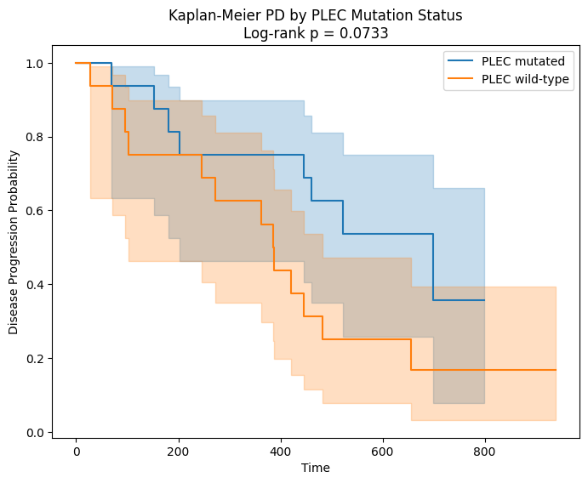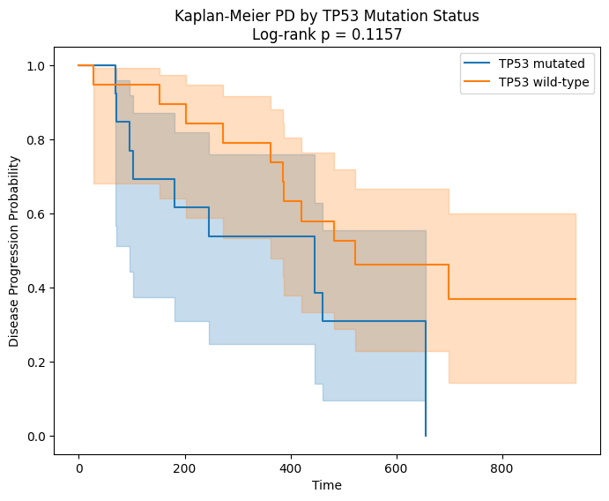

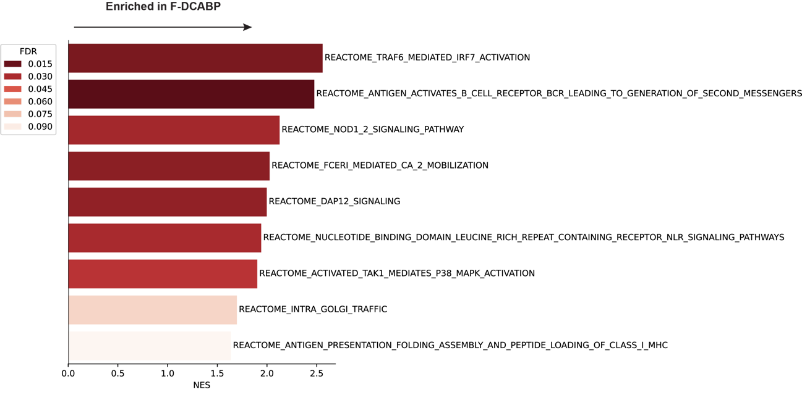

Figure S7: Genomic and transcriptomic correlates of hyper-DCABPs. (A) PFS Kaplan-Meier estimates of patietns according to their TP53 and PLEC tumor mutational status. (B) Plot representing the Reactome gene sets enriched in PBMCs from patients with a predominant F-DCABP.

